In the *Figure 1.*, it can be seen the waveform of a lightening impulse without the surge arrestor. The negative voltage reaches a value of -45kV, if the system is not rated for such high absolute electrical potentials, it is possible that it breaks down. For this reason, a surge arrestor can be implemented in the circuit.

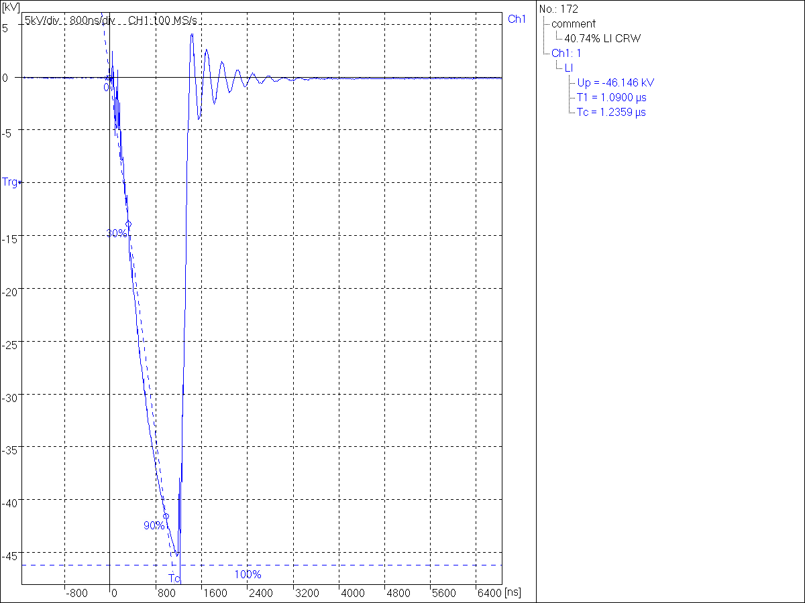

*Figure 1. Lightening impulse without surge arrestor.*

If the surge arrestor is implemented in the circuit, a different reaction is seen when a lightening strike occurs. In the *Figure 2.*, it is shown how the maximum absolute voltage reached is about 34kV even though the input voltage strike was equal. This means that the surge arrestor has broken down before the actual circuit does, preventing it from having a breakdown.

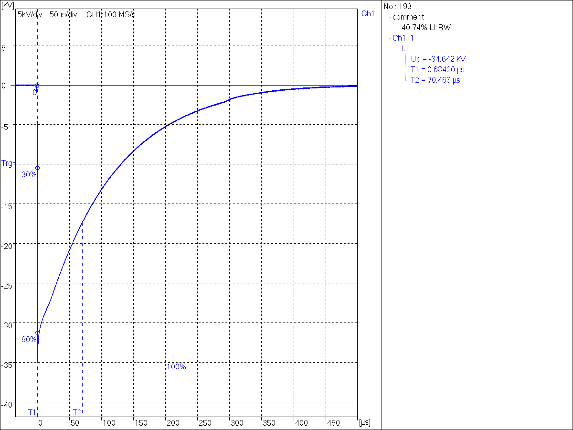

*Figure 2. Lightening impulse with surge arrestor.*