Driver circuitry troubleshooting

# General info

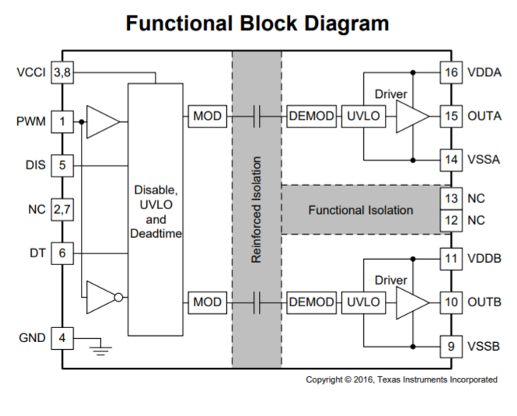

FIgure Functional block of driver IC

# Problem

During VF test the driver IC UCC20520 got damaged: the PWM signal at the input was not reflected at its output. This event happened when the DC Link voltage was increased until 36 V. A test with around 10-15 V had been performed earlier, apparently without damaging the driver circuitry. The circuit will be analysed to diagnose the root cause of why the system stopped working.

# Approach

The driver designer (SemesterProject ‘Development, Modelling and Implementation of an Electrical Drivetrain for a Go-Kart’ from 2018) performed a LTSpice model of the driver circuitry. The model will be used and the working conditions of the driver IC will be analysed against its absolute maximum ratings from datasheet.

# The Model

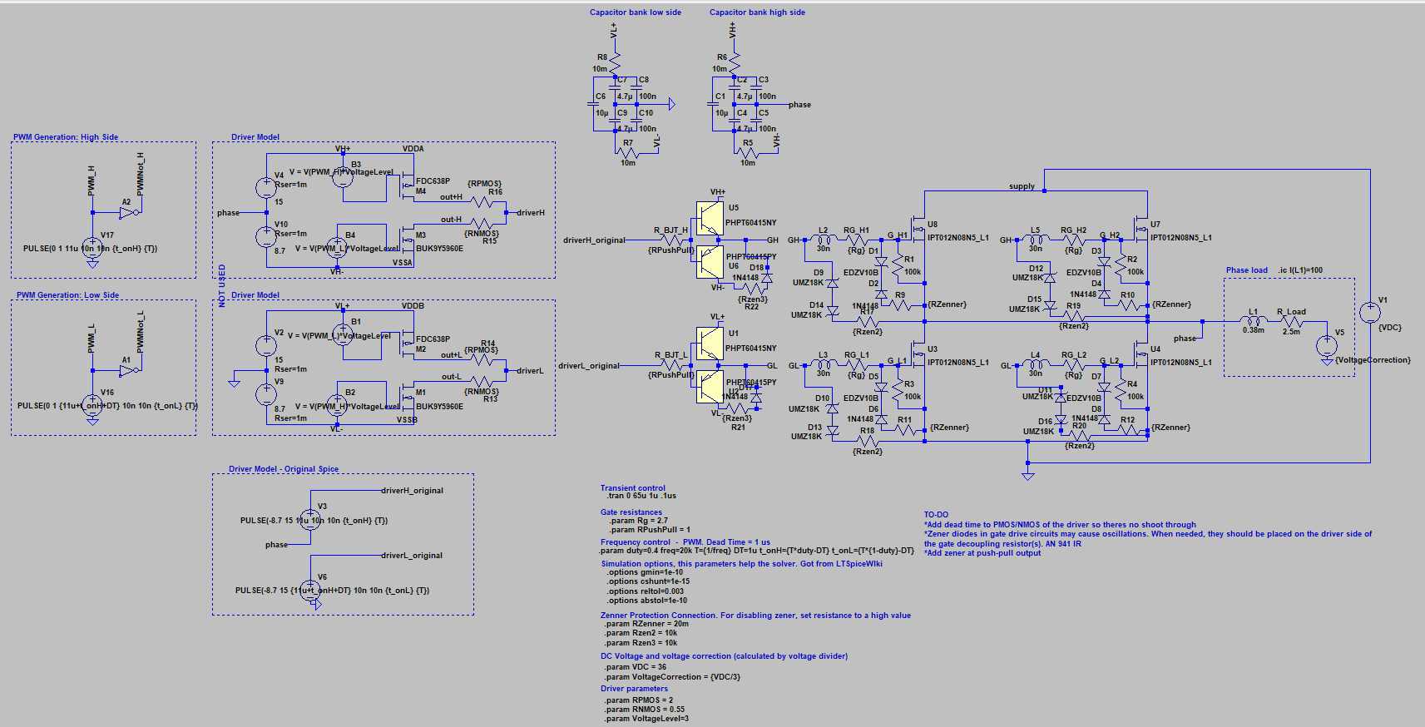

The provided file, models the driver IC output stage as a voltage source as seen in ‘Driver Model – Original Spice’. When thi input is used for simulating:

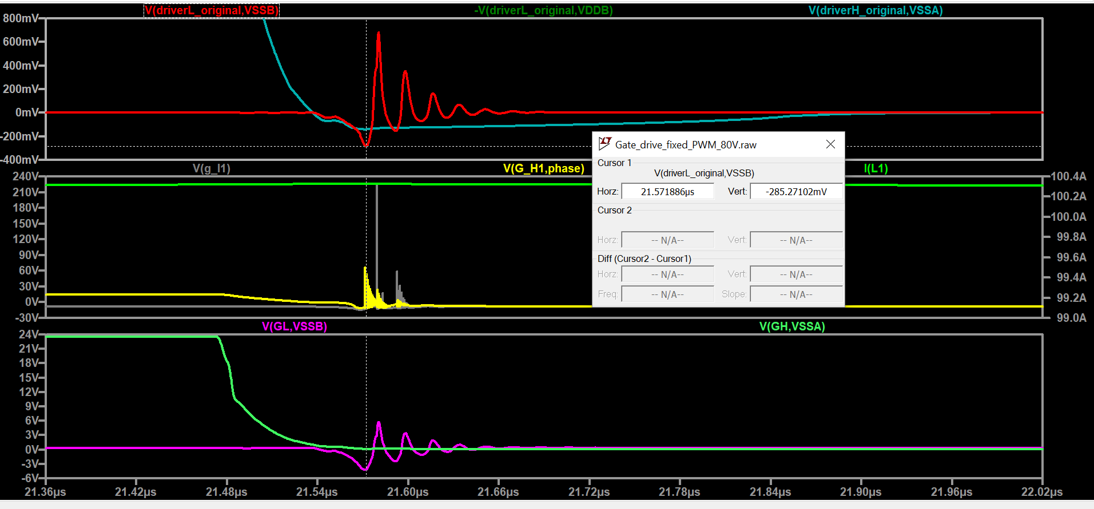

Voltage spikes can be seen when looking at the voltage between the output and vss/vdd. In the model, OUTA is driverH_original and OUTB is driverL_original. A voltage spike reaching -0.285 V can be seen. The minimum voltage according to datasheet is -0.3 V. Working so close to the absolute maximum rating could be dangerous, as unexpected conditions might increase (increase negative value) that voltage beyond safe margins.

Similar behavior can be seen when analyzing the voltage spikes of the outputs comparing with VDDA/B. In this case the maximum voltage according to datasheet is supply voltage + 0.3 = 15 - -8.7 + 0.3 = 24 V. In the simulation below, it can be seen that the voltage reaches 23.98 V.

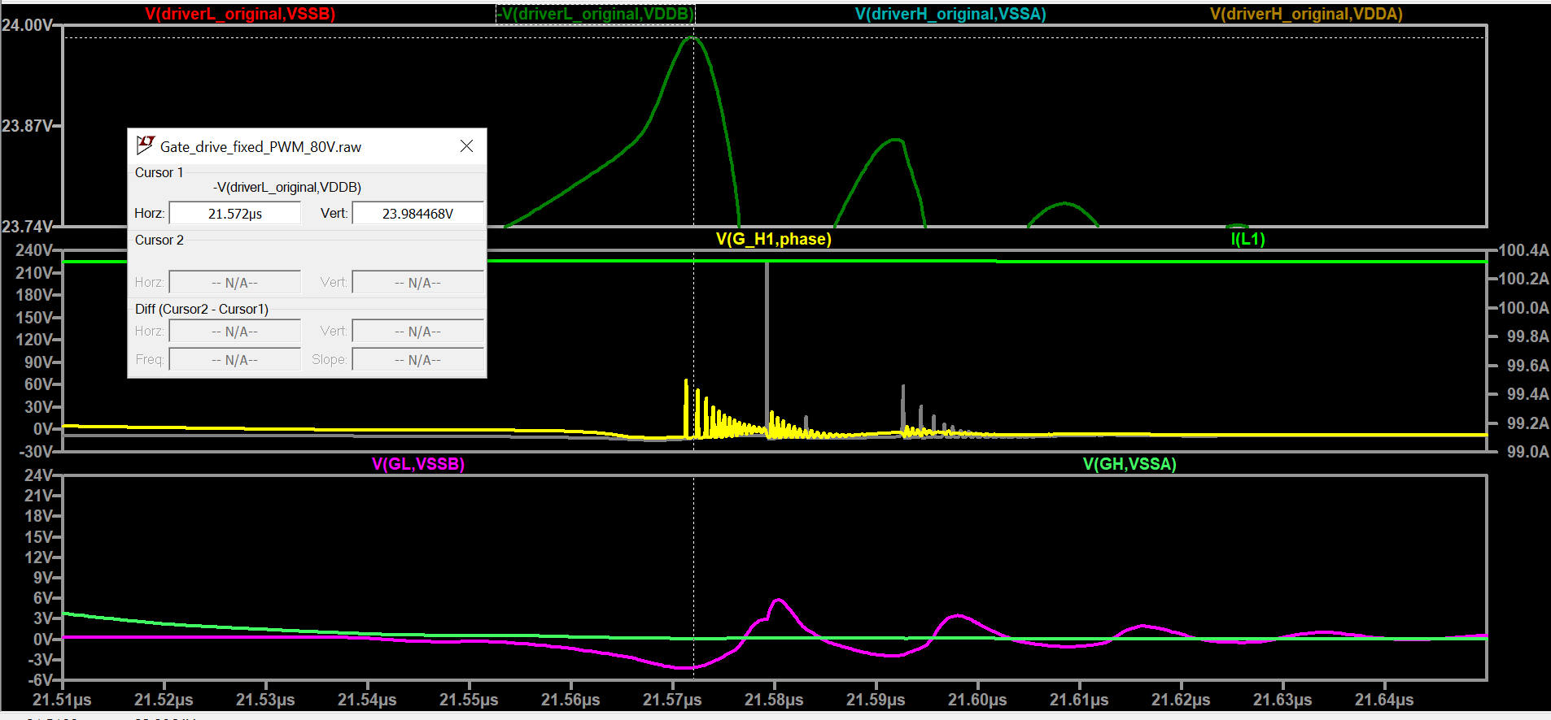

# Proposed solution

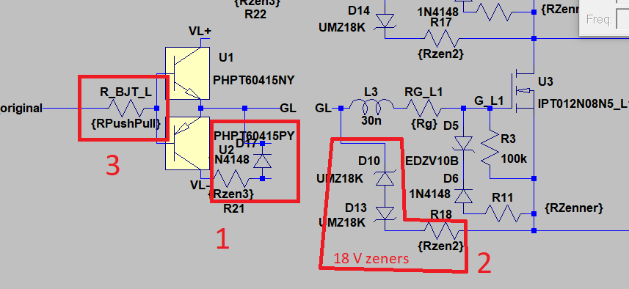

The solution could be approached by using dissipative networks as seen in the image below. The highlighted components are not in the current design. Solution 2 consists of two 18V zener diodes. Solution 1 is a common 1N4148 diode. Solution 3 is increasing the push-pull limiting resistance from 1 Ohm to 100 Ohm.

For testing the different approaches, the reistors Rzen3 and Rzen2 can be used for enabling or disabling the solution. Notice the fact that solution 2 is in the driver side of Rg.

The goal is to reduce the spikes by using the least amount of components. The effect of the different solutions is analysed.

## Only using solution 1

## Only using solution 2

Positive spike

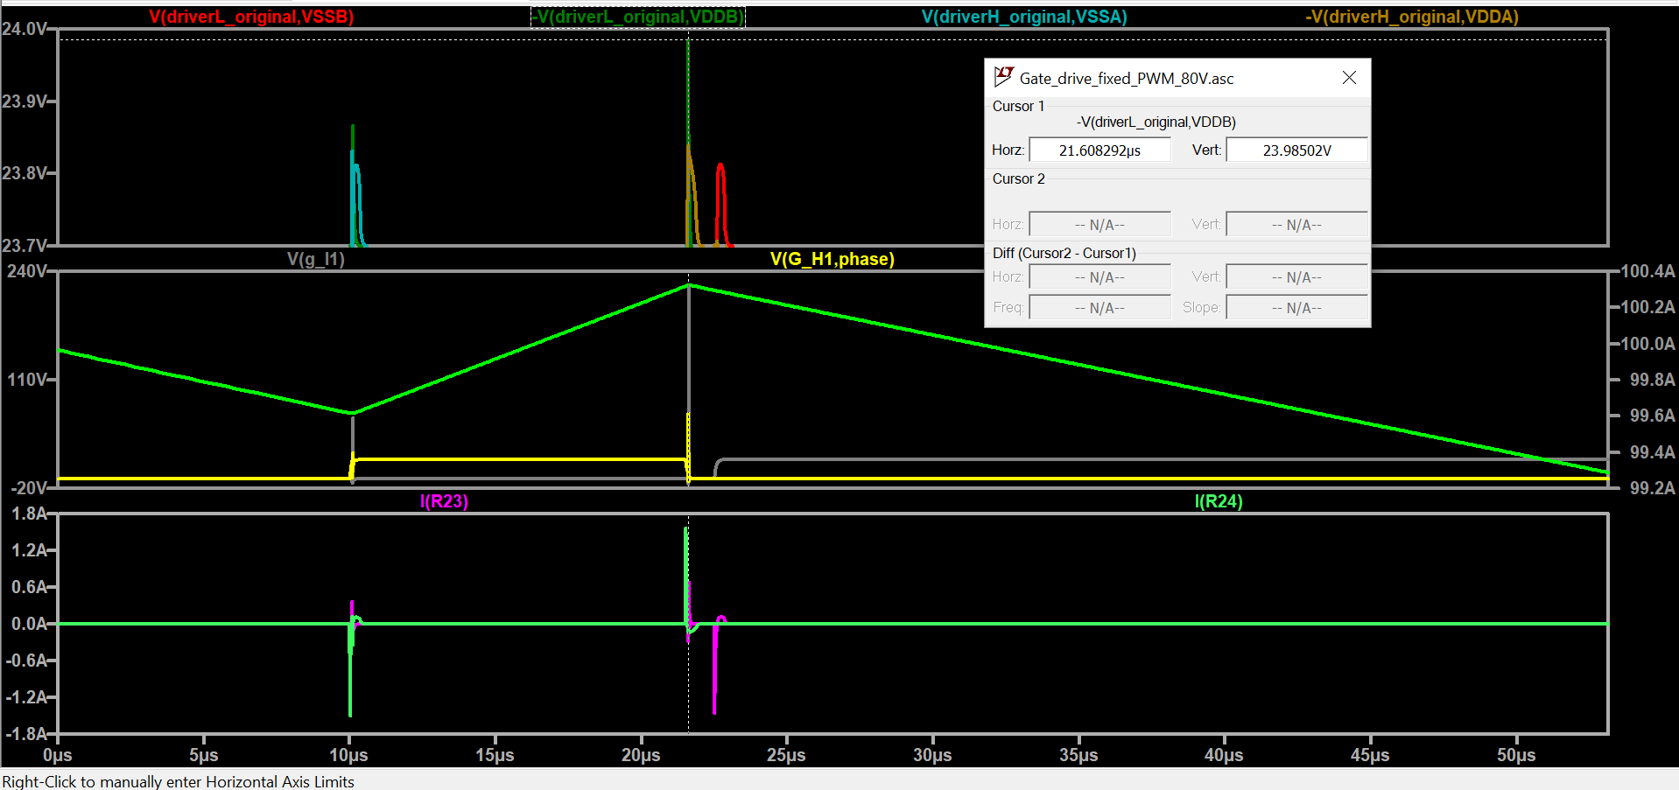

Negative spike

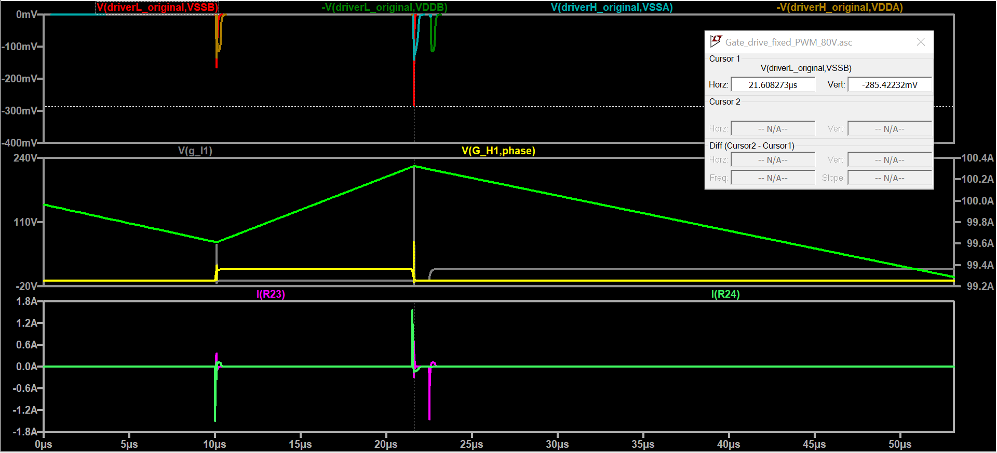

The current in the driver in both cases is way within threshold (cursor is not pointing anywhere):

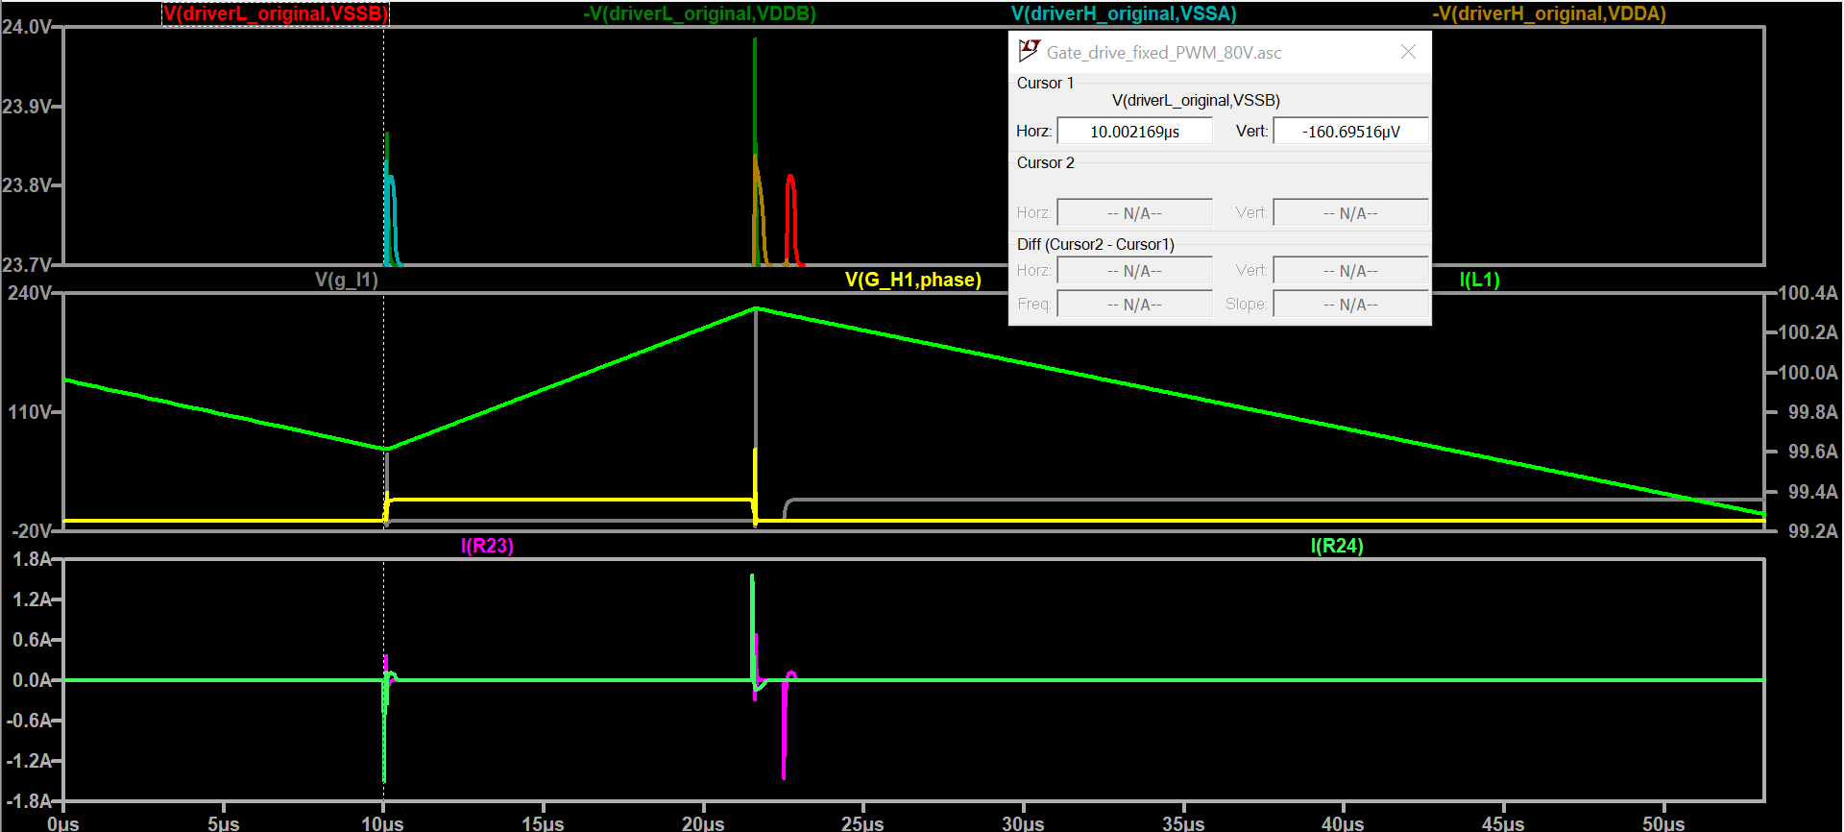

## Using solutions 1 and 2

The spike is reduced around 140mV (which might be enough)

Negative spike

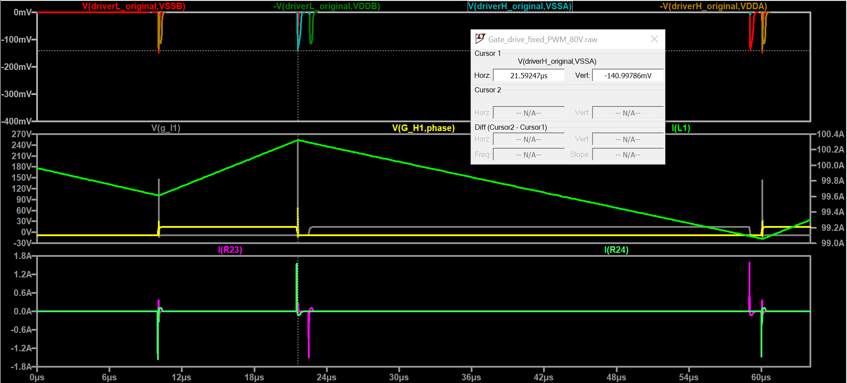

Positive spike:

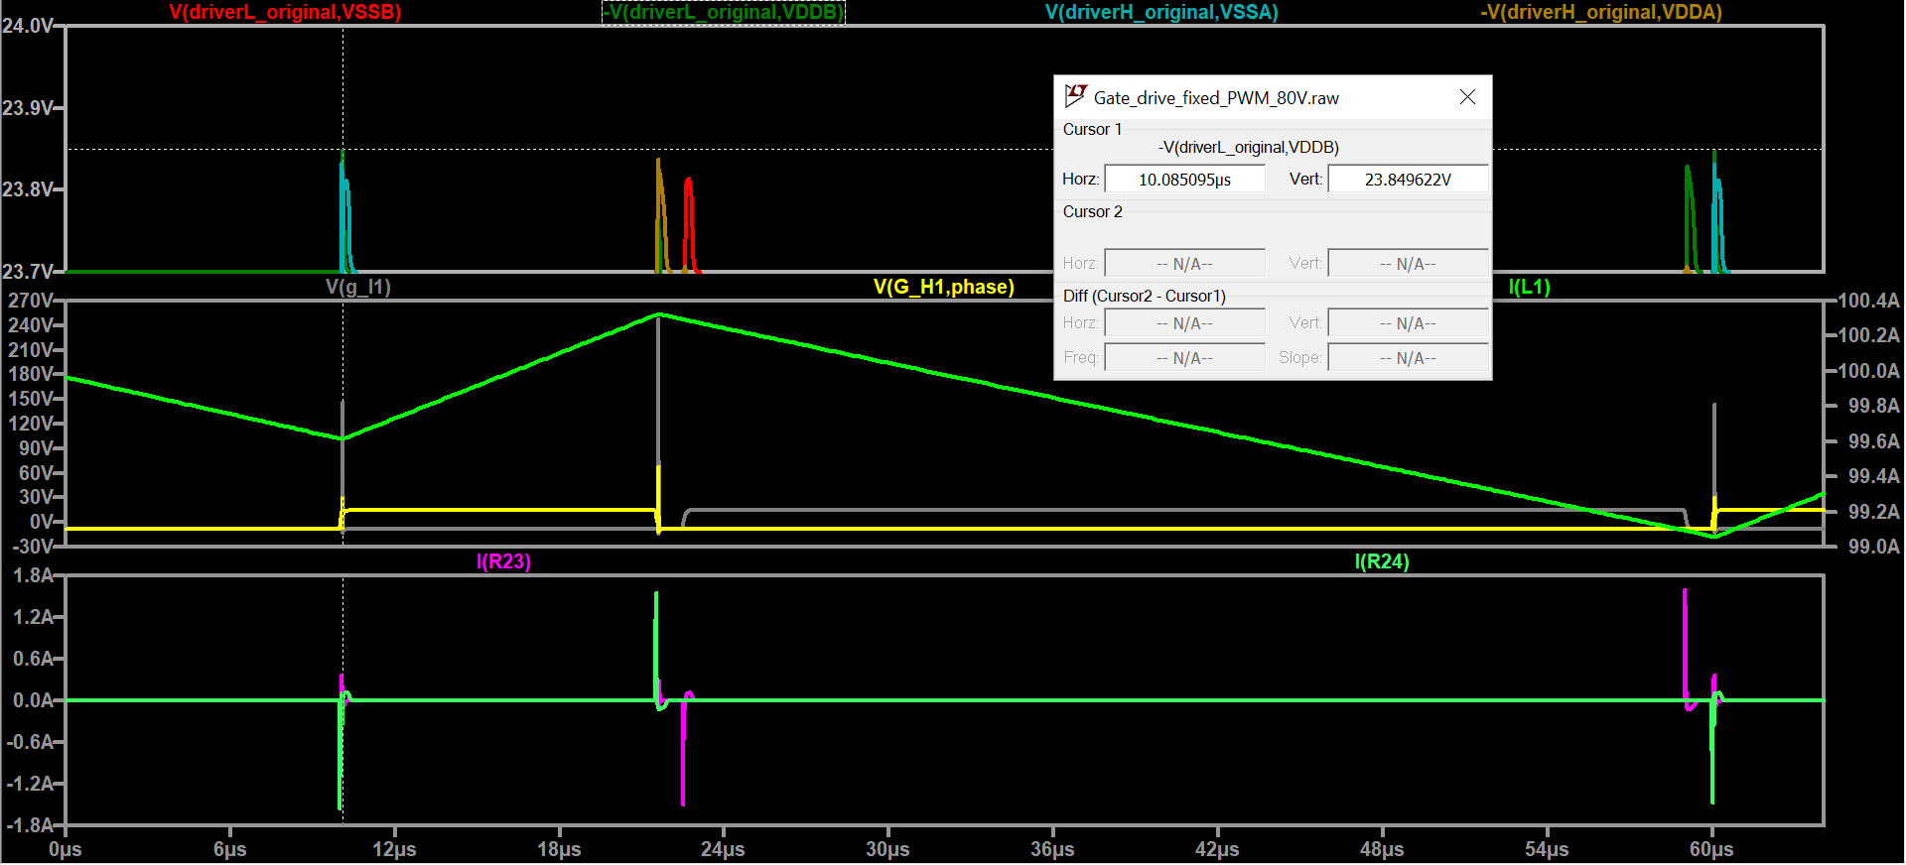

# Only using solution 3

Solution 3 shows the desired behavior of removing voltage spikes (the spikes lay in the resistor).

## Voltage spikes analysis

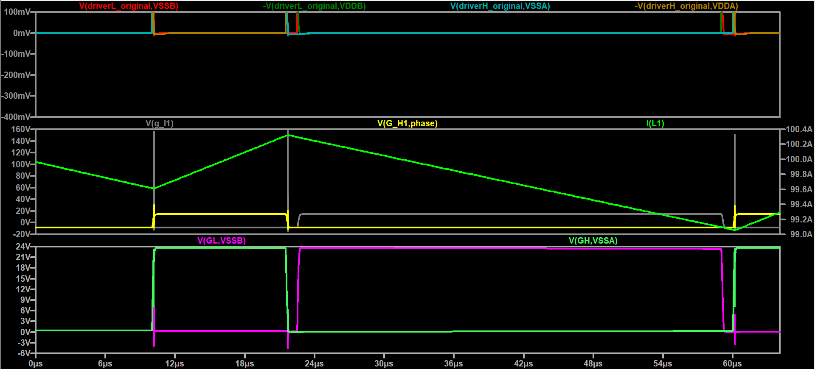

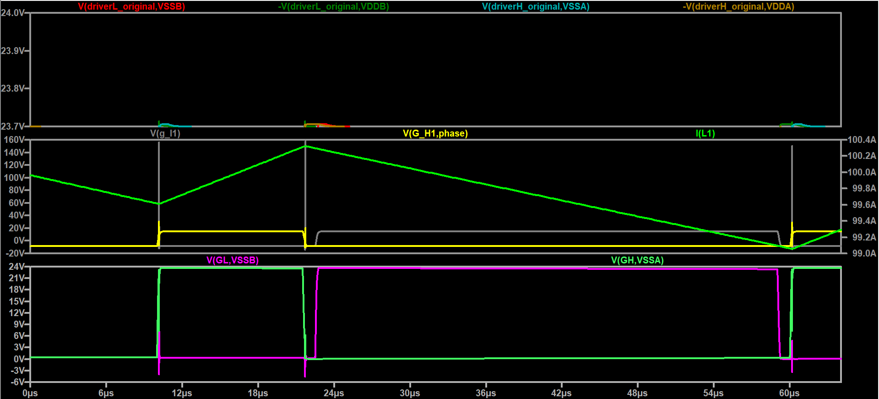

## Power dissipation in Push-pull base resistor

The dissipation produces power dissipation peaks as seen in the figure below. Although significant, these spikes lay within safe operating area for a 1206 resistor.

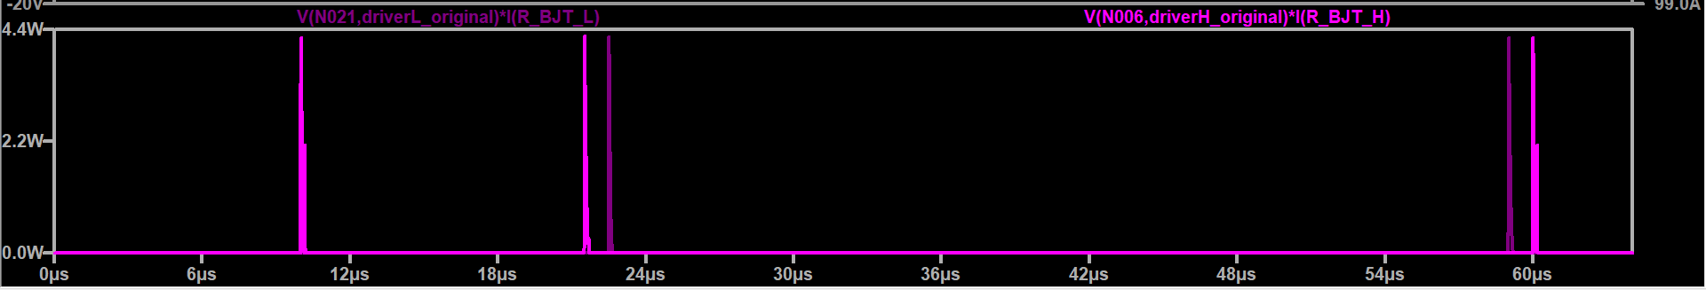

## Decrease in speed due to increase of resistor

The time from 10% to 90% of Vds mosfet increased from 22 ns to 23 ns.

# Using solutions 1 and 2 and 3

Negative spike

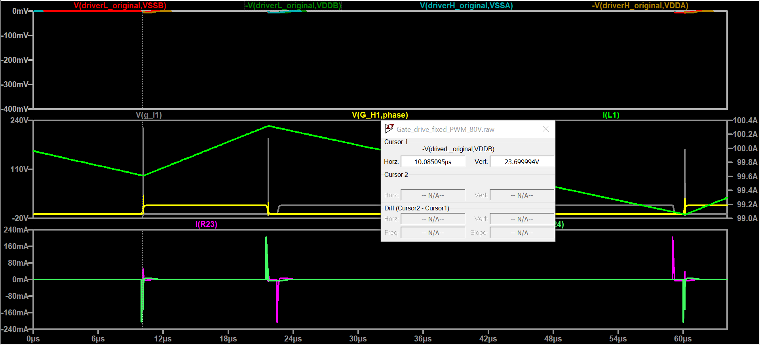

Positive spike 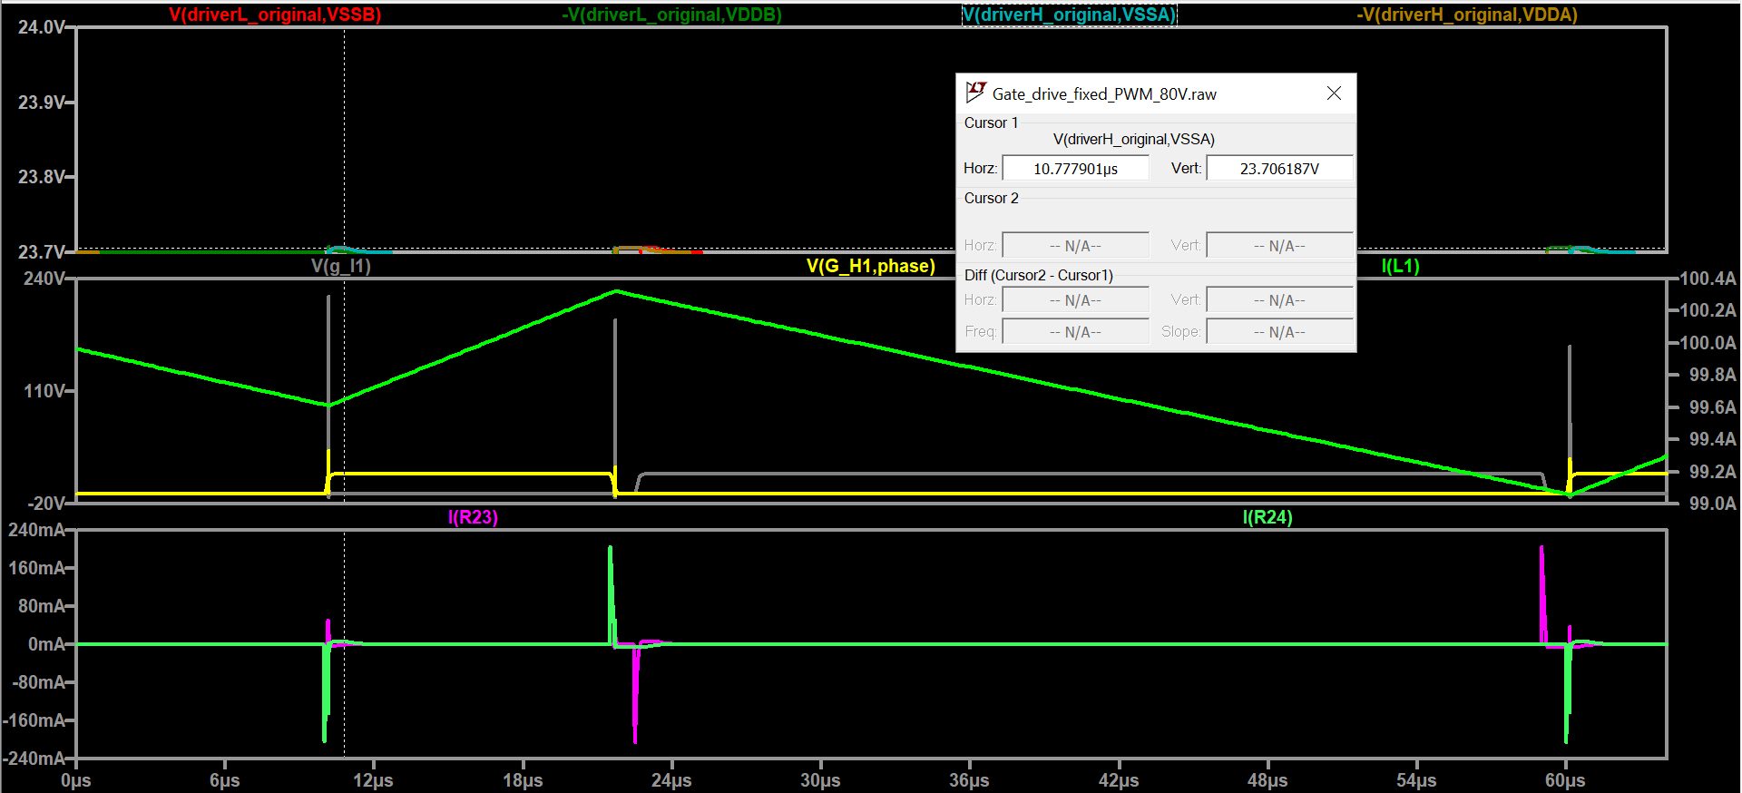

# Conclusion

Solution 3 by itself shows an excellent performance diminishing voltage spikes at driver. In addition, the workaround only implies changing the value of a resistor, which is easy and doesn’t require changes in PCB. However, it should be checked thoroughly if the change has any other undesired reaction in the system.