Test2

Netværk scanning

# Scannings grundlag

I denne rapport vil vi fremvise resultaterne af netværk scanning for Test2. Vi har scannet efter:

|  |
| --- |
| thing |
| thing2 |

Ud fra dette data er der lavet topologi kort over jeres lokale netværk og Azure miljø.

# Topologikort

## Lokal infrastruktur

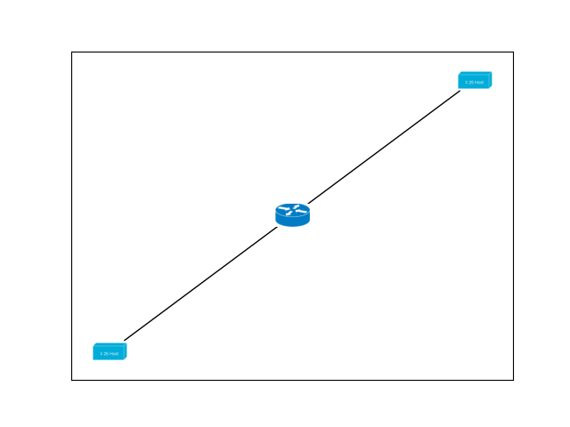

# Cloud infrastruktur

# Device scanning

## Lokal infrastruktur

|  |
| --- |
| homebox  192.168.1.1  7c:03:d8:cd:ef:61  Sagemcom Broadband SAS  up  Router - Default gateway  Huawei HG8245T GPON ONU WAP (Linux 2.6.21) or Sagemcom F@st 4350 WAP  99  [[53, 'open'], [80, 'open']]  ______________________________________ |
| Nicolajs-vrelse  192.168.1.16  c8:d0:83:ef:5f:cc  Apple, Inc.  up  Not identified  Apple iPod touch audio player (iPhone OS 2.2)  97  []  ______________________________________ |
| HPA24B8A  192.168.1.27  f4:39:09:a2:4b:8a  Hewlett Packard  up  Not identified  VxWorks  98  [[80, 'open']]  ______________________________________ |

## Cloud infrastruktur