Test4

Netværk scanning

# Scannings grundlag

I denne rapport vil vi fremvise resultaterne af netværk scanning for Test4. Vi har scannet efter:

|  |
| --- |
| thing |
| thing2 |

Ud fra dette data er der lavet topologi kort over jeres lokale netværk og Azure miljø.

# Topologikort

## Lokal infrastruktur

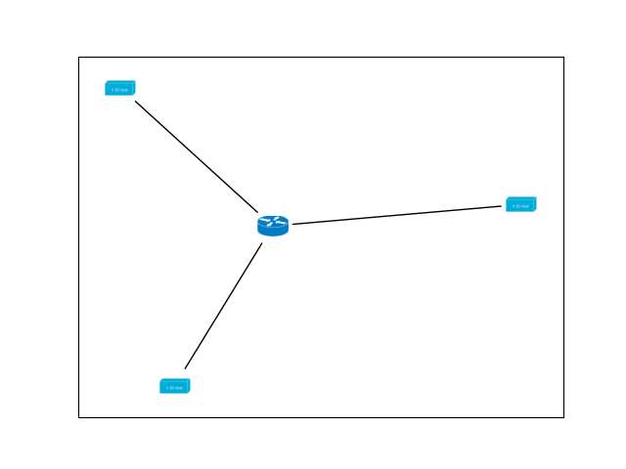

# Cloud infrastruktur

# Device scanning

## Lokal infrastruktur

|  |
| --- |
| homebox  192.168.1.1  7c:03:d8:cd:ef:61  Sagemcom Broadband SAS  up  Router - Default gateway  Huawei HG8245T GPON ONU WAP (Linux 2.6.21) or Sagemcom F@st 4350 WAP  100  [[53, 'open'], [80, 'open']]  ______________________________________ |
| Dell-1  192.168.1.17  5c:26:0a:75:83:9e  Dell Inc.  up  Not identified  Microsoft Windows 7 SP1 or Windows Server 2008 R2 SP1 or Windows 8.1 Update 1  100  [[80, 'closed']]  ______________________________________ |
| Nicolajs-vrelse  192.168.1.16  c8:d0:83:ef:5f:cc  Apple, Inc.  up  Not identified  Apple Mac OS X 10.7.0 (Lion) - 10.12 (Sierra) or iOS 4.1 - 9.3.3 (Darwin 10.0.0 - 16.4.0)  94  []  ______________________________________ |
| 192.168.1.12  c4:36:6c:dc:47:d3  LG Innotek  up  Not identified  Linux 2.6.32  98  []  ______________________________________ |

## Cloud infrastruktur