Multi-Platform Report (Adaptive vs Responsive)
Rappid app development
LNL
2020
Table of Contents
Adaptive Web Design 1
Responsive Web Design 1

Adaptive Web Design
Adaptive Web Design was first introduced by web designer Aaron Gustafson in his book, Adaptive Web Design: Crafting Rich Experiences with Progressive Enhancement which released in 2011. It is also known as progressive enhancement of a website.
Adaptive Web Design involves creating fixed layouts. When the site detects the available space, it selects the layout most appropriate for the screen. So, when you open a browser on the desktop, the site chooses the best layout for that desktop screen; resizing the browser has no impact on the design.
Due to Adaptive Web Design having fixed layouts it has many benefits these include allowing designers to build the best user experience for the appropriate device, mobile devices can sense their user’s environment, and designers can optimize advertisements based on user data from smart devices. Although there are many benefits to using Adaptive Web Design there are a lot more cons to using it, these include labour-intensive to create – most adaptive designs are retrofitting traditional sites to make them more accessible, tablets and netbooks can have trouble with site configuration tending to be smartphone or desktop oriented, challenging to SEO — Search engines have trouble appreciating identical content on multiple sites.
As a result of the negatives of Adaptive Web Design it is less used that Responsive web Design for modern web pages
An example of Adaptive Web Design is
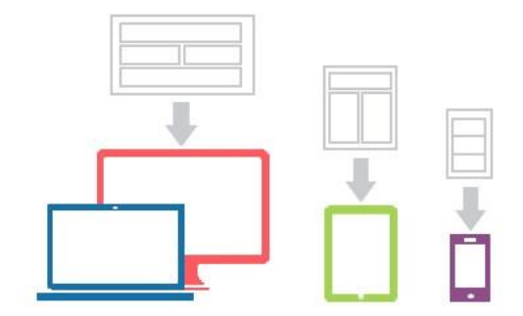

Responsive Web Design
Responsive Design was first coined by the web designer and developer Ethan Marcotte in his book, Responsive Web Design. Responsive designs respond to changes in browser width by adjusting the placement of design elements to fit in the available space.
A responsive website shows content based on the available browser space. If you open a responsive site on the desktop and then change the size of the browser window, the content will move dynamically to arrange itself optimally for the browser window. On mobile phones, this process is automatic; the site checks for the available space and then presents itself in the ideal arrangement.
Due to Responsive Web Design having fluid layouts it has many benefits these include it being uniform and seamless leading to good user experience, abundance of templates to use, SEO friendly, often easier to implement Although there are many benefits to using Responsive Web Design there are also a lot of cons to using it, these include less screen size design control, elements can move around, advertisements may be lost on screen, longer mobile download times.
As a result of the fewer negatives of Responsive Web Design it is more used that Adaptive web Design for modern web pages
An example of Responsive Web Design is
