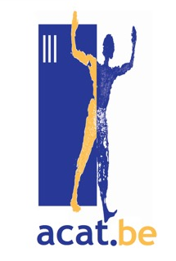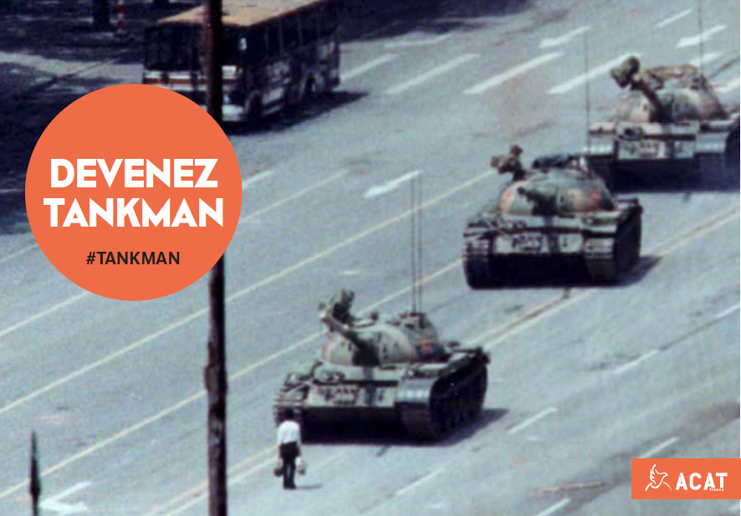**Tiananmen, la nuit de 3 au 4 juin 1989 :** Le gouvernement chinois réprime le mouvement démocratique qui demande des réformes politiques dans le sang. Un homme qui ose affronter les chars du régime est immortalisé par un photographe de Reuters. On l'appelle Tankman.

Aujourd'hui, 30 ans plus tard, le gouvernement cherche toujours à effacer ces événements de la mémoire collective chinoise.

Pour résister à cette terreur culturelle, un artiste chinois exilé en Australie a décidé de rendre hommage à la figure de Tankman. Le 4 juin 2016, l'artiste a revêtu les mêmes habits que le héros anonyme dans les rues d'Adelaide. Depuis, son initiative s'est diffusée aux quatre coins du monde.

Le 4 juin, l'ACAT-France vous invite à devenir Tankman à votre tour et ses équipes seront présentes toute la journée Place de la République à Paris .

Mais vous pouvez aussi rejoindre la campagne sur les réseaux sociaux et faire revivre Tankman dans votre ville ou région. C’est simple: enfilez un pantalon noir et un t-shirt blanc et munissez vous d’un sac ou cabas à provisions. Pour un plus grand retentissement, vous pouvez choisir un lieu symbolique dans votre ville, ou l’ambassade chinoise ou l’institut Confucius. L’ACAT France vous propose des affiches avec des slogans pour expliquer votre action.

N’hésitez pas à engager la conversation avec le public afin d’expliquer la situation des droits humains en Chine. Pour finir vous pouvez poster des photos ou vidéos de cette action sur les medias sociaux accompagnés des hashtags the hashtags #BecomeTankman and #Tiananmen, and share the GIF sent by ACAT-France. Puis partager le Gif proposé par l’ACAT- France.

Davantage d’explications sur : https://www.acatfrance.fr/evenement/commemorons-les-30-ans-de-tiananmen-

**Ce message contient les pièces jointes suivantes :**  
Affiches ANG A3 Tiananmen.pdf (1010 KB), Affiches ANG A4 Tiananmen.pdf (982 KB), Affiches FR A3 Tiananmen.pdf (1010 KB), Affiches FR A4 Tiananmen.pdf (983 KB), GIF Become Tankman.gif (5 MB)  
**Pour télécharger ces fichiers, rendez vous sur :**  
> <https://clients-ext.powermail.fr/bm/avalon/104393512-tinwVgtR9wQExoDTXUqA>

**- courrier en anglais de Nathalie Seff, Déléguée générale de l’ACAT France**

Dear all,

 As you may know, June 4th will mark the 30th anniversary of the Tiananmen massacre in Beijing, China. In order to raise awareness around the events of June 4th and keep the spirit of Tiananmen alive, ACAT-France is launching operation #BecomeTankman and wishes to invite your groups to take part in it.

 Inspired by an original idea by Chinese political cartoonist Badiucao, we urge everyone to become “Tankman” for a day, the famous dissident icon who stood up to the tanks in Beijing. Tankman has been a symbol for peaceful resistance in China since 1989, but it is also fading away due to brutal censorship and sophisticated propaganda from the Chinese government. Stepping in the shoes of Tankman for a day would be a way not only to keep the memory of Tiananmen alive, but also to celebrate the contemporary figures of resistance in China : human rights defenders.

 To join the digital campaign and re-enact Tankman, all you need is a white shirt, black pants and grocery bags. For more impact, you can chose a symbolic location in your town, or a place related to China (Chinese embassy, Confucius Institute, etc.) to hold your event. ACAT-France is sharing signs with slogans to accompany your action. During the action, do not hesitate to engage with the public to explain why you are here and present the current situation of human rights in China. Finally, you can post pictures and videos of your gathering on social media along the hashtags #BecomeTankman and #Tiananmen, and share the GIF sent by ACAT-France.

 Here is some background on the events of June 4th 1989:

 In the spring of 1989, millions of citizens took the streets in Beijing and across China to support a student-led movement calling for political reforms and the end of corruption. Gathered on Tiananmen square in Beijing, they were asking for a dialogue with the government. The pro-democracy movement was officially referred to as a “counterrevolutionary rebellion” by the government and violently repressed by the People’s Liberation Army in the night of 3 to 4 June 1989. Estimates of the death toll vary from several hundreds to thousands. The vast majority of the victims were students, intellectuals and workers.

 Since then, the Chinese authorities never revised their position, nor have they acknowledged and taken responsibility for the massacre.  Every year, as June 4th gets closer, the suppression of the remembrance of Tiananmen intensifies : activists who wish to commemorate the events of Tiananmen and mourn the victims of the bloodshed can be subject to arbitrary detention, house arrest and surveillance. Public memorials are banned. Online, censorship agencies tighten their grip over social media and delete any Tiananmen related content.

 The authorities go as far as depriving families of their right to mourn by preventing them from honouring the memory of their loved ones who were killed on Tiananmen square. Around June 4th, they are forbidden to go pay their respects to their relatives on the place they were killed. Security is traditionally stepped up around Tiananmen Square itself. 30 years after the massacre, Chinese authorities maintain a tight control over any information related to the brutal crackdown.

 Our main demands to the Chinese authorities are to:

-          provide a detailed account of the number of victims

-          bring those responsible to justice in accordance with international standards

-          put an end to the restrictions on freedom of expression and association as well as censorship around Tiananmen events

-          put an end to the crackdown on peaceful activism around June 4th

 We hope you consider joining this global campaign and show support to Chinese human rights defenders !