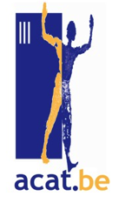**THE BALKAN TRAGEDY: WHEN CONFLATING FEAR OF THE VIRUS AND OF THE ALIENS THREATENS THE FOUNDATIONS OF THE EU**

**Brutish pushbacks of Migrants, forced to leave a country as soon as they set a foot on it have become kind of systemic. Those refoulements, deprived of any judicial base are characteristic of EU‘s lockdown and exclude all examination and getting asylum chances in Europe.**

**BOSNIA-HERZEGOVIN**A.

Decentralised parliamentary system: one central state, two entities (the BHz Croat-Muslim Federation with 10 cantons and the Republika Srpska and Brcko District). Capital: Sarajevo

International High Representative: Valentin Inzko

Collegial Presidency: Sefik Dzaferovic (since March)

51,209 km2

Muslims (50.7%) and Orthodox (30.7%).

Human Development Index HDI 2017: 0.768

GDP per capita 4,783€.

(By way of comparison, France 32 900; Belgium 41420;

HDI 0.891 and 0.919 respectively)

**CROATIA**.

Parliamentary, Democratic and Multiparty Republic

Chair: Zoran Milanović (after Ms Grabar-Kitarović) Capital: Zagreb ; 56,594 km2, 4,105,493 inhab.

HDI 0.831 GDP per capita : 12 150€.

As migrants unrelentingly search for new routes throughout the Balkans, violence is growing. Not only in and Hungary, Bulgaria and Greece, but also, more and more, in Croatia, in Rumania and Serbia. There, whole families that have been left in the greatest deprivation in transit zones, with only one GP for the most vulnerable among them, sometimes afflicted with the earnest pathologies.

Croatia, that was just about to integrate the Schengen space in March 2020, has subsequently monitored its external frontier rather covetously. Its police forces are both over-equipped and financed by the EU. Since the Salvini Era and the soaring police presence in Trieste, migrants have been chased towards Slovenia, which in turn usually pushes them to Croatia. Intercepted in the latter, they are usually violently pushed back to Bosnia-Herzegovina. The 5000 or so available accommodations are not enough to provide for approximately 12000 migrants on the run, who may have no choice but to still **move forth** on roads paved with mines. This, added to the thuggish nature of the Croatian police forces, makes Bosnia a dead end for migrants.

In Una-Sana at the limes with Croatia, migrants usually find a shelter in factories, relinquished stations or even in the forests. In Bihac, scarred by the remnants of the war, a former refrigerators plant, now equipped with containers, holds 2000 migrants, among which 400 **unaccompanied minors**. Elsewhere one would sleep and cook on cardboards laid upon the bare earth, some in tents, others in abandoned industrial facilities, even sometimes on garbage dumps. Dressed in rags they are cold, have no soap, nothing to eat, no drugs, no luggage any more: they had been taken away. From time to time, the humanitarian help nonetheless reaches the isolated camps, where there’s no water at all, no electricity and no medical attendance. Although the horror camp of Vutciak has been closed (800 refugees living in inhuman conditions) since Dec.2019, new erected camps, either in Lipa or Mira, are not much better off.

Since the beginning of the crisis, the jaunts of the migrants have been drastically reduced. And because gatherings are also strictly prohibited, humanitarian aid henceforth hardly gets to Bihac, whose mayor has accused the migrants of being behind the current confusion. Voluntary workers are getting scarcer. Simultaneously the Guards ‘corruption increases dramatically, in [Velika Kladuza](https://www.google.com/search?q=Velika+Kladusa+migrants&client=firefox-b-e&sxsrf=ALeKk00PGNIWUHqa7tgPnxvzset7QSzqpw:1587462432382&tbm=isch&source=iu&ictx=1&fir=iWqmCO56_Fk8QM%3A%2C_1HcnfsMsddoFM%2C_&vet=1&usg=AI4_-kSRxuBPHZh7awxHLrg9YSNrjjLgvQ&sa=X&ved=2ahUKEwiNkoGznvnoAhWfTBUIHTI9DxoQ9QEwCXoECAkQGw#imgrc=iWqmCO56_Fk8QM:), for instance. The anger of exiles and inhabitants on both side of the border explodes. Xenophobia exacerbates: the foreigners tend to become the scapegoats of the locals, who wave boards around, banning the outlanders from entering supermarkets.

The great Game :

Whenever an exhausted migrant has collapsed, the squadrons usually ignore him. The *game* now will be to get to the other side of the border without meeting the black balaclavas- hooded Croatian policemen, who have the habit of burning all personal effects (phones, food), before pointing their weapon to anyone solely hankering after a new destiny ». With their clothes and shoes confiscated, the migrants realised nto the wild by night, sometimes in hazardous zones –riversides, abrupt hills, and mined lands. They have no choice but to plunge naked in frozen streams, might they be able to swim or not. After they ‘ve reached the other bank, they sleep huddled on filthy mattresses or even on the tilings of some mosques‘ toilets. Everywhere, you’ll meet broken faces, broken limps (even by children), which reflects the brutality attributable to the cruelty of the police. A savageness which humanitarian and voluntary workers, or the rare journalists still on the spot, bear witness of.

Croatia violates international and European Laws openly. Croatian as well as Serbian pushbacks are the very evidence of that infringement. However, as for today, the EU had imposed no sanction on Croatia at all. And Covid 19 has further exacerbated the hostility towards foreigners. Recession and social conflicts that may logically follow the pandemic are likely to trigger a recrudescence of the migrations flux.

As the custodians of a long tradition of multiculturalism and solidarity, the Bosnians are keen on offering the exiles a meal, a roof, tents, even hotels accommodations. Halas, this sense of hospitality blunts. The absolute priority focuses on the population’s security. A European Project commemorating the holocaust has shown that historical negationism in Croatia remains particularly vivid. Many attacks regularly target the least favoured groups in civil society, as the Romas, so that a climate of both intolerance and

hostility prevails.

**Fiche d’informations complémentaires**

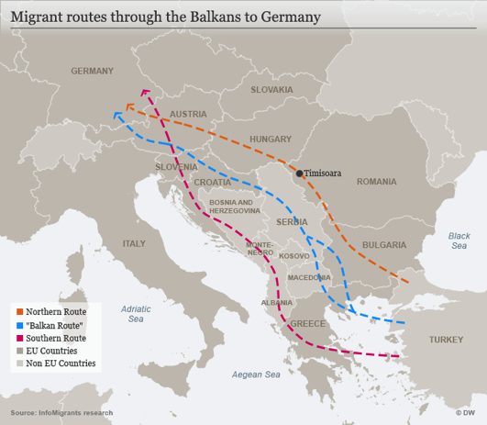Bosnia and Herzegovina -three autonomous, though not independent territorial entities - has not made provision so far for the reception of exiled persons. A manifold of actors, including international institutions, - UN mandate on the district of Brčko – are involved in the governance. The European Union has allocated the almost exclusive 7.2 million euros of pre-accession aid to the EU (IPA) to the international organisations on the field (IOM, UNHCR and UNICEF), rather than to the government. This circumvention of state institutions has weakened the state as the warrant of the compliance with international obligations. In addition, the complex structure of the country, established in 1995, prevents the Muslim-Croat Federation and the Bosnian-Serb Republika Srpska (RS) - representing two parts of the country - from agreeing on a common approach.

* The Balkan route is bound to be a perilous journey through the mountains, over territories that have never been cleared of the mines of the last Balkan war. Some are heading for Serbia, where accommodation conditions are not as bad as in Bosnia. (CIMADE)

According to the Croatian interior ministry nearly 12000 migrants and asylum seekers were registered during the first 8 months of 2019. They come mainly from Afghanistan Pakistan and Turkey. That represents an increase of 8600 migrants, in comparison to 2018. Only 71 asylum applications out of 974 were then approved.

EUROPEAN COMMISSION Brussels, 29.4.2020 COM(2020) 315 final COMMUNICATION FROM THE COMMISSION TO THE EUROPEAN PARLIAMENT, THE COUNCIL, THE EUROPEAN ECONOMIC AND SOCIAL COMMITTEE AND THE COMMITTEE OF THE REGIONS Support to the Western Balkans in the fight against COVID-19 and recovery from the pandemic. Commission contribution to the EU-Western Balkans Leaders' meeting on 6 May 2020) https://ec.europa.eu/transparency/regdoc/rep/1/2020/FR/COM-2020-315-F1-FR-MAIN-PART-1.PDF

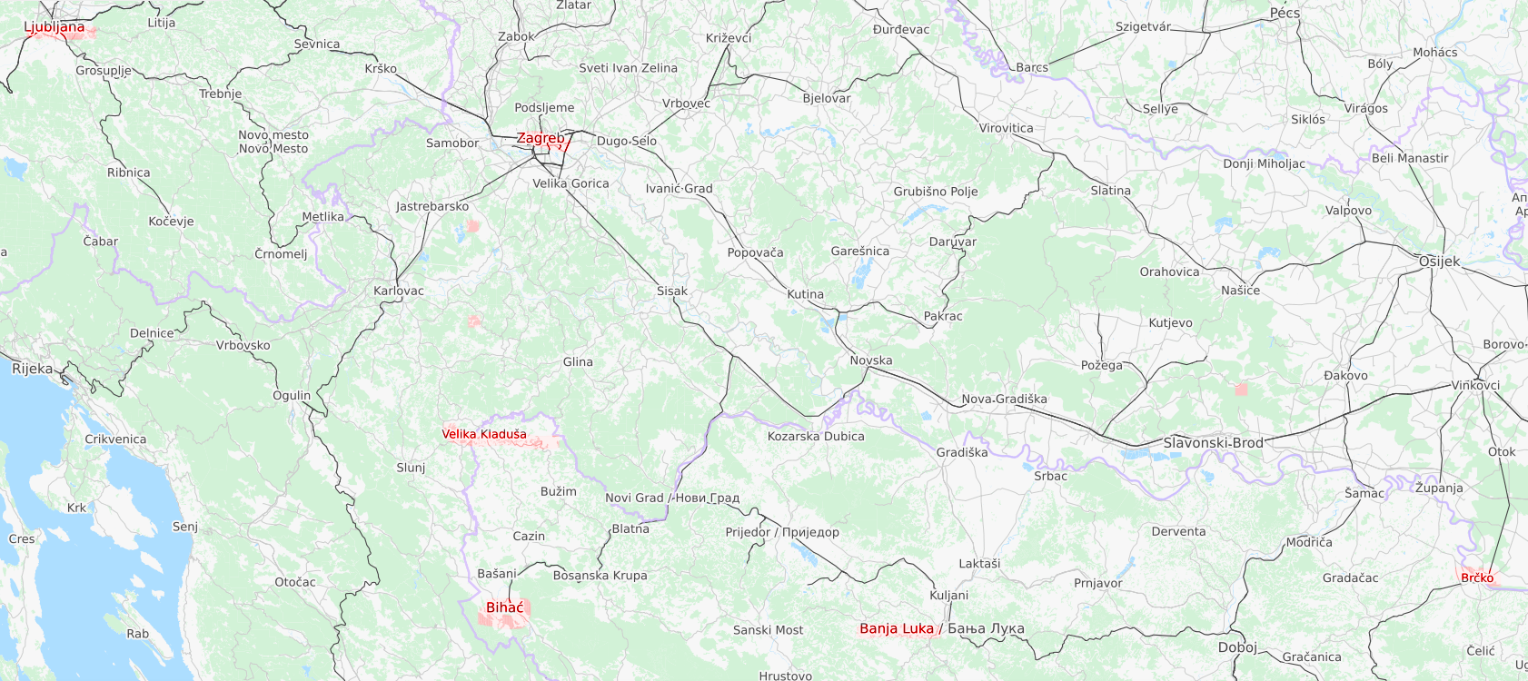“A true ignominy for Europe, the cradle of human rights”, such are the words of a worker in a leading position from HRW, as she qualifies Ursula von der Leyen’s acknowledgement to Greece, that has in effect become Europe’s shield. Border forces resort to weapons and harass boats. Europe clearly tolerates and even, in some cases, supports the assaults towards exiles.

**The EU and Turkey blame each another.** After 33 Turkish soldiers died in northern Syria, Turkey blamed the EU to trample its promises by reversing its prior commitment to stop migratory flows heading for Europe. As a result refugees in the makeshift camps nearby the border have been egged on to depart for Europe. Besides the EU accuses its Turkish counterpart (that sends refugees to Greece) to betray the 2016 agreement aiming at curbing the flow of Syrian people.

On the other hand, Greece has, In the meantime, been reinforcing its limes. On March 7th 2020 Greek police resorted to water canons to keep thousands of migrants away, who had been about to climb on the fences in Edina province at the Greco-Turkish border. Migrants retaliated by throwing stones.

Countries such as Lydia often bear the brunt of the violence inflicted to migrants. But EU’s non-official policy, on display along the border, makes the EU into an accomplice of this brutality. For example, according to the Rumanian border Police, the migrants spot on its territory, become subject to an enquiry, in that respect strictly abiding by asylum rules, along with national and international laws. This assertion nonetheless is at odds with the men’s hodgepodge on mattresses in grubby derelict bedrooms and with diverse repeated abuses at the Serbian border. Since the start of the pandemic, Serbian and Bosnian militaries have anyway closed the camps on security grounds.

EU’s borders police implement ever more advanced technologies, in order to hinder border crossings –helicopters, cameras and swarms of drones, night vision goggles worn at maximum capacity and alerting the police. "Like in a kind of grisly film", migrants get surrounded by drones as they cross a forest, until they have left. As part of this militarization, a project of the Hungarian Academy of Sciences is now building automated air, land and underwater vehicles capable of creating "swarms" to hunt migrants.

Taking on the role of custodian of Europe, Frontex ‘s budget, has reached 420millions€, 34% more than in 2019. Frontex can thus purchase surveillance equipment and avail itself an autonomous border force, scheduled to account for 15000 officers and 10000 men by 2027. The agency has set mechanisms monitoring the respect of the fundamental rights. However in its 2018 report, its consultative Forum disputes those observation mechanisms ’real impact.

In effect patrols have recently been mugging groups of migrants trying to cross to Serbia and Hungary (the latest firmly denies having taken up or part in any pushback). In one instance, Frontex guards showed up and informed the migrants they had the possibility to apply for asylum. Here is the evidence that Frontex’s presence assuredly helps curbing violence. Nonetheless, Frontex sometimes clearly acts as the silent partner of the violation of European human’s rights, namely in enabling illegal returns of migrants and in front of the guards’ violence, for instance at the Greek border.

Urgent call and fact sheet based on information from La Cimade, Human Rights Watch, Amnesty International and from an article by Remy Oum in Le Monde, as well as Paul Hildebrandt's report on Deutschlandfunkkultur.

* To go farther:
* [**https://www.dw.com/en/refugees-on-new-balkan-route-stuck-in-limbo/a-44509373**](https://www.dw.com/en/refugees-on-new-balkan-route-stuck-in-limbo/a-44509373)
* [**https://www.dw.com/en/bosnias-vucjak-camp-migrants-a-garbage-dump-and-a-road-to-nowhere/a-51279684**](https://www.dw.com/en/bosnias-vucjak-camp-migrants-a-garbage-dump-and-a-road-to-nowhere/a-51279684)
* [**https://www.facebook.com/dirk.planert/videos/10221258201352960/**](https://www.facebook.com/dirk.planert/videos/10221258201352960/) **-** an **aid worker handing out sandwiches to 300 migrants under for once, the police's debonair eyes.**