|  |  |  |  |
| --- | --- | --- | --- |
| 1 | 2 | 3 | 4 |

|  |  |  |  |
| --- | --- | --- | --- |
| 1 | 2 | 3 | 4 |

|  |  |  |  |
| --- | --- | --- | --- |
| 1 | 2 | 3 | 4 |

|  |  |  |  |
| --- | --- | --- | --- |
| … |  |  |  |

|  |  |  |
| --- | --- | --- |
| Pixel 1 | Pixel 2 | Pixel 3 |
| Pixel 4 | Pixel 5 | Pixel 6 |
| Pixel 7 | Pixel 8 | Pixel 9 |

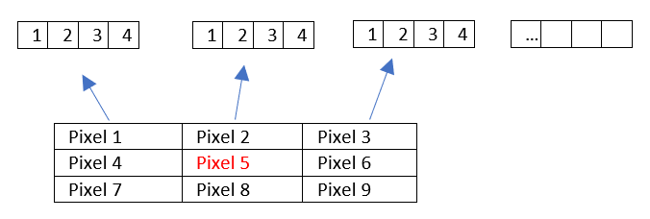

1 ligne du dataframe

On cherche à prédire la classe du pixel rouge