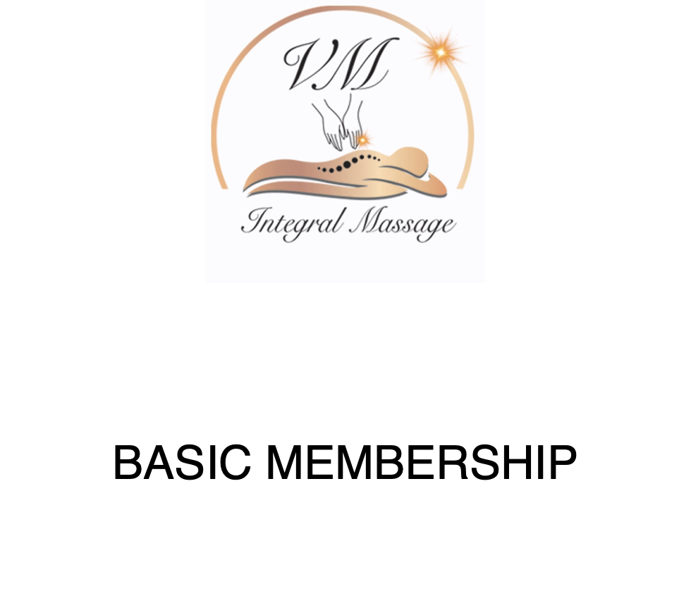
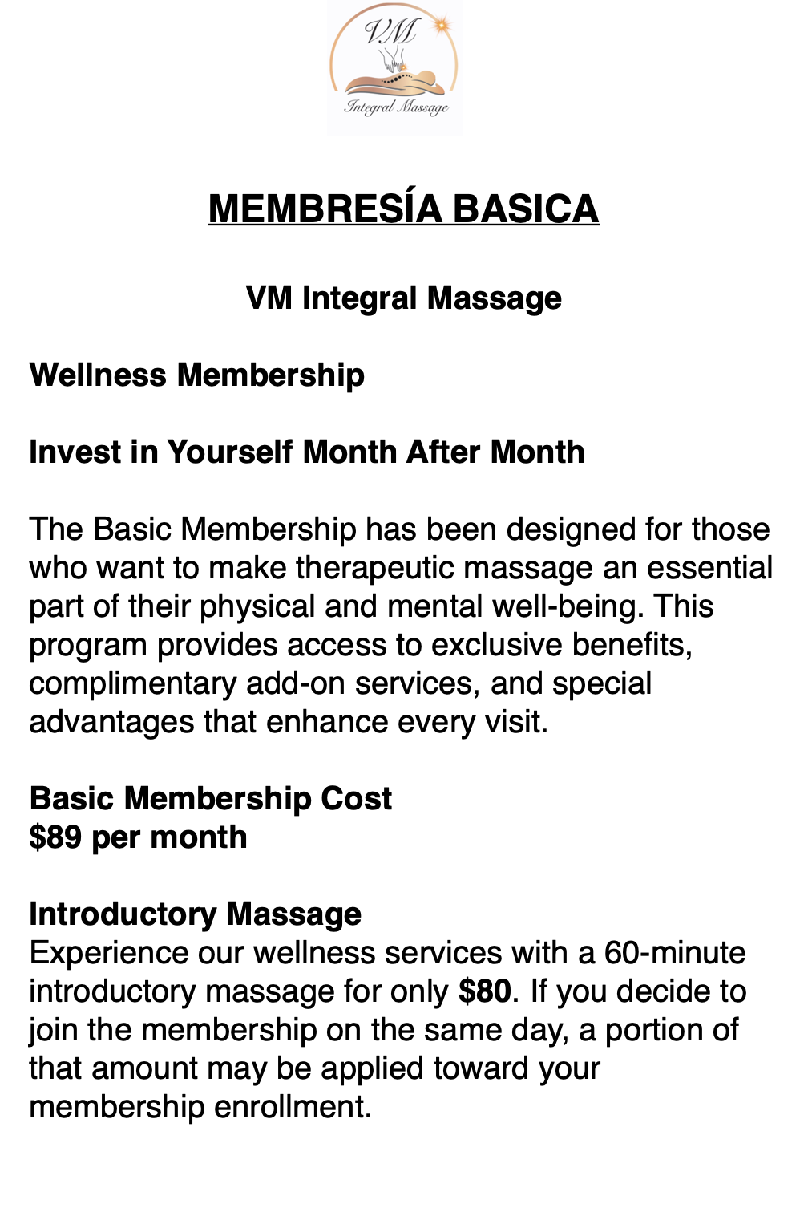
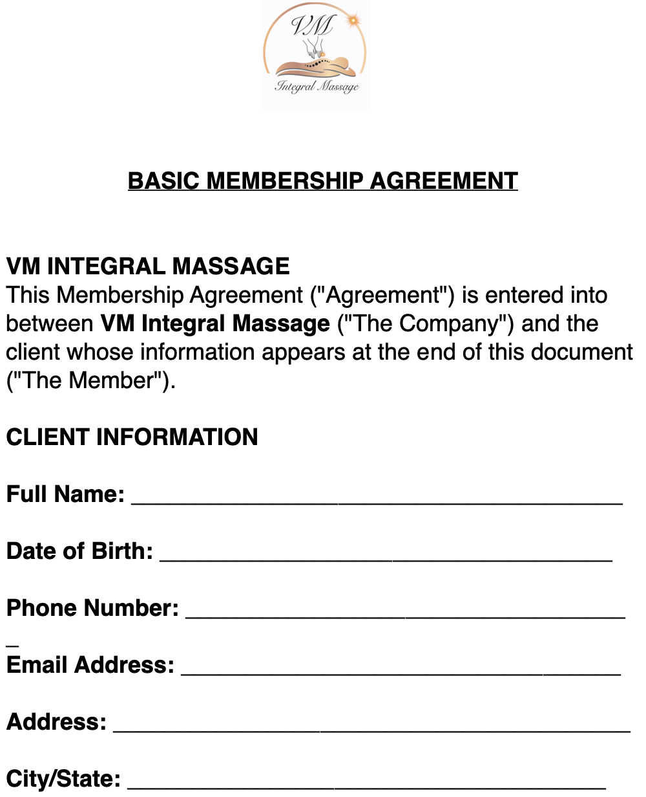

CLIENT INFORMATION

Full Name: {{full_name}}

Date of birth: {{dob}}

Phone Number: {{phone}}

Email Adress: {{email}}

Address: {{address}}

City/State: {{city_state}}

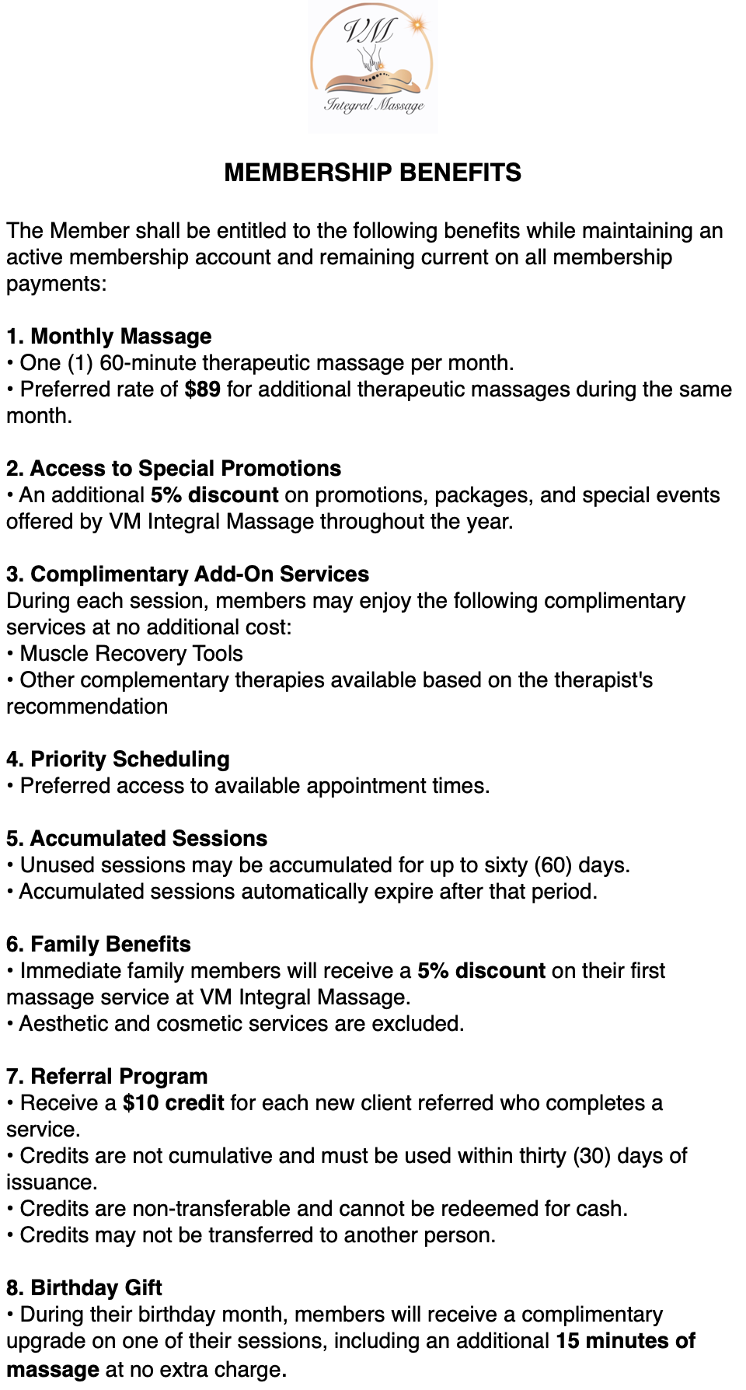
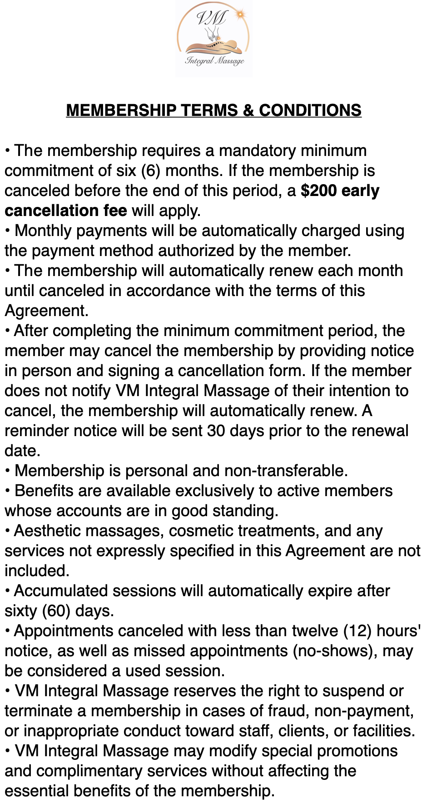


MEMBERSHIP DETAILS

Membership Type: BASIC

Start Date: {{start_date}}

Monthly Payment: $89.00

Payment Method: {{payment_method}}

Last 4 Digits of Card: {{card_last4}}

PAYMENT AUTHORIZATION
I authorize VM Integral Massage to charge the monthly membership fee associated with my membership using the payment method on file.

Cardholder Signature:__________________

Date: {{cardholder_date}}

AGREEMENT ACCEPTANCE

I acknowledge that I have read, understood, and accepted all the terms and conditions set forth in this Membership Agreement

Client Signature:__________________

Date: {{client_date}}

VM Integral Massage Representative:__________________

Date: {{rep_date}}

