During these Chrismas holidays, while digging into some cupboard, I found an almost 10 years old and reliable Dlink DNS 325.
Specs wise, this NAS is running a single core ARMv7 CPU with 256Mb RAM.
As I was actually needing a NAS to broadcast some music and movies in a country side house, I decided to revive this Dlink DNS 325 by installing Debian Buster with latest OpenMediaVault 5.5.
Checking on the net, I found a lot of very interesting informations for different Marvell powered NAS, but no simple guide to install Debian and OMV on this venerable NAS.
So, here is a step by step guide to install Debian 10 + OMV 5.5 on a system disk. As this NAS is having a USB port, you can either use an external USB disk or an internal SATA disk to handle the system disk.
In this guide, different operations will be performed either from a linux workstation or from the NAS itself. As this can be quite confusing, I’ll follow this simple rule :
- shell prompt on linux workstation starts with #
- shell prompt on DNS325 starts with $

Prepare the USB key
As the USB key will be the NAS main drive and will hold the complete system, it should be as fast as possible and 16Gb should be a comfortable minimum. As DNS 325 CPU is quite slow, using an SSD drive will be a nice boost.
All following operations should be done from any Linux workstation.
I did it on a Ubuntu 18.04 LTS laptop.
First step is to format the drive with a single Ext2 partition and to label it rootfs.
rootfs label is very important as it will be used later to declare the boot device on the NAS.
After formatting, we need to install debootstrap environment :
# apt install debootstrap qemu-user-static

We now need to log as root and to install a minimal Marvell Debian system under /root/rootfs.
# sudo su
# cd /root

We can now run debootstrap to create minimal filesystem for armel CPU :

# debootstrap --verbose --foreign --arch=armel --variant=minbase –include=init,dialog,locales,udev,ifupdown,mtd-utils,procps,iproute2,iputils-ping,isc-dhcp-client,ne,nano,wget,netbase,acl,openssh-server,avahi-daemon,python-minimal,u-boot-tools,lsb-release,htop,iotop,net-tools,fancontrol buster rootfs http://http.debian.net/debian

We can now chroot to the new rootfs structure :

# cp /usr/bin/qemu-arm-static ./rootfs/usr/bin
# mount -t proc none ./rootfs/proc
# mount -o bind /dev ./rootfs/dev
# chroot rootfs

We are logged in the new NAS filesystem. As we have done a cross architecture debootstrap, we need to launch the second stage installation and then to finalise installation.

I have no name!# ./debootstrap/debootstrap --second-stage

We need to declare Debian repositories and to finalise system configuration for locales and timezone.

I have no name!# nano /etc/apt/sources.list

deb http://deb.debian.org/debian buster main contrib non-free
# Mises a jour de securite
deb http://security.debian.org/debian-security buster/updates main contrib non-free
deb http://http.debian.net/debian/ buster-updates main

I have no name!# apt update
I have no name!# dpkg-reconfigure locales
I have no name!# dpkg-reconfigure tzdata

Next step is to declare a script that will be used to regenerate uImage and uInitrd everytime a Debian update will bring a new kernel version. This script will be called after every kernel compilation to update the kernel boot files.

I have no name!# nano /etc/kernel/postinst.d/zz-local-build-image
I have no name!# chmod a+x /etc/kernel/postinst.d/zz-local-build-image

#!/bin/sh -e
# passing the kernel version is required
version="$1"
[ -z "${version}" ] && exit 0

# NB: change depending on your NAS model
cat /boot/vmlinuz-${version} \
/usr/lib/linux-image-${version}/kirkwood-dns325.dtb > /tmp/appended_dtb
/usr/bin/mkimage -A arm -O linux -T kernel -C none -n uImage \
-a 0x00008000 -e 0x00008000 \
-d /tmp/appended_dtb /boot/uImage-${version}
ln -sf /boot/uImage-${version} /boot/uImage
/usr/bin/mkimage -A arm -O linux -T ramdisk -C gzip -n uInitrd \
-a 0x00e00000 -e 0x00e00000 \
-d /boot/initrd.img-${version} /boot/uInitrd-${version}
ln -sf /boot/uInitrd-${version} /boot/uInitrd

We can now install the kernel for marvell CPU.

I have no name!# apt install linux-image-marvell

Next we will :
- declare a host name
- tune fstab to boot from rootfs disk and to use tmpfs for /tmp
- shorten shutdown delays
- declare the network interfaces
- allow SSH root login
- declare default modules for the NAS

I have no name!# nano /etc/hostname

dns325-buster

I have no name!# nano /etc/fstab

# /etc/fstab: static file system information.
#
# <file system> <mount point> <type> <options> <dump> <pass>
LABEL=rootfs / ext2 noatime,errors=remount-ro 0 1
tmpfs /tmp tmpfs defaults 0 0

I have no name!# nano /etc/systemd/system.conf

...
DefaultTimeoutStopSec=30s
…

I have no name!# nano /etc/network/interfaces

# ...
auto eth0
allow-hotplug eth0
iface eth0 inet dhcp

I have no name!# nano /etc/ssh/sshd_config

# ...
PermitRootLogin yes

I have no name!# nano /etc/modules

# Load required modules
gpio-fan
kirkwood_thermal
btrfs

I have no name!# nano /etc/initramfs-tools/modules

# Thermal management
gpio-fan
kirkwood_thermal
# SATA
ehci_orion
sata_mv
# Ethernet
mv643xx_eth
marvell
mvmdio
ipv6
# Power / USB buttons
evdev
gpio_keys
# USB disks
sd_mod
usb_storage

As my DNS 325 is loosing date after each and every startup (realtime clock battery may be dead), I need to setup the date after every boot. The simplest approach I found was to get the time from an old Google redirection page. So I’ve written a simple service to do just that.

I have no name!# nano /usr/local/sbin/init-date
I have no name!# chmod +x /usr/local/sbin/init-date

#!/bin/bash
# ---------------------------------------------------
# ReadyNAS 102 date initialisation at startup
#
# Revision history :
# 10/01/2021, V1.0 - Creation by N. Bernaerts
# ---------------------------------------------------

# update current time from google site
date -s "$(wget -qSO- --max-redirect=0 google.com 2>&1 | grep Date: | cut -d' ' -f5-8)Z"

I have no name!# nano /etc/systemd/system/init-date.service
I have no name!# systemctl enable init-date.service

[Unit]
Description=system date initialisation
Wants=network-online.target
After=network-online.target

[Service]
Type=simple
ExecStart=/usr/local/sbin/init-date
Restart=on-failure
TimeoutStopSec=1

[Install]
WantedBy=multi-user.target

Last disk preparation step is to do some cleanup and to set a root password.

I have no name!# apt clean
I have no name!# rm /tmp/* /var/cache/debconf/*

I have no name!# pwconv
I have no name!# passwd
I have no name!# exit

rootfs directory structure is now ready to be transfered to the newly formated disk. After plugin the disk, it should be available under /media/yourlogin/rootfs.
# umount ./rootfs/proc
# umount ./rootfs/dev
# cp -arv /root/rootfs/* /media/nicolas/rootfs/
# sync

The disk is now ready to be plugged to the DNS-325 for its first Debian Buster boot !
You can umount and remove it from your linux workstation.

Setup Serial Port connexion
During the first boot process, we need to have access to the DNS-325 serial console.
It is accessible on the motherboard thru a 4 pins connector.
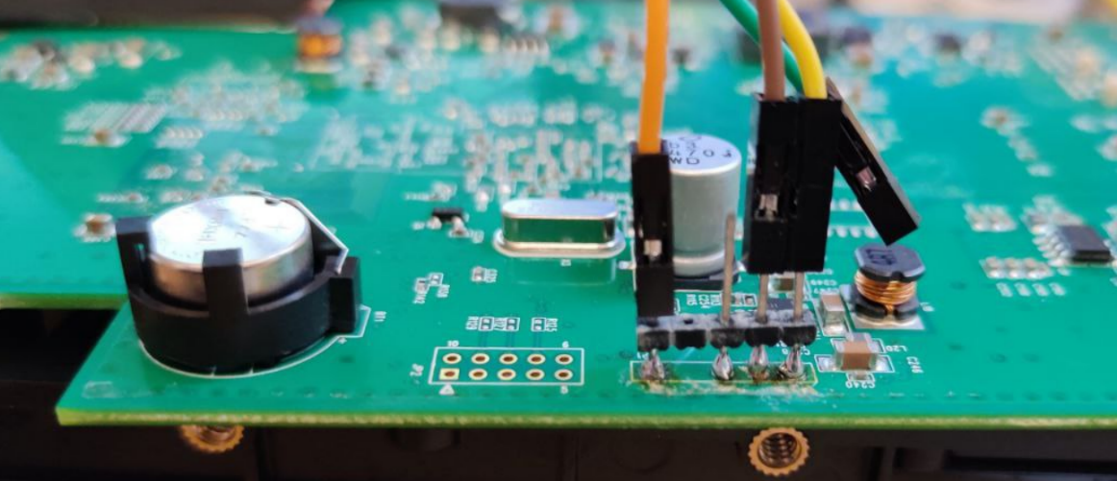

Pinout is as follow :
Rx |  | Vcc | Gnd | Tx

You just need to connect it to your computer thu a 3.3V USB serial adaptor.
Make sure to use a 3.3V adapter or you can damage your NAS motherboard.
Once you’ve connected the 3 pins (GND, Tx and Rx) of the USB adpator, launch any serial terminal (I personaly use GtkTerm) and configure it for 115200 bauds, 8 bits, no parity, 1 stop bit and no flow control.
You can now plug your DNS-325 to the mains and press the power button.
You should see the boot process on your serial terminal.
U-Boot 2012.10-00004-g8aac38e (Dec 08 2012 – 23:15:05)
DNS-325
SoC: Kirkwood 88F6281_A1
DRAM: 256 MiB
WARNING: Caches not enabled
NAND: 128 MiB
In: serial
Out: serial
Err: serial
Net: egiga0
Hit any key to stop autoboot: 0
=>
When you see « Hit any key to stop autoboot, press ENTER.
You now have a Marvel prompt.
First step is to print the Marvel environment and to save it to a text file. This may be useful in case you change an unexpected value later in the process. You’ll then be able to restore the original value.
Marvell>> printenv
autoload=no
baudrate=115200
bootcmd=if test -n ${bootenv} && usb start; then if run loadbootenv; then echo Loaded environment ${bootenv} from usb;run importbootenv;fi;if test -n ${bootenvcmd}; then echo Running bootenvcmd ...;run bootenvcmd;fi;fi;run setnandbootenv subbootcmd;
bootdelay=3
bootenv=uEnv.txt
console=ttyS0,115200
ethact=egiga0
importbootenv=echo Importing environment ...; env import -t ${loadaddr} ${filesize}
loadaddr=0x800000
loadbootenv=fatload usb 0 ${loadaddr} ${bootenv}
mtdparts=mtdparts=orion_nand:896k(u-boot),128k(u-boot-env),5m(kernel),-(rootfs)
nandloadimage=nand read ${loadaddr} kernel
nandroot=ubi0:rootfs ubi.mtd=rootfs
nandrootfstype=ubifs
setbootargs=setenv bootargs console=${console} ${optargs} ${mtdparts} root=${bootenvroot} rootfstype=${bootenvrootfstype}
setnandbootenv=echo Booting from nand ...; setenv bootenvroot ${nandroot}; setenv bootenvrootfstype ${nandrootfstype}; setenv bootenvloadimage ${nandloadimage}
stderr=serial
stdin=serial
stdout=serial
subbootcmd=run setbootargs; if run bootenvloadimage; then bootm ${loadaddr};fi;

Environment size: 1117/131068 bytes

We will increase slightly the delay to get access to the prompt. We will set it to 5s instead of 3s and then save it to the NAND memory.

Marvell>> setenv bootdelay 5
Marvell>> saveenv
Saving Environment to NAND...
Erasing Nand...
Writing to Nand... done

To restart the boot process, you can just run the reset command :

Marvell>> reset

Your DNS325 will reboot and you will have 5 seconds to press a key to stop the boot process.

First Boot under Debian Buster

Now that we are back to the Marvell prompt, it’s now time to adapt the Marvel environment to boot from the new drive.
It is important to fix your ethernet adapter MAC address as it is not initialised by default. You’ll need to get your DNS325 MAC address from the case label to set it in the Marvell environment variables.
Marvell>> setenv ethaddr 84:C9:B2:xx:xx:xx

If you are connecting your system disk on the USB port, run the following commands on the serial console :

Marvell>> setenv bootargs 'console=ttyS0,115200 root=LABEL=rootfs usb-storage.delay_use=0 rootdelay=1 rw'
Marvell>> setenv load_uimage 'ext2load usb 0:1 0xa00000 /boot/uImage'
Marvell>> setenv load_uinitrd 'ext2load usb 0:1 0xf00000 /boot/uInitrd'
Marvell>> setenv bootcmd_debian 'run load_uimage; run load_uinitrd; bootm 0xa00000 0xf00000'
Marvell>> setenv bootcmd 'usb start; run bootcmd_debian'

If you are connecting your HDD on the left SATA port inside the DNS325, run the following commands on the serial console :

Marvell>> setenv bootargs 'console=ttyS0,115200 root=LABEL=rootfs rootdelay=1 rw'
Marvell>> setenv load_uimage 'ext2load ide 0:1 0xa00000 /boot/uImage'
Marvell>> setenv load_uinitrd 'ext2load ide 0:1 0xf00000 /boot/uInitrd'
Marvell>> setenv bootcmd_debian 'run load_uimage; run load_uinitrd; bootm 0xa00000 0xf00000'
Marvell>> setenv bootcmd 'ide reset; run bootcmd_debian'

For the new disk to be used as a permanent boot device, you need to save this new environment to the flash memory.
Marvell>> saveenv
Saving Environment to NAND…
Erasing Nand…
Writing to Nand... done
You are now ready to boot under Debian Buster :
Marvell>> boot
You should now see the loading of uimage, uinitrd and then the Debian boot process !
If everything goes fine, you’ll get the root login prompt.
You can now log to your new debian box thru the serial console or thru SSH with the password you’ve previously set.
Your NAS should be accessible on the LAN thru the hostname you’ve set earlier.

Packages and Kernel update

It’s now time to log into your DNS 325 running latest Debian 10.
Check what kernel is running.
$ uname -a
Linux dns325-buster 4.19.0-13-marvell #1 Debian 4.19.160-2 (2020-11-28) armv5tel GNU/Linux

Update all installed packages :

$ apt update
$ apt upgrade

Enable and start the date initialisation service :
$ systemctl enable init-date
Created symlink /etc/systemd/system/multi-user.target.wants/init-date.service → /etc/systemd/system/init-date.service.
$ systemctl start init-date
$ systemctl status init-date
● led-activity.service - disks LED activity
Loaded: loaded (/etc/systemd/system/led-activity.service; enabled; vendor preset: enabled)
Active: active (running) since Thu 2021-01-07 22:11:55 CET; 33s ago
Main PID: 17429 (led-activity)
Tasks: 5 (limit: 1092)
Memory: 928.0K
CGroup: /system.slice/led-activity.service
├─17429 /bin/bash /usr/local/sbin/led-activity
└─18600 /bin/bash /usr/local/sbin/led-activity

Install OMV

To install Open Media Vault on the DNS 325, you just need to follow the standard Debian installation procedure described at https://openmediavault.readthedocs.io/en/5.x/installation/on_debian.html
Because of the old single core CPU, installation may take a while.

$ apt install –yes ca-certificates gnupg
$ wget -O "/etc/apt/trusted.gpg.d/openmediavault-archive-keyring.asc" https://packages.openmediavault.org/public/archive.key
$ apt-key add "/etc/apt/trusted.gpg.d/openmediavault-archive-keyring.asc"
$ nano /etc/apt/sources.list.d/openmediavault.list
/etc/apt/sources.list.d/openmediavault.list
deb https://packages.openmediavault.org/public usul main
# deb https://downloads.sourceforge.net/project/openmediavault/packages usul main
## Uncomment the following line to add software from the proposed repository.
# deb https://packages.openmediavault.org/public usul-proposed main
# deb https://downloads.sourceforge.net/project/openmediavault/packages usul-proposed main
## This software is not part of OpenMediaVault, but is offered by third-party
## developers as a service to OpenMediaVault users.
deb https://packages.openmediavault.org/public usul partner
# deb https://downloads.sourceforge.net/project/openmediavault/packages usul partner

$ export LANG=C.UTF-8
$ export DEBIAN_FRONTEND=noninteractive
$ export APT_LISTCHANGES_FRONTEND=none
$ apt update
$ apt --yes --auto-remove --show-upgraded --allow-downgrades --allow-change-held-packages --no-install-recommends --option Dpkg::Options::="--force-confdef" --option DPkg::Options::="--force-confold" install openmediavault-keyring openmediavault
$ omv-confdbadm populate
$ wget -O - https://github.com/OpenMediaVault-Plugin-Developers/packages/raw/master/install | bash

You should get OpenMediaVault connexion page at http://dns325-buster/ !

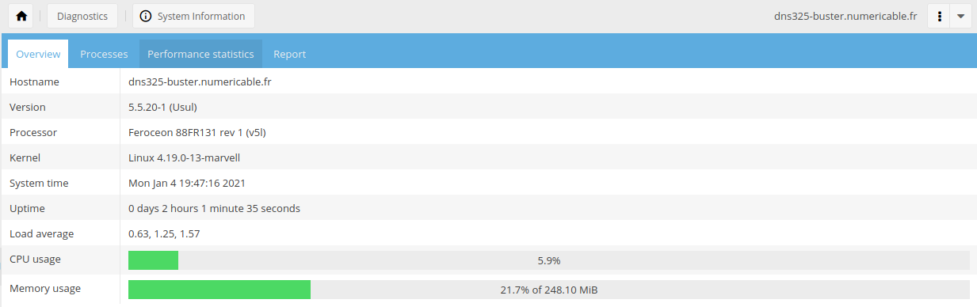

Minimise log size

Depending on your system disk size, if you want to minimise logs, you can change log rotate defaults to :
- rotate logs hourly instead of daily
- limit log file size to 10MB
- rotate logs on 7 files

$ mv /etc/cron.daily/logrotate /etc/cron.hourly/logrotate
$ nano /etc/logrotate.conf
$ rm /var/log/*.log.* /var/log/*/*.log.*
$ service logrotate restart

/etc/logrotate.conf
# see "man logrotate" for details

# max log size is 10Mb
maxsize 10M
…
# by default, keep 4 rotations worth of backlogs
rotate 4

…

Minidlna

If you want to use your DNS 325 as a DLNA server to stream your music and movies, you’ll need to install a DLNA server as OMV DNLA server plugin is not available for armel architecture.

Thanks to MiniDLNA package, it very easy :

$ apt install minidlna
$ usermod -a -G users minidlna

If you have lots of music and movie files, you need to increase the inotify buffers :

$ echo 131072 > /proc/sys/fs/inotify/max_user_watches
$ nano /etc/sysctl.conf

…
# increase inotify limit for minidlna
fs.inotify.max_user_watches = 131072

As OMV is managing the disk mounting at startup, media files should not be available immediatly after boot. So, we need to add an extra delay before the MiniDLNA service starts. For me 15 seconds were more than enought.

$ nano /lib/systemd/system/minidlna.service

…
[Service]
ExecStartPre=/bin/sleep 15
…

You finally need to configure your media directories in the default configuration file /etc/minidlna.conf and to reboot your NAS. After some time, all your media files should be accessible thru any DLNA player.

