Etude de cas : Explication des crimes à Boston et ses environs

Nicolas Derumigny et Anton Daumen

6 Novembre 2017

## Premier affichage des données sélectionnées

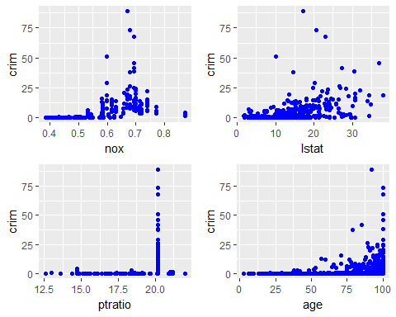

## Regression Linéaire Univariée

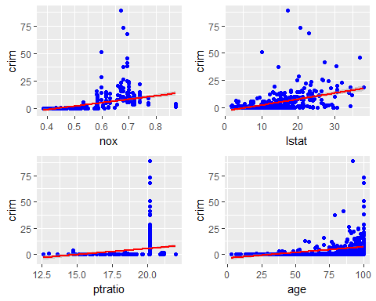

## Régression Polynomiale Univariée

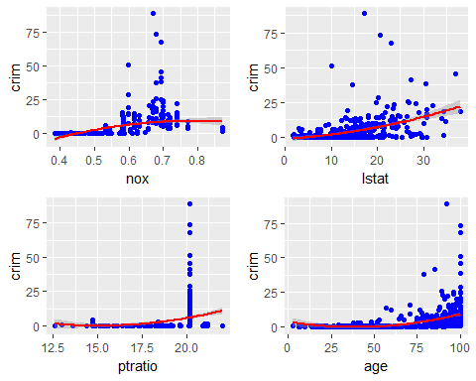

## Régression Linéaire Multivariée

##   
## Call:  
## lm(formula = crim ~ nox + ptratio + lstat + age, data = Boston)  
##   
## Residuals:  
## Min 1Q Median 3Q Max   
## -11.612 -3.111 -0.595 1.264 80.860   
##   
## Coefficients:  
## Estimate Std. Error t value Pr(>|t|)   
## (Intercept) -21.53615 3.38344 -6.365 4.41e-10 ***  
## nox 19.64202 4.36262 4.502 8.37e-06 ***  
## ptratio 0.59831 0.16521 3.622 0.000323 ***  
## lstat 0.32284 0.06301 5.124 4.29e-07 ***  
## age -0.01273 0.01816 -0.701 0.483690   
## ---  
## Signif. codes: 0 '***' 0.001 '**' 0.01 '*' 0.05 '.' 0.1 ' ' 1  
##   
## Residual standard error: 7.416 on 501 degrees of freedom  
## Multiple R-squared: 0.2625, Adjusted R-squared: 0.2566   
## F-statistic: 44.58 on 4 and 501 DF, p-value: < 2.2e-16

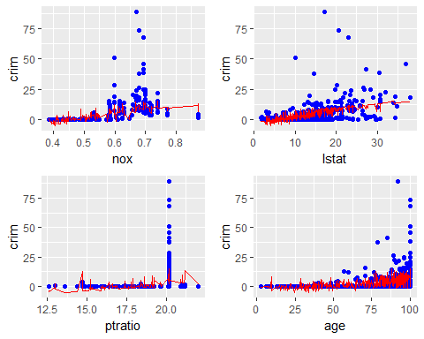

## Régression Polynomiale Multivariée

##   
## Call:  
## lm(formula = crim ~ nox + I(nox^2) + ptratio + I(ptratio^2) +   
## lstat + I(lstat^2) + age + I(age^2), data = Boston)  
##   
## Residuals:  
## Min 1Q Median 3Q Max   
## -16.749 -2.702 -0.616 1.031 81.204   
##   
## Coefficients:  
## Estimate Std. Error t value Pr(>|t|)   
## (Intercept) -6.344e+01 2.592e+01 -2.448 0.014721 *   
## nox 1.025e+02 3.334e+01 3.073 0.002233 **   
## I(nox^2) -6.577e+01 2.614e+01 -2.516 0.012167 *   
## ptratio 3.494e+00 2.641e+00 1.323 0.186500   
## I(ptratio^2) -8.395e-02 7.561e-02 -1.110 0.267375   
## lstat -3.279e-01 1.912e-01 -1.715 0.086962 .   
## I(lstat^2) 1.863e-02 5.328e-03 3.496 0.000514 ***  
## age -1.429e-01 6.571e-02 -2.175 0.030088 *   
## I(age^2) 1.067e-03 5.474e-04 1.949 0.051833 .   
## ---  
## Signif. codes: 0 '***' 0.001 '**' 0.01 '*' 0.05 '.' 0.1 ' ' 1  
##   
## Residual standard error: 7.266 on 497 degrees of freedom  
## Multiple R-squared: 0.2977, Adjusted R-squared: 0.2864   
## F-statistic: 26.33 on 8 and 497 DF, p-value: < 2.2e-16

