# Introduction

The Java Database GUI application called **myLyrics** will enable people to store their favourite songs and lyrics on their computer through a simple and easy to use interface. The application accepts several users who can register and log in to the app, add information and lyrics of their favourite songs, view all their songs, edit data that they have entered and also delete data.

# The Application

When the user opens the application, the following window appears.

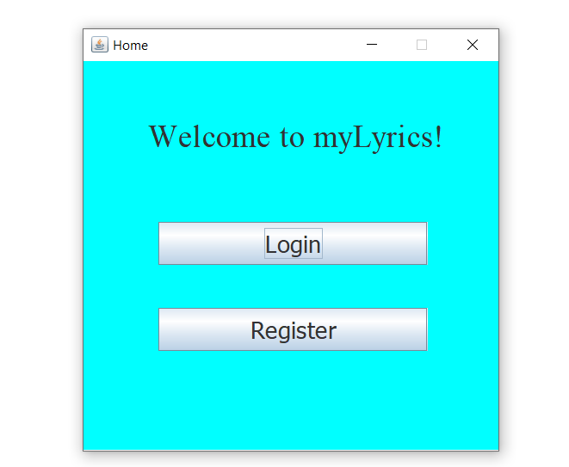

# Register

If the user already has an account he just has to log in, or he can easily create an account. Clicking on Register opens this window.

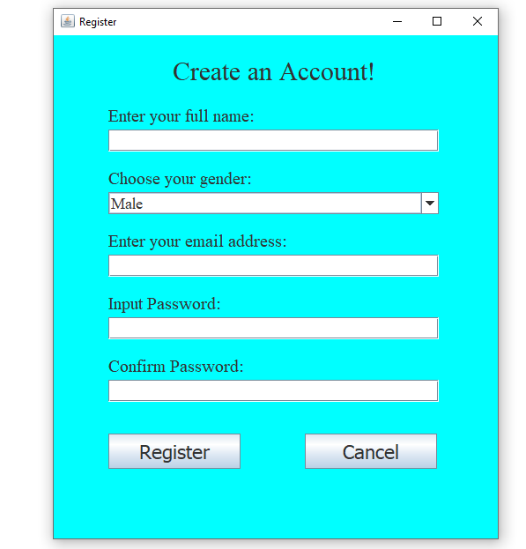

After the user has filled in the required information, the system will check if the email address which has been entered does not already exist in the database, else the user is asked to enter another email address.

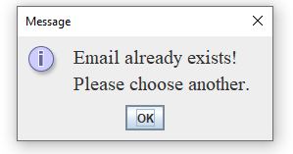

The system will also check if the password and confirm password are the same, and if the password entered contains more than 6 characters.

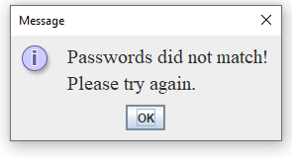

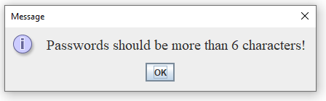

If registration is successful, a message appears and the system sends the user to the login page.

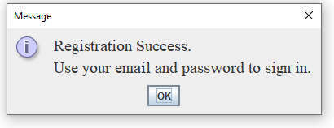

# Login

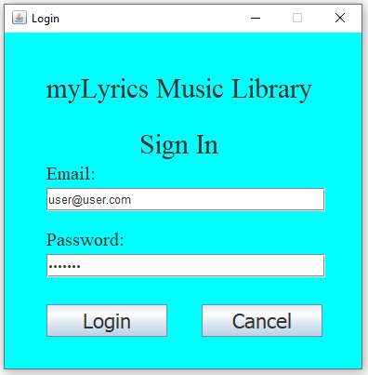

When the user clicks on login or after registration, the login window opens as shown above. If the email entered is not good or if the password does not correspond, an error message appears.

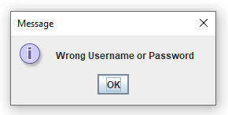

If login is successful, the main application opens.

# myLyrics

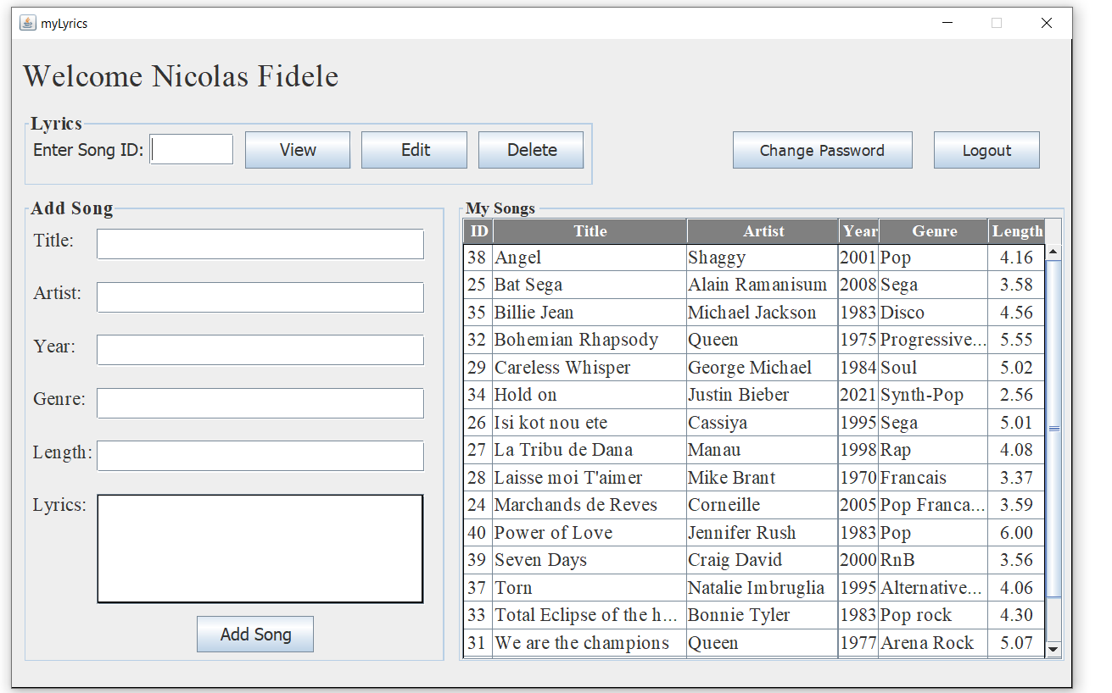

As soon as the user logs in, this window appears. It displays the user’s name and have four sections. One to view, edit and delete songs. Then one section to add new songs and lyrics. A section displays all the user’s favourite song information. A last section where the user can change password or log out.

To view, edit or delete any song, the user can either enter the song ID or click on the appropriate row in the table (this will automatically input the ID in the Enter Song ID field. If the ID entered by the user is not in the table an error message appears.

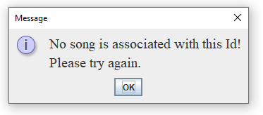

## View Song

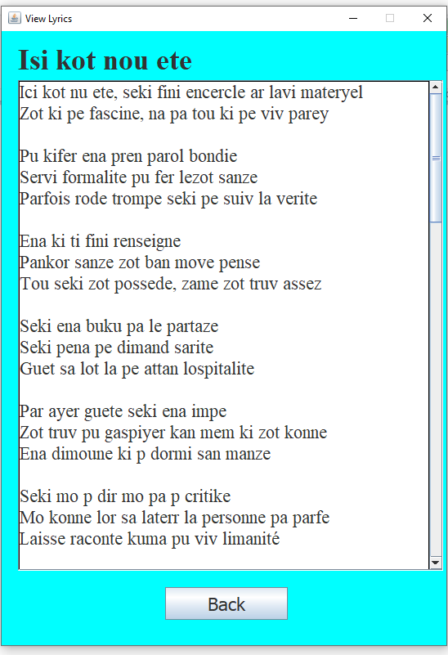

## Edit Song

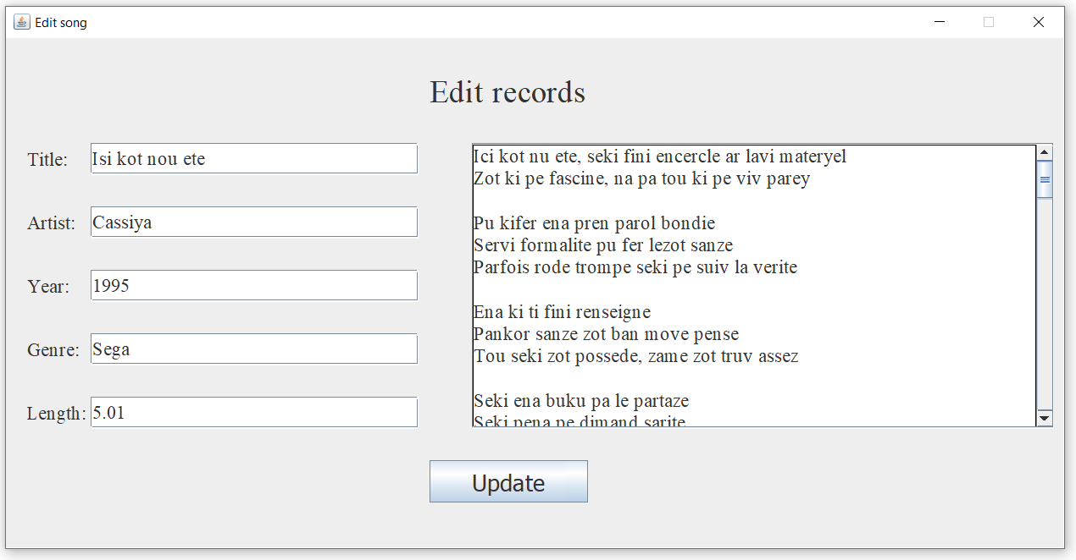

As the user makes changes and clicks on Update, records are updated in the database.

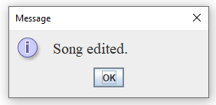

## Delete song

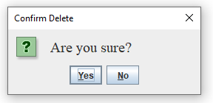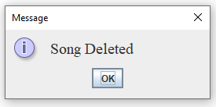

## Add song

When the user adds a new song, the table in the window is automatically updated and the data in the text fields are automatically cleared. If the fields are left empty when clicking on Add song, a warning message appears.

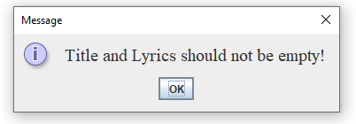

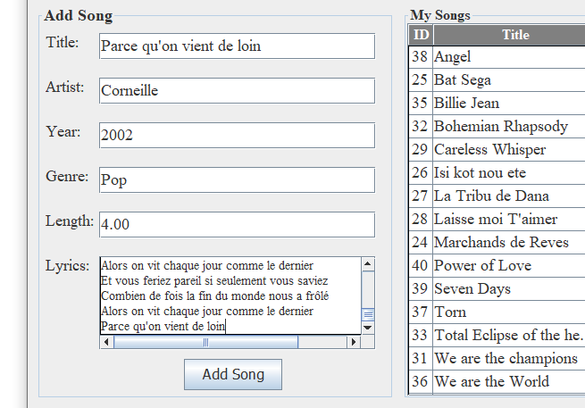

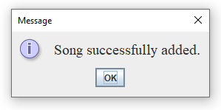

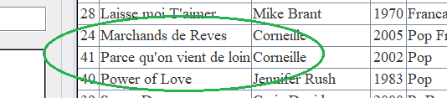

## Table

The Table will display all the songs that have been entered by the user. The latter can click on any row, then click on View, Edit or Delete to perform operations on his records.

## Change Password

The system allows the user to change his password. A new window appears to change the password and if the password is too short a message appears.

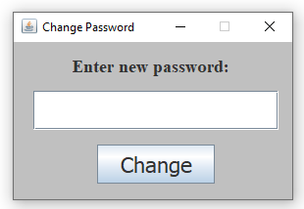

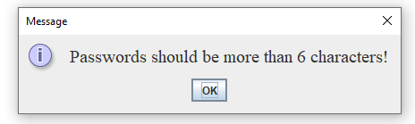

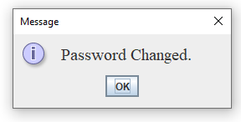

## Log out

When the user is done, the latter can log out. A confirm message appears.

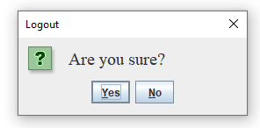

If user chooses No, the system returns to the main window, else it returns to index page (login and register).

# File Structure

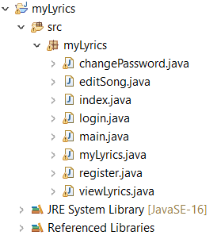

* index.java – code for home window
* Login.java – code for login window
* Register.java – code for register window
* myLyrics.java – code for main application to add, delete, view, edit + display table + change password and logout.
* editSong.java – code for editing song details and lyrics when user clicks on Edit
* viewLyrics.java – code to view lyrics when user clicks on View
* changePassword.java – code to to change password

# Database Structure

The Database contains two tables, users table and songs table. Both have IDs as primary key and the songs table has a user id attribute used as foreign key to relate to the users table.

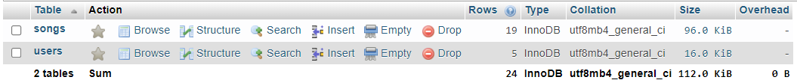

## users table

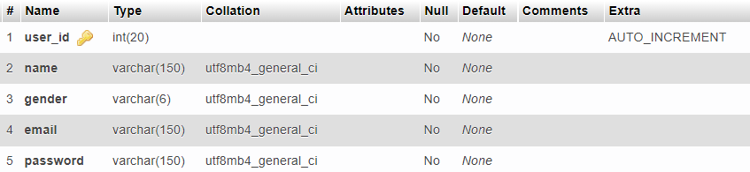

## songs table

