Database = hashcode

Tables : user(user_id, u_firstname, u_lastname, u_password, identifier, ranking)  
 team(team_id, t_name)  
 user-team(#user_id, #team_id)  
 organizer(organizer_id, o_firstname, o_lastname, o_password)  
 challenge(challenge_id, c_name, nb_teams, success, begin, end, #media_id)  
 organizer-challenge(#organizer_id, #challenge_id)  
 media(media_id, description, figure, video)  
 data(data_id, file)  
 challenge-data(#challenge_id, #data_id)  
 solution(solution_id, s_name, language, solution, version, ranked, ranking, submit_date)  
 participation(#challenge_id, #team_id, #solution_id)  
 admin(admin_id, identifier, a_password)  
 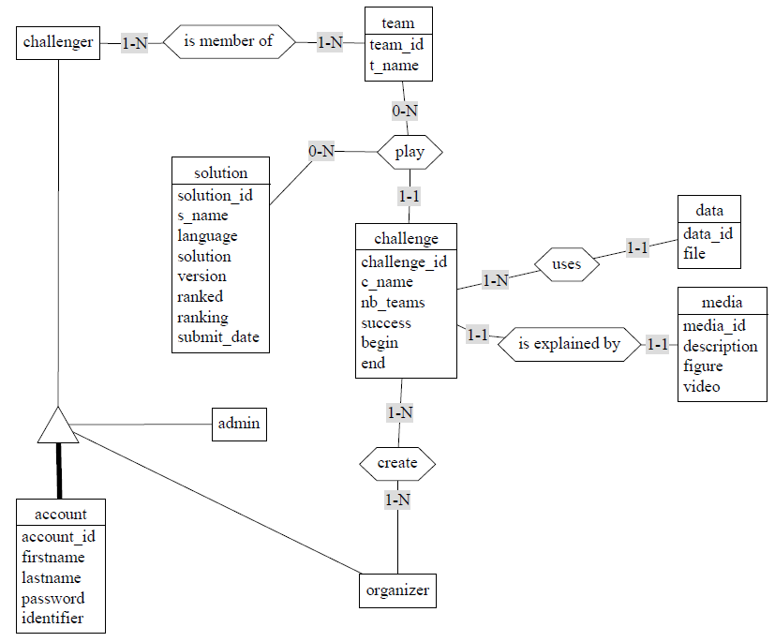

Tables : account(id_account, firstname, lastname, email, password, token, image, #id_role)  
 role(id_role, name)

team(id_team, t_name, #challenge, #leader)  
 challenge(id_challenge, c_name, nb_teams, date_inscription, begin, end, mediaXML)  
 solution(id_solution, s_name, language, solution, version, ranking, submit_date, #challenge, #team, #account)  
 data(id_data, file)

challenger-team(#id_challenger, #id_team)­  
 challenge-organizer(#id_challenge, #id_organizer)

DF :

* Account :
  + "id_account" définit tous les autres champs dans la tables
  + Email --> id_account
  + Token --> id_account
* Role :
  + Id_role --> name
* Team :
  + "id_team" définit tous les autres champs dans la tables
* Challenge :
  + "id_challenge" définit tous les autres champs dans la tables
  + Begin --> id_challenge
  + End --> id_challenge
* Solution :
  + "id_solution" définit tous les autres champs dans la tables
* Data :
  + Id_data --> file
* Team :
  + "id_team" définit tous les autres champs dans la tables

