# Rapport de dimensionnement

1. Description

Type de bois : C24

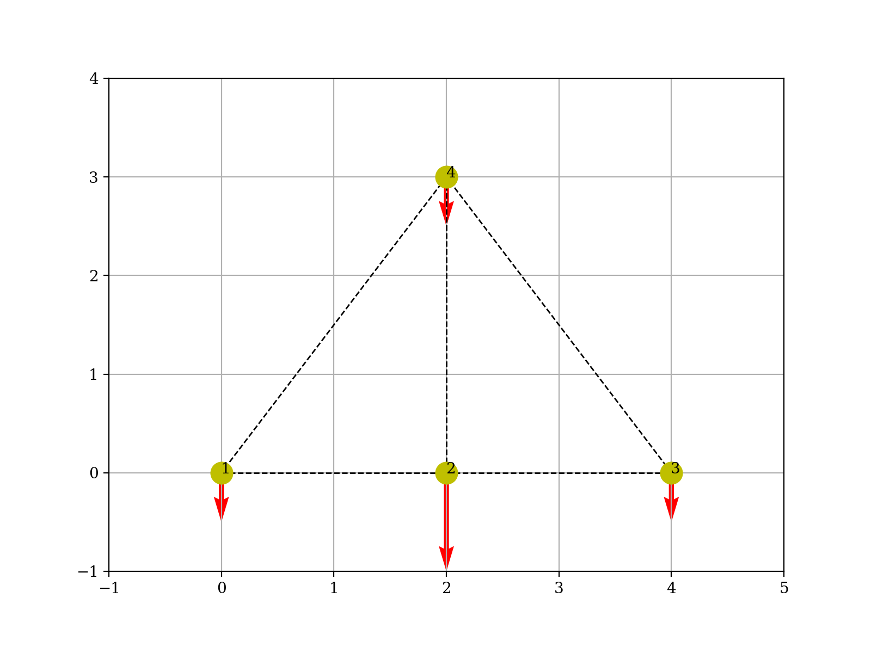

Figure 1 : Vue de coupe de la charpente

|  |  |  |  |
| --- | --- | --- | --- |
| node | X | | Y |
| 1 | | 0 | 0 |
| 2 | | 2 | 0 |
| 3 | | 4 | 0 |
| 4 | | 2 | 3 |

1. Résultats

La contrainte maximale est de 30 MPa dans l’entrait.

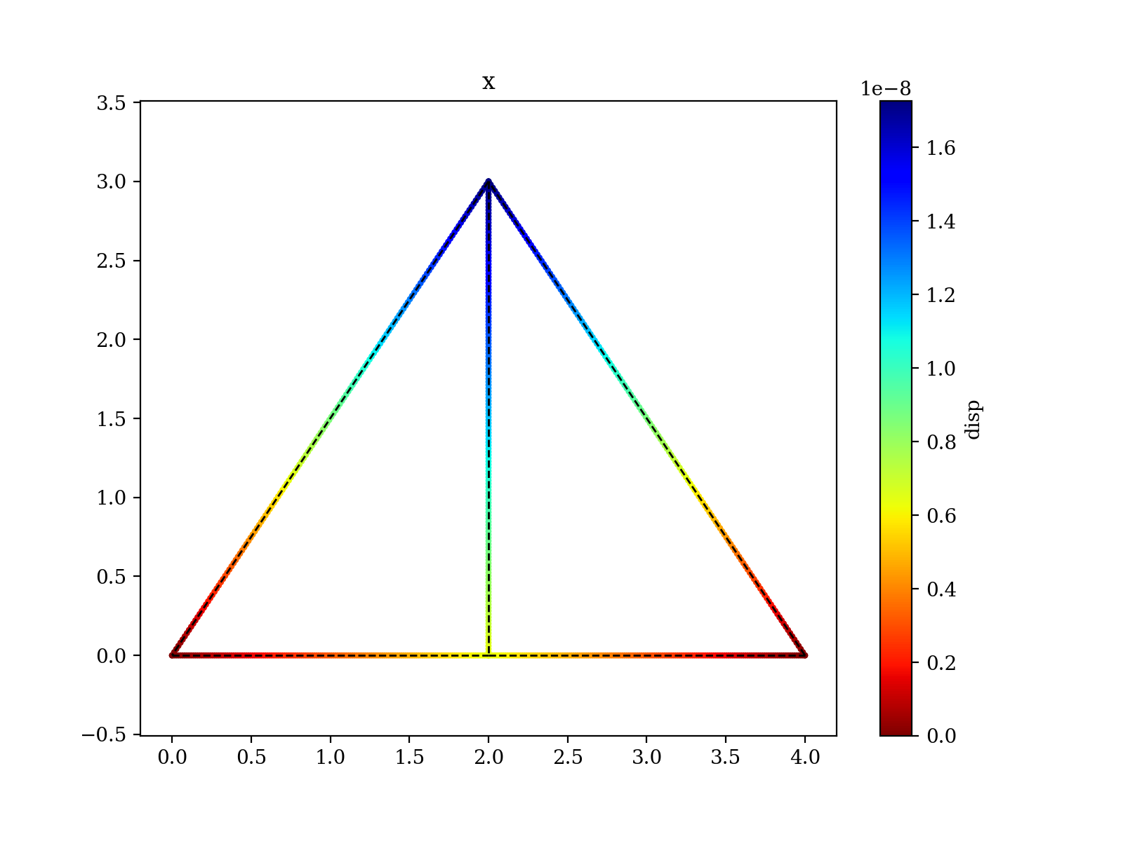

|  |  |  |  |  |  |
| --- | --- | --- | --- | --- | --- |
| node | Ux | | Uy | | phi |
| 1 | | 0.0 | 0.0 | 0.0 | |
| 2 | | 0.0 | 0.0 | 6.36579583491252e-09 | |
| 3 | | 0.0 | 6.36579583491252e-09 | -3.0711549069974525e-06 | |
| 4 | | 6.36579583491252e-09 | -3.0711549069974525e-06 | -1.3750976640455945e-06 | |