STUDENT-TO-TUTOR SCHEDULING AND
AVAILABILITY MANAGEMENT SYSTEM
DESIGN DOCUMENT
Milestone 2
Prepared by: Nicolas Imhof (114606862)
Course: Systems Design and Implementation
Instructor: Renu Balyan
Version: 1.0
Date: March 2026
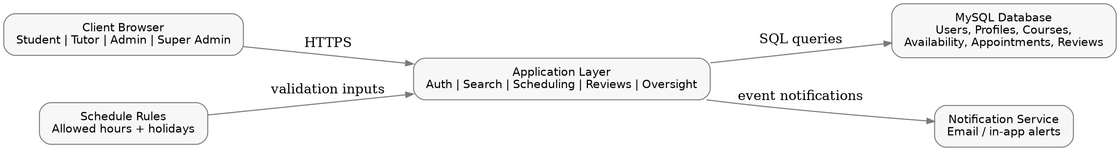
Proposed web-based design for account approval, tutor search, scheduling, reviews, and administrative oversight.

TABLE OF CONTENTS
1. Overview of the Design
1.1 Assumptions / Constraints / Risks
1.1.1 Assumptions
1.1.2 Constraints
1.1.3 Risks
2. Detailed Design
2.1 Data Models and Database Design
2.1.1 Data Models (Logical & Physical Design)
2.1.2 Data Dictionary (Physical Structure)
2.1.3 Database Schema (Logical & Physical Design)
2.2 User Interface
2.2.1 Structure and Navigation
2.2.2 Screen Descriptions
2.3 API Development
3. Non-Functional Requirements
4. Tests
Appendix A. References
Appendix B. Key Terms

1. Overview of the Design
This design document translates the approved Milestone 1 concept into a concrete web-application design for the Student-to-Tutor Scheduling and Availability Management System. The system is organized around four roles - Student, Tutor, Admin, and Super Admin - and supports the workflow defined in the original requirements: account application and approval, profile management, tutor search, availability control, appointment scheduling, review handling, and administrative oversight.
The proposed implementation follows a browser-based client/server model with role-based access control, a relational database for transactional records, and a notification layer for confirmations and status updates. On first use, a user submits an account request, an administrator approves or denies access, and the approved user is directed to a role-specific dashboard. Common failure conditions such as invalid login, booking conflicts, unavailable time selections, or unauthorized access are handled through validation messages, permission checks, and transaction-safe appointment updates.

Figure 1. Proposed high-level application architecture.

1.1 Assumptions / Constraints / Risks

1.1.1 Assumptions
- Users will access the system primarily through current desktop or laptop web browsers with stable Internet access.
- The system is intended for a school-managed tutoring environment in which users have school IDs and belong to an approved role.
- Students and tutors can submit account requests, but normal system access begins only after an Admin approves the account.
- Course records and tutor capability mappings are maintained accurately enough for search results to remain useful.
- Ratings shown on tutor profiles are derived from completed student reviews and are not editable directly by tutors.
- One relational database is sufficient for the expected scale of users, appointments, reviews, and schedule rules.
- Exactly one Super Admin record exists at a time and retains the highest profile visibility level in the system.

1.1.2 Constraints
- The design is limited to an internal tutoring workflow rather than a public tutoring marketplace.
- Students cannot book appointments outside tutor-defined availability, outside system-approved hours, or during holiday blocks.
- Tutors cannot create, edit, or delete reviews and cannot reveal the student's identity when viewing review content.
- Admins can manage profiles, review moderation, and schedule rules, but cannot edit another Admin profile.
- Super Admin can view all accounts and profiles but cannot create tutor schedules or directly create tutoring appointments.
- The matching approach is filter-based (course, capability, rating, time) rather than algorithmically personalized.
- Time and project scope favor one web interface for all roles instead of separate mobile-native applications.

1.1.3 Risks
Risk | Mitigation Strategy
Double-booking or overlapping appointments | Mitigated by validating slot availability during booking and by storing appointment creation in a transaction that locks the selected slot.
Inaccurate or outdated tutor availability | Mitigated by allowing tutors and admins to manage schedule changes and by showing appointment status history to both sides.
Privacy exposure through profiles or reviews | Mitigated by role-based field visibility, hidden student identities in tutor review views, and admin moderation rights.
Delayed account approval or admin backlog | Mitigated by a dashboard approval queue, status tracking, and notification messages for approval decisions.
Low adoption if workflows feel too manual | Mitigated by focused dashboards, default filters, clear navigation, and summary counts on home screens.

2. Detailed Design
This section provides the design-level detail needed to implement the tutoring system introduced in Milestone 1. It covers data organization, core interface flows, API planning, validation rules, and test preparation without referring to future milestones or placeholder template text.

2.1 Data Models and Database Design
The system uses a normalized relational design centered on user accounts, role-specific profiles, course mappings, availability windows, appointments, reviews, and administrative control tables. Search and scheduling depend on course-to-tutor mappings and time-slot validation, while oversight depends on schedule rules, holiday blocks, notifications, and admin audit logs.

2.1.1 Data Models (Logical & Physical Design)
The logical data model below shows the business entities and their named relationships. The physical model then shows the relational tables that support those entities.
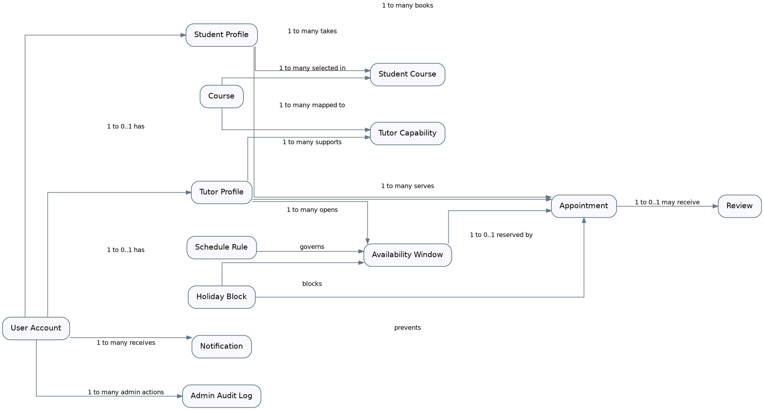
Figure 2. Logical data model for the Student-to-Tutor Scheduling System.
The logical model highlights the core design decisions behind the application. user_account is the shared identity anchor for every role, while student_profile and tutor_profile separate role-specific data from general account fields. Search depends on course, student_course, and tutor_capability, and scheduling depends on availability_window, appointment, schedule_rule, and holiday_block. Review, notification, and admin_audit_log support feedback, visibility, and oversight.
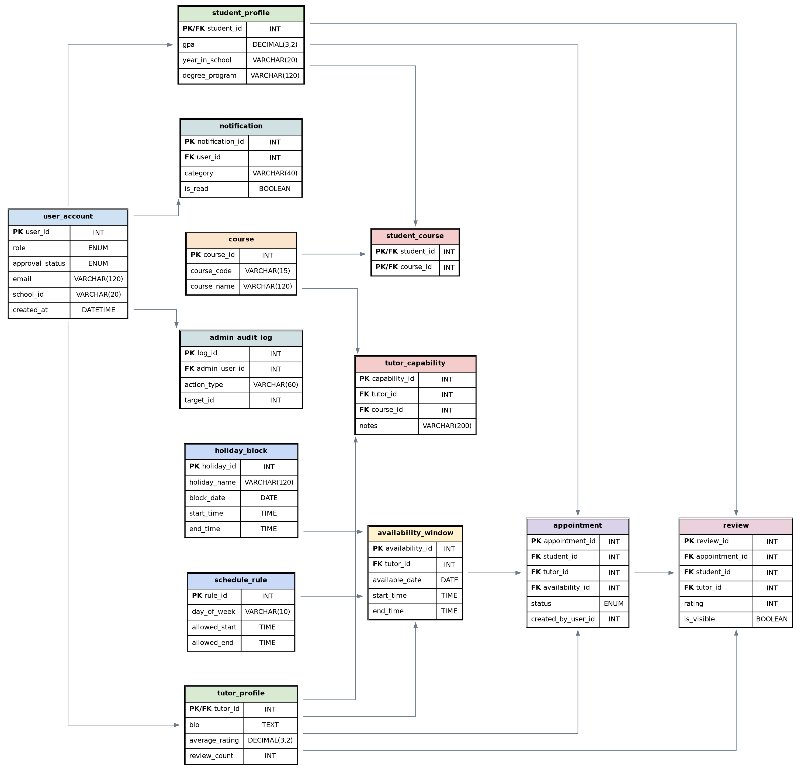
Figure 3. Physical schema view of the core relational tables.
The physical schema preserves referential integrity around booking, moderation, and notifications. availability_window and appointment are separated so that the system can validate open slots before booking and later preserve appointment history even when availability changes. admin_audit_log captures high-risk admin actions such as approval decisions, review moderation, and schedule changes.

2.1.2 Data Dictionary (Physical Structure)
The following tables summarize the physical structure of the main entities used by the design. Each table lists the key fields, data types, validation rules, and the business purpose of the attribute.

user_account
Attribute | Key | Type | Size | Req. | Validation | Description
user_id | PK | INT | 11 | Yes | Auto-increment unique identifier | Primary key for all user-linked records
role | - | ENUM | 20 | Yes | Student | Tutor | Admin | SuperAdmin | Controls permissions and dashboard routing
approval_status | - | ENUM | 20 | Yes | Pending | Approved | Denied | Used by admin approval workflow
school_id | UNI | VARCHAR | 20 | Yes | Unique school-issued ID | Shown in role-appropriate profile views
email | UNI | VARCHAR | 120 | Yes | Valid email format required | Login identity and notification target
password_hash | - | VARCHAR | 255 | Yes | Stored as hash only | Authentication secret, never exposed to UI
first_name | - | VARCHAR | 50 | Yes | Letters and standard name symbols | Identity field
last_name | - | VARCHAR | 50 | Yes | Letters and standard name symbols | Identity field
date_of_birth | - | DATE | 10 | Yes | Must be a valid date | Stored for account record completion
zip_code | - | VARCHAR | 10 | Yes | US ZIP pattern | Address-related field used in profile data

student_profile
Attribute | Key | Type | Size | Req. | Validation | Description
student_id | PK/FK | INT | 11 | Yes | Must exist in user_account(user_id) | Extends user_account for Student-specific data
gpa | - | DECIMAL | 3,2 | No | 0.00 to 4.00 | Shown to tutor only in basic booking view
year_in_school | - | VARCHAR | 20 | Yes | Freshman/Sophomore/Junior/Senior/etc. | Academic standing
degree_program | - | VARCHAR | 120 | Yes | Text | Student academic program
address_line | - | VARCHAR | 150 | No | Text | Editable profile address

tutor_profile
Attribute | Key | Type | Size | Req. | Validation | Description
tutor_id | PK/FK | INT | 11 | Yes | Must exist in user_account(user_id) | Extends user_account for Tutor data
bio | - | TEXT | - | No | Free text with length limit | Student-visible tutoring summary
average_rating | - | DECIMAL | 3,2 | Yes | Derived from reviews | Display-only aggregate
review_count | - | INT | 11 | Yes | Derived integer >= 0 | Display-only aggregate
years_in_school | - | VARCHAR | 20 | Yes | Text | Tutor academic standing

course
Attribute | Key | Type | Size | Req. | Validation | Description
course_id | PK | INT | 11 | Yes | Auto-increment | Primary key
course_code | UNI | VARCHAR | 15 | Yes | Example: CIS 312 | Searchable course key
course_name | - | VARCHAR | 120 | Yes | Text | Readable course title
is_active | - | BOOLEAN | 1 | Yes | 0 or 1 | Allows admin to retire a course without deleting history

student_course
Attribute | Key | Type | Size | Req. | Validation | Description
student_id | PK/FK | INT | 11 | Yes | Must exist in student_profile | Associates student to current course
course_id | PK/FK | INT | 11 | Yes | Must exist in course | Associates course to student

tutor_capability
Attribute | Key | Type | Size | Req. | Validation | Description
capability_id | PK | INT | 11 | Yes | Auto-increment | Primary key
tutor_id | FK | INT | 11 | Yes | Must exist in tutor_profile | Owner tutor
course_id | FK | INT | 11 | Yes | Must exist in course | Tutored course
capability_note | - | VARCHAR | 200 | No | Optional text | Short description of tutoring strength

availability_window
Attribute | Key | Type | Size | Req. | Validation | Description
availability_id | PK | INT | 11 | Yes | Auto-increment | Primary key
tutor_id | FK | INT | 11 | Yes | Must exist in tutor_profile | Owner tutor
available_date | - | DATE | 10 | Yes | Must not be holiday-blocked | Date offered by tutor
start_time | - | TIME | 8 | Yes | Within allowed schedule window | Opening time
end_time | - | TIME | 8 | Yes | Must be after start_time | Closing time
status | - | ENUM | 20 | Yes | Open | Reserved | Closed | Controls whether students can book the slot

appointment
Attribute | Key | Type | Size | Req. | Validation | Description
appointment_id | PK | INT | 11 | Yes | Auto-increment | Primary key
student_id | FK | INT | 11 | Yes | Must exist in student_profile | Booking student
tutor_id | FK | INT | 11 | Yes | Must exist in tutor_profile | Booked tutor
availability_id | FK | INT | 11 | Yes | Must reference an open slot | Connects appointment to selected availability
appointment_date | - | DATE | 10 | Yes | Must match availability date | Calendar date
start_time | - | TIME | 8 | Yes | Must match selected slot start | Start time
end_time | - | TIME | 8 | Yes | Must match selected slot end | End time
status | - | ENUM | 20 | Yes | Scheduled | Rescheduled | Canceled | Completed | Lifecycle state
created_by_user_id | FK | INT | 11 | Yes | Must exist in user_account | Tracks Student, Tutor, or Admin creation
created_source | - | VARCHAR | 30 | Yes | StudentBooking | AdminOverride | TutorReschedule | Explains how the row was created

review
Attribute | Key | Type | Size | Req. | Validation | Description
review_id | PK | INT | 11 | Yes | Auto-increment | Primary key
appointment_id | FK | INT | 11 | Yes | Must reference completed appointment | Connects review to attended session
student_id | FK | INT | 11 | Yes | Must exist in student_profile | Owner student; hidden in tutor-facing UI
tutor_id | FK | INT | 11 | Yes | Must exist in tutor_profile | Reviewed tutor
rating | - | INT | 1 | Yes | Allowed values 1-5 | Rating score
review_text | - | TEXT | - | No | Length-limited text | Student written feedback
is_visible | - | BOOLEAN | 1 | Yes | 0 or 1 | Supports moderation and soft-hide
created_at | - | DATETIME | 19 | Yes | System generated | Audit timestamp

schedule_rule
Attribute | Key | Type | Size | Req. | Validation | Description
rule_id | PK | INT | 11 | Yes | Auto-increment | Primary key
day_of_week | - | VARCHAR | 10 | Yes | Monday-Sunday | Rule scope
allowed_start | - | TIME | 8 | Yes | Valid time | Earliest booking/availability time
allowed_end | - | TIME | 8 | Yes | Valid time after allowed_start | Latest booking/availability time
is_active | - | BOOLEAN | 1 | Yes | 0 or 1 | Allows temporary suspension of a rule

holiday_block
Attribute | Key | Type | Size | Req. | Validation | Description
holiday_id | PK | INT | 11 | Yes | Auto-increment | Primary key
holiday_name | - | VARCHAR | 120 | Yes | Text | Readable holiday/block reason
block_date | - | DATE | 10 | Yes | Valid date | Date blocked
start_time | - | TIME | 8 | No | Nullable for all-day block | Start of blocked period
end_time | - | TIME | 8 | No | Nullable for all-day block | End of blocked period
is_all_day | - | BOOLEAN | 1 | Yes | 0 or 1 | If true, entire date is unavailable

notification
Attribute | Key | Type | Size | Req. | Validation | Description
notification_id | PK | INT | 11 | Yes | Auto-increment | Primary key
user_id | FK | INT | 11 | Yes | Must exist in user_account | Notification recipient
category | - | VARCHAR | 40 | Yes | Approval | Booking | Status | Review | Message type
message_body | - | VARCHAR | 255 | Yes | Text | Short notification text
is_read | - | BOOLEAN | 1 | Yes | 0 or 1 | Read/unread state
created_at | - | DATETIME | 19 | Yes | System generated | Timestamp

admin_audit_log
Attribute | Key | Type | Size | Req. | Validation | Description
log_id | PK | INT | 11 | Yes | Auto-increment | Primary key
admin_user_id | FK | INT | 11 | Yes | Must reference Admin or SuperAdmin user | Actor who performed the action
action_type | - | VARCHAR | 60 | Yes | Examples: APPROVE_ACCOUNT, REMOVE_REVIEW | Audit category
target_entity | - | VARCHAR | 40 | Yes | User, Review, Appointment, Rule | Affected record type
target_id | - | INT | 11 | Yes | Must identify affected record | Affected record ID
action_note | - | VARCHAR | 255 | No | Optional note | Human-readable context
created_at | - | DATETIME | 19 | Yes | System generated | Timestamp

2.1.3 Database Schema (Logical & Physical Design)
The core MySQL schema below expresses the physical tables used by the system. These definitions are implementation-oriented excerpts and are intentionally aligned with the data model and validation rules shown above.

user_account
CREATE TABLE user_account (
user_id INT AUTO_INCREMENT PRIMARY KEY,
role ENUM('Student','Tutor','Admin','SuperAdmin') NOT NULL,
approval_status ENUM('Pending','Approved','Denied') NOT NULL DEFAULT 'Pending',
school_id VARCHAR(20) NOT NULL UNIQUE,
email VARCHAR(120) NOT NULL UNIQUE,
password_hash VARCHAR(255) NOT NULL,
first_name VARCHAR(50) NOT NULL,
last_name VARCHAR(50) NOT NULL,
date_of_birth DATE NOT NULL,
zip_code VARCHAR(10) NOT NULL,
created_at DATETIME NOT NULL DEFAULT CURRENT_TIMESTAMP
);

student_profile
CREATE TABLE student_profile (
student_id INT PRIMARY KEY,
gpa DECIMAL(3,2),
year_in_school VARCHAR(20) NOT NULL,
degree_program VARCHAR(120) NOT NULL,
address_line VARCHAR(150),
FOREIGN KEY (student_id) REFERENCES user_account(user_id)
ON DELETE CASCADE
);

tutor_profile
CREATE TABLE tutor_profile (
tutor_id INT PRIMARY KEY,
bio TEXT,
average_rating DECIMAL(3,2) NOT NULL DEFAULT 0.00,
review_count INT NOT NULL DEFAULT 0,
years_in_school VARCHAR(20) NOT NULL,
FOREIGN KEY (tutor_id) REFERENCES user_account(user_id)
ON DELETE CASCADE
);

course
CREATE TABLE course (
course_id INT AUTO_INCREMENT PRIMARY KEY,
course_code VARCHAR(15) NOT NULL UNIQUE,
course_name VARCHAR(120) NOT NULL,
is_active BOOLEAN NOT NULL DEFAULT TRUE
);

student_course
CREATE TABLE student_course (
student_id INT NOT NULL,
course_id INT NOT NULL,
PRIMARY KEY (student_id, course_id),
FOREIGN KEY (student_id) REFERENCES student_profile(student_id)
ON DELETE CASCADE,
FOREIGN KEY (course_id) REFERENCES course(course_id)
ON DELETE CASCADE
);

tutor_capability
CREATE TABLE tutor_capability (
capability_id INT AUTO_INCREMENT PRIMARY KEY,
tutor_id INT NOT NULL,
course_id INT NOT NULL,
capability_note VARCHAR(200),
FOREIGN KEY (tutor_id) REFERENCES tutor_profile(tutor_id)
ON DELETE CASCADE,
FOREIGN KEY (course_id) REFERENCES course(course_id)
ON DELETE CASCADE
);

availability_window
CREATE TABLE availability_window (
availability_id INT AUTO_INCREMENT PRIMARY KEY,
tutor_id INT NOT NULL,
available_date DATE NOT NULL,
start_time TIME NOT NULL,
end_time TIME NOT NULL,
status ENUM('Open','Reserved','Closed') NOT NULL DEFAULT 'Open',
FOREIGN KEY (tutor_id) REFERENCES tutor_profile(tutor_id)
ON DELETE CASCADE
);

appointment
CREATE TABLE appointment (
appointment_id INT AUTO_INCREMENT PRIMARY KEY,
student_id INT NOT NULL,
tutor_id INT NOT NULL,
availability_id INT NOT NULL UNIQUE,
appointment_date DATE NOT NULL,
start_time TIME NOT NULL,
end_time TIME NOT NULL,
status ENUM('Scheduled','Rescheduled','Canceled','Completed') NOT NULL,
created_by_user_id INT NOT NULL,
created_source VARCHAR(30) NOT NULL,
FOREIGN KEY (student_id) REFERENCES student_profile(student_id),
FOREIGN KEY (tutor_id) REFERENCES tutor_profile(tutor_id),
FOREIGN KEY (availability_id) REFERENCES availability_window(availability_id),
FOREIGN KEY (created_by_user_id) REFERENCES user_account(user_id)
);

review
CREATE TABLE review (
review_id INT AUTO_INCREMENT PRIMARY KEY,
appointment_id INT NOT NULL UNIQUE,
student_id INT NOT NULL,
tutor_id INT NOT NULL,
rating INT NOT NULL CHECK (rating BETWEEN 1 AND 5),
review_text TEXT,
is_visible BOOLEAN NOT NULL DEFAULT TRUE,
created_at DATETIME NOT NULL DEFAULT CURRENT_TIMESTAMP,
FOREIGN KEY (appointment_id) REFERENCES appointment(appointment_id),
FOREIGN KEY (student_id) REFERENCES student_profile(student_id),
FOREIGN KEY (tutor_id) REFERENCES tutor_profile(tutor_id)
);

schedule_rule
CREATE TABLE schedule_rule (
rule_id INT AUTO_INCREMENT PRIMARY KEY,
day_of_week VARCHAR(10) NOT NULL,
allowed_start TIME NOT NULL,
allowed_end TIME NOT NULL,
is_active BOOLEAN NOT NULL DEFAULT TRUE
);

holiday_block
CREATE TABLE holiday_block (
holiday_id INT AUTO_INCREMENT PRIMARY KEY,
holiday_name VARCHAR(120) NOT NULL,
block_date DATE NOT NULL,
start_time TIME NULL,
end_time TIME NULL,
is_all_day BOOLEAN NOT NULL DEFAULT TRUE
);

notification
CREATE TABLE notification (
notification_id INT AUTO_INCREMENT PRIMARY KEY,
user_id INT NOT NULL,
category VARCHAR(40) NOT NULL,
message_body VARCHAR(255) NOT NULL,
is_read BOOLEAN NOT NULL DEFAULT FALSE,
created_at DATETIME NOT NULL DEFAULT CURRENT_TIMESTAMP,
FOREIGN KEY (user_id) REFERENCES user_account(user_id)
ON DELETE CASCADE
);

admin_audit_log
CREATE TABLE admin_audit_log (
log_id INT AUTO_INCREMENT PRIMARY KEY,
admin_user_id INT NOT NULL,
action_type VARCHAR(60) NOT NULL,
target_entity VARCHAR(40) NOT NULL,
target_id INT NOT NULL,
action_note VARCHAR(255),
created_at DATETIME NOT NULL DEFAULT CURRENT_TIMESTAMP,
FOREIGN KEY (admin_user_id) REFERENCES user_account(user_id)
);

Database performance and recovery considerations
- Indexes should exist on user_account(role, approval_status), course(course_code), tutor_capability(course_id), availability_window(tutor_id, available_date), and appointment(student_id, tutor_id, appointment_date, status) to keep search and scheduling responsive.
- appointment should enforce uniqueness at the selected slot level so that the same availability window cannot be booked twice.
- review records retain the student_id for internal ownership and moderation, but tutor-facing screens mask the author identity.
- Average rating and review count on tutor_profile are treated as derived values updated after review create, update, or delete operations.
- Daily database backups and point-in-time recovery logs should be used so account, appointment, and moderation actions can be restored after an outage.

2.2 User Interface
The interface is organized around role-specific dashboards and focused task screens. The wireframes below describe the structure, navigation, major states, and validation rules needed before implementation begins.

2.2.1 Structure and Navigation
Numbers in the navigation diagram cross-reference the detailed screen descriptions in Section 2.2.2.
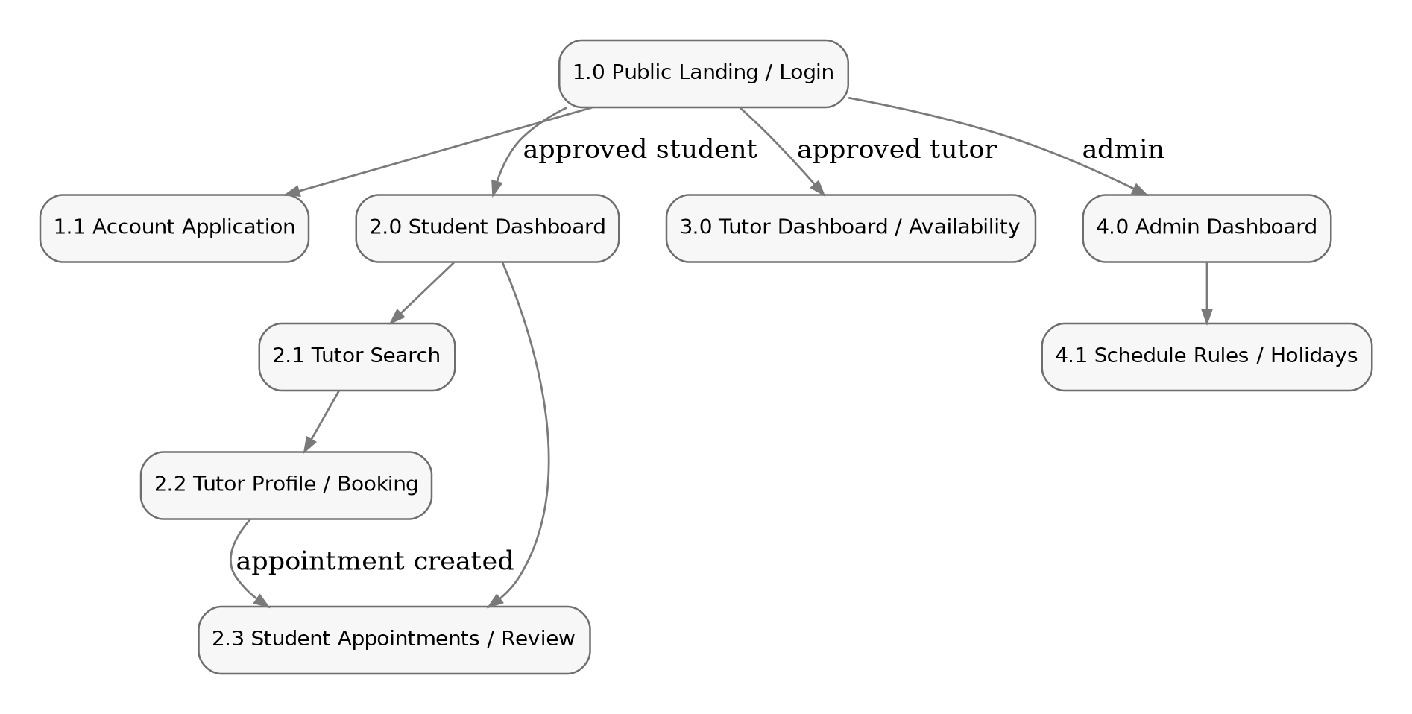
Figure 4. Structure and navigation map.
Navigation is role-aware. Public users see only the landing page and account application. After login, Students route to search and appointment screens, Tutors route to availability and appointment control, and Admins route to approval, moderation, and schedule-control screens. Buttons are hidden or disabled when a role lacks permission.

2.2.2 Screen Descriptions

1.0 Public Landing / Login
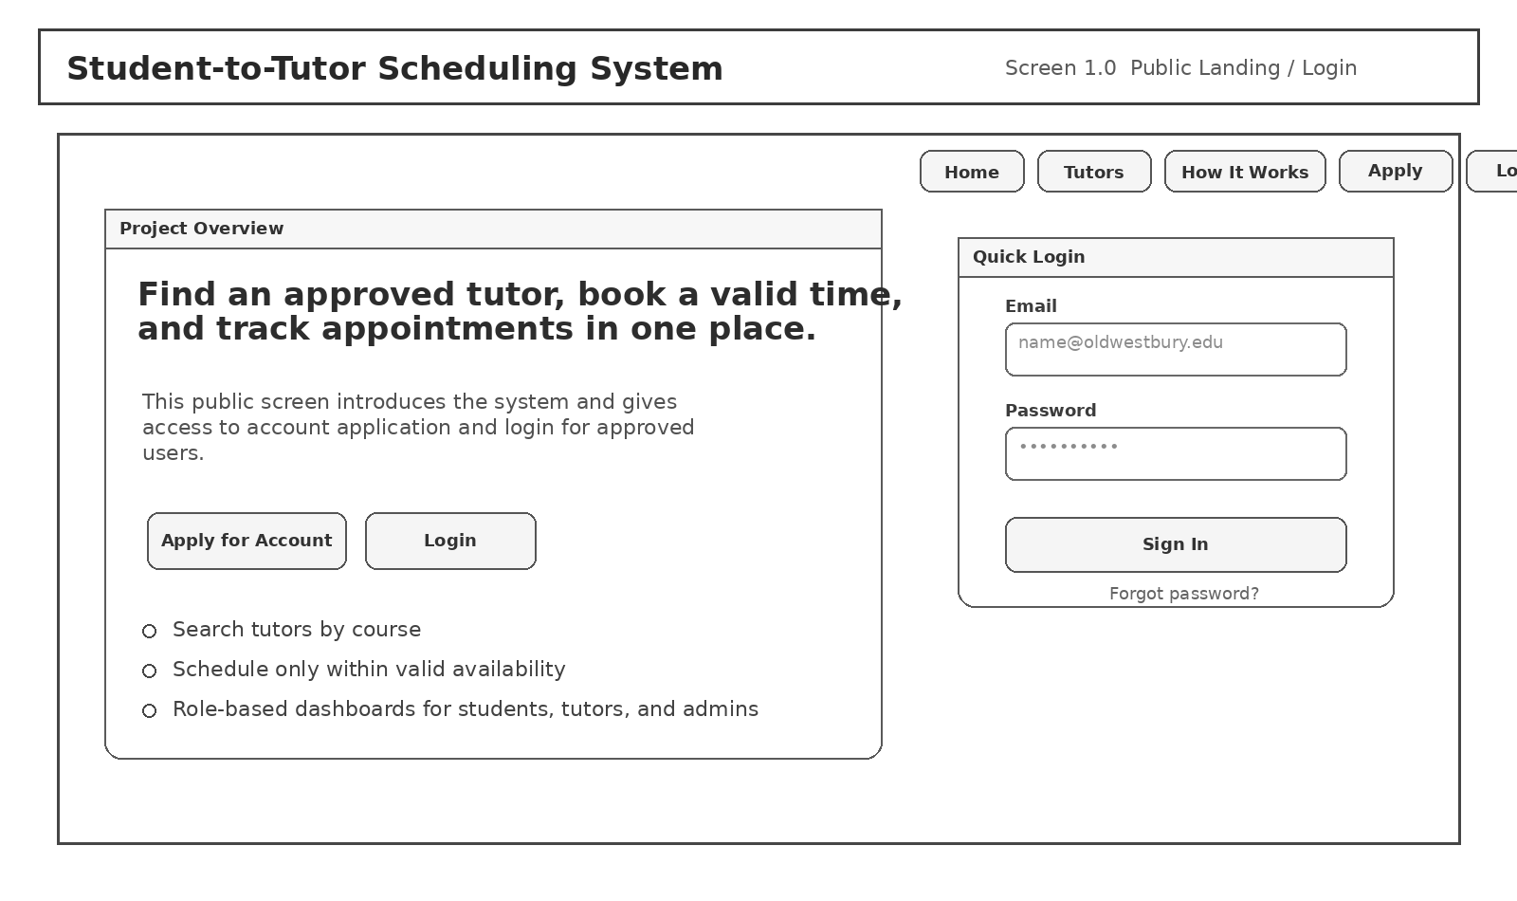
Description | Introduces the system, explains the purpose of the application, and provides access to account application and login.
Navigation | Available to public users. From this screen the user can open account application, log in, or read basic system information.
Access / Rules | The Login button is disabled until required fields are present. Apply and Login are visible to public users; role dashboards are not.
Notes | Screen numbering matches the structure diagram and is used to organize the design discussion.
Key screen elements
Element | Type | Label | Behavior / Validation
Top navigation | Navigation buttons | Home / Tutors / How It Works / Apply / Login | Moves between public information and entry actions.
Project overview panel | Content area | Project Overview | Explains what the system does and what roles it supports.
Email field | Text field | Email | Requires valid email format.
Password field | Password field | Password | Masked input; required for login.
Sign In button | Action button | Sign In | Submits credentials and routes approved users to the correct dashboard.

1.1 Account Application
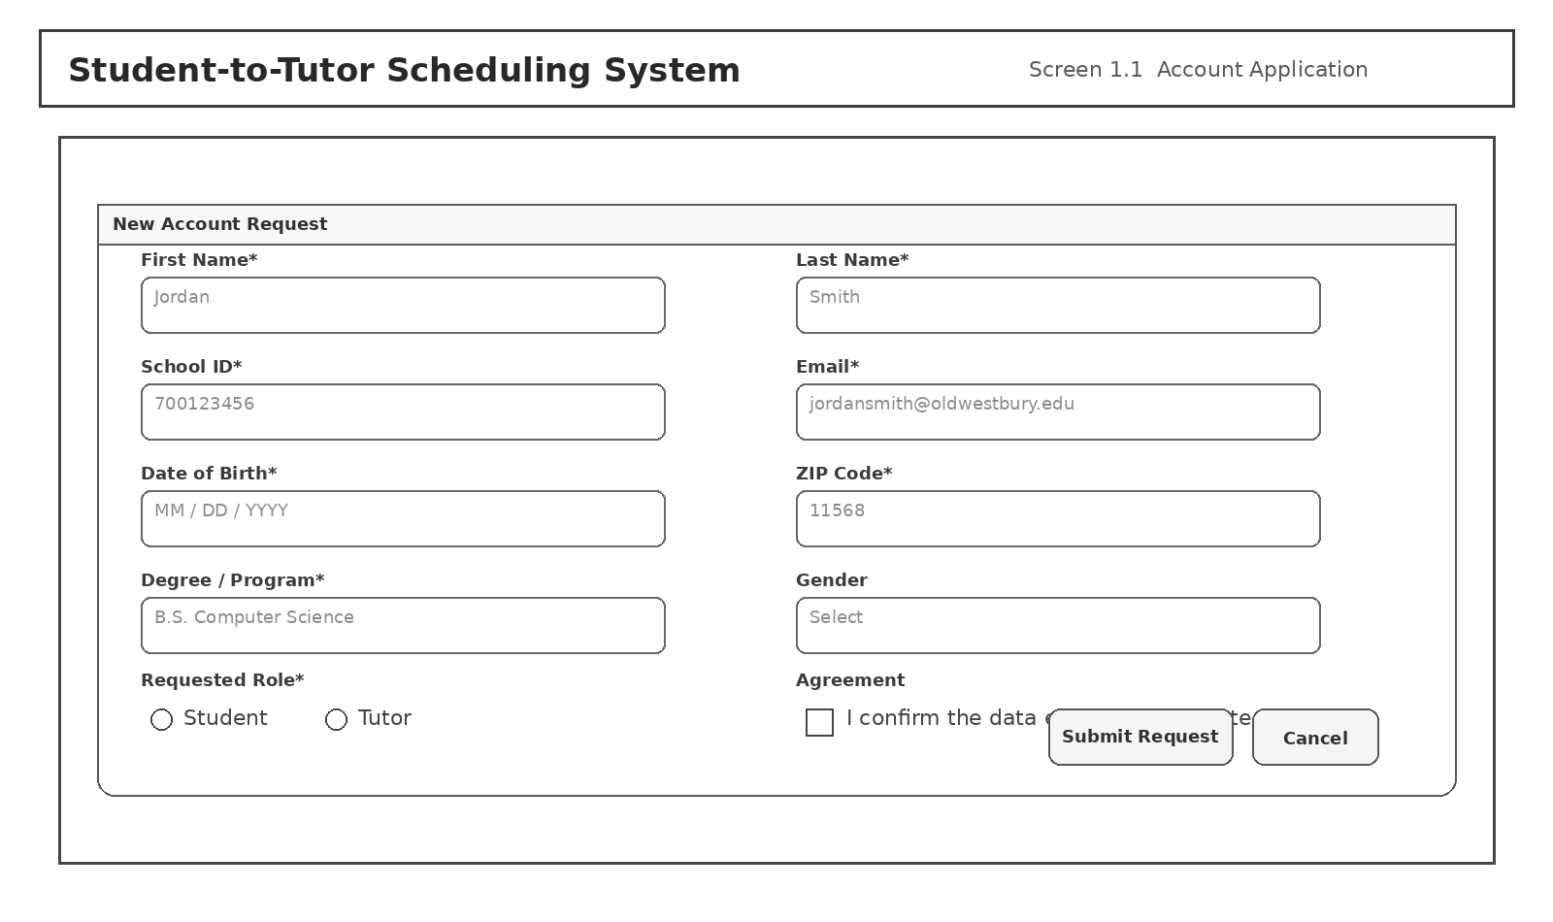
Description | Collects identity and profile fields for a new Student or Tutor account request.
Navigation | Opened from the public landing page. A successful submission returns the user to a confirmation state and waits for Admin approval.
Access / Rules | Submit remains disabled until all required fields and the accuracy confirmation are completed.
Notes | Screen numbering matches the structure diagram and is used to organize the design discussion.
Key screen elements
Element | Type | Label | Behavior / Validation
Identity fields | Form inputs | First Name / Last Name / DOB / School ID | Required for account review.
Contact fields | Form inputs | Email / ZIP Code / Address | Used for account and profile record creation.
Requested Role | Radio selection | Student or Tutor | Controls downstream approval path.
Degree / Program | Text field | Degree / Program | Used in basic academic profile data.
Submit Request | Action button | Submit Request | Creates a pending account record.

2.0 Student Dashboard
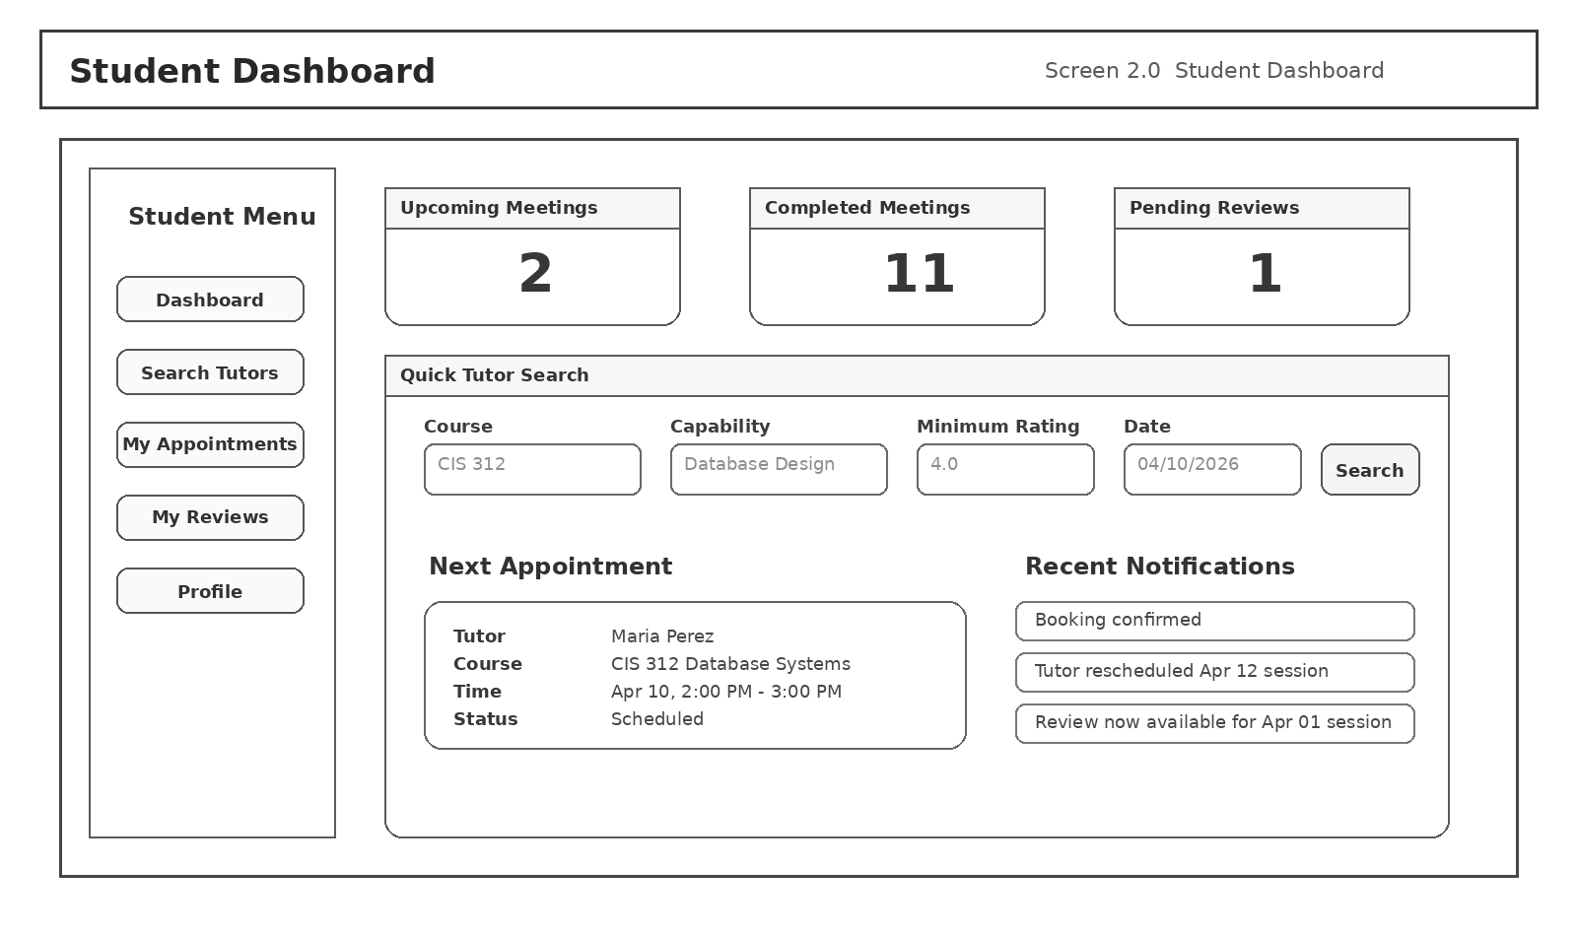
Description | Student home screen with summary counts, notification snippets, and quick tutor search controls.
Navigation | Reached after approved Student login. Side menu routes to search, appointments, reviews, and profile.
Access / Rules | Counts refresh after booking, cancellation, completion, or review activity. Search panel accepts optional filters.
Notes | Screen numbering matches the structure diagram and is used to organize the design discussion.
Key screen elements
Element | Type | Label | Behavior / Validation
Student menu | Sidebar navigation | Dashboard / Search / Appointments / Reviews / Profile | Role-specific navigation.
Summary cards | Dashboard widgets | Upcoming / Completed / Pending Reviews | Show key counts for the current student.
Quick Tutor Search | Filter panel | Course / Capability / Rating / Date | Supports immediate search without leaving the dashboard.
Next Appointment card | Status panel | Tutor / Course / Time / Status | Shows the next scheduled meeting.
Recent Notifications | List panel | Booking and status messages | Surfaces recent system events.

2.1 Tutor Search Results
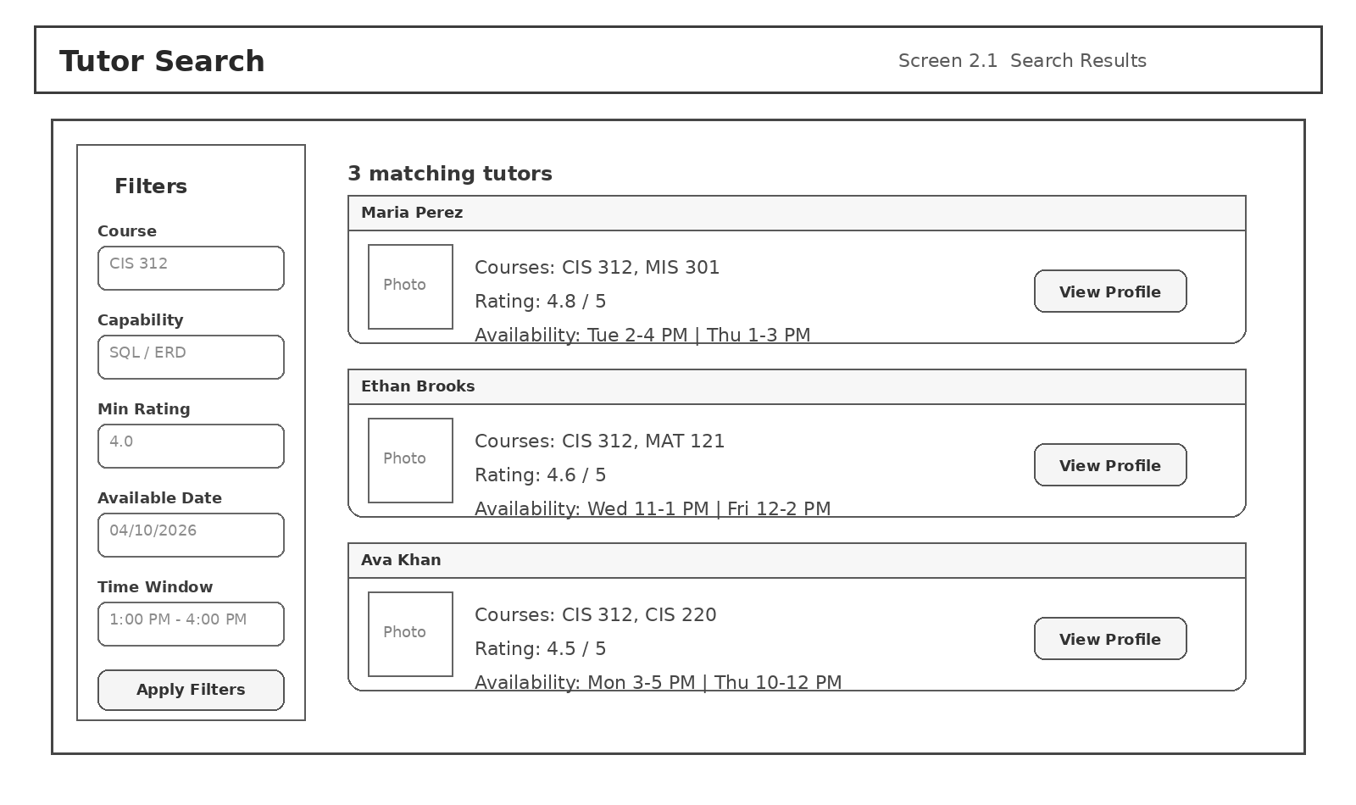
Description | Displays filtered tutor results using course, capability, rating, and date/time inputs.
Navigation | Opened from Student Dashboard or by direct search flow. Selecting View Profile opens Screen 2.2.
Access / Rules | The system returns only tutors whose capabilities and open availability match the selected filters.
Notes | Screen numbering matches the structure diagram and is used to organize the design discussion.
Key screen elements
Element | Type | Label | Behavior / Validation
Filter panel | Form panel | Course / Capability / Rating / Date / Time | Query inputs used to narrow results.
Tutor result card | Search result card | Tutor name, courses, rating, availability | Shows only student-approved basic profile data.
View Profile | Action button | View Profile | Loads the selected tutor's basic profile and booking screen.

2.2 Tutor Basic Profile / Booking
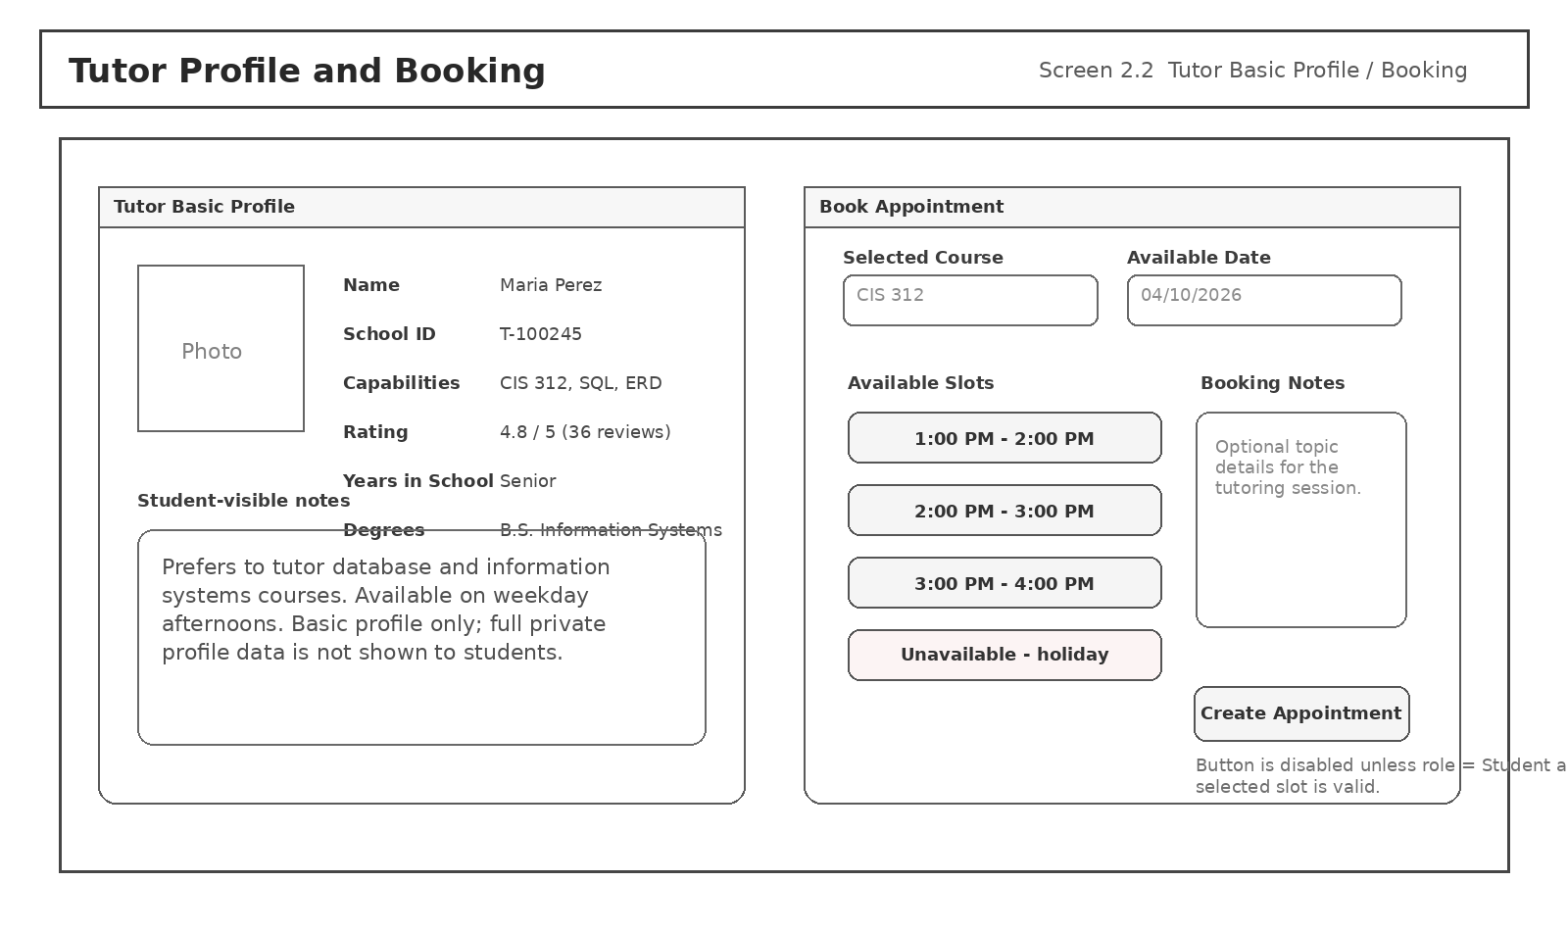
Description | Shows the tutor's student-visible profile data and open time slots for booking.
Navigation | Opened from tutor search results. Create Appointment sends the selected slot into the appointment workflow and returns the student to appointments or confirmation.
Access / Rules | Create Appointment is visible only to Students and remains disabled unless the selected slot is still open and schedule rules are satisfied.
Notes | Screen numbering matches the structure diagram and is used to organize the design discussion.
Key screen elements
Element | Type | Label | Behavior / Validation
Basic profile panel | Read-only profile | Name / School ID / Capabilities / Rating | Restricted to the minimum data needed by Students.
Available slots | Selectable buttons | Time-slot list | Only open slots that pass rule checks are shown.
Booking notes | Optional text area | Booking Notes | Allows the student to provide topic detail for the session.
Create Appointment | Action button | Create Appointment | Creates Scheduled appointment if validation passes.

2.3 Student Appointments / Review
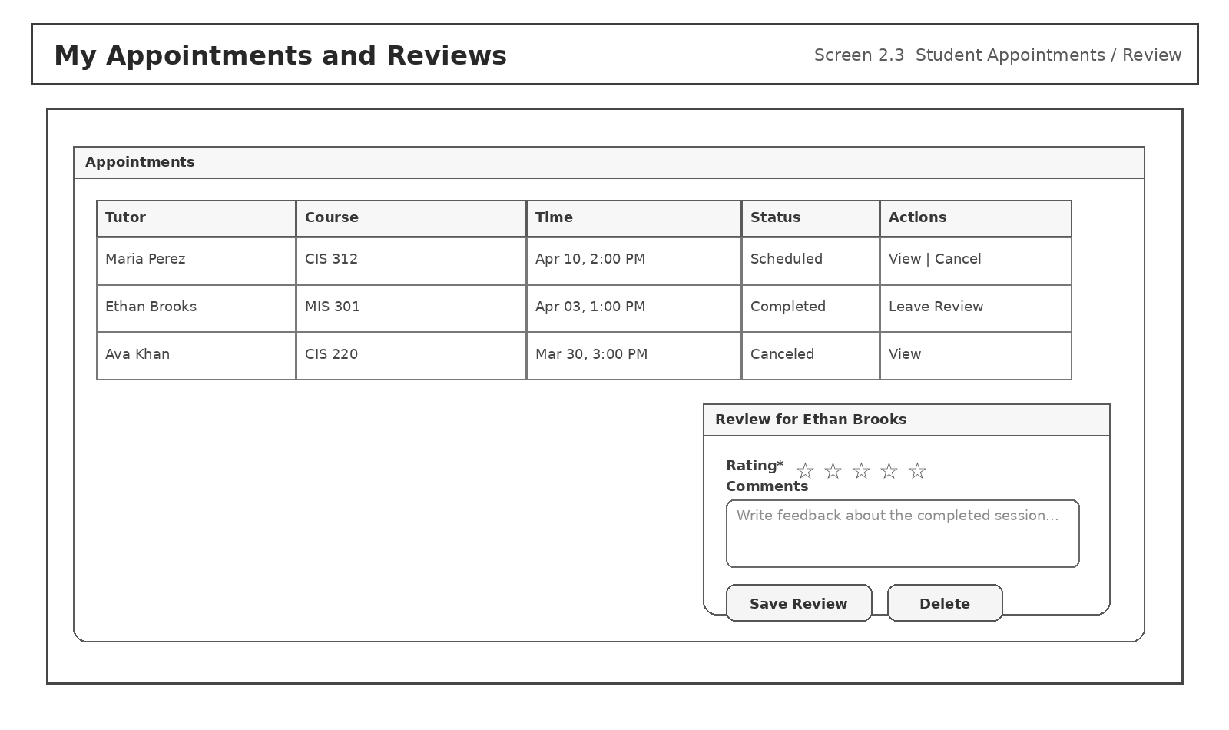
Description | Lists current and historical student appointments and provides review entry after a completed session.
Navigation | Opened from Student Dashboard. Leave Review launches or reveals the review entry controls for a completed appointment.
Access / Rules | Review create, edit, and delete operations are allowed only for the owning student and only after the related appointment reaches Completed.
Notes | Screen numbering matches the structure diagram and is used to organize the design discussion.
Key screen elements
Element | Type | Label | Behavior / Validation
Appointment table | Data grid | Tutor / Course / Time / Status / Actions | Shows booking history for the student.
Action links | Inline controls | View / Cancel / Leave Review | Available actions depend on current appointment status.
Review panel | Form panel | Rating / Comments | Only available for completed appointments.
Save Review | Action button | Save Review | Creates or updates review and refreshes tutor aggregates.
Delete | Action button | Delete | Removes the student's own review.

3.0 Tutor Dashboard / Availability
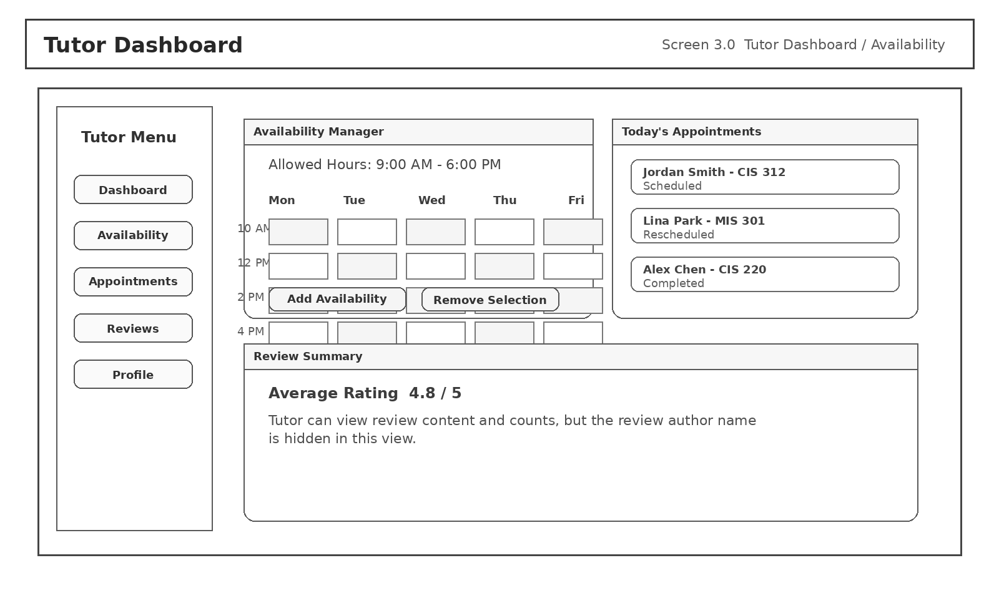
Description | Tutor home screen for availability control, appointment status management, and review summary visibility.
Navigation | Reached after approved Tutor login. Tutor menu routes to availability, appointments, reviews, and profile.
Access / Rules | Add Availability and Remove Selection are blocked when the time selection violates allowed hours or holiday blocks.
Notes | Screen numbering matches the structure diagram and is used to organize the design discussion.
Key screen elements
Element | Type | Label | Behavior / Validation
Tutor menu | Sidebar navigation | Dashboard / Availability / Appointments / Reviews / Profile | Role-specific navigation.
Availability grid | Calendar-style control | Weekday time blocks | Represents open and closed tutoring windows.
Today's Appointments | List panel | Scheduled / Rescheduled / Completed items | Provides quick access to current sessions.
Review Summary | Read-only panel | Average rating and review notice | Tutor can read visible review content but not author names.

4.0 Admin Dashboard / Moderation
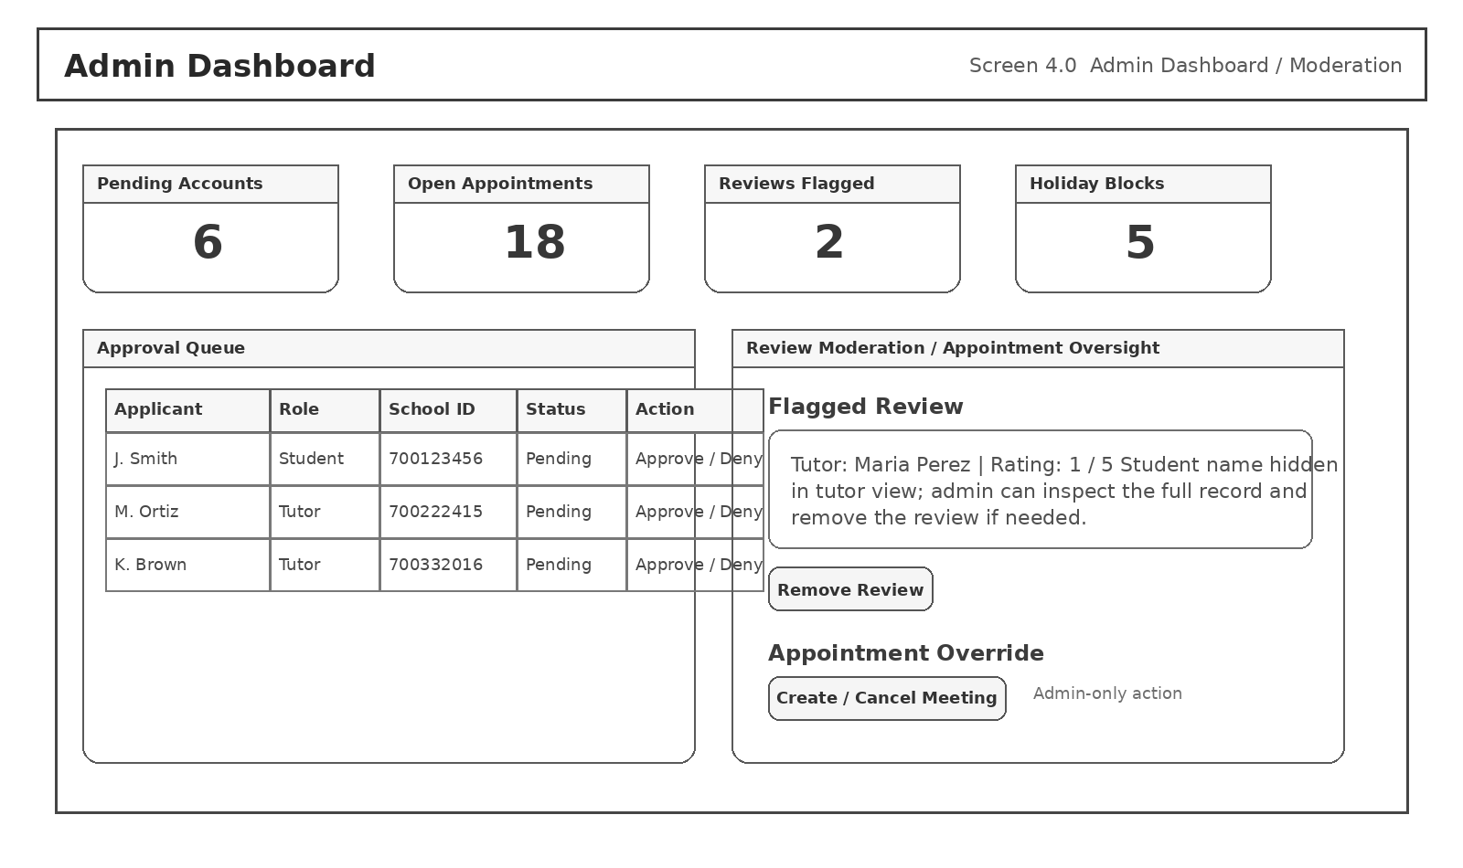
Description | Central workspace for approvals, appointment oversight, review moderation, and system totals.
Navigation | Reached after Admin login. Buttons and links route to detailed approval, profile edit, appointment override, and schedule control workflows.
Access / Rules | Admin-only actions write audit logs. Review removal and account approval actions require explicit confirmation.
Notes | Screen numbering matches the structure diagram and is used to organize the design discussion.
Key screen elements
Element | Type | Label | Behavior / Validation
Summary cards | Dashboard widgets | Pending Accounts / Open Appointments / Flagged Reviews / Holiday Blocks | Quick oversight counts.
Approval queue | Data grid | Applicant / Role / School ID / Status / Action | Supports approve and deny workflow.
Review moderation panel | Moderation controls | Flagged Review / Remove Review | Allows policy enforcement on review content.
Appointment override | Action button | Create / Cancel Meeting | Admin-only ability to intervene in scheduling.

4.1 Schedule Rules / Holidays
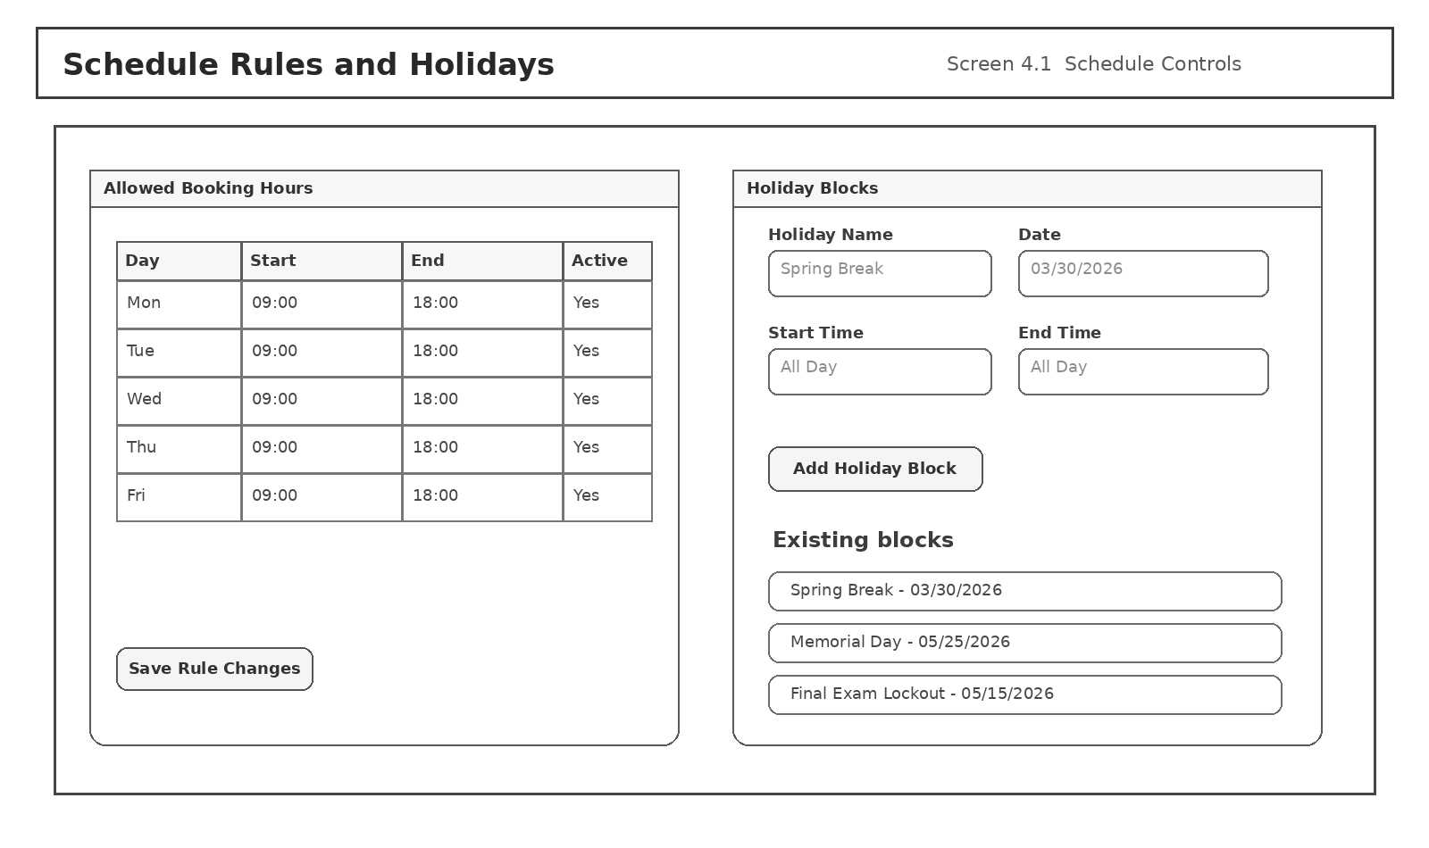
Description | Maintains weekday booking windows and holiday/date blocks used by availability and appointment validation.
Navigation | Opened from Admin Dashboard or Super Admin controls. Saving changes updates downstream booking checks immediately.
Access / Rules | Only Admin and Super Admin can access the screen. A holiday block with is_all_day = true suppresses all slots for that date.
Notes | Screen numbering matches the structure diagram and is used to organize the design discussion.
Key screen elements
Element | Type | Label | Behavior / Validation
Allowed booking hours | Rule table | Day / Start / End / Active | Defines system-wide scheduling window by day.
Holiday fields | Form inputs | Holiday Name / Date / Start / End | Creates or edits a blocked period.
Add Holiday Block | Action button | Add Holiday Block | Saves a new holiday record.
Existing blocks | Data list | Holiday block list | Shows current rule exceptions for editing or removal.

2.3 API Development
The application layer is exposed through internal REST-style endpoints. Authentication, search, availability management, appointment status changes, reviews, and admin oversight are represented as separate API groups. Every request is validated against role permissions before business rules are applied.

API security and request rules
- All endpoints require authentication except register, login, and public read-only landing content.
- Role-based authorization is checked before database work begins. For example, only Students or Admins can create appointments, and only Admin or Super Admin can edit schedule rules.
- Every mutating request validates required fields, data types, date/time rules, and ownership before saving.
- Sensitive responses exclude fields not needed by the caller. Tutor review views, for example, exclude the student author's name.
Method | Endpoint | Role | Purpose | Request | Response
POST | /api/auth/register | Public | Submit Student or Tutor account request | role, schoolId, email, password, identity fields | 201 Created with pending status
POST | /api/auth/login | Public | Authenticate approved user | email, password | 200 OK with session token / cookie
POST | /api/auth/logout | Any authenticated user | End current session | session | 204 No Content
GET | /api/profile/me | Authenticated user | Load current user's profile and dashboard summary | - | 200 OK with role-specific profile payload
PUT | /api/profile/me | Authenticated user | Update own editable profile fields | profile fields allowed for role | 200 OK with updated profile
GET | /api/tutors | Student | Search tutors by course, capability, rating, and date | query params | 200 OK with filtered tutor cards
GET | /api/tutors/{tutorId} | Student | Read tutor basic profile only | path param | 200 OK with student-safe tutor data
GET | /api/tutors/{tutorId}/availability | Student / Admin | Read open availability slots for a tutor | date range | 200 OK with valid open slots
POST | /api/availability | Tutor | Create a new availability window | date, startTime, endTime | 201 Created if within allowed hours and not holiday blocked
DELETE | /api/availability/{availabilityId} | Tutor | Close or remove an open availability slot | path param | 204 No Content if slot not already reserved
POST | /api/appointments | Student / Admin | Create a tutoring appointment | studentId, tutorId, availabilityId, notes | 201 Created with Scheduled status
GET | /api/appointments/my | Student / Tutor | Load role-specific appointment list | status/date filters optional | 200 OK with appointment list
PATCH | /api/appointments/{appointmentId}/status | Tutor / Admin | Reschedule, cancel, or complete an appointment | status, optional reason, optional new availabilityId | 200 OK with updated status
POST | /api/reviews | Student | Create review after completed appointment | appointmentId, rating, reviewText | 201 Created; tutor aggregate rating refreshed
PUT | /api/reviews/{reviewId} | Student owner | Edit own review | rating, reviewText | 200 OK if review belongs to caller
DELETE | /api/reviews/{reviewId} | Student owner / Admin | Delete own review or moderate it | path param | 204 No Content
GET | /api/reviews/tutor/{tutorId} | Tutor / Student / Admin | Read visible reviews for a tutor | path param | 200 OK; student identity masked for tutor view
GET | /api/admin/pending-accounts | Admin | Load pending account approval queue | - | 200 OK with pending requests
PATCH | /api/admin/accounts/{userId}/approval | Admin | Approve or deny a user | approvalStatus, note | 200 OK and notification created
GET | /api/admin/schedule-rules | Admin / Super Admin | Load allowed hours and holiday blocks | - | 200 OK
PUT | /api/admin/schedule-rules | Admin / Super Admin | Update weekday allowed hours | rule payload | 200 OK
POST | /api/admin/holidays | Admin / Super Admin | Create holiday block | holiday fields | 201 Created
POST | /api/admin/appointments | Admin | Create or override a tutoring meeting | studentId, tutorId, time details, reason | 201 Created with created_source = AdminOverride

Example request / response
Example: create appointment (Student booking)
POST /api/appointments
{
"studentId": 42,
"tutorId": 18,
"availabilityId": 311,
"notes": "Need help with ERD normalization."
}
201 Created
{
"appointmentId": 9007,
"status": "Scheduled",
"appointmentDate": "2026-04-10",
"startTime": "14:00:00",
"endTime": "15:00:00",
"message": "Appointment scheduled successfully."
}
Example: approve pending account (Admin)
PATCH /api/admin/accounts/42/approval
{
"approvalStatus": "Approved",
"note": "Student record verified."
}

3. Non-Functional Requirements
Non-functional requirements define how the system should behave beyond its functional use cases. The categories below align the design with performance, privacy, maintainability, and operating expectations.
Category | Design Requirement
Security | Password hashes are stored instead of plain text; role checks are enforced on every profile, schedule, review, and admin endpoint; booking and review actions require an authenticated session.
Capacity | The initial design supports hundreds of users and thousands of appointments without schema changes. Archived appointments and logs can be moved to history tables if volume grows.
Compatibility | Primary support target is modern Chrome, Edge, and Firefox on desktop/laptop devices. The layout remains usable on tablets, but mobile-first behavior is not the main design target.
Reliability / Availability | Users should be able to access the system during normal academic hours with predictable uptime. Critical failures should preserve committed data and display safe fallback error states.
Maintainability / Manageability | The design separates profiles, search data, schedule rules, and review moderation into clear modules. Admin screens centralize routine maintenance tasks such as approvals and holiday management.
Scalability | The design can scale vertically by increasing database and application resources and horizontally by separating the web and database layers. Search filters remain based on indexed relational queries.
Usability | Each role lands on a dashboard that exposes its most common actions first. Buttons are disabled or hidden when a role does not have permission or when required input is missing.
Performance | Search and schedule lookups should respond in a few seconds under normal load. Conflict checks must happen before confirmation so the user never receives a successful booking for an invalid slot.
Privacy / Compliance | Only the minimum fields required for each role are exposed. Review author names are masked in tutor-facing views, and admin actions are captured in audit logs.

4. Tests
Testing will confirm that the system enforces permissions, preserves database integrity, validates schedule rules, and returns the correct user-facing results. The following cases represent the minimum functional and design-level test coverage required before a stable implementation can be claimed.
ID | Area | Action / Input | Expected Result
TC-01 | Account request form | Public user opens account application and submits required fields | Request is saved with approval_status = Pending and the applicant receives a confirmation message.
TC-02 | Account approval | Admin approves a pending Student or Tutor request | Approved user can sign in; denied user remains blocked and sees the decision message.
TC-03 | Role-based profile visibility | Student views tutor profile and Tutor views student booking details | Each role sees only approved basic fields; hidden fields never render in the interface or response payload.
TC-04 | Tutor search filters | Student filters by course, capability, minimum rating, and date | Only matching tutors appear; empty filters fall back to the broadest allowed search.
TC-05 | Booking validation | Student attempts to create an appointment using a valid available slot | Appointment is created with status Scheduled and the slot is no longer available to others.
TC-06 | Booking conflict prevention | A second user tries to book a slot that has already been reserved | System blocks the request and returns a clear conflict message without creating a duplicate appointment.
TC-07 | Holiday / allowed-hours enforcement | Tutor or Student attempts to create availability or booking on a blocked date or outside allowed hours | System rejects the request and explains which schedule rule was violated.
TC-08 | Appointment status management | Tutor reschedules, cancels, or marks an appointment completed | Appointment status updates correctly, related notifications are generated, and the dashboard counts refresh.
TC-09 | Review ownership and privacy | Student creates, edits, and deletes a review after a completed session; Tutor views the result | Review operations are allowed only to the owning student; tutor can read the review content but cannot see the author's identity.
TC-10 | Admin review moderation | Admin removes an inappropriate review | The review is hidden or deleted according to policy and the action is recorded in admin_audit_log.
TC-11 | Schedule controls | Admin updates weekday hours or adds a holiday block | New rules apply to subsequent availability and booking actions immediately.
TC-12 | Database integrity | Create, update, cancel, and delete operations are executed across profiles, appointments, and reviews | Foreign keys, non-null rules, and audit logging preserve referential integrity and prevent orphan records.
TC-13 | Notification delivery | Booking, approval, cancellation, and moderation events are triggered | The correct in-app and email notification template is generated for the target user.
TC-14 | Unauthorized API access | User calls an endpoint outside the role's permission set | API returns an authorization error and no restricted data is exposed.

Appendix A. References
Reference | Description | Location
Design Document Template PDF | Course template used to determine the required Milestone 2 section structure, UI section organization, API planning section, and test section layout. | Uploaded file
Sample1_ConoCancer_final.pdf | Used as an example of a completed design document with detailed data models, dictionaries, non-functional requirements, and tests. | Uploaded file
Sample2_PantherPals_Final.pdf | Used as an example of structure/navigation diagrams, screen descriptions, and design-document formatting choices. | Uploaded file
Sample3_ReadingWish.pdf | Used as an example of data dictionary presentation, UI mock-up placement, and document sequencing. | Uploaded file
Sample4_GymPages_Final.pdf | Used as an example of schema excerpts, data modeling pages, and overall design-document completeness. | Uploaded file
Systems design and implementation Renu.txt | Primary requirements source for user permissions, restrictions, and allowed actions. | Uploaded file
Milestone 1 Concept Document | Base conceptual design used to carry the approved user roles, business rules, and workflow into Milestone 2. | Previously submitted file

Appendix B. Key Terms
The following terms are used throughout the design document.
Term | Definition
Account Approval | The admin-controlled decision that changes a pending user into an approved active account or a denied request.
Availability Window | A tutor-defined date and time slot that can be offered to students if it passes system rule checks.
Basic Profile | The reduced set of fields another role is permitted to see, such as tutor rating or student academic summary.
Created Source | A field showing how an appointment row was created, such as StudentBooking or AdminOverride.
Holiday Block | A date or time range that prevents availability creation and appointment booking.
Role-Based Access Control | The permission model that determines which screens, data, and endpoints each role can use.
Schedule Rule | A system-wide weekday rule that defines the allowed booking window.
Review Moderation | Administrative ability to hide or remove a review that violates policy.
Audit Log | A record of sensitive admin actions such as approvals, review removals, and schedule-rule edits.
Super Admin | The single highest-visibility oversight role in the system.

