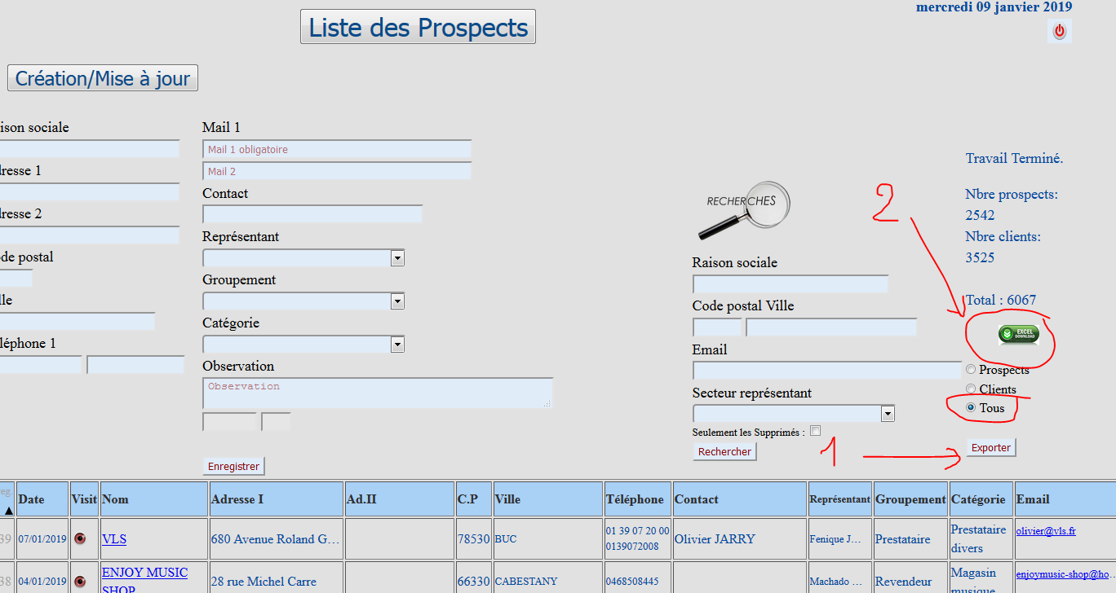

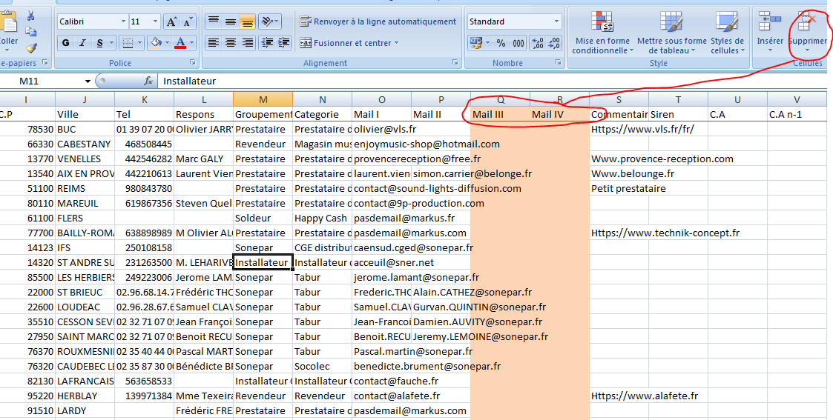

Compte gmail : groupesodelmiradoux@gmail.com

https://docs.google.com/spreadsheets/d/1rvWlxu3cmkzsp72GuC2EE3P6gxgDBYR07Gq6ORUidOU/edit#gid=0

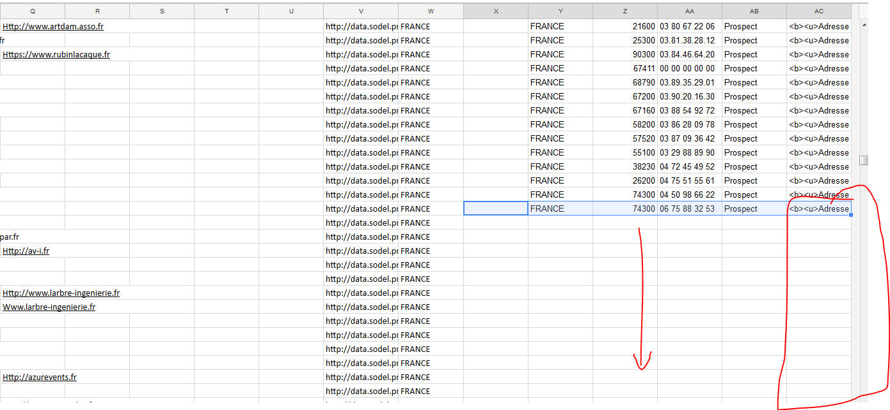

https://mapalist.com/auth/Manage.aspx

