**COM3504 Intelligent Web - PWA Assignment Documentation**

It is importance that you do not ignore techniques and examples provided to you during the lectures and lab classes. Referring back to them during your planning/implementation stages will give you the base from where to start, as well as a point of comparison/discussion where your ideas differ from what already presented to you (i.e., do not reinvent the wheel – if it has been done before, reuse it and complement it where it lacks functionality). You may use diagrams to aid your explanation in these sections, but please note that a diagram alone is not acceptable and must be accompanied by an explanation/discussion.

**Length: maximum 5 pages (3 pages for the first part).**

**Index Table**

**Introduction**

**Diagram**

**For each task**

1. Interface to insert and search data via forms:

2. Interface to search data via map

3. PWA – caching of the app template using a web worker

– Aiming to implement a **Cache then network** caching strategy

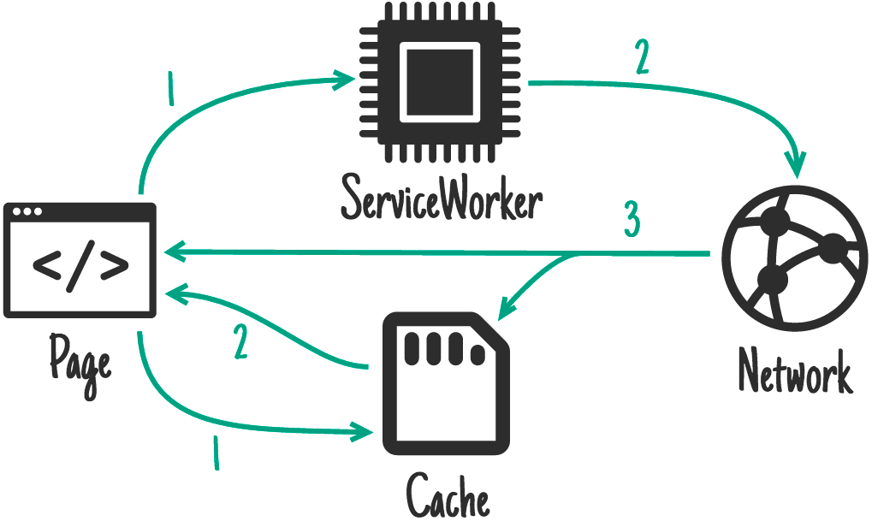

4. PWA: caching data using IndexedDB

5. NodeJS server including non-blocking organisation of multiple dedicated servers

6. MongoDB

7. Quality of Web solution

Create a subsection for each of them strictly following the organisation below (Challenges, Solution, Requirements and Limitation).

**Challenges** [10% of the report marks for this section] - Introduce the task and the challenges that you are faced with (i.e. why is it complex?).

**Solution:** Design and its motivations: [55% of the report marks for this section] explain how your solution works and explain why you chose to design your solution in this particular way (e.g. to optimise number of twitter queries). Does it have advantages/disadvantages over other design choices?

**Requirements:** [20% of the report marks for this section] how does this design comply with the requirements specified in the original assignment sheet? Are you meeting all requirements?

**Limitations:** [15% of the report marks for this section] have you thought about exceptional situations that may limit your solution? Is your solution extensible? Can it be easily adapted for other requirements? Remember that no design is flawless!

**Conclusions**

**Division of Work**

**Extra Information**

**Bilbliography**