scissors -si-zrz

Wolf

Thread - thred

 fabric

Tired – tai-urd

PRESENTE SIMPLE

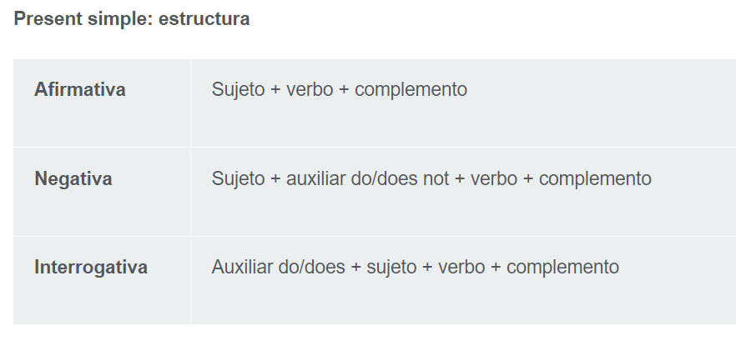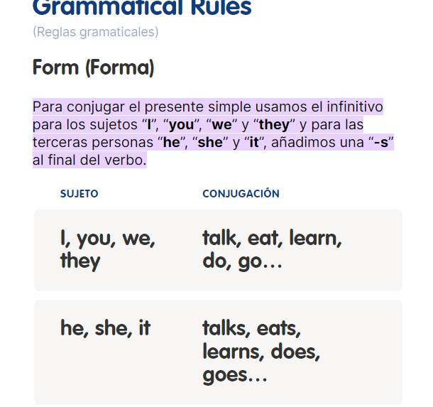

verb: eat

She eats burgers.

She doesn’t eat hamburgers.

Does She eat burgers?

work

She works in the office.

She doesn’t work in the office.

Does She work in the office?

 Study

She studies in her house.

She doesn’t study in her house.

cook

She cooks MOLE in the kitchen every day.

She doesn’t cook MOLE in the kitchen every day.

draw

He draws with a pencil every morning.

He doesn’t draw with a pencil every morning.

jump

She jumps the rope in the gym every afternoon.

She doesn’t jump the rope in the gym every afternoon.

walk

They walk in the beach every morning.

They do not/ don’t walk in the beach every morning.

play

Childrens play soccer in the field every weekend.

Childrens do not play soccer in the field every weekend

laugh – Laªf

Laura laughs with her mom

Laura doesn’t laugh with her mom

cry

Karina cries for her mother all day!

Karina doesn’t cry for her mother all day.

wash the dishes

You wash the dishes in the kitchen.

You don’t wash the dishes in the kitchen



Raul watches TV in the house every afternoon.

Raul doesn’t watch tv in the house every afternoon.

See - (ver)Algo que no puedes evitar ver.

Look – (Mirar) – Poner atención.

Watch – Mayor nivel de atencion- Mirar películas TV.









SHE WORKS IN THE OFICCE EVERY DAY-

---------------------------------SHE EATS TACOS IN A RESTAURANT_EVERYX

------------------------------ HE CRIES FOR HIS BOYSFRIEND EVERY NIGHT

Pasado Simple – Simple Past

**Verbos Irregulares:** **Los verbos irregulares no siguen el patrón "-ed" para formar el pasado simple y el pasado participio. Cada verbo irregular tiene su propia forma específica para estos tiempos verbales, que generalmente se deben aprender de memoria.**

1. go – went
2. eat - ate
3. swim – swam (nadar)
4. see - saw
5. take – took (tomar algo)
6. give – gave (dar)
7. drive – drove (conducir)
8. come – came (venir)
9. drink – drank (beber)
10. break – broke (romper)

**Verbos Regulares:** **Los verbos regulares siguen un patrón predecible para formar el pasado simple y el pasado participio. En su forma base, terminan en "-ed" para formar el pasado simple y el pasado participio**

1. play - played
2. work - worked
3. walk - walked
4. talk – talked (Hablar / coversar)
5. watch – watched (Ver)
6. cook – cooked ( cocinar)
7. love – loved (amar)
8. help – helped (Ayudar)
9. clean – cleaned (Limpiar)
10. jump – jumped
11. Close – Closed
12. Believe - Believed (creer)
13. Stop – Stopped (Detener)
14. La –d es para verbos cuya última letra es e.
15. La –ed es para verbos en cualquier otra terminación.
16. Cuando hay una Y al final, después de una vocal, solo hay que agregar –ed
17. Cuando no hay vocal antes de la Y, se cambia por i+ ed
18. En otros casos, la última consonante de la palabra debe repetirse para agregar la fórmula –ed

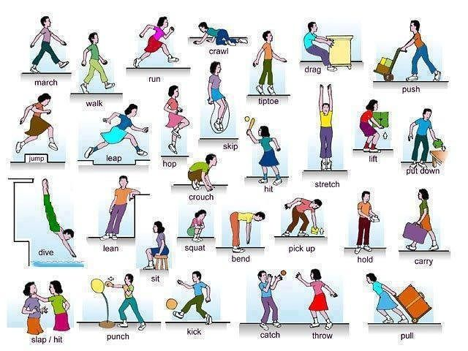

--------REGULARES------

* Play
* Work
* Talk
* Love
* Clean
* Plan
* Stop
* Drop
* Control
* Worry
* Marry
* Apply
* Enjoy
* Try
* Hurry
* Copy
* Hunt
* Visit
* Wait
* Start

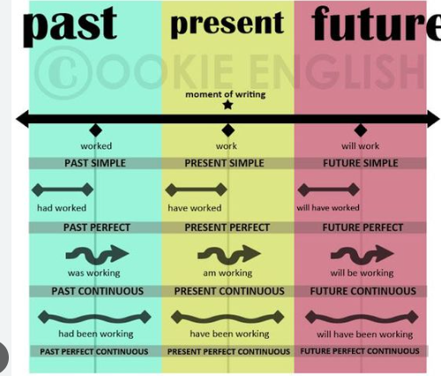

**Afirmativa**:Sujeto + verbo en pasado simple + complemento

Ejemplo: She played tennis yesterday. (Ella jugó tenis ayer.)

**Negativa**: Sujeto + did not (didn't) + verbo en forma base + complemento

Ejemplo: They did not go to the party. (Ellos no fueron a la fiesta.)

**Interrogativa**: Did + sujeto + verbo en forma base + complemento + ?

Ejemplo: Did you read the book? (¿Leíste el libro?).

Mi mama lavo la ropa ayer.

My mom washed the clothes yesterday.

My mom didn’t wash the clothes yesterday.

Did my mom wash the clothes yesterday?

What did you do today morning?

What did your sister do yesterday?

What does your mom do in the morning?

How often do you talk with your dad?

FUTURE

Introducción:

El futuro simple es un tiempo verbal en inglés que se utiliza para hablar sobre acciones que **ocurrirán en el futuro**.

A menudo se usa para expresar **planes**, **predicciones**, **promesas**, **decisiones espontáneas** y otras acciones futuras.

Estructura:

La estructura básica del futuro simple en inglés se forma utilizando el verbo modal "**will**" (o la forma contraída "´ll") seguido del verbo en su forma base (infinitivo sin "to").

**(+)Afirmativas:** Sujeto + will + verbo en forma base + complemento

**(-) Negativas:** Sujeto + will not (won't) + verbo en forma base + complemento

**(?)Interrogativas:** Will + sujeto + verbo en forma base + complemento + **?**

travel (viajar)

study (Estudiar)

eat (Comer)

watch (Ver)

forget (Olvidar)

come (Venir)

call (Llamar)

visit (Visitar)

think(Pensar)

help(Ayuda)

have(Tener)

Viajaré a París el próximo verano – I Will travel to Paris next summer.

Ella estudiará mucho para el examen.

Ellos visitarán a sus abuelos este fin de semana.

No comeré comida rápida nunca más. – I won’t eat fast food anymore.

Él no verá televisión esta noche

Ellos no olvidarán tu cumpleaños.

¿Vendrás a la fiesta mañana? Will you come to the pary tomorrow?

¿Me llamará más tarde?

¿Visitarán el museo este fin de semana?

To – para – regalar algo. To you.

To – a - de las 5 a las 9…. 5pm to 6pm

A/an– un caballo / una sombrilla--- a horse /// an unbrella..

I - my

You - your

We - our

They - their

He - his

She - her

It – its

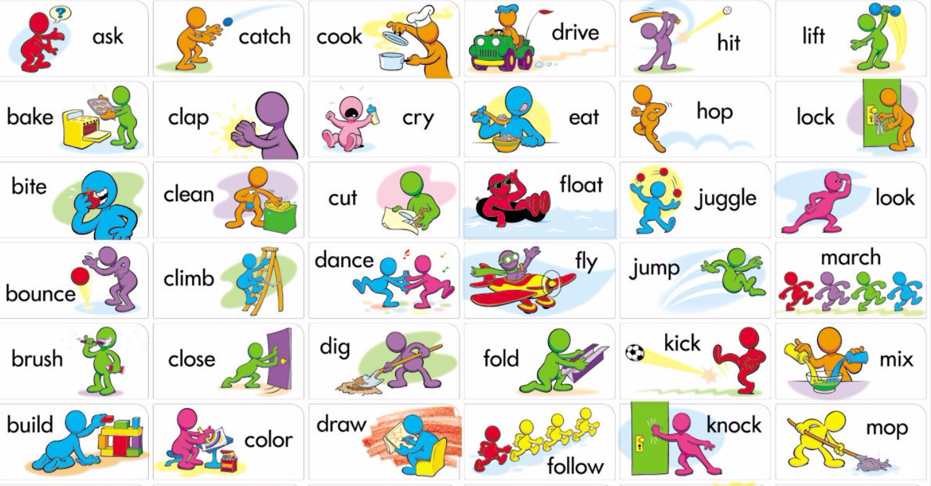

Presente continuo o presente progresivo.

Se utiliza para expresar acciones que están ocurriendo en el momento actual o alrededor del momento en el que se habla.

(+)Forma positiva: Sujeto + verbo "to be" (am, is, are) + verbo principal + -ing.

(-)Forma negativa: Sujeto + verbo "to be" (am not, isn't, aren't) + verbo principal + -ing.

(?)Forma interrogativa: Verbo "to be" (Am, Is, Are) + sujeto + verbo principal + -ing.

Study - studying

Read – Reading

Write – writing

Sing – singing

Swim – swimming

Eat – eating

Dance - dancing

Need – needing

Listen – listening

Skip – skipping (faltar , faltar a clases , a la escuela)

Get up - getting up

(+)Forma positiva: Sujeto + verbo "to be" (am, is, are) + verbo principal + -ing.

I am singing my favorite song right now.

You are reading this sentence in this moment.

She is skipping classes today.

They are getting up early these days.

Forma negativa: Sujeto + verbo "to be" (am not, isn't, aren't) + verbo principal + -ing.

I am not crying right now because my boyfriend is very beautiful.

He isn’t eating his soup

It isn’t listening to its mom.

We aren’t playing soccer because they are using the field.

(?)Forma interrogativa: Verbo "to be" (Am, Is, Are) + sujeto + verbo principal + -ing.

Is She learning English in this class?

No , She isn’t learning English in this class.

Are We trying teach her English right now?

Yes, We are trying teach her English right now

Are You paying attention to English class?

Yes , You are paying attention to English class.

Am I understanding the sentences in English?

Yes , I am understanding the sentences in English.

Understand = entender

Understood – Entendio

Understanding – Entendiendo.

I am - I’m

You are

We are

They are

She is

He is

It is

La conjugación de verbos en inglés en la forma "-ing" (gerundio) generalmente sigue un patrón bastante simple. Aquí tienes algunas reglas generales para formar el gerundio de un verbo en inglés:

Verbos regulares:

La mayoría de los verbos regulares simplemente agregan "-ing" al final de la forma base del verbo. Por ejemplo:

walk (caminar) → walking (caminando)

talk (hablar) → talking (hablando)

play (jugar) → playing (jugando)

Verbos que terminan en "e":

Si un verbo termina en "e", generalmente debes eliminar la "e" final y agregar "-ing". Por ejemplo:

take (tomar) → taking (tomando)

write (escribir) → writing (escribiendo)

Verbos de una sola sílaba que terminan en una vocal + consonante:

Si un verbo es de una sola sílaba, y termina en una vocal seguida de una sola consonante, debes duplicar la consonante final antes de agregar "-ing". Por ejemplo:

run (correr) → running (corriendo)

sit (sentarse) → sitting (sentado)

Verbos irregulares:

Los verbos irregulares pueden tener formas de gerundio únicas y a menudo deben aprenderse de memoria. Algunos ejemplos incluyen:

go (ir) → going (yendo)

swim (nadar) → swimming (nadando)



10 verbos en ing.

Visiting Having Hearing Helping Going Closing Buying Breaking Feeling Forgetting

¡Claro! El presente continuo (también conocido como presente progresivo) es un tiempo verbal en inglés que se utiliza para hablar de acciones que están ocurriendo en el momento actual o que están en progreso en un momento específico

**Formación del presente continuo:**

El presente continuo se forma utilizando el verbo auxiliar "to be" (am, is, are) seguido del verbo principal en su forma "-ing" (gerundio). La estructura general es la siguiente:

* **Affirmative (Afirmativa):** Sujeto + am/is/are + verbo en forma "-ing."
* **Negative (Negativa):** Sujeto + am/is/are + not + verbo en forma "-ing" (o la contracción 'isn't' o 'aren't' en inglés coloquial).
* **Interrogative (Interrogativa):** Am/Is/Are + sujeto + verbo en forma "-ing."

I am visiting my grandmother.

I visited my grandmother.

I visit my grandmother every weekend.

Present , past , future , present continuous. Listen.

* I listen to music every day.
* I listened to music yesterday.
* You will listen to music every day.
* You are listening to music right now.

Close.

You close the window every night.

You closed the window last night.

We will close the window today night.

We are closing the window in this moment.

Forgetting

He forgets his bag in the morning class.

He forgot his bag in the morning class yesterday.

He will forget his bag in the morning class next Monday.

He is forgetting his bag in this class.

Buy

They don’t buy pizza .

They didn’t buy pizza.

They won’t buy pizza.

They aren’t buying pizza.

Pasado(+)

She bought pizza.

Did she buy pizza yesterday?

+ -> Yes , She bought pizza yesterday.

(--) No , She didn’t buy pizza yesterday.

Presente

Does she buy pizza every weekend?

Yes , She buys pizza every weekend.

No , She doesn’t buy pizza every weekend.



Do they play video games every day?

Does she jump in her bed every day?

Yes , She jumps in her bed every day.

Does Your mom cook every morning?

Yes , My mother cooks every morning.

No , My mother doesn’t cook every morning.

Can – Poder.

You can do it! – Yes! Tu puedes hacerlo

Just do it! Solo aslo! Or Aslo!

Just – Solo

Alone = estar solo

Do you remember where is typed this sentence?



Do you remember the time?



Have – tener

Do you have a car?

No , i haven’t a car.

You try to speak English.

How often do you visit your grand mother?

I visit my grandmother every Tuesday.