Descriptive Statistics

Nicolas Restrepo

4/3/2020

## Study 1

Here, I present figures showing the distribution of the data collected in study one. Here, are the ratings for the immorality of scenarios, their harmfulness, and their unexpectedness:

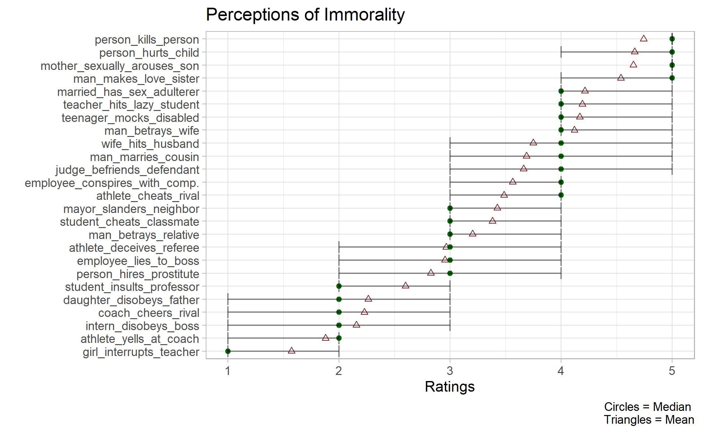

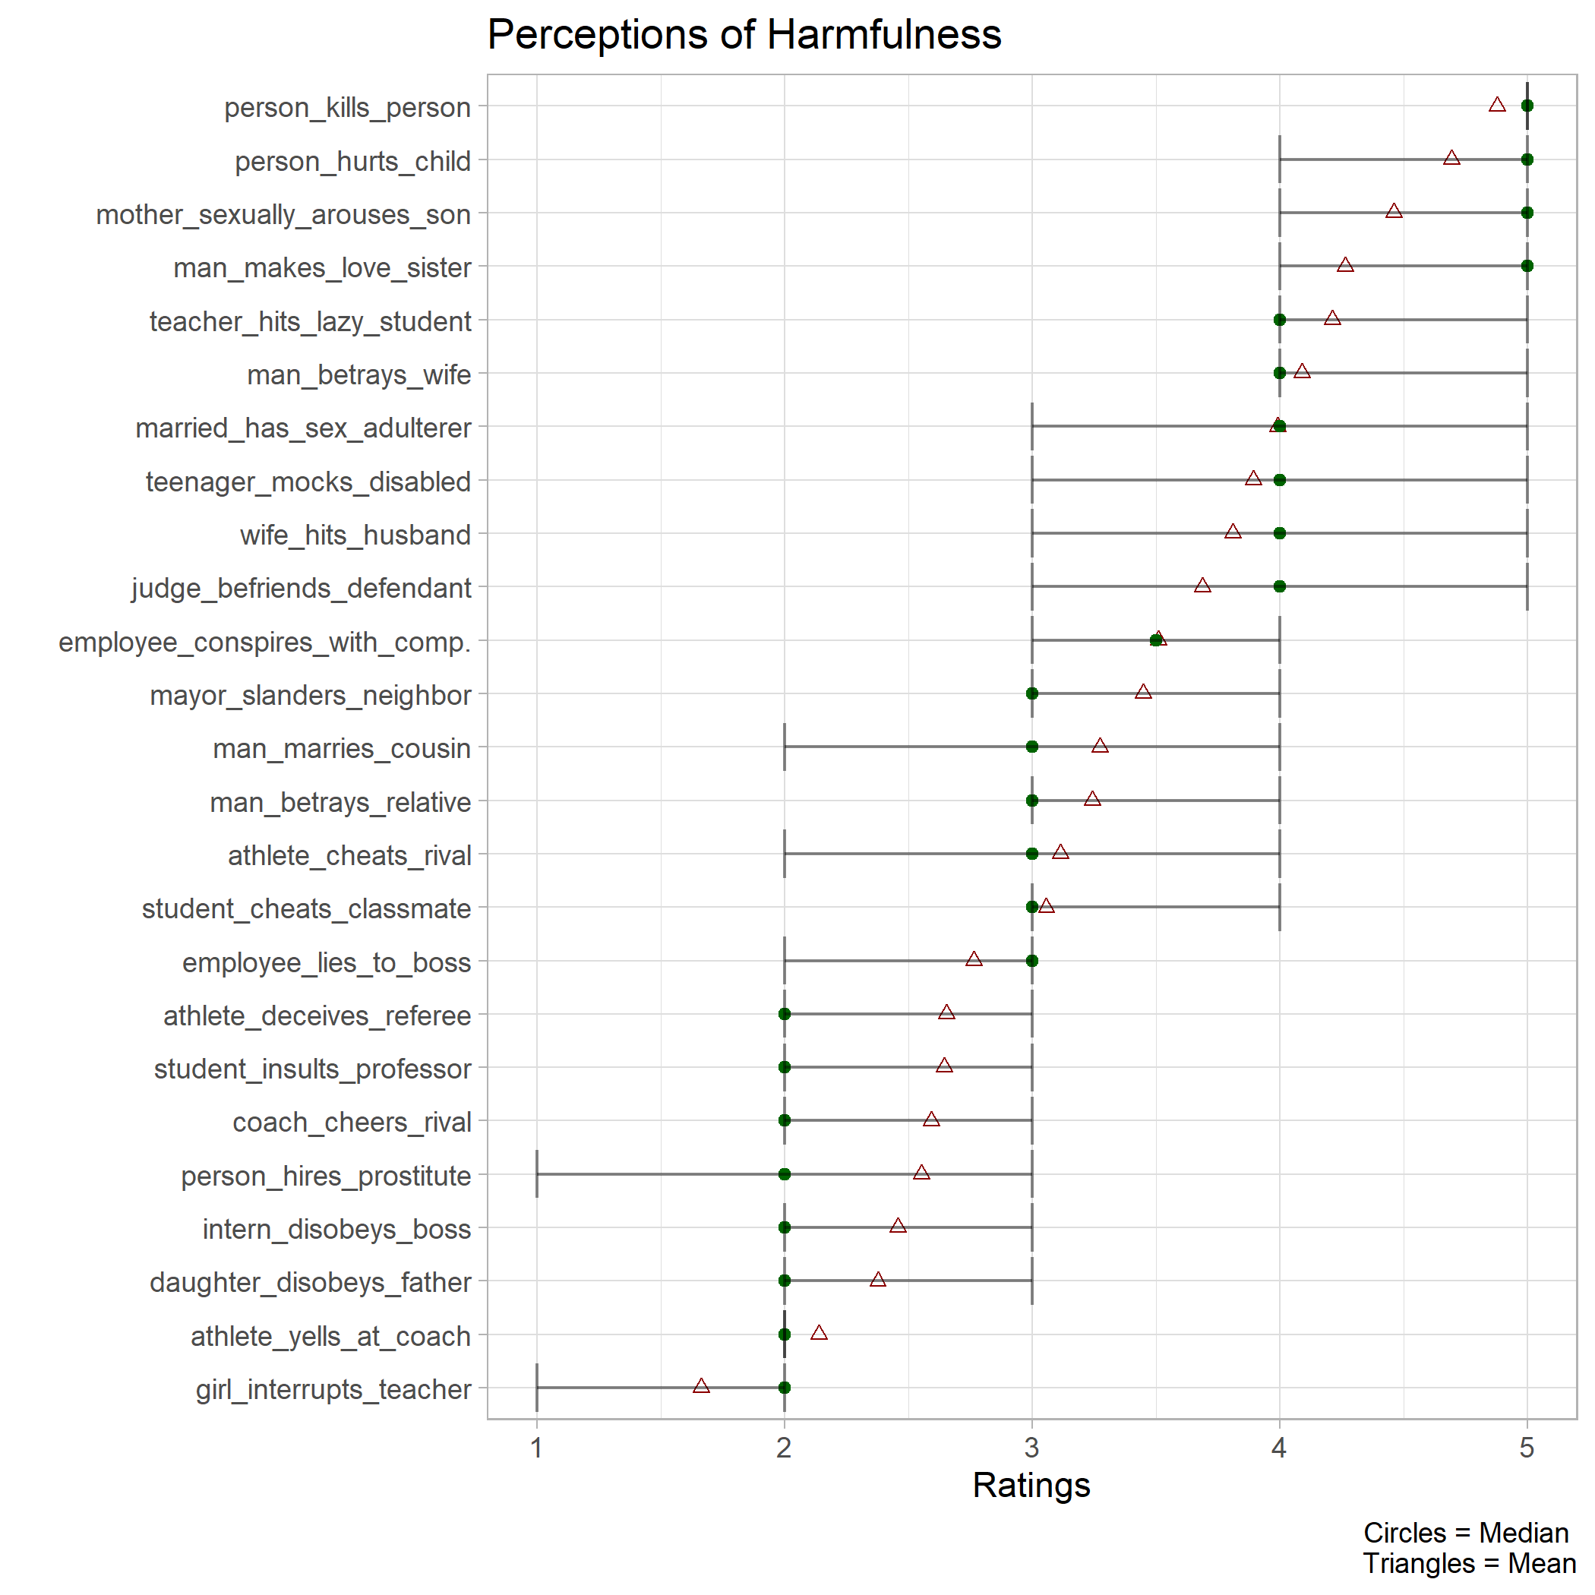

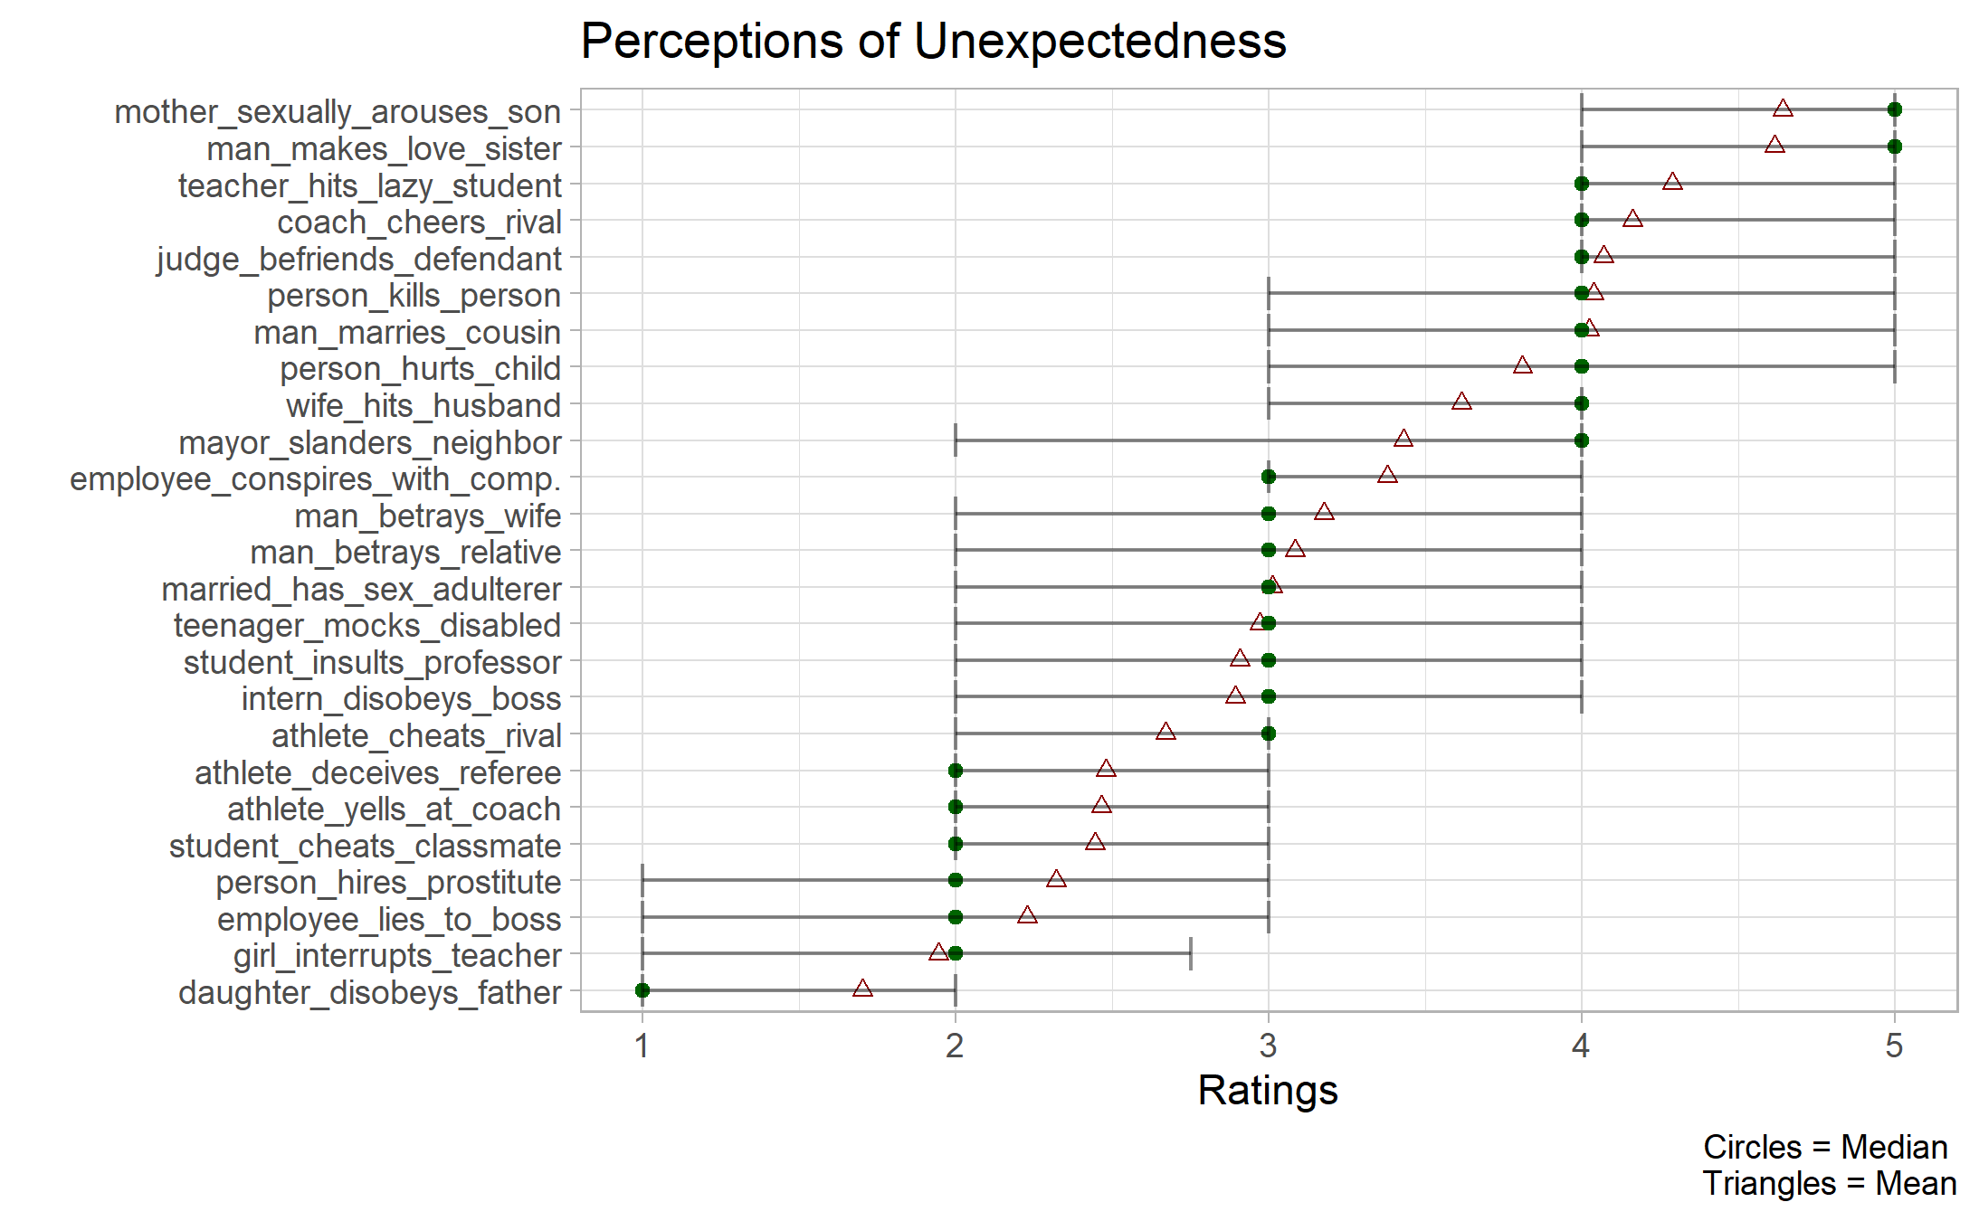

## Study 2

Next, I present the descriptive plots for the reaction time data collected in Study 2.

