Prepared by Nicolás Muñoz - Business Analyst Portfolio Project - June 2026

Food Delivery Business Analytics

End-to-End SQL & Tableau Project

1. Project Overview

Objective
The objective of this project was to analyze operational and customer data from a food delivery platform to identify revenue drivers, customer behaviour, operational performance, and opportunities to support business decision-making.
The analysis combines SQL for data preparation and business analysis with Tableau for dashboard development, transforming raw operational data into actionable business insights.

Note: The dataset represents a food delivery business operating in India. All monetary values in this report are expressed in Indian Rupees (INR / ₹).
Data Source: Kaggle Food Delivery Dataset (used for educational and portfolio purposes).
Datasets
Four datasets were used throughout the analysis:
- Clean Orders – order information including restaurant, revenue, delivery distance, ratings and basket size.
- Customer Details – customer demographic information.
- Customer Summary – customer purchasing behaviour.
- Weather Daily – daily weather conditions.

Tools
- PostgreSQL
- Tableau
- Microsoft Excel (CSV)
- GitHub

2. Methodology
The analysis followed a structured workflow:
- Import and validate the datasets.
- Explore the available data.
- Define business questions.
- Clean and prepare the data using SQL.
- Join multiple datasets to create analytical views.
- Calculate KPIs using SQL aggregations and conditional logic.
- Export SQL outputs to Tableau.
- Build executive dashboards.
- Translate analytical findings into business recommendations.

SQL Concepts Used
- INNER JOIN
- LEFT JOIN
- GROUP BY
- Aggregate Functions
- CASE WHEN
- Conditional Aggregation
- Common Table Expressions (CTEs)
- Window Functions

3. SQL Analysis
The analysis focused on answering practical business questions.

Revenue Analysis
- Which restaurant partners drive the majority of company revenue?
- How is revenue distributed among restaurants?
- Is revenue concentrated among a small number of restaurants?

Customer Analysis
- Which customers contribute most to long-term revenue?
- Does basket size influence customer satisfaction?

Operational Analysis
- How do restaurants compare in total order volume?
- Does delivery distance influence customer ratings?
- Does weather affect customer satisfaction?
The SQL results were exported into CSV files and used to build the Tableau dashboards presented below.
4. Executive Dashboard Summary

The dashboards summarize the main operational, revenue and customer insights obtained from the SQL analysis.

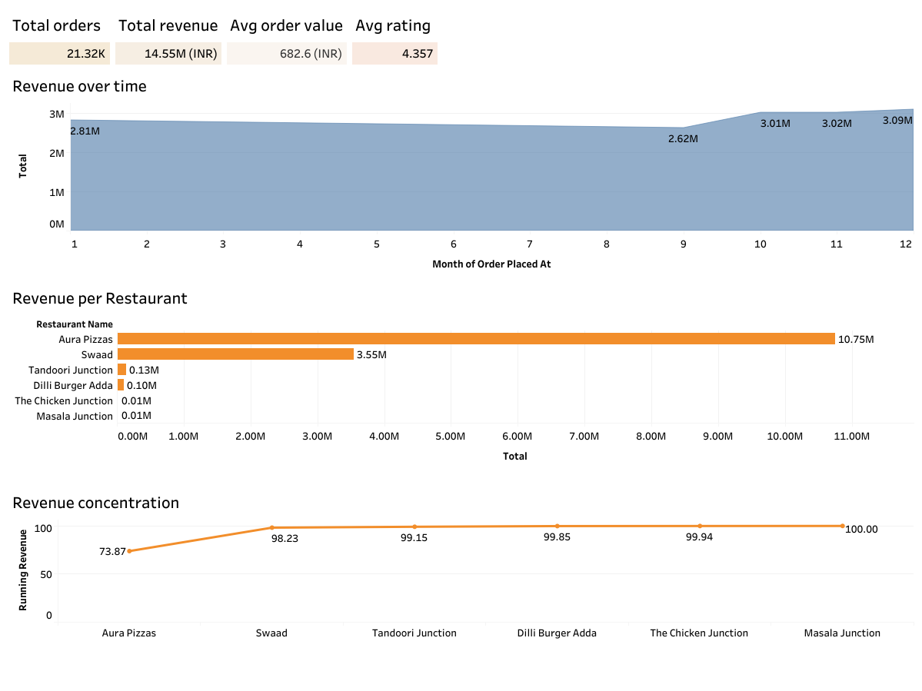

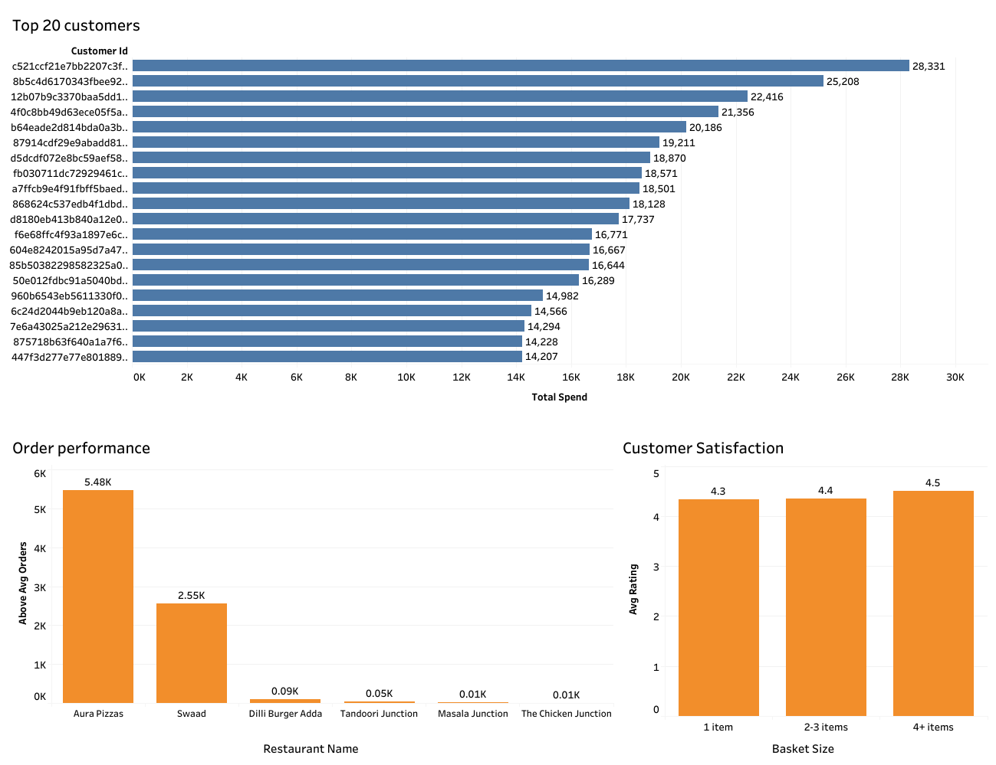

Executive KPIs
KPI | Value
Total Orders | 21.32K
Total Revenue | ₹14.55M
Average Order Value | ₹682.60
Average Customer Rating | 4.36 / 5

Key Findings

Revenue Concentration
Revenue is heavily concentrated among only two restaurants.
- Aura Pizzas generated approximately ₹10.75M.
- Swaad generated approximately ₹3.55M.
- Together these restaurants contributed 98.23% of total revenue.
This indicates a strong dependency on a limited number of restaurant partners.

Revenue Trend
Revenue remained relatively stable throughout most of the year, with noticeable growth during the final months, suggesting seasonal demand patterns.

High-Value Customers
The Top 20 customers generated between approximately ₹14K and ₹28K in total spending.
These customers represent a valuable segment that could benefit from loyalty and retention initiatives.

Restaurant Order Performance
Aura Pizzas consistently processed the highest number of orders, followed by Swaad, confirming that these restaurants drive the majority of business activity.

Customer Satisfaction
Customer ratings remained consistently high regardless of basket size.
Customers placing larger orders (four or more items) achieved the highest average ratings, suggesting that larger basket sizes are associated with a better customer experience.

5. Business Recommendations
Based on the findings, the following recommendations are proposed.

1. Diversify Restaurant Partnerships
The business currently relies heavily on two restaurants.
Expanding partnerships with additional high-performing restaurants would reduce revenue concentration risk and create a more balanced business portfolio.

2. Strengthen Customer Loyalty

Since the top 20 customers account for a significant share of customer spending, targeted loyalty initiatives and personalised offers could improve retention and maximise customer lifetime value.

3. Increase Basket Size
Since larger basket sizes are associated with higher customer satisfaction, bundle promotions, meal combinations and upselling strategies could improve both revenue and customer experience.
4. Prepare for Seasonal Demand
Revenue growth during the final months suggests seasonal demand patterns.
Monitoring these trends can improve staffing, operational planning and marketing campaigns.

5. Continue Monitoring Operational KPIs
Interactive dashboards should be maintained to continuously monitor restaurant performance, customer behaviour and key operational metrics, supporting data-driven business decisions.

Conclusion
The project demonstrates the ability to transform raw operational data into meaningful business insights by combining SQL analysis, data visualization and stakeholder-oriented recommendations.

