Link Github: https://github.com/Nicolavickh/OCBC-H8/tree/main/010_Nicolavickh_FinalProject

Select All

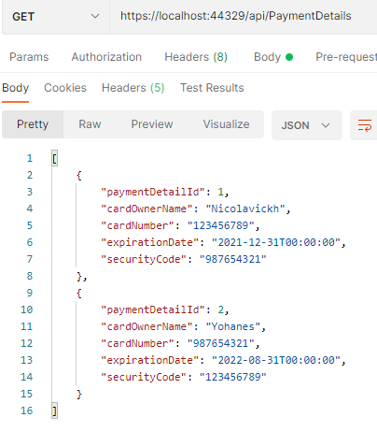

Select By id

Insert

Sebelum Insert

Insert

Setelah Insert (id 4 karena id 3 sudah pernah dibuat dan di delete saat testing)

Update

Sebelum Update

Update

Setelah Update

Delete

Sebelum Delete

Delete

Setelah Delete

