Game Design Document

Fill up the following document

1. Write the title of your project.

Save Earth

1. What is the goal of the game?

The goal is to destroy the asteroids for saving earth, there would be 5 lives by losing all lives the game will be over

1. Write a brief story of your game.

Aliens have attacked on earth by throwing space asteroids on earth,our heros have planned to save our earth from these aliens by using fighting jet

1. Which are the playing characters of this game?

* Playing characters are the ones who respond to the user based on the input from the user.
* Cars, monkeys, dinos, wizards, etc., are the playing characters in the game.

|  |  |  |
| --- | --- | --- |
| Number | Character Name | What can this character do? |
| 1 | Fighting jet/missile | Will help to save earth by shooting missile |
| 2 | Asteroid 1 | A danger to earth |
| 3 | Asteroid 2 | Same as above |
| 4 | Coin bag | Gives 5 more points/score if missile collide |
| 5 | unicorn | Appear when there a deduction in life |
| 6 |  |  |
| 7 |  |  |
| 8 |  |  |

1. Which are the Non-Playing Characters of this game?

* Non-Playing characters are the ones that don't have an action or behavior when the user interacts with the game.
* Hurdles, stones, bananas, coins, etc., are non-playing characters in the game.

|  |  |  |
| --- | --- | --- |
| Number | Character Name | What can this character do? |
| 1 | Earth |  |
| 2 | Score/life |  |
| 3 |  |  |
| 4 |  |  |
| 5 |  |  |
| 6 |  |  |
| 7 |  |  |
| 8 |  |  |

Draw your imagination of this game. What does this game look like?

* Draw the game either on your computer or on paper.
* Add images of the game scenes to show each of the playing and non-playing characters at least once.

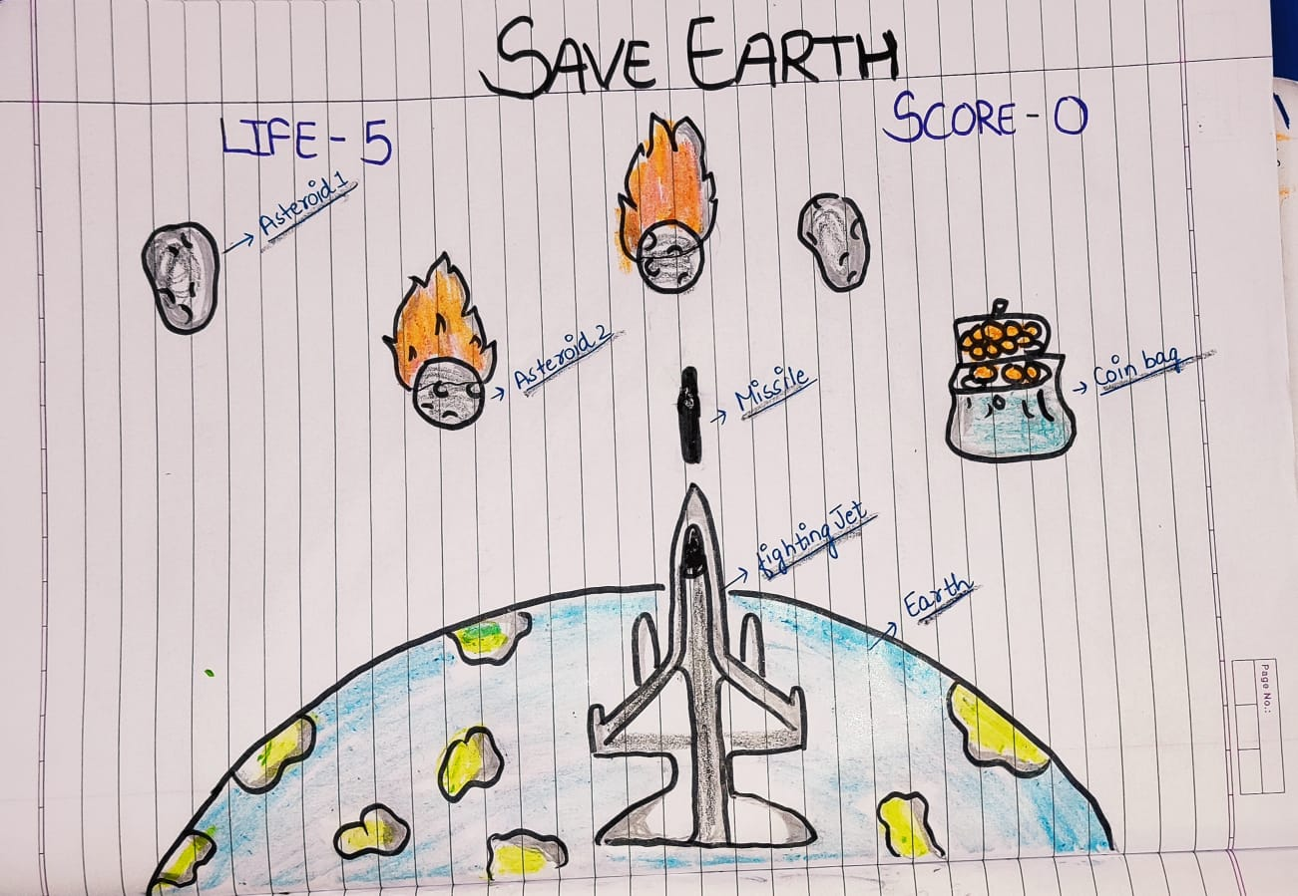

How do you plan to make your game engaging?