**Course Management System**

Name: *Nicole Yousef Almoughrabi*

**index**

**Introduction 2**

**Abstract 2**

**System Structure 2**

**ERD 3**

**WireFrame 4**

**System Design 5**

**Features overview 5**

**Conclusion 6**

**Future Enhancements 6**

**1. Introduction**

The Course Management System is a web-based platform designed to facilitate course enrollment and management for students and administrators. The system allows students to browse, enroll, and track their courses while providing administrators with tools to manage courses and student data effectively.

**2. Abstract**

This project is built using Django as the backend framework, utilizing a relational database to store user and course information. The platform supports user authentication, role-based access control, course management, and student enrollment tracking. The system is designed to be responsive, ensuring accessibility across both desktop and mobile devices.

**3. System Structure**

The system consists of the following core modules:

1. **User Authentication Module**
   * Signup and login (on the same page)
   * Login with email or phone number
   * Role-based access (Admin/Student)
2. **Course Management Module**
   * Admin can add, edit, remove courses
   * Students can view, enroll, and cancel enrollment
   * Course list with details displayed in a tabular format
3. **Student Management Module**
   * Admin can manage student accounts (view, edit, deactivate)
   * Students can view their profile and enrolled courses
4. **Responsive Design**
   * Optimized for desktop and mobile screens
   * Consistent UI/UX using HTML, CSS, and Bootstrap/Tailwind
5. **Additional Pages**
   * About Us (includes project details, developer info)
   * Student list page (admin only)
   * Student details page (admin and student)

**4. ERD (Entity-Relationship Diagram)**

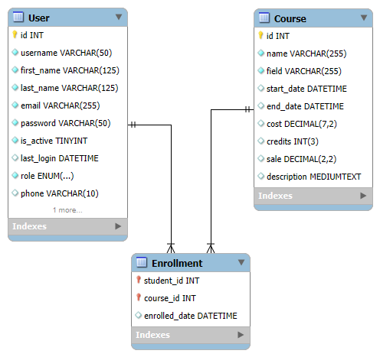

**5. WireFrame**

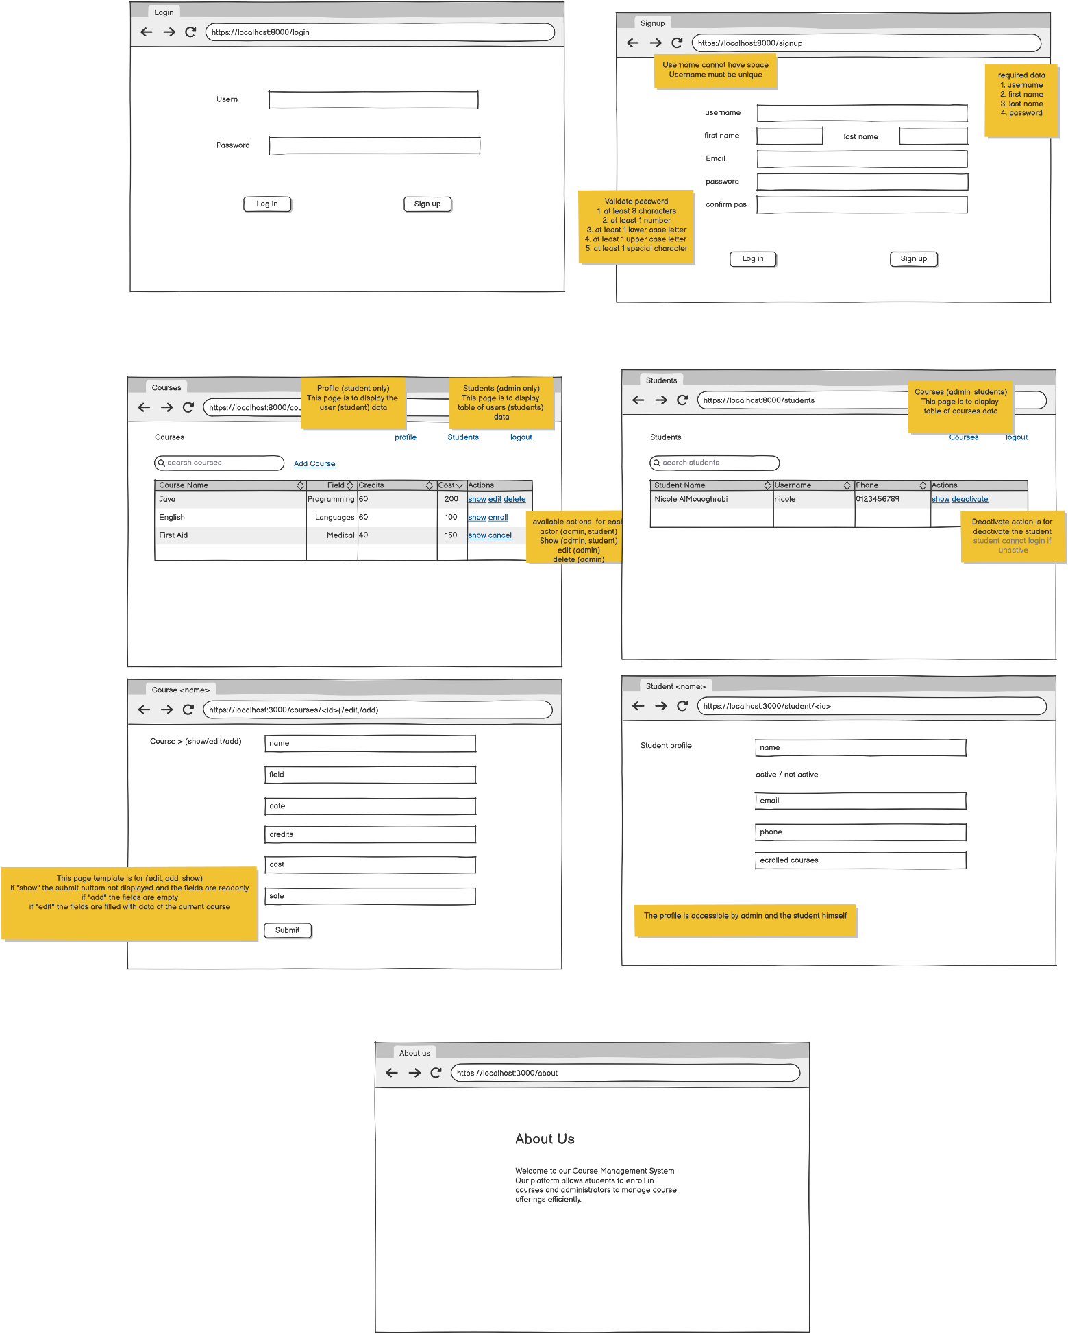

**6. System Design**

**6.1 Frontend Design**

The system’s frontend is designed with:

* HTML, CSS (Bootstrap/Tailwind) for a clean UI
* Responsive layout for both desktop and mobile
* Tables for course and student lists with actions

**6.2 Backend Design**

* Django framework with a modular approach
* SQLite database integration
* RESTful views for handling CRUD operations
* Role-based access control for admin and student functionalities

**7. Features Overview**

|  |  |  |
| --- | --- | --- |
| Feature | Admin | Student |
| Signup/Login | ✅ | ✅ |
| View Course List | ✅ | ✅ |
| Add/Edit/Remove Courses | ✅ | ❌ |
| Enroll/Cancel Enrollment | ❌ | ✅ |
| View Course Details | ✅ | ✅ |
| View Student List | ✅ | ❌ |
| View/Edit Student Profile | ✅ | ✅ |
| Deactivate Student | ✅ | ❌ |

**8. Conclusion**

This Course Management System provides a structured and efficient way to manage courses and student enrollment. With role-based functionalities, responsive design, and a well-structured database, the system ensures a smooth user experience for both administrators and students.

**8. Future Enhancements**

* Adding more profile data (photo, gender, ...etc.)
* Authentication requirements (email verification, forgot password, change password)
* Implementing real-time notifications for course updates
* Adding payment integration for premium courses
* Enhancing the UI with modern frameworks like React or Angular