# 9. System Architecture Design

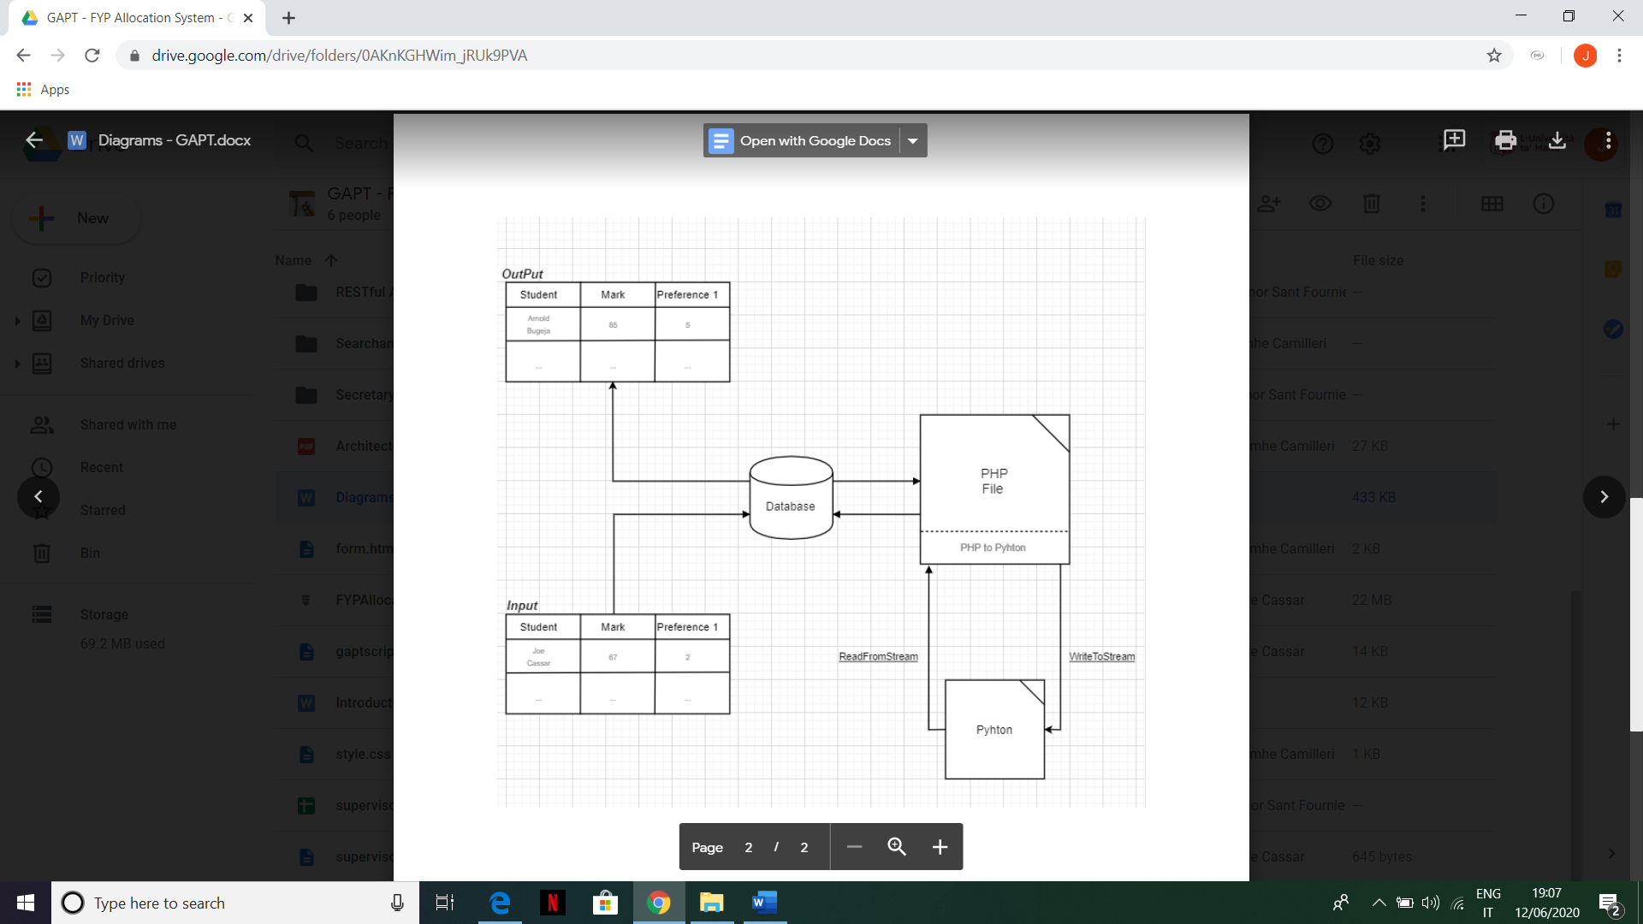

# Guide to Setting up the System

1. Install Microsoft SQL Server Management Studio and connect to a server
2. After installing the project, open Visual Studio and go on ‘appsettings.json’ where one is able to change the connection string to match the same path that was set on the database from SSMS.
3. Go to ‘AllocationController.cs’ and change the ‘**serverName**’ variable marked with a comment towards the top of the document. This will allow for the executed join queries to be run with a connection to the local MSSQL server.
4. [Will add steps to restore included database backup whilst writing testing section] – Connor

The following user accounts already exist

|  |  |  |
| --- | --- | --- |
| Username | Password | Roles |
| connor.sant.17@um.edu.mt | FYPsRule! | Student |
| jabela@um.edu.mt | FYPMaster! | Supervisor |
| secretary@um.edu.mt | FYPMaster! | Administrator |

**Note:** When logging in the users are automatically set to page access restrictions, dependent on user role.

# Project Planning

|  |  |  |  |  |  |  |  |  |  |  |  |
| --- | --- | --- | --- | --- | --- | --- | --- | --- | --- | --- | --- |
| Activity | | | | | Week Number | | | | | | |
|  | 1-2 | 3-4 | 5-6 | 7-8 | | 9-10 | 11-12 | 13-14 | 15-16 | 17 |
| Planning and resourcing |  |  |  |  | |  |  |  |  |  |
| System Needs Analysis |  |  |  |  | |  |  |  |  |  |
| Design |  |  |  |  | |  |  |  |  |  |
| Verification and Validation |  |  |  |  | |  |  |  |  |  |
| Product Build (i.e. Coding) |  |  |  |  | |  |  |  |  |  |
| Testing and Quality Assurance |  |  |  |  | |  |  |  |  |  |
| User Acceptance Testing |  |  |  |  | |  |  |  |  |  |
| Documentation |  |  |  |  | |  |  |  |  |  |