HI-BREED: A MOBILE APPLICATION FOR PET OWNERS.

A Capstone Research Proposal

Presented to the Faculty of the

College of Computer Studies, University of Cebu-Banilad

In Partial Fulfillment of the Requirements

For the Degree of the Bachelor of Science in Information Technology

By:

Dionico Noe Alegarbes

Kemberly Nicole Tayong

Kenneth Dela Cruz

Engr. Edsel Paray

Adviser

December 2022

**ABSTRACT**

The researchers analyze societal problems in this study and provide an innovative solution. This study focuses on the challenge of a pet owner finding a suitable pair for their pet around him/her and finding a breeder or shooter that sells or offers the pet owner’s desired product or services. This project will include a knowledge component that will improve pet owner’s experiences in finding a perfect mate and for their pet care inquiries. Our team conducted a survey to collect data that will assist us in determining which features and functionality we should add to the application. The survey results show that many pet owners still have difficulty finding a suitable mate for their pets and/or the perfect pet for them, causing them to keep searching randomly on different websites and wasting time. With this project, pet owners will be able to easily find or acquire the pets or services they are looking for. This implies that Hi-Breed is a great tool for providing pet owners with the necessities they need and recommending pets and services that they are seeking, allowing pet breeders, shooters, and veterinarians to simultaneously market and advertise the products or services that they offer.

**ACKNOWLEDGEMENT**

This study would not have been successful without the help and support of the following persons who inspired us to write this thesis. It is our greatest pleasure that we may be able to extend our heartfelt thanks to the following:

**Mrs. Moma D. Ortega**, our Dean of the College of Computer Studies, for giving us the opportunity to extend our knowledge, ability and skills for this study.

**Ms. Marijoy Yaun**, our Capstone Subject Adviser, for her support and words of encouragement and also for giving a long period of time to depend on this manuscript.

**Engr. Edsel Paray**, our Capstone Adviser, for the support, guidance, pieces of advice, valuable comments, suggestions, and provision that benefited us much in the completion and success of this study.

**Ms. Miriam Flores**, our Grammarian, for her time and effort in checking this manuscript, and giving us enough time to make this manuscript.

**To the person with whom we conducted the interview and gathered data,** for cooperating and helping us to connect the pieces of information.

**To our parents, guardians, and friends**, for sharing their support, either morally, financially or physically, thank you.

Above all, **to the Great Almighty**, the author of knowledge and wisdom, for his countless love. We thank you.

**DEDICATION**

This study is wholeheartedly dedicated to our beloved parents, who have been our source of inspiration and gave us strength when we thought of giving up and who continually provide their moral, spiritual, emotional, and financial support.

To our brother, sister, relatives, mentor, friends, and classmates who gave us words of wisdom and encouragement to finish our studies.

Finally, we dedicated our project to God Almighty. Thank you for your guidance, strength, protection, and skills, as well as for providing us with a healthy life. We offer all of this to you.

**TABLE OF CONTENTS**

Page No.

Title Page

Abstract I

Acknowledgment II

Dedication III

Table of Contents IV

List of Table and Figures

**CHAPTER I: INTRODUCTION**

Rationale of the Study

Objectives of the Study

Scope and Limitations of the Study

Significance of the Study

Flow of the Study

Definition of Terms

**CHAPTER II: REVIEW OF RELATED LITERATURES AND STUDIES**

Theoretical Background

Related Literature

Review of Related Studies

Comparative Matrix

**CHAPTER III: RESEARCH METHODOLOGY**

Research Environment

Software Engineering Methodology

Planning/Conception-Initiation Phase

Business Model Canvas

Program Workflow

Validation Board

Gantt Chart

Functional Decomposition Diagram

Analysis-Design Phase

Use Case Diagram

User Interface Design

Storyboard

Database Design

Entity Relationship Diagram

Data Dictionary

Network Topology

Development/Construction/Build Phase

Technology Stack Diagram

Software Specification

Hardware Specification

Program Specification

List of Modules

**REFERENCES**

**APPENDICES**

A – Transmittal Letter

B – Censor’s Certificate

C – Research Instrument (Survey Questionnaire)

D – Results and Findings

**TEAM COMPOSITION**

**LIST OF TABLES AND FIGURES**

**List of Tables**

**Table Description Page No.**

1. Comparative Matrix
2. Business Model Canvas
3. Validation Board
4. Gantt Chart
5. Data Dictionary - OWNER COLLECTION TABLE
6. Data Dictionary - OWNER SECURITY COLLECTION TABLE`
7. Data Dictionary - OWNER VALIDATION COLLECTION TABLE
8. Data Dictionary - OWNER CARD COLLECTION TABLE
9. Data Dictionary - PET DATA COLLECTION TABLE
10. Data Dictionary - BREEDER COLLECTION TABLE
11. Data Dictionary - BREEDER SECURITY COLLECTION TABLE
12. Data Dictionary - BREEDER VALIDATION COLLECTION TABLE
13. Data Dictionary - PET SALE COLLECTION TABLE
14. Data Dictionary - SHOOTER COLLECTION TABLE
15. Data Dictionary - SHOOTER SECURITY COLLECTION TABLE
16. Data Dictionary - SHOOTER VALIDATION COLLECTION TABLE
17. Data Dictionary - SERVICE COLLECTION TABLE
18. Data Dictionary - VET COLLECTION TABLE
19. Data Dictionary - VET SECURITY COLLECTION TABLE
20. Data Dictionary - VET VALIDATION COLLECTION TABLE
21. Data Dictionary - PRODUCT COLLECTION TABLE
22. Data Dictionary - ADMIN COLLECTION TABLE
23. Data Dictionary - TRANSACTION COLLECTION TABLE
24. Data Dictionary - ORDER COLLECTION TABLE
25. Data Dictionary - OFFICIAL RECEIPT COLLECTION TABLE

**26** Technology Stack Diagram

**27** List of Modules

**List of Figures Figure**

1. Flow of the Study
2. Agile Methodology
3. Pet Owner Workflow
4. Pet Breeder/Shooter Workflow
5. Veterinarian Workflow
6. Admin Workflow
7. Functional Decomposition Diagram
8. Use Case Diagram
9. Welcome Page
10. Login Page
11. Sign up Page
12. Dashboard/Homepage Page
13. Marketplace Page
14. Profile Page
15. Add Payment Method Page
16. Product/Service Page
17. Filter Page
18. Ask a Professional Page
19. Date Finder Page
20. Add Pet Page
21. My Shop Page
22. Listing Page
23. Add Pet/Product/Service Page
24. Update Pet/Product/Service Page
25. Admin Login Page
26. Activity Page
27. User Page
28. Transaction Page
29. Questions Page
30. System Page
31. Pet Owner’s Storyboard
32. Pet Breeder/Shooter/Veterinarian’s Storyboard
33. Hi-Breed Database Design
34. Entity Relationship Diagram
35. Network Model
36. Network Topology

**CHAPTER I**

**INTRODUCTION**

Animals play an essential role in the world, whether in scientific advancements, environmental sustainability, or industrial production, such as food, medicine, or entertainment. Pets provide companionship and emotional support, lowering stress levels and feelings of isolation. Pet owners keep animals for companionship and joy, as the human-animal bond has been scientifically explored (NIFA, 2008). In accordance with NIFA, Lundgren et al. (2021) further report that pets can improve a person's mental health and bring positive changes to their lifestyle. American Kennel Club (2016) stated that the customary owning of pets had sprung pet breeding. People desperately search for puppies, and a shortage occurs in breeds. According to FOUR PAWS International, they have been investigating the illegal puppy trade for many years. They have gathered extensive evidence that breeders use animals for profit and disregard the health and welfare of dogs. The Illegal puppy trade is profitable, especially when little care is given to the dogs involved. Veterinary care is lacking, the breeding animals are disposed of when they cannot produce puppies anymore, and the puppies themselves are taken from their mother too young and without consideration for their needs. Many of the puppies bred for the trade belong to the most popular breeds, as they can be sold best for profit (Mba, 2020). Meanwhile, breeders rely on online media to search and screen for customers, such as sales platforms, classified ad services, Facebook Groups, and even their kennel websites.

On the other hand, the usage of e-commerce has been rapidly growing. E-commerce or Electronic Commerce means acquiring or selling goods or services over the internet. It has evolved to make products/services more straightforward to find and purchase through different online platforms (Shopify, 2020). It includes using various data, systems, and resources for online buyers and sellers, from mobile shopping to encryption of online payments and more (Ecommerce Guide, 2020). In order to perform both online marketing and sales activities, most organizations with ecommerce attributes use an e-commerce store or an e-commerce platform. The platform would serve as a medium for both seller and customer, providing a more comprehensive community for business opportunities or inquiries. Bigcommerce (2021) reported that an estimated 1.8 billion people worldwide made online purchases in 2018. Bloomenthal (2021) claims that e-commerce can be conducted over computers, tablets, or smartphones, unlike traditional commercial transactions. This method creates a presence that pet breeders can utilize to provide an affordable

and efficient distribution platform for their for-sale pets or services. This particular advancement in the commercial industry is considered a disruptive technology. Integrating e-commerce and animal breeding and welfare opens new opportunities for animal breeders to widen business opportunities and buyers interested in purchasing pets or livestock for personal or business development. Determining the pros and cons that come with the integration of both information and using it to address the problems that may come.

**Rationale of the Study**

An estimated four out of ten children are born into a family with domestic animals; 90 percent of all children live with a pet at some point during childhood. (Melson, 2011). It can undoubtedly demonstrate the impact of having pets around children and their families in general and how large and small creatures teach, thrill, and offer people a particular type of companionship. Strickland (2021) added that pets could help alleviate stress, encourage learning and nurturing, enhance heart health, and even assist children in developing their emotional and social abilities.

Many owners find the companionship of their dog so rewarding that they want to breed their dog, continue the bloodline, or keep a puppy. However, there are many things to consider before taking the necessary steps to enter into dog breeding. After all, dog breeding requires professionalism, responsibility, and commitment. Purebred Breeding Critical Information (2015) states that puppy breeding can be rather complicated, particularly when the pet owner has no idea what he/she has been doing. Specific breeders can make a spare time activity of breeding dogs; nevertheless, the specialists have research behind it and learn precisely what they truly are performing. McMillan (2017) stated that increased fear in a dog was also identified in response to unfamiliar people, children, other dogs, and non-stimuli. Undesirable behaviors related to separation, attention-seeking, and a heightened sensitivity to touch have been reported because of how dogs are born in commercial breeding establishments. Accordingly, for any dog breeding operation, a standard of care that adequately redresses the welfare of the mother and puppy and the risk of later behavior problems attendant with early stress and distress needs to be formulated and followed in a manner supported by the emerging data. Additionally, If the pet owner decides to buy a dog breed, it is better to buy from professional breeders. Though looking at a dog is excellent, the pet owner may need a specific type of dog.

According to Breeding Business (2020), finding the perfect breeding partner for the owner’s pet can be difficult, they may require one who is located near them, has a certain color, has clear health, and an owner with proper ethics which is important to be fulfilled. In addition to that, Cosgrove (2023) stated that the Philippines has had a significant increase in pet interest, especially during the pandemic. According to the FCI, they had 20,329 registered members in 2020, which was up from 19,455 in 2019. In 2021, the number rose significantly to 27,415 registered members. The group estimates that there were 11.6 million dog owners in 2020, including owners of purebred and mixed-breed dogs. As reported by Chaudhari et al., 2021, 1.8% of the survey that is conducted in Quezon City shows that 1.8% said that pet owners owned dogs to breed.

Therefore, the proponents introduced the "Hi-Breed" application for connecting pet owners, breeders, and shooters to aid the problems regarding pet services. This application aims to develop a safe and secure system that will stand as a dating online platform for pet owners to find suitable mates for their pets.

It will also let the users filter out their ideal pet’s mate’s physical appearance and locate any available shooter within the premises where they can assist the pet owner’s inquiries and transactions. Additionally, the application will provide a list of the basic needs of the pets during the breeding process.

Furthermore, the application may not only benefit the pet owners but also breeders/shooters because they can advertise their products and services to boost their business in the future. Keeping track of appointments is essential but quickly overwhelming in a real-life scenario. Initial deployment of the platform gives Filipinos a set of advantages, including ease of access, a user-friendly interface, and at the same time, a quick transaction with security-enabled features to ensure the safety of the respected stakeholders as they were about to test and use the application itself. The main idea of this study is to escalate the traditional practice of pet breeding into a more technical approach, using smartphones or any mobile device as your tool, the users will feel much more convenient and secure to ensure that their pets will have their proper and safe pet breeding without any hassle. That is where the Hi-Breed application can be advantageous.

**Objectives of the Study**

This study aims to develop a mobile pet dating application for pet owners. In order to achieve this aim, the specific objectives are:

1. gather data on the problems encountered by pet owners for pet breeding and shooting;
2. identify the mechanism for verification and validation of pet owners;
3. define an algorithm for pet-dating and recommendation services; and
4. determine the notification scheme for the system.

**Scope and Limitations**

This study implementation will only be on mobile devices that can connect to the internet because the application will not work as expected if it is not online. The proponents can only implement the web for admin access and as a medium for feedback and reviews of the users.

The platform only includes the following features: swiping of pets profile, communication between pet owners and breeders, transactions, tracking of orders, list of liked pet profiles, pets and services offered, and activity status.

Upon registration, the platform will require pet breeders/shooters to submit legal records, such as waivers for the validity of services and products and years of experience.

The platform will not offer courier services. Products or services purchased by the customers must be processed externally by the pet breeder. The pet owners can also request for cancellation of scheduled purchased service under the management terms and conditions.

In the pet breeder's profile, activity status is limited only to show the total number of sold pets or services, schedules, and the user's reviews.

This study is limited to pet breeders in the Philippines only. This is intended to help Filipinos find a suitable mate and a trusted breeder who can provide health and welfare for their pets.

For the mobile specifications, the mobile application will only run on android devices with an operating system with a minimum of version 5.0, which is Lollipop and up to the latest version. The mobile application will only run-on Android mobile operating systems.

**Significance of the Study**

**Pet Owners.** The pet owners will be the ones who will stand to benefit the most from this study. They will have the option to search for the product/services that they need to acquire easily on the grounds that they do not have to go to various pet breeders/veterinarians shops any longer to search for a specific product.

**Pet breeders.** The pet breeders will stand to benefit from this study. Their products and services will have a place to advertise and be seen more frequently by online customers since it will be included in the application in the event that they sell the product that the pet owners is looking for.

**Pet Shooters.** The pet shooters will stand to benefit from this study. Their services will have a place to advertise and to be seen more frequently by online customers since it will be included in the application in the event that they sell the service that the customers is looking for.

**Veterinarians.** The veterinarians will stand to benefit from this study. They will be able to show their products more efficiently and their products and services will be recommended to the customers if they have a higher customer approval rating.

**Researchers.** The researchers will stand to benefit from this study. The researchers will be able to user the gathered data from different e-commerce platform so as to create an application that will enable pet owners to purchase/inquire products and services online effortlessly and enables pet breeders/veterinarians to have a place where they can showcase their available pets, products and services to the users.

**Future Researchers.** The research will stand to benefit from this study. They will be able to use this research as a reference for their future research studies.

**Flow of the Study**

This study will use a software development life cycle in developing Hi-Breed. All inputs must be identified and processed in producing the expected output.

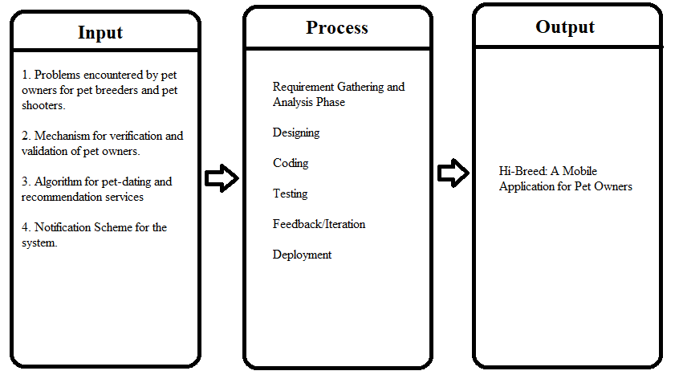Figure 1: **Flow of the Study**

Figure 1 shows that the proponents decided to gather the information that is needed in developing an application for the benefit of Pet Owners and Pet Breeders. The inputs are the data about the useful features of the existing e-commerce and dating platforms, data and processes of pet breeding services, the mechanism for verification and validation of pet breeders, pet owners, and transactions, the machine learning of dating apps, and the techniques to search and filter products based on user choices and recommendation algorithms to identify top-selling products.

When the proponents meet the essential inputs, the team will examine everything and create the user interface and code essential statements then proceed on testing the application. Then users will provide feedback to improve the application’s performance. After the researchers followed the process, the study’s output is expected to be released and it is described as “Hi-Breed: A Mobile Application for Pet Owners and Pet Breeders.”

**Definition of Terms**

To further understand, the proponents have highlighted some terms that are relevant in helping to complete the study including technical words.

**Algorithm for pet-dating and recommendation service.** The terms refer to the method wherein the user’s preferences will be automatically detected by the system and the next time it will look for a new mate, the pets that have the same attribute as the liked profile before will be posted on the user’s screen.

**Mechanism for verification and validation.** The system is responsible for authentication, particularly for the breeders through the submission of a waiver upon registration. Once verified, the breeders can use the platform and market its services.

**Mobile pet dating application.** This term refers to the output of the study that will serve as the dating application for pet owners to find a suitable mate for their pets and find a trusted breeder.

**Notification Scheme.** This term defines rules that determine which users are notified about selected event.

**CHAPTER II**

**REVIEW OF RELATED LITERATURE AND RELATED STUDIES**

This section also discusses the different concepts, understanding, and further development of the study, which will guide the proponents in developing the research.

**Theoretical Background**

The study is anchored to the Organizational Adaptation Theory which asserts that businesses will adjust how they work or function in an effort to keep up with changing market conditions or shifting environmental factors. According to this theory, organizations that adapt are more successful in the long term. It requires corrective actions from businesses to improve due to external factors affecting the change (Hendricks, 2021).

Organizational adaptation theory states that organizational adaptation is necessary to correct imbalances and improve inefficient processes within an organization and how the organization works. Implementing changes in an organization's procedures and culture to adapt or anticipate changes in the market or legal landscape the organization operates. It can be reactive, or it can be precautionary. Changes do not have to be caused by external factors but by an organization's initiative to anticipate a difference in the market or field (Purna, 2017).

According to Hendricks (2021), one famous example of this theory in both proactive and reactive cases is the Netflix adaptation. In 1997, Netflix presented a new medium for consumers to watch or view old to recent movies on DVD which is through mail. Netflix was able to capitalize on the initiative of avoiding the need to go to a video store. Starting from watching through mail, Netflix then moved and adapted to streaming media due to electronic advancements.

The anchored theory is supported by the Network Effect theory; this theory was derived from Metcalfe's Law. This law states that the advantage of a telecommunication network is equal to the square of the number of associated users. Network Effect is an event where existing users of a product or service benefit when additional users adopt the product or service. This effect is conceived by multiple users when value is added to their use of the product. (CFI, 2021). This is a useful way to think about the scaling benefits of networks but also illustrates the fundamental weakness of a model where all meaningful connections originate from the center.

According to Hutcheson (2018) Metcalfe’s Law is on the demand side of the value equation drawing on the network effect of economics for the creation of demand via emergent behavior. As more users join, a network becomes more attractive for other users to join. Facebook is an extreme example of this effect. Others are smartphones, PCs, telephones, and even cities. Metcalfe’s Law brings an emergent behavior mechanism beyond the essential need for computing: Here demand growth occurs as a communications network grows.

Among those, theoretically and empirically, Expectation Confirmation Theory (ECT), is believed to provide an explanation on a consumer’s repurchase intention. ECT is thus widely used in the marketing area, particularly in consumer behavior literature, to study consumer satisfaction and post-purchase intention. This theory proposes that consumers form expectations (expectancy beliefs) for a product or service before purchasing the product or service, and they will confirm the degree of self-expectation (satisfaction) to the product or service after actual purchase and consumption (Oliver, 1980; Lin et al., 2022). The Expectation Confirmation Model originated from market research, which was based on the difference theory to explain the formation of satisfaction which was the relationship between initial expectation and satisfaction derived from difference theory (Dai et al., 2020).

Satisfaction with a learning system has been observed to be conveyed by the relationship between usefulness, validation, and the quality of resources and the intention to pursue it (Joo & Choi, 2016) i.e. users’ intent to prosecute is determined by their satisfaction with previous use, the self-efficacy of the internet, and their expectations of the results. The outcome of expectations, in turn, was found to be influenced by satisfaction with previous use and previously perceived confirmation (Hsu et al., 2004; Lin et al., 2022). According to Wu et al. (2020), Lin et al., 2022, online impulse buying is an unexpected individual behavior with a strong interaction with online stores for spontaneous purchases. The study identified a specific buying process for the same by listing three key elements to the process viz. perceived risk, online store design, and buyer’s mental health. Additionally, the study defined the design of online stores according to the theory of the Confirmation of Expectations (ECM) model.

Moreover, Hi-Breed’s primary goal was to connect pet owners to other co-pet owners, shooters, and breeders. Sales, agreement, and e-commerce were also related to this actual concept. The three theories provide relevant data by focusing on the specific variables that the proponents will need in analyzing and interpreting the data.

**Related Literature**

Animals perform an essential role in people’s lives. In addition to seeing-eye dogs and dogs that can be trained to detect multiple health problems such as seizures and tic attacks, animals can also be used in different kinds of therapies that increase patients’ recovery. Animals are also valued as partners, which can undoubtedly affect the quality of our lives (NCHR, 2021).

Casciotti et al., (2021) mentioned that animals could impact the physical health of every person. Improving heart health by decreasing blood pressure and regulating the heart rate during stressful situations. Children's exposure to companion animals may also ease anxiety. Since the late 1970s, scientific evidence has accumulated showing that pet ownership can have positive effects on people’s physical and mental wellbeing. (Wells, 2019). According to Cleveland Clinic, Cardiovascular disease is a group of diseases affecting your heart and blood vessels. These diseases can affect one or many parts of your heart and/or blood vessels. A person may be symptomatic (physically experiencing the disease) or asymptomatic (not feeling anything at all). So, finding a way of both reducing the risk of developing Cardiovascular Disease and enhancing recovery is therefore of utmost importance.

Some studies point to a preventative role of pet ownership in the development of Cardiovascular Disease(Wells, 2019). For example, systolic blood pressure was found to be significantly lower in a sample of pet owners than non-owners attending an Australian screening clinic for heart disease, even when controlling for body mass index and other health-related variables. More Recently, an online study highlighted a lower risk of self-reported hypertension in dog owners than non-owners (Lentino, Visek, McDonnell, & DiPietro, 2012), while a study on Chinese patients revealed a protective factor of pet ownership, and notably dog ownership, for Cardiovascular Disease(Zhi-Yong et al., 2017). More specific to the elderly population, Friedmann et al. (2013) reported that the mere presence of a pet, and in particular a dog, improved ambulatory blood pressure in older (50–83 years) adults with hypertension.

Animal breeding is a method of controlling the propagation of domestic animals in order to improve desirable qualities. (Freeman, 2017). Freeman also states that humans have been modifying domesticated animals for centuries to better suit their needs. According to Yourgenome (2021), selective breeding is a breeding method that involves choosing certain wellsprings that have particular traits to breed together and produce offspring with more desirable traits. - Animal breeding is described as mating good quality animals to produce highly productive and suitable animals to enhance the overall performance of the next generations and to improve production and profitability. (Vikaspedia, 2021).

According to the Michigan Behavioral Risk Factor. (2005) survey, roughly 60% of dog walkers met the criteria for regular leisure-time physical activity compared with 45% for non-dog owners and dog owners who do not walk their dog. Heeckeren (2021) indicated that having a feline friend can reduce the risk of death due to cardiovascular illnesses like stroke and heart attack. In addition, the Human-Animal Bond Research Institute (HABRI) also stated that people without cats have a 40% higher relevant risk of heart attack than non-cat owners. Today, as the pandemic continues, people are turning to pets for help to endure the challenging situation but, the pandemic restrictions are making pet owners concerned for their pets’ health as some pets are showing signs of stress, such as increased barking, fear of loud or sudden noises, and anxiety when at home alone (May, R. 2021). An August Washington Post article reported a surge in pet adoptions and sales, driven by the need to calm the effects of the pandemic with the unconditional love pets offer (Horsey, 2020). However, like many basic services, pet care strikingly changed. The Covid-19 pandemic caused delay or missed care for pets in many countries, which is causing some veterinarians to worry that pet health may suffer as a result. According to a survey of pet owners around Europe and America, the pandemic caused 27% pet owners to delay or avoid their veterinary visits, while 13% missed essential and routine treatments (Health for Animals). Among the people with relationships to pets affected are the breeders. Market demand dictates breed goals; however, it is not easy to predict what consumers will want several years in advance. Sometimes, the marketplace demands a product that was defined as desirable in the original breeding objective. When this happens, breeders have to adjust their program, which results in less-efficient selection than if the new breeding goal had been used from the beginning (Freeman, A. E. 2017).

The importance of animal breeding establishes a constant enhancement of farm animals, and pets for generation after generation. Animal breeding is practiced to create a sustainable breeding environment, to reach long-term views and desired conditions. (EFAB, 2018). EFAB also states that global demand for animal products is expected to double due to an increasing global population and global wealth. Animal products are one of the ideal sources of protein and are required for a balanced diet. To meet this rising need, the worldwide animal output should be increased while also taking environmental sustainability, food safety, and animal welfare into consideration. Breeding can help the development of cost-effective and resource-efficient solutions that reduce or remove environmental strain, are climate change-adaptive, benefit animal health and welfare, enhance food quality and safety, and satisfy the requirements of citizens today and in the future.

Englar et al., (2021) stated that dog breeders that have apparent lack of training in theriogenology among veterinarians was a primary concern. Both dog breeders and cat breeders felt sidelined from patient care when veterinarians were dismissive, made assumptions about their character or motivation for breeding, or expressed disapproval of mating companion animals for profit.

According to McMillan (2017), If puppies were aged less than 8 weeks when purchased, they showed an increased likelihood of later exhibiting aggression and separation-related behaviors. In addition, dogs from less-responsible breeders who had more than 1 liter to offer exhibited more fear and aggression in adulthood.

In summary, all of this related literature helps to support the argument on which the study is based. The problem of finding a mate for the owner’s pets, acquiring a shooter for its service and finding a trusted breeder is still very present until today. Pet enthusiasts are also struggling to market the product or services they offer to their clients.

**Related Studies**

In the study of Katrina Holland, in many parts of the world, pet dogs are highly prevalent. Dog ownership is reported in 49% of US households, 39% of Australian households, and 26% of UK households. Other factors that prospective owners might consider include dog breed, type (e.g., fighting, herding, hound, lap, ratters, sporting, working), and physical or behavioral characteristics pertaining to the individual animal chosen. Furthermore, the prospective owner must also decide from which of the various sources (e.g., breeder, third-party seller, or rescue center) to acquire their dog. Most notably, the dog’s physical appearance, temperament and behavior have all been found to be of significance with regard to owner preferences and acquisition behavior. While breed health is a determinant of the decision to acquire a dog for some owners, overall, the dog’s appearance seems to be more important than the dog’s health.

On the other hand, the research on Pet Business Strategy and Service Design in Internet Economy by Fengfeng Jian, Jie Tan, and Yuntian Bi (researchgate, 2021) talks about business approaches of the pet industry under the Web economy. The Internet economy enhances the allocation of resources, improves the application rate, separates products and businesses, avoids the direct connection between business interests and products, and avoids overcapacity. It is transforming the means of production, with advanced science and technology being the most important means. Pet Business Strategy and Service Design in Internet Economy study shows trends in pet consumption characteristics, namely first, food and nutrition and safety. There has been an inflated demand for pet nutrition products for more than 20% in 2 consecutive years. Second, the demand for smart devices is now a trend in taking care of pets. It includes monitoring, smart wear, and intelligent feeding. The next trend is the online platform consultation, and the last is being treated as family partners.

Benefits of Successful Adoption of Online Channels by Pet Care Small Businesses by John E. Holloway IV mentioned the chances of small businesses failing because of not utilizing what technology has to offer them. With numerous citations, Holloway, J. (2017) states that a study of pet owners showed that many want the use of smartphones in accessing pet health records to order medication for their pets. The demand from pet owners for electronic media for accessible pet care services and procurement of pet supplies shows pet care providers have an opportunity to adopt new online technologies such as electronic commerce (e-commerce) and mobile commerce (mcommerce).

As the proposed application includes a group of pet breeders and businessmen who sell other pet services, one famous application it could take inspiration from is Shopee. It is the leading e-commerce platform in Southeast Asia and Taiwan. It creates a big community for buyers and sellers. According to Torok, L. (2021), it offers a wide variety of products from electronics to beauty. Shopee is an online e-commerce application for buying and selling through mobile easily and quickly. Shopee offers a variety of products ranging from fashion products to products for daily needs which comes in two forms; a website application, and also available as a mobile application to make it easier for users to do online shopping without having to open a website through a computer device (Wardhani, 2018).

Another application related to the study is Rover. Rover was founded in 2011 with the goal of connecting pet parents with loving pet sitters and dog walkers in neighborhoods across the US, Canada, The UK, and Europe. It is an online marketplace where people can buy and sell pet services famous for dog walking, boarding, house sitting, and daycare. The transaction is done online using their application, Rover- Dog Walking and Boarding (Rover, 2011).

Furthermore, Trivago is an application that combines technology and commerce in one platform. The travel industry has been devasted by the pandemic. In the months ahead, one organization whose aim is to assist individuals in finding lodging hopes to reinvent its position. Trivago (TRIV) is a search engine that assists consumers in finding lodging and then charges the hotels and online travel companies who provide it, has seen a significant drop in business as a result of the pandemic. (Salzman, 2020). According to Jet (2017), Trivago is a hotel metasearch service that swiftly sifts through the metadata of hotel sites and other travel booking portals to get the best bargain in seconds. Trivago, like Kayak and Google Flights, does not allow the user to book directly but instead redirects users to the hotel's website or a booking site (such as Expedia, Cancelon, etc.) to begin the reservation process. When the user book a hotel room, and Trivago gets a modest referral fee. The Trivago website serves as a metasearch site rather than a direct booking site. If a customer clicks on an offer, customers are taken to the booking site where they complete the booking.

Overall, these related studies show different solutions to the problems in the pet industry. However, The studies considered in this review had a range of important limitations which must be acknowledged to include them in this study to provide a solution. The one thing that makes this study unique compared to other previous studies is that they do not include professional shooters who will help the pet owners during the mating process. This study aims to develop a mobile platform that serves as a medium for the pet owners to find their pets suitable mates, market breeders products, and shooters services.

**Comparative Matrix**

The proponents have listed the existing studies that can give their similarities and differences with their features, scope, and other details compared to current developmental research named “Hi-Breed: A Mobile Application Connecting Pets and Pet Enthusiasts in the Philippines.”

**Table 1.1**

COMPARATIVE MATRIX

|  |  |  |  |  |  |
| --- | --- | --- | --- | --- | --- |
| Related Studies | Features | Limitations | Platform Details | Support | Monetization Scheme |
| Name: Love and hate at the Cultural Interface:  Indigenous Australians and dating apps (Tinder, Grindr)    URL:  https://journal s.sagepub.co m/doi/full/10.  1177/144078 3319833181# bibr59-  14407833198  33181    Proponents:  Bronwyn  Carlson,  Macquarie  University,  North Ryde | * E-commerce System * Payment Options \ * Swipe * Geolocation * Login/Sign Up | Works worldwide | Mobile and  Web  Platform | Customer Service | Subscription Fee |

**Table 1.2**

COMPARATIVE MATRIX

|  |  |  |  |  |  |
| --- | --- | --- | --- | --- | --- |
| Related Studies | Features | Limitations | Platform Details | Support | Monetization Scheme |
| Name:What is Shoppee    URL:  https://global eyez.net/what -shopee/    Proponents:  Torok Lili | * E-commerce System * Payment Options * Swipe * Geolocation * Login/Signup | Works in  Southeast  Asia | Mobile Application and Web Application | Customer Service | marketplace commissions, transaction fees, CPC advertising on its platform, fulfillment services, payment fees |

**Table 1.3**

COMPARATIVE MATRIX

|  |  |  |  |  |  |
| --- | --- | --- | --- | --- | --- |
| Related Studies | Features | Limitations | Platform Details | Support | Monetization Scheme |
| Name:About  Rover    URL:  https://www.r over.com/abo ut-us/    Proponents: Rover | * E-commerce System * Payment Options * Swipe * Geolocation * Login/Signup * Setting Appointments | Works in  US, Canada, the UK, and Europe | Mobile Applicatio n and Web Applicatio n | Customer Service | Service fees, revenue from background checks, affiliate revenue, and selling products  through their e-commerce store |

**Table 1.4**

COMPARATIVE MATRIX

|  |  |  |  |  |  |
| --- | --- | --- | --- | --- | --- |
| Related Studies | Features | Limitations | Platform Details | Support | Monetization Scheme |
| Name:  What's the Deal with Trivago?    URL:  https://www.f orbes.com/sit es/johnnyjet/ 2017/09/22/w hats-thedealwith%20trivago/? sh=5f69b598 415d    Proponents:  Jet J. | * E-commerce System * Payment Options * Reviews * Geolocation * Login/Signup * Booking | Works  Worldwide | Mobile Applicatio n and Web Applicatio n | Customer Service | Cost Per  Click Model |

Table 1.1, 1.2, 1.3, and 1.4 shows a list of comparisons with Hi-Breed to other applications including their Features, Limitations, Platform Details, Support, and Monetization Scheme. Hi-Breed is unique among the other applications because of its artificial intelligence-powered recommendation system to generates personalized recommendations based on owner’s recent filtered and clicked preferences. Each swipe that is made by the owners is embedded in the algorithm that represents the possible characteristics of the user and when it’s a match, the system will automatically suggest a shooter that will help the newly matched fur parents during the mating process. An in-app messaging feature is also offered to help pet owners, breeders, and shooters communicate with each other for smooth and faster transactions.

**CHAPTER III**

**RESEARCH METHODOLOGY**

This chapter includes the procedures involved in creating the proposed system. It contains software engineering methodologies the researchers will use. The research team will now conduct technical or developmental efforts, such as creating the user interface and database structure that will give us a clearer picture of the proposed system and its functionalities. Additionally, this section will also include several charts and diagrams that will explain the procedures and promote a clearer understanding of the proposed topic.

**Research Environment**

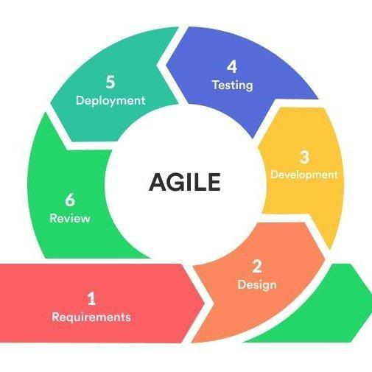 Agile Methodology is a way to manage a project by dividing the tasks into several phases. It involves constant collaboration with stakeholders and continuous improvement at every stage. This agile process is an iterative process in which changes can be made according to the user’s satisfaction. In agile process, new features can be added easily by using multiple iterations.

Figure 2: **Software Engineering Methodology**

In this study, the proponents will be using the Agile Model to develop the application. This model makes the development of the application much more organized and it will give support on how the details will run along.

**Requirements.** In this phase, the proponents must define the requirements for the application and plan the time and effort needed to build the project. Once the requirements are identified, the proponents can evaluate technical and economic feasibility based on the information gathered. Therefore, the proponents made a virtual survey questionnaire which is forwarded to the different users of the application, such as; pet owners, pet breeders, pet shooters, and veterinarians. After gathering the conducted survey, the proponents then scheduled a meeting to discuss what features and functions will be included in the application. During this phase, the team creates a Gantt Chart to track the time spent on each task assigned to each member and determine whether the team members meet or exceed the deadline.

**Design.** In this phase, the project is identified. The proponents will base the survey gathered to define the requirements and use user flow diagrams or UML diagrams to show the work of new features and show how it will apply to the existing system. Therefore, the proponents create the user interface design using the recommended IDE tools; including its mobile and web platform. Additionally, the Functional Decomposition Diagram, Program Workflow, and Use Case Diagram were made by the proponents during this phase to support the User Interface created.

**Development.** This is the third phase of the cycle and during this phase, this is where the work begins. The developers will start to work on their project, which aims to deploy a working application. The application will undergo various stages of improvement, so it includes simple, minimal functionality and during this phase, the proponents start developing the application based on the UI design and the database model for the application that was decided during the requirements phase. The tools used in developing the application are Android SDK for the User Interface and Google Firebase for the application’s database.

The proponents use a recommendation system for the algorithm. The proponents will be using the Content Based System, this system generates recommendations based on the user’s preferences and profile. It tries to match users to items that they’ve liked previously. The level of similarity between items is generally established based on attributes of items liked by the user during their previous use. Content-Based Systems focuses on the ratings provided by the target user themselves and the approach leverages different sources of data to generate recommendations.

**Testing.** In this phase, the team examines the application performance and looks for bugs. Therefore, the proponents did several testing processes as part of the quality assurance of the application. During this phase, several series of tests have been conducted to fix any bugs, if there are, or syntax errors until all the problems are solved before the deployment of the application.

**Deployment.** In this phase, the team issues an application for the user's work environment. Hence,the proponents will be releasing the application to the end-users after the testing phase with no errors.

**Review.** This is the final phase of the methodology and after the application is deployed. The last step is review. In this, the team receives reviews from different users about the application and works through the reviews. Here, the proponents gather reviews from the users who have installed the application and take down notes on what requires immediate modification to meet users' satisfaction.

**Planning/Conception-Initiation Phase**

**Business Model Canvas**

The Business Model Canvas is a presentation of Hi-Breed’s value proposition, customers, revenue streams, and other resources. This great tool helps the proponents to have a deep understanding of the business structure of the application that is being developed.

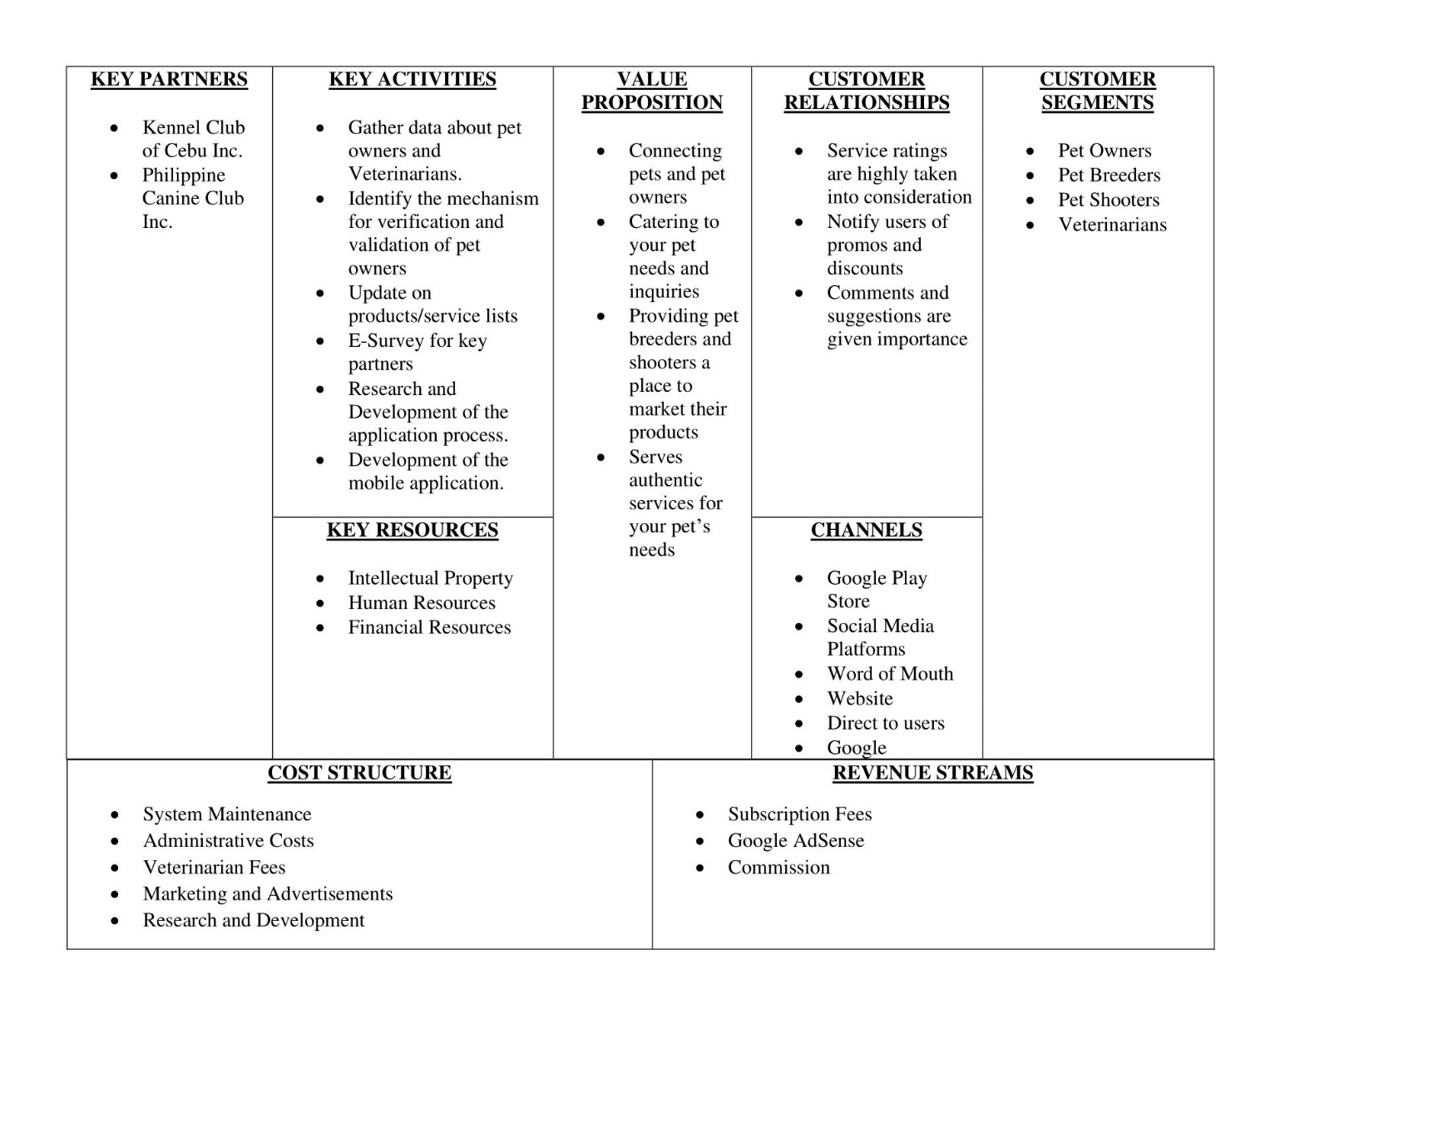**Table 2**

**BUSINESS MODEL CANVAS**

Table 2 indicates the overall important administration business activities and plans. Hi-

Breed’s Key Partners are the Kennel Club of Cebu Inc. and Philippine Canine Club Inc. These organizations handle the registration of the growing number of pure-bred dogs in the Philippines. In Key Activities, the proponents will have to identify and list down what are the activities that need to be completed to fulfill the application’s purpose. Therefore, it is essential to gather data and conduct an e-survey to provide a solution to the existing problem that the proponents are trying to solve through our application. Additionally, in the value proposition, the proponents identify the specific algorithm that will be used and other features to be added to the application that plays an important role to reach the proponent’s objectives.

In Customer relationships, the proponents need to establish the type of relationship that will have for each customer segment listed in Table 2 or how the proponents will interact with the users throughout the journey of the application. Therefore, service ratings and user feedback/comments are highly taken into consideration and regular maintenance will also be implemented to provide the best experience for the users.

Furthermore, in Customer Segments, these are the people that the proponents are trying to target and sell their product or service. Here anyone who is a pet owner can register and use the application, other than that, pet breeders, pet shooters, and a veterinarian who possesses documents to prove their legitimacy could also register in the application and may market their product or services.

As for the Key Resources, the proponents list down which main inputs that need to carry out Hi-Breed’s key activities in order to create the value proposition. Hi-Breed’s key activities include; Intellectual Resources which Hi-Breed depends on existing mechanisms and algorithms. Second is Human Resources, which includes the developers that made this application possible and will do the regular application maintenance upon deployment. Lastly, Financial Resources, the most important resource is capital, this is needed during research and development because it is used for the expenses during the entire project.

For the Cost Structure, the proponents identify all the costs associated with operating the business model. Here, the proponents will spend on the maintenance of the system to make sure that all of the bugs that are reported will be immediately fixed, the second cost structure is the administrative costs, and the third is veterinarian fees for the Ask a professional feature where the application will have to pay the veterinarian who answers the users inquiry, and fourth is the marketing and advertisements which will help the application to have more users or customers, and lastly are the expenses during Research and Development.

Lastly, the source of revenue of the application Hi-Breed, the proponents have subscription fees where if users are interested to experience the premium feature, they will have to subscribe to the application. Next is Google AdSense, which works by matching ads to the application based on the content and visitors. The ads that will be posted on the application are created and paid for by advertisers who want to promote their products. Since these advertisers pay different prices for different ads, the amount that the application will earn will vary. Lastly is Commission Rates, a certain percentage of the service that will be offered by the Pet Shooters will be deducted to the total amount of earnings per month. In this way, the application will also earn money and at the same time will market the shooter’s products and services.

**Program Workflow**

The workflow diagram provides a graphical overview of the business process. Using standardized symbols and shapes, the workflow shows step by step process on how the task is completed from start to finish.

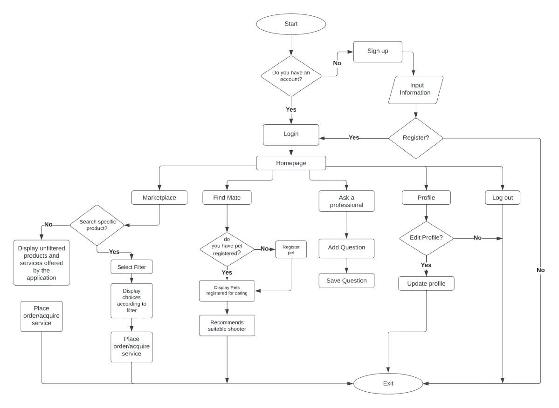

Figure 3: **Program Workflow (General user/Pet Owners)**

Figure 3 shows the program workflow of the registered users/pet owners in the Hi-Breed application. It shows the different functionalities that the user can execute. Figure 3 helped the programmers plan the design and features that are essential for users to have for the application. It also shows a detailed sequence of actions that the users can execute to have a tailored experience while using the application.

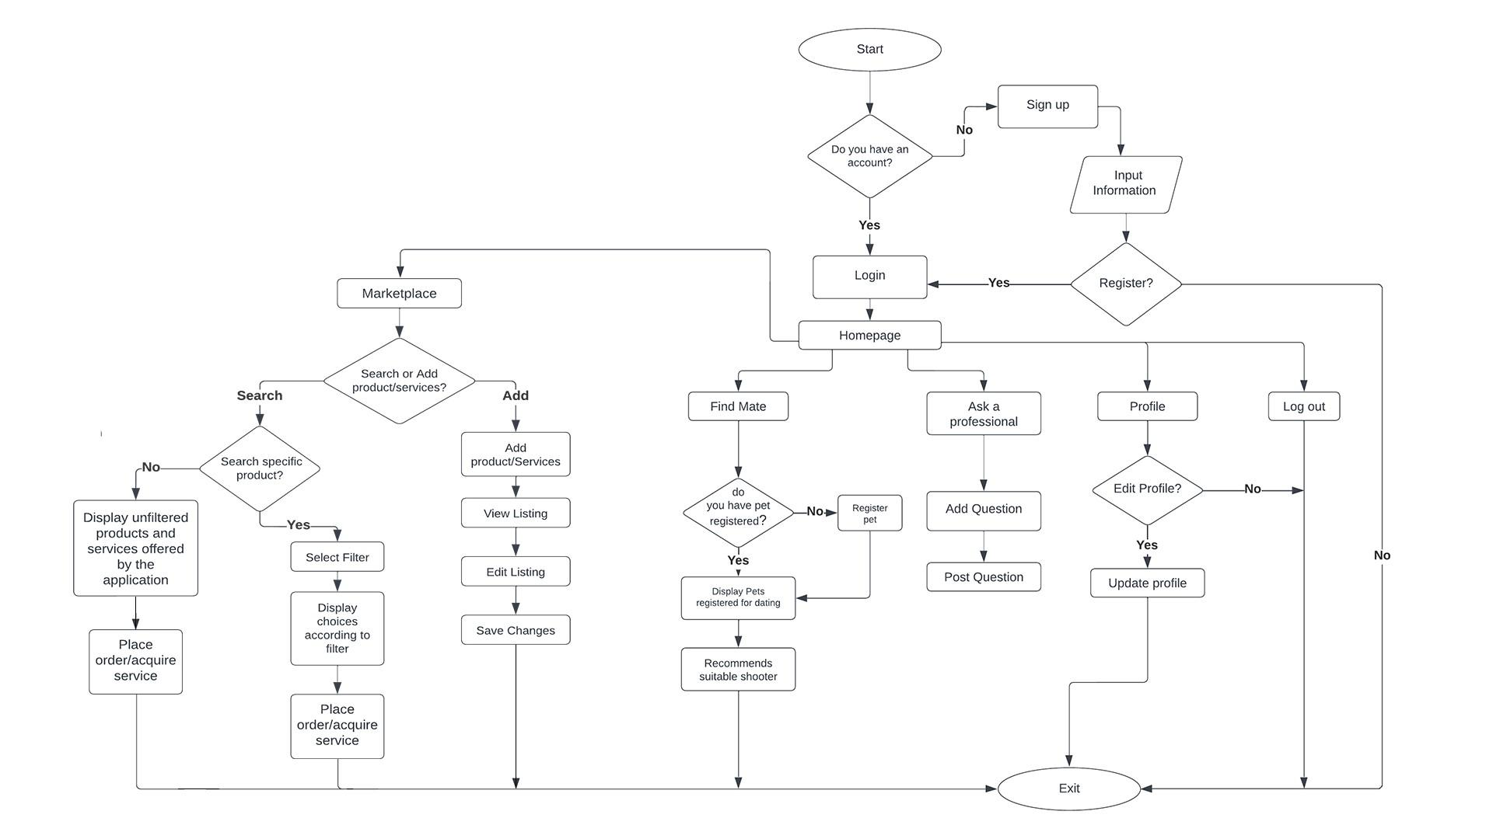The application starts with the welcome page where users can choose to log in or sign up. If the user selects sign up, the application will ask what type of role the user is specialized in, once the pet owner role is selected then the application prompts the user to the registration page where the user will have to input all the necessary information. Once completed, users can log in using the registered email and password and they can use the different features offered by the application including the Marketplace, Find Mate, Ask a Professional, and their Profiles. In the Marketplace feature, users can search for a specific product that they are looking for. Users can also display the filtered and unfiltered products and services offered by the application then they can place the order/service that they want to check out. In the Find Mate feature, users can register their pet profiles to be able to find a mate for their pets. This registered pet profile will be shown in the pet dating for the other users to like and once a match is successful the application will recommend a suitable breeder for them. Next is the Ask a Professional feature, users can add a question or save a question that will be answered only by a veterinarian. And lastly is the profile, users can update their profile anytime in the application.

Figure 3.1: **Program Workflow (Pet Breeders and Shooters)**

Figure 3.1 shows the program workflow of the pet breeders and shooters registered in the Hi-Breed application. This shows the sequence of events the breeder or Shooter can execute that differ from a regular user.

The application starts with the welcome page where users can choose to log in, if they have already registered or signup. If the user selects sign up, the application will ask what type of role the user is specialized in, once the role is selected then the application prompts the user to the registration page where they will have to input all the necessary information. Once completed, users can log in using their registered email and password. Pet Breeders and Shooters have also access to the Marketplace where they can search and add their products and services. If the user is searching for a product and went to Marketplace, the application will display the unfiltered products or services offered. However, if the user is looking for a specific product, the user can select the filter according to the user’s preference and then the application will display the filtered products. Once the user selects the products or services that the user is looking for, the user can place an order or acquire the service. Also, if the user wants to add a product or service, the application will ask for complete details and afterward, the user can view the list of the products or services that the user added. The user could also edit and save the changes of the products and services that the user wants to update.

Additionally, users can also add their pets to the Find Mate feature. If the user’s pet has not registered yet, the application will ask the user to register their pet in order for them to find a mate. Once the registration is successful, the user’s pet will be displayed in pet dating and the owner can start searching for a mate. Once the user’s pet found a match, the application will recommend a suitable shooter. Also, Pet Shooters and Pet Breeders have also access for the Ask a Professional feature, the user can add a question and post them in the feed. These questions will be answered by the Veterinarians. Lastly, user can update their profile in the application.

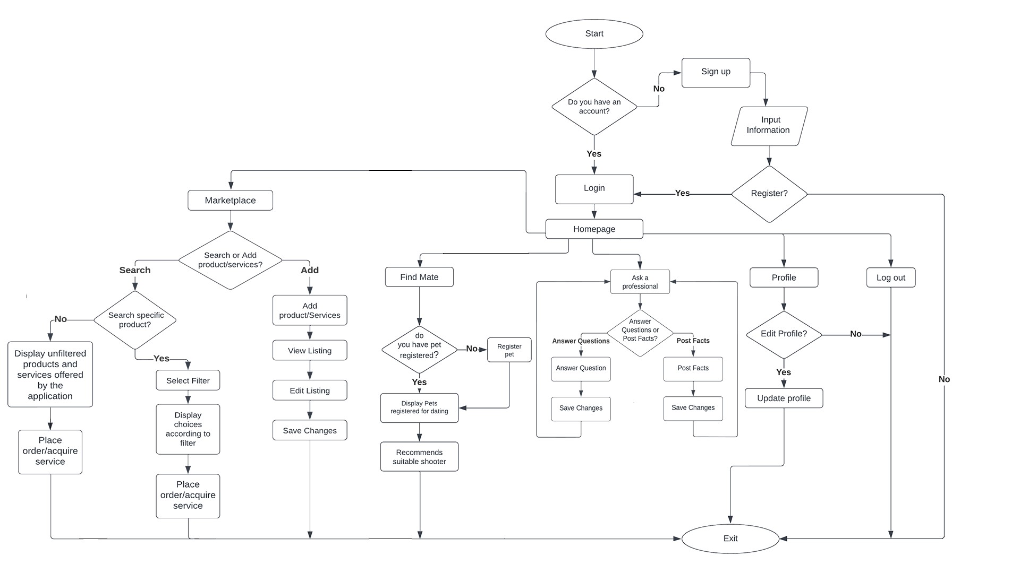

Figure 3.2: **Program Workflow (Veterinarian)**

Figure 3.2 shows the program workflow of the veterinarians registered in the Hi-Breed application. This shows the sequence of events the veterinarian can execute that differ from a regular user.

The application starts with the welcome page where users can choose to log in, if they have already registered or signup. If the user selects sign up, the application will ask what type of role the user is specialized in, once the role is selected then the application prompts the user to the registration page where they will have to input all the necessary information. Once completed, users can log in using their registered email and password. Veterinarians have also access to the Marketplace where they can also search and add the products and services that they want to advertise in the application. However, if the user wants to purchase a product or acquire a service from other users the application will display the unfiltered products or services offered in the marketplace by the application. Also, if the user is looking for a specific product, the user can select the filter according to the user’s preference. Once the user found the products or services that the user is looking for, the user can place an order or acquire the service. Furthermore, if the user wants to add a product or service, the application will ask for the complete details and afterward, the user can now view the list of the products or services that the user added. The user can also edit and save the changes of the products and services that the user wants to update.

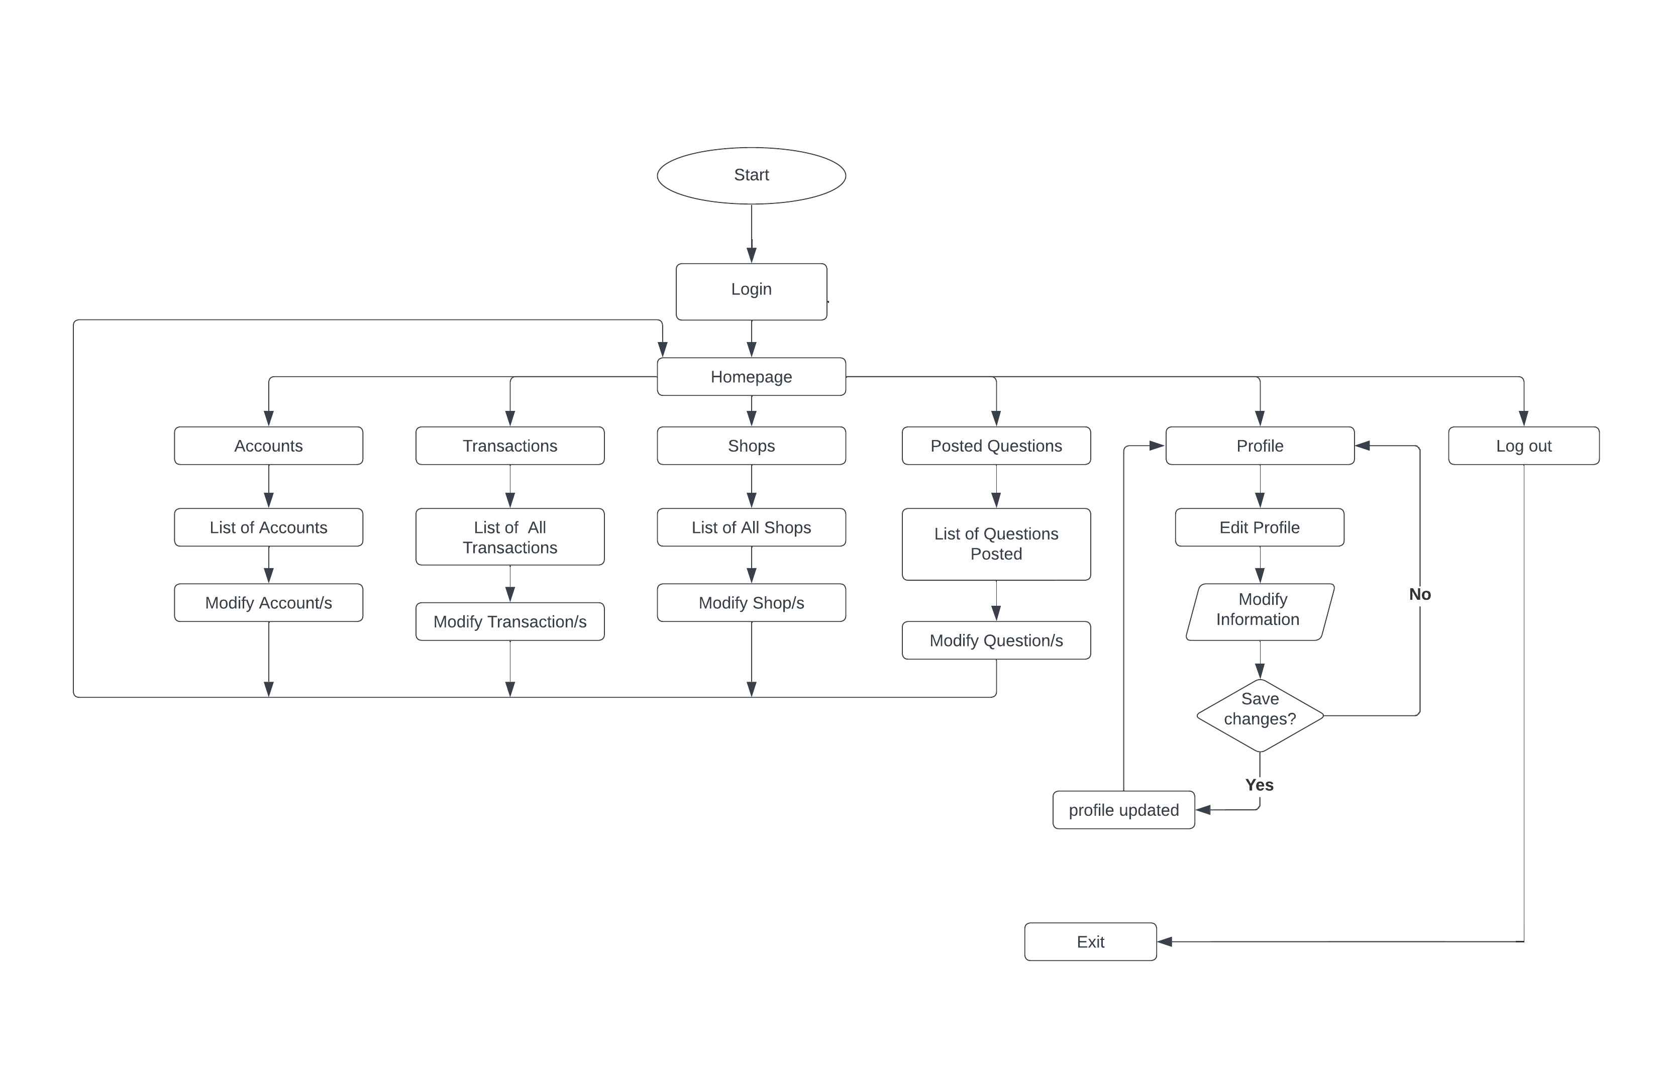Additionally, Veterinarians can also add their pets to the Find Mate feature. If the user’s pet has not registered yet, the application will ask the user to register their pet. Once the registration is successful, the user’s pet will be displayed in pet dating and the owner can start searching for a mate. Once the user’s pet found a match, the application will then recommend a suitable shooter. Moreover, Veterinarians are the only users that can answer the questions posted by other users and post facts in the Ask a Professional page. Lastly, Veterinarians can edit their information in profile page.

Figure 3.3: **Program Workflow (Admins)**

Figure 3.3 shows the program workflow of the admin in the Hi-Breed application. This shows the sequence of events the administrator can execute. Admins have different access from other aforementioned users since this user is capable to oversee all the activity that the other users have been doing in the application using their accounts. Admin can use the registered email and password to login into their account. Once validated, it will then prompt to the homepage where the admin can check and modify the list of accounts and transactions of the different users. Also, Admin can check the list and modify the shops registered in the application by Pet Breeders, Pet Shooters, and Veterinarians.

Additionally, Admin is capable of overseeing the list and modifying the questions posted in Ask a Professional page. Lastly, Admin can edit or modify their information in profile page.

**Validation Board**

Proponents made another activity that will serve as their validation point wherein it will provide an outcome that will show if this study was meant to be executed. The validation board is a tool that tracks the progress and focuses on what matters for Hi-Breed. Using this activity, the proponents may turn their idea into experiments by defining the hypothesis. This canvas is built with a set of necessary elements to validate an idea based on testing, learning, and pivoting. On this board, proponents started with identifying the different users and the problems of each user, then the solution, the riskiest assumptions, the methods and success, results and destination, and lastly, the learning. The proponents will then gather answers from different users to validate the idea.

**Table 3**

**VALIDATION BOARD**

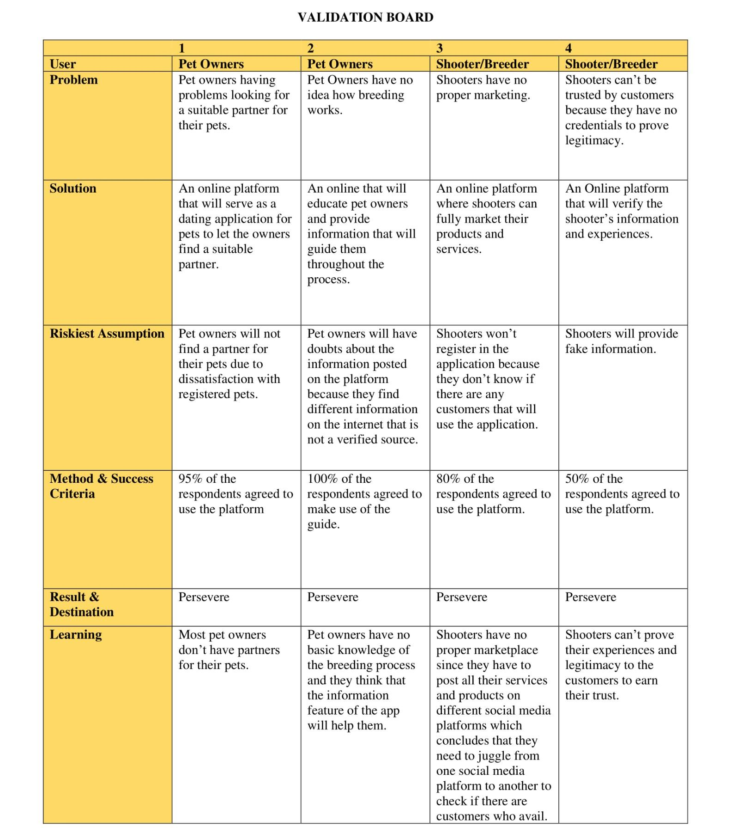

Table 3 shows the various pain points of this research’s target market. Where it additionally shows the result of it leads to perseverance or not. Overall, the result shows that the researcher’s planned solution to the issues through its proposed project: Hi-Breed turns out that 81% of the respondents agreed to use the mobile application. This is because the application will help different users with the stated pain points such as pet owners who are having a hard time finding a suitable mate for their pets and those owners who have no idea how breeding works. Especially as to how to make sure that their pets will be safe during the mating process and whom to trust with handling their pet’s welfare. Additionally, this application will also help pet breeders and pet shooters to market their products and services in one place.

**Gantt Chart**

Gantt Chart is a tool used to assist the team in planning and scheduling of projects of all sizes. A Gantt Chart is defined as a graphical representation of activity against time which helps the team to monitor the progress. Here, it shows the start and end dates of each task and who is the owner of each task.

**Table 4**

**GANTT CHART**