1. What is Inheritance? Try to explain in Mandarin.

子類別繼承父類別的屬性以及方法, 在kotlin中所有東西預設都是final,所以若想要繼承, 則需要在繼承的東西前面加open, 若想要修改父類別屬性內容,則須加上override.

2. How to split a string in Android? Explain your understanding, and even better to attach some sample code.

將一個字串裡面有的符號拆開,String有.split的方法, 再設立一個String把拆開後的字串印出來

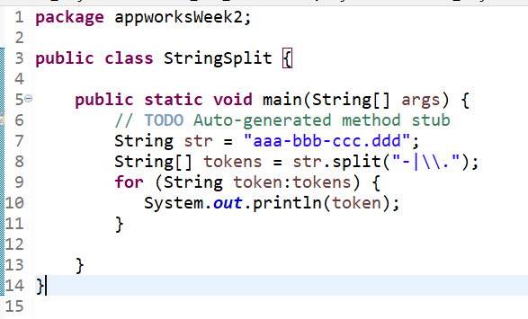

3. What kind of key-value pair collection do we use in Android? Attach a sample code that uses for-loop to print each key-value pair.

fun main(args: Array<String>){

val hashMap:HashMap<Int,String> = HashMap<Int,String>() hashMap.put(1,"Ajay")

hashMap.put(3,"Vijay")

hashMap.put(4,"Praveen")

hashMap.put(2,"Ajay")

for(key in hashMap.keys){

println("Element at key $key = ${hashMap[key]}")

}}

Element at key 1 = Ajay

Element at key 2 = Ajay

Element at key 3 = Vijay

Element at key 4 = Praveen

4. What’s the difference between ArrayList and LinkedList? Try to explain in Mandarin.

[ArrayList](https://www.geeksforgeeks.org/arraylist-in-java/)是**[集合框架](https://www.geeksforgeeks.org/collections-in-java-2/)**的一部分。它存在於[**java.util**](https://www.geeksforgeeks.org/java-util-package-java/)包中，並為我們提供了 Java 中的動態數組。雖然，它比[LinkedList](https://www.geeksforgeeks.org/linked-list-in-java/)慢，但在需要對數組進行大量操作的程序中很有幫助。我們可以動態添加和刪除項目。它會自動調整大小。

[LinkedList](https://www.geeksforgeeks.org/linked-list-in-java/)是一種線性數據結構，其中元素不存儲在連續的位置，每個元素都是具有數據部分和地址部分的單獨[對象。](https://www.geeksforgeeks.org/classes-objects-java/)元素使用指針和地址鏈接。每個元素稱為一個節點。由於插入和刪除的動態性和易用性，比array更受歡迎。

看完網路的比較差異後

我的認知是當需要大量修改數據時可以使用ArrayList, 且刪掉後arrayList空間會自動調整大小

LinkedList則是可以有更多方法可以使用, 例如.addLast , .removeFirst(), 靈活性比ArrayList來的大

5. What are Value Type variables? List out the Value Type variables you know.

| **類型** | **大小（位）** | | **最小值** | **最大值** |
| --- | --- | --- | --- | --- |
| Byte | 8 | -128 | | 127 |
| Short | 16 | -32768 | | 32767 |
| Int | 32 | -2,147,483,648 (-2 31 ) | | 2,147,483,647 (2 31 - 1) |
| Long | 64 | -9,223,372,036,854,775,808 (-2 63 ) | | 9,223,372,036,854,775,807 (2 63 - 1) |
| char |  |  | |  |
| String |  |  | |  |

| **類型** | **大小（位）** | **有效位** | **指數位** | **十進制數字** |
| --- | --- | --- | --- | --- |
| Float | 32 | 24 | 8 | 6-7 |
| Double | 64 | 53 | 11 | 15-16 |

6. What’s the maximum value of Int? If you want to represent integers larger than the limit, what should you do instead of using int variables?

Int最大值是2147483647

long 的最大值為9,223,372,036,854,775,807