1. **How to apply for Kubeflow Access**
2. Go to <https://wiki.ith.intel.com/display/BIandAI/MLOps+Platform+-+Kubeflow#deck-Access%20Request>
3. Fill up the engagement form under Engagement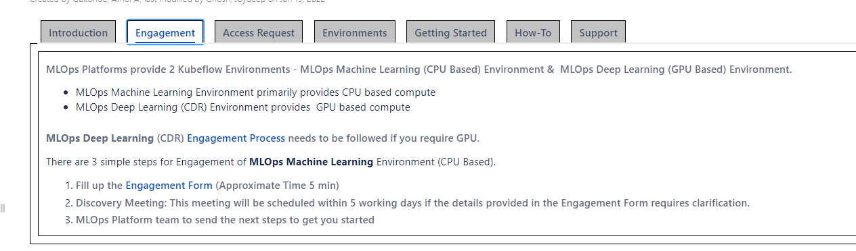
4. In the engagement form, fill IAP (iap.intelcom) and IT Value Stream Name as not applicable. Select GPU Required as No as additional charge is needed for GPU
5. Apply for Kubeflow access in AGS following the instructions in Access Request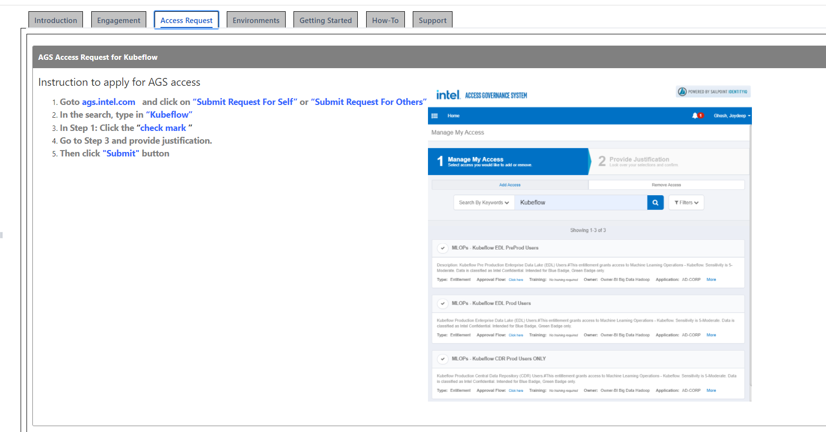
6. Select Kubeflow CDR, specify that no GPU is needed in the comment

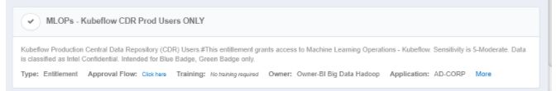

1. **Getting started with Kubeflow**
2. Go to [https://kubeflow.mlops.intel.com](https://kubeflow.mlops.intel.com/) (only select this if CDR is chosen). Refer to the application URL in Environments if others is chosen

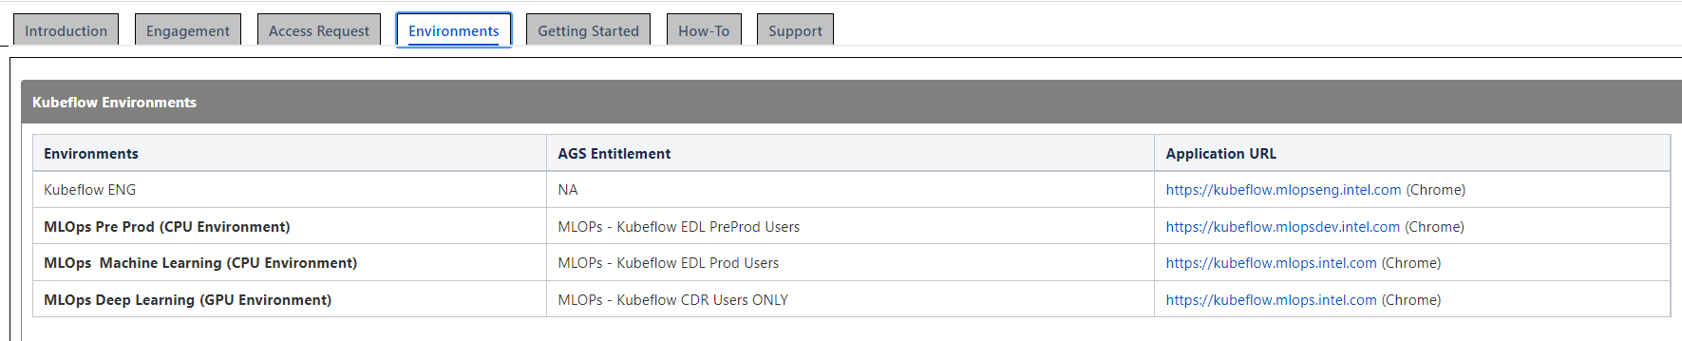

1. Log in with IDSID and Windows password

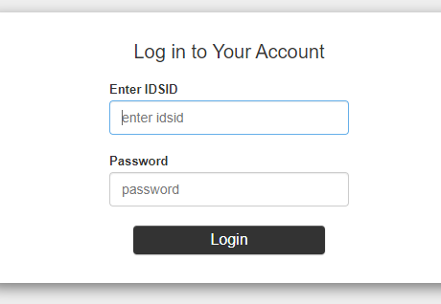

1. Click Create a new Notebook server

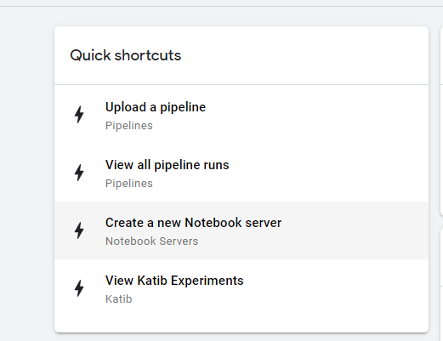

1. Specify the name of notebook server (i.e. name of the project)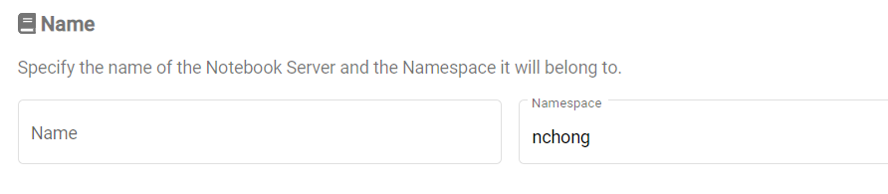
2. Select CPU and memory (Max for each user -> GPU : 0 | CPU : 10 | Memory : 20 GB | Storage : 21 GB ), leave GPU as none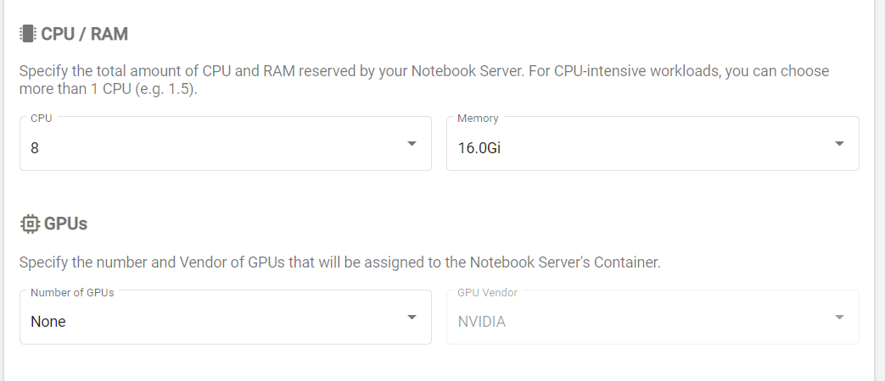
3. Go to notebook servers and click connect after notebook server is created. You will be connected to the notebook server

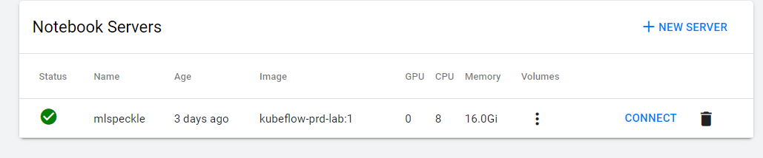

1. Select the up arrow to upload existing notebooks (if there is) and datasets

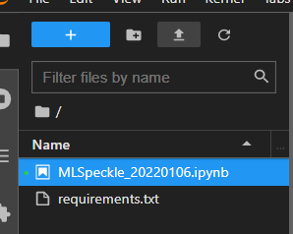

1. **Packages installation (first time user)**

To install packages, list the packages and their version in requirements.txt, upload to the notebook server and run !pip install -r requirements.txt. More info can be found here <https://wiki.ith.intel.com/display/BIandAI/Install+Packages>