1. **FIRST COURSE**

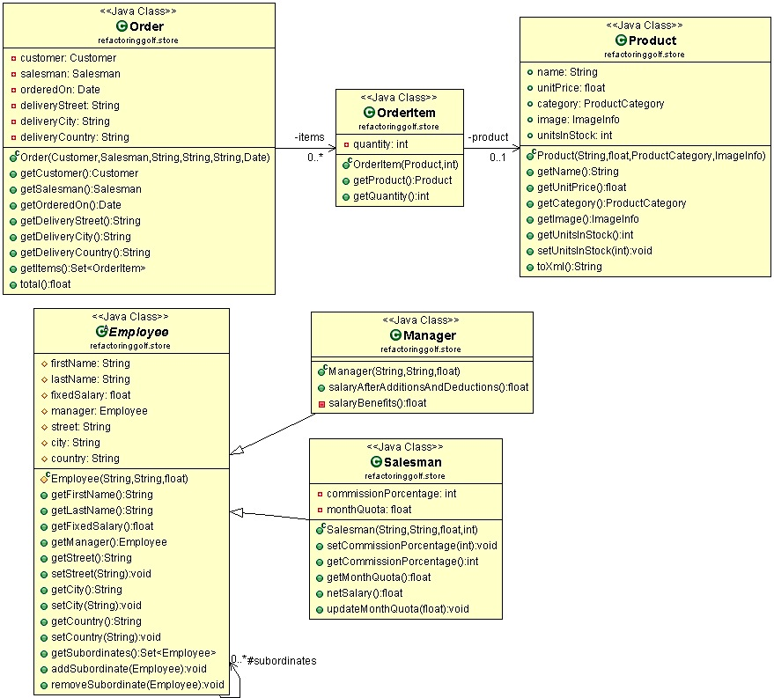

**INITIAL TEE**

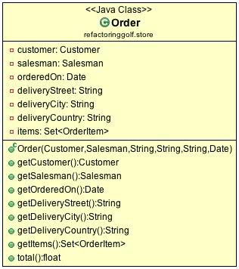

**public** **class** Order {

**public** **float** total() {

**float** totalItems = 0;

**for** (OrderItem item : items) {

**float** totalItem=0;

**float** itemAmount = item.getProduct().getUnitPrice() * item.getQuantity();

**if** (item.getProduct().getCategory() == ProductCategory.*Accessories*) {

**float** booksDiscount = 0;

**if** (itemAmount >= 100) {

booksDiscount = itemAmount * 10 / 100;

}

totalItem = itemAmount - booksDiscount;

}

**if** (item.getProduct().getCategory()== ProductCategory.*Bikes*) {

// 20% discount for Bikes

totalItem = itemAmount - itemAmount * 20 / 100;

}

**if** (item.getProduct().getCategory() == ProductCategory.*Cloathing*) {

**float** cloathingDiscount = 0;

**if** (item.getQuantity() > 2) {

cloathingDiscount = item.getProduct().getUnitPrice();

}

totalItem = itemAmount - cloathingDiscount;

}

totalItems += totalItem;

}

**if** (**this**.deliveryCountry == "USA"){

// total=totalItems + tax + 0 shipping

**return** totalItems + totalItems * 5 / 100;

}

// total=totalItemst + tax + 15 shipping

**return** totalItems + totalItems * 5 / 100 + 15;

}

}

**FIRST HOLE**

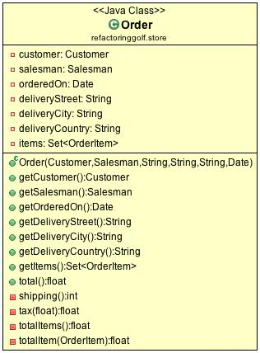

**public** **class** Order {

**public** **float** total() {

**float** totalItems = totalItems();

**float** tax = tax(totalItems);

**int** shipping = shipping();

**return** totalItems + tax + shipping;

}

**private** **int** shipping() {

**int** shipping = 15;

**if** (**this**.deliveryCountry == "USA") {

shipping = 0;

}

**return** shipping;

}

**private** **float** tax(**float** totalItems) {

**return** totalItems * 5 / 100;

}

**private** **float** totalItems() {

**float** totalItems = 0;

**for** (OrderItem item : items) {

totalItems += totalItem(item);

}

**return** totalItems;

}

**private** **float** totalItem(OrderItem item) {

**float** totalItem=0;

**float** itemAmount = item.getProduct().getUnitPrice() * item.getQuantity();

**if** (item.getProduct().getCategory()==ProductCategory.*Accessories*) {

**float** booksDiscount = 0;

**if** (itemAmount >= 100) {

booksDiscount = itemAmount * 10 / 100;

}

totalItem = itemAmount - booksDiscount;

}

**if** (item.getProduct().getCategory() == ProductCategory.*Bikes*) {

// 20% discount for Bikes

totalItem = itemAmount - itemAmount * 20 / 100;

}

**if** (item.getProduct().getCategory() == ProductCategory.*Cloathing*) {

**float** cloathingDiscount = 0;

**if** (item.getQuantity() > 2) {

cloathingDiscount = item.getProduct().getUnitPrice();

}

totalItem = itemAmount - cloathingDiscount;

}

**return** totalItem;

}

}

**SECOND HOLE**

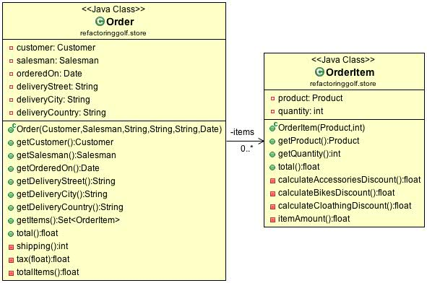

**public** **class** Order {

**private** **float** totalItems() {

**float** totalAmount = 0;

**for** (OrderItem item : items) {

totalAmount += item.total();

}

**return** totalAmount;

}

}

**public** **class** OrderItem {

**public** **float** total() {

**float** discount = 0;

**if** (getProduct().getCategory() == ProductCategory.*Accessories*) {

discount = calculateAccessoriesDiscount();

}

**if** (getProduct().getCategory() == ProductCategory.*Bikes*) {

discount = calculateBikesDiscount();

}

**if** (getProduct().getCategory() == ProductCategory.*Cloathing*) {

discount = calculateCloathingDiscount();

}

**return** itemAmount() - discount;

}

**private** **float** calculateAccessoriesDiscount() {

**float** discount = 0;

**float** unitPricePerQuantity = itemAmount();

**if** (unitPricePerQuantity >= 100) {

discount = unitPricePerQuantity * 10 / 100;

}

**return** discount;

}

**private** **float** calculateBikesDiscount() {

**return** itemAmount() * 20 / 100;

}

**private** **float** calculateCloathingDiscount() {

**float** discount = 0;

**if** (getQuantity() > 2) {

discount = getProduct().getUnitPrice();

}

**return** discount;

}

**private** **float** itemAmount() {

**return** getProduct().getUnitPrice() * getQuantity();

}

}

**THIRD HOLE**

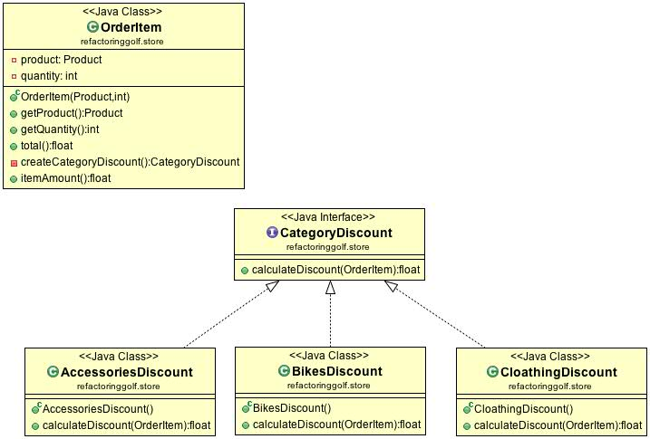

**public** **class** OrderItem {

**private** CategoryDiscount createCategoryDiscount() {

CategoryDiscount categoryDiscount=**null**;

**if** (getProduct().getCategory() == ProductCategory.*Accessories*) {

categoryDiscount = **new** AccessoriesDiscount();

}

**if** (getProduct().getCategory() == ProductCategory.*Bikes*) {

categoryDiscount = **new** BikesDiscount();

}

**if** (getProduct().getCategory() == ProductCategory.*Cloathing*) {

categoryDiscount = **new** CloathingDiscount();

}

**return** categoryDiscount;

}

}

**public** **interface** CategoryDiscount {

**float** calculateDiscount(OrderItem orderItem);

}

**public** **class** AccessoriesDiscount **implements** CategoryDiscount {

**public** **float** calculateDiscount(OrderItem orderItem) {

**float** discount = 0;

**float** unitPricePerQuantity = orderItem.itemAmount();

**if** (unitPricePerQuantity >= 100) {

discount = unitPricePerQuantity * 10 / 100;

}

**return** discount;

}

}

**public** **class** BikesDiscount **implements** CategoryDiscount{

**public** **float** calculateDiscount(OrderItem orderItem) {

**return** orderItem.itemAmount() * 20 / 100;

}

}

**public** **class** CloathingDiscount **implements** CategoryDiscount {

**public** **float** calculateDiscount(OrderItem orderItem) {

**float** discount = 0;

**if** (orderItem.getQuantity() > 2) {

discount = orderItem.getProduct().getUnitPrice();

}

**return** discount;

}

}

**FOURTH HOLE**

* **PREVIOUS HOLE (THIRD HOLE)**

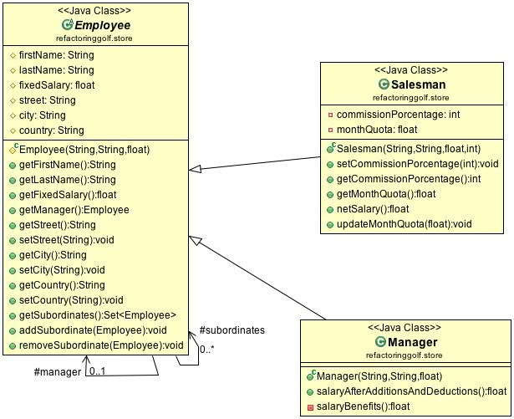

**public** **abstract** **class** Employee {

**protected** Set<Employee> subordinates = **new** HashSet<Employee>();

**public** Set<Employee> getSubordinates() {

**return** Collections.*unmodifiableSet*(subordinates);

}

**public** **void** addSubordinate(Employee subordinate) {

subordinates.add(subordinate);

subordinate.manager = **this**;

}

**public** **void** removeSubordinate(Employee subordinate) {

subordinates.remove(subordinate);

subordinate.manager = **null**;

}

}

**public** **class** Salesman **extends** Employee {

**public** **float** netSalary() {

**float** benefits = monthQuota * commissionPorcentage / 100;

**float** pensionFounds = fixedSalary * 10 / 100;

**float** tax = 0;

**if** (fixedSalary > 3500)

tax = fixedSalary * 5 / 100;

**return** fixedSalary + benefits - pensionFounds - tax;

}

**public** **void** updateMonthQuota(**float** addQuota) {

monthQuota = monthQuota + addQuota;

}

}

**public** **class** Manager **extends** Employee {

**public** **float** salaryAfterAdditionsAndDeductions() {

**float** benefits = salaryBenefits();

**float** pensionFounds = **this**.fixedSalary * 10 / 100;

**float** tax = 0;

**if** (fixedSalary > 3500)

tax = fixedSalary * 5 / 100;

**return** fixedSalary + benefits - pensionFounds - tax;

}

**private** **float** salaryBenefits() {

**return** **this**.subordinates.size() * 20;

}

}

* **CURRENT HOLE**

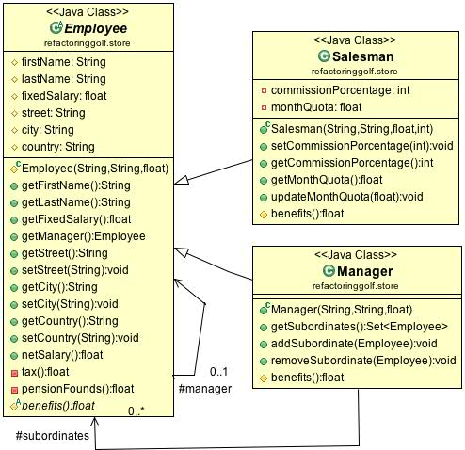

**public** **abstract** **class** Employee {

**public** **float** netSalary() {

**return** fixedSalary + benefits() - pensionFounds() - tax();

}

**private** **float** tax() {

**float** tax = 0;

**if** (fixedSalary > 3500)

tax = fixedSalary * 5 / 100;

**return** tax;

}

**private** **float** pensionFounds() {

**return** **this**.fixedSalary * 10 / 100;

}

**protected** **abstract** **float** benefits();

}

**public** **class** Salesman **extends** Employee {

**protected** **float** benefits() {

**return** monthQuota * commissionPorcentage / 100;

}

}

**public** **class** Manager **extends** Employee {

**protected** Set<Employee> subordinates = **new** HashSet<Employee>();

**public** Set<Employee> getSubordinates() {

**return** Collections.*unmodifiableSet*(subordinates);

}

**public** **void** addSubordinate(Employee subordinate) {

subordinates.add(subordinate);

subordinate.manager = **this**;

}

**public** **void** removeSubordinate(Employee subordinate) {

subordinates.remove(subordinate);

subordinate.manager = **null**;

}

**protected** **float** benefits() {

**return** **this**.subordinates.size() * 20;

}

}