**JavaScript**

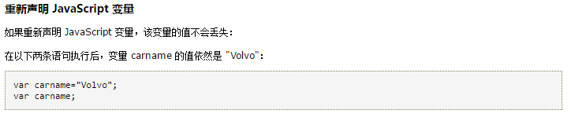

**Force-directed graph**

As few as crossing edges as possible-------assign forces among the sets of edges and nodes to minimize energy

