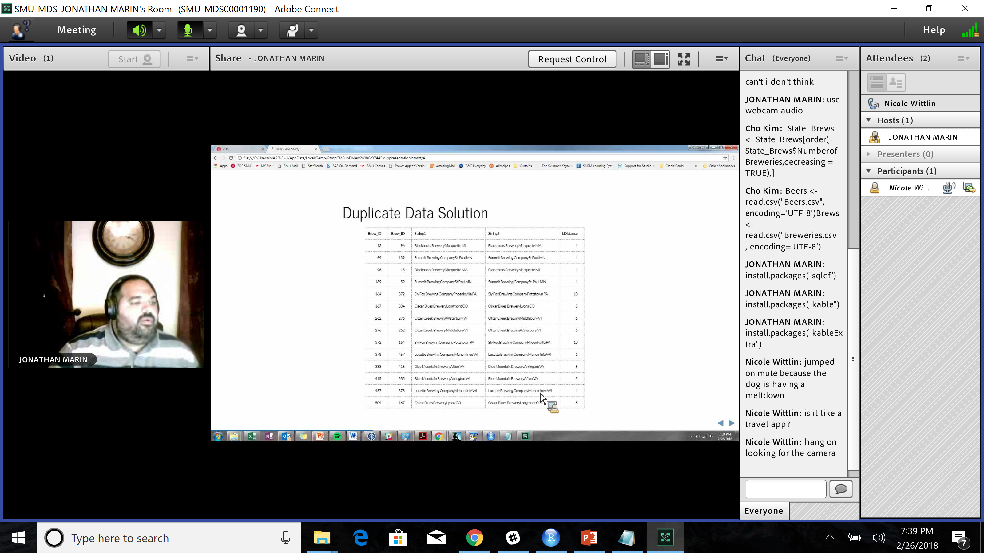Actually – it is spelled Menomonie. Wrong on both accounts.

