TECNOLOGIE WEB

29/01/2020   
Available time: 2 hours

**Rules.**

You can use your browser to access only this list of hosts:

- localhost

- <http://achecker.ca/checker/index.php> (in order to validate accessibility of HTML code)

- <https://validator.w3.org/> (in order to validate syntax of HTML code)

To open the links, use Ctrl-C + Ctrl-V on Google Chrome address bar.

In the exam folder you can find a copy of W3Schools contents, for off line navigation by using the browser. Any editor can be used to edit code.

**IMPORTANT NOTE**:

**You have to save in your submission folder all code files (HTML, CSS, PHP, JS). You can answer to the question in exercise 3, writing directly in this word document. Remember to save the solution of exercise 3 in the submission folder.**

|  |
| --- |
| ESERCIZIO N. 1 **(7 punti)** |

Write an HTML document using accessible, valid and semantically correct HTML5 code. The document title is “Abbonamenti al trasporto pubblico”; the document contains a section entitled “Studenti dei campus della Romagna”; it contains the following table. The caption of the table is “Abbonamenti nei campus”

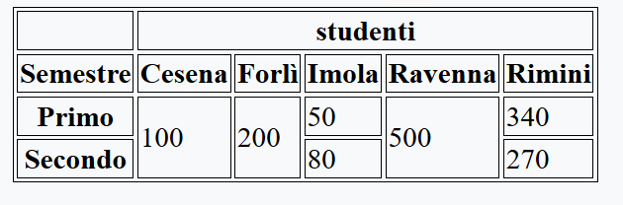

|  |
| --- |
| ESERCIZIO N. 2 **(6 punti)** |

**CSS**

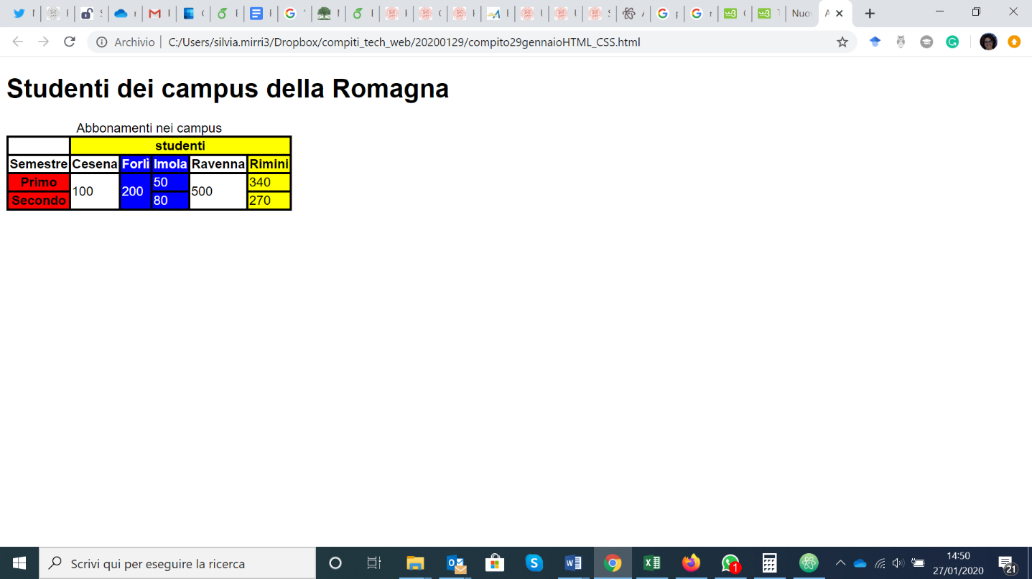

Taking into account the HTML file resulting from Exercise nr. 1, create an external CSS file so as to get layout and style as the ones depicted in the above screenshot (taken with Chrome). If needed, it is possible to change the HTML file.

Moreover, it is necessary to create a transition related to the table cell with number “100” as content, when the mouse pointer is within the corresponding area. The transition duration is 3 seconds and it modifies the following characteristics (obtaining the result shown in the screenshot below):

* Font size: 150%.
* Bold text.
* Background color: yellow.
* Text color: blue.

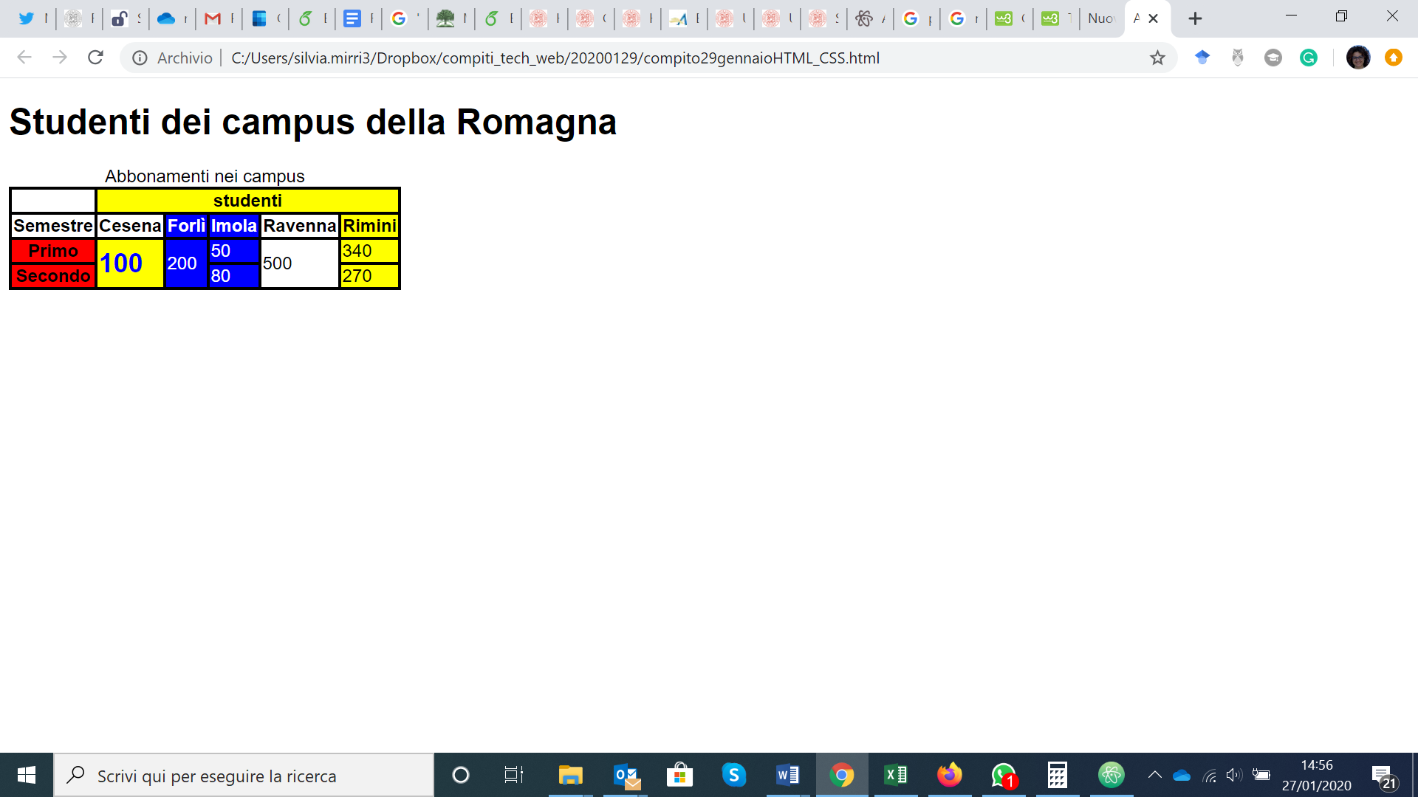

|  |
| --- |
| ESERCIZIO N. 3 **(5 punti)** |

List main differences between the use of variables in PHP and in Javascript, comparing aspects such as types or scope. Only comparative statements will be taken into account in the assessment.

Scrivere qui la risposta:

|  |
| --- |
| ESERCIZIO N. 4 **(7 punti)** |

**JQuery**

Taking into account the html file ‘esercizio_javascript.html', create the file ‘soluzione.js’ using JavaScript or jQuery so that:

* When the page loads:
  + The form must be hidden.
  + A new row must be added to the table, containing the following column headers: Name, Email, Description, Action.
* When the button “Insert” is clicked, you will have to:
  + Insert as the text of the submit button the string “Add”.
  + Show the form, whose inputs must be empty.
  + When the button “Add” is clicked, you will have to:
    - Read the three input fields. If one or more fields are empty, visualize an error message in a paragraph.
    - Create a new row of the table with the entered data (the name must be use as a header). In the column action, insert two buttons: “Update” and “Delete”.
    - Hide the form.
* When the button “Delete” is clicked, you will have to remove the correspondent row of the table.
* When the button “Update” is clicked, you will have to:
  + Show the form (it is not necessary insert in the inputs the current values) whose submit input must have as text the string “Update Now”.
  + When the button “Update Now” is clicked, you will have to:
    - Update the columns of the row being edited with the ones inserted (visualize an error message if one or more fields are empty).
    - Hide the form.
* **NB:** 
  + **THE TABLE HAVE TO BE ACCESSIBLE**
  + **CHANGES TO THE HTML FILE ARE NOT ALLOWED**

|  |
| --- |
| ESERCIZIO N. 5 **(7 punti)** |

**PHP**

Write valid PHP code (it runs correctly on Apache web server) that allows you to fill in a multi-page form and print the user’s choices at the end of the form. To do this you will have to use **session variables**.

The first page (*index.php*) should:

* Initialize the session.
* Set up the eventual display of errors in the appropriate element with id = "error".
* In case of error, destroy the session.

The second page (*page2.php*) should:

* Check if the fields on the first page are not empty, in case redirect to the first page.
* Sanitize the "email" field to check that the pattern is correct.
* Sanitize the "contact" field by checking that it only has 10 numeric characters.
* Save all the data of the first page on a session variable called "post".
* Set up a section for the errors in the appropriate element with id = "error".

The third page (*page3.php*) should:

* Check if the fields on the second page are not empty, in case redirect to the first page.
* Save all the data of the second page on a session variable called "post".
* Set up a section for the errors in the appropriate element with id = "error".

The fourth page (*page4.php*) should:

* Save all the data of the third page on a session variable called "post".
* Print all the data chosen by the user, each in a different <p> element within the element with main class.
* Destroy the session.