**LOCAL GOVERNMENT UNIT 3: PUBLIC-PRIVATE PARTNERSHIP MANAGEMENT SYSTEM WITH PREDICTIVE TOOL FOR EVALUATING PROJECT VIABILITY IN BARANGAY NOVALICHES PROPER**

An Information Security Compilation

In Partial Fulfillment

of the Requirements for Data Privacy and Security:

Bachelor of Science in Information Technology

**PROPONENTS:**

**AIRA JANE FUERTE**

**JELLA A. PRONTON**

**MARY JOY M. SANTOS**

**August 2025**

# ABSTRACT

Title  **LOCAL GOVERNMENT UNIT 3: PUBLIC-PRIVATE PARTNERSHIP MANAGEMENT SYSTEM WITH PREDICTIVE TOOL FOR EVALUATING PROJECT VIABILITY IN BARANGAY NOVALICHES PROPER**

Authors **AIRA JANE FUERTE**

**JELLA A. PRONTON**

**MARY JOY M. SANTOS**

Degree **BACHELOR OF SCIENCE IN INFORMATION TECHNOLOGY**

Major **INFORMATION SECURITY**

Date of Completion **AUGUST 2025**

Public-Private Partnerships (PPPs) have become a viable strategy for local government units to tap into private sector skills and financing in service provision and infrastructure development. PPPs allow the local government units (LGUs) to utilize their limited public resources effectively by sharing the risks and operations of service provision and infrastructure construction with private partners while achieving public sector initiatives.

However, there are still challenges such as lack of project evaluation and capacity issues at the grassroots level that limit the full implementation of PPPs. This is where technological innovations such as data analytics and predictive tools that can model project outcomes based on financial, economic, and environmental factors come in. Using this predictive capability helps LGUs like Brgy. Novaliches Proper to immediately identify potential risks, have more transparent decision-making, and better policymaking.

To address this, the project team developed the Public-Private Partnership Management System (PPPMS) with a Predictive Tool for Evaluating Project Viability for Barangay Novaliches Proper. The team collected data from face to face interviews with barangay officials and observation of the current workflow. The Agile Scrum methodology was used where development was divided into sprints. In each sprint, prioritized features such as project tracking, document management, and predictive evaluation were developed, which were reviewed with stakeholders to ensure they met the needs.

Overall, this capstone project aims to develop a PPPMS with predictive tools for better project appraisal and implementation. Through this, it is expected to achieve more transparent, efficient, and value-adding infrastructure projects that will strengthen socio-economic development and public service delivery in Brgy. Novaliches Proper.

# TABLE OF CONTENTS

**ABSTRACT 1**

**TABLE OF CONTENTS 5**

**1. Product Backlog for EIS Information Security 6**

**2. Sprint Backlog for Information Security 7**

**2.1.1 Information Security 8**

**3. Information Security 9**

**3.1.1 Privacy and Security 9**

**Appendices: 10**

**Appendix A Sprint Burndown Charts for Information Security 10**

**Appendix B Information Security Screenshots 11**

# Product Backlog for EIS Information Security

|  |  |  |  |  |
| --- | --- | --- | --- | --- |
| **EIS IS No.** | **EIS IS Stories** | **EIS IS Priority** | **Revision Priority** | **Status** |
|  | As an **Admin**, I want the system to be secured, it should have a login system (username/email + password) so that only authorized admin users can access the system. | 1 | 1 | Done |
| **2** | As an **Admin**, I want to have role-based access control, so that users only see or access data relevant to their responsibilities. | 1 | 1 | Ongoing |
| **3** | As a **User**, I would like to receive an OTP (One-Time Password) after entering login credentials, and that will be sent to a registered mobile phone via SMS so that accounts are more secure. | 1 | 1 | Ongoing |
| **4** | As an **Admin** I want the system to encrypt passwords in the database, so that sensitive user credentials will be encrypted. | 1 | 1 | Ongoing |
| **5** | As a **User**, I want an automatic logout session timeout after inactivity, so that the system cannot be misused if left open. | 1 | 1 | Ongoing |
| **6** | As an **Admin**, I want a failed login attempt lockout (e.g., after 3 attempts) so that brute force attacks can be prevented. | 2 | 2 | Ongoing |

***Table 1: Product Backlog - EIS Information Security***

# Sprint Backlog for Information Security

***Table 2: Sprint Backlog - Information Security***

|  |  |  |  |  |
| --- | --- | --- | --- | --- |
| **IS Story No.** | **IS Stories** | **Task** | **Timeline** | **Responsible Team Member/s** |
| **1** | As a **System Developer**, I want a secure log in form so only authorized users can access the PPP system. | Planning | 8 hours | Aira Jane Fuerte  Jella Pronton  Mary Joy Santos |
| Designing | Aira Jane Fuerte  Jella Pronton  Mary Joy Santos |
| Coding | Aira Jane Fuerte |
| Testing | Aira Jane Fuerte  Jella Pronton  Mary Joy Santos |
| Documenting | Aira Jane Fuerte  Jella Pronton  Mary Joy Santos |
| **2** | As a **System Developer**, I like to generate OTP whenever login credentials for high-level accounts for added security | Planning | 4 hours | Aira Jane Fuerte Jella Pronton |
| Designing | 3 hours | Aira Jane Fuerte Jella Pronton |
| Coding | 5 hours | Aira Jane Fuerte |
| Testing | 3 hours | Jella Pronton  Mary Joy Santos |
| Documenting | 2 hours | Aira JaneFuerte Mary Joy Santos |
| **3** | As a **System Developer**, I want password encryption in the database so that credentials are not easily accessed. | Planning | 3 hours | Aira Jane Fuerte |
| Designing | 2 hours | Aira Jane Fuerte Jella Pronton |
| Coding | 5 hours | Aira Jane Fuerte |
| Testing | 3 hours | Jella Pronton |
| Documenting | 2 hours | Mary Joy Santos |
| **4** | As a **System Developer,** I want an automatic logout after inactivity on the system to prevent accounts from being misused. | Planning | 2 hours | Jella Pronton  Mary Joy Santos |
| Designing | 2 hours | Aira Jane Fuerte  Jella Pronton |
| Coding | 4 hours | Aira Jane Fuerte |
| Testing | 2 hours | Jella Pronton  Mary Joy Santos |
| Documenting | 1 hour | Aira Jane Fuerte |
| **5** | As a **System Developer,** I want to lock out the system after 3 failed login attempts to prevent brute force attacks. | Planning | 2 hours | Mary Joy Santos |
| Designing | 2 hours | Aira Jane Fuerte  Mary Joy Santos |
| Coding | 3 hours | Aira Jane Fuerte |
| Testing | 2 hours | Jella Pronton |
| Documenting | 1 hour | Jella Pronton  Mary Joy Santos |

**2.1.Information Security**

|  |  |  |  |  |  |  |  |  |  |  |  |  |  |  |  |
| --- | --- | --- | --- | --- | --- | --- | --- | --- | --- | --- | --- | --- | --- | --- | --- |
| **Sprint 1 Backlog** | | **Sprint 1 (2 weeks)** | | | | | | | | | | | | | |
| **#** | **User Stories** | **1** | **2** | **3** | **4** | **5** | **6** | **7** | **8** | **9** | **10** | **11** | **12** | **13** | **14** |
| **1** | As an Admin, I want a secure login (username/email & password) | 5 | 5 | 4 | 4 | 3 | 3 | 2 | 2 | 1 | 0 | 0 | 0 | 0 | 0 |
| **2** | As a System, I want OTP verification for high-level accounts | 3 | 3 | 2 | 2 | 2 | 2 | 1 | 1 | 0 | 0 | 0 | 0 | 0 | 0 |
| **3** | As a System, I want automatic logout after inactivity | 2 | 2 | 2 | 2 | 1 | 1 | 1 | 1 | 0 | 0 | 0 | 0 | 0 | 0 |
| **4** | As a System, I want failed login attempt lockout after 3 tries | 2 | 2 | 2 | 2 | 1 | 1 | 1 | 0 | 0 | 0 | 0 | 0 | 0 | 0 |
| **5** | As a System, I want password encryption for stored credentials | 3 | 3 | 3 | 2 | 2 | 2 | 1 | 1 | 0 | 0 | 0 | 0 | 0 | 0 |

|  |  |
| --- | --- |
| **TOTAL** | **82** |

***Table3: Sprint 1 Burndown Chart - Information Security***

# Information Security

### **Privacy and Security**

This section will provide additional details on the security measures, regulations, and protocols put in place in the Public-Private Management System with Predictive Tool for Evaluating Project Viability project to safeguard confidential information and data from potential breaches and other harmful cybersecurity threats.

* **Authentication and Authorization**

**Login System**

Only authorized admin users can access the system via a secure login using a username/email and password.

**Role-Based Access Control (RBAC)**

The PPMS system uses role-based access control (RBAC) to ensure that each user has limited access based on their role and responsibilities.

* **Two-factor Authentication (2FA)**

The PPMS system will use 2FA, that after entering login credentials, users will receive a One-Time Password (OTP) sent to their registered mobile number via SMS to enhance account security.

* **Password Security**

The PPMS system will use password security where user credentials are stored in the database using password encryption to protect against credential theft.

* **Session Management**

The PPMS system includes an automatic session logout after a period of inactivity to prevent misuse if it is left open.

* **Account Protection**

**Failed Login Attempt Lockout**

The ppms system will use a failed login attempt lockout where accounts are temporarily locked after multiple failed login attempts (e.g., 3 times) to prevent brute force attacks.

# Appendices:

## **Appendix A Sprint Burndown Charts for Information Security**

Figure 1: User Stories - Sprint 1

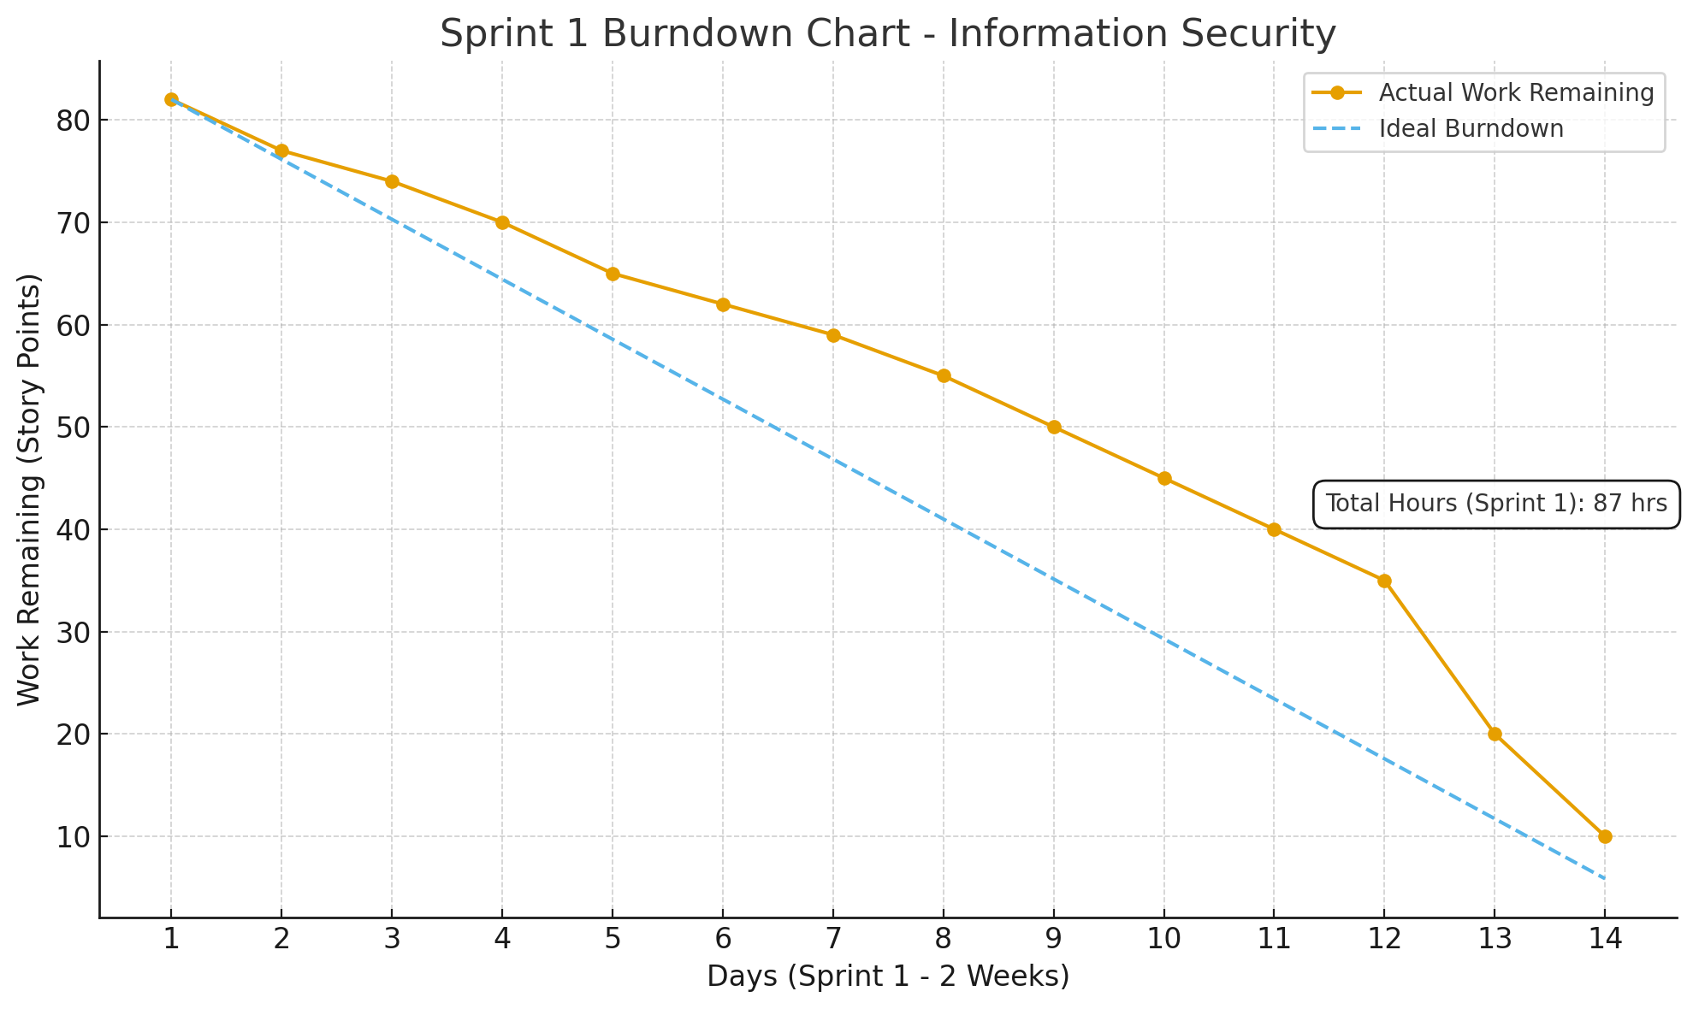

## **Appendix B Information Security Screenshots**

**LOG IN FORM**

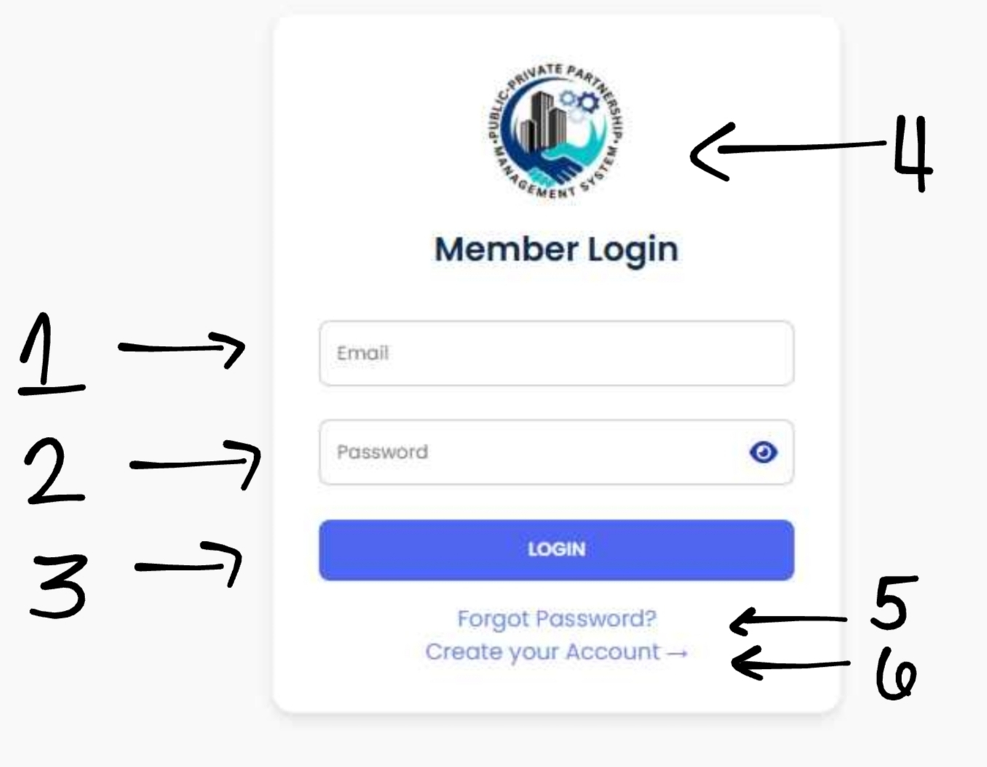

* + - 1. Username text field
      2. Password
      3. Login Button
      4. Company Name and Loo
      5. Mark Check to keep signed in
      6. Forgot Password
      7. Create Account