Task 1: Cloning and Forking

1. Cloning a Repository:

- Choose a public GitHub repository of interest (e.g., a project related to your field of study).

- Clone the repository to your local machine.

- Explore the repository's structure, files, and history.

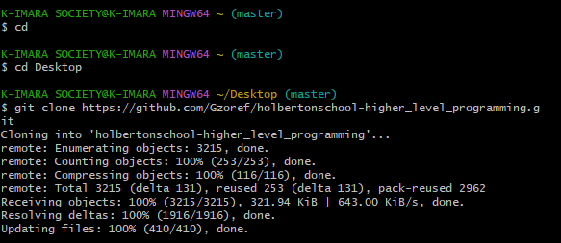

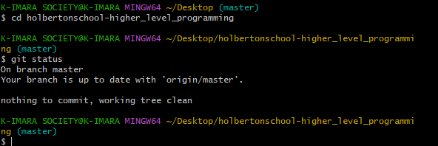

2. Forking a Repository:

- Fork the same repository you cloned in Task 1 to your GitHub account.

- Clone the forked repository to your local machine.

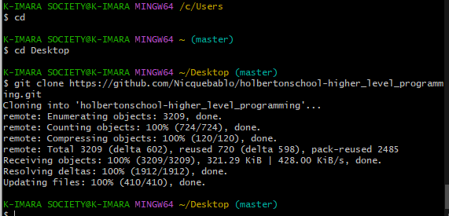

Task 2: Managing Branches

3. Creating and Switching Branches:

- In your local repository, create a new branch (e.g., `feature-update`).

- Switch to the newly created branch.

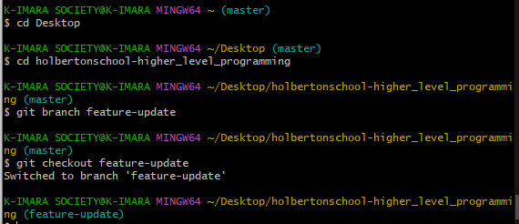

4. Making Changes and Committing:

- Make changes to a file or add a new file.

- Commit the changes to the branch.

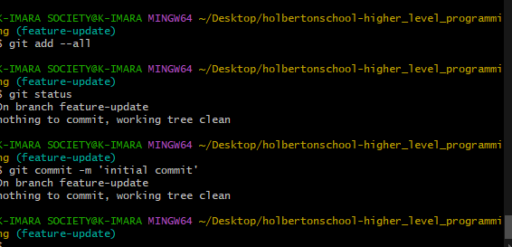

5. Merging Changes:

- Switch back to the main branch.

- Merge the changes from the `feature-update` branch into the main branch.

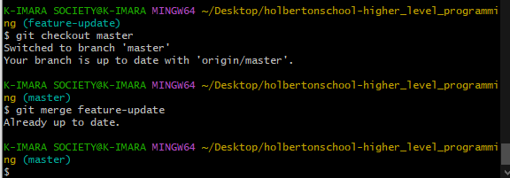

Task 3: Handling Conflicts

6. Creating Conflicts:

- In your forked repository, make changes to the same file that you modified in Task 4.

- Commit the changes.

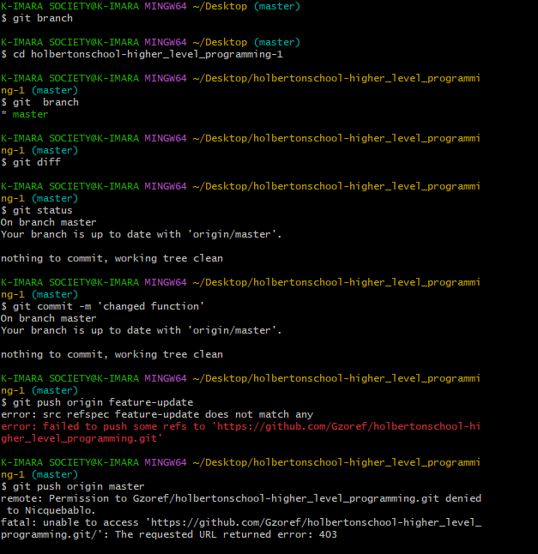

7. Resolving Conflicts:

- Create a new branch to resolve the conflict.

- Resolve the conflict manually in the file.

- Commit the changes and merge the branch back into `main`.

