R Assignment 1 EDA

2024-07-31

## Introduce your data

This data is based on EPA estimates for fuel economy for 234 cars from the years 1999 and 2008. I’m interested in the city fuel economy of these cars.

## Calculate two Summary Statistics

# The code for your 1st statistic goes here  
mean(mpg$cty, na.rm = TRUE)

## [1] 16.85897

# The code for your 2nd statistic goes here  
fivenum(mpg$cty, na.rm = TRUE)

## [1] 9 14 17 19 35

## Make a plot

# Write some ggplot() code for a plot here.   
ggplot(data = mpg, mapping = aes(x = class)) +  
 geom_bar() +   
 labs(title = "Popular Car types",  
 subtitle = " From Years 1999 to 2008",  
 x = "Type of Car",  
 y = "Number of Cars ")

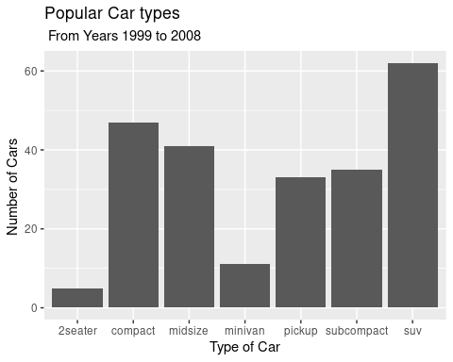

## Conclusion

This dataset is mostly comprised of suvs. The average city fuel economy is less than 17 mpg which I feel is just ok. The max fuel economy is 35 mpg, and that car is a Volkswagon New Beetle. The worst average fuel city fuel economy is a Dodge Dakota.