**1.PPT上的实例**

betweenness (4) =

注意：1，每对节点，看看端点不为4、路径中间经过4的路径

2，每对节点，所有路径里面，上述路径的比例

|  |  |
| --- | --- |
| 某两个点的最短路径 | 对betweenness(4)的贡献 $\frac{σ_{st}(4)}{σ_{st}}$ |
| 0 1 : [[0, 3, 1]]  0 2 : [[0, 3, 2]]  0 3 : [[0, 3]]  0 4 : [[0, 3, 4]]  0 5 : [[0, 3, 4, 5]]  0 6 : [[0, 3, 4, 5, 6], [0, 3, 4, 9, 6]]  0 7 : [[0, 3, 4, 5, 6, 7], [0, 3, 4, 9, 6, 7]]  0 8 : [[0, 3, 4, 5, 6, 8], [0, 3, 4, 9, 6, 8]]  0 9 : [[0, 3, 4, 9]]  0 10 : [[0, 3, 4, 9, 10]]  1 2 : [[1, 3, 2]]  1 3 : [[1, 3]]  1 4 : [[1, 3, 4]]  1 5 : [[1, 3, 4, 5]]  1 6 : [[1, 3, 4, 5, 6], [1, 3, 4, 9, 6]]  1 7 : [[1, 3, 4, 5, 6, 7], [1, 3, 4, 9, 6, 7]]  1 8 : [[1, 3, 4, 5, 6, 8], [1, 3, 4, 9, 6, 8]]  1 9 : [[1, 3, 4, 9]]  1 10 : [[1, 3, 4, 9, 10]]  2 3 : [[2, 3]]  2 4 : [[2, 3, 4]]  2 5 : [[2, 3, 4, 5]]  2 6 : [[2, 3, 4, 5, 6], [2, 3, 4, 9, 6]]  2 7 : [[2, 3, 4, 5, 6, 7], [2, 3, 4, 9, 6, 7]]  2 8 : [[2, 3, 4, 5, 6, 8], [2, 3, 4, 9, 6, 8]]  2 9 : [[2, 3, 4, 9]]  2 10 : [[2, 3, 4, 9, 10]]  3 4 : [[3, 4]]  3 5 : [[3, 4, 5]]  3 6 : [[3, 4, 5, 6], [3, 4, 9, 6]]  3 7 : [[3, 4, 5, 6, 7], [3, 4, 9, 6, 7]]  3 8 : [[3, 4, 5, 6, 8], [3, 4, 9, 6, 8]]  3 9 : [[3, 4, 9]]  3 10 : [[3, 4, 9, 10]]  4 5 : [[4, 5]]  4 6 : [[4, 5, 6], [4, 9, 6]]  4 7 : [[4, 5, 6, 7], [4, 9, 6, 7]]  4 8 : [[4, 5, 6, 8], [4, 9, 6, 8]]  4 9 : [[4, 9]]  4 10 : [[4, 9, 10]]  5 6 : [[5, 6]]  5 7 : [[5, 6, 7]]  5 8 : [[5, 6, 8]]  5 9 : [[5, 4, 9], [5, 6, 9]]  5 10 : [[5, 4, 9, 10], [5, 6, 9, 10]]  6 7 : [[6, 7]]  6 8 : [[6, 8]]  6 9 : [[6, 9]]  6 10 : [[6, 9, 10]]  7 8 : [[7, 6, 8]]  7 9 : [[7, 6, 9]]  7 10 : [[7, 6, 9, 10]]  8 9 : [[8, 6, 9]]  8 10 : [[8, 6, 9, 10]]  9 10 : [[9, 10]] | 0  0  0  0  1  1  1  1  1  1  0  0  0  1  1  1  1  1  1  0  0  1  1  1  1  1  1  0  1  1  1  1  1  1  0  0  0  0  0  0  0  0  0  0.5  0.5  0  0  0  0  0  0  0  0  0  0 |
|  | 累加起来为25 |

G(4)为25

(n-1)(n-2)/2=（11-1）(11-2)/2=45

标准化：25/45=0.5555555=0.56

**2.概念**

Compute the shortest-path Betweenness centrality for nodes.

Betweenness centrality of a node v is the sum of the fraction of all-pairs shortest paths that pass through v:

c_B(v) =\sum_{s,t \in V} \frac{\sigma(s, t|v)}{\sigma(s, t)}

where V is the set of nodes, \sigma(s, t) is the number of shortest (s, t)-paths, and \sigma(s, t|v) is the number of those paths passing through some node v other than s, t. If s = t, \sigma(s, t) = 1, and if v \in {s, t}, \sigma(s, t|v) = 0

 If True the Betweenness values are normalized by 2/((n-1)(n-2)) for graphs, and 1/((n-1)(n-2)) for directed graphs where n is the number of nodes in G

**3.示例**

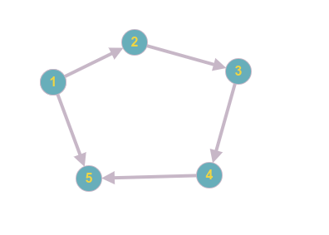

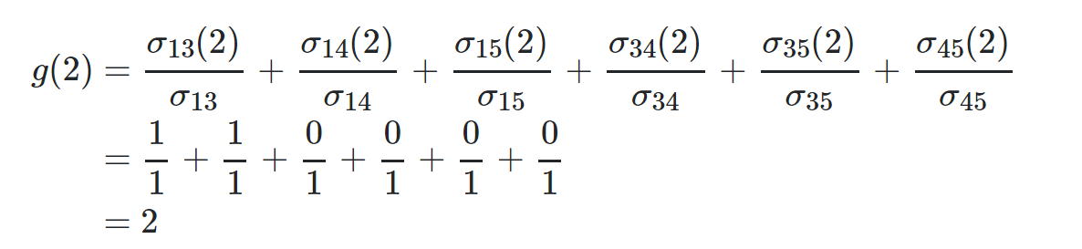

标准化除以4\*3

节点2的betweenness中心度为2/12