

Project Scope Document

Team
Popescu Sabin
Picatureanu Nicusor

Project Charter

Need/Purpose

Developing a website that will provide customers with a wide range of products at the best prices with increased security and an interface that emphasizes customer requirements

Product Description

A website that will provide online shopping in a secure and user-friendly environment including all documentation.

Sponsor Expectations

Our team expects the website to be developed as per their specified requirements, fully functional, completed and on-line by March 1, 2021.

Key Roles

Client – Our Company will provide resources necessary for project completion.

Project Manager – The Project Manager is accountable for the overall direction of the project. The role includes integration of the project plan, approval, reporting, risk and change management. The Project Manager will provide the team support required to lead the team to successful project completion.

Business Consultant – The Business Consultant will provide the information and business expertise necessary to facilitate the website development process to the specifications of our company. Compiling documentation and training materials will be this team members’ responsibility.

Website Developer – With the input and direction provided by the above stakeholders, the Website Developer is responsible for coding of the website to specification and on schedule.

Approved By

______________________________ ______________________________
Project Manager Date

______________________________ ______________________________
Client Date

Project Scope Statement

Justification:
In support of the City’s, our company want to simplify and streamline online shopping . To this end, we plan to develop a website that will allow our citizens to apply & pay for things like clothes, electronics or clocks online via the Internet.

Description:
The website will have the following features - it will be accessible from any browser, safe and easy to use (in terms of ease of use). Users will be able to use a free account to make their purchases online

Deliverables:
- functional website allowing users access at their convenience (24 hours a day, 7 days a week)
- user documentation & help feature
- staff training, support & maintenance documentation

Objectives:
- site will be constructed & available for testing by February 1, 2021
- go live date: March 1, 2021 – permit applications will be accepted & processed via the website - final testing & staff training will be complete

Constraints:
- project to be completed within the $35,000 budget
- due to the mayor’s early announcement of the project roll out (press conference), the March 1, 2021 date is fixed.

Assumptions:
- Our company will make budget and other resources available.
- Legal issues regarding signature authentication will be overcome prior to project start date of December 1, 2020.
- Security and credit authorization issues will be managed corporately and with existing mechanisms.

Approved By

______________________________ ______________________________
Project Manager Date

______________________________ ______________________________
Client Date

Work Breakdown Structure

WBS | Task Name
1 | Project Management
1.1 | Scope
1.1.1 | Determine project scope
1.1.2 | Define preliminary resources
1.1.3 | Develop preliminary budget
1.1.4 | Secure project sponsorship
1.1.5 | Secure core resources
1.1.6 | Scope complete
1.2 | Post Implementation Review
1.2.2 | Review with team members/stakeholder
1.2.3 | Post implementation review complete
1.2.1 | Document lessons learned
1.3 | Communication
1.3.1 | Site Promotion
1.3.1.1 | Develop Site Promotion Strategy
1.3.1.2 | Obtain Approval
1.3.1.3 | Forward approved strategy to Corporate Communications Dept
1.3.2 | Project communication
1.3.2.1 | Stakeholder Review
1.3.2.1 | Project Status Meetings
2 | Analysis/Website Requirements
2.1 | Develop Website Content
2.2 | Draft preliminary website specifications
2.3 | Review website specifications/budget with team
2.4 | Analysis complete
3 | Site Design
3.1 | Review preliminary website specifications
3.2 | Develop functional specifications
3.3 | Develop site security requirements
3.4 | Develop prototype based on functional/security specifications
3.5 | Validate functional/security specifications
3.6 | Obtain design approval
3.7 | Design complete
4 | Initial Site Development
4.1 | Review functional design
4.2 | Identify external interfaces
4.3 | Develop website and interfaces
4.4 | Initial site development complete

Work Breakdown Structure (Continued)

WBS | Task Name
5 | Test Plan Development
5.1 | Develop unit test plans using website specifications
5.2 | Develop external interface test plan
5.3 | Develop security test plan
6 | Site Testing and Final Development
6.1 | Review testing plans
6.2 | Test to specifications
6.3 | Identify gaps to specifications
6.4 | Modify website
6.5 | Re-test modified website
6.6 | Site Testing and Final Development complete
7 | Training
7.1 | Develop in-house training requirements
7.2 | Develop in-house training materials
7.3 | Train support staff
7.4 | Training complete
8 | Documentation
8.1 | Develop online help documentation
8.2 | Develop programmer documentation
8.3 | Documentation complete
9 | Deployment
9.1 | Develop deployment plan
9.2 | Install and deploy website
9.3 | Deployment complete

Budget

WEBSITE 2000 Budget Plan | Nov. 10,2000
Analysis | $ 3,400.00
Communication | $ 1,300.00
Deployment | $ 1,200.00
Documentation | $ 1,600.00
Initial Development | $ 7,000.00
Post Implementation Review | $ 1,600.00
Project Management | $ 4,000.00
Site Design | $ 3,600.00
Site Testing and Final Development | $ 4,100.00
Test Plan Development | $ 1,200.00
Training | $ 3,200.00
Miscellaneous Project Expense | $ 2,800.00
Grand Total | $ 35,000.00

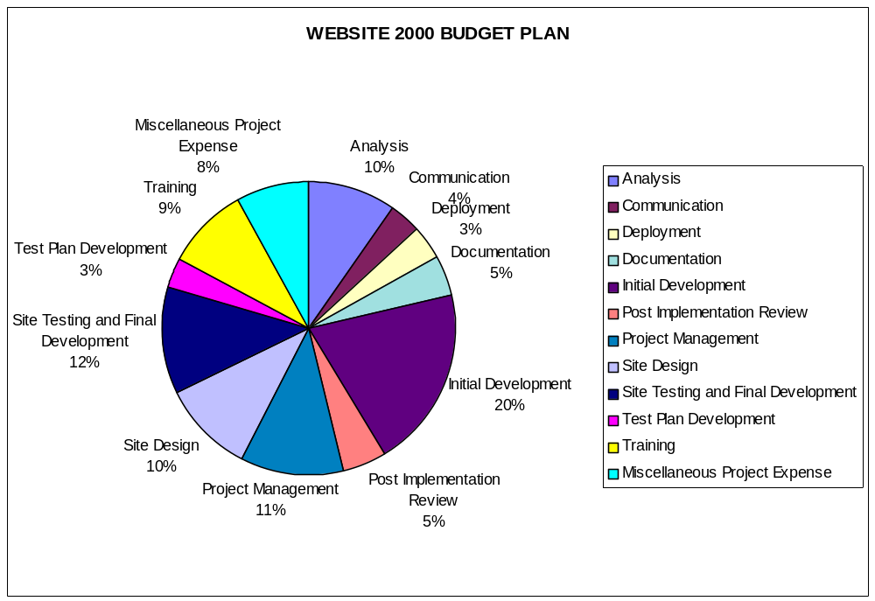
Human Resource Plan

Roles and responsibilities

Project Managers: Popescu Sabin and Picatureanu Nicusor have over 15 years of experience in project management in both small and large projects with a proven track record of implementing projects on time, within budget and specifications. Popescu Sabin and Picatureanu Nicusor brings excellent communication, interpersonal, and interdepartmental skills allowing for allowing for effective integration of project deliverables and meeting of client expectations.

Business Consultant: Ken Allen, B Comm, CACE, with 18 years of experience in the Public Works Department, brings extensive knowledge of the organization and the permit services processes.

Website Developer: Derek Graves, B Sc, CET, with 9 years of varied project programming experience with the City. Derek has been involved in the development of the overall website standards for the City.

Reporting Structure

Project Risk Analysis

Risk: Interfacing to City’s Credit Authorization System | Risk Number: 1
Risk Owner: Website Developer | Phone: 789-1234
Date: 14 Nov 2000 | Approval: Picatureanu Nicusor and Popescu Sabin

Risk Identification

Interfacing from the Department of public works website to the City’s Credit Authorization back-end systems may be problematic and cause a delay in the implementation of the project

Risk Quantification

If all goes well, this risk will not manifest itself but if these problems do arise, we foresee a two-day schedule overrun which will cost us an additional $800 in regular time wages (+/- 1 day). Based on similar projects we’ve undertaken, there is a less-than 25% chance of this risk occurring.

Risk Response

Given the nature of programming projects, this small risk is not an unusual one and has been accepted by the team. The Project Managers will monitor the schedule for any variance in this area and will confer with the developer to ensure that should this risk event occur, the project will still be completed on time.

Adjustments to the Project Plan

Some of the float days at the end of the project may be consumed in covering this risk event.

Approved By

______________________________ ______________________________
Project Manager Date
Project Risk Analysis

Risk: Legal Issues Regarding Signatory Authentication | Risk Number: 2
Risk Owner: Project Manager | Phone: 987-5432
Date: 14 Nov 2000 | Approval: Popescu Sabin  Picatureanu Nicusor

Risk Identification

The City’s Legal Services Department approval is required for use of electronic signatures.

Risk Quantification

If unapproved, an alternative (manual) method of authentication will be required and much of the functionality of the website (as described in our scope statement deliverables) will be unavailable to permit applicants. A manual process would have a significant negative impact on project cost and scope. A new business process for handling these transactions manually would need to be developed as well as a new application interface to confirm signatures on-file. Additionally, ongoing labour costs to implement this solution would be higher than planned.

Risk Response

In attempting to mitigate this risk event, the Project Managers will contact Legal Services and get approval in principle prior to commencement of the analysis of website requirements.

Adjustments to the Project Plan

No adjustments will be made at this time but a manual process may need to be developed if the Project Manager does not get approval from Legal Services.

Approved By

______________________________ ______________________________
Project Manager Date

