A Project Report On
Online Book Orbit Store
Submitted in partial fulfillment of the requirement for the award of the degree
Bachelor of Computer Application (BCA)
Academic Year 2025–26
Student PAYAL KHUNTI
Enrollment No. 92300527185
Internal Guide : Jignesh Hirapara
Faculty of Computer Applications (FCA)
Marwadi University
Rajkot-Morbi Road, At & PO : Gauridad, Rajkot 360 003. Gujarat, India.


CERTIFICATE

This is to certify that the project work entitled “Online Book Orbit Store” submitted in partial fulfillment for the award of the degree of Bachelor of Computer Application of Marwadi University is a result of the bonafide work carried out by the following students during the academic year 2025–26:
1) PAYAL KHUNTI Enrollment No. 92300527185
Faculty Guide: Jignesh Hirapara
HOD: sunil bajeja
Dean: Dr. R. Sridharan

DECLARATION
We hereby declare that this project work entitled “Online Book Orbit Store” is an original record of work carried out by us. The matter embodied in this project is genuine and has not been submitted to this or any other University/Institute for any course of study.
Place: marwadi university
Date: 25-8-25
Student : PAYAL KHUNTI (payal)

ACKNOWLEDGEMENT
We express our sincere gratitude to our internal guide for continuous guidance and support throughout the project. We also thank the FCA faculty, HoD and Dean for their encouragement, and our friends for their cooperation.

CONTENTS
1. SYNOPSIS
2. PREAMBLE
2.1 General Introduction
2.2 Module Description
3. REVIEW OF LITERATURE
4. TECHNICAL DESCRIPTION
4.1 Hardware Requirement
4.2 Software Requirement
5. SYSTEM DESIGN AND DEVELOPMENT
5.1 Architectural Design
5.2 Dynamic Modelling (Use Case, Sequence, Activity)
5.3 Database Design (ER)
5.4 Menu Design
5.5 Screen Design
6. CONCLUSION
7. LEARNING DURING PROJECT WORK
8. BIBLIOGRAPHY

1. SYNOPSIS
Online Book Orbit is a simple ASP.NET WebForms application that demonstrates core e-commerce features for a book store: user login, a catalog of books, a shopping cart using Session state, user reviews with star ratings, and a checkout confirmation page. The prototype stores data in in-memory DataTables and Session for demonstration and can be extended to a database-backed implementation.

2. PREAMBLE

2.1 General Introduction
The project showcases a web application where users can browse technical books, add selected titles to a cart, post reviews, and complete a mock checkout. It is built with ASP.NET WebForms (ASPX pages with C# code-behind) and Bootstrap-based styling.

2.2 Module Description
• User Authentication (Login)
• Book Catalog (Browse & Add to Cart)
• Shopping Cart
• Reviews & Ratings
• Checkout & Order Confirmation

3. REVIEW OF LITERATURE
E-commerce application patterns commonly utilize session-based carts, grid-based product listing, and event-driven WebForms. This project adopts a minimal session-centric design suitable for academic demonstration and future migration to layered architectures.

4. TECHNICAL DESCRIPTION

4.1 Hardware Requirement
• Development Machine: Intel/AMD CPU, 8 GB RAM, 10 GB free disk
• Deployment: IIS-capable Windows server (for WebForms)

4.2 Software Requirement
• OS: Windows 10/11
• IDE: Visual Studio
• Framework: .NET Framework (WebForms)
• Server: IIS/ASP.NET Development Server
• UI: Bootstrap (CSS)

5. SYSTEM DESIGN AND DEVELOPMENT

5.1 Architectural Design
Three-layer view: Client Browser → ASP.NET WebForms (Pages + Session) → Data Layer/Database.
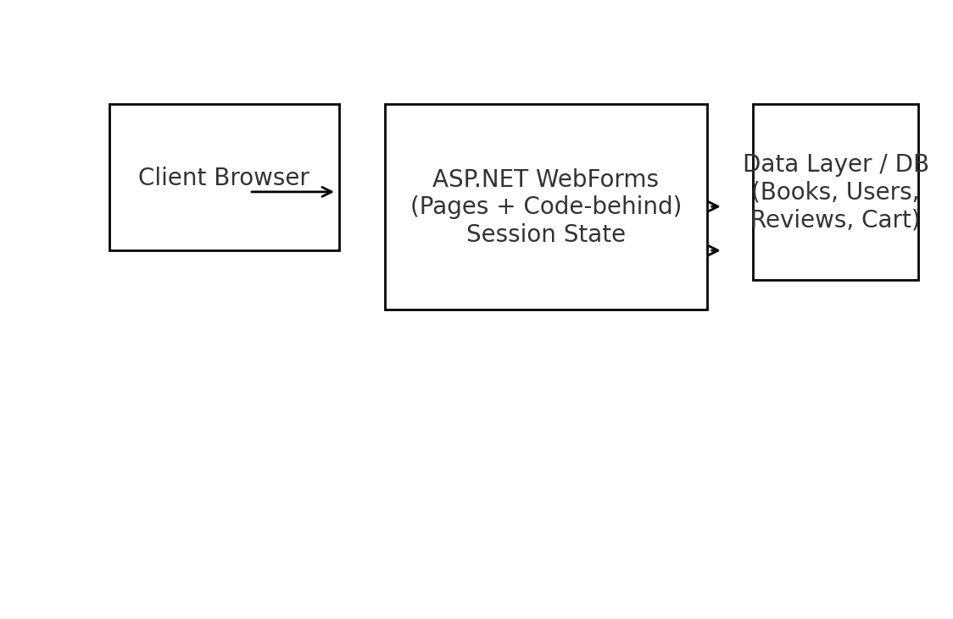

5.2 Dynamic Modelling
5.2.1 Use Case Diagram
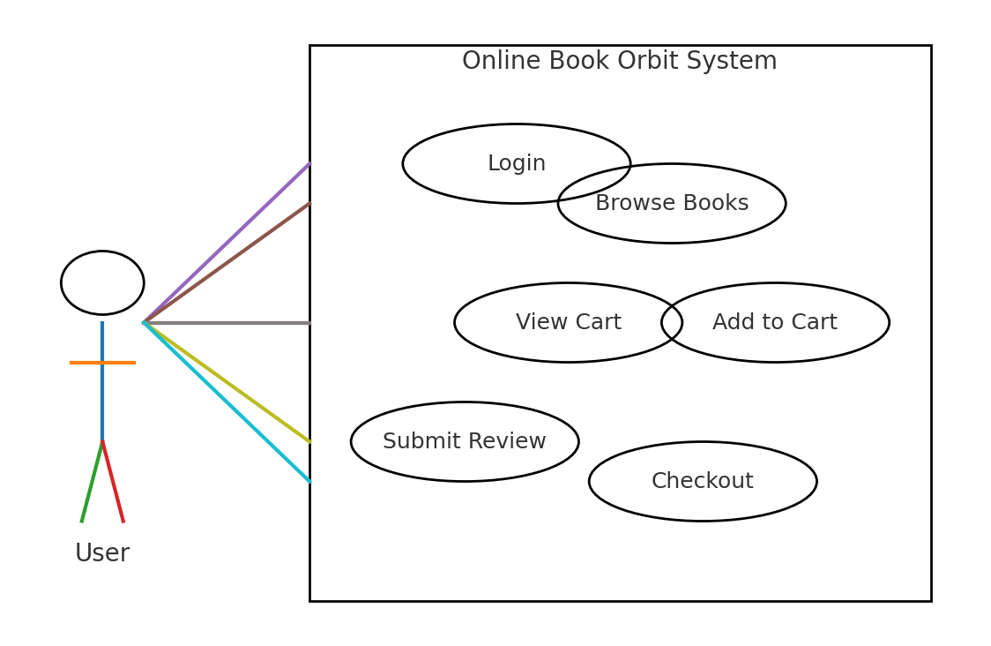
5.2.2 Sequence Diagram (Add to Cart & Checkout)
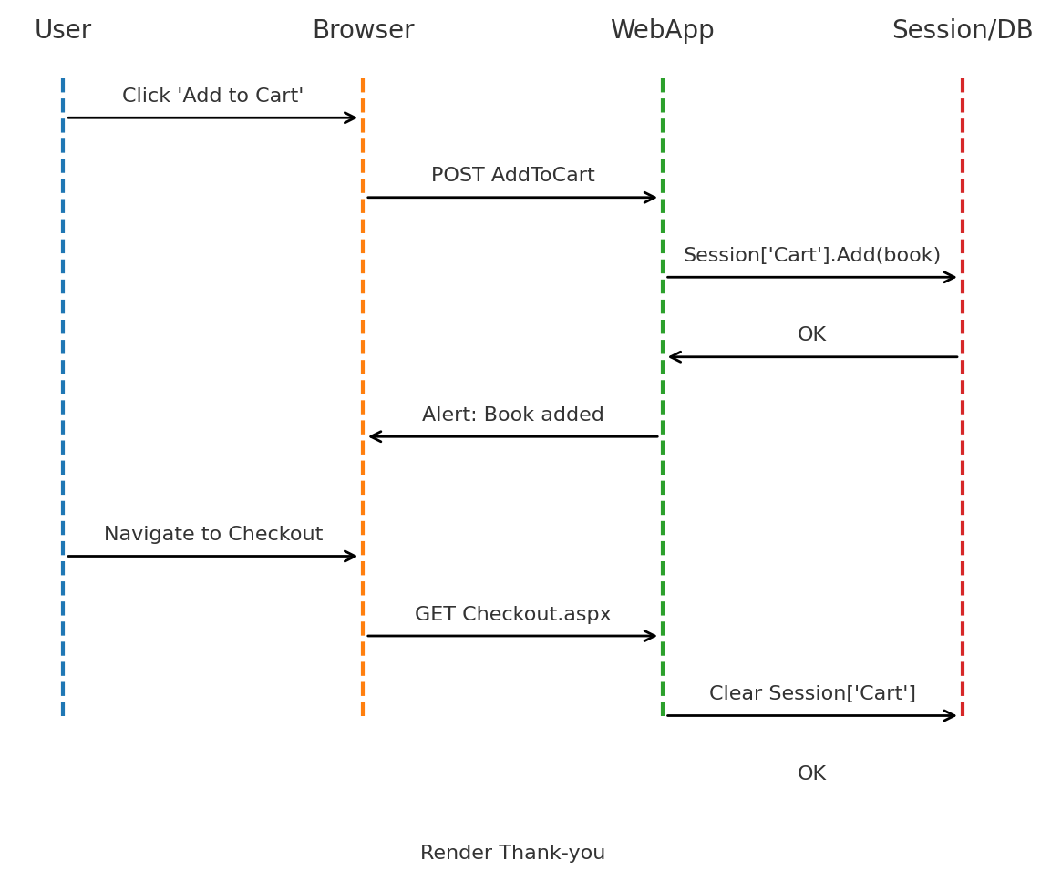
5.2.3 Activity Diagram (Login Flow)
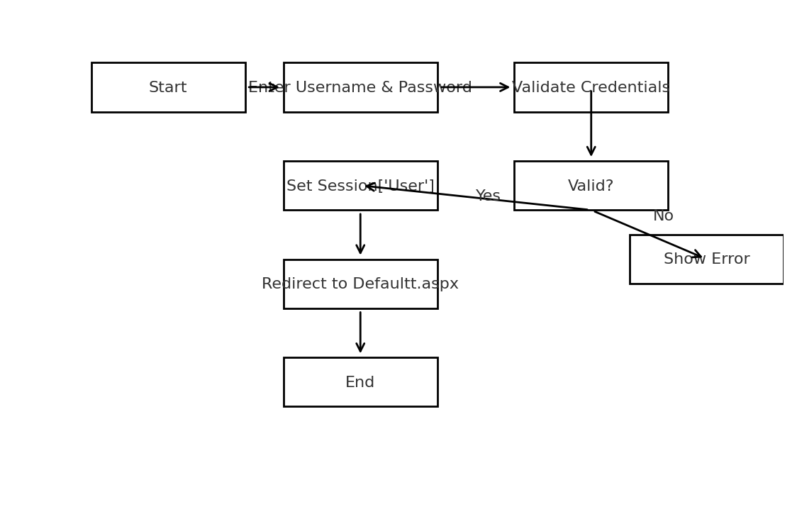

5.3 Database Design (ER)
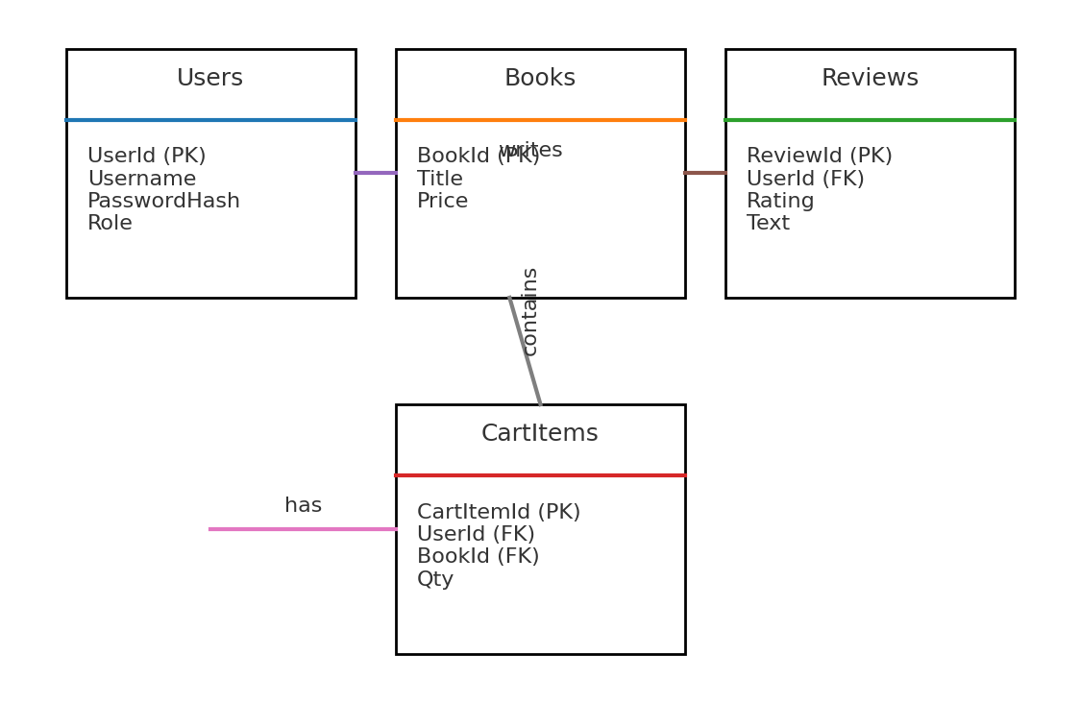

5.4 Menu Design
Top-level navigation:
• Home (Defaultt.aspx) – shows book grid with Add to Cart
• Cart (Cart.aspx) – shows selected items
• Reviews (Reviews.aspx) – submit/view feedback
• Login (Login.aspx) – user authentication

5.5 Screen Design
Login.aspx
– Username & Password input
– Hardcoded demo users: 'user/123', 'admin/admin'
– Sets Session['User'] and redirects to Defaultt.aspx on success
– Shows error label on failure
Defaultt.aspx
– Shows grid of books (Id, Title, Price)
– Add to Cart button per row
– Session-based welcome label using Session['User']
– Links: Cart.aspx, Reviews.aspx, Login.aspx
Cart.aspx
– Displays Session['Cart'] items inside GridView
– Shows 'cart is empty' message when applicable
– Link back to Defaultt.aspx for shopping
Reviews.aspx
– Star rating (1–5) via inputs
– Text review box
– Stores reviews in Session['Reviews']
– Displays reviews in BulletedList
Checkout.aspx
– Thank-you page
– Clears Session['Cart'] on load

5.6 Class Diagram (Code-Behind Overview)
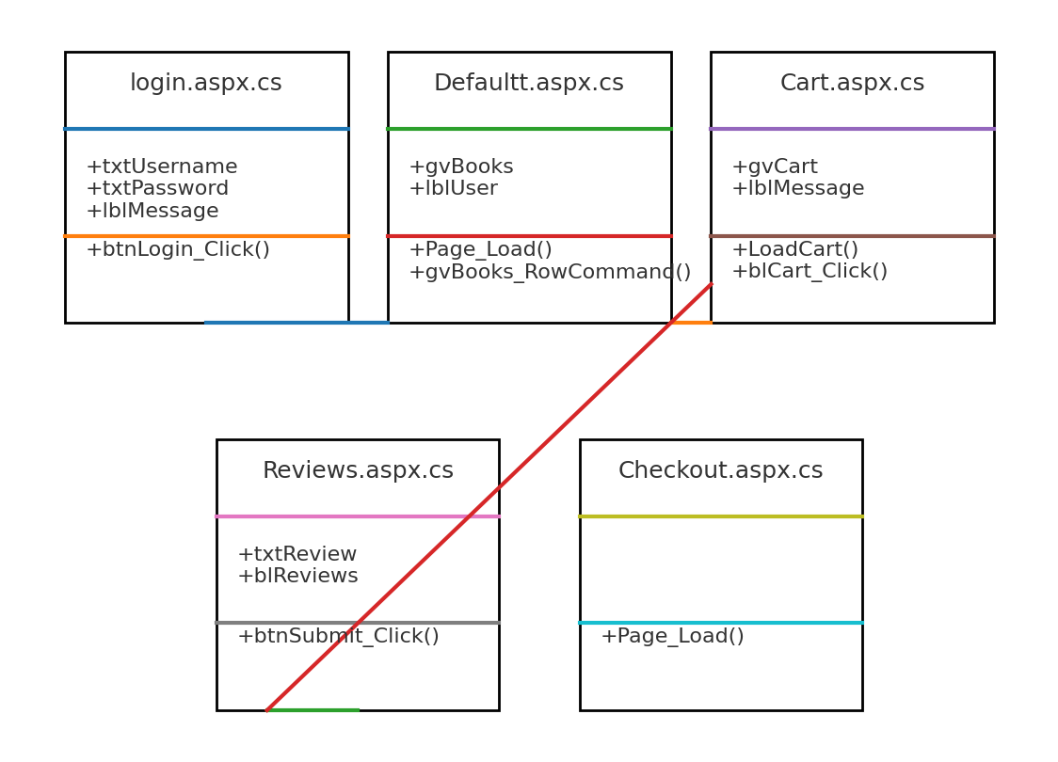

6. CONCLUSION
The prototype demonstrates a compact online bookstore with core flows implemented using ASP.NET WebForms. Future work includes integrating a relational database, proper authentication/authorization, and robust validation.

7. LEARNING DURING PROJECT WORK
• Implemented event-driven web programming with ASP.NET WebForms.
• Used Session state for user context (cart, reviews).
• Designed basic UML and ER diagrams from existing code.
• Understood the pathway to database-backed persistence and layered architecture.

8. BIBLIOGRAPHY
Online references:
• Microsoft Docs: ASP.NET Web Forms overview
• Bootstrap documentation
Offline references:
• Web Application Architecture texts and class notes

