1. THREE CONCLUSIONS WHICH CAN BE MADE ABOUT KICKSTARTER CAMPAIGNS GIVEN THE DATA PROVIDED?
   1. The Kickstarter community displays an affinity for supporting projects with a category related to the arts, as theater, music, and film & video were among the categories with the highest percentage of successful campaigns
   2. There is an apparent correlation between launch dates and success rates, with April – July being the most pronounced time period for launches of successful campaigns.
   3. Cancellation rates appear to have a little to no correlation to seasonal factors based on launch dates
2. WHAT ARE SOME OF THE LIMITATIONS OF THE DATA SET?
   1. This data is not inclusive of all elements which could contribute to the outcome of a campaign. Elements such as quality of the idea, marketing efforts outside the Kickstarter program, experience of the project creators. Goal as a ratio of total needed funding etc.
   2. There is not a declaration on the quality of the data, is it a full set of records for the given time period? Are there data points already omitted? Which criteria were used to assemble the data set? All these elements could contribute to a quality rating for using the data in decision making or evaluative processes.
3. WHAT ARE SOME OF THE POSSIBLE TABLES/GRAPHS WE COULD CREATE?
   1. Correlation between Goal & State outcome (is there a size of project which succeeds more often)
   2. Correlation on marketing efforts on campaign success (staff picks & spotlight)
   3. Concentration of projects by country (is my market underserved or saturated?)
   4. Funding benchmarks (% to goal and average spend) to rate the popularity of a project or as a leading indicator to pace a live project

Chart Examples:

Pivot #1

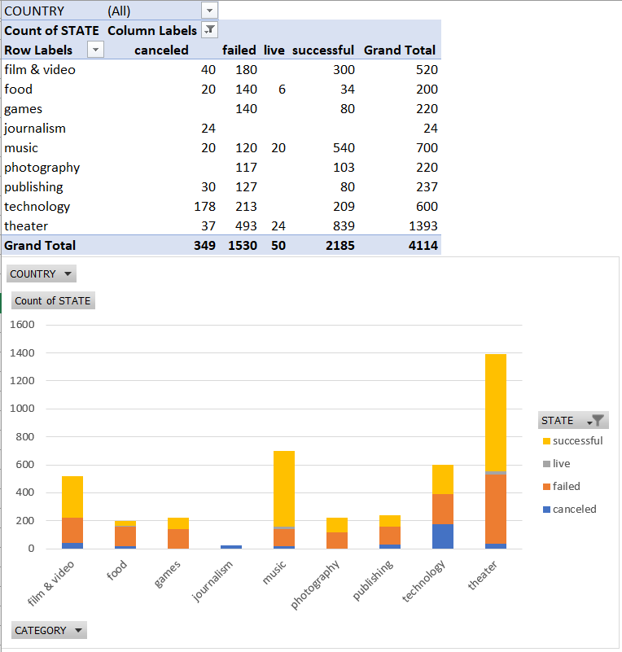

PIVOT #2

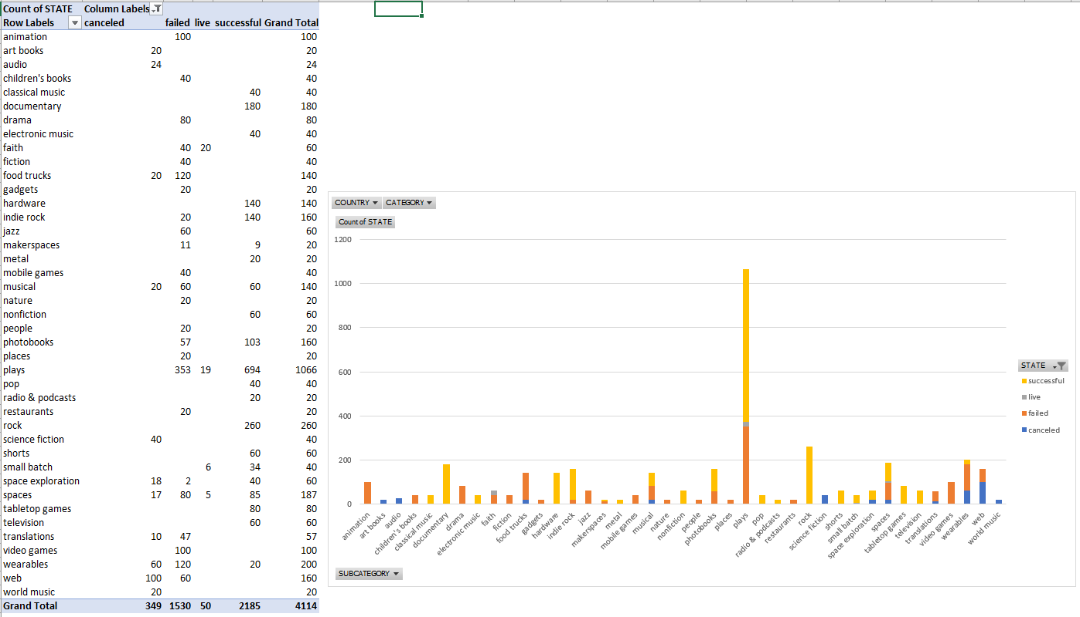

PIVOT #3

