Nida Khan
SP23-BSE-011
BSE-8A
22/OCT/2026
BUSINESS PROCESS
EVOLUTION
Company Analysis and BPMN Case Studies
Executive Summary
This assignment examines how large companies have changed the way they deliver products and services. It first introduces five major companies, then models the evolution of two business processes: Amazon order fulfilment and Walmart grocery pickup/delivery. For each case, a simplified “early/traditional” workflow is compared with a “current/digital” workflow using BPMN-style diagrams. The early diagrams are analytical reconstructions of common historical practices, not claimed to be official internal company diagrams. Current workflows are based on public customer-facing documentation, and internal operational details that are not public are not assumed.
Contents
- 1. Introduction and method
- 2. Five major companies
- 3. Case Study A: Amazon order fulfilment
- 4. Case Study B: Walmart grocery pickup and delivery
- 5. Cross-case comparison and outcomes
- 6. Information artifacts and resources
- 7. Conclusion
- References
1. Introduction and Method
A business process is a connected set of activities used to achieve an outcome, such as receiving an order, preparing a product, and delivering it to a customer. Business process evolution means changing those activities, roles, information flows, and technologies to improve speed, accuracy, cost, customer experience, or control.
BPMN (Business Process Model and Notation) provides a standard visual language for representing processes. In these diagrams, circles represent start/end events, rounded rectangles represent tasks, diamonds represent decisions or gateways, and arrows show sequence flow. Swimlanes identify the participants responsible for work. The diagrams below are simplified BPMN-style models for classroom analysis rather than executable process models.
Method and limitations: the “early version” describes a plausible traditional/manual process that many retailers used before mature e-commerce and app-based fulfilment; it should not be read as a verified exact first process used by Amazon or Walmart. The “current version” follows features publicly described by the companies. Public customer-facing documentation can verify visible steps, but not every internal warehouse algorithm or staffing rule.
2. Five Major Companies
Company | Why it is significant | Main products/services | Process example
1. Amazon | E-commerce, cloud computing, digital services, and logistics. It is a major company because it serves customers at large scale and combines online shopping with extensive fulfilment and delivery operations. | Online retail; marketplace; Prime; AWS. | Order-to-delivery fulfilment.
2. Apple | Designs and sells devices and provides digital services. Its integrated hardware, software, retail, and service ecosystem creates a consistent customer experience. | iPhone, Mac, iPad, Apple services, online and physical retail. | Online order delivery or store pickup.
3. Walmart | A large retailer combining physical stores with online shopping, pickup, delivery, and shipping. Its store network can support both in-store sales and fulfilment of online orders. | Stores, Walmart.com, app, grocery, pickup and delivery. | Grocery order pickup/delivery.
4. Microsoft | Provides productivity software, operating systems, cloud services, developer tools, and AI services. Its business is large and diversified across consumer and enterprise customers. | Microsoft 365, Windows, Azure, Teams, developer and AI tools. | Cloud service provisioning (not diagrammed).
5. Alphabet (Google) | Provides information and digital services used globally, including Search, YouTube, Android, Maps, Gmail, and Google Cloud. Its scale comes from widely adopted platforms and advertising-supported services. | Search, YouTube, Android, Maps, Gmail, Cloud. | Search/ad service delivery (not diagrammed).

3. Case Study A: Amazon Order Fulfilment
3.1 Process objective
The objective is to take a customer order, confirm that it can be fulfilled, prepare the package, hand it to a delivery provider, and inform the customer of delivery progress. The public customer experience includes digital ordering and order-status information; the internal fulfilment process is simplified here because Amazon does not publish all of its internal operational rules.
3.2 Early / traditional version
Before online retail became common, a typical retail fulfilment process relied on a physical store or a sales desk, manual order records, staff checking stock, manual packing, and a carrier or postal service. This is used as a baseline illustration, not as a claim that Amazon started with this exact workflow.
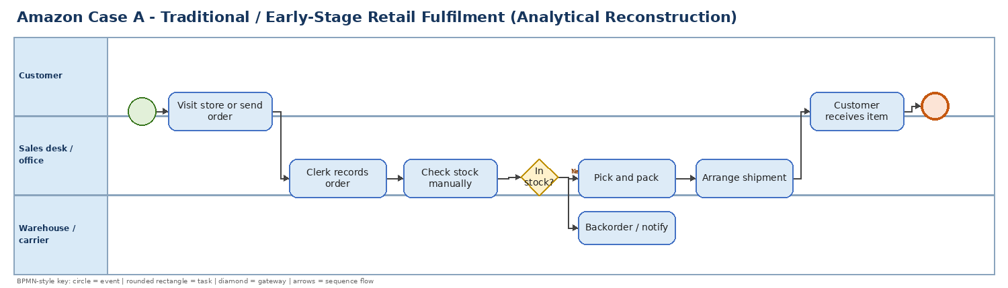
Figure 1. Traditional/manual retail fulfilment baseline (analytical reconstruction).
3.3 Current digital version
In a current online order journey, a customer browses a digital catalogue, places an order, and receives order and shipment information. Behind the customer interface, payment validation, inventory allocation, picking, packing, carrier handoff, tracking, and delivery coordination must be connected. The diagram abstracts these internal activities into a BPMN-style model; exact warehouse automation and allocation logic vary by order and are not asserted as a complete description of Amazon’s internal systems.
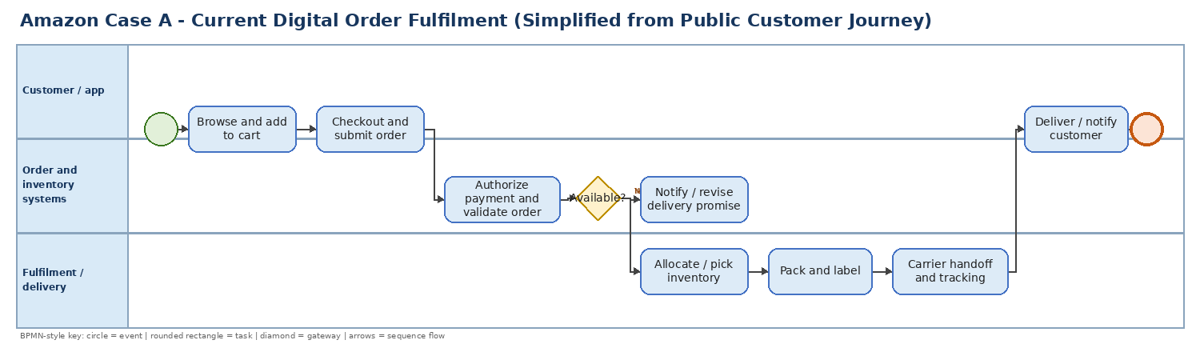
Figure 2. Simplified current digital order-fulfilment process.
3.4 Evolution and rationale
Dimension | Traditional baseline | Current digital model | Expected result
Order capture | In-person or paper/telephone request | Website/app checkout | Convenience and wider geographic reach
Order information | Manual records and staff communication | Structured electronic order record | Fewer transcription errors; easier status visibility
Inventory check | Physical/manual stock check | System-supported availability and allocation | Faster stock decisions; better coordination
Warehouse work | Manual picking and packing | Digitally coordinated fulfilment; tools/automation may assist | Throughput and consistency can improve
Delivery communication | Limited proactive status updates | Shipment notices and tracking information | More transparency for customers
Exception handling | Phone call or manual follow-up | System notices, revised promises, or support route | Exceptions become more visible and manageable

3.5 Information artifacts and resources
- Customer order/cart: items, quantity, delivery address, and selected delivery option.
- Payment authorization/status: determines whether the order can proceed.
- Inventory/availability record: supports allocation and exception handling.
- Pick list and packing label: guide warehouse staff and identify the package.
- Shipment record/tracking number: links the parcel to delivery progress.
- Customer notifications/order-status page: communicate confirmation, shipment, and delivery updates.
- Resources/roles: customer, e-commerce interface, payment service, inventory/order management system, fulfilment staff and equipment, carrier, customer support.
4. Case Study B: Walmart Grocery Pickup and Delivery
4.1 Process objective
The process objective is to let a customer select grocery items and a fulfilment option, pay for an order, have store associates gather the items, and either hand the order to the customer at pickup or deliver it to the requested address. Walmart’s public help pages describe ordering online, selecting pickup or delivery, choosing a time slot, receiving a ready notification, and checking in for curbside pickup.
4.2 Early / traditional version
In the traditional grocery-shopping baseline, customers travelled to a store, selected products themselves, paid at checkout, and carried the groceries home. If an item was unavailable, the customer usually had to select another item or return later. This baseline is a general comparison, not an official historical internal process map from Walmart.
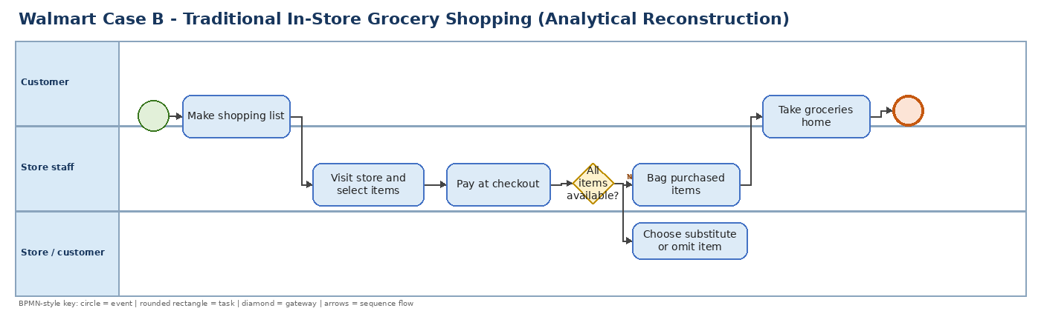
Figure 3. Traditional in-store grocery-shopping baseline (analytical reconstruction).
4.3 Current digital version
In the current app/site process, the customer signs in, chooses the fulfilment method and store, selects products, and submits an order. A store associate gathers and bags the items. The customer receives a ready notification and checks in on arrival, or the order is delivered where service is available. Walmart’s public documentation says customers can select a pickup slot or delivery and use app/text/email links to check in for curbside pickup.
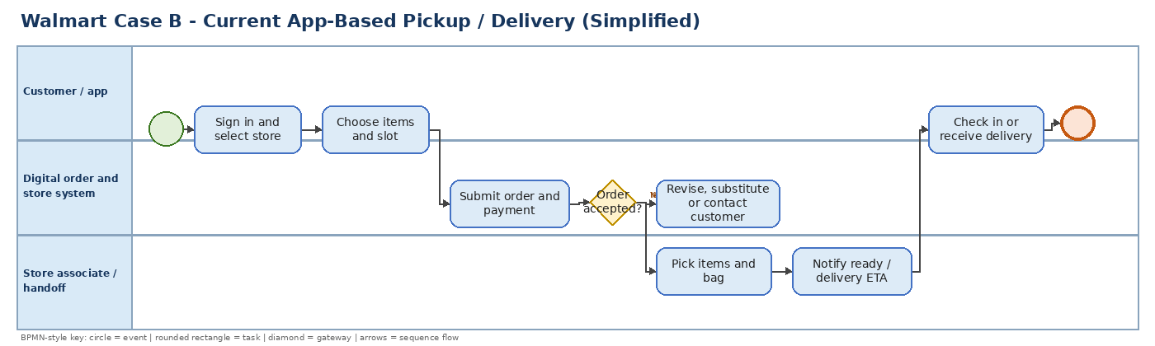
Figure 4. Simplified current Walmart app-based pickup/delivery process.
4.4 Evolution and rationale
Dimension | Traditional baseline | Current digital model | Expected result
Shopping access | Customer visits aisles | Items selected online in advance | Saves in-store shopping time
Item gathering | Customer picks every item | Store associate picks and bags order | Convenience; store becomes fulfilment point
Time planning | Arrival time largely customer-controlled | Pickup time slot or delivery option | Improved planning and demand scheduling
Communication | Mostly face-to-face/in-store | Ready notifications and app/text check-in | Clearer handoff and fewer unnecessary waits
Handoff | Customer carries basket through checkout | Curbside associate handoff or doorstep delivery | More convenient collection/delivery
Exceptions | Customer substitutes in aisle | Availability changes may require substitutions/contact | Need accurate inventory and clear communication

4.5 Information artifacts and resources
- Customer account and selected store/location.
- Online basket/order record with item quantities and fulfilment method.
- Pickup slot or delivery address and estimated time.
- Availability and substitution information for out-of-stock items.
- Payment/order confirmation and ready-for-pickup notification.
- Customer check-in status, parking spot/vehicle detail when applicable, and handoff confirmation.
- Resources/roles: customer, Walmart website/app, order and store systems, store associate, pickup staging area, delivery worker/partner when selected, customer support.
5. Cross-Case Comparison and Outcomes
Aspect | Amazon online fulfilment | Walmart grocery pickup/delivery
Main process goal | Move a product from order to shipment and delivery. | Prepare a grocery order and hand it to the customer by pickup or delivery.
Digital starting point | Catalogue, cart, checkout. | Customer account, store selection, online basket and time slot.
Physical operations | Fulfilment centre/warehouse and carrier. | Retail store, picking/staging area, curbside handoff or delivery.
Customer visibility | Order status, shipment information and tracking. | Order confirmation, ready notice, check-in, pickup/delivery status.
Most important information | Order, payment, inventory, package and shipment records. | Basket, item availability, slot, substitutions, ready status and handoff.
Likely benefits | Scale, reach, visibility, and improved coordination. | Time saving, convenient collection, and use of stores as fulfilment locations.
Key risks | Inventory mismatch, delivery delay, payment/technical errors. | Stock-outs, substitutions, late picking, slot capacity and last-mile delays.

5.1 Outcomes and interpretation
The primary change in both examples is not simply “using a website.” It is the redesign of the whole process around shared digital information. An online order becomes a structured record that can coordinate payment, stock, preparation, status messages, and delivery/pickup. This can improve convenience and transparency, but only if the information is accurate and staff, systems, and physical operations remain well coordinated.
Potential outcome measures for a real organization would include order cycle time, order accuracy, stock-out/substitution rate, on-time fulfilment rate, cost per order, customer satisfaction, and number of support contacts. No numeric performance improvements are claimed in this assignment because a consistent before-and-after company dataset was not available from the cited public sources.
5.2 Peer review and comparison checklist
When comparing classmates’ submissions, use the following criteria and write the actual names and observations after reviewing their PDFs. Do not invent peer results before viewing the other submissions.
Review criterion | Questions to ask | Outcome to record
Company selection | Are the companies clearly introduced and their significance explained? | Strong / adequate / needs improvement + reason
Process evolution | Does each case show a clear baseline and current process? | Identify the clearest evolution and why
BPMN quality | Are events, tasks, gateways, arrows and roles understandable? | Note missing or ambiguous notation
Evidence | Are current steps backed by credible public references? | Note claims that lack sources
Artifacts/resources | Are data records, roles, systems and physical resources identified? | List any missing artifacts/resources
Overall result | Which solution is clearest, most realistic and best supported? | Summarize strengths, gaps and lessons learned

Peer-review conclusion template: “After reviewing the submissions, I found that the strongest solution was __________ because __________. A common strength was __________, while a common gap was __________. My main learning was __________.” Complete this paragraph after reviewing classmates’ work.
6. Information Artifacts and Resources at a Glance
Artifact/resource | Amazon fulfilment | Walmart pickup/delivery
Primary data object | Customer order and order status | Grocery basket/order and fulfilment choice
Decision data | Payment result and inventory availability | Item availability, slot capacity, substitution/acceptance
Work instruction | Pick list, pack/label instruction | Store picking list and bag/staging instruction
Communication | Confirmation, shipment and tracking updates | Confirmation, ready notice, check-in/pickup instructions
Human resources | Fulfilment staff, carrier, customer support | Store picker, pickup associate/delivery worker, support
Technology resources | Web/app, order/inventory services, tracking systems | Website/app, store/order systems, notifications and check-in
Physical resources | Warehouse, packaging material, transport network | Store shelves, staging area, parking/handoff and delivery vehicle

BPMN modeling note: artifacts can be represented as data objects (documents/records) and data stores when producing a more formal diagram. The diagrams in this assignment keep the main sequence flows readable and list the supporting artifacts separately.
7. Conclusion
The five companies demonstrate how large organizations combine products, services, digital platforms, and physical operations. The Amazon and Walmart case studies illustrate two different process designs: shipping goods through a fulfilment and delivery network, and using stores to prepare customer-selected grocery orders for pickup or delivery. Both processes have evolved from high customer effort and manual coordination toward digitally coordinated, more visible customer journeys. The most important lesson is that successful process evolution requires aligned people, information, technology, and physical resources—not technology alone.

