**Assignment**

**Name Nida Mubarak**

**Istitute Kicsuet**

**Istructor Sir.Tahir Shafi**

**Topic Color Meanings**

**Red:**

Powerful and Passionate: Confidence - Energy - Intensity

The color red attracts attention and evokes strong emotions from viewers. It is universally seen as representative of romance. It also causes increased heart rate and appetite, as well as a sense of urgency.

What a Red Logo Says About Your Brand

A red logo shows that your brand is powerful and high-energy. If your company is a restaurant, red is a wise choice. It’s been proven to increase appetite, which is ideal for a business that is trying to encourage food purchases. Its ability to **increase heart rate** is also good for brands trying to create urgency, like in clearance sales or for items that are typically impulse buys.

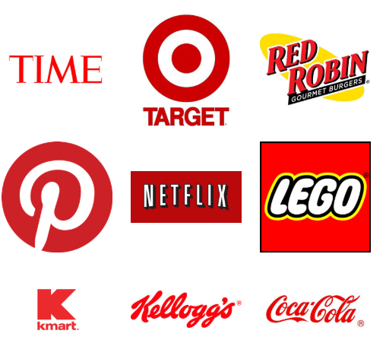

**Black:**

Serious and Sophisticated: Elegance - Seriousness - Exclusivity

Black is seen as a serious, no-frills color, and can evoke a feeling of sophistication. Although it might look plain, it is often used for luxury products because of its sense of elegance and glamor. Black can also show consumers that your brand is mysterious and exclusive.

What a Black Logo Says About Your Brand

If your company has a black logo, you probably aren’t using it to attract attention. Your company wants to be seen as **well-established**, with a strong reputation or sense of elegance, and your logo is part of that desire. You don’t feel that flashy colors are necessary to send a message.

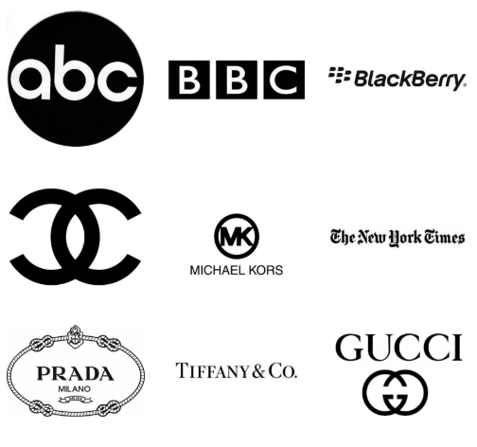

**Green:**

Youthful and Earth-Friendly: Health - Tranquility - Freshness

Green represents growth, and evokes a feeling of relaxation and healing. It is the color of healthy vegetation, so it reminds viewers of nature and health. It is also associated with money and wealth.

What a Green Logo Says About Your Brand

Above all, a green logo conveys the message that your company is **environmentally friendly**. This explains why it is so popular with organic and vegetarian brands, as well as companies that strive for ethical practices. It can also be a good choice for financial companies, since it **reminds consumers of money**.



**Purple:**

Luxurious and Wise: Royalty - Wealth - Success

As the classic color of nobility and kings, it is no surprise that purple is commonly associated with **wealth and luxury**. It is also representative of fantasy, mystery, and magic, and can evoke a feeling of wisdom and imagination. Beauty brands often use shades of purple in their logos, especially those with anti-aging products.

What a Purple Logo Says About Your Brand

A purple logo shows that your brand is luxurious and imaginative. It can attract consumers who want to be seen as wealthy or wise, as well as ones who are inclined towards a feeling of magic or mystery.

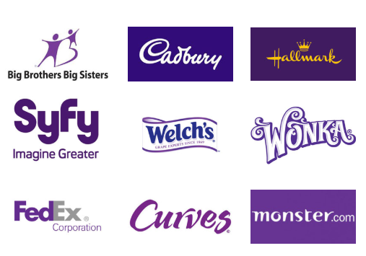

**Orange:**

Playful and Enthusiastic: Excitement - Warmth - Creativity

Orange is associated with playfulness and enthusiasm. This color is said to **activate brain activity**, but it can also be seen as aggressive due to its eye-catching nature. This combination of friendliness and mental stimulation makes it great for inspiring consumers to take action.

What an Orange Logo Says About Your Brand

An orange logo sends the message that your company is friendly and cheerful. This makes it a good choice for brands who want to be seen as light-hearted and not too serious, but still confident.

