Imdad AI
Project Flow and Pipeline Overview
Product  AI-powered IT ticket desk | Roles  User, Support Engineer, Admin | Purpose  Resolve faster and track support work

1. Project Summary
Imdad AI is a role-based AI help desk system that helps users report technical issues, receive instant Knowledge Base or AI troubleshooting, and create support tickets when human support is required.
- Frontend: React and Vite with a premium SaaS-style multi-page UI.
- Backend/data layer: Supabase for tickets, Knowledge Base entries, and chat history.
- AI workflow: Knowledge Base-first search, then AI troubleshooting when no KB match is found.
- Roles: User, Support Engineer, and Admin, each with its own dashboard and permissions.

2. End-to-End System Flow
The full system starts with role-based access, then routes each role into the right workspace.
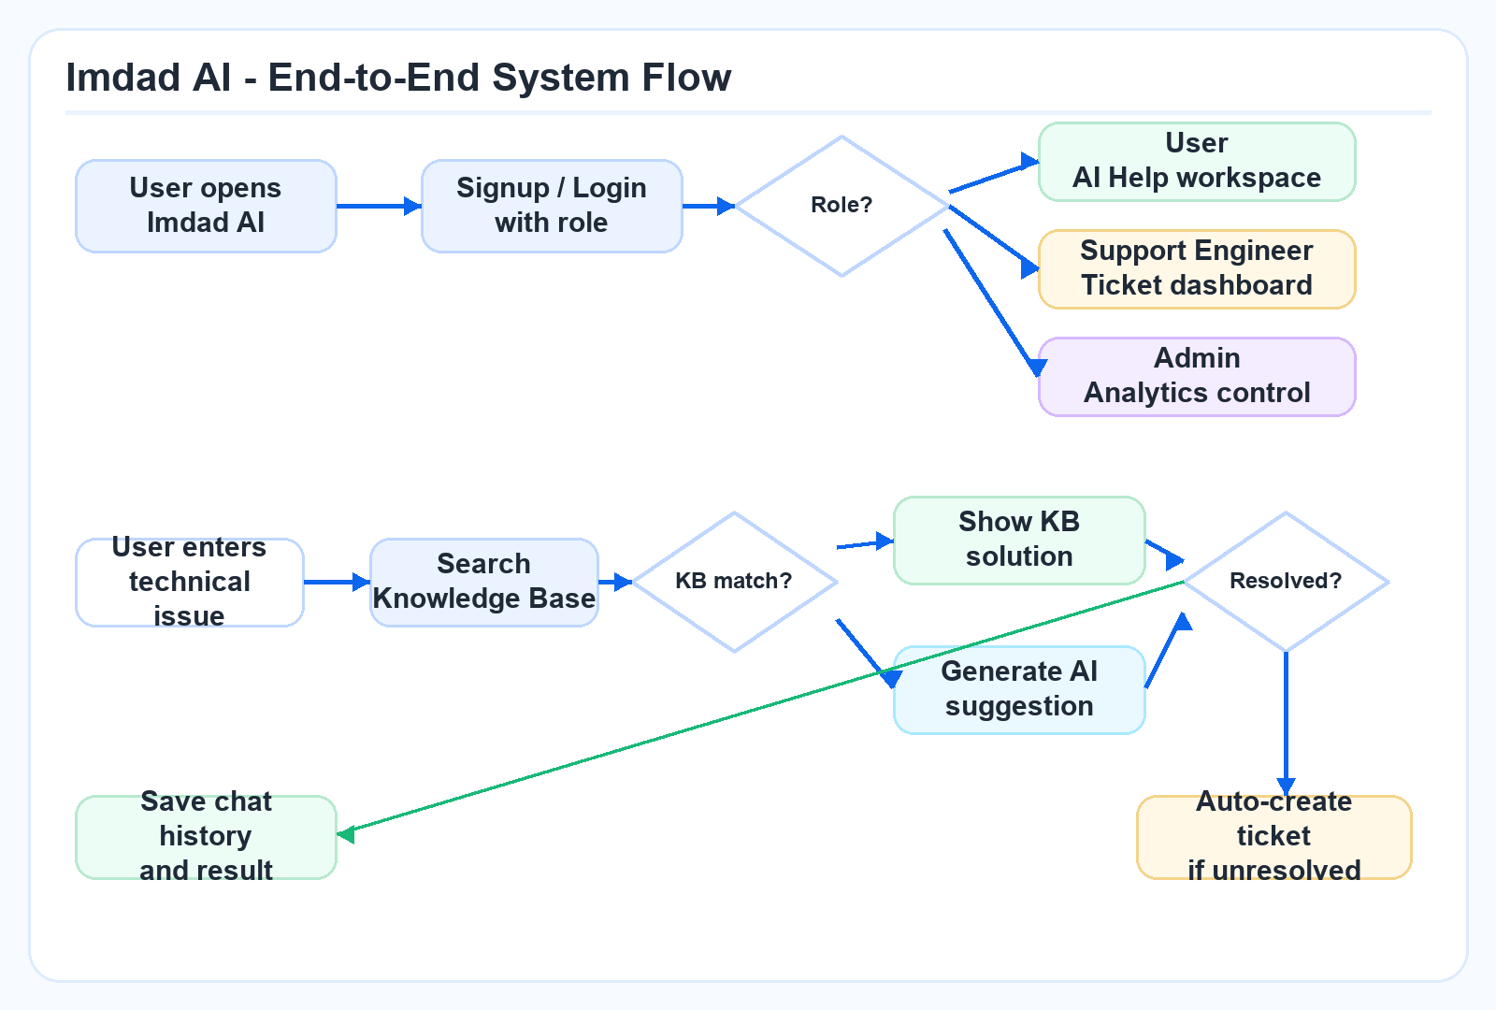

3. User Support Pipeline
- The user enters a technical issue in the AI Help module.
- The system searches Knowledge Base entries by keyword.
- If a match exists, the KB solution is shown immediately.
- If no match exists, the issue is sent to the AI troubleshooting layer.
- If the issue is resolved, the interaction is stored as resolved chat history.
- If unresolved, a ticket is created automatically and becomes trackable.

4. Ticket Creation Pipeline
When human support is needed, the system converts the conversation into a structured support ticket.
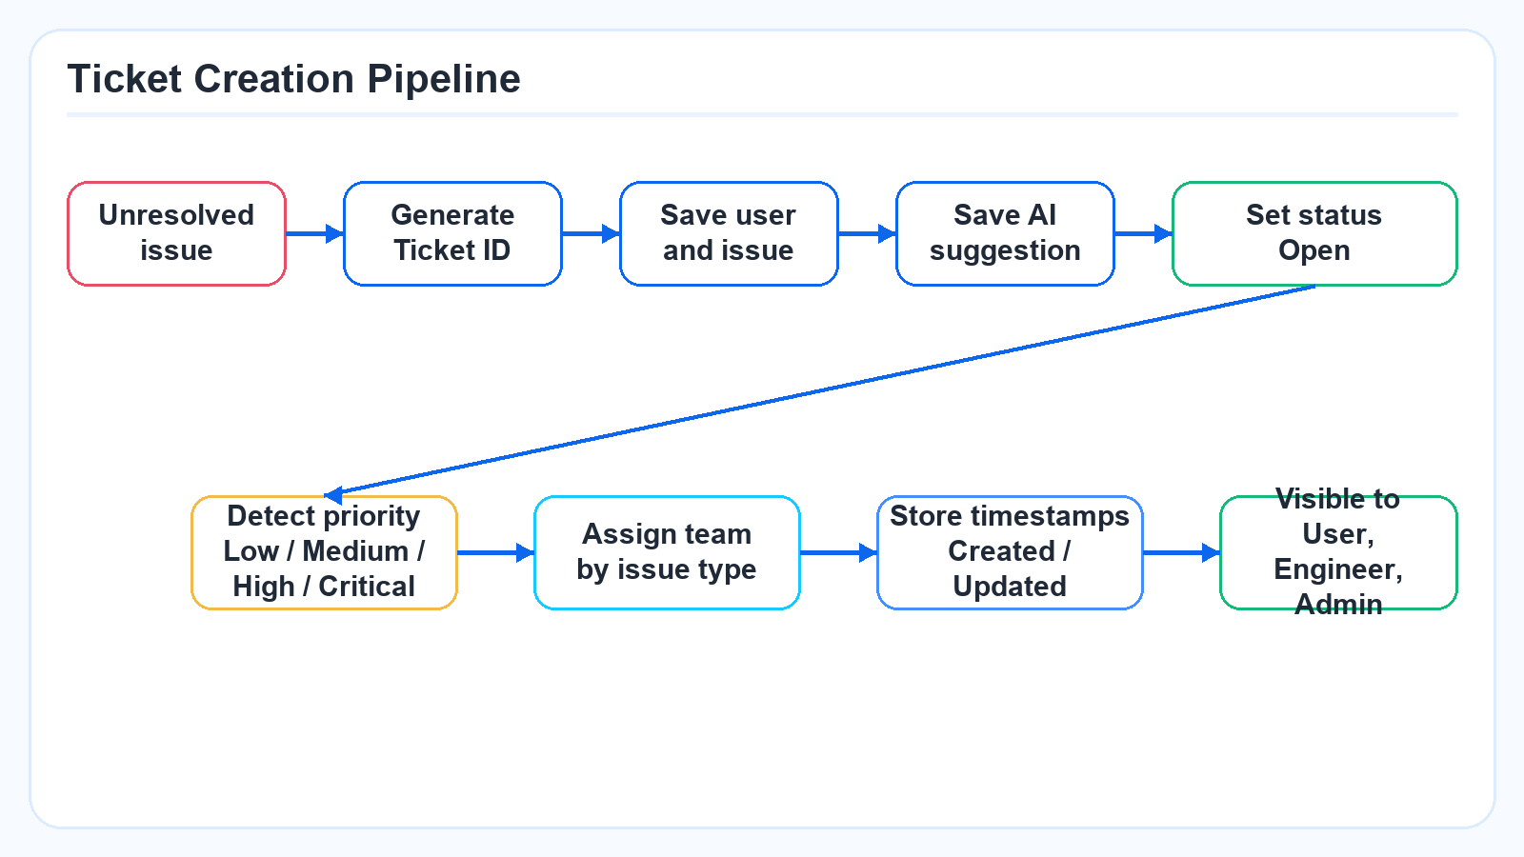

5. Role-Based Workflow
Each role has a focused workflow so users only see what they need and support staff can manage work efficiently.
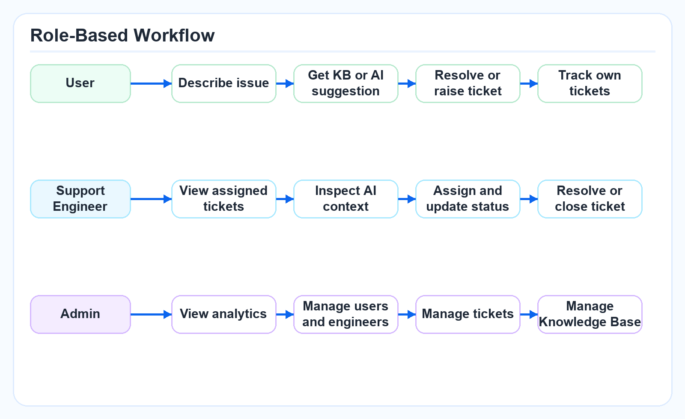

6. Client Value
- Reduces repetitive support work by solving common IT issues through the Knowledge Base.
- Improves response speed by using AI suggestions before escalation.
- Creates consistent, complete tickets for unresolved issues.
- Gives engineers the context needed to resolve tickets faster.
- Gives admins visibility into ticket status, priority, workload, and support performance.

