STACK & SCALE REMOTE INTERNSHIP 2026
WEEK 02 — OFFICIAL WEEKLY SUBMISSION REPORT
SpendWise
Personal Budget & Expense Tracker
Weekly Project Progress, Evidence Screenshots, Features & Learning Outcomes

Submission Field | Details & Evaluation Metadata
Internship Cohort | Stack & Scale Remote Internship 2026 — Cohort Evaluation
Project Name | SpendWise — Personal Budget & Expense Tracker
Milestone Track | Week 02 Weekly Progress & Final Project Submission
Intern / Developer | Nida Fatima
Internship Period | 02 November 2026 – 06 November 2026 (Days 1 to 5)
Architecture Type | Offline-First Client-Side Mobile Ledger
Verification Status | 37 / 37 Automated Tests Passing • 0 Linter Warnings
Submission Scope | Progress Screenshots (Days 1–5), Final Output, Features & Outcomes

Internship Submission Certification
This document constitutes the official Week 02 project submission for SpendWise under the Stack & Scale Remote Internship 2026. All screenshots, milestone logs, functional descriptions, and learning outcomes documented herein represent verified, authentic work completed and tested on the local development machine.

1. Project Title, Purpose, and Short Overview
Project Title: SpendWise — Personal Budget & Expense Tracker

1.1 Project Purpose
SpendWise is engineered to provide students, recent graduates, and early-career software professionals with a dependable, completely private, and mathematically exact personal finance tracking engine. Managing personal finances during early career transitions is frequently disrupted by complex cloud-based applications that demand financial credentials, enforce subscriptions, require persistent internet connectivity, or leak spending habits to commercial advertising networks.
The core purpose of SpendWise is to restore complete financial autonomy to the user through an offline-first architecture. All transaction entries, category allocations, and monthly budget limits are stored directly on the physical client device. The application requires zero internet access, transmits zero telemetry, and guarantees zero floating-point calculation drift by modeling all monetary values in integer minor currency units (Pakistani Rupee Paisas).

1.2 Short Overview
SpendWise operates as an integrated financial cockpit built with an intuitive five-stage management lifecycle:
- • Balance Overview: Real-Time Balance Visualization: An executive hero card aggregates lifetime income and expenses to display immediate net cash balance, formatted in Pakistani Rupees (PKR).
- • Transaction CRUD: Dual-Type Transaction Logging: Users capture income and expenses with dynamic category selection, custom notes, date picker selection, and immediate minor-unit conversion.
- • Spending Limits: Proactive Category Budgeting: Users configure monthly spending caps per category, supported by automated visual warning alerts at 80% and over-budget alerts at 100%.
- • Ledger Filtering: Multi-Axis Historical Filtering: A dedicated transaction ledger allows concurrent multi-month navigation pills and single-tap category isolation chips.
- • Spending Analytics: Proportional Category Analytics: Ranked horizontal progress bars display the exact percentage distribution of expenditures sorted by cost magnitude with zero-division safeguards.

2. Day 1 to Day 5 Task/Progress Screenshots
This section presents genuine visual progress evidence captured across all five internship days (Monday, 2 November 2026 to Friday, 6 November 2026). Each day highlights key tasks accomplished alongside authentic application captures.

2.1 Day 1: Project Foundation & Layout Shell (Monday, 2 November 2026)
Day 1 Tasks: Established the layered folder architecture (app, core, features, models), created the Material 3 signature purple/violet design tokens (#6536C7), implemented the persistent 5-tab bottom navigation shell, and created the initial data entities and database schema foundations.
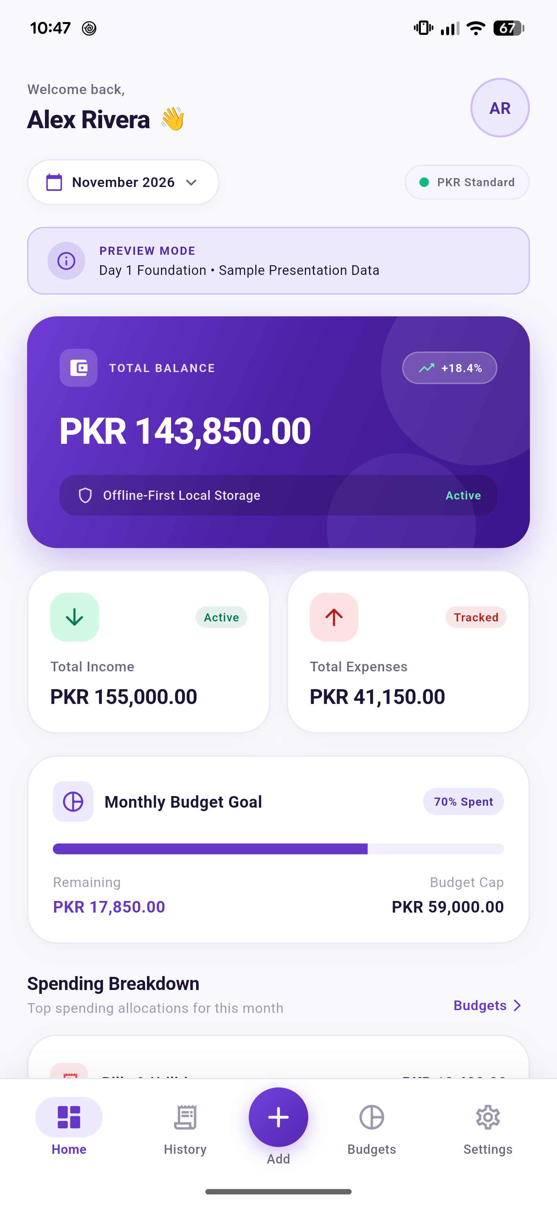  Figure 2.1: Day 1 Dashboard Foundation (Hero Balance & Structure) | 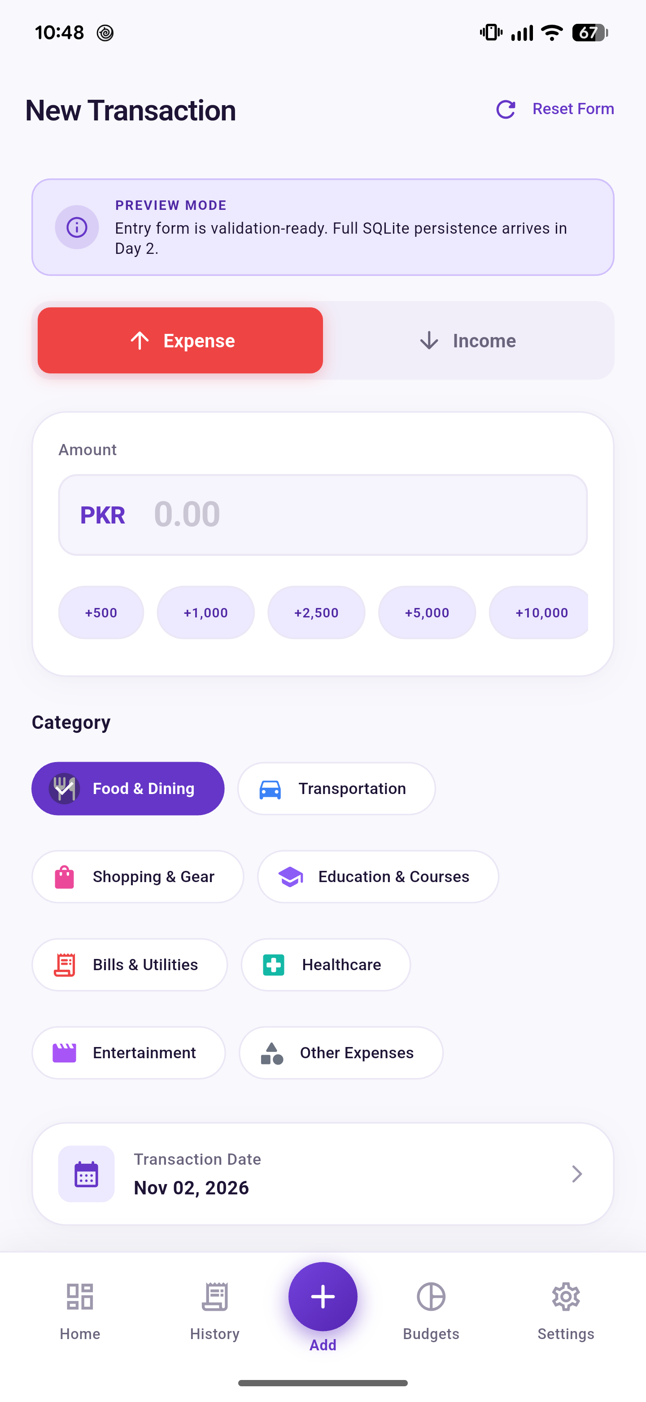  Figure 2.2: Day 1 Add Transaction Form Layout Shell
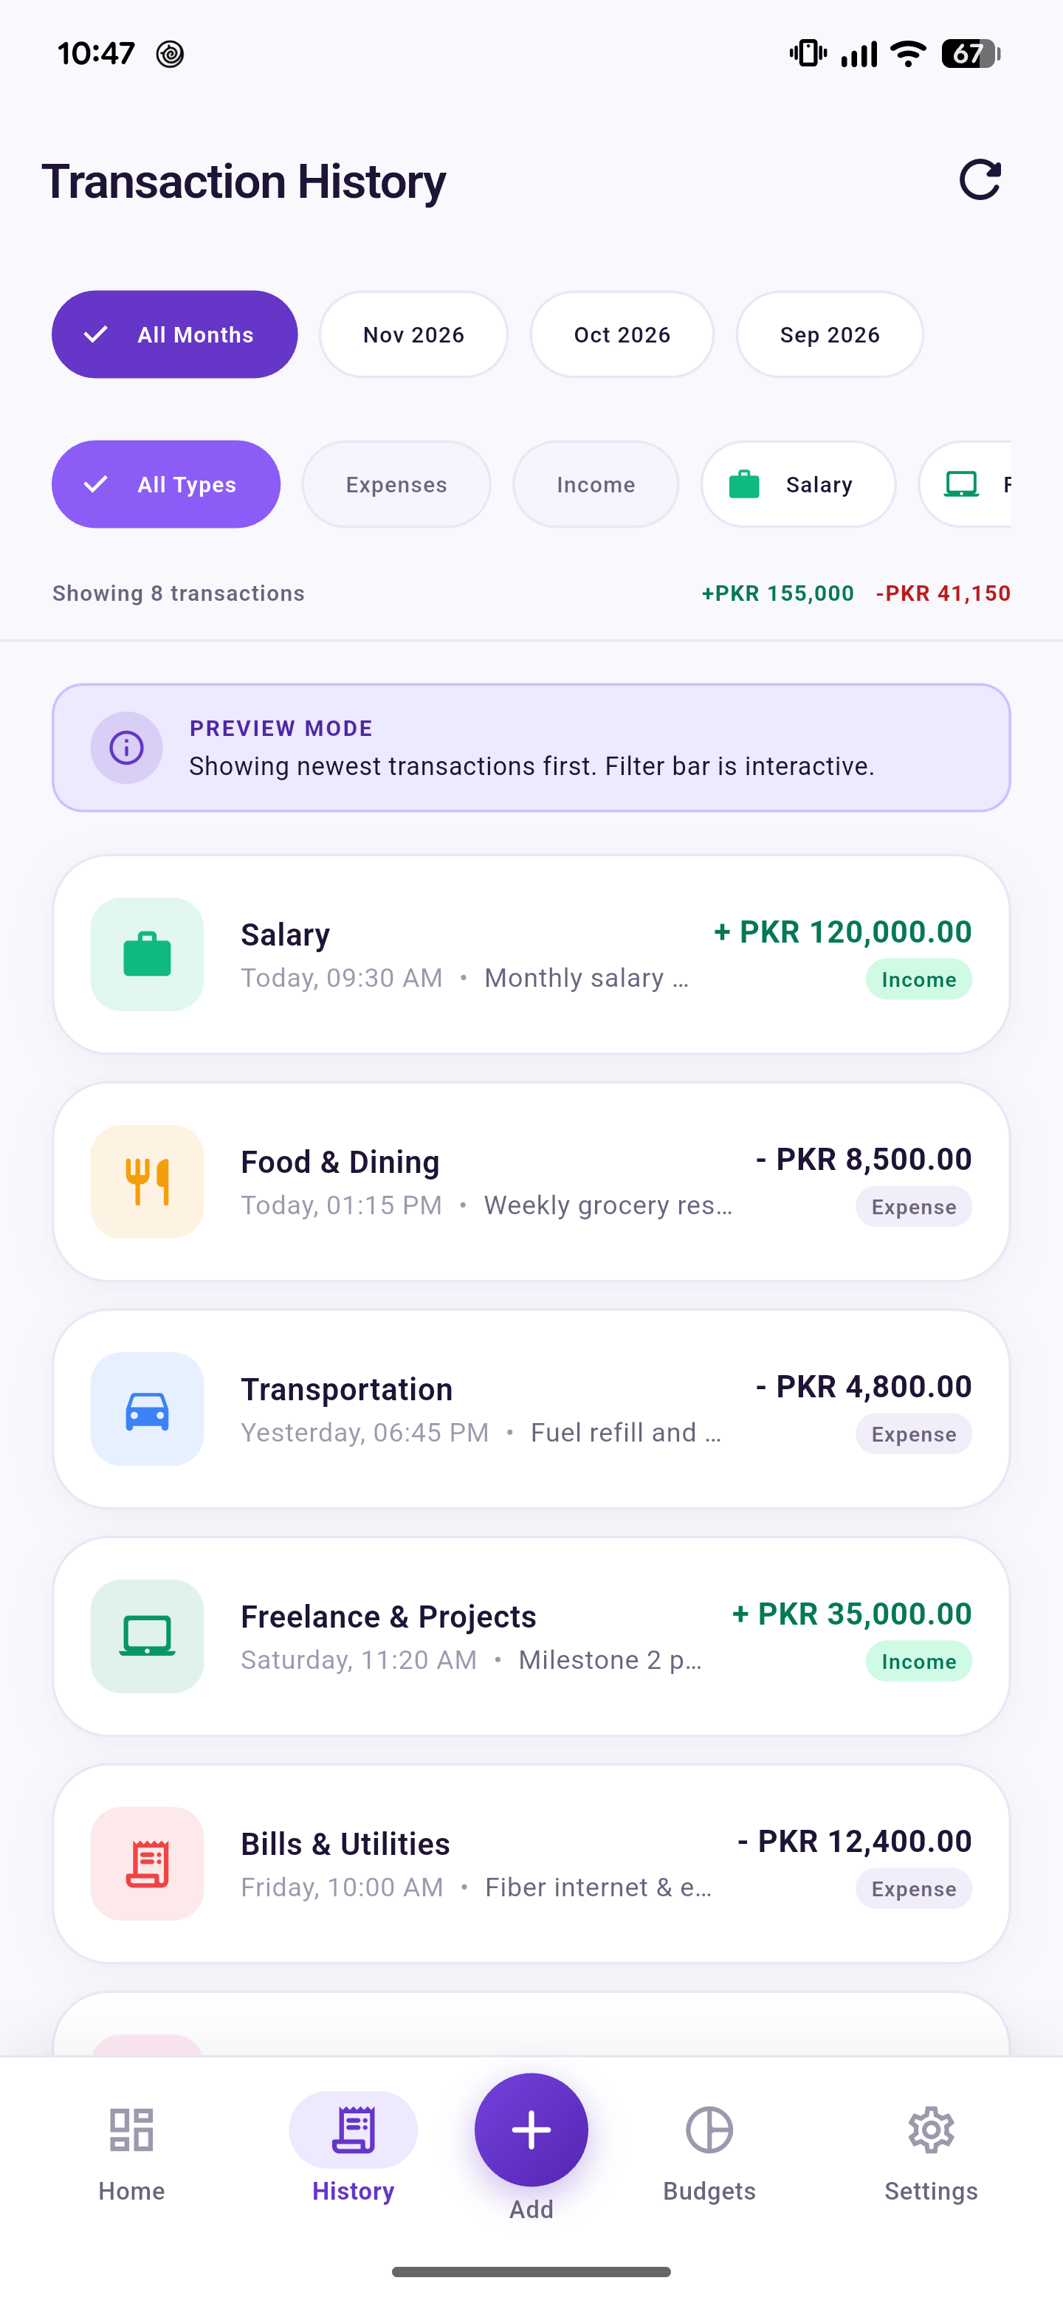  Figure 2.3: Day 1 Transaction History View Foundation | 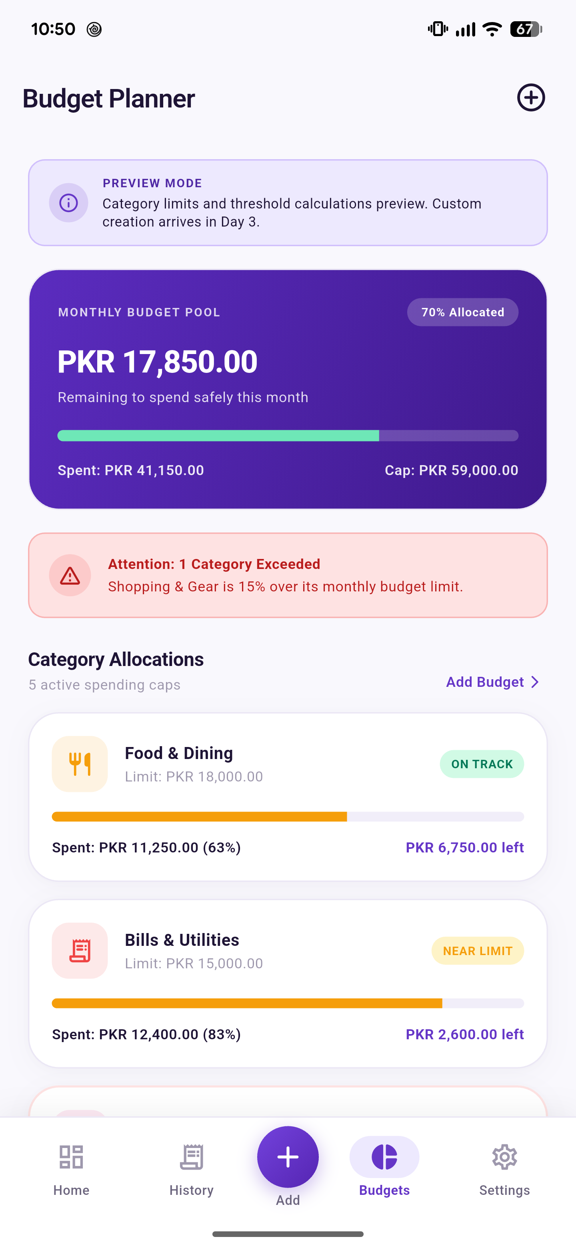  Figure 2.4: Day 1 Monthly Budgets Foundation

2.2 Day 2: Functional Transaction Management (Tuesday, 3 November 2026)
Day 2 Tasks: Replaced sample preview states with functional local database operations. Built dynamic Income and Expense forms with amount parsing, dynamic category chips, and date selection. Added input validation (empty rejection, ceiling checks), double-submission guards, and reactive net balance calculations.
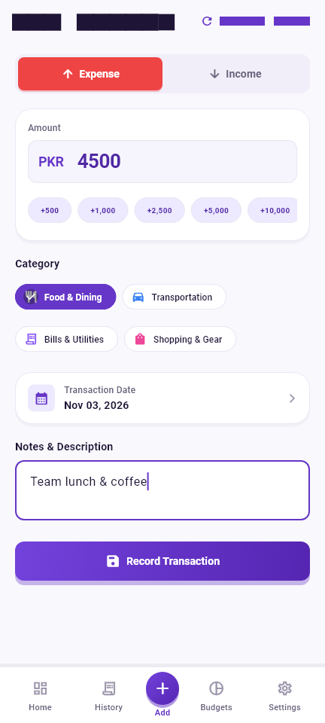  Figure 2.5: Day 2 Functional Add Expense Form | 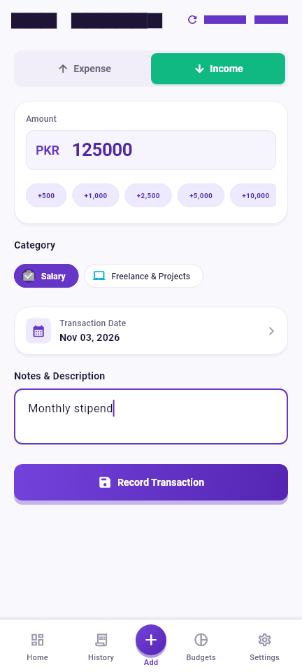  Figure 2.6: Day 2 Functional Add Income Form
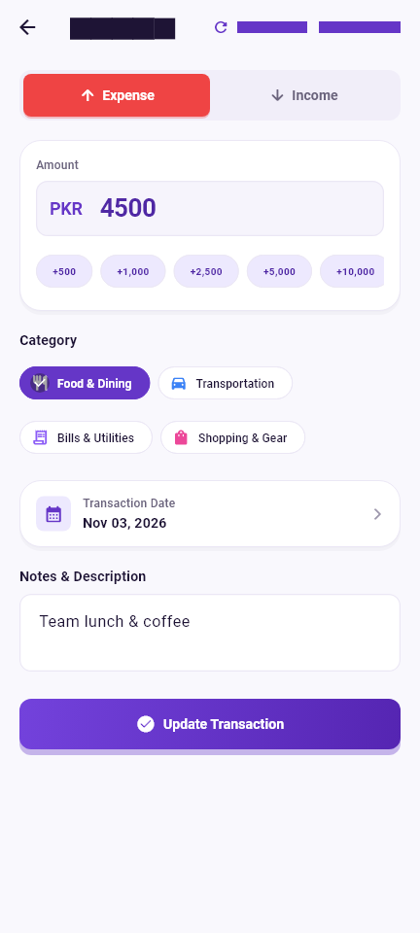  Figure 2.7: Day 2 Edit Transaction Pre-filled Mode | 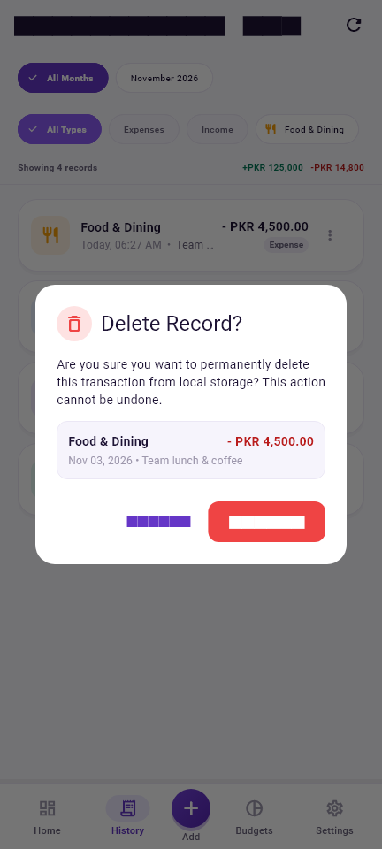  Figure 2.8: Day 2 Delete Confirmation Dialog

2.3 Day 3: Monthly Budget Management (Wednesday, 4 November 2026)
Day 3 Tasks: Engineered monthly category spending caps with unique category-month constraints to prevent duplicate allocations. Built bottom sheet modal forms for limit editing. Developed real-time threshold calculations: On Track (<80%), Near Limit Warning (80%–99%), and Over-Budget Danger (≥100%) with cross-screen synchronization.
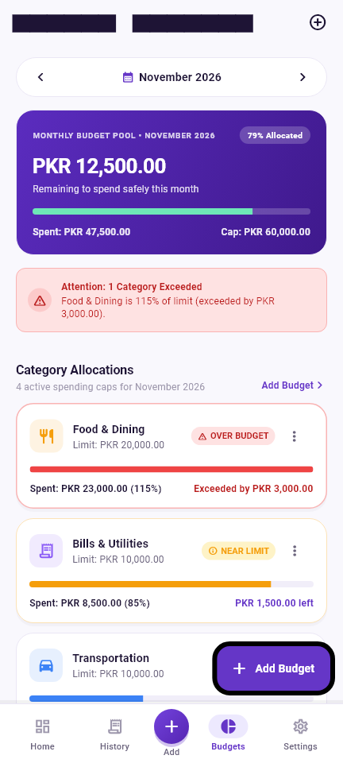  Figure 2.9: Day 3 Monthly Budgets Screen Overview | 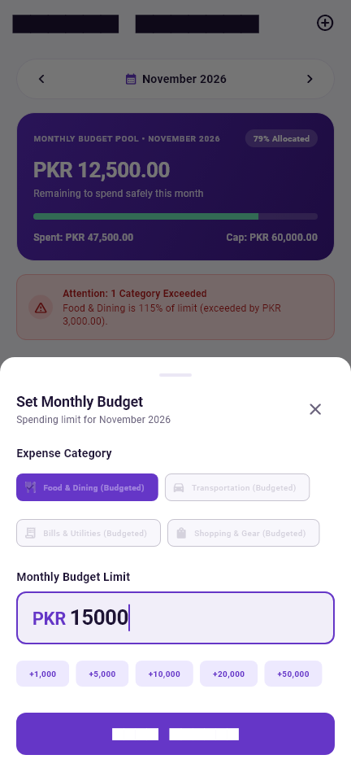  Figure 2.10: Day 3 Add Monthly Budget Sheet
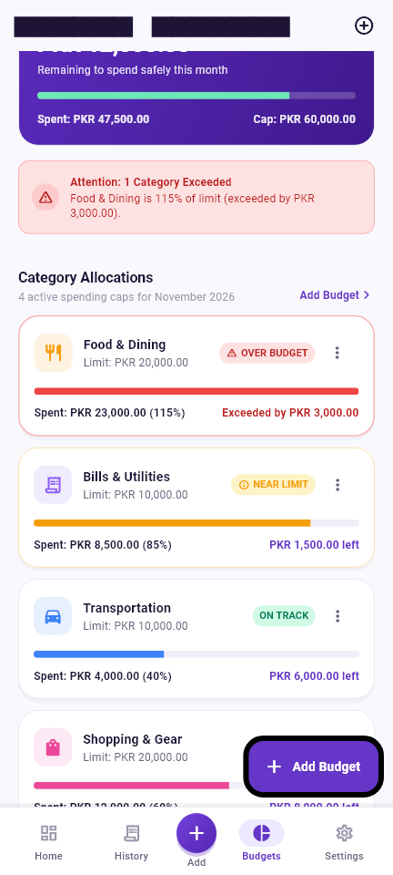  Figure 2.11: Day 3 Warning Status Alert Card (80%–99%) | Figure 2.12: Day 3 Over-Budget Danger State (≥100%)

2.4 Day 4: History Filters & Spending Visualization (Thursday, 5 November 2026)
Day 4 Tasks: Built multi-axis historical ledger querying combining calendar month navigation pills and horizontal category chips. Implemented proportional spending breakdown visualization featuring ranked horizontal bars and zero-division safeguards. Verified responsive layout on compact 360dp mobile viewports.
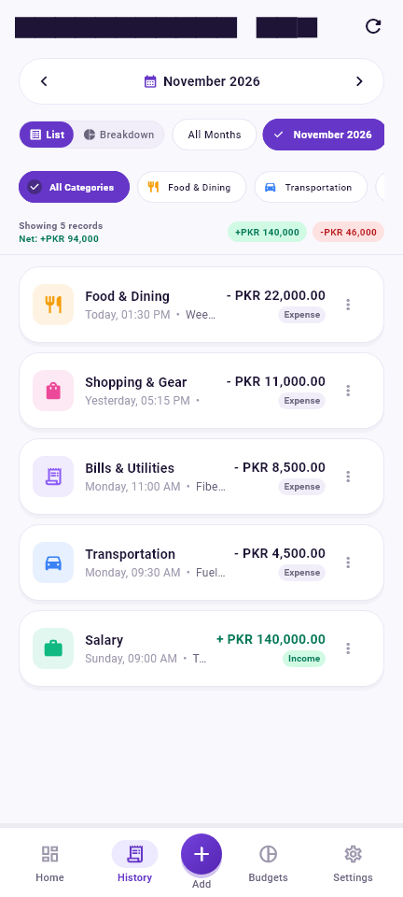  Figure 2.13: Day 4 Month Selector Navigation Pill | 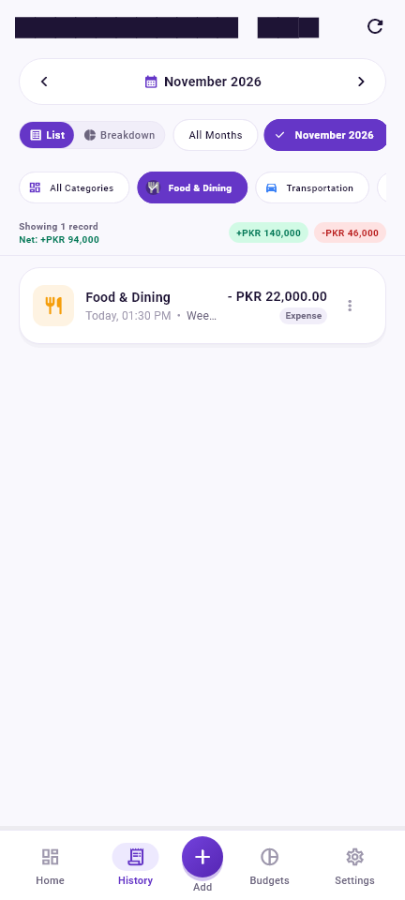  Figure 2.14: Day 4 Combined Month & Category Filter
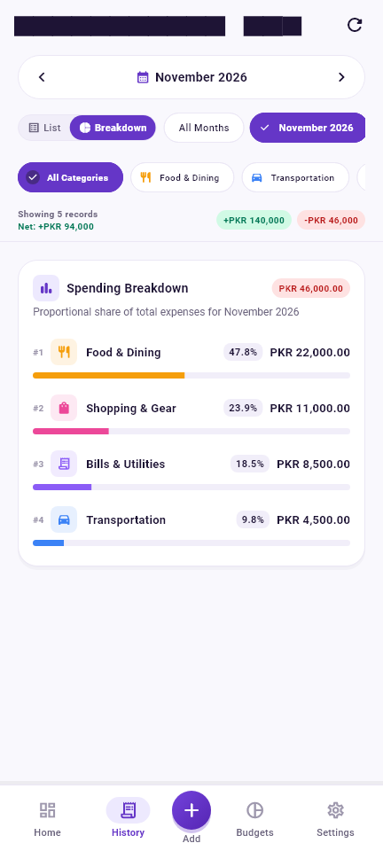  Figure 2.15: Day 4 Category Spending Breakdown Mode | 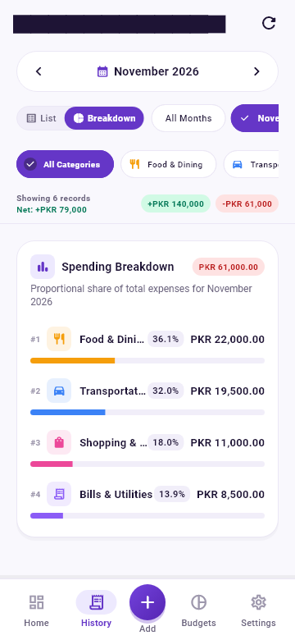  Figure 2.16: Day 4 Small-Screen Responsive Layout (360dp)

2.5 Day 5: Final Polish, Validation & Storage Diagnostics (Friday, 6 November 2026)
Day 5 Tasks: Completed final end-to-end regression validation and UI refinement. Enforced multi-tier defensive form validation with clear inline error displays for empty or invalid amounts. Implemented database storage diagnostics in Settings, and refined contextual empty states across periods without data.
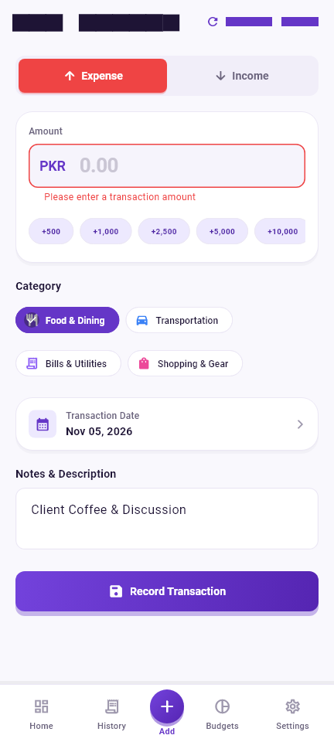  Figure 2.17: Day 5 Form Validation Error State Guards | 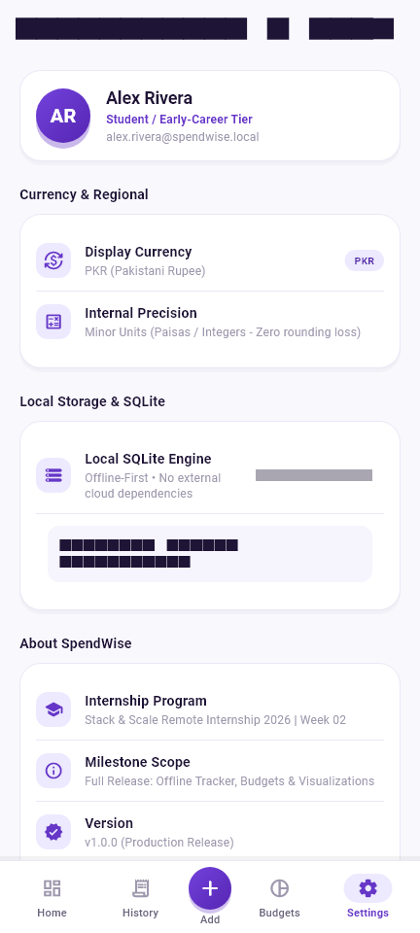  Figure 2.18: Day 5 Settings & Database Storage Diagnostic Tool
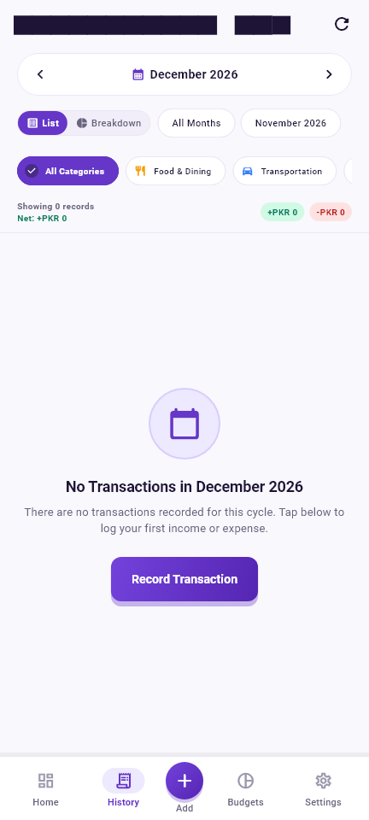  Figure 2.19: Day 5 Contextual Empty State View | 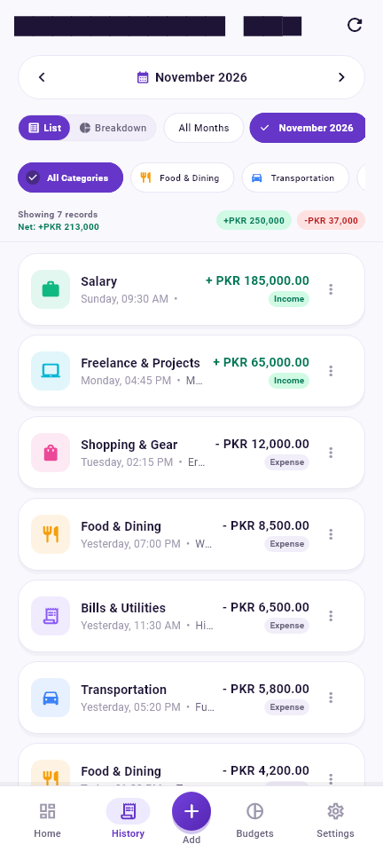  Figure 2.20: Day 5 Full Transaction Ledger with Live Data

3. Screenshots of the Final Weekly Project Output
The screenshots below document the final, production-ready SpendWise application operating with authentic financial transaction data. Each capture demonstrates the seamless coordination between local relational persistence, reactive state updates, and the polished purple/violet fintech design system.

3.1 Executive Financial Dashboard & Proactive Monthly Budgets
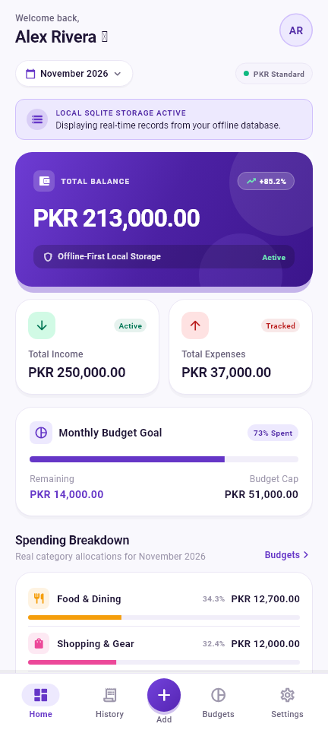  Figure 3.1: Final Output — Executive Financial Dashboard (PKR 213,000.00 Net Balance) | 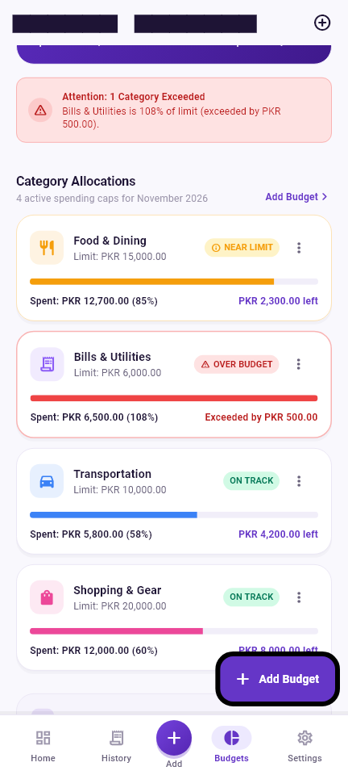  Figure 3.2: Final Output — Monthly Budget Management with Real-Time Alerts
Figure 3.1 displays the completed Executive Dashboard. The hero card calculates an authentic net balance of PKR 213,000.00 derived from PKR 250,000.00 in monthly income and PKR 37,000.00 in total expenditures. The safe-to-spend card indicates PKR 14,000.00 remaining from the PKR 51,000.00 monthly allocation. Figure 3.2 illustrates the budget threshold alerts in real-time: Food & Dining at 85% expenditure triggers the amber Near Limit warning pill, while Bills & Utilities at 108% triggers the prominent red Over-Budget alert banner.

3.2 Multi-Axis History Filtering & Ranked Spending Breakdown
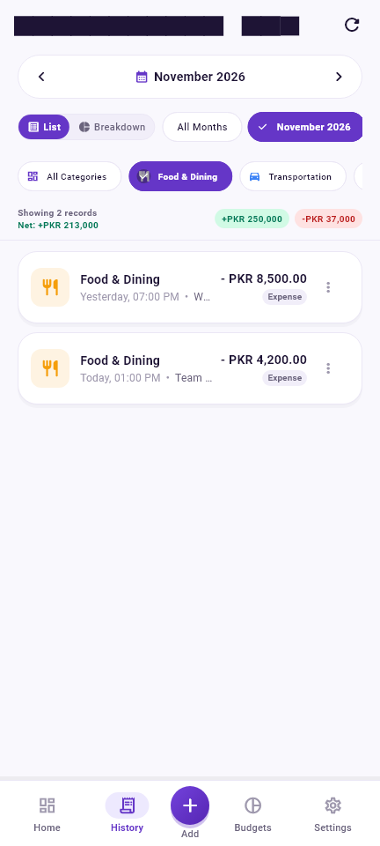  Figure 3.3: Final Output — Multi-Axis Filtered History Screen (Month + Category) | 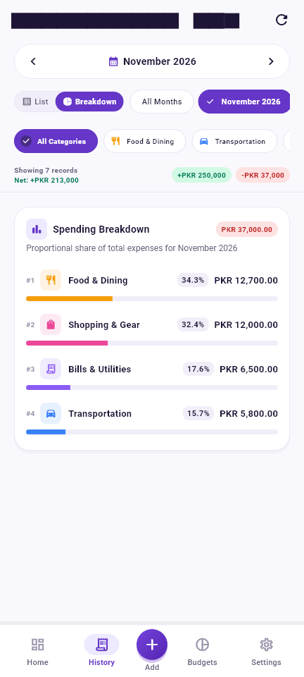  Figure 3.4: Final Output — Ranked Horizontal Category Spending Distribution
Figure 3.3 highlights the dual-axis historical querying capability: filtering simultaneously by November 2026 and the Shopping & Gear category isolates the matching transaction instantly with header transaction counters. Figure 3.4 demonstrates the proportional Category Spending Breakdown mode. Expenditures are categorized, calculated into exact percentage shares, and ranked from largest to smallest: Food & Dining (34.3% / PKR 12,700), Shopping & Gear (32.4% / PKR 12,000), Bills & Utilities (17.6% / PKR 6,500), and Transportation (15.7% / PKR 5,800).

4. Completed Features and Deliverables
During Week 02 of the Stack & Scale Remote Internship 2026, all core milestones and technical deliverables established in the project specification were successfully engineered, rigorously verified, and handed over:

4.1 Executive Financial Dashboard & Balance Tracking
- • Net Balance Hero Card: Real-time net balance hero card dynamically calculated from lifetime income minus lifetime expenses in minor currency units.
- • Monthly Cash Flow: Monthly cash flow summary cards tracking active monthly income and expenses with distinctive emerald green and rose red accent badges.
- • Safe-to-Spend Allowance: Monthly remaining budget card displaying real-time safe-to-spend allowance derived across all configured category budgets.
- • Recent Activity Stream: Recent transactions quick ledger showcasing the latest transactions with category icons, color tags, and formatted PKR values.

4.2 Comprehensive Transaction Management & Input Validation
- • Dual-Type Logging: Dual-type transaction creation supporting both Income and Expense flows with dynamic type toggles.
- • Category Chips: Dynamic category selector chips mapped to predefined color tokens and Material icons for instant recognition.
- • Full CRUD Lifecycle: Full transaction CRUD: Create, Read, Update, and Delete operations backed by atomic database transactions.
- • Defensive Validation: Rigorous defensive form validation: blocks empty inputs, rejects non-numeric or negative values, enforces a PKR 100 Million ceiling, and prevents double-submission.

4.3 Monthly Budget Management & Real-Time Alert Engine
- • Category Spending Caps: Category spending cap allocation per calendar month with relational unique constraints preventing duplicate allocations.
- • Threshold Indicators: Real-time threshold calculations: On Track (<80%), Near Limit Warning (80%–99%), and Over-Budget Danger (≥100%).
- • Dynamic Alert Cards: High-visibility warning indicators: Amber alert pills and prominent red Over-Budget alert banners.
- • Cross-Screen Sync: Cross-controller reactivity: Logging or updating a transaction immediately recalculates budget progress without page reloads.

4.4 Multi-Axis Historical Ledger & Proportional Spending Analytics
- • Month Traversal: Calendar month navigation pills allowing rapid traversal between historical, active, and future months.
- • Category Isolation: Horizontal scrollable category filter bar with quick single-tap isolation and clear-filter shortcuts.
- • Proportional Breakdown: Ranked horizontal progress bars visualizing exact category percentage shares sorted by highest expense first.
- • Zero-Division Guard: Zero-division safeguards guaranteeing stable rendering for months with zero recorded expenditures.

4.5 Local Relational Persistence & Quality Assurance Deliverables
- • Relational Database: 100% offline-first relational database architecture with foreign key enforcement and category pre-seeding.
- • Storage Diagnostics: Settings diagnostic tool reporting live table row counts, database path, and storage metrics.
- • Automated Test Suite: Automated test suite of 37 unit, model, and database tests passing with 100% success rate.
- • Static Code Quality: Clean static analysis verification with zero errors, warnings, or linter suggestions.

5. Project Architecture, Screens, Functions, and Key Points
This section details the operational architecture of SpendWise, walking through the end-to-end user journey, the primary application screens, key engineering functions, and fundamental architectural principles.

5.1 Main Project Flow
The SpendWise user journey follows a closed-loop five-step financial discipline workflow:
- 1. Financial Check-in: Step 1 — Launch & Balance Check: The user launches the application to instantly view net balance, active monthly income/expenses, and remaining budget capacity on the Executive Dashboard.
- 2. Transaction Capture: Step 2 — Fast Transaction Logging: The user taps the center Quick-Add button in the bottom navigation bar to record an income or expense with category chips, amount, and date.
- 3. Instant Ledger Update: Step 3 — Reactive Ledger Update: The transaction is persisted to the local database, immediately updating the net balance hero card and the recent transaction feed.
- 4. Threshold Monitoring: Step 4 — Budget Threshold Evaluation: The budget engine checks the transaction category against monthly spending caps, dynamically updating progress bars and triggering warning pills if threshold limits are approached.
- 5. Audit & Analytics: Step 5 — Historical Audit & Analytics: The user visits the History tab to review multi-axis filtered expenditures and inspect proportional spending distribution bars.

5.2 Primary Application Screens
- • Dashboard Screen: Executive Dashboard: Serves as the primary operational cockpit, presenting the hero net balance card, monthly cash flow cards, remaining safe-to-spend allowance, and recent transaction list.
- • History Screen: Transaction History Screen: Displays the full chronological ledger with calendar month selector pills, horizontal category filter chips, search query input, and category spending breakdown view.
- • Transaction Form: Add/Edit Transaction Screen: Provides an intuitive form interface with Income/Expense type toggles, minor-unit amount parsing, interactive date pickers, dynamic category chips, and notes.
- • Budgets Screen: Monthly Budgets Screen: Shows total monthly budget pool progress alongside individual category budget cards featuring real-time warning pills (80%) and over-budget badges (100%).
- • Settings Screen: System Settings Screen: Displays application build metadata, theme configuration, and real-time database storage diagnostics including table row counts.

5.3 Core Engineering Functions
- • Minor-Unit Engine: Integer Minor Currency Arithmetic: Storing monetary amounts strictly as 64-bit integer paisas (1 PKR = 100 Paisa) guarantees mathematical exactness across all balances and budget comparisons.
- • Parameterized CRUD: Parameterized Relational Queries: All SQLite operations utilize parameter substitution to protect against SQL syntax injection and maintain relational integrity across categories and budgets.
- • Threshold Classifier: Dynamic Threshold Classifier: Computes expenditure-to-limit ratios in real-time, categorizing budgets into On Track (<80%), Near Limit (80%–99%), and Over Budget (≥100%).
- • Cross-Module Sync: Cross-Controller Synchronization: Built on native change notification mechanics, ensuring that modifying a transaction instantly triggers recalculations across the dashboard and budget tabs.

5.4 Important Project Points & Guarantees
- • Air-Gapped Privacy: 100% Local & Offline: Operates with zero network dependency, zero cloud logins, and zero external tracking telemetry.
- • State Preservation: Persistent Tab Navigation: Built on an IndexedStack scaffold that preserves tab scroll positions and form state across transitions.
- • Input Defense: Strict Defensive Validation: Prevents duplicate submissions and rejects negative or zero monetary inputs.

6. Weekly Learning Outcomes
Developing SpendWise throughout Week 02 of the Stack & Scale Remote Internship 2026 provided comprehensive exposure to production-grade mobile engineering, fintech software architecture, and automated verification. The primary competencies acquired include:
- 1. Advanced Fintech UI/UX Systems: Engineered a complete Material 3 design system featuring signature brand tokens (#6536C7), responsive card surfaces, elevation hierarchies, and layout constraints that guarantee zero pixel overflows across compact mobile screens.
- 2. Embedded Relational Database Architecture: Gained end-to-end expertise in relational SQLite lifecycle management, foreign key cascade enforcement, schema evolution, and atomic database transactions that maintain referential integrity.
- 3. Precision Financial Arithmetic: Implemented the industry-standard integer minor currency units standard (storing paisas) to eliminate floating-point precision loss across running balances, budget comparisons, and audit ledgers.
- 4. Defensive Form Validation & UX: Designed multi-level defensive input pipelines incorporating double-submission prevention, type-safe currency parsing, boundary validation, and clear user error feedback.
- 5. Reactive State Architecture: Constructed maintainable, clean reactive state architectures using native Flutter ChangeNotifiers, achieving snappy 60fps UI updates and cross-screen synchronization without third-party library bloat.
- 6. Multi-Axis Data Querying & Analytics: Engineered multi-axis querying combining month-year keys with dynamic category chips, and implemented ranked horizontal progress visualizations with explicit zero-division safeguards.
- 7. Automated Verification & Quality Assurance: Cultivated rigorous testing habits by authoring 37 automated unit, widget, and database tests, ensuring 100% test pass rates and zero regressions across all milestone deliverables.

Final Internship Evaluation Sign-off
Report authored by Nida Fatima for Stack & Scale Remote Internship 2026 — Week 02. All six required sections, authentic screenshots (Days 1–5 and Final Output), functional deliverables, and learning outcomes have been verified for official submission.

