**myPortfolio: Easy Way to Create Your Amazing Portfolio**

DESCRIPTION

**Project Objective:**

As a Full Stack Developer, you have to create a frontend for the myPortfolio application.

**Background of the problem statement:**

In the third sprint, the scrum team agreed to develop the frontend of the application using an Angular framework. Since you were recently trained in working on this framework, you’re chosen to lead this project and complete the initial part of the application. You agree to complete this task as early as possible, as the release of the application is next week.

**Creating a new project**

* Angular has been installed in your practice labs using npm (Refer FSD: Lab Guide - Phase 4)
* To verify the installation:
  + Open the command-line interface
  + Type in the command:

**ng --version**

* Create a new project using the command:

*ng new angular-app*

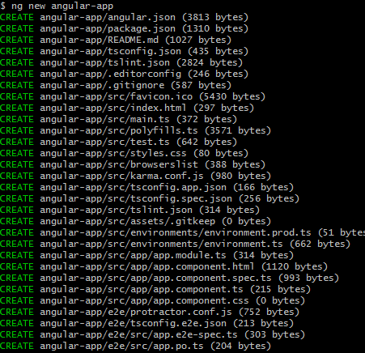

* Move the code to the application folder and start the server.

*cd angular-app*

*ng serve*

**Creating Angular components**

* Open Visual Studio Code
* Navigate to the created myPortfolio project folder.

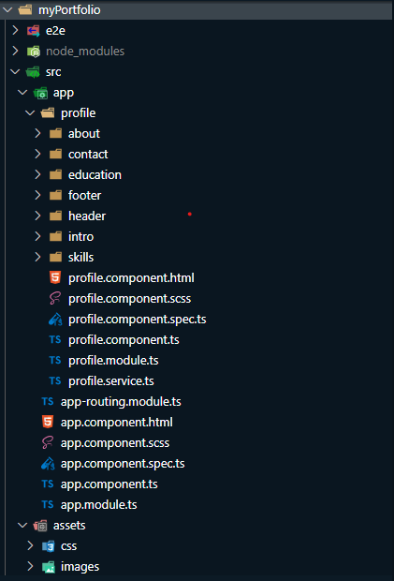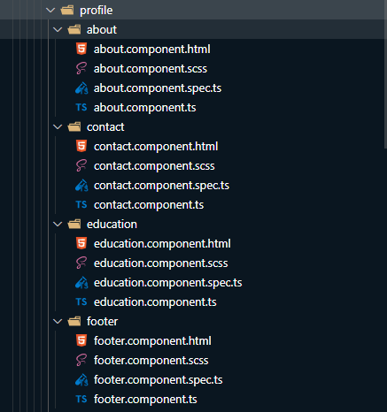

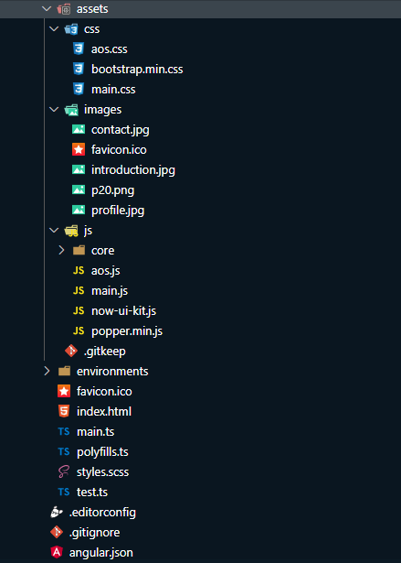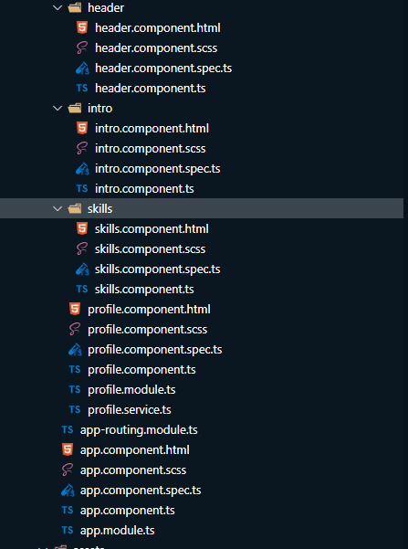

**Open Src/app/index.html**

<!doctype *html*>

<html *lang*="en">

<head>

  <meta *charset*="utf-8">

  <title>PersonalPortfoliAngular</title>

  <base *href*="/">

  <meta *name*="viewport" *content*="width=device-width, initial-scale=1">

  <link *href*="https://fonts.googleapis.com/css?family=Montserrat:400,700,200" *rel*="stylesheet" />

  <link *href*="https://use.fontawesome.com/releases/v5.0.6/css/all.css" *rel*="stylesheet">

  <link *href*="https://maxcdn.bootstrapcdn.com/font-awesome/latest/css/font-awesome.min.css" *rel*="stylesheet">

  <link *href*="assets/css/aos.css" *rel*="stylesheet">

  <link *href*="assets/css/bootstrap.min.css" *rel*="stylesheet">

  <link *href*="assets/css/main.css" *rel*="stylesheet">

  <link *rel*="icon" *type*="image/x-icon" *href*="favicon.ico">

</head>

<body>

  <app-root></app-root>

  <script *src*="https://ajax.googleapis.com/ajax/libs/jquery/3.5.1/jquery.min.js"></script>

  <script *src*="assets/js/core/popper.min.js"></script>

  <script *src*="assets/js/core/bootstrap.min.js"></script>

  <script *src*="assets/js/now-ui-kit.js?v=1.3.0"></script>

  <script *src*="assets/js/aos.js"></script>

  <script *src*="assets/js/main.js"></script>

</body>

</html>

**Create a folder name it as profile**

**In Profile folder Create sub folder name it as about**

**Create about.component.html**

<div *class*="section" *id*="about">

    <div *class*="container">

        <div *class*="card" *data-aos*="fade-up" *data-aos-offset*="10">

            <div *class*="row">

                <div *class*="col-lg-6 col-md-12">

                    <div *class*="card-body">

                        <div *class*="h4 mt-0 title">About Me</div>

                            <p align="justify">From a young age, I’ve always had a sense of motivation and passion driving me forward. Whether it’s exploring unique opportunities, learning additional skills, or meeting new people, I bring these values to every experience throughout my life on a personal and professional level.</p>

                            <p align="justify">Lover of innovation and everything related to generate new knowledge.Face problems with a smile and solve them as soon as possible. Very calculated about the time I spend and work I do.</p>

                            <p align="justify">To learn more about me, keep exploring my site or reach out directly.</p>

                    </div>

                </div>

                <div *class*="col-lg-6 col-md-12">

                    <div *class*="card-body">

                        <div *class*="h4 mt-0 title">Basic Information</div>

                        <div *class*="row">

                            <div *class*="col-sm-4">

                                <strong *class*="text-uppercase">Date of Birth:</strong>

                            </div>

                            <div *class*="col-sm-8">Sep 10, 1998</div>

                        </div>

                        <div *class*="row mt-4">

                            <div *class*="col-sm-4">

                                <strong *class*="text-uppercase">Email:</strong>

                            </div>

                            <div *class*="col-sm-8">rahulkumar.nidamanuri@gmail.com</div>

                        </div>

                        <div *class*="row mt-4">

                            <div *class*="col-sm-4">

                                <strong *class*="text-uppercase">Mobile No:</strong>

                            </div>

                            <div *class*="col-sm-8">8919236779</div>

                        </div>

                        <div *class*="row mt-4">

                            <div *class*="col-sm-4">

                                <strong *class*="text-uppercase">Address:</strong>

                            </div>

                            <div *class*="col-sm-8">#201,AVN Residency,Opp.Gayatri Mandir,M.M Road,Ongole,523002</div>

                        </div>

                        <div *class*="row mt-4">

                            <div *class*="col-sm-4">

                                <strong *class*="text-uppercase">Language:</strong>

                            </div>

                            <div *class*="col-sm-8">Telugu,hindhi,English</div>

                        </div>

                     </div>

                </div>

            </div>

        </div>

    </div>

</div>

**Create about.component.css**

**Create about.component.spec.ts**

import { async, ComponentFixture, TestBed } from '@angular/core/testing';

import { AboutComponent } from './about.component';

describe('AboutComponent', () => {

  let component: AboutComponent;

  let fixture: ComponentFixture<AboutComponent>;

  beforeEach(async(() => {

    TestBed.configureTestingModule({

      declarations: [ AboutComponent ]

    })

    .compileComponents();

  }));

  beforeEach(() => {

    fixture = TestBed.createComponent(AboutComponent);

    component = fixture.componentInstance;

    fixture.detectChanges();

  });

  it('should create', () => {

    expect(component).toBeTruthy();

  });

});

**Create about.components.ts**

import { Component, OnInit } from '@angular/core';

@Component({

  selector: 'app-about',

  templateUrl: './about.component.html',

  styleUrls: ['./about.component.scss']

})

export class AboutComponent *implements* OnInit {

  constructor() { }

  ngOnInit(): void {

  }

}

**In Profile folder Create sub folder name it as content**

**Create contact.component.html**

<div *class*="section" *id*="contact">

    <div *class*="cc-contact-information" *style*="background-image: url('assets/images/contact.jpg');">

      <div *class*="container">

        <div *class*="cc-contact">

          <div *class*="row">

            <div *class*="col-md-9">

              <div *class*="card mb-0" *data-aos*="zoom-in">

                <div *class*="h4 text-center title">Contact Me</div>

                <div *class*="row">

                  <div *class*="col-md-6">

                    <div *class*="card-body">

                      <form *name*="form" *(ngSubmit)*="f.form.valid ; f.resetForm()" *#f*="ngForm" *novalidate*>

                        <div *class*="p pb-3">

                          <strong>Feel free to contact me </strong>

                        </div>

                        <div *class*="row mb-3">

                          <div *class*="col">

                            <div *class*="input-group">

                              <input *class*="form-control" *type*="text" *name*="name" *#name* *placeholder*="Name"

*[(ngModel)]*="model.name" *#name*="ngModel"

*[ngClass]*="{ 'is-invalid': f.submitted && name.invalid }" *required* />

                            </div>

                          </div>

                        </div>

                        <div *class*="row mb-3">

                          <div *class*="col">

                            <div *class*="input-container">

                              <input *class*="form-control" *type*="text" *name*="subject" *#subject* *placeholder*="Subject"

*[(ngModel)]*="model.subject" *#subject*="ngModel"

*[ngClass]*="{ 'is-invalid': f.submitted && subject.invalid }" *required* />

                            </div>

                          </div>

                        </div>

                        <div *class*="row mb-3">

                          <div *class*="col">

                            <div *class*="input-group">

                              <input *class*="form-control" *type*="text" *name*="email"  *#email* *placeholder*="E-mail"

*[(ngModel)]*="model.email" *#email*="ngModel"

*[ngClass]*="{ 'is-invalid': f.submitted && email.invalid }"

*pattern*="^([a-zA-Z0-9_\-\.]+)@([a-zA-Z0-9_\-\.]+)\.([a-zA-Z]{2,5})$" *required* />

                            </div>

                          </div>

                        </div>

                        <div *class*="row mb-3">

                          <div *class*="col">

                            <div *class*="form-group">

                              <textarea *class*="form-control" *name*="message" *#message* *placeholder*="Your Message"

*[(ngModel)]*="model.message" *#message*="ngModel"

*[ngClass]*="{ 'is-invalid': f.submitted && message.invalid }" *required*></textarea>

                            </div>

                          </div>

                        </div>

                        <div *class*="row">

                          <div *class*="col">

                            <button *class*="btn btn-primary" *type*="submit" *(click)*="onSubmit(name.value, subject.value, email.value, message.value)"> Send</button>

                          </div>

                        </div>

                      </form>

                    </div>

                  </div>

                  <div *class*="col-md-6">

                    <div *class*="card-body">

                        <p *class*="mb-0">

                            <strong>Phone</strong>

                        </p>

                        <p *class*="pb-2">+91 8919236779</p>

                        <p *class*="mb-0">

                            <strong>Email</strong>

                        </p>

                        <p>rahulkumar.nidamanuri@gmail.com</p>

                    </div>

                </div>

                </div>

              </div>

            </div>

          </div>

        </div>

      </div>

    </div>

  </div>

  <ng-snotify *class*="material"></ng-snotify>

**Create contact.component.scss**

**Create contact.component.spec.ts**

import { async, ComponentFixture, TestBed } from '@angular/core/testing';

import { ContactComponent } from './contact.component';

describe('ContactComponent', () => {

  let component: ContactComponent;

  let fixture: ComponentFixture<ContactComponent>;

  beforeEach(async(() => {

    TestBed.configureTestingModule({

      declarations: [ ContactComponent ]

    })

    .compileComponents();

  }));

  beforeEach(() => {

    fixture = TestBed.createComponent(ContactComponent);

    component = fixture.componentInstance;

    fixture.detectChanges();

  });

  it('should create', () => {

    expect(component).toBeTruthy();

  });

});

**Create contact.component.ts**

import { Component, OnInit } from '@angular/core';

import { HttpClient } from '@angular/common/http';

import { HttpHeaders} from '@angular/common/http';

import { ProfileService } from '../profile.service';

import { SnotifyService } from 'ng-snotify';

import { environment } from '../../../environments/environment';

@Component({

  selector: 'app-contact',

  templateUrl: './contact.component.html',

  styleUrls: ['./contact.component.scss']

})

  export class ContactComponent *implements* OnInit {

    model: any = {};

    constructor(

*private* http: HttpClient

    ){}

    ngOnInit() {

       }

       onSubmit(name, subject, email, message) {

          const headers = new HttpHeaders({ 'Content-Type': 'application/json' });

          this.http.post('https://formspree.io/f/mwkwpzve',

            { name: name, subject: subject, replyto: email, message: message },

            { 'headers': headers }).subscribe(

              response => {

                console.log(response);

              }

            );

        }

}

**In Profile folder Create sub folder name it as education**

**Create education.component.html**

<div *class*="section" *id*="education">

    <div *class*="container cc-education">

        <div *class*="h4 text-center mb-4 title">Education</div>

            <div *class*="card">

                <div *class*="row">

                    <div *class*="col-md-3 bg-primary" *data-aos*="fade-right" *data-aos-offset*="50" *data-aos-duration*="500">

                        <div *class*="card-body cc-education-header">

                            <p>2015-2019</p>

                        <div *class*="h5">Bachelor Degree</div>

                        </div>

                    </div>

                    <div *class*="col-md-9" *data-aos*="fade-left" *data-aos-offset*="50" *data-aos-duration*="500">

                        <div *class*="card-body">

                            <div *class*="h4">Bachelor of Engineering</div>

                                <h4 *class*="category">QIS College Of Engineering and Technology</h4>

                                <ul>

                                    <li> QIS College Of Engineering and Technology <b>ranks 2st</b> in AndhraPradesh </li>

                                        <li>Completed B-tech in Computer Science and Engineering with <b>83% </b>.</li>

                                </ul>

                        </div>

                    </div>

                </div>

            </div>

            <div *class*="card">

                <div *class*="row">

                    <div *class*="col-md-3 bg-primary" *data-aos*="fade-right" *data-aos-offset*="50" *data-aos-duration*="500">

                        <div *class*="card-body cc-education-header">

                            <p>2013-2015</p>

                        <div *class*="h5">Secondary education</div>

                        </div>

                    </div>

                    <div *class*="col-md-9" *data-aos*="fade-left" *data-aos-offset*="50" *data-aos-duration*="500">

                        <div *class*="card-body">

                            <div *class*="h4">Inter MPC</div>

                            <h4 *class*="category">Sri Chaitanya jr College</h4>

                            <ul>

                                    <li>Completed secondary education with <b>73%</b> aggregate.</li>

                            </ul>

                        </div>

                    </div>

                </div>

            </div>

            <div *class*="card">

                <div *class*="row">

                    <div *class*="col-md-3 bg-primary" *data-aos*="fade-right" *data-aos-offset*="50" *data-aos-duration*="500">

                        <div *class*="card-body cc-education-header">

                            <p>2013</p>

                        <div *class*="h5">Primary education</div>

                        </div>

                    </div>

                    <div *class*="col-md-9" *data-aos*="fade-left" *data-aos-offset*="50" *data-aos-duration*="500">

                        <div *class*="card-body">

                            <div *class*="h5">tel Medium</div>

                                <h4 *class*="category">Damodara Public Schoole</h4>

                                <ul>

                                        <li>Completed with <b>80% </b>aggregate.</li>

                                </ul>

                        </div>

                    </div>

                </div>

            </div>

        </div>

</div>

**Create education.component.scss**

**Create education.component.spec.ts**

import { async, ComponentFixture, TestBed } from '@angular/core/testing';

import { EducationComponent } from './education.component';

describe('EducationComponent', () => {

  let component: EducationComponent;

  let fixture: ComponentFixture<EducationComponent>;

  beforeEach(async(() => {

    TestBed.configureTestingModule({

      declarations: [ EducationComponent ]

    })

    .compileComponents();

  }));

  beforeEach(() => {

    fixture = TestBed.createComponent(EducationComponent);

    component = fixture.componentInstance;

    fixture.detectChanges();

  });

  it('should create', () => {

    expect(component).toBeTruthy();

  });

});

**Create education.component.ts**

import { Component, OnInit } from '@angular/core';

@Component({

  selector: 'app-education',

  templateUrl: './education.component.html',

  styleUrls: ['./education.component.scss']

})

export class EducationComponent *implements* OnInit {

  constructor() { }

  ngOnInit(): void {

  }

}

**In Profile folder Create sub folder name it as footer**

**Create footer.component.html**

<footer *class*="footer">

    <div *class*="container text-center">

        <a *class*="cc-facebook btn btn-link" *href*="https://www.facebook.com/Mr.YuvaKeratam/" *target*="_blank">

            <i *class*="fa fa-facebook fa-2x " *aria-hidden*="true"></i>

        </a>

        <a *class*="cc-instagram btn btn-link" *href*="https://www.instagram.com/mr.yuvakeratam/" *target*="_blank">

            <i *class*="fa fa-instagram fa-2x " *aria-hidden*="true"></i>

        </a>

        <a *class*="cc-github btn btn-link " *href*="https://https://github.com/NidamanuriRahulKumar/" *target*="_blank">

            <i *class*="fa fa-github fa-2x " *aria-hidden*="true"></i>

        </a>

    </div>

    <div *class*="text-center text-muted">

        <p>&copy; All rights reserved.</p>

    </div>

</footer>

**Create footer.component.scss**

**Create footer.component.spec.ts**

import { async, ComponentFixture, TestBed } from '@angular/core/testing';

import { FooterComponent } from './footer.component';

describe('FooterComponent', () => {

  let component: FooterComponent;

  let fixture: ComponentFixture<FooterComponent>;

  beforeEach(async(() => {

    TestBed.configureTestingModule({

      declarations: [ FooterComponent ]

    })

    .compileComponents();

  }));

  beforeEach(() => {

    fixture = TestBed.createComponent(FooterComponent);

    component = fixture.componentInstance;

    fixture.detectChanges();

  });

  it('should create', () => {

    expect(component).toBeTruthy();

  });

});

**Create footer.component.ts**

import { Component, OnInit } from '@angular/core';

@Component({

  selector: 'app-footer',

  templateUrl: './footer.component.html',

  styleUrls: ['./footer.component.scss']

})

export class FooterComponent *implements* OnInit {

  constructor() { }

  ngOnInit(): void {

  }

}

**In Profile folder Create sub folder name it as header**

**Create header.component.html**

<header>

    <div *class* = "profile-page sidebar-collapse">

        <nav *class*="navbar navbar-expand-lg fixed-top navbar-transparent bg-primary" *color-on-scroll*="400">

            <div *class*="container">

            <div *class*="navbar-translate">

                <a *class*="navbar-brand" *href*="#" *rel*="tooltip">Mr.YuvaKeratam</a>

                <button *class*="navbar-toggler navbar-toggler" *type*="button" *data-toggle*="collapse" *data-target*="#navigation" *aria-controls*="navigation" *aria-expanded*="false" *aria-label*="Toggle navigation">

                    <span *class*="navbar-toggler-bar bar1"></span>

                    <span *class*="navbar-toggler-bar bar2"></span>

                    <span *class*="navbar-toggler-bar bar3"></span>

                </button>

            </div>

            <div *class*="collapse navbar-collapse justify-content-end" *id*="navigation">

                <ul *class*="navbar-nav">

                  <li *class*="nav-item">

                    <a *class*="nav-link smooth-scroll" *href*="#about">About</a>

                  </li>

                    <li *class*="nav-item">

                    <a *class*="nav-link smooth-scroll" *href*="#skill">Skills</a>

                  </li>

                  <li *class*="nav-item">

                    <a *class*="nav-link smooth-scroll" *href*="#education">Education</a>

                  </li>

                  <li *class*="nav-item">

                      <a *class*="nav-link smooth-scroll" *href*="#reference">Reference</a>

                    </li>

                  <li *class*="nav-item">

                    <a *class*="nav-link smooth-scroll" *href*="#contact">Contact</a>

                  </li>

                </ul>

              </div>

            </div>

        </nav>

    </div>

</header>

**Create header.component.scss**

**Create header.component.spec.ts**

import { async, ComponentFixture, TestBed } from '@angular/core/testing';

import { HeaderComponent } from './header.component';

describe('HeaderComponent', () => {

  let component: HeaderComponent;

  let fixture: ComponentFixture<HeaderComponent>;

  beforeEach(async(() => {

    TestBed.configureTestingModule({

      declarations: [ HeaderComponent ]

    })

    .compileComponents();

  }));

  beforeEach(() => {

    fixture = TestBed.createComponent(HeaderComponent);

    component = fixture.componentInstance;

    fixture.detectChanges();

  });

  it('should create', () => {

    expect(component).toBeTruthy();

  });

});

**Create header.component.ts**

import { Component, OnInit } from '@angular/core';

@Component({

  selector: 'app-header',

  templateUrl: './header.component.html',

  styleUrls: ['./header.component.scss']

})

export class HeaderComponent *implements* OnInit {

  constructor() { }

  ngOnInit(): void {

  }

}

**In Profile folder Create sub folder name it as intro**

**Create intro.component.html**

<div *class*="profile-page">

    <div *class*="wrapper">

        <div *class*="page-header page-header-small" *filter-color*="orange">

            <div *class*="page-header-image" *data-parallax*="true" *style*="background-image: url('assets/images/introduction.jpg');">

            </div>

        <div *class*="container">

            <div *class*="content-center">

                <div *class*="profile-image">

                    <a *href*="#">

                        <img *src*="assets/images/profile.jpg" *alt*="Image" />

                    </a>

                </div>

                <div *class*="h2 title">Nidamanuri Rahul Kumar</div>

                <p *class*="category text-white">Java Full STack Developer</p>

                <a *class*="btn btn-primary smooth-scroll mr-2" *href*="#contact" *data-aos*="zoom-in" *data-aos-anchor*="data-aos-anchor">Hire Me</a>

                <a *class*="btn btn-primary"*href*="https://docs.google.com/document/d/1HSVZPYX0c_d6fkFsfNOAAnb3--LGD2Lo/edit?usp=sharing&ouid=105500183977979454287&rtpof=true&sd=true" *target*="_blank" *data-aos*="zoom-in" *data-aos-anchor*="data-aos-anchor">Download CV</a>

            </div>

        </div>

        <div *class*="section">

            <div *class*="container">

                <div *class*="button-container">

                    <a *class*="btn btn-default btn-round btn-lg btn-icon" *href*="https://www.facebook.com/Mr.YuvaKeratam/" *target*="_blank" *rel*="tooltip" *title*="Follow me on Facebook">

                        <i *class*="fa fa-facebook"></i>

                    </a>

                    <a *class*="btn btn-default btn-round btn-lg btn-icon" *href*="https://www.instagram.com/mr.yuvakeratam/" *target*="_blank" *rel*="tooltip" *title*="Follow me on Linkedin">

                        <i *class*="fa fa-linkedin"></i>

                    </a>

                    <a *class*="btn btn-default btn-round btn-lg btn-icon" *href*="https://github.com/NidamanuriRahulKumar/" *target*="_blank" *rel*="tooltip" *title*="Follow me on Github">

                        <i *class*="fa fa-github"></i>

                    </a>

                </div>

            </div>

        </div>

        </div>

    </div>

</div>

**Create intro.component.scss**

**Create intro.component.spec.ts**

import { async, ComponentFixture, TestBed } from '@angular/core/testing';

import { IntroComponent } from './intro.component';

describe('IntroComponent', () => {

  let component: IntroComponent;

  let fixture: ComponentFixture<IntroComponent>;

  beforeEach(async(() => {

    TestBed.configureTestingModule({

      declarations: [ IntroComponent ]

    })

    .compileComponents();

  }));

  beforeEach(() => {

    fixture = TestBed.createComponent(IntroComponent);

    component = fixture.componentInstance;

    fixture.detectChanges();

  });

  it('should create', () => {

    expect(component).toBeTruthy();

  });

});

**Create intro.component.ts**

import { Component, OnInit } from '@angular/core';

@Component({

  selector: 'app-intro',

  templateUrl: './intro.component.html',

  styleUrls: ['./intro.component.scss']

})

export class IntroComponent *implements* OnInit {

  constructor() { }

  ngOnInit(): void {

  }

}

**In Profile folder Create sub folder name it as skills**

**Create skills.component.html**

<div *class*="section" *id*="skill">

    <div *class*="container">

      <div *class*="h4 text-center mb-4 title">Skills</div>

      <div *class*="card" *data-aos*="fade-up" *data-aos-anchor-placement*="top-bottom">

        <div *class*="card-body">

          <div *class*="row">

            <div *class*="col-md-6">

              <div *class*="progress-container progress-primary">

                <span *class*="progress-badge">Java</span>

                <div *class*="progress">

                  <div *class*="progress-bar progress-bar-primary" *data-aos*="progress-full" *data-aos-offset*="10"

*data-aos-duration*="2000" *role*="progressbar" *aria-valuenow*="60" *aria-valuemin*="0" *aria-valuemax*="100"

*style*="width: 85%;"></div>

                  <span *class*="progress-value">85%</span>

                </div>

              </div>

            </div>

          <div *class*="row">

            <div *class*="col-md-6">

              <div *class*="progress-container progress-primary">

                <span *class*="progress-badge">Spring Framework</span>

                <div *class*="progress">

                  <div *class*="progress-bar progress-bar-primary" *data-aos*="progress-full" *data-aos-offset*="10"

*data-aos-duration*="2000" *role*="progressbar" *aria-valuenow*="60" *aria-valuemin*="0" *aria-valuemax*="100"

*style*="width: 70%;"></div>

                  <span *class*="progress-value">70%</span>

                </div>

              </div>

            </div>

            <div *class*="col-md-6">

              <div *class*="progress-container progress-primary">

                <span *class*="progress-badge">Angular8</span>

                <div *class*="progress">

                  <div *class*="progress-bar progress-bar-striped progress-bar-animated" *data-aos*="progress-full" *data-aos-offset*="10"

*data-aos-duration*="2000" *role*="progressbar" *aria-valuenow*="60" *aria-valuemin*="0" *aria-valuemax*="100"

*style*="width: 60%;"></div>

                  <span *class*="progress-value">60%</span>

                </div>

              </div>

            </div>

          </div>

          <div *class*="row">

            <div *class*="col-md-6">

              <div *class*="progress-container progress-primary">

                <span *class*="progress-badge">RDBMS</span>

                <div *class*="progress">

                  <div *class*="progress-bar progress-bar-primary" *data-aos*="progress-full" *data-aos-offset*="10"

*data-aos-duration*="2000" *role*="progressbar" *aria-valuenow*="60" *aria-valuemin*="0" *aria-valuemax*="100"

*style*="width: 75%;"></div>

                  <span *class*="progress-value">75%</span>

                </div>

              </div>

            </div>

            <div *class*="col-md-6">

              <div *class*="progress-container progress-primary">

                <span *class*="progress-badge">HTML,CSS,JS</span>

                <div *class*="progress">

                  <div *class*="progress-bar progress-bar-primary" *data-aos*="progress-full" *data-aos-offset*="10"

*data-aos-duration*="2000" *role*="progressbar" *aria-valuenow*="60" *aria-valuemin*="0" *aria-valuemax*="100"

*style*="width: 70%;"></div>

                  <span *class*="progress-value">70%</span>

                </div>

              </div>

            </div>

          </div>

        </div>

      </div>

    </div>

  </div>

**Create skills.component.scss**

**Create skills.component.spec.ts**

import { async, ComponentFixture, TestBed } from '@angular/core/testing';

import { SkillsComponent } from './skills.component';

describe('SkillsComponent', () => {

  let component: SkillsComponent;

  let fixture: ComponentFixture<SkillsComponent>;

  beforeEach(async(() => {

    TestBed.configureTestingModule({

      declarations: [ SkillsComponent ]

    })

    .compileComponents();

  }));

  beforeEach(() => {

    fixture = TestBed.createComponent(SkillsComponent);

    component = fixture.componentInstance;

    fixture.detectChanges();

  });

  it('should create', () => {

    expect(component).toBeTruthy();

  });

});

**Create skills.component.ts**

import { Component, OnInit } from '@angular/core';

@Component({

  selector: 'app-skills',

  templateUrl: './skills.component.html',

  styleUrls: ['./skills.component.scss']

})

export class SkillsComponent *implements* OnInit {

  constructor() { }

  ngOnInit(): void {

  }

}

**In Profile create profile.component.html**

<app-header></app-header>

<div *class* ="page-content">

    <app-intro></app-intro>

    <app-about></app-about>

    <app-skills></app-skills>

    <app-education></app-education>

    <app-contact></app-contact>

</div>

<app-footer></app-footer>

<ngx-spinner *bdColor*="rgba(255,255,255,1)" *size*="medium" *color*="#033d5b" *type*="ball-spin-clockwise"></ngx-spinner>

**In Profile create profile.component.scss**

**In Profile create profile.component.spec.ts**

import { async, ComponentFixture, TestBed } from '@angular/core/testing';

import { ProfileComponent } from './profile.component';

describe('ProfileComponent', () => {

  let component: ProfileComponent;

  let fixture: ComponentFixture<ProfileComponent>;

  beforeEach(async(() => {

    TestBed.configureTestingModule({

      declarations: [ ProfileComponent ]

    })

    .compileComponents();

  }));

  beforeEach(() => {

    fixture = TestBed.createComponent(ProfileComponent);

    component = fixture.componentInstance;

    fixture.detectChanges();

  });

  it('should create', () => {

    expect(component).toBeTruthy();

  });

});

**In Profile create profile.component.ts**

import { Component, OnInit } from '@angular/core';

import { NgxSpinnerService } from 'ngx-spinner';

@Component({

  selector: 'app-profile',

  templateUrl: './profile.component.html',

  styleUrls: ['./profile.component.scss']

})

export class ProfileComponent *implements* OnInit {

  constructor(

*private* spinner: NgxSpinnerService

  ) { }

  ngOnInit() {

    this.spinner.show();

    setTimeout(() => {

        this.spinner.hide();

    }, 2000);

  }

}

**In Profile create profile.module.ts**

import { NgModule } from '@angular/core';

import { CommonModule } from '@angular/common';

import { SnotifyModule, SnotifyService, ToastDefaults } from 'ng-snotify';

import { ProfileComponent } from './profile.component';

import { HeaderComponent } from './header/header.component';

import { FooterComponent } from './footer/footer.component';

import { IntroComponent } from './intro/intro.component';

import { AboutComponent } from './about/about.component';

import { NgxSpinnerModule } from 'ngx-spinner';

import { ContactComponent } from './contact/contact.component';

import { EducationComponent } from './education/education.component';

import { SkillsComponent } from './skills/skills.component';

import {FormsModule,ReactiveFormsModule} from '@angular/forms';

@NgModule({

  imports: [

    CommonModule,

    FormsModule,

    SnotifyModule,

    FormsModule,

    ReactiveFormsModule,

    NgxSpinnerModule

  ],

  declarations: [

    ProfileComponent,

    HeaderComponent,

    FooterComponent,

    AboutComponent,

    IntroComponent,

    ContactComponent,

    EducationComponent,

    SkillsComponent,

  ],

  providers: [

    { provide: 'SnotifyToastConfig', useValue: ToastDefaults},

    SnotifyService,

  ]

})

export class ProfileModule { }

**In profile Create profile.service.ts**

import { Injectable } from '@angular/core';

import { Observable } from 'rxjs';

import { HttpClient } from '@angular/common/http';

import { environment } from '../../environments/environment';

@Injectable({

    providedIn: 'root'

  })

  export class ProfileService {

    baseUrl = environment.baseUrl;

  constructor(

*private* http: HttpClient

  ) { }

  contactus(data: any): Observable<any> {

    return this.http.post('http://localhost:4200/contact',data);

  }

  }

**In profile open app.component.html**

<router-outlet></router-outlet>

**In profile open app.module.ts**

import { BrowserModule } from '@angular/platform-browser';

import { NgModule } from '@angular/core';

import { AppComponent } from './app.component';

import { RouterModule, Routes, ExtraOptions } from '@angular/router';

import { ProfileComponent } from './profile/profile.component';

import { ProfileModule } from './profile/profile.module';

import { HttpClientModule } from '@angular/common/http';

import {FormsModule,ReactiveFormsModule} from '@angular/forms';

const routes: Routes = [

  {

    path: '',

    component: ProfileComponent

  }

];

const config: ExtraOptions = {

  useHash: true,

};

@NgModule({

  declarations: [

    AppComponent

  ],

  imports: [

    BrowserModule,

    FormsModule,

    ReactiveFormsModule,

    RouterModule.forRoot(routes, config),

    ProfileModule,

    HttpClientModule

  ],

  providers: [],

  bootstrap: [AppComponent]

})

export class AppModule { }

**In profile open app.component.spec.ts**

import { TestBed, async } from '@angular/core/testing';

import { RouterTestingModule } from '@angular/router/testing';

import { AppComponent } from './app.component';

describe('AppComponent', () => {

  beforeEach(async(() => {

    TestBed.configureTestingModule({

      imports: [

        RouterTestingModule

      ],

      declarations: [

        AppComponent

      ],

    }).compileComponents();

  }));

  it('should create the app', () => {

    const fixture = TestBed.createComponent(AppComponent);

    const app = fixture.componentInstance;

    expect(app).toBeTruthy();

  });

  it(`should have as title 'Personal-Portfolio-Angular'`, () => {

    const fixture = TestBed.createComponent(AppComponent);

    const app = fixture.componentInstance;

    expect(app.title).toEqual('Personal-Portfolio-Angular');

  });

  it('should render title', () => {

    const fixture = TestBed.createComponent(AppComponent);

    fixture.detectChanges();

    const compiled = fixture.nativeElement;

    expect(compiled.querySelector('.content span').textContent).toContain('Personal-Portfolio-Angular app is running!');

  });

});

**Open JS folder create file main.js**

*// Add your javascript here*

*// Don't forget to add it into respective layouts where this js file is needed*

$(document).ready(function() {

  AOS.init( {

*// uncomment below for on-scroll animations to played only once*

*// once: true*

  }); *// initialize animate on scroll library*

});

*// Smooth scroll for links with hashes*

$('a.smooth-scroll')

.click(function(event) {

*// On-page links*

  if (

    location.pathname.replace(/^\//, '') == this.pathname.replace(/^\//, '')

    &&

    location.hostname == this.hostname

  ) {

*// Figure out element to scroll to*

    var target = $(this.hash);

    target = target.length ? target : $('[name=' + this.hash.slice(1) + ']');

*// Does a scroll target exist?*

    if (target.length) {

*// Only prevent default if animation is actually gonna happen*

      event.preventDefault();

      $('html, body').animate({

        scrollTop: target.offset().top

      }, 1000, function() {

*// Callback after animation*

*// Must change focus!*

        var $target = $(target);

        $target.focus();

        if ($target.is(":focus")) { *// Checking if the target was focused*

*return* false;

        } else {

          $target.attr('tabindex','-1'); *// Adding tabindex for elements not focusable*

          $target.focus(); *// Set focus again*

        };

      });

    }

  }

});

**For Complete SourceCode follow my GitHub**

**https://github.com/NidamanuriRahulKumar/Phase4_Practice_Assignments.git**

**To run the project Open Terminal Gitbush**

**Then move to Source folder Cd myPortfolio**

**$ ng serve –open**

**Or**

**$ ng s**

**Pushing the code to your GitHub repositories**

* Open your command prompt and navigate to the folder where you have created your files.

**cd <folder path>**

* Initialize your repository using the following command:

**git init**

* Add all the files to your git repository using the following command:

**git add .**

* Commit the changes using the following command:

**git commit . -m “Changes have been committed.”**

* Push the files to the folder you initially created using the following command:

**git push -u origin master**