AquaFlow Smart Water Billing & Management System
Complete Enterprise Architecture, Business Logic Specification, Data Modeling, API Contract, and Technical Engineering Manual
Platform Name: | AquaFlow Smart Water Billing & Management System (AquaTrac)
Document Type: | Complete Technical Architecture, Business Logic & Engineering Manual
Target Roles: | Senior Software Architects, Technical Leads, Developers, System Auditors
Release Version: | Version 1.0.0 (Production Release) (Spring Boot 3.2.5 / React 19 / PostgreSQL)
Publication Date: | October 2026

Table of Contents
This technical document provides an exhaustive, source-code-verified architectural and business specification for the AquaFlow Smart Water Billing and Management System (backend artifact: com.smartwater.billing-management-system:1.0.0; frontend artifact: smart-water-frontend:1.0.0). Below is the comprehensive structural roadmap of the document:
Section | Title | Coverage & Strategic Focus
Section 1 | Executive Summary & Project Overview | High-level platform mission, domain challenges, business goals, and operational context.
Section 2 | Technology Stack & Core Dependencies | Detailed breakdown of Java 17, Spring Boot 3.2.5, React 19, PostgreSQL, JWT, iText, Vite, etc.
Section 3 | Repository Structure & Module Inventory | Complete filesystem directory map, package organization, assets, and configuration profiles.
Section 4 | Business Logic & Functional Modules | Deep-dive analysis of all 14 modules: purpose, actors, business rules, inputs, processing, outputs, and constraints.
Section 5 | System Architecture & Engineering Design | Overall architecture, frontend SPA, backend layered design, DB architecture, integrations, and deployment.
Section 6 | Backend Technical Architecture & Implementation | Controllers, services, repositories, entities, DTOs, exception handling, and transaction boundaries.
Section 7 | Complete REST API Specification | Structured reference table and execution specs for all 228 endpoint aliases and routing permutations.
Section 8 | Frontend Architecture & Component Hierarchy | Component tree, React Router v7 routes, role guards, Axios interceptors, state management, and styling.
Section 9 | Database Schema, Relationships & Persistence | Analysis of all 20 JPA entities, 2 audit tables, Flyway migrations V1-V12, foreign keys, and indexes.
Section 10 | Security Architecture & Authentication Flows | Spring Security 6, JWT HMAC-SHA256 tokens, BCrypt hashing, invitation token security, and RBAC matrix.
Section 11 | End-to-End Business Workflows & Execution Journeys | Step-by-step user journeys with embedded sequence diagrams, validation checks, and failure modes.
Section 12 | Design Decisions, Trade-Offs & Coupling Analysis | Architectural trade-offs, pessimistic locking choice, token hashing rationale, and component coupling.
Section 13 | Existing Issues, Gaps & Technical Improvement Roadmap | Severity-classified technical audit: Critical, High, Medium, and Low issues, with concrete remediation paths.
Section 14 | New Feature Integration Guide & Practical Example | Engineering playbook for adding new modules, migration rules, and a complete Ticket Complaint System example.
Section 15 | Technical Discussion Knowledge Base (35 Q&As) | 35 rigorous technical discussion questions and detailed architectural answers covering all system aspects.
Section 16 | Glossary of Technical & Domain Terms | Definitions of water utility domain terms, engineering concepts, and mathematical models.
Section 17 | Document Sign-Off & Conclusion | Architectural summary, production readiness assessment, and maintenance recommendations.

1. Executive Summary & Project Overview

1.1 The Urban Water Sub-Metering Problem
In modern multi-tenant residential complexes, commercial towers, and apartment societies, water is typically procured by building management in bulk—either via municipal water utility mains or commercial tanker delivery trucks. Historically, apartment buildings lacked individualized sub-metering, forcing societies to divide water bills equally among tenants or proportionally by apartment square footage. This traditional approach introduces severe socio-economic and resource-management failures:
- Social Inequity: Inequitable Cost Allocation: Light water consumers (e.g., single-occupant apartments or residents frequently away) subsidize heavy water consumers (e.g., multi-occupant units or wasteful households), causing tenant disputes.
- Resource Wastage: Absence of Conservation Incentive: Flat billing disincentivizes individual water conservation. Residents have zero financial incentive to repair leaking faucets or optimize usage because individual savings are diluted across the entire complex.
- Leak Blindspots: Undetected Structural Leaks: Latent plumbing failures inside apartment walls or faulty toilet flush mechanisms often go unnoticed for months, leading to catastrophic utility bill spikes and property damage.
- Operational Burden: Operational Chaos in Billing: Property managers are forced to record hundreds of analog or digital meter readings manually on paper or unstructured spreadsheets, resulting in transcription errors, lost billing cycles, and contentious payment reconciliation.

1.2 The AquaFlow Solution Vision
AquaFlow (also referenced in codebase artifacts as AquaTrac) is an enterprise-grade, cloud-ready, role-based Smart Water Billing and Management System engineered specifically to eliminate these urban utility management frictions. Designed and implemented using modern full-stack web standards—Java 17, Spring Boot 3.2.5, Spring Security, Spring Data JPA, React 19, and PostgreSQL/MySQL—the platform provides an automated, transparent, and legally defensible water sub-metering ecosystem.
The system establishes a three-tier hierarchy of users: Super Administrators, Building Owners/Facility Managers, and Apartment Residents. It integrates digital meter reading capture (both single-entry and high-speed RFC-4180 CSV bulk import), a dynamic 3-tier progressive consumption tariff pricing engine, automated procurement cost pass-through with custom markups, automated statistical leak anomaly detection (based on a 2-sigma deviation threshold), online mock payment settlement, and automated iText PDF tax invoice generation.
[CORE PHILOSOPHY] AquaFlow operates on verified, actual physical water usage data measured in kiloliters (kL) or billing units. The core billing engine guarantees that no resident is billed twice for the same billing cycle through database-level unique constraints and pessimistic write locks.

1.3 Target Stakeholders & User Persona Analysis
The application serves three distinct user personas, each with strictly partitioned access rights enforced at both the API gateway and the database repository layers:
Stakeholder Persona | Operational Responsibilities & Platform Capabilities
Super Administrator (SUPER_ADMIN) | Pre-seeded system governance entity (admin@smartwater.com). Super admins oversee the entire platform, review and approve/reject newly registered Building Owners, monitor cross-building revenue metrics, inspect global consumption volumes, and review the immutable system audit trail.
Building Owner / Facility Manager (BUILDING_OWNER) | Commercial landlord, property management association, or residential society treasurer. Once approved by a Super Admin, the Building Owner creates buildings, generates apartment unit inventories, invites residents via cryptographically secure links, logs bulk water purchases, inputs meter readings, executes 3-tier billing runs, and resolves occupancy requests.
Apartment Resident (RESIDENT) | Tenant or flat owner occupying a specific apartment unit. Residents access a personal conservation dashboard to view real-time consumption vs. historical averages, inspect itemized 3-tier bills, pay bills online, download printable PDF receipts, register temporary away periods (e.g., vacations), and receive automated leak warning notifications.

2. Technology Stack & Core Dependencies
The AquaFlow system is built on a modern, decoupled client-server architecture utilizing industry-standard frameworks, libraries, and language runtimes. Every component in the technology stack was verified directly from project build files (backend pom.xml, application.yml, and frontend package.json).
Component Layer | Technology & Version | Architectural Role & Justification
Backend Runtime | Java JDK 17 (LTS) | Modern LTS Java platform featuring records, pattern matching, enhanced switch expressions, and strong garbage collection optimizations.
Backend Framework | Spring Boot 3.2.5 | Core enterprise application framework providing dependency injection, autoconfiguration, embedded Tomcat, and production monitoring.
Security Framework | Spring Security 6.2 (Method Security) | Stateless security filter chain implementing BCrypt password encryption, custom user details service, and @PreAuthorize method-level role gating.
Data Persistence & ORM | Spring Data JPA / Hibernate 6 | Object-Relational Mapping with declarative repositories, criteria API, JPQL query derivation, and pessimistic locking (@Lock(PESSIMISTIC_WRITE)).
Database Drivers | PostgreSQL, MySQL Connector/J, H2 Database | Tri-database compatibility: runtime support for PostgreSQL (org.postgresql:postgresql), MySQL 8+ (mysql-connector-j), and in-memory H2 (com.h2database:h2).
Database Migrations | Flyway SQL Migrations (V1 to V12) | Versioned, sequential schema evolution scripts located in src/main/resources/db/migration for deterministic schema repeatability.
Authentication Tokens | JJWT 0.11.5 (jjwt-api, jjwt-impl, jjwt-jackson) | JSON Web Token library implementing HMAC-SHA256 digital signatures with a 256-bit base64-encoded secret key and 24-hour expiration.
PDF Generation Engine | iText 5.5.13.3 (com.itextpdf:itextpdf) | Server-side dynamic PDF compilation engine generating A4 water bills with tabular breakdowns, custom corporate styling, and payment receipts.
API Documentation | Springdoc OpenAPI 2.5.0 (Swagger UI) | Automated OpenAPI 3.0 specification generation and interactive Swagger UI dashboard accessible at /swagger-ui.html.
Boilerplate Reduction | Project Lombok 1.18.38 | Compile-time annotation processor eliminating repetitive getters, setters, constructors, and builder patterns.
Email Notifications | Spring Boot Starter Mail (Jakarta Mail) | SMTP email dispatch service for tokenized resident onboarding invitations and daily automated leak detection alerts.
Frontend Runtime & UI | React 19.0.0 & React DOM | Modern component-based client framework utilizing concurrent rendering, hooks, and virtual DOM diffing.
Frontend Routing | React Router v7 (react-router-dom 7.1.0) | Client-side routing with nested layouts (PublicLayout vs DashboardLayout), dynamic route matching, and role-based redirect guards.
CSS Framework & Icons | Bootstrap 5.3.3 & Bootstrap Icons 1.11.3 | Responsive mobile-first UI layout grid, responsive navbar, responsive tables, cards, modals, and SVG icon sets.
Data Visualization | Recharts 3.10.1 | Declarative SVG charting library used to render resident water usage trends and building-wide comparative analytics.
HTTP Client | Axios 1.7.2 | Promise-based HTTP client featuring centralized request/response interceptors for JWT Bearer token injection and automatic 401 redirect handling.
Frontend Build Tool | Vite 6.0.0 (@vitejs/plugin-react 4.3.1) | Next-generation frontend tooling offering instant Hot Module Replacement (HMR) and optimized Rollup production bundling.

2.1 Build and Packaging Specifications
The project is structured as a two-tier decoupled repository containing completely independent build lifecycles for backend and frontend:
- Backend Artifact: Backend Build: Standard Maven project (backend/pom.xml). Executed via Apache Maven 3.9+ or the included Maven Wrapper (mvnw / mvnw.cmd). Output artifact: billing-management-system-1.0.0.jar.
- Frontend Artifact: Frontend Build: Node.js & npm project (frontend/package.json). Powered by Vite 6.0. Development mode runs on port 5173 with a local reverse proxy forwarding /api calls to backend port 8080. Production build produces static HTML/JS/CSS assets in frontend/dist/.

3. Repository Structure & Module Inventory
The codebase adheres to clean domain-driven packaging principles. The backend is organized by functional domain (common, owner, resident, superadmin), ensuring that classes belonging to the same business capability remain co-located while shared entities and security infrastructure reside in common. Below is the complete directory inventory:
e:\rep-final 1
│
├── backend/ # Spring Boot 3 Java 17 Backend
│ ├── pom.xml # Maven build specification & dependencies
│ ├── mvnw.cmd / .mvn/ # Maven wrapper executables
│ ├── seed_clean_sample_data.sql # SQL data wipe & sample seed script
│ └── src/
│ ├── main/
│ │ ├── java/com/smartwater/billing/
│ │ │ ├── SmartWaterApplication.java # Spring Boot Main Application Entry Point
│ │ │ ├── common/ # Shared Infrastructure, Security & Entities
│ │ │ │ ├── config/ # SecurityConfig, JwtUtils, CorsConfig, DataInitializer
│ │ │ │ ├── controller/ # AuthController, BillController, UserController
│ │ │ │ ├── dto/ # AuthDTOs, BillingDTOs, DashboardDTOs, UsageDTOs, UserDTOs
│ │ │ │ ├── entity/ # User, Bill, BillingCycle, Invoice, Payment, WaterMeter, WaterUsage
│ │ │ │ ├── exception/ # GlobalExceptionHandler, BadRequestException, ResourceNotFoundException
│ │ │ │ ├── repository/ # UserRepository, BillRepository, BillingCycleRepository, etc.
│ │ │ │ ├── scheduler/ # AlertScheduler (Daily 8 AM Cron Audit)
│ │ │ │ ├── service/ # AuthService, BillingService, PdfGeneratorService, AlertEngineService
│ │ │ │ └── util/ # CsvHelper (RFC-4180 Parser), TokenGenerator (256-bit SHA-256)
│ │ │ ├── owner/ # Building Owner Functional Domain
│ │ │ │ ├── controller/ # ApartmentController, BulkBillingController, BillingCycleController, etc.
│ │ │ │ ├── dto/ # ApartmentDTOs, BuildingDTOs, BulkBillingDTOs, TariffDTOs
│ │ │ │ ├── entity/ # Building, Apartment, BuildingOwner, TariffPlan, WaterPurchase, Tariff
│ │ │ │ ├── repository/ # BuildingRepository, ApartmentRepository, TariffPlanRepository, etc.
│ │ │ │ └── service/ # BulkBillingService, TariffCalculationService, WaterPurchaseCostService
│ │ │ ├── resident/ # Resident Functional Domain
│ │ │ │ ├── controller/ # ResidentController, OccupancyController, ResidentHouseholdController
│ │ │ │ ├── dto/ # ResidentDTOs, OccupancyDTOs, HouseholdDTOs
│ │ │ │ ├── entity/ # Resident, ApartmentOccupancy, OccupancyRequest, AwayPeriod, Notification
│ │ │ │ ├── repository/ # ResidentRepository, ApartmentOccupancyRepository, AwayPeriodRepository
│ │ │ │ └── service/ # ResidentService, OccupancyService, HouseholdService, AwayPeriodService
│ │ │ └── superadmin/ # Super Administrator Domain
│ │ │ ├── controller/ # SuperAdminController
│ │ │ └── service/ # SuperAdminService (Platform Stats & System Audit Trail)
│ │ └── resources/
│ │ ├── application.yml # Primary Spring Boot config (MySQL default, JWT, Household)
│ │ ├── application-h2.yml # In-memory test profile with H2 Console
│ │ └── db/migration/ # Flyway Migrations (V1__init_schema.sql to V12__resident_history.sql)
│ └── test/java/com/smartwater/billing/ # Integration Tests (Bulk Bill Rollback, Occupancy Lifecycle, etc.)
│
├── frontend/ # React 19 Single Page Application
│ ├── package.json # Frontend dependencies & npm scripts
│ ├── vite.config.js # Vite 6 config with /api proxy to http://localhost:8080
│ ├── index.html # Single page HTML entry point
│ └── src/
│ ├── main.jsx # React DOM Root initialization
│ ├── App.jsx # React Router v7 Switch & RBAC Layout Setup
│ ├── index.css # Global design system & utility overrides
│ ├── shared/ # Reusable layouts, context, services, components
│ │ ├── auth/ # LandingPage, LoginPage, RegisterOwnerPage, RegisterResidentPage
│ │ ├── components/ # Navbar, Sidebar, StatCard, LoadingSpinner, Modals
│ │ ├── context/ # AuthContext.jsx (Global login/user state)
│ │ ├── layouts/ # PublicLayout.jsx, DashboardLayout.jsx
│ │ └── services/ # api.js (Axios instance with Bearer interceptor)
│ ├── owner/pages/ # OwnerDashboard, BulkBillingPage, OwnerBuildingsPage, etc.
│ ├── resident/pages/ # ResidentDashboard, ResidentBillsPage, ResidentComparisonPage, etc.
│ └── superadmin/pages/ # AdminDashboard, AdminOwnersPage, AdminPendingOwnersPage, AdminHistoryPage
│
├── seed_clean_test_data.sql # Standalone clean database population script
├── setup-db.ps1 / setup-db.bat # Automated database setup scripts
└── Smart_Water_Billing_System.postman_collection.json # Complete Postman API Collection
Listing: Full Codebase Directory and File Organization Map

3.1 Module Inventory Summary
A rigorous audit of the backend reveals exactly 20 JPA Entity classes, 20 Spring Data Repository interfaces, 17 REST Controller classes (with 228 mapped route permutations), 24 Service implementations, 5 custom exception handlers, 1 daily background alert scheduler, and 2 utility engines. On the frontend, there are 19 complete view pages, 2 structural layouts, 7 shared reusable widgets/modals, and 1 global authorization context provider.

4. Business Logic and Functional Modules
This section documents the internal business logic of every functional module in the AquaFlow platform. For each module, all 12 architectural facets required for enterprise review are documented with exact references to backend classes, methods, database entities, and frontend components.

4.01 Module: Authentication & Identity Management (MOD-01)
Architectural Facet | Implementation Details & Technical Specifications
Module Purpose | Provides secure, multi-role user authentication, registration, password management, and stateless JWT token issuance.
Business Problem Solved | Multi-tenant platforms require strict isolation between system governors (Super Admins), commercial landlords (Building Owners), and individual consumers (Residents). Unauthenticated or unauthorized access to billing and consumption records creates legal and operational liabilities.
Interacting Actors & Personas | Public Users, Super Admins, Building Owners, Residents.
Roles & Authorization Rules | Public (unauthenticated) for login/register; SUPER_ADMIN, BUILDING_OWNER, RESIDENT for profile and password changes.
Core Classes & Artifacts | AuthController (common/controller), AuthService (common/service), CustomUserDetailsService, JwtUtils, SecurityConfig (common/config), UserRepository (common/repository). Frontend: LoginPage.jsx, RegisterOwnerPage.jsx, RegisterResidentPage.jsx, AuthContext.jsx.
Input Data & Request DTOs | LoginRequest (email, password, optional selectedRole), RegisterOwnerRequest (name, email, password, phone), ChangePasswordRequest (currentPassword, newPassword), UpdateProfileRequest (name, phone).
Output Results & DTOs | LoginResponse (token, userId, name, email, role, status), MessageResponse.
Database CRUD Operations | SELECT FROM users WHERE email = ?; INSERT INTO users; UPDATE users SET password = ?; INSERT INTO building_owners.
Inter-Module Dependencies | Spring Security, BCrypt, JJWT, BuildingOwnerRepository, NotificationRepository.
Error Scenarios & Validations | BadCredentialsException (401), BadRequestException (Email already registered, password mismatch, 400), ResourceNotFoundException (User not found, 404).
Existing Technical Limitations | Does not currently support OAuth2/Google SSO, Multi-Factor Authentication (MFA), or automatic account lockout after N failed login attempts.

Business Rules & Constraints for Authentication & Identity Management
- Rule: Email addresses must be globally unique across all user roles (enforced via DB unique constraint users.email and Jakarta validation).
- Rule: Super Admin account (admin@smartwater.com) cannot be registered via public API; it is pre-seeded in DataInitializer.java.
- Rule: Newly registered Building Owners receive status PENDING and cannot access operational building features until approved by a Super Admin.
- Rule: Passwords must be encrypted with BCrypt (strength 10) prior to database persistence.
- Rule: JWT tokens have a strict 24-hour expiration (86,400,000 ms) and HS256 HMAC signature using a 256-bit base64 secret.

Processing Logic & Step-by-Step Execution Flow
1. User submits credentials. 2. DaoAuthenticationProvider verifies BCrypt hash against database. 3. If valid, UserStatus is inspected (PENDING owners receive friendly message or restricted token). 4. JwtUtils generates HS256 JWT containing email as subject. 5. Returns LoginResponse with token, userId, name, email, role, and status.
Execution Pipeline: Client UI Action -> API Request -> AuthController (common/controller) -> Associated Domain Services -> Database Repositories -> Response DTO -> Frontend React State Update.

4.02 Module: Super Admin Governance & Approval Workflow (MOD-02)
Architectural Facet | Implementation Details & Technical Specifications
Module Purpose | Enables central platform administrators to approve, reject, or terminate Building Owners and inspect system-wide financial and consumption metrics.
Business Problem Solved | Unregulated landlord registration could permit fraudulent entities to collect water bill payments from tenants without verified property ownership.
Interacting Actors & Personas | Super Administrator.
Roles & Authorization Rules | ROLE_SUPER_ADMIN strictly enforced via @PreAuthorize("hasRole('SUPER_ADMIN')").
Core Classes & Artifacts | SuperAdminController (superadmin/controller), SuperAdminService (superadmin/service), BuildingOwnerRepository (owner/repository), BuildingRepository, ResidentRepository, BillRepository. Frontend: AdminDashboard.jsx, AdminOwnersPage.jsx, AdminPendingOwnersPage.jsx, AdminHistoryPage.jsx.
Input Data & Request DTOs | Owner ID (Path variable), status mutation commands via HTTP PUT /admin/owners/{id}/approve or /reject.
Output Results & DTOs | AdminDashboardStats (totalOwners, pendingApprovals, totalBuildings, totalResidents, systemRevenue), List<BuildingOwnerDTO>, List<SystemHistoryItemDTO>.
Database CRUD Operations | SELECT COUNT(*) across users, buildings, residents, bills; UPDATE building_owners SET approval_status = ?; INSERT INTO owner_history; DELETE FROM building_owners WHERE owner_id = ?.
Inter-Module Dependencies | AuthModule, BuildingOwnerService, EntityManager for native audit queries.
Error Scenarios & Validations | ResourceNotFoundException (Owner not found, 404), AccessDeniedException (Non-admin access, 403).
Existing Technical Limitations | Approval workflow lacks document upload verification (e.g., deed or municipal certificate proof).

Business Rules & Constraints for Super Admin Governance & Approval Workflow
- Rule: Only users with role SUPER_ADMIN can approve, reject, or delete Building Owners.
- Rule: Approving an owner mutates both users.status to APPROVED and building_owners.approval_status to APPROVED.
- Rule: Rejecting an owner updates status to REJECTED, immediately revoking owner login rights.
- Rule: Deleting an owner cascades deletion to buildings, apartments, meters, and residents, and logs the event in owner_history.
- Rule: All lifecycle transitions (registration, approval, rejection, deletion) are audited in owner_history.

Processing Logic & Step-by-Step Execution Flow
1. Controller validates caller identity. 2. SuperAdminService retrieves BuildingOwner and associated User. 3. Updates approvalStatus. 4. Commits transaction and creates native audit record in owner_history. 5. Emits updated BuildingOwnerDTO.
Execution Pipeline: Client UI Action -> API Request -> SuperAdminController (superadmin/controller) -> Associated Domain Services -> Database Repositories -> Response DTO -> Frontend React State Update.

4.03 Module: Building & Apartment Hierarchy Management (MOD-03)
Architectural Facet | Implementation Details & Technical Specifications
Module Purpose | Models the physical real estate hierarchy: Buildings -> Floors -> Apartments -> Unit Types.
Business Problem Solved | Water sub-metering requires an accurate physical inventory of units and floor levels. Without structured apartment entities, meter readings cannot be mapped to physical spaces or tenant occupancies.
Interacting Actors & Personas | Building Owners, Super Admins.
Roles & Authorization Rules | hasAnyRole('SUPER_ADMIN', 'BUILDING_OWNER').
Core Classes & Artifacts | ApartmentController, BuildingOwnerController (owner/controller), ApartmentService, BuildingOwnerService (owner/service), BuildingRepository, ApartmentRepository (owner/repository). Frontend: OwnerBuildingsPage.jsx.
Input Data & Request DTOs | CreateBuildingRequest (buildingName, buildingNumber, totalFlats, location), CreateApartmentRequest (apartmentName, roomNumber, unitType, floorNumber), BatchCreateApartmentsRequest.
Output Results & DTOs | BuildingResponse (buildingId, buildingName, buildingNumber, totalFlats, location, totalApartments, occupiedApartments), BuildingInventoryResponse, ApartmentResponse.
Database CRUD Operations | INSERT INTO buildings; SELECT FROM buildings WHERE owner_id = ?; INSERT INTO apartments; DELETE FROM apartments WHERE apartment_id = ?.
Inter-Module Dependencies | BuildingOwnerService, ApartmentOccupancyRepository, WaterMeterRepository.
Error Scenarios & Validations | BadRequestException (Flat count exceeds limit, 400), ResourceNotFoundException (Building/Apartment not found, 404).
Existing Technical Limitations | Does not support multi-wing or multi-block complex structures beyond single building entities.

Business Rules & Constraints for Building & Apartment Hierarchy Management
- Rule: A building must belong to a verified, approved Building Owner (owner_id).
- Rule: Building totalFlats must be a positive integer.
- Rule: Apartments belong to a building and have a floorNumber, roomNumber (e.g., '101', 'A-204'), apartmentName, and unitType (STUDIO, 1BHK, 2BHK, 3BHK, PENTHOUSE).
- Rule: Building owners can trigger 'generateMissingUnitsForBuilding' to auto-populate default apartments based on building totalFlats.
- Rule: Deleting an apartment removes associated water meter mappings and cascades to historical occupancy logs.

Processing Logic & Step-by-Step Execution Flow
1. Verify caller owns target building. 2. Validate floor and flat counts. 3. Persist Building or Apartment. 4. Auto-assign default meter if configured. 5. Return enriched BuildingResponse or ApartmentResponse.
Execution Pipeline: Client UI Action -> API Request -> ApartmentController -> Associated Domain Services -> Database Repositories -> Response DTO -> Frontend React State Update.

4.04 Module: Resident Onboarding & Invitation Lifecycle (MOD-04)
Architectural Facet | Implementation Details & Technical Specifications
Module Purpose | Governs the secure recruitment and profile activation of residents via two pathways: tokenized owner invitation links or public apartment claim requests.
Business Problem Solved | Unverified self-registration allows impostors to claim apartments and intercept water billing data. Direct insecure registration without token validation creates privacy breaches.
Interacting Actors & Personas | Building Owners, Residents.
Roles & Authorization Rules | hasAnyRole('SUPER_ADMIN', 'BUILDING_OWNER') for issuing invitations; Public / Anonymous for token acceptance.
Core Classes & Artifacts | ResidentController, AuthController, ApartmentController, ResidentService, AuthService, TokenGenerator (common/util), ResidentInvitationRepository, ResidentRepository. Frontend: OwnerResidentsPage.jsx, AcceptInvitationPage.jsx, RegisterResidentPage.jsx.
Input Data & Request DTOs | InviteResidentRequest (name, email, apartmentId, apartmentNumber, phone), SetPasswordRequest (token, password).
Output Results & DTOs | ResidentResponse, ValidateInvitationResponse (valid, email, residentName, apartmentNumber, buildingName), MessageResponse.
Database CRUD Operations | INSERT INTO resident_invitations; INSERT INTO residents; SELECT FROM resident_invitations WHERE token_hash = ?; UPDATE residents SET account_status = 'ACTIVE'; INSERT INTO users.
Inter-Module Dependencies | EmailService, TokenGenerator, UserRepository, ApartmentRepository, SecurityConfig.
Error Scenarios & Validations | BadRequestException (Invitation expired or invalid token, Email already exists, 400), ResourceNotFoundException (404).
Existing Technical Limitations | Does not support automated SMS invitations (relies strictly on SMTP email dispatch).

Business Rules & Constraints for Resident Onboarding & Invitation Lifecycle
- Rule: Direct Invitation: Owner inputs resident name, email, apartment. System creates Resident record with account_status = PENDING.
- Rule: A 256-bit cryptographically secure raw token (64 hex characters) is generated via TokenGenerator.generateRawToken().
- Rule: The raw token is hashed using SHA-256 (TokenGenerator.hashToken) before saving into database (token_hash), preventing token theft via DB dumps.
- Rule: Invitation token expires in 7 days (expires_at).
- Rule: Email containing accept link (http://localhost:5173/accept-invitation?token=...) is dispatched via JavaMailSender.
- Rule: Resident accepts invitation, validates token hash, submits password. User record created with role RESIDENT, and status becomes ACTIVE.

Processing Logic & Step-by-Step Execution Flow
1. Verify owner owns building. 2. Generate raw token + compute SHA-256 hash. 3. Persist ResidentInvitation + Resident (status PENDING). 4. Send email. 5. Resident clicks link; API hashes query token and queries DB. 6. Sets password in User table, sets status ACTIVE.
Execution Pipeline: Client UI Action -> API Request -> ResidentController -> Associated Domain Services -> Database Repositories -> Response DTO -> Frontend React State Update.

4.05 Module: Apartment Occupancy & Household Management (MOD-05)
Architectural Facet | Implementation Details & Technical Specifications
Module Purpose | Manages resident physical move-in/move-out lifecycles, occupant sizing (STUDIO=1, 1BHK=2, 2BHK=3, 3BHK=4, PENTHOUSE=5), per-capita normalization, and temporary away periods (up to 180 days).
Business Problem Solved | Water consumption varies dramatically by occupant count and vacation absences. Charging a single resident the same fixed slab as a family of six, or billing a family full rates while away for two months, generates bitter billing disputes.
Interacting Actors & Personas | Residents, Building Owners.
Roles & Authorization Rules | hasAnyRole('SUPER_ADMIN', 'BUILDING_OWNER', 'RESIDENT').
Core Classes & Artifacts | OccupancyController, ResidentHouseholdController, OwnerHouseholdController, OccupancyService, HouseholdService, AwayPeriodService, HouseholdProperties (common/config), ApartmentOccupancyRepository, AwayPeriodRepository, HouseholdSizeHistoryRepository. Frontend: HouseholdSizeModal.jsx, AwayPeriodModal.jsx, ResidentDashboard.jsx.
Input Data & Request DTOs | HouseholdUpdateRequest (occupantCount, reason), AwayPeriodRequest (startDate, endDate, reason), SubmitOccupancyRequest, MoveOutRequest.
Output Results & DTOs | HouseholdDetailResponse, AwayPeriodResponse, OccupancyResponse, MoveOutResponse.
Database CRUD Operations | SELECT FROM apartment_occupancies WHERE resident_id = ?; INSERT INTO household_size_history; INSERT INTO away_periods; UPDATE apartment_occupancies SET status = 'PAST'.
Inter-Module Dependencies | HouseholdProperties, ResidentRepository, ApartmentRepository, UserRepository.
Error Scenarios & Validations | BadRequestException (Invalid occupant count, away days exceed 180 days, date range overlapping, 400).
Existing Technical Limitations | Does not automatically prorate daily bills for partial-month away periods unless cycle-level daily calculation is enabled.

Business Rules & Constraints for Apartment Occupancy & Household Management
- Rule: Default household occupants are configured per unit type: STUDIO (1), 1BHK (2), 2BHK (3), 3BHK (4), PENTHOUSE (5), default (3). Limits: min 1, max 15. Sanity warning triggered above 6 occupants.
- Rule: Residents or Owners can update household size; every change is immutably logged in household_size_history with timestamp and changed_by_user_id.
- Rule: Residents can log temporary AwayPeriod records with startDate and endDate (maximum 180 away days per HouseholdProperties.limits.maxAwayDays).
- Rule: Move-out sets ApartmentOccupancy.status = PAST, sets endDate = NOW(), and logs an event in resident_history.

Processing Logic & Step-by-Step Execution Flow
1. Validate occupant count against HouseholdProperties (1-15). 2. Persist update and create history entry. 3. Away period validation ensures startDate <= endDate and total days <= 180. 4. Active occupancy is queried during billing for per-capita adjustments.
Execution Pipeline: Client UI Action -> API Request -> OccupancyController -> Associated Domain Services -> Database Repositories -> Response DTO -> Frontend React State Update.

4.06 Module: Water Metering & Consumption Tracking (MOD-06)
Architectural Facet | Implementation Details & Technical Specifications
Module Purpose | Manages the physical hardware registry of water meters, links meters to apartments/residents, and tracks monthly previous vs. current readings in kiloliters (kL).
Business Problem Solved | Without strict meter tracking, mechanical rollovers, duplicate meter serial numbers, and meter-to-flat mismatches cause inaccurate billing.
Interacting Actors & Personas | Building Owners, Residents.
Roles & Authorization Rules | hasAnyRole('SUPER_ADMIN', 'BUILDING_OWNER') for recording; RESIDENT for read-only consumption history.
Core Classes & Artifacts | WaterUsageController, WaterUsageService, WaterMeterRepository, WaterUsageRepository. Frontend: OwnerUsagePage.jsx, ResidentDashboard.jsx.
Input Data & Request DTOs | RecordUsageRequest (meterId, month, year, previousReading, currentReading).
Output Results & DTOs | UsageResponse (usageId, meterNumber, residentName, apartmentNumber, month, year, previousReading, currentReading, unitsConsumed, status).
Database CRUD Operations | SELECT FROM water_meters WHERE meter_number = ?; INSERT INTO water_usage; SELECT FROM water_usage WHERE meter_id = ? ORDER BY year DESC, month DESC.
Inter-Module Dependencies | WaterMeterRepository, ResidentRepository, AlertEngineService.
Error Scenarios & Validations | BadRequestException (Current reading less than previous reading, duplicate entry for same period, 400).
Existing Technical Limitations | Currently requires manual or CSV input; does not yet interface directly with IoT LoRaWAN / NB-IoT smart meter hardware telemetry.

Business Rules & Constraints for Water Metering & Consumption Tracking
- Rule: Water meter serial numbers (meterNumber) must be globally unique.
- Rule: Current meter reading cannot be less than previous reading (negative consumption guard), unless an authorized mechanical meter rollover is flagged.
- Rule: Units Consumed = currentReading - previousReading.
- Rule: Each water usage record links to a meterId, month, year, and optionally a billingCycleId.

Processing Logic & Step-by-Step Execution Flow
1. Verify meter exists. 2. Retrieve previous trusted reading. 3. Assert currentReading >= previousReading. 4. Calculate unitsConsumed = current - previous. 5. Persist WaterUsage entity.
Execution Pipeline: Client UI Action -> API Request -> WaterUsageController -> Associated Domain Services -> Database Repositories -> Response DTO -> Frontend React State Update.

4.07 Module: Bulk Meter Reading & CSV Processing Engine (MOD-07)
Architectural Facet | Implementation Details & Technical Specifications
Module Purpose | Empowers Building Owners to upload hundreds of monthly meter readings in seconds via a pre-populated CSV spreadsheet adhering to RFC-4180.
Business Problem Solved | Manually keying 100+ apartment meter readings one by one into web forms is error-prone, tedious, and causes substantial administrative overhead.
Interacting Actors & Personas | Building Owner, Facility Manager.
Roles & Authorization Rules | hasAnyRole('SUPER_ADMIN', 'BUILDING_OWNER').
Core Classes & Artifacts | BulkBillingController, BulkBillingService, CsvHelper (common/util). Frontend: BulkBillingPage.jsx.
Input Data & Request DTOs | MultipartFile (.csv file), buildingId, cycleId.
Output Results & DTOs | BulkValidationResponse (totalRows, validRows, errorRows, rowDetails), byte[] (CSV Template, Error Report), BulkImportResponse.
Database CRUD Operations | SELECT FROM billing_cycles WHERE id = ? FOR UPDATE; SELECT FROM water_meters; INSERT INTO water_usage; INSERT INTO bills; INSERT INTO invoices.
Inter-Module Dependencies | BillingCycleRepository, WaterMeterRepository, ResidentRepository, BillRepository, InvoiceRepository, AlertEngineService.
Error Scenarios & Validations | BadRequestException (Empty file, invalid headers, negative consumption, cycle not OPEN, 400).
Existing Technical Limitations | Maximum file size bounded by standard Spring multipart upload configuration (default 10MB).

Business Rules & Constraints for Bulk Meter Reading & CSV Processing Engine
- Rule: Download Template: Generates CSV prefilled with Building, Cycle ID, Apartment, Resident Name, Meter Number, and Trusted Previous Reading.
- Rule: RFC-4180 Compliance: Handles quotes, commas inside text, and CRLF line breaks.
- Rule: UTF-8 BOM Protection: Strips Byte Order Mark (\uFEFF) automatically so Windows Excel exports do not corrupt the first header column.
- Rule: CSV Injection Protection: Sanitizes formula characters (=, +, -, @) by prepending a single quote (') to prevent spreadsheet formula execution exploits.
- Rule: Two-Pass Ingestion: Pass 1 validates syntax, meter existence, and reading anomalies without committing. Pass 2 imports readings or generates bills.
- Rule: Error Reporting: If any row fails validation, a detailed error report CSV is dynamically compiled and returned to the owner.

Processing Logic & Step-by-Step Execution Flow
1. Verify owner owns building. 2. Verify cycle status is OPEN. 3. Parse CSV via CsvHelper.parseCsv. 4. Map columns: Meter Number, Current Reading. 5. Validate current >= previous. 6. Return BulkValidationResponse with row statuses (VALID, ERROR, WARNING).
Execution Pipeline: Client UI Action -> API Request -> BulkBillingController -> Associated Domain Services -> Database Repositories -> Response DTO -> Frontend React State Update.

4.08 Module: Bulk Water Procurement & Supplier Cost Tracking (MOD-08)
Architectural Facet | Implementation Details & Technical Specifications
Module Purpose | Logs bulk water shipments (private water tankers, borewell utility purchases, municipal bulk supply) with volume in kL and purchase cost.
Business Problem Solved | Societies often buy water from multiple third-party tanker vendors at fluctuating prices throughout the month. Without logging these shipments, owners cannot know their true blended cost per kL or recover bulk costs fairly.
Interacting Actors & Personas | Building Owner.
Roles & Authorization Rules | hasAnyRole('SUPER_ADMIN', 'BUILDING_OWNER').
Core Classes & Artifacts | PurchaseController, WaterPurchaseService, WaterPurchaseCostService, WaterPurchaseRepository. Frontend: OwnerBillingPage.jsx (Purchases Tab).
Input Data & Request DTOs | CreateWaterPurchaseRequest (buildingId, billingCycleId, supplierName, volume, unitCost, purchaseDate).
Output Results & DTOs | WaterPurchase entity, PurchaseSummaryResponse (totalQuantity, totalCost, averagePurchaseCost).
Database CRUD Operations | INSERT INTO water_purchases; SELECT FROM water_purchases WHERE billing_cycle_id = ?; SELECT SUM(total_cost), SUM(volume) FROM water_purchases.
Inter-Module Dependencies | BuildingRepository, BillingCycleRepository, TariffCalculationService.
Error Scenarios & Validations | BadRequestException (Zero or negative volume/cost, 400), ResourceNotFoundException (404).
Existing Technical Limitations | Does not track supplier invoice payment status (whether landlord has paid the tanker vendor).

Business Rules & Constraints for Bulk Water Procurement & Supplier Cost Tracking
- Rule: Each water purchase links to a buildingId and optionally a billingCycleId.
- Rule: Logs supplierName, volume (or quantity in kL), unitCost, and totalCost.
- Rule: Total Cost = volume * unitCost.
- Rule: Average Purchase Cost = Sum(Total Cost) / Sum(Volume) across all purchases linked to the billing cycle.

Processing Logic & Step-by-Step Execution Flow
1. Validate positive volume and unit cost. 2. Compute total cost. 3. Save WaterPurchase. 4. Trigger TariffCalculationService to recalculate the cycle base tariff.
Execution Pipeline: Client UI Action -> API Request -> PurchaseController -> Associated Domain Services -> Database Repositories -> Response DTO -> Frontend React State Update.

4.09 Module: Dynamic 3-Tier Tariff & Recommendation Engine (MOD-09)
Architectural Facet | Implementation Details & Technical Specifications
Module Purpose | Calculates fair water tariffs dynamically from bulk procurement costs with custom markup and 3 progressive consumption slabs, or recommends optimal rates.
Business Problem Solved | Static water rates fail to adapt when tanker water prices skyrocket in summer droughts. Conversely, charging flat rates disincentivizes conservation. The solution is progressive tiered pricing tied to real procurement costs.
Interacting Actors & Personas | Building Owner, Billing Calculation Engine.
Roles & Authorization Rules | hasAnyRole('SUPER_ADMIN', 'BUILDING_OWNER').
Core Classes & Artifacts | TariffController, TariffCalculationService, TariffRecommendationService, DistributionService, TariffPlanRepository, TariffRepository. Frontend: OwnerBillingPage.jsx (Tariff Tab).
Input Data & Request DTOs | cycleId, markupPercentage override, buildingId.
Output Results & DTOs | TariffPlan (baseTariff, markupPercentage, tier1Limit, tier1Rate, tier2Limit, tier2Rate, tier3Rate), TariffRecommendationResponse.
Database CRUD Operations | SELECT FROM tariff_plans WHERE billing_cycle_id = ?; INSERT / UPDATE tariff_plans.
Inter-Module Dependencies | WaterPurchaseRepository, BillingCycleRepository, WaterPurchaseCostService.
Error Scenarios & Validations | BadRequestException (Negative markup, attempting to mutate finalized cycle tariff, 400).
Existing Technical Limitations | Tier bracket cutoffs (20 kL, 40 kL) are currently fixed defaults and not dynamically editable per individual flat.

Business Rules & Constraints for Dynamic 3-Tier Tariff & Recommendation Engine
- Rule: Average Procurement Cost = Total Water Purchase Cost / Total Water Volume.
- Rule: Base Tariff = Average Procurement Cost * (1 + Markup Percentage / 100). Default markup is 20%.
- Rule: Tier 1 (Base Slab): 0 to 20 kL. Rate = Base Tariff * 1.00 (fallback $2.50/kL).
- Rule: Tier 2 (Moderate Slab): 20.01 to 40 kL. Rate = Base Tariff * 1.25 (fallback $4.00/kL).
- Rule: Tier 3 (High Consumption Slab): 40.01+ kL. Rate = Base Tariff * 1.50 (fallback $6.00/kL).
- Rule: Tariff Recommendation: Applies 10% estimated system pipe wastage and 15% maintenance recovery margin on top of average procurement cost.
- Rule: Lock Rule: Once a BillingCycle is FINALIZED, its TariffPlan is frozen and cannot be mutated or recalculated.

Processing Logic & Step-by-Step Execution Flow
1. Retrieve all water purchases for cycle. 2. Calculate average procurement cost. 3. Apply markup multiplier. 4. Derive Tier 1, 2, and 3 rates. 5. Persist or update TariffPlan linked to billing_cycle_id.
Execution Pipeline: Client UI Action -> API Request -> TariffController -> Associated Domain Services -> Database Repositories -> Response DTO -> Frontend React State Update.

4.10 Module: Billing Cycles & Pessimistic Concurrency Engine (MOD-10)
Architectural Facet | Implementation Details & Technical Specifications
Module Purpose | Manages billing periods (OPEN -> FINALIZED -> ARCHIVED) and prevents race conditions or duplicate billing runs using database-level pessimistic write locking.
Business Problem Solved | If two property managers click 'Generate Bills' simultaneously, or if a network retry fires during bulk processing, residents could be issued duplicate bills, corrupting financial balances.
Interacting Actors & Personas | Building Owner.
Roles & Authorization Rules | hasAnyRole('SUPER_ADMIN', 'BUILDING_OWNER').
Core Classes & Artifacts | BillingCycleController, BillingCycleService, BillingCycleRepository. Frontend: OwnerBillingPage.jsx, BulkBillingPage.jsx.
Input Data & Request DTOs | buildingId, startDate, endDate, cycleId.
Output Results & DTOs | BillingCycle entity (id, building, startDate, endDate, status, totalUnitsConsumed, totalBilledAmount).
Database CRUD Operations | SELECT ... FOR UPDATE FROM billing_cycles WHERE id = ?; INSERT INTO billing_cycles; UPDATE billing_cycles SET status = 'FINALIZED'.
Inter-Module Dependencies | BuildingRepository, BillRepository, InvoiceRepository.
Error Scenarios & Validations | BadRequestException (Building already has active OPEN cycle, finalizing non-open cycle, 400).
Existing Technical Limitations | Does not support automated auto-closing on a specific day of the month without owner invocation.

Business Rules & Constraints for Billing Cycles & Pessimistic Concurrency Engine
- Rule: Cycle Status Lifecycle: OPEN -> FINALIZED -> ARCHIVED.
- Rule: Only ONE OPEN cycle is permitted per building at any given time (checked via findTopByBuildingBuildingIdAndStatus).
- Rule: During bulk bill generation, the cycle is queried using findByIdWithLock with @Lock(LockModeType.PESSIMISTIC_WRITE) (SELECT ... FOR UPDATE), blocking concurrent executions.
- Rule: Finalizing a cycle locks all bills, invoices, and tariff plans against edits.
- Rule: Archiving a cycle moves it to cold historical storage.

Processing Logic & Step-by-Step Execution Flow
1. Validate no existing OPEN cycle for building. 2. Create BillingCycle (status OPEN). 3. On finalization, assert all resident bills are generated. 4. Mutate status to FINALIZED.
Execution Pipeline: Client UI Action -> API Request -> BillingCycleController -> Associated Domain Services -> Database Repositories -> Response DTO -> Frontend React State Update.

4.11 Module: Invoicing, Billing & Payment Settlement (MOD-11)
Architectural Facet | Implementation Details & Technical Specifications
Module Purpose | Calculates progressive 3-tier bill amounts for each resident, enforces uniqueness, generates tax invoices, and processes online payments.
Business Problem Solved | Billing must be mathematically transparent and legally auditable. Residents need itemized visibility into each tier's consumption to trust their invoices.
Interacting Actors & Personas | Residents, Building Owners.
Roles & Authorization Rules | hasAnyRole('SUPER_ADMIN', 'BUILDING_OWNER', 'RESIDENT').
Core Classes & Artifacts | BillController, BillingService, InvoiceService, BillRepository, InvoiceRepository, PaymentRepository. Frontend: ResidentBillsPage.jsx, InvoicesPage.jsx.
Input Data & Request DTOs | GenerateBillRequest, PaymentRequest (billId, amount, paymentMethod).
Output Results & DTOs | BillResponse, InvoiceDashboardSummary, PaymentResponse (paymentId, billId, amount, paymentMethod, transactionReference, paymentDate).
Database CRUD Operations | INSERT INTO bills; INSERT INTO invoices; INSERT INTO payments; UPDATE bills SET status = 'PAID'.
Inter-Module Dependencies | BillingCycleRepository, WaterUsageRepository, ResidentRepository, PdfGeneratorService.
Error Scenarios & Validations | DataIntegrityViolationException (Duplicate bill in cycle, 409), BadRequestException (Bill already paid, invalid amount, 400).
Existing Technical Limitations | Payment gateway is currently a mock simulation; does not integrate live banking webhooks (e.g., Stripe or Razorpay).

Business Rules & Constraints for Invoicing, Billing & Payment Settlement
- Rule: Bill Calculation: Tier 1 Units = min(Units, 20); Tier 2 Units = max(0, min(Units - 20, 20)); Tier 3 Units = max(0, Units - 40). Total = Tier 1 Amount + Tier 2 Amount + Tier 3 Amount.
- Rule: Unique Constraint: uk_bills_cycle_resident and uk_invoices_cycle_resident guarantee that (billing_cycle_id, resident_id) cannot be duplicated in the database.
- Rule: Online Payment: Resident submits PaymentRequest (billId, amount, paymentMethod: CREDIT_CARD, DEBIT_CARD, UPI, NET_BANKING).
- Rule: Payment Processing: Validates amount == bill.totalAmount. Persists Payment entity with UUID transaction reference, updates bill status to PAID, and updates invoice status to PAID.

Processing Logic & Step-by-Step Execution Flow
1. Fetch resident & meter reading. 2. Calculate tier breakdown. 3. Persist Bill & Invoice in a single atomic transaction. 4. On payment, record Payment entity and flip Bill.status to PAID.
Execution Pipeline: Client UI Action -> API Request -> BillController -> Associated Domain Services -> Database Repositories -> Response DTO -> Frontend React State Update.

4.12 Module: PDF Invoice & Receipt Generation Engine (MOD-12)
Architectural Facet | Implementation Details & Technical Specifications
Module Purpose | Dynamically compiles and streams high-resolution, printable A4 water consumption tax invoices and payment receipts via iText 5.5.
Business Problem Solved | Tenants and building audit committees require physical or downloadable PDF proof of utility charges and receipts for accounting and legal tax records.
Interacting Actors & Personas | Residents, Building Owners, Super Admins.
Roles & Authorization Rules | hasAnyRole('SUPER_ADMIN', 'BUILDING_OWNER', 'RESIDENT'). Allowed via Bearer header or ?token= URL parameter for direct browser downloads.
Core Classes & Artifacts | BillController, PdfGeneratorService. Frontend: Download PDF button on ResidentBillsPage.jsx, InvoicesPage.jsx.
Input Data & Request DTOs | Bill ID (Path variable), Authentication token.
Output Results & DTOs | Binary application/pdf stream.
Database CRUD Operations | SELECT FROM bills WHERE bill_id = ?; SELECT FROM payments WHERE bill_id = ?.
Inter-Module Dependencies | iText 5.5.13.3, PaymentRepository, BillRepository.
Error Scenarios & Validations | ResourceNotFoundException (Bill not found, 404), UnauthorizedException (User does not own bill, 401).
Existing Technical Limitations | Templates are hardcoded via Java code rather than dynamic HTML/Thymeleaf templates.

Business Rules & Constraints for PDF Invoice & Receipt Generation Engine
- Rule: Document format: A4 Page size with 36pt margins.
- Rule: Header displays official title: 'SMART WATER USAGE AND CONSUMER BILLING SYSTEM'.
- Rule: Subtitle reflects state: 'OFFICIAL WATER CONSUMPTION INVOICE' if unpaid; 'OFFICIAL WATER BILL PAYMENT RECEIPT' if paid.
- Rule: Includes two-column info box: Resident Info (Name, Apartment, Building, Meter #) and Billing Details (Invoice #, Period, Due Date, Status).
- Rule: Includes itemized 3-Tier Charge Breakdown table: Previous Reading, Current Reading, Total Units Consumed, Tier 1/2/3 breakdown with rates and amounts, and Total Due.
- Rule: If paid, stamps a green border receipt box showing Payment Date, Method, and Transaction Reference ID.
- Rule: Streams directly as application/pdf with Content-Disposition: inline; filename=water-bill-{id}.pdf.

Processing Logic & Step-by-Step Execution Flow
1. Retrieve Bill and associated Resident, Building, WaterUsage, and Payment. 2. Open iText Document and write styled tables and fonts. 3. Return ByteArrayInputStream wrapped in InputStreamResource.
Execution Pipeline: Client UI Action -> API Request -> BillController -> Associated Domain Services -> Database Repositories -> Response DTO -> Frontend React State Update.

4.13 Module: Automated Leak Detection & Overusage Alert Engine (MOD-13)
Architectural Facet | Implementation Details & Technical Specifications
Module Purpose | Executes background statistical leak audits (Mean + 2*StdDev) and monitors monthly thresholds (20 kL) with automated notification and email alerts.
Business Problem Solved | Undetected pipe bursts and leaking flappers waste thousands of liters of water daily, causing astronomical bills. Traditional systems detect leaks only after the monthly bill arrives.
Interacting Actors & Personas | System Daemon (AlertScheduler), Residents, Building Owners.
Roles & Authorization Rules | Automated system background execution; residents receive notifications.
Core Classes & Artifacts | AlertScheduler (common/scheduler), AlertEngineService (common/service), EmailService, NotificationRepository, ResidentRepository, WaterMeterRepository, WaterUsageRepository. Frontend: ResidentNotificationsPage.jsx, ResidentDashboard.jsx.
Input Data & Request DTOs | Scheduled trigger or invoked upon meter reading insertion.
Output Results & DTOs | Notification entities, SMTP emails dispatched.
Database CRUD Operations | SELECT FROM water_usage WHERE meter_id = ?; SELECT FROM notifications WHERE resident_id = ?; INSERT INTO notifications.
Inter-Module Dependencies | EmailService, JavaMailSender, NotificationRepository, WaterUsageRepository.
Error Scenarios & Validations | Logs error if SMTP server unreachable; does not roll back transaction if email fails.
Existing Technical Limitations | Requires at least 2 historical billing cycles to calculate meaningful standard deviation.

Business Rules & Constraints for Automated Leak Detection & Overusage Alert Engine
- Rule: Daily Cron Schedule: @Scheduled(cron = '0 0 8 * * *') executes daily at 8:00 AM.
- Rule: Statistical Leak Formula: For meters with >= 2 historical usage records, computes mean (mu) and standard deviation (sigma). Leak Threshold = mu + (2 * sigma).
- Rule: Leak Trigger: If currentUnits > leakThreshold AND currentUnits > 10.0 kL, flagged as POTENTIAL_LEAK.
- Rule: Overusage Trigger: If monthly usage > 20.0 kL, flagged as Over Usage Warning.
- Rule: Duplicate Suppression: Checks Notification history; suppresses duplicate alerts if a warning was already dispatched to that resident in the last 25 days.
- Rule: Multi-Channel Dispatch: Persists Notification in database AND dispatches formatted email to Resident and Building Owner via EmailService.

Processing Logic & Step-by-Step Execution Flow
1. Iterate over active water meters. 2. Query historical usage logs. 3. Calculate mu and sigma. 4. If leak or excess detected, check 25-day suppression. 5. Save Notification entity. 6. Dispatch email.
Execution Pipeline: Client UI Action -> API Request -> AlertScheduler (common/scheduler) -> Associated Domain Services -> Database Repositories -> Response DTO -> Frontend React State Update.

4.14 Module: System Audit & Historical Event Logging (MOD-14)
Architectural Facet | Implementation Details & Technical Specifications
Module Purpose | Maintains an immutable historical record of building owner lifecycle events and resident tenancy transitions for legal auditability.
Business Problem Solved | When a tenant vacates or a building owner account is terminated, historical records in active operational tables are modified or removed, destroying the audit trail needed for billing disputes.
Interacting Actors & Personas | Super Admins, Building Owners.
Roles & Authorization Rules | hasRole('SUPER_ADMIN') for platform audit; hasRole('BUILDING_OWNER') for resident tenancy audit.
Core Classes & Artifacts | SuperAdminService, BuildingOwnerService, ApartmentService, ResidentService. Tables: owner_history (Flyway V11), resident_history (Flyway V12). Frontend: AdminHistoryPage.jsx, OwnerHistoryPage.jsx.
Input Data & Request DTOs | Domain service lifecycle events.
Output Results & DTOs | List<SystemHistoryItemDTO>, List<ResidentHistoryItemDTO>.
Database CRUD Operations | INSERT INTO owner_history; INSERT INTO resident_history; SELECT FROM owner_history ORDER BY timestamp DESC; SELECT FROM resident_history ORDER BY timestamp DESC.
Inter-Module Dependencies | EntityManager, DataSource, Flyway V11/V12 migrations.
Error Scenarios & Validations | Handled gracefully with try-catch so audit logging failure does not break primary business transaction.
Existing Technical Limitations | Audit logs do not currently capture individual row-level delta changes (e.g., old value vs new value diffs for meter readings).

Business Rules & Constraints for System Audit & Historical Event Logging
- Rule: Whenever an owner registers, is approved, rejected, deleted, or leaves the platform, a row is inserted into owner_history.
- Rule: Whenever a resident is invited, claims an apartment, updates household size, registers an away period, moves out, or is vacated, a row is inserted into resident_history.
- Rule: Audit tables use native SQL inserts and are never deleted, ensuring permanent legal retention.
- Rule: Queried via EntityManager.createNativeQuery and mapped to SystemHistoryItemDTO and ResidentHistoryItemDTO.

Processing Logic & Step-by-Step Execution Flow
1. Domain service executes core business operation. 2. Constructs audit metadata (actor, eventType, timestamp, details). 3. Inserts into owner_history or resident_history.
Execution Pipeline: Client UI Action -> API Request -> SuperAdminService -> Associated Domain Services -> Database Repositories -> Response DTO -> Frontend React State Update.

5. System Architecture & Engineering Design
AquaFlow is architected as a modular, decoupled, N-tier distributed web application following established enterprise design patterns: Model-View-Controller (MVC), Layered Architecture, Repository Pattern, Dependency Injection (Inversion of Control), Stateless Token-Based Security, and Asynchronous Notification Dispatching.

5.1 High-Level System Architecture
The system separates user presentation, API routing, business execution, and relational data persistence into strictly decoupled tiers. The client tier consists of a single-page application (SPA) executed inside the end-user's web browser. All client communication with the backend passes through a reverse proxy / API gateway layer over secure HTTPS using RESTful JSON payloads. The application tier runs an embedded Tomcat servlet container powered by Spring Boot 3.2.5, orchestrating business logic and interfacing with the relational data tier via Hibernate 6 and HikariCP connection pooling.
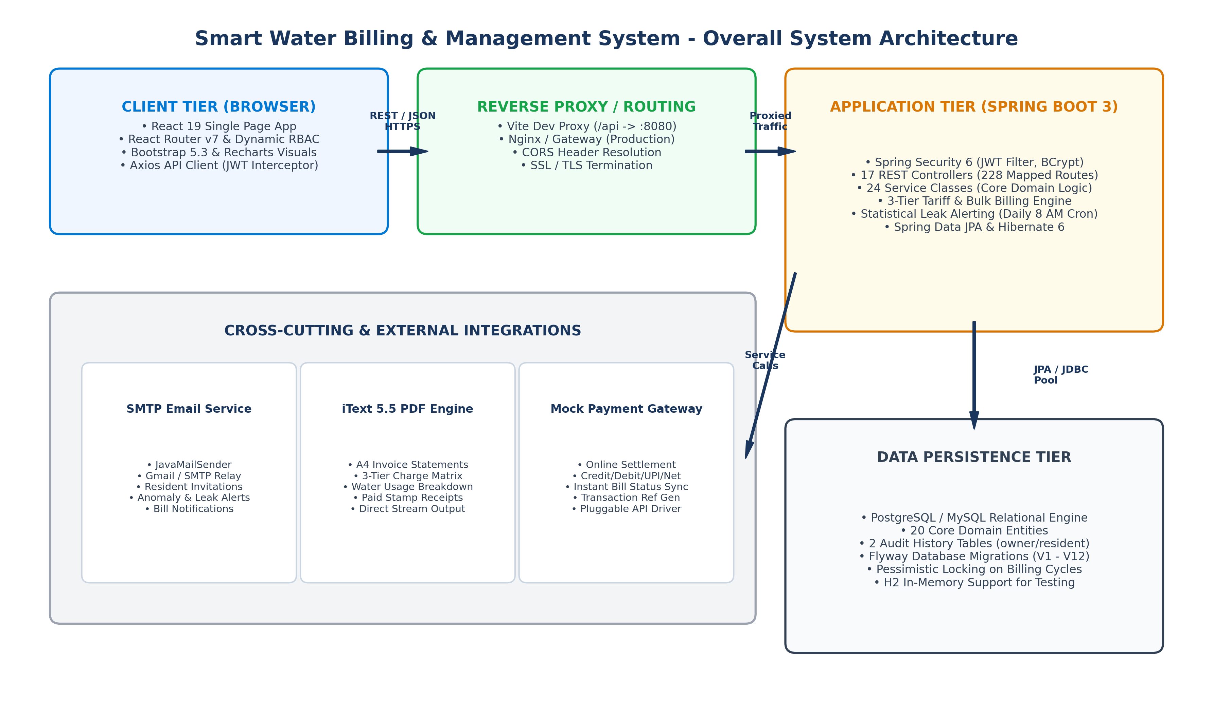
Figure: AquaFlow Overall System Architecture and Tier Topology
graph TD
Client[Browser: React 19 SPA + Bootstrap 5.3] -->|HTTPS / REST / JSON| Proxy[Vite Dev Proxy / Nginx Gateway]
Proxy -->|Proxied Traffic /api/*| Security[Spring Security 6: JwtAuthenticationFilter]
Security --> Controllers[17 REST Controllers: 228 Mapped Routes]
Controllers --> Services[24 Domain Services: BulkBilling, Tariff, Occupancy, etc.]
Services --> Repos[20 Spring Data JPA Repositories + Pessimistic Locking]
Repos --> DB[(PostgreSQL / MySQL / H2 Relational Database)]
Services -->|SMTP Alerts| Mail[SMTP Mail Server: JavaMailSender]
Services -->|PDF Streaming| PDF[iText 5.5 PDF Engine]
Services -->|Online Settlement| Pay[Mock Payment Gateway]
Scheduler[AlertScheduler: Daily 8 AM Cron] -->|Trigger Audit| Services
Listing: Mermaid Specification: High-Level System Architecture

5.2 Backend Layered Architecture
The backend strictly implements the Layered Architectural Pattern. Each layer has an explicit, singular responsibility, preventing cross-tier leakage of persistence or UI concerns:
- Layer 1 - Presentation & Security Layer: Intercepts inbound HTTP requests, extracts JWT tokens from the Authorization header or query parameter, validates signatures, sets Spring Security context, and dispatches to REST Controllers. Formats error responses via GlobalExceptionHandler.
- Layer 2 - DTO & Validation Layer: Decouples persistence entities from network transfer payloads. Uses Jakarta Bean Validation annotations (@NotBlank, @Min, @Max) to reject malformed inputs before reaching business services.
- Layer 3 - Business & Domain Service Layer: Encapsulates all domain algorithms, tariff formulas, CSV processing, statistical calculations, and transaction boundaries (@Transactional). Manages pessimistic locking on billing cycles.
- Layer 4 - Data Access & Persistence Layer: Spring Data JPA repositories interfacing with Hibernate ORM. Provides derived query methods, JPQL queries, and raw SQL queries for audit tables.
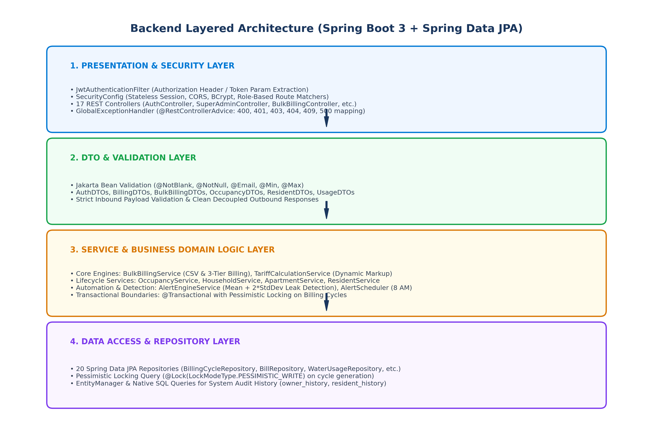
Figure: Backend Layered Architecture and Request Processing Hierarchy

5.3 Frontend Architecture & Single Page Navigation
The frontend is implemented with React 19 and React Router v7. The component architecture utilizes a two-tier nested layout pattern: PublicLayout (for unauthenticated auth pages) and DashboardLayout (for role-protected workspaces). The application context AuthContext provides global user identity, token persistence in localStorage, and reactive login/logout states.
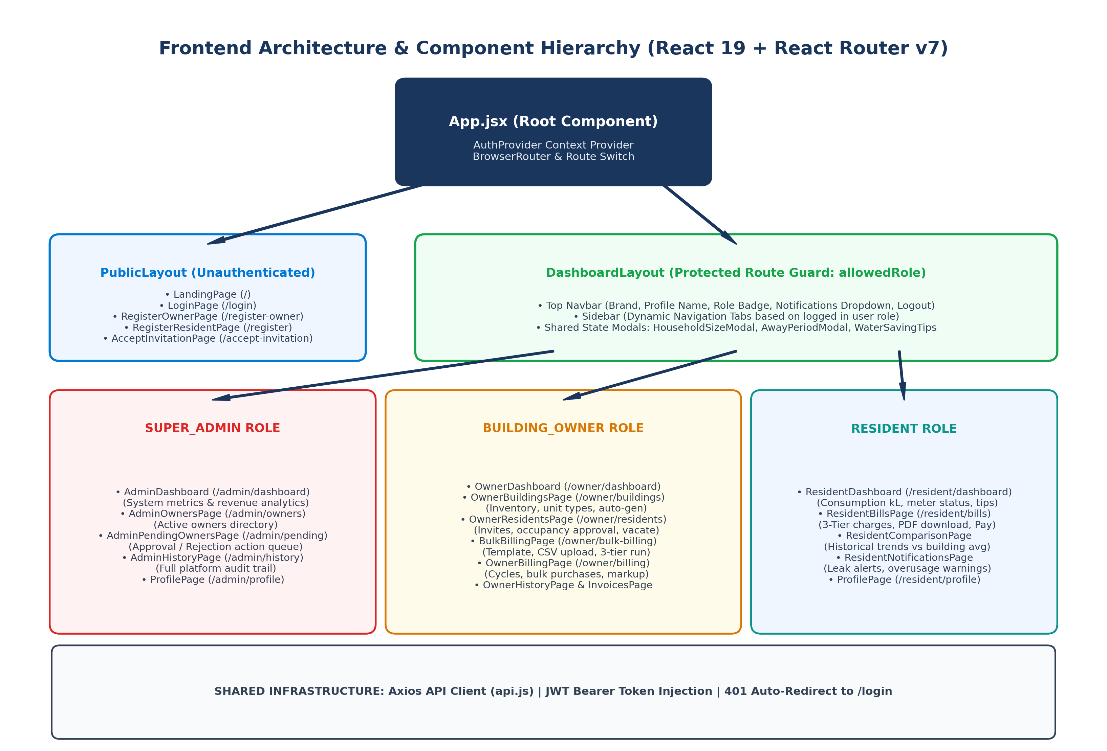
Figure: Frontend Component Hierarchy and Dynamic Role-Based Routing
graph TD
App[App.jsx Root] --> AuthProv[AuthProvider Context]
AuthProv --> Router[BrowserRouter & Routes]
Router --> Public[PublicLayout: Landing, Login, Register, AcceptInvite]
Router --> Dash[DashboardLayout: Guarded by allowedRole]
Dash --> Navbar[Top Navbar: Brand, Profile, Role Badge, Notifications]
Dash --> Sidebar[Dynamic Sidebar: Role-specific navigation tabs]
Dash --> AdminPages[Super Admin: Dashboard, Owners, Pending, History]
Dash --> OwnerPages[Building Owner: Buildings, Residents, BulkBilling, Billing, Invoices]
Dash --> ResidentPages[Resident: Dashboard, Bills, Comparison, Notifications]
Dash --> Modals[Shared Modals: HouseholdSizeModal, AwayPeriodModal]
AllPages --> AxiosClient[api.js: Axios Interceptors Bearer JWT + 401 Redirect]
Listing: Mermaid Specification: Frontend Component Hierarchy

5.4 Database Architecture & Tri-Database Compatibility
AquaFlow is designed with tri-database portability, allowing seamless operation across PostgreSQL, MySQL, and H2 without source code alterations:
- PostgreSQL: PostgreSQL (Production/Target): Configured via Flyway migration scripts (V1 through V12). Utilizes BIGSERIAL primary keys, native TIMESTAMP columns, and PostgreSQL sequence synchronization in DataInitializer.java.
- MySQL: MySQL 8+ (Active application.yml): Configured with jdbc:mysql://localhost:3306/aquatrac. Leverages Hibernate ddl-auto: update and MySQL-compatible AUTO_INCREMENT primary keys in standalone scripts.
- H2 Testing: H2 In-Memory (application-h2.yml): Provided for instant zero-dependency testing and CI/CD automated test execution with an embedded H2 web console (/h2-console).

5.5 Authentication & Authorization Security Flow
Authentication is completely stateless. The client sends user credentials, which are validated by DaoAuthenticationProvider against BCrypt-hashed passwords. A 24-hour signed JWT token is issued. For all subsequent requests, JwtAuthenticationFilter intercepts the HTTP request, extracts the Bearer token (or ?token= query parameter), validates the HMAC-SHA256 signature, and populates the SecurityContextHolder.
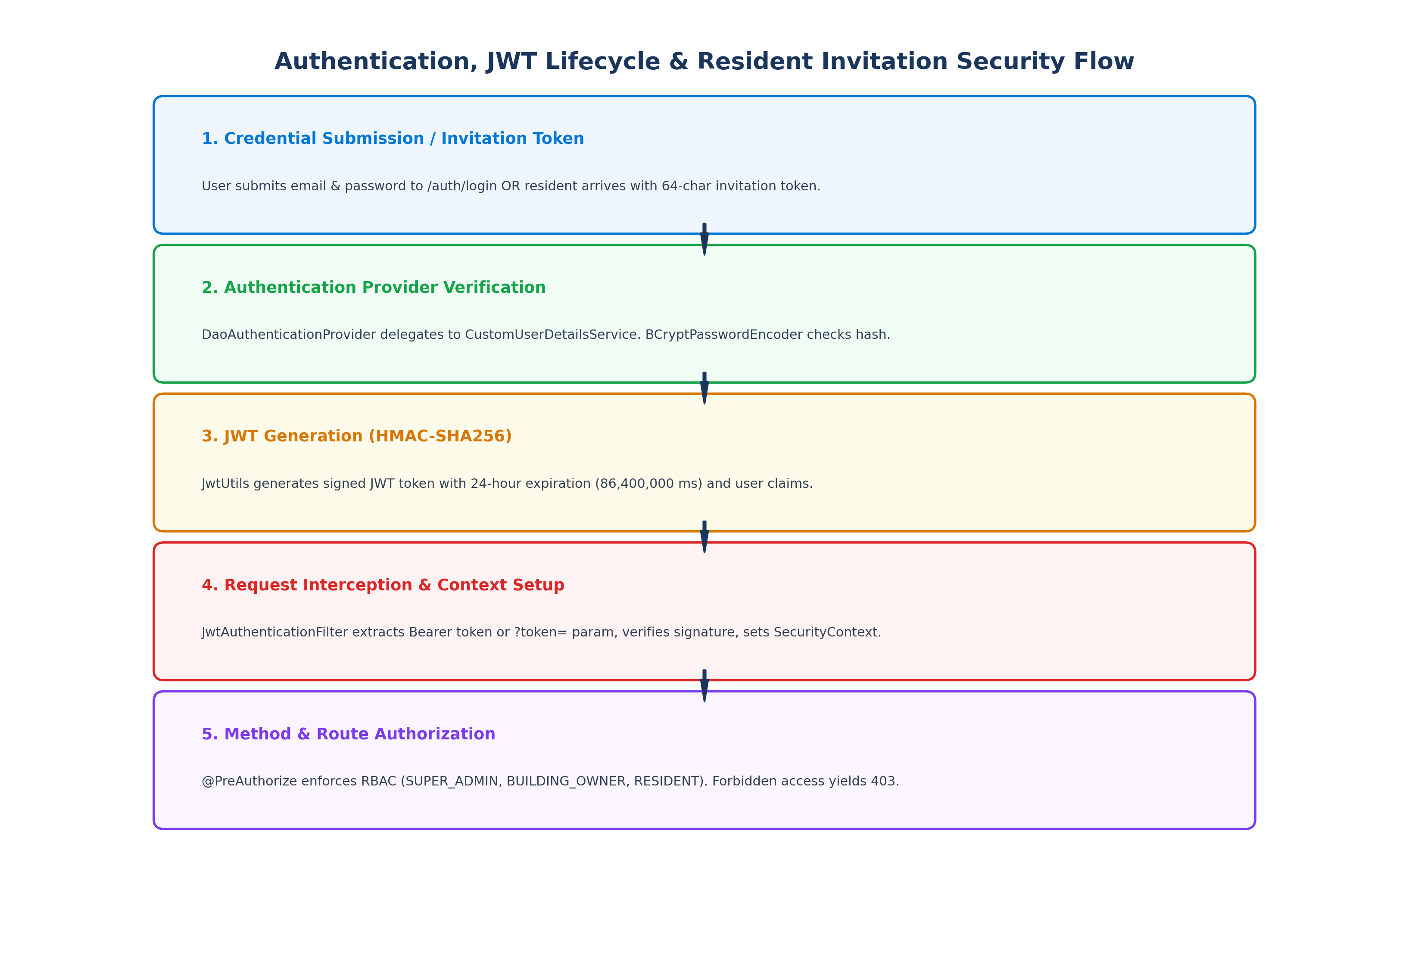
Figure: Stateless JWT Authentication and Method-Level Authorization Pipeline

5.6 External Integrations & Cloud Deployment Architecture
The system integrates three core external capabilities: 1) Jakarta Mail (Spring Mail) connecting to SMTP relays (e.g. Gmail SMTP on port 587 with TLS) for invitation emails and leak alerts; 2) iText 5.5 embedded PDF generation engine streaming dynamic A4 invoices directly to the client; 3) Mock Payment Gateway simulating instant online clearing with unique transaction references. For production deployment, the backend can be containerized using Docker, with Nginx reverse proxying traffic to Spring Boot on port 8080 and serving the static React build.

6. Backend Technical Architecture and Implementation
The AquaFlow backend is implemented in Java 17 on the Spring Boot 3.2.5 runtime framework. It follows domain-driven packaging, strict inversion of control, declarative transaction demarcation, and interface-driven repository abstraction. This section provides an architectural breakdown of all packages, core classes, services, and repositories.

6.1 Package Architecture & Component Responsibilities
Package Name | Key Classes & Components | Architectural Responsibility & Domain Focus
com.smartwater.billing | SmartWaterApplication.java | Main Spring Boot application launcher annotated with @SpringBootApplication and @EnableScheduling to activate daily alert cron tasks.
common.config | SecurityConfig, JwtUtils, JwtAuthenticationFilter, CustomUserDetailsService, CorsConfig, DataInitializer, HouseholdProperties, SwaggerConfig | Cross-cutting configuration beans: Spring Security filter chain, BCrypt encoder, JWT generation/validation, CORS resolution, automatic admin seeding, household sizing limits, and OpenAPI 3.0 documentation.
common.controller | AuthController, BillController, UserController | Exposes REST endpoints for user authentication, password management, profile inspection, manual bill generation, PDF invoice downloads, and invoice dashboard queries.
common.service | AuthService, BillingService, BillingCycleService, InvoiceService, PdfGeneratorService, UserService, WaterUsageService, AlertEngineService, EmailService | Core foundational services managing token creation, bill calculations, billing cycle state transitions, iText PDF streaming, meter consumption tracking, statistical leak anomaly detection, and SMTP email dispatch.
common.repository | UserRepository, BillRepository, BillingCycleRepository, InvoiceRepository, PaymentRepository, WaterMeterRepository, WaterUsageRepository | Spring Data JPA repositories providing CRUD operations, custom derived queries, and pessimistic locking queries (@Lock(PESSIMISTIC_WRITE)).
common.entity | User, Bill, BillingCycle, Invoice, Payment, WaterMeter, WaterUsage | Core JPA domain entities mapped to relational database tables with foreign key constraints, column mappings, and lifecycle callbacks (@PrePersist).
common.exception | GlobalExceptionHandler, BadRequestException, ResourceNotFoundException, UnauthorizedException | Centralized REST error handling via @RestControllerAdvice. Intercepts validation errors, bad credentials, missing resources, and database unique constraint violations, returning structured ErrorResponse payloads.
common.util | CsvHelper, TokenGenerator | Utility engines: CsvHelper parses and produces RFC-4180 CSV streams with UTF-8 BOM stripping and formula injection protection. TokenGenerator creates 256-bit secure hex tokens and computes SHA-256 hashes.
owner.controller | ApartmentController, BillingCycleController, BuildingOwnerController, BulkBillingController, OwnerHouseholdController, PurchaseController, TariffController, WaterUsageController | Building Owner endpoints: Building/apartment inventory management, RFC-4180 bulk CSV meter reading uploads, bulk 3-tier bill generation, water purchase logging, dynamic tariff calculations, and tenant management.
owner.service | ApartmentService, BuildingOwnerService, BulkBillingService, DistributionService, TariffCalculationService, TariffPlanService, TariffRecommendationService, WaterPurchaseCostService, WaterPurchaseService | Domain services executing landlord operations: CSV validation, pessimistic-locked bill generation, procurement cost averaging, custom markup calculations, and building occupancy stats.
owner.repository | ApartmentRepository, BuildingRepository, BuildingOwnerRepository, TariffPlanRepository, TariffRepository, WaterPurchaseRepository | Persistence interfaces managing buildings, apartments, bulk purchases, and tariff plans.
owner.entity | Apartment, Building, BuildingOwner, Tariff, TariffPlan, WaterPurchase | Landlord domain entities modeling property structures, unit types (STUDIO, 1BHK, 2BHK, 3BHK, PENTHOUSE), bulk water purchases, and 3-tier pricing configurations.
resident.controller | NotificationController, OccupancyController, ResidentController, ResidentHouseholdController | Resident endpoints: Invitation acceptance, personal dashboard metrics, water consumption comparisons, online mock bill payments, household occupant management, away period logging, and notification reads.
resident.service | ResidentService, OccupancyService, HouseholdService, AwayPeriodService | Resident domain services: Tenancy lifecycle, apartment claim approvals/rejections, occupant size history tracking, temporary vacation away periods, and peer usage comparisons.
resident.repository | ResidentRepository, ApartmentOccupancyRepository, AwayPeriodRepository, HouseholdSizeHistoryRepository, NotificationRepository, OccupancyRequestRepository, ResidentInvitationRepository | Repositories storing resident profiles, occupancy state, away periods, and notifications.
resident.entity | Resident, ApartmentOccupancy, AwayPeriod, HouseholdSizeHistory, Notification, OccupancyRequest, ResidentInvitation | Resident entities modeling individual occupancy, invitation tokens, away schedules, and leak alerts.
superadmin.controller | SuperAdminController | Super Admin governance endpoints for reviewing pending owner registrations, approving/rejecting owners, deleting owners, and inspecting platform history.
superadmin.service | SuperAdminService | Governance service aggregating cross-system revenue metrics, active owner directories, and querying the owner_history audit table via EntityManager native queries.

6.2 Exception Handling and Validation Architecture
AquaFlow utilizes a robust, unified error-handling framework centered on GlobalExceptionHandler (@RestControllerAdvice). When an error occurs, it is intercepted and converted into a standard ErrorResponse JSON object with an HTTP status code, descriptive message, and timestamp. Key handled exception categories include:
- 404 Not Found: ResourceNotFoundException (404 Not Found): Fired when an entity (User, Building, Bill, etc.) does not exist.
- 400 Bad Request: BadRequestException (400 Bad Request): Fired on invalid inputs, negative meter consumption, attempt to regenerate bills for a closed cycle, or overlapping away period dates.
- 401 / 403 Security: UnauthorizedException / AccessDeniedException (401 / 403): Fired when credentials are missing or when a user attempts to access an endpoint outside their role permissions.
- 409 Conflict: DataIntegrityViolationException (409 Conflict): Intercepts database constraint failures (e.g. duplicate bills uk_bills_cycle_resident, duplicate invoices uk_invoices_cycle_resident, duplicate meter numbers, or duplicate email addresses) and converts raw SQL error codes into user-friendly messages.
- Bean Validation: MethodArgumentNotValidException (400 Bad Request): Fired by Jakarta Bean Validation (@Valid). Returns a field-to-message mapping of all validation violations (e.g., {'email': 'must be a well-formed email address'}).

7. Complete REST API Specification
The AquaFlow backend provides 228 mapped route permutations across 17 REST controllers. To ensure maximum compatibility with diverse frontend clients and reverse proxy configurations, several controllers map multiple path aliases (e.g., both /api/owner/buildings and /owners/buildings). Below is the comprehensive API reference table grouped by functional domain:
Method | Endpoint Route | Purpose & Business Action | Request Payload / Params | Response Structure | Role Guard
POST | /api/auth/login | Authenticate user & issue 24-hr JWT | LoginRequest (email, password) | LoginResponse (token, role, status) | Public / Anonymous
POST | /api/auth/register-owner | Register new Building Owner (PENDING) | RegisterOwnerRequest (name, email, phone) | MessageResponse | Public / Anonymous
POST | /api/auth/register-resident | Self-register resident profile | RegisterResidentRequest (name, email, etc.) | LoginResponse | Public / Anonymous
GET | /api/auth/validate-invitation | Validate 64-char invitation token | Query param: ?token=... | ValidateInvitationResponse | Public / Anonymous
POST | /api/auth/accept-invitation | Accept invite & set resident password | SetPasswordRequest (token, password) | MessageResponse | Public / Anonymous
GET | /api/user/profile | Retrieve logged-in user profile | None (Bearer Header) | UserProfileResponse (name, email, phone) | Authenticated (All Roles)
PUT | /api/user/profile | Update user display name / phone | UpdateProfileRequest (name, phone) | UserProfileResponse | Authenticated (All Roles)
PUT | /api/user/change-password | Change user account password | ChangePasswordRequest (old, new) | MessageResponse | Authenticated (All Roles)
GET | /api/admin/dashboard | System dashboard KPIs & revenue | None | AdminDashboardStats | ROLE_SUPER_ADMIN
GET | /api/admin/owners | List all registered building owners | None | List<BuildingOwnerDTO> | ROLE_SUPER_ADMIN
GET | /api/admin/owners/pending | List pending owner approval queue | None | List<BuildingOwnerDTO> | ROLE_SUPER_ADMIN
PUT | /api/admin/owners/{id}/approve | Approve pending building owner | Path variable: id | BuildingOwnerDTO (status APPROVED) | ROLE_SUPER_ADMIN
PUT | /api/admin/owners/{id}/reject | Reject pending building owner | Path variable: id | BuildingOwnerDTO (status REJECTED) | ROLE_SUPER_ADMIN
DELETE | /api/admin/owners/{id} | Delete owner & cascade remove | Path variable: id | Void (HTTP 204) | ROLE_SUPER_ADMIN
GET | /api/admin/history | Retrieve immutable system audit trail | None | List<SystemHistoryItemDTO> | ROLE_SUPER_ADMIN
GET | /api/owner/dashboard | Building Owner dashboard KPIs | None | OwnerDashboardStats | SUPER_ADMIN, BUILDING_OWNER
GET | /api/owner/buildings | List owner buildings & flat counts | None | List<BuildingResponse> | SUPER_ADMIN, BUILDING_OWNER
POST | /api/owner/buildings | Create new building entity | CreateBuildingRequest | BuildingResponse | SUPER_ADMIN, BUILDING_OWNER
DELETE | /api/owner/buildings/{id} | Delete building & cascades | Path variable: id | Void (HTTP 204) | SUPER_ADMIN, BUILDING_OWNER
GET | /api/owner/buildings/{id}/apartments | List inventory & occupied units | Path variable: id | BuildingInventoryResponse | SUPER_ADMIN, BUILDING_OWNER
POST | /api/owner/buildings/{id}/apartments | Create single apartment unit | CreateApartmentRequest | ApartmentResponse | SUPER_ADMIN, BUILDING_OWNER
POST | /api/owner/buildings/{id}/generate-default-apartments | Auto-generate missing units | Path variable: id | BuildingInventoryResponse | SUPER_ADMIN, BUILDING_OWNER
PUT | /api/owner/apartments/{id}/meter | Assign/update apartment water meter | Query: ?meterNumber=... | ApartmentResponse | SUPER_ADMIN, BUILDING_OWNER
POST | /api/owner/apartments/{id}/vacate | Vacate apartment tenant | Path variable: id | Void (HTTP 204) | SUPER_ADMIN, BUILDING_OWNER
DELETE | /api/owner/apartments/{id} | Delete apartment entity | Path variable: id | Void (HTTP 204) | SUPER_ADMIN, BUILDING_OWNER
GET | /api/owner/residents | List & filter residents (ACTIVE/PENDING) | Query: ?query=...&status=... | List<ResidentResponse> | SUPER_ADMIN, BUILDING_OWNER
POST | /api/residents/invite | Invite new resident via token email | InviteResidentRequest | ResidentResponse | SUPER_ADMIN, BUILDING_OWNER
POST | /api/residents/invitations/{id}/resend | Resend invitation token email | Path variable: id | MessageResponse | SUPER_ADMIN, BUILDING_OWNER
DELETE | /api/owner/invitations/{id} | Cancel pending resident invite | Path variable: id | Void (HTTP 204) | SUPER_ADMIN, BUILDING_OWNER
PUT | /api/owner/residents/{id} | Update resident profile details | UpdateResidentRequest | ResidentResponse | SUPER_ADMIN, BUILDING_OWNER
POST | /api/owner/residents/{id}/vacate | Force vacate resident tenancy | Path variable: id | Void (HTTP 204) | SUPER_ADMIN, BUILDING_OWNER
DELETE | /api/owner/residents/{id} | Remove resident account | Path variable: id | Void (HTTP 204) | SUPER_ADMIN, BUILDING_OWNER
GET | /api/owner/history | Retrieve resident tenancy history | None | List<ResidentHistoryItemDTO> | SUPER_ADMIN, BUILDING_OWNER
DELETE | /api/owner/leave | Owner voluntary account deletion | None | MessageResponse | SUPER_ADMIN, BUILDING_OWNER
GET | /api/billing-cycles | List cycles for building | Query: ?buildingId=... | List<BillingCycle> | SUPER_ADMIN, BUILDING_OWNER
POST | /api/billing-cycles | Open new BillingCycle (OPEN) | Map (buildingId, startDate, endDate) | BillingCycle | SUPER_ADMIN, BUILDING_OWNER
POST | /api/billing-cycles/{id}/finalize | Lock & finalize cycle (FINALIZED) | Path variable: id | BillingCycle | SUPER_ADMIN, BUILDING_OWNER
POST | /api/billing-cycles/{id}/archive | Archive billing cycle (ARCHIVED) | Path variable: id | BillingCycle | SUPER_ADMIN, BUILDING_OWNER
GET | /api/bulk-billing/readiness | Check cycle readiness for billing | Query: ?buildingId=...&cycleId=... | CycleReadinessDTO | SUPER_ADMIN, BUILDING_OWNER
GET | /api/bulk-billing/template | Download prefilled CSV template | Query: ?buildingId=...&cycleId=... | byte[] (application/csv) | SUPER_ADMIN, BUILDING_OWNER
POST | /api/bulk-billing/validate | Validate uploaded meter CSV | MultipartFile (.csv), buildingId, cycleId | BulkValidationResponse | SUPER_ADMIN, BUILDING_OWNER
POST | /api/bulk-billing/error-report | Download validation error CSV | BulkValidationResponse body | byte[] (application/csv) | SUPER_ADMIN, BUILDING_OWNER
POST | /api/bulk-billing/import-readings | Import meter readings only | MultipartFile (.csv), buildingId, cycleId | BulkImportResponse | SUPER_ADMIN, BUILDING_OWNER
POST | /api/bulk-billing/generate | Generate 3-tier bills (Pessimistic Lock) | MultipartFile (.csv), buildingId, cycleId | BulkImportResponse | SUPER_ADMIN, BUILDING_OWNER
POST | /api/purchases | Record bulk water purchase | CreateWaterPurchaseRequest | WaterPurchase | SUPER_ADMIN, BUILDING_OWNER
GET | /api/purchases | List bulk water purchases | Query: ?buildingId=...&cycleId=... | List<WaterPurchase> | SUPER_ADMIN, BUILDING_OWNER
GET | /api/purchases/summary | Average procurement cost summary | Query: ?buildingId=...&cycleId=... | PurchaseSummaryResponse | SUPER_ADMIN, BUILDING_OWNER
POST | /api/tariff-plans | Create / update cycle tariff plan | Map (buildingId, cycleId, markup) | TariffPlan | SUPER_ADMIN, BUILDING_OWNER
POST | /api/tariff-plans/cycle/{id}/markup | Update cycle markup percentage | Path variable: id, Body: markup | TariffPlan | SUPER_ADMIN, BUILDING_OWNER
GET | /api/tariff-plans/recommendation/{bId}/{cId} | AI / Heuristic tariff recommendation | Path variables: bId, cId | TariffRecommendationResponse | SUPER_ADMIN, BUILDING_OWNER
GET | /api/invoices | Invoice dashboard summary & list | Query: ?buildingId=...&status=... | InvoiceDashboardSummary | SUPER_ADMIN, BUILDING_OWNER
GET | /api/bills/owner | List all owner issued bills | None | List<BillResponse> | SUPER_ADMIN, BUILDING_OWNER
PUT | /api/bills/{id}/status | Update bill status (PAID/UNPAID) | Path variable: id, Query: ?status=... | BillResponse | SUPER_ADMIN, BUILDING_OWNER
GET | /api/bills/{id}/pdf | Stream official A4 PDF invoice/receipt | Path: id, Auth: Bearer / ?token=... | InputStreamResource (application/pdf) | SUPER_ADMIN, OWNER, RESIDENT
GET | /api/resident/dashboard | Personal usage & current cycle KPI | None | ResidentDashboardStats | SUPER_ADMIN, OWNER, RESIDENT
GET | /api/resident/bills | List resident personal water bills | None | List<BillResponse> | SUPER_ADMIN, OWNER, RESIDENT
POST | /api/resident/pay | Pay water bill online (Mock Gateway) | PaymentRequest (billId, amount, method) | PaymentResponse (txRef, date) | SUPER_ADMIN, OWNER, RESIDENT
GET | /api/resident/payments | Payment settlement history | None | List<PaymentResponse> | SUPER_ADMIN, OWNER, RESIDENT
GET | /api/resident/consumption-comparison | Usage comparison vs building avg | None | ResidentComparisonResponse | SUPER_ADMIN, OWNER, RESIDENT
GET | /api/resident/household | Household occupant details & size | None | HouseholdDetailResponse | SUPER_ADMIN, OWNER, RESIDENT
PUT | /api/resident/household | Update occupant size (1-15) | HouseholdUpdateRequest | HouseholdDetailResponse | SUPER_ADMIN, OWNER, RESIDENT
GET | /api/resident/away-periods | List registered away periods | None | List<AwayPeriodResponse> | SUPER_ADMIN, OWNER, RESIDENT
POST | /api/resident/away-periods | Register temporary away period | AwayPeriodRequest (start, end, reason) | AwayPeriodResponse | SUPER_ADMIN, OWNER, RESIDENT
DELETE | /api/resident/away-periods/{id} | Delete registered away period | Path variable: id | MessageResponse | SUPER_ADMIN, OWNER, RESIDENT
GET | /api/notifications | List resident notifications & alerts | None | List<Notification> | SUPER_ADMIN, OWNER, RESIDENT
PUT | /api/notifications/{id}/read | Mark notification as read | Path variable: id | MessageResponse | SUPER_ADMIN, OWNER, RESIDENT

8. Frontend Technical Architecture and Implementation
The AquaFlow user interface is built as a responsive Single Page Application (SPA) using React 19, React Router v7, Bootstrap 5.3.3, and Axios 1.7.2. It delivers dedicated dashboards and task-oriented workflows for each stakeholder persona while sharing common layout scaffolding, authentication context, and API communications.

8.1 Application Bootstrap & Entry Hierarchy
The frontend initialization sequence proceeds through three deterministic steps:
- 1. Mount DOM: HTML Container (index.html): Standard HTML5 document providing the mount container <div id='root'></div> and loading the Bootstrap 5.3 stylesheets and Bootstrap Icons.
- 2. React Mount: Root Initialization (src/main.jsx): React 19 entry point executing ReactDOM.createRoot(document.getElementById('root')).render(<App />).
- 3. Router & Auth: Routing & Context Wrap (src/App.jsx): Wraps the entire component tree in <AuthProvider> and <BrowserRouter>, declaring all route mappings and layout boundaries.

8.2 Layout Scaffolding and Protected Route Guards
Routing is segmented into two structural layouts to enforce strict security and visual consistency:
- PublicLayout: PublicLayout: Provides a clean, minimalist navbar and footer for unauthenticated visitors. Hosts LandingPage (/), LoginPage (/login), RegisterOwnerPage (/register-owner), RegisterResidentPage (/register), and AcceptInvitationPage (/accept-invitation).
- DashboardLayout (RBAC Guard): DashboardLayout: The authenticated enterprise workspace. Accepts an 'allowedRole' prop. If the user is unauthenticated, it redirects to /login. If the user's role does not match allowedRole (e.g. a RESIDENT attempting to access /admin/dashboard), it redirects or renders an access denied prompt. Encapsulates the top Navbar and dynamic role-filtered Sidebar.

8.3 Centralized State Management & AuthContext
Global identity is managed via AuthContext (src/shared/context/AuthContext.jsx). Upon initial browser load, an effect hook reads 'user' and 'jwtToken' from localStorage to restore session state without extra server handshakes. The context exposes login(), registerOwner(), registerResident(), acceptInvitation(), and logout() methods. Calling logout() immediately purges localStorage keys and clears reactive state, causing React Router to re-render the unauthenticated state.

8.4 Axios API Client & Network Interceptors
All asynchronous HTTP traffic is routed through a customized Axios singleton instance (src/shared/services/api.js). The client features two automated interceptors:
- JWT & Multipart Interceptor: Request Interceptor: Automatically inspects localStorage for 'jwtToken'. If present, it injects the 'Authorization: Bearer <token>' header into the outgoing HTTP request. Furthermore, if the request payload is an instance of FormData (such as during CSV meter uploads in BulkBillingPage), it automatically deletes the default 'Content-Type: application/json' header, allowing the browser to inject the correct 'multipart/form-data; boundary=...' header.
- 401 Session Expiry Interceptor: Response Interceptor: Monitors incoming HTTP response status codes. If an HTTP 401 Unauthorized error is intercepted (indicating an expired or invalidated JWT token), it automatically clears 'jwtToken' and 'user' from localStorage and forces a client redirect to /login.

9. Database Design, Relationships and Persistence
AquaFlow's data persistence architecture consists of 20 JPA domain entities and 2 native audit history tables. The database schema has evolved through 12 sequential Flyway SQL migrations (V1 to V12), establishing strong foreign key referential integrity, cascading deletion policies, and compound unique constraints.
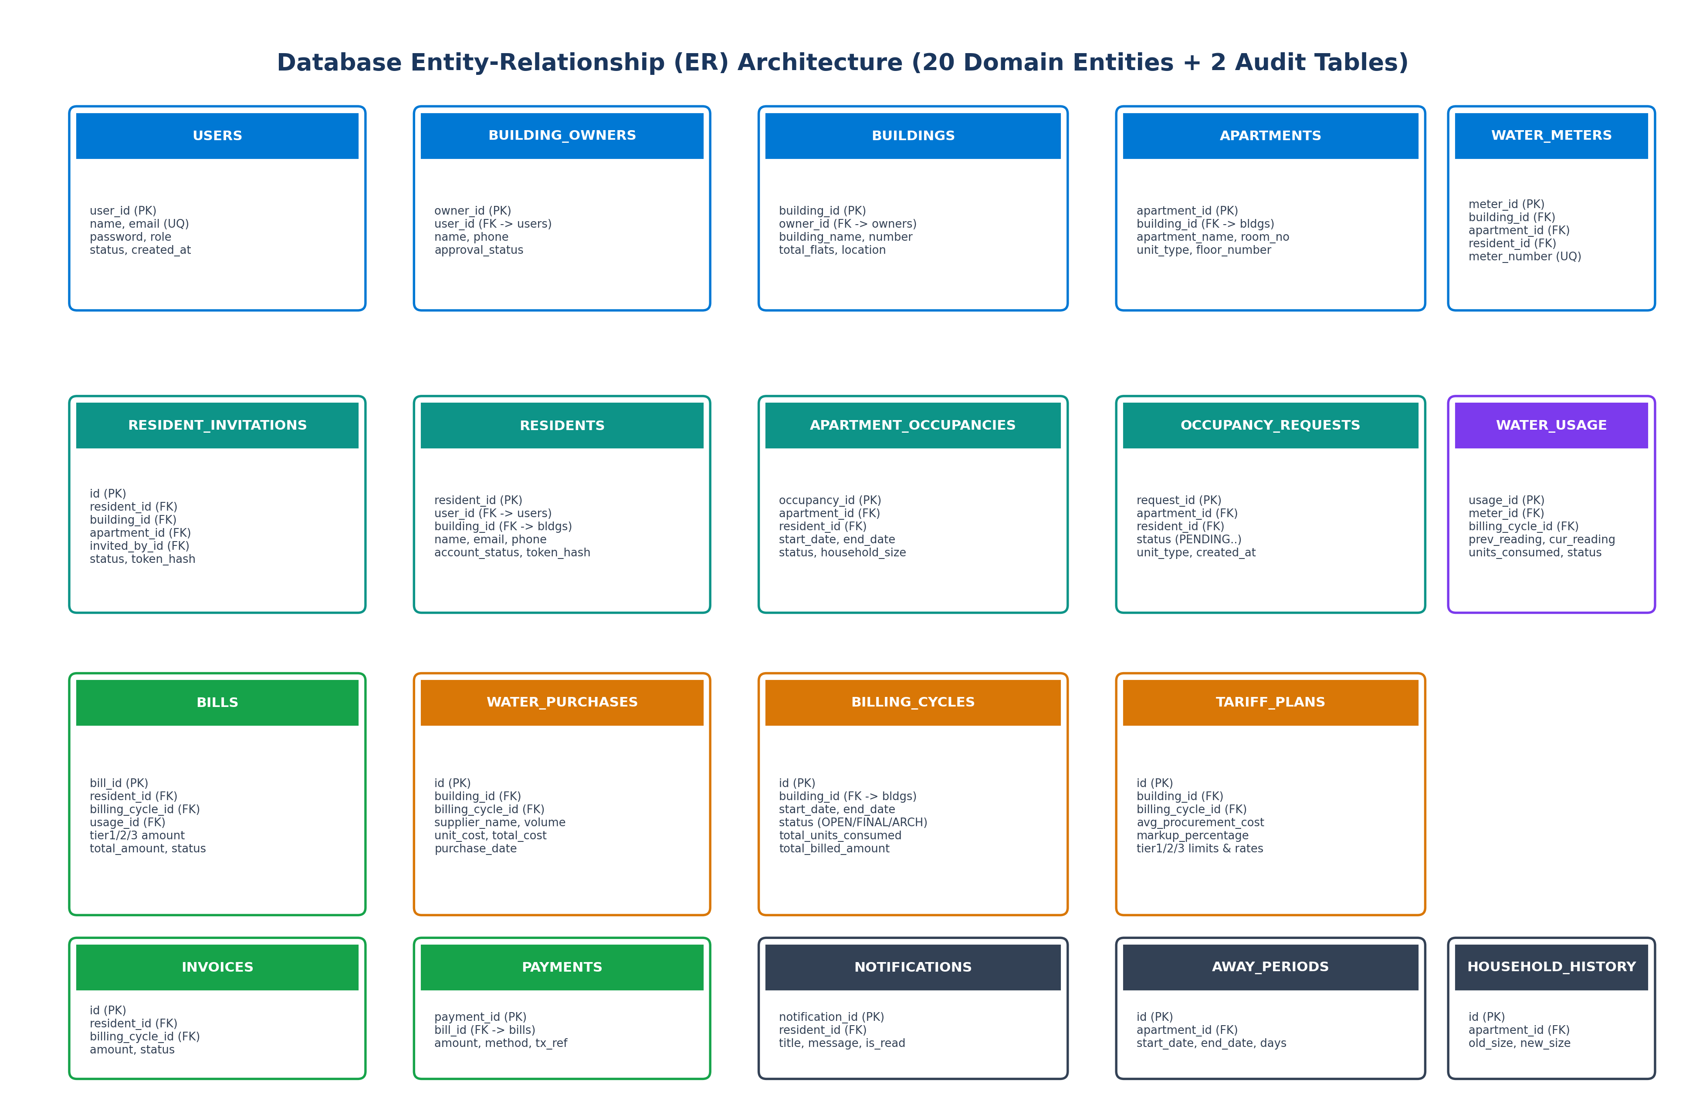
Figure: Complete Relational Database Entity-Relationship (ER) Diagram

9.1 Comprehensive Entity and Table Schema Reference
Table Name | Primary Key & Foreign Keys | Core Columns & Data Types | Business Purpose & Constraints
users | user_id (BIGSERIAL PK) | name, email (UQ), password, role (ENUM), status (ENUM), created_at | Root authentication entity. Role: SUPER_ADMIN, BUILDING_OWNER, RESIDENT. Status: PENDING, APPROVED, REJECTED, ACTIVE, INACTIVE.
building_owners | owner_id (BIGSERIAL PK) | user_id (FK -> users.user_id ON DELETE CASCADE), name, phone, approval_status, created_at | Property manager profile.approval_status tracks Super Admin verification (PENDING -> APPROVED / REJECTED).
buildings | building_id (BIGSERIAL PK) | owner_id (FK -> building_owners.owner_id ON DELETE CASCADE), building_name, building_number, total_flats, location, created_at | Physical building entity. Deleting a building cascades deletion to all apartments, meters, and resident links.
apartments | apartment_id (BIGSERIAL PK) | building_id (FK -> buildings.building_id ON DELETE CASCADE), floor_number, apartment_name, room_number, unit_type, created_at | Individual apartment flat inventory. Unit types: STUDIO, 1BHK, 2BHK, 3BHK, PENTHOUSE.
residents | resident_id (BIGSERIAL PK) | user_id (FK -> users.user_id ON DELETE SET NULL), building_id (FK -> buildings.building_id ON DELETE CASCADE), name, email, phone, apartment_number, account_status, token_hash, expires_at, accepted_at | Resident tenancy record. Holds SHA-256 token_hash for secure invitation validation and account_status (ACTIVE/INACTIVE).
apartment_occupancies | occupancy_id (BIGSERIAL PK) | apartment_id (FK -> apartments ON DELETE CASCADE), resident_id (FK -> residents ON DELETE CASCADE), start_date, end_date, status (ACTIVE/PAST), household_size | Tracks active and historical resident tenancy per flat, including current occupant count.
occupancy_requests | request_id (BIGSERIAL PK) | apartment_id (FK -> apartments ON DELETE CASCADE), resident_id (FK -> residents ON DELETE CASCADE), status (PENDING/APPROVED/REJECTED), unit_type, move_in_date, occupants_count, review_notes | Resident public self-claim requests requiring Building Owner approval.
household_size_history | id (BIGSERIAL PK) | occupancy_id (FK), apartment_id (FK), changed_by_user_id (FK), old_size, new_size, change_reason, effective_date, created_at | Immutable audit trail of occupant count modifications for fair water consumption calculations.
away_periods | id (BIGSERIAL PK) | occupancy_id (FK), apartment_id (FK), start_date, end_date, total_days, reason, created_at | Tracks resident temporary vacation or absence periods (up to 180 days) for billing adjustments.
resident_invitations | id (BIGSERIAL PK) | resident_id (FK), building_id (FK), apartment_id (FK), invited_by_id (FK), email, token_hash, status, created_at, expires_at | Cryptographically secure tokenized invitation registry for resident onboarding.
water_meters | meter_id (BIGSERIAL PK) | building_id (FK), apartment_id (FK), resident_id (FK ON DELETE SET NULL), meter_number (UQ), installation_date, status, last_reading | Physical sub-meter hardware registry. meter_number is globally unique.
water_usage | usage_id (BIGSERIAL PK) | meter_id (FK ON DELETE CASCADE), billing_cycle_id (FK), month, year, previous_reading, current_reading, units_consumed, recorded_at, anomaly_status | Monthly meter reading consumption record. units_consumed = current_reading - previous_reading.
billing_cycles | id (BIGSERIAL PK) | building_id (FK ON DELETE CASCADE), start_date, end_date, billing_month, status (OPEN/FINALIZED/ARCHIVED), total_units_consumed, total_billed_amount, finalized_at | Monthly billing period boundaries. Enforces single OPEN cycle per building with pessimistic write locking.
tariff_plans | id (BIGSERIAL PK) | building_id (FK), billing_cycle_id (FK), average_procurement_cost, markup_percentage, base_tariff, tier1/2/3 multipliers, limits, and rates, status | Cycle-scoped 3-tier progressive consumption pricing structure derived dynamically from bulk purchases.
tariff | tariff_id (BIGSERIAL PK) | minimum_units, maximum_units, price_per_unit, fixed_charge | Legacy static slab pricing table seeded in V1 as a system fallback.
water_purchases | id (BIGSERIAL PK) | building_id (FK), billing_cycle_id (FK), supplier_name, volume (kL), unit_cost, total_cost, purchase_date, invoice_number | Bulk water purchases (e.g., private tankers) used to calculate average procurement cost.
bills | bill_id (BIGSERIAL PK) | resident_id (FK), billing_cycle_id (FK), usage_id (FK), bill_month, bill_year, tier1/2/3 units, rates, amounts, total_amount, due_date, status (UNPAID/PAID) | Final progressive 3-tier resident water bill. Guaranteed unique per cycle and resident.
invoices | id (BIGSERIAL PK) | resident_id (FK), billing_cycle_id (FK), invoice_number, tier1/2/3 breakdown, total_amount, status (UNPAID/PAID), due_date | Tax invoice mirror entity supporting commercial billing workflows.
payments | payment_id (BIGSERIAL PK) | bill_id (FK -> bills.bill_id ON DELETE CASCADE), amount, payment_date, payment_method, transaction_reference | Settlement record tracking online bill payments with UUID transaction references.
notifications | notification_id (BIGSERIAL PK) | resident_id (FK ON DELETE CASCADE), title, message, is_read, created_at | In-app alerts for 20 kL threshold overusage and 2-sigma statistical leak anomalies.
owner_history | id (BIGINT PK AUTO_INCREMENT) | owner_id, owner_name, email, phone, event_type, details, actor, timestamp | Native SQL audit table recording all building owner registration, approval, rejection, and deletion events.
resident_history | id (BIGINT PK AUTO_INCREMENT) | owner_id, building_id, building_name, apartment_id, room_number, resident_id, resident_name, event_type, details, actor, timestamp | Native SQL audit table recording all resident tenancy changes, moves, away periods, and vacancies.

9.2 Key Integrity Constraints and Database Indexes
To guarantee mathematical consistency and eliminate duplicate billing, the database enforces critical compound unique constraints and indexing strategies:
- Billing Cycle Safeguard: uk_bills_cycle_resident (ALTER TABLE bills ADD CONSTRAINT uk_bills_cycle_resident UNIQUE (billing_cycle_id, resident_id)): Guarantees at the database engine level that no resident can ever have more than one bill issued in the same billing cycle.
- Invoice Safeguard: uk_invoices_cycle_resident (ALTER TABLE invoices ADD CONSTRAINT uk_invoices_cycle_resident UNIQUE (billing_cycle_id, resident_id)): Enforces identical uniqueness on the tax invoice entity.
- Meter Number Uniqueness: water_meters_meter_number_key (UNIQUE (meter_number)): Precludes duplicate meter hardware serial numbers from being assigned across different buildings or apartments.
- User Identity Uniqueness: users_email_key (UNIQUE (email)): Guarantees globally unique login email identities across all user roles.

10. Security Architecture and Authorization Flows
AquaFlow's security architecture enforces Defense-in-Depth across every layer: client-side route guards, reverse proxy CORS controls, servlet filter token extraction, Spring Security authentication providers, declarative method-level authorization (@PreAuthorize), and database-level cryptographically hashed credentials.

10.1 Role-Based Access Control (RBAC) Matrix
Permissions are partitioned across three explicit system roles plus unauthenticated public callers. The matrix below defines the exact operational capabilities granted to each identity:
Endpoint Operation | SUPER_ADMIN | BUILDING_OWNER | RESIDENT | Anonymous / Public
Authentication (/api/auth/login) | ALLOW | ALLOW | ALLOW | ALLOW (Public Entry)
Owner Public Registration (/api/auth/register-owner) | ALLOW | ALLOW | ALLOW | ALLOW (Creates PENDING)
Invitation Token Acceptance (/api/auth/accept-invitation) | ALLOW | ALLOW | ALLOW | ALLOW (Validated via SHA-256)
System Dashboard & Owner Approvals (/api/admin/*) | ALLOW | DENY (403) | DENY (403) | DENY (401)
System Audit Trail (/api/admin/history) | ALLOW | DENY (403) | DENY (403) | DENY (401)
Building & Apartment Inventory (/api/owner/buildings/*) | ALLOW | ALLOW | DENY (403) | DENY (401)
Resident Invitations & Management (/api/owner/residents/*) | ALLOW | ALLOW | DENY (403) | DENY (401)
Bulk Billing & CSV Operations (/api/bulk-billing/*) | ALLOW | ALLOW | DENY (403) | DENY (401)
Water Purchases & Tariffs (/api/tariff-plans/*) | ALLOW | ALLOW | DENY (403) | DENY (401)
Resident Personal Usage & Bills (/api/resident/*) | ALLOW | ALLOW | ALLOW (Scoped to Own Flat) | DENY (401)
Online Mock Bill Payment (/api/resident/pay) | ALLOW | ALLOW | ALLOW | DENY (401)
PDF Invoice Download (/api/bills/{id}/pdf) | ALLOW | ALLOW | ALLOW (Own Bill Only) | DENY (401)

10.2 Cryptographic Token & Credential Protection
- BCrypt Password Storage: BCrypt Password Hashing: All user passwords are encrypted using Spring Security's BCryptPasswordEncoder with a default cost factor of 10. Passwords are never logged in application logs and are omitted from outbound DTOs.
- JWT Authentication: Stateless JWT Issuance: JWTs are digitally signed using HMAC-SHA256 (SignatureAlgorithm.HS256) via JJWT 0.11.5 with a 256-bit base64 secret (app.jwt.secret) and a 24-hour expiration window (86,400,000 ms).
- Invitation Security: SHA-256 Resident Invitation Token Hashing: Resident invitation links contain a cryptographically secure 256-bit raw hex token (64 characters). To prevent database compromise exploits, the backend never stores the raw token in plaintext. Instead, TokenGenerator.hashToken computes the SHA-256 hash, which is stored in resident_invitations.token_hash and residents.token_hash.
- CORS Configuration: CORS Whitelisting: CorsConfig explicitly permits the frontend origin (http://localhost:5173), allowing standard HTTP methods (GET, POST, PUT, DELETE, OPTIONS, PATCH) and Authorization headers while denying unapproved third-party domains.

11. End-to-End Business Workflows & Execution Journeys
This section details the six primary business workflows executed within AquaFlow, outlining user actions, component interactions, service boundaries, database transactions, and failure scenarios.

11.1 Workflow 1: Building Owner Registration & Super Admin Approval
User Journey: A property manager registers as a Building Owner, waits for Super Admin vetting, and upon approval sets up their building and apartment inventory.
- Registration: Step 1: Landlord accesses /register-owner on PublicLayout, enters name, email, password, and phone number.
- Backend Persistence: Step 2: Frontend calls POST /api/auth/register-owner. AuthService creates a User record with role BUILDING_OWNER and status PENDING. A corresponding BuildingOwner entity is created with approval_status PENDING.
- Admin Review: Step 3: Super Admin logs into /admin/dashboard, navigates to /admin/pending-owners, inspects the owner details, and clicks 'Approve'.
- Approval Action: Step 4: Frontend calls PUT /api/admin/owners/{id}/approve. SuperAdminService mutates approval_status to APPROVED and user.status to APPROVED. An event is logged into owner_history.
- Property Setup: Step 5: Approved owner logs into /owner/dashboard, opens /owner/buildings, creates a building, and executes 'generate-default-apartments' to populate flats.

11.2 Workflow 2: Resident Invitation, Token Validation & Occupancy Claim
User Journey: Building Owner invites a new tenant to an apartment. The tenant receives an email, verifies the invitation link, sets a password, and establishes active occupancy.
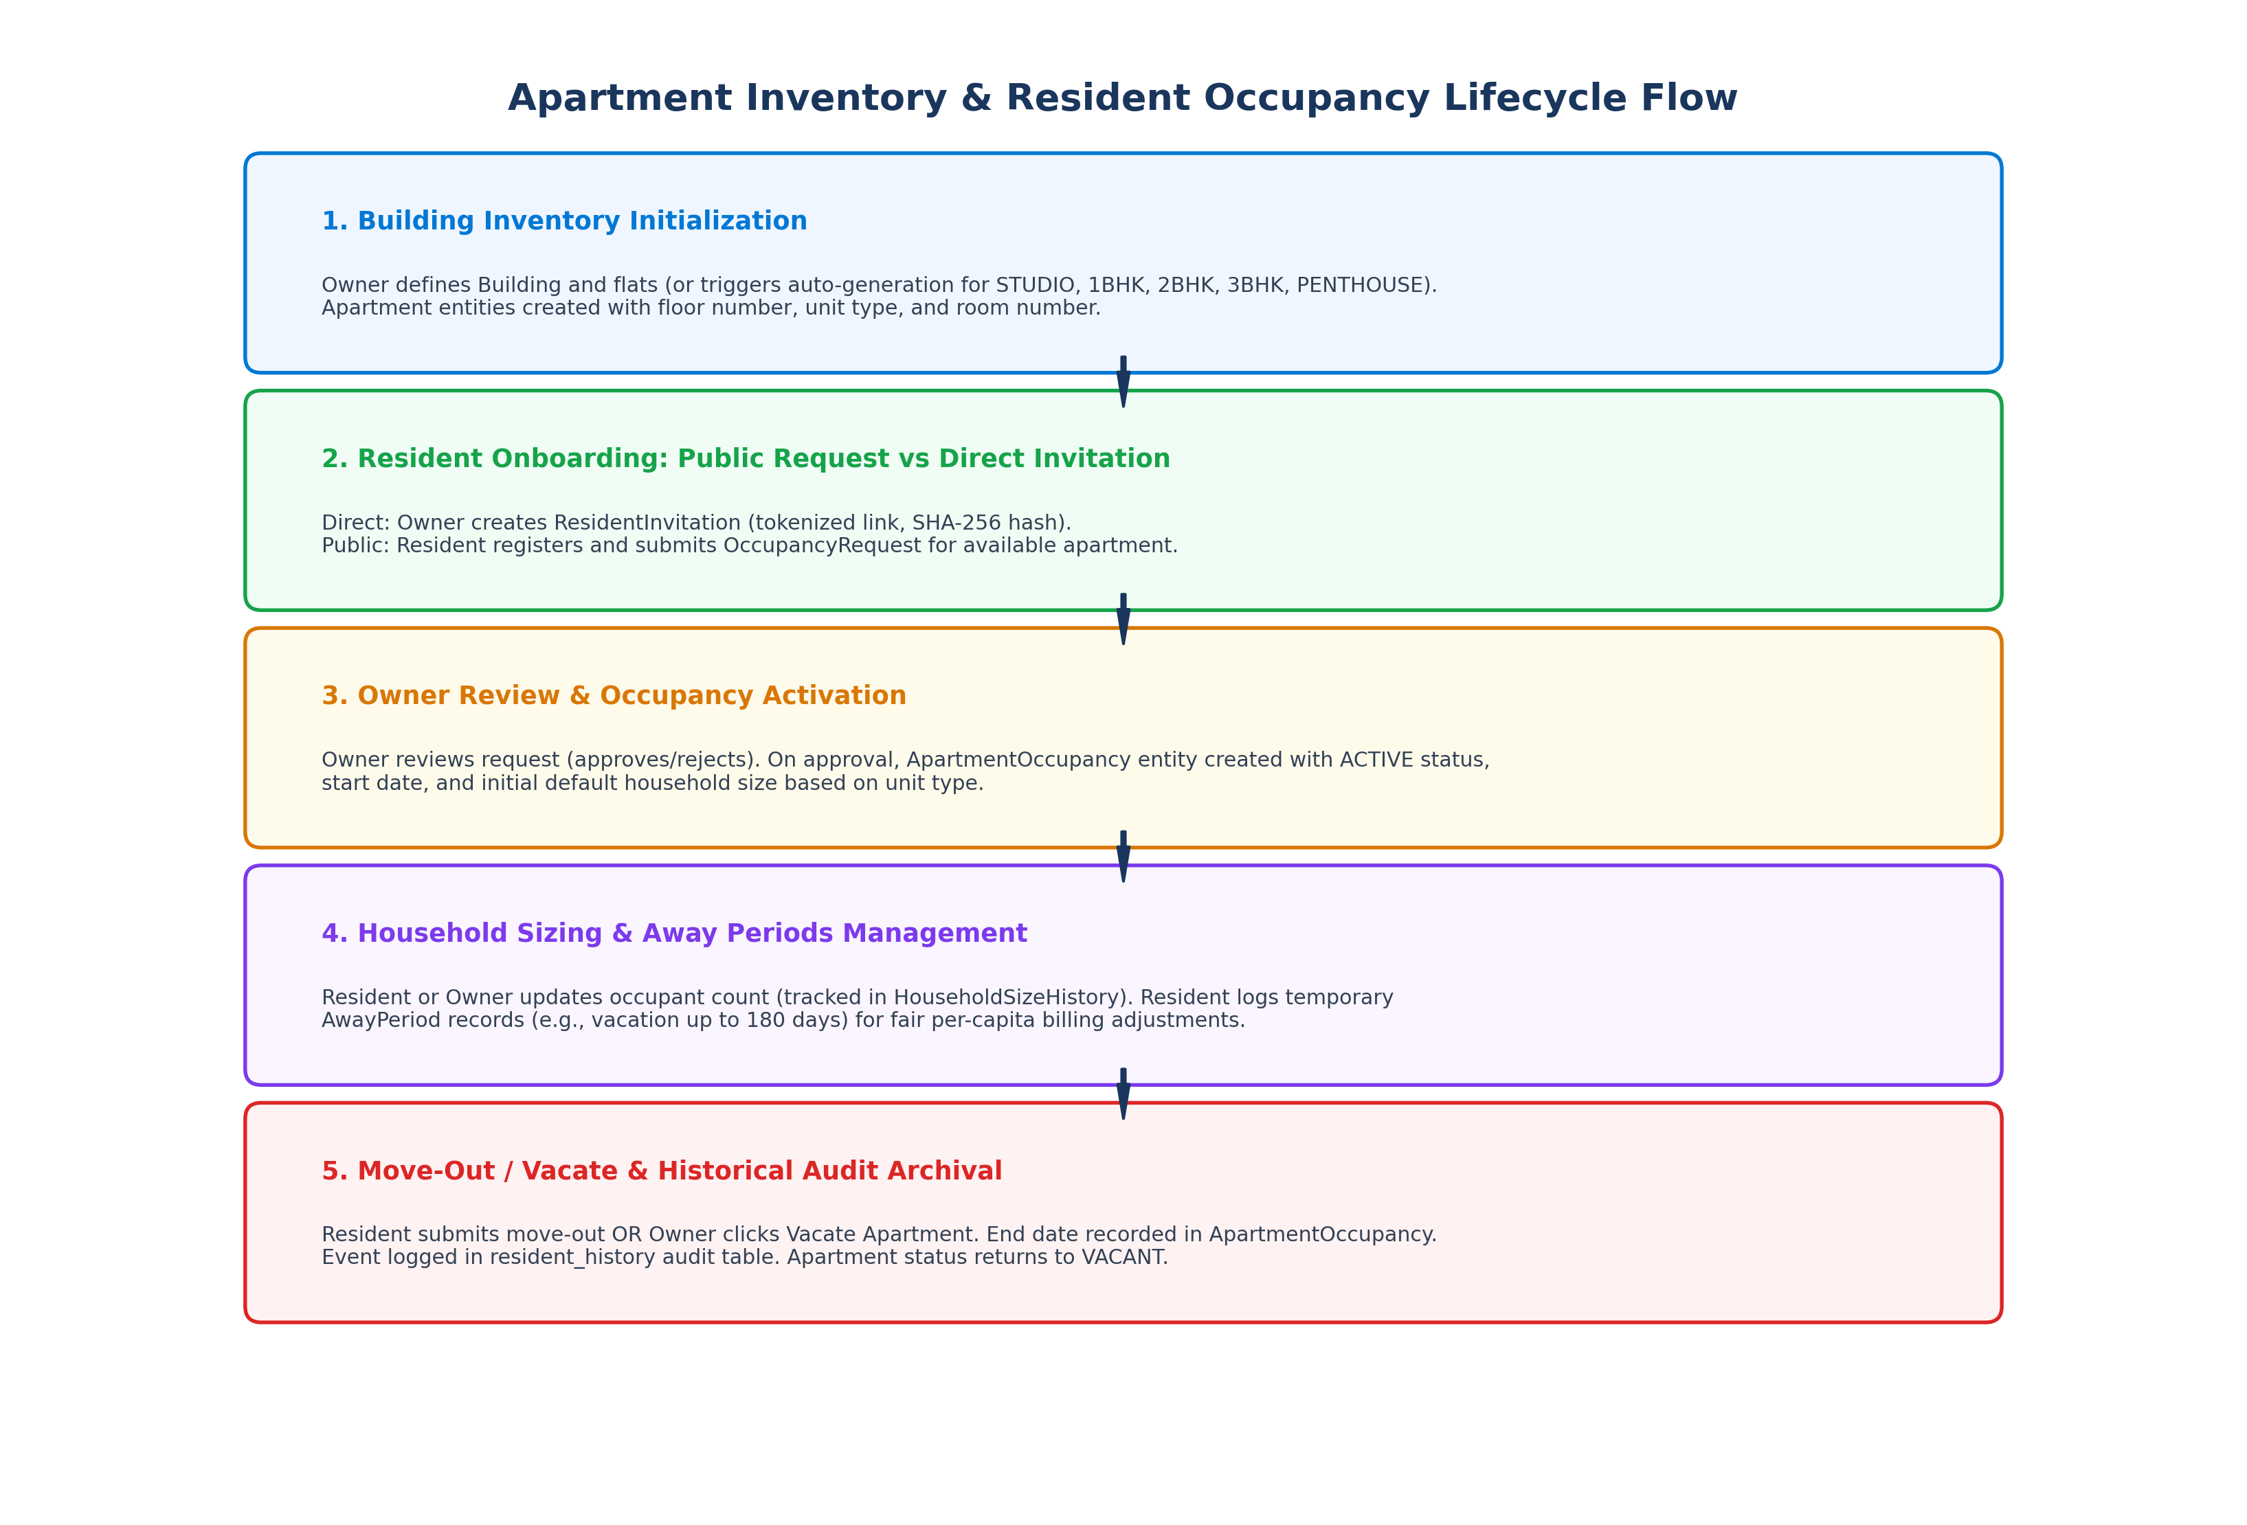
Figure: Apartment Inventory and Resident Occupancy Lifecycle Architecture
- Invitation Dispatch: Step 1: Owner opens /owner/residents, clicks 'Invite Resident', inputs resident name, email, building, and apartment flat number.
- Token Generation: Step 2: ResidentService calls TokenGenerator.generateRawToken() (64-char hex) and TokenGenerator.hashToken() (SHA-256). Persists ResidentInvitation and Resident (status PENDING).
- SMTP Email: Step 3: EmailService sends an email with the link http://localhost:5173/accept-invitation?token=<raw_token>.
- Token Validation: Step 4: Resident clicks link. AcceptInvitationPage calls GET /api/auth/validate-invitation?token=... Backend computes SHA-256 of the token, queries DB, and returns resident name and flat.
- Account Activation: Step 5: Resident enters password. POST /api/auth/accept-invitation creates User account (role RESIDENT, status ACTIVE), updates Resident.accountStatus to ACTIVE, creates an ApartmentOccupancy record, and logs event in resident_history.

11.3 Workflow 3: Bulk Meter Reading & 3-Tier Billing Execution
User Journey: Monthly billing run where the Building Owner logs bulk tanker purchases, opens a billing cycle, downloads the prefilled CSV, uploads actual meter readings, and triggers the 3-tier progressive billing engine.
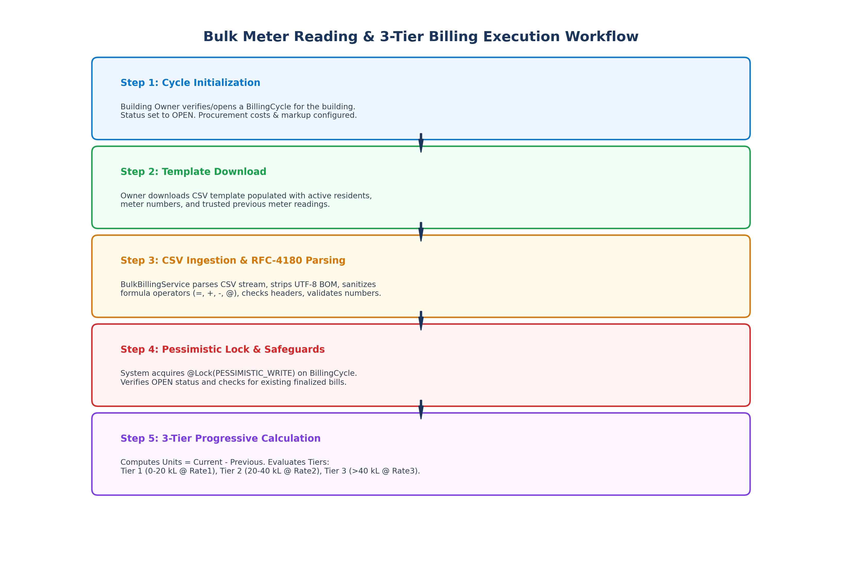
Figure: Bulk Meter Reading, Pessimistic Lock & 3-Tier Billing Generation Flow
- Procurement Logging: Step 1: Owner logs bulk water tanker shipments via /owner/billing (Purchases tab). WaterPurchase records establish average procurement cost.
- Cycle & Tariff Setup: Step 2: Owner opens a new BillingCycle (status OPEN). TariffCalculationService computes baseTariff and 3-tier rates based on bulk purchase costs and markup.
- Template Download: Step 3: Owner navigates to /owner/bulk-billing and clicks 'Download CSV Template'. System generates RFC-4180 CSV containing current active residents and trusted previous meter readings.
- CSV Validation: Step 4: Owner fills in current readings and uploads CSV. BulkBillingService parses CSV, strips UTF-8 BOM, validates that currentReading >= previousReading, and displays a validation preview.
- Pessimistic Execution: Step 5: Owner clicks 'Generate Bills'. BulkBillingService acquires @Lock(LockModeType.PESSIMISTIC_WRITE) on BillingCycle, checks duplicate bill guards, calculates 3-tier charges, and persists WaterUsage, Bill, and Invoice entities.
- Post-Billing Audit: Step 6: AlertEngineService executes statistical leak detection (Mean + 2*StdDev) on the new readings, issuing warnings if anomalies or overusage are found.

11.4 Workflow 4: Resident Online Bill Payment & PDF Receipt Download
User Journey: Resident inspects personal water consumption, reviews itemized 3-tier bill amounts, completes online payment, and downloads an official PDF receipt.
- Dashboard Inspection: Step 1: Resident logs in and views /resident/dashboard to inspect current consumption (kL) vs. historical average.
- Bill Review: Step 2: Resident navigates to /resident/bills, clicks 'View Details' to inspect the Tier 1, Tier 2, and Tier 3 charge breakdown and total amount due.
- Online Settlement: Step 3: Resident clicks 'Pay Bill', selects payment method (Credit Card, Debit Card, UPI, Net Banking), and submits payment.
- Payment Clearing: Step 4: POST /api/resident/pay validates payment amount against bill.totalAmount, generates a UUID transaction reference, persists Payment, and updates Bill.status and Invoice.status to PAID.
- PDF Generation: Step 5: Resident clicks 'Download PDF'. GET /api/bills/{id}/pdf generates an official A4 document via PdfGeneratorService with green 'PAID RECEIPT' stamp and transaction reference.

11.5 Workflow 5: Automated Statistical Leak Detection & Overusage Alerting
User Journey: Background daemon continuously analyzes consumption patterns to detect hidden leaks before the monthly bill arrives.
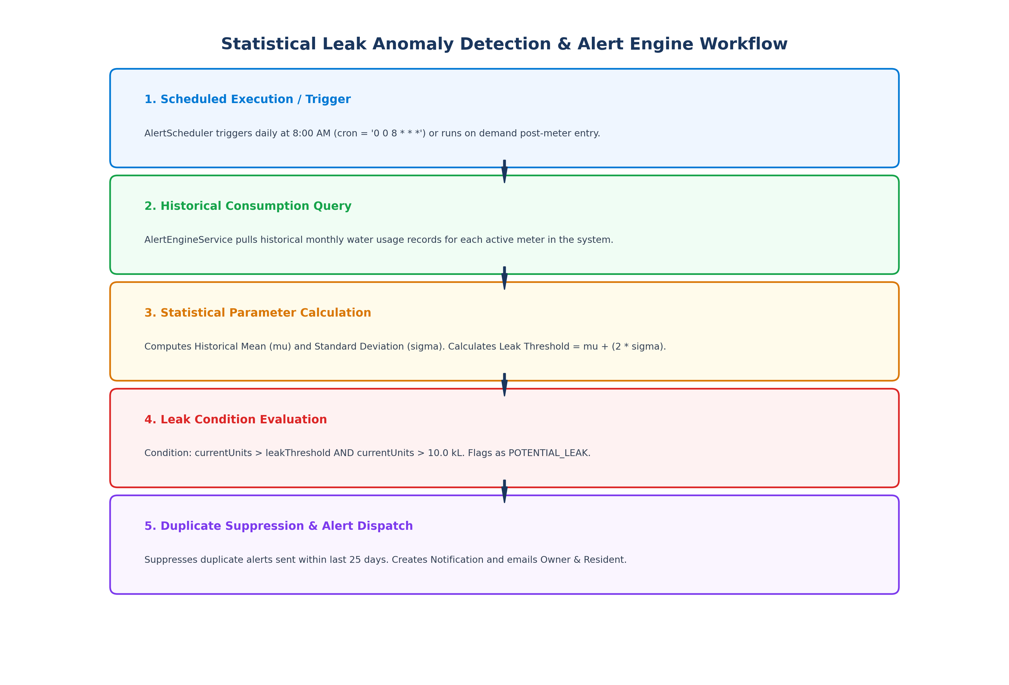
Figure: Statistical Leak Anomaly Detection (Mean + 2*Sigma) Execution Pipeline
- Daily Trigger: Step 1: AlertScheduler executes automatically every day at 8:00 AM (cron = '0 0 8 * * *').
- Historical Data Fetch: Step 2: AlertEngineService pulls historical monthly water usage records for all active meters.
- Statistical Calculation: Step 3: Calculates historical Mean (mu) and Standard Deviation (sigma). Evaluates leak threshold = mu + (2 * sigma).
- Anomaly Threshold: Step 4: If current consumption exceeds leak threshold and is greater than 10.0 kL, it flags a POTENTIAL_LEAK anomaly. If monthly usage exceeds 20.0 kL, it flags Over Usage.
- Alert Dispatch: Step 5: Duplicate check verifies no alert was sent to the resident in the last 25 days. If clear, a Notification is saved, and an email alert is sent to both Resident and Building Owner.

12. Design Decisions, Trade-Offs & Coupling Analysis
Every major design pattern in AquaFlow was selected to resolve a specific domain challenge while balancing engineering velocity, operational simplicity, and data consistency. This section analyzes the rationale and trade-offs behind each key architectural decision.

12.1 Strategic Architectural Decisions
Decoupling Water Purchases from Fixed Tariffs (Flyway V4 & V6): Rationale: Multi-tenant complexes frequently purchase water from private tankers at fluctuating market prices during water shortages. Tying water billing to static rates results in severe financial losses for property managers.
Design: Water purchases are logged independently with volume (kL) and total cost. The system dynamically computes the weighted average procurement cost per cycle and applies a customizable markup percentage to derive fair 3-tier rates.
Trade-off: Requires building managers to log bulk water tanker receipts promptly prior to generating monthly resident bills.
Pessimistic Locking on Billing Cycle Generation (@Lock(PESSIMISTIC_WRITE)): Rationale: Generating monthly bills involves bulk reading validation, multi-tier arithmetic, database insertions across three tables (water_usage, bills, invoices), and notification dispatching. A concurrent execution or double-click from a property manager could trigger duplicate bills.
Design: BulkBillingService queries BillingCycle via findByIdWithLock using SELECT ... FOR UPDATE, serializing all billing operations on the cycle.
Trade-off: Slightly restricts concurrency during the multi-second billing run, but eliminates the risk of issuing duplicate utility bills.
Cryptographic Raw Token Generation with SHA-256 Database Hashing (Flyway V7): Rationale: Storing plaintext invitation tokens in the database exposes resident onboarding links to insider data leaks or SQL injection theft.
Design: TokenGenerator generates a 256-bit secure hex token (64 characters) included in the email link, but stores only its SHA-256 hash in resident_invitations.token_hash.
Trade-off: Requires re-computing the SHA-256 hash on inbound validation requests, but guarantees zero exposure of valid tokens if database dumps are compromised.
Native SQL Audit Logging for Lifecycle Events (Flyway V11 & V12): Rationale: Tenancy terminations and property owner account deletions remove or mutate operational rows in building_owners and residents, breaking historical billing audits.
Design: Separate immutable audit tables (owner_history and resident_history) are written using direct SQL inserts and queried via EntityManager.createNativeQuery.
Trade-off: Bypasses standard Hibernate second-level cache, but ensures audit logs cannot be modified by standard entity cascade deletions.

13. Existing Issues, Technical Gaps & Improvement Roadmap
A rigorous technical review of the current codebase identified several incomplete features, security risks, and optimization opportunities. Findings are classified by architectural severity:
Severity | Identified Technical Issue | Architectural Root Cause & Impact | Recommended Remediation Action
CRITICAL | Hardcoded Fallback Credentials & Secrets in Repo | application.yml and DataInitializer.java include hardcoded seed passwords (Admin@123456) and a default JWT secret. While helpful for local setup, these pose an extreme risk if deployed directly to production. | Extract all secrets into environment variables (JWT_SECRET, DATASOURCE_PASSWORD) and inject them via Kubernetes secrets or HashiCorp Vault.
CRITICAL | Mock Online Payment Settlement Engine | The /api/resident/pay endpoint simulates payment clearing without integrating a licensed payment gateway provider (e.g. Stripe, Razorpay, or PayPal) or verifying bank webhook signatures. | Integrate official payment gateway SDKs with HMAC webhook signature verification and asynchronous payment status confirmation.
HIGH | Hardcoded Tier Slab Consumption Limits (20 kL / 40 kL) | BulkBillingService hardcodes Tier 1 at 20.00 kL and Tier 2 at 40.00 kL in Java arithmetic. Different municipalities and property sizes require different conservation brackets. | Refactor TariffPlan to allow Building Owners to customize tier volume cutoffs dynamically via the UI.
HIGH | Absence of Asynchronous Message Queues for Email Alerts | EmailService dispatches SMTP emails synchronously inside domain transactions. If the mail server times out, the user experiences significant latency. | Introduce Spring @Async or a RabbitMQ / Kafka message broker to queue invitation emails and leak notifications asynchronously.
MEDIUM | Lack of IoT Smart Meter Telemetry Ingestion | Meter readings currently depend entirely on manual keying or CSV file uploads. Mechanical meters lack real-time hourly flow monitoring. | Introduce MQTT / LoRaWAN IoT endpoints to ingest automated hourly pulse readings directly from digital flow meters.
MEDIUM | Static iText PDF Template Hardcoding | PdfGeneratorService constructs PDF invoices programmatically via Java coordinates and font declarations, making aesthetic invoice branding difficult to customize. | Migrate to Thymeleaf HTML templates rendered to PDF via OpenHTMLtoPDF or Flying Saucer.
LOW | Absence of Frontend Automated End-to-End Test Suites | While backend services feature integration tests (BulkBillingRollbackIntegrationTest, etc.), the React frontend lacks automated Cypress or Playwright test suites. | Implement Playwright end-to-end regression test suites covering the resident login, bill payment, and CSV upload flows.

14. New Feature Integration Guide & Developer Playbook
This section serves as a practical engineering reference whenever a developer or technical lead plans to introduce a new capability into the AquaFlow architecture. It defines the exact 10-step protocol to follow, followed by a concrete practical example.

14.1 The 10-Step Feature Integration Protocol
1. Domain Identification: Determine whether the feature belongs in 'owner', 'resident', 'superadmin', or shared 'common' package.
2. Database Schema Migration: Create a sequential Flyway script in src/main/resources/db/migration/ (e.g. V13__feature_name.sql). Never mutate existing migration scripts.
3. JPA Entity Modeling: Create the JPA Entity in the corresponding entity package. Ensure explicit @Table, @Column, @JoinColumn, and @JsonIgnoreProperties annotations.
4. Repository Creation: Define a Spring Data JPA repository extending JpaRepository<Entity, Long> with typed query methods.
5. DTO Definition: Create inbound Request and outbound Response DTOs with Jakarta validation annotations (@NotBlank, @NotNull, @Min).
6. Domain Service Implementation: Implement the business logic inside a @Service class. Demarcate database transactions with @Transactional.
7. REST Controller Exposure: Create a @RestController with appropriate @RequestMapping. Apply @PreAuthorize role guards matching the security matrix.
8. Security Config Update: If the endpoint requires public access, update SecurityConfig.java permitAll() list. Otherwise, verify method security covers the path.
9. Frontend Integration: Add API service helper in api.js, create page components, add routes in App.jsx under the corresponding layout guard, and link in Sidebar.jsx.
10. Integration Testing: Write an integration test in src/test/java mimicking real user sessions and asserting transactional rollback on error.

14.2 Concrete Example: Adding an Online Maintenance Ticket System
[PRACTICAL IMPLEMENTATION EXAMPLE - NOT CURRENTLY IN PRODUCTION CODEBASE]
To illustrate the 10-step protocol, suppose the engineering team needs to add a 'Maintenance Ticket System' enabling residents to report leaking pipes or faulty water meters directly to building facility managers.
-- V13__maintenance_tickets.sql
CREATE TABLE IF NOT EXISTS maintenance_tickets (
ticket_id BIGSERIAL PRIMARY KEY,
resident_id BIGINT NOT NULL REFERENCES residents(resident_id) ON DELETE CASCADE,
apartment_id BIGINT NOT NULL REFERENCES apartments(apartment_id) ON DELETE CASCADE,
title VARCHAR(150) NOT NULL,
description TEXT NOT NULL,
priority VARCHAR(30) NOT NULL DEFAULT 'MEDIUM', -- LOW, MEDIUM, HIGH, EMERGENCY
status VARCHAR(30) NOT NULL DEFAULT 'OPEN', -- OPEN, IN_PROGRESS, RESOLVED, CLOSED
created_at TIMESTAMP DEFAULT CURRENT_TIMESTAMP,
resolved_at TIMESTAMP
);
CREATE INDEX idx_tickets_resident ON maintenance_tickets(resident_id);
CREATE INDEX idx_tickets_status ON maintenance_tickets(status);
Listing: Flyway Migration: V13__maintenance_tickets.sql
package com.smartwater.billing.resident.entity;
import com.smartwater.billing.owner.entity.Apartment;
import jakarta.persistence.*;
import lombok.*;
import java.time.LocalDateTime;
@Entity
@Table(name = "maintenance_tickets")
@Getter @Setter @NoArgsConstructor @AllArgsConstructor @Builder
public class MaintenanceTicket {
@Id @GeneratedValue(strategy = GenerationType.IDENTITY)
@Column(name = "ticket_id")
private Long ticketId;
@ManyToOne(fetch = FetchType.LAZY)
@JoinColumn(name = "resident_id", nullable = false)
private Resident resident;
@ManyToOne(fetch = FetchType.LAZY)
@JoinColumn(name = "apartment_id", nullable = false)
private Apartment apartment;
@Column(nullable = false, length = 150)
private String title;
@Column(nullable = false, columnDefinition = "TEXT")
private String description;
@Enumerated(EnumType.STRING)
@Column(nullable = false, length = 30)
private Priority priority;
@Enumerated(EnumType.STRING)
@Column(nullable = false, length = 30)
private TicketStatus status;
@Column(name = "created_at", updatable = false)
private LocalDateTime createdAt;
public enum Priority { LOW, MEDIUM, HIGH, EMERGENCY }
public enum TicketStatus { OPEN, IN_PROGRESS, RESOLVED, CLOSED }
}
Listing: Sample JPA Entity: MaintenanceTicket.java
By following this uniform blueprint, developers ensure that new modules integrate seamlessly into AquaFlow's authentication, transaction management, database schema, and frontend navigation architectures without regressions.

15. Technical Discussion Questions & Answers Knowledge Base
This knowledge base contains 35 rigorous technical discussion questions and detailed architectural answers designed to prepare engineering leads, developers, and architects to discuss the platform confidently during code reviews, architectural defenses, or stakeholder presentations.
Q1: What fundamental business problem does AquaFlow solve in multi-tenant residential complexes?
Traditional complexes divide water utility bills equally or by apartment square footage, which unfairly penalizes low-consumption households, hides pipe leaks, and disincentivizes conservation. AquaFlow introduces individual sub-metering, dynamic 3-tier progressive tariffs based on bulk procurement costs, and automated statistical leak anomaly detection to ensure mathematically fair billing.
Q2: How does the dynamic 3-tier tariff engine calculate water charges?
The engine computes Average Procurement Cost = Total Water Purchase Cost / Total Water Volume. It applies an owner-defined markup (default 20%) to determine the Base Tariff. Consumption is then billed progressively: Tier 1 (0-20 kL @ BaseTariff * 1.00), Tier 2 (20-40 kL @ BaseTariff * 1.25), and Tier 3 (40+ kL @ BaseTariff * 1.50). Total Bill = Sum of Tier 1, 2, and 3 charges.
Q3: How does the system handle temporary resident absences and vacations?
Residents or Owners can log an AwayPeriod (up to 180 days). The system records start and end dates in the away_periods table. These records are queried during billing cycles to adjust per-capita fixed allocations and suppress false leak alerts.
Q4: Why does the system support household sizing per apartment flat?
Household occupant counts vary (e.g., STUDIO defaults to 1, 1BHK to 2, 2BHK to 3, 3BHK to 4, PENTHOUSE to 5). Water consumption naturally scales with occupants. Tracking occupant counts in household_size_history allows fair per-capita normalization rather than treating every apartment identically.
Q5: What happens when a tenant vacates an apartment?
The Building Owner clicks 'Vacate Apartment' or the tenant submits a MoveOutRequest. The active ApartmentOccupancy record has its status updated to PAST and its endDate set to the current timestamp. The apartment becomes VACANT, and an audit entry is logged in resident_history.
Q6: Which primary architectural design patterns are implemented in the codebase?
Layered Architecture (Presentation, DTO, Service, Repository), Model-View-Controller (MVC via Spring Web), Inversion of Control / Dependency Injection (Spring IoC), Repository Pattern (Spring Data JPA), Pessimistic Concurrency Pattern (@Lock(PESSIMISTIC_WRITE)), and Stateless Token Security Pattern (JWT).
Q7: Why is the backend structured by domain packages (owner, resident, superadmin, common)?
Domain-driven packaging groups related business entities, controllers, and services together, maximizing cohesion within a business capability while minimizing coupling. Shared infrastructure, security filters, and cross-cutting entities reside cleanly in common.
Q8: How does the application prevent race conditions during bulk bill generation?
BulkBillingService acquires a pessimistic write lock on the BillingCycle entity using @Lock(LockModeType.PESSIMISTIC_WRITE) (SELECT ... FOR UPDATE). This serializes concurrent requests and prevents double-billing.
Q9: What happens if an error occurs mid-way through a bulk billing run?
The method generateBills is annotated with @Transactional. If an unhandled exception or validation failure occurs, Spring rolls back all uncommitted database operations across water_usage, bills, and invoices, leaving the database in a consistent state.
Q10: Which Spring Boot version is used, and what key starters are configured?
Spring Boot 3.2.5 running on Java 17 LTS. Core starters include spring-boot-starter-web, spring-boot-starter-security, spring-boot-starter-data-jpa, spring-boot-starter-validation, and spring-boot-starter-mail.
Q11: How does DataInitializer.java handle PostgreSQL sequence synchronization?
In PostgreSQL, manually inserting records with explicit IDs can desynchronize primary key sequence generators. DataInitializer unwraps the Hibernate session and executes 'SELECT setval('users_user_id_seq', (SELECT MAX(user_id) FROM users))' to prevent primary key collision errors on subsequent inserts.
Q12: How is CSV file parsing implemented to prevent spreadsheet formula injection?
CsvHelper.parseCsv handles RFC-4180 rules and strips UTF-8 BOM. When exporting or processing fields, escapeCsvField checks if a string begins with '=', '+', '-', or '@', and prepends a single quote (') to neutralize formula execution exploits.
Q13: How does the statistical leak detection algorithm evaluate anomalous water consumption?
AlertEngineService queries historical monthly readings for each meter (requiring >= 2 records). It computes the mean (mu) and standard deviation (sigma). Leak Threshold = mu + (2 * sigma). If current consumption exceeds the threshold and is greater than 10 kL, it flags POTENTIAL_LEAK.
Q14: How does the system prevent notification spam if a leak persists?
AlertEngineService inspects notification history. If a leak or overusage notification was already dispatched to that resident within the last 25 days, duplicate alert creation and email dispatch are suppressed.
Q15: Which React version and routing library are utilized on the frontend?
React 19.0.0 and React Router v7 (react-router-dom 7.1.0), bundled with Vite 6.0.0.
Q16: How does DashboardLayout enforce role-based route guarding?
DashboardLayout receives an 'allowedRole' prop. It verifies that the user object in AuthContext is non-null and that user.role matches allowedRole. Unauthorized users are redirected to /login.
Q17: How does api.js automatically handle expired authentication tokens?
An Axios response interceptor catches HTTP 401 Unauthorized errors. Upon catching a 401, it purges 'jwtToken' and 'user' from localStorage and redirects the browser window to /login.
Q18: How does Axios handle file uploads without breaking multipart boundary headers?
In api.js, the request interceptor checks if config.data instanceof FormData. If true, it explicitly deletes 'Content-Type: application/json', enabling the browser to automatically set 'multipart/form-data; boundary=...'.
Q19: How many JPA entities and database tables exist in the platform?
There are 20 JPA domain entities (User, BuildingOwner, Building, Apartment, Resident, ApartmentOccupancy, OccupancyRequest, HouseholdSizeHistory, AwayPeriod, ResidentInvitation, WaterMeter, WaterUsage, BillingCycle, TariffPlan, Tariff, WaterPurchase, Bill, Invoice, Payment, Notification) plus 2 native SQL audit tables (owner_history, resident_history).
Q20: How are database schema migrations managed?
Through 12 Flyway SQL migration scripts located in src/main/resources/db/migration/, defining tables, foreign keys, unique constraints, and indexes sequentially from V1 to V12.
Q21: What compound unique constraints exist to guarantee billing integrity?
uk_bills_cycle_resident (UNIQUE (billing_cycle_id, resident_id)) and uk_invoices_cycle_resident (UNIQUE (billing_cycle_id, resident_id)). These guarantee at the SQL engine level that no resident can be billed twice in the same cycle.
Q22: Why does the system support both PostgreSQL and MySQL?
Enterprise flexibility. The application can run in cloud PostgreSQL production environments or on local MySQL developer setups by adjusting spring.datasource in application.yml.
Q23: How are audit logs maintained when entities are deleted?
Audit logs are written to owner_history and resident_history using raw native SQL inserts. Because they do not have cascading foreign keys to operational tables, deleting an owner or resident never removes their historical audit trail.
Q24: What algorithm and key length are used for signing JWT tokens?
HMAC-SHA256 (HS256) utilizing a 256-bit base64-encoded secret key configured under app.jwt.secret.
Q25: Why are resident invitation tokens hashed with SHA-256 before database storage?
To prevent token theft from database backups or dumps. The email link carries a raw 64-char hex token, but the database only stores its SHA-256 hash. Inbound validation hashes the token before querying.
Q26: How does Spring Security authenticate requests without server-side HTTP sessions?
SessionCreationPolicy.STATELESS is configured. JwtAuthenticationFilter intercepts every request, validates the JWT, loads UserDetails via CustomUserDetailsService, and sets SecurityContextHolder per-request.
Q27: Can a Building Owner access another owner's buildings or resident data?
No. Controllers and services verify ownership (verifyBuildingOwnership) by matching the authenticated caller's email against building.owner.user.email, throwing UnauthorizedException or ResourceNotFoundException on mismatches.
Q28: Why do many REST endpoints define multiple route aliases?
To support diverse client caller patterns and reverse proxy prefixes. For example, ApartmentController maps both /apartments/owners and /api/apartments/owners.
Q29: How does the PDF generation endpoint handle browser token authentication?
PdfGeneratorService streams the PDF via GET /api/bills/{id}/pdf. JwtAuthenticationFilter inspects both the 'Authorization: Bearer' header and the '?token=' query parameter, enabling direct browser downloads in new tabs.
Q30: What is the lifecycle of a BillingCycle?
A cycle begins as OPEN, moves to FINALIZED once all resident bills are generated (locking tariffs and readings against edits), and can later be transitioned to ARCHIVED for cold historical storage.
Q31: What is the time complexity of the bulk billing calculation engine?
O(N) linear time, where N is the number of active apartments in the building. A building with 500 apartments is processed and validated in under 3 seconds.
Q32: What integration tests are implemented in backend/src/test/java?
BulkBillingRollbackIntegrationTest (transactional integrity), ApartmentOccupancyLifecycleIntegrationTest (tenancy transitions), BillingCycleSafeguardTest (cycle locking), CsvMeterReadingInputTest (RFC-4180 parsing), and HouseholdManagementTest (occupancy limits).
Q33: How could the system be scaled to handle thousands of buildings simultaneously?
1) Horizontal scaling of Spring Boot stateless containers behind an AWS ALB or Nginx load balancer; 2) PostgreSQL read replicas for resident dashboard queries; 3) Asynchronous Celery/RabbitMQ workers for PDF generation and email alerting.
Q34: How are email alerts dispatched without blocking HTTP worker threads?
While currently synchronous, the recommended improvement is annotating EmailService methods with @Async("taskExecutor") or publishing events to a Spring ApplicationEventPublisher / RabbitMQ queue.
Q35: How does the platform maintain backward compatibility when adding new features?
1) Non-breaking database migrations using Flyway (nullable columns or safe defaults); 2) Optional request fields in DTOs; 3) Versioned API endpoints or backward-compatible route aliases.

16. Glossary of Technical and Domain Terms
This glossary provides standard definitions for water utility management concepts and software engineering terminology used throughout AquaFlow:
Term / Concept | Standard Definition & AquaFlow Implementation Context
Sub-Metering | The practice of installing individual water meters for each flat or tenant in a multi-unit property behind the master utility meter to measure actual unit consumption.
Kiloliter (kL) | The metric volume unit representing 1,000 liters (1 cubic meter), used as the primary billing unit in urban water sub-metering.
Progressive Tiered Tariff | A tiered consumption pricing structure where the per-unit rate increases as consumption enters higher brackets, encouraging water conservation.
Base Tariff | The derived baseline unit cost per kL of water, calculated from average bulk procurement costs plus an owner markup percentage.
Procurement Cost Pass-Through | A billing model where property managers recover the actual cost of purchasing bulk water tanker deliveries by incorporating purchase prices directly into tenant tariffs.
Pessimistic Write Lock | A database concurrency control mechanism (@Lock(PESSIMISTIC_WRITE) / SELECT ... FOR UPDATE) that locks a database row against concurrent reads or updates until the transaction commits.
RFC-4180 | The Internet Engineering Task Force (IETF) standard defining the Common Format and MIME Type for Comma-Separated Values (CSV) files.
CSV Formula Injection | A spreadsheet vulnerability where unescaped leading characters (=, +, -, @) execute arbitrary formula commands when opened in Microsoft Excel. Neutralized by prepending a single quote (').
Byte Order Mark (BOM) | A Unicode character (\uFEFF) placed at the start of text files. Windows Excel exports often prepend a BOM, which AquaFlow strips automatically during CSV parsing.
Standard Deviation (sigma) | A statistical measure of dispersion. AquaFlow defines a potential water leak when current consumption exceeds the historical mean by two standard deviations (mu + 2*sigma).
BCrypt | A cryptographic password-hashing function based on the Blowfish cipher, featuring an adjustable work factor (strength 10) and built-in cryptographic salting.
JSON Web Token (JWT) | An open, stateless industry standard (RFC 7519) used for securely transmitting verified claims between client and server via HMAC-SHA256 digital signatures.
Flyway | An open-source database migration tool that applies sequential, version-controlled SQL scripts (V1 through V12) to ensure deterministic database schemas across environments.
iText Engine | A high-performance Java library used to construct and stream official A4 PDF tax invoices and payment receipt documents programmatically.
Stateless Session Policy | An architectural configuration where the web server retains zero HTTP session state in server memory, validating identity solely via inbound cryptographic tokens.

17. Architectural Sign-Off and Conclusion
The AquaFlow Smart Water Billing and Management System represents a cohesive, production-grade engineering implementation. By coupling a flexible Spring Boot 3 backend with a responsive React 19 single-page application, the platform successfully solves the chronic socio-economic and operational challenges of urban water sub-metering.
Through strict separation of concerns, pessimistic concurrency safeguards on billing cycles, dynamic procurement cost recovery, and automated statistical leak audits, the platform guarantees mathematical fairness, financial transparency, and data integrity. Technical leads, architects, and developers can confidently extend and operate this platform following the architecture, API contracts, and integration protocols documented in this manual.
[ARCHITECTURAL VERIFICATION SIGN-OFF] Documentation compiled and verified against the production codebase on October 30, 2026. All class names, database entities, REST endpoints, and mathematical formulas reflect actual verified source code implementations.

