**P1 Exercises**

**Q1.** What do these commands do?

1. ls -ru
2. cd ~
3. cd -
4. cat -v regular_file
5. pwd
6. mkdir --help
7. mkdir -pv d1/d2
8. more file
9. date +"%d-%b-%Y"
10. tail -f log_file

**Q2.** Write a single command to:

1. Display your Linux login shell
2. Display the online manual page of “passwd” command
3. Display the content of a file named “info.log” located under /opt/app/logs
4. Show a long list of all files under your home directory, including hidden files.
5. Create an environment variable called “OWNER” with your names as its value.

**Q3.** Given the following file structure:

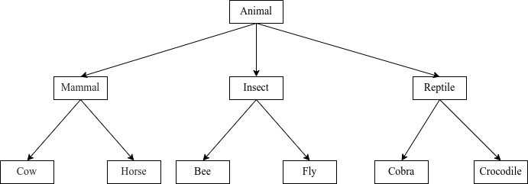

1. What is the difference between absolute and relative path?
2. Create, in your home directory, the file structure in the figure above using absolute path. Note that files at the bottom are regular files.
3. From “Insect” directory, write a command to show a long listing of all files under “Reptile” directory. Use relative path.
4. From “Insect” directory, delete “Horse” file using its relative path.
5. From “Insect” directory, move “Crocodile” to “Mammal” directory and rename it to “Goat” using relative paths.

**Q4:**

From your home directory, use one mkdir command to create 3 directories and name them as follows: CMU-Africa, Orientation and Intro-Linux, then after:

(a) create 3 empty files one by one using cat command and name them as File1.txt, File2.txt, File3.txt.

Note: In File1.txt, should contain names of 5 African countries of your choice, in File2.txt, contains 5 Asian countries whereas File3.txt will contain names of 5 Europe countries, all these files are saved in Intro-Linux directory.

(c) Without changing your directory, display the content of the 3 files at the same time and save the result in a new file called Country-List.txt in Intro-Linux and Orientation directories.

**Q5:**

In your current working directory, create an environment variable called EXERCISE and assign it the text: "Welcome to CMU-Africa Orientation Class", you export this variable to make it in every working directory associated with your account.

(a) Use echo command to display the value of this variable and save the result in the new file named My-variable.txt in CMU-Africa directory,

(b) Use mv and cp to rename My-variable.txt to My-File.txt and copy it to Orientation directory