**P1 Exercises**

**Q1.** What do these commands do?

1. ls -ru: Lists the content in reverse order based on time i.e., older first.
2. cd ~: Change directory to home
3. cd -: Go back to the previous directory
4. cat -v regular_file: Outputs the content of the file and shows where the tabs are.???
5. pwd: Print the working directory
6. mkdir –help: Getting help with the usage of the mkdir command
7. mkdir -pv d1/d2: Creating the d2 directory inside d1 and printing the message
8. more file: Reading the contents of the file
9. date +"%d-%b-%Y": Display the current date in the format of day-month-year
10. tail -f log_file: Print the last ten line of log_file and output appended as the file grows.

**Q2.** Write a single command to:

1. Display your Linux login shell

echo $HOME

1. Display the online manual page of the “passwd” command

man passwd

1. Display the content of a file named “info.log” located under /opt/app/logs

cat /opt/app/logs/info.log

1. Show a long list of all files under your home directory, including hidden files.

ls -al $HOME

1. Create an environment variable called “OWNER” with your names as its value.

export OWNER=”Niyomwungeri Parmenide Ishimwe”

**Q3.** Given the following file structure:

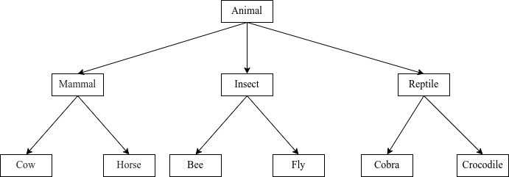

1. What is the difference between absolute and relative paths?

The absolute path starts from the root (/) while the relative starts from the current working directory

1. Create, in your home directory, the file structure in the figure above using an absolute path. Note that the files at the bottom are regular files.

mkdir /home/parmenin/Mammal /home/parmenin/Insect /home/parmenin/Reptile

cat > /home/parmenin/Mammal/Cow

cat > /home/parmenin/Mammal/Horse

cat > /home/parmenin/Insect/Bee

cat > /home/parmenin/Insect/Fly

cat > /home/parmenin/Reptile/Cobra

cat > /home/parmenin/Reptile/Crocodile

You can also use touch to create all at once instead of using cat >

1. From the “Insect” directory, write a command to show a long listing of all files under the “Reptile” directory. Use relative path.

ls -l ../Reptile

1. From the “Insect” directory, delete the “Horse” file using its relative path.

rm ../Mammal/Horse

1. From the “Insect” directory, move the “Crocodile” to the “Mammal” directory and rename it to “Goat” using relative paths.

mv../Reptile/Crocodile ../Mammal

mv ../Mammal/Crocodile ../Mammal/Goat

**Q4:**

From your home directory, use one mkdir command to create 3 directories and name them as follows: CMU-Africa, Orientation, and Intro-Linux, then after:

mkdir CMU-Africa Orientation Intro-Linux

(a) create 3 empty files one by one using the cat command and name them File1.txt, File2.txt, and File3.txt.

cat > File1.txt

cat > File2.txt

cat > File3.txt

Note: In File1.txt, should contain names of 5 African countries of your choice, in File2.txt, contains 5 Asian countries whereas File3.txt will contain names of 5 Europe countries, all these files are saved in the Intro-Linux directory.

mv File1.txt Intro-Linux

mv File2.txt Intro-Linux

mv File3.txt Intro-Linux

(c) Without changing your directory, display the content of the 3 files at the same time and save the result in a new file called Country-List.txt in Intro-Linux and Orientation directories.

cat Intro-Linux/File1.txt Intro-Linux/File2.txt Intro-Linux/File3.txt > Country-List.txt

**Q5:**

In your current working directory, create an environment variable called EXERCISE and assign it the text: "Welcome to CMU-Africa Orientation Class", you export this variable to make it in every working directory associated with your account.

export EXERCISE=”Welcome to CMU-Africa Orientation Class”

(a) Use the echo command to display the value of this variable and save the result in the new file named My-variable.txt in the CMU-Africa directory,

echo $EXERCISE > My-variable.txt

(b) Use mv and cp to rename My-variable.txt to My-File.txt and copy it to the Orientation directory

mv My-variable.txt My-File.txt

cp My-File.txt Orientation