Course Name: Java Programming
Chapter 1: Introduction to Java Programming
Java is a high-level programming language originally developed by Sun Microsystems and released in 1995. Java runs on a variety of platforms, such as Windows, Mac OS, and the various versions of UNIX. This course gives a complete understanding of Java.
Java programming language was originally developed by Sun Microsystems which was initiated by James Gosling and released in 1995 as core component of Sun Microsystems' Java platform (Java 1.0 [J2SE]).
The latest release of the Java Standard Edition is Java SE 8. With the advancement of Java and its widespread popularity, multiple configurations were built to suite various types of platforms. Ex: J2EE for Enterprise Applications, J2ME for Mobile Applications.
The new J2 versions were renamed as Java SE, Java EE and Java ME respectively. Java is guaranteed to be Write Once, Run Anywhere.
J2SE stands for Java 2 Standard Edition and is normally for developing desktop applications, forms the core/base API.
J2EE stands for Java 2 enterprise edition for applications which run on servers, for example web sites.
J2ME stands for Java 2 micro edition for applications which run on resource constrained devices (small scale devices) like cell phones and embedded devices, for example games.

Java Developments
J2SE
Java 2 Platform Standard Edition (J2SE) software is the premier platform for rapidly developing and deploying secure, portable applications that run on server and desktop systems.
J2EE
J2EE (Java 2 Platform, Enterprise Edition) is a Java platform designed for the mainframe-scale computing typical of large enterprises. Sun Microsystems (together with industry partners such as IBM) designed J2EE to simplify application development in a thin client tiered environment. J2EE simplifies application development and decreases the need for programming and programmer training by creating standardized, reusable modular components and by enabling the tier to handle many aspects of programming automatically.
J2EE includes many components of the Java 2 Platform, Standard Edition (J2SE):
- The Java Development Kit (JDK) is included as the core language package.
- Write Once Run Anywhere technology is included to ensure portability.
- Support is provided for Common Object Request Broker Architecture (CORBA), a predecessor of Enterprise JavaBeans (EJB), so that Java objects can communicate with CORBA objects both locally and over a network through its interface broker.
- Java Database Connectivity 2.0 (JDBC), the Java equivalent to Open Database Connectivity (ODBC), is included as the standard interface for Java databases.
- A security model is included to protect data both locally and in Web-based applications.
J2EE also includes a number of components added to the J2SE model, such as the following:
- Full support is included for Enterprise JavaBeans. EJB is a server-based technology for the delivery of program components in an enterprise environment. It supports the Extensible Markup Language (XML) and has enhanced deployment and security features.
- The Java servlet API (application programming interface) enhances consistency for developers without requiring a graphical user interface (GUI).
- Java Server Pages (JSP) is the Java equivalent to Microsoft's Active Server Pages (ASP) and is used for dynamic Web-enabled data access and manipulation.
The J2EE architecture consists of four major elements:
- The J2EE Application Programming Model is the standard programming model used to facilitate the development of multi-tier, thin client applications.
- The J2EE Platform includes necessary policies and APIs such as the Java servlets and Java Message Service (JMS).
- The J2EE Compatibility Test Suite ensures that J2EE products are compatible with the platform standards.
- The J2EE Reference Implementation explains J2EE capabilities and provides its operational definition.

J2ME
J2ME (Java 2 Platform, Micro Edition) is a technology that allows programmers to use the Java programming language and related tools to develop programs for mobile wireless information devices such as cellular phones and personal digital assistants (PDAs). J2ME consists of programming specifications and a special virtual machine, the K Virtual Machine, that allows a J2ME-encoded program to run in the mobile device.
Java ME technology was originally created in order to deal with the constraints associated with building applications for small devices. For this purpose Oracle defined the basics for Java ME technology to fit such a limited environment and make it possible to create Java applications running on small devices with limited memory, display and power capacity.
Java Platform, Micro Edition (Java ME) provides a robust, flexible environment for applications running on embedded and mobile devices in the Internet of Things: micro-controllers, sensors, gateways, mobile phones, personal digital assistants (PDAs), TV set-top boxes, printers and more. Java ME includes flexible user interfaces, robust security, built-in network protocols, and support for networked and offline applications that can be downloaded dynamically. Applications based on Java ME are portable across many devices, yet leverage each device's native capabilities.
Java Programming Environment

JDK (Java Development Kit)
Java Development Kit (JDK) is a bundle of software components that is used to develop Java based applications. JDK is an implementation of either of Java SE, Java EE or Java ME. Usually, learners start from JDK implementation of Java SE to learn core Java features, which is also known as Java SDK. JDK includes the JRE, set of API classes, Java compiler, Webstart and additional files needed to write Java applets and applications. Java Development Kit is a bundle of the following software components that are needed to develop Java based applications.
- Java Compiler: Java compiler is javac tool located in /bin folder of the JDK installation directory. The javac tool (accessed using javac command) reads class and interface definitions, written in the Java programming language, and compiles them into bytecode class files. It can also process annotations in Java source files and classes.
There are two ways to pass source code file names to javac:
  - For a small number of source files, simply list the file names on the command line separated by blank space. For example:
D:\JavaPrograms>javac SelectionSortDemo.java SequentialSearchDemo.java
- For a large number of source files, list the file names in a file, separated by blanks or line breaks. Then use the list file name on the javac command line, preceded by an @ character. For an example, store three source file names SelectionSortDemo.java, SequentialSearchDemo.java, SystemOutPrintlnDemo.java in a file named source-file-list and then supply following command in order to compile the source code files stored in source-file-list.
D:\JavaPrograms>javac @source-file-list
Inner class definitions produce additional class files. These class files have names combining the inner and outer class names, such as MyClass$MyInnerClass.class.
- Java Interpreter: Java interpreter is used to interpret the .class Java files that have been compiled by Java compiler (javac). Java interpreter is accessed using java command. The java command starts a Java application. It does this by starting a Java runtime environment, loading a specified class, and calling that class's main method.
The method must be declared public and static, it must not return any value, and it must accept a String array as a parameter. The method declaration has the following form:
public static void main(String[] args)
By default, the first argument without an option is the name of the class to be called. A fully qualified class name should be used. If the -jar option is specified, then the first non-option argument is the name of a JAR file containing class and resource files for the application, with the startup class indicated by the Main-Class manifest header.
The Java runtime searches for the startup class, and other classes used, in three sets of locations: the bootstrap class path, the installed extensions, and the user class path.
Non-option arguments after the class name or JAR file name are passed to the main function.
- Java Disassembler: The javap command is the disassembly tool of JDK that disassembles one or more class files. Its output depends on the options used. If no options are used, javap prints out the package, protected, and public fields and methods of the classes passed to it.
- Java Header File Generator: Java Header File Generator (javah command-line tool) generates C header and source files that are needed to implement native methods. The generated header and source files are used by C programs to reference an object's instance variables from native source code. The .h file contains a struct definition whose layout parallels the layout of the corresponding class. The fields in the struct correspond to instance variables in the class.

- Java Documentation: Java Documentation helps to maintain code. The javadoc tool comes as part of Java Development Kit that parses the declarations and documentation comments in a set of Java source files and produces a corresponding set of HTML pages describing (by default) the public and protected classes, nested classes (but not anonymous inner classes), interfaces, constructors, methods, and fields. You can use it to generate the API (Application Programming Interface) documentation or the implementation documentation for a set of source files.
You can run the javadoc tool on entire packages, individual source files, or both. When documenting entire packages, you can either use -subpackages for traversing recursively down from a top-level directory, or pass in an explicit list of package names. When documenting individual source files, you pass in a list of source (.java) file names.
- Java Debugger: The Java Debugger, jdb, is a simple command-line debugger for Java classes. It is a demonstration of the Java Platform Debugger Architecture that provides inspection and debugging of a local or remote Java Virtual Machine.
- Java Applet Viewer: This is used to view the Java applets. The appletviewer command connects to the documents or resources designated by urls and display each applet referenced by the documents in its own window. Note: if the documents referred to by urls do not reference any applets with the OBJECT, EMBED, or APPLET tag, then appletviewer does nothing.

JDK, JRE, JVM and JIT Compiler
- Java Development Kit (JDK): Java Development Kit contains two parts. One part contains the utilities like javac, debugger, jar which helps in compiling the source code (.java files) into byte code (.class files) and debug the programs. The other part is the JRE, which contains the utilities like java which help in running/executing the byte code. If we want to write programs and run them, then we need the JDK installed.
- Java Compiler (javac): javac is the executable/application which compiles the .java source files into the byte code (.class files). javac is included in JDK.
- Java Run-time Environment (JRE): Java Run-time Environment helps in running the programs. JRE contains the JVM, the java classes/packages and the run-time libraries. If we do not want to write programs, but only execute the programs written by others, then JRE alone will be sufficient.
- Java Virtual Machine (JVM): Java Virtual Machine is important part of the JRE, which actually runs the programs (.class files), it uses the java class libraries and the run-time libraries to execute those programs. Every operating system(OS) or platform will have a different JVM.
- Java Executable(java): java is the application which runs/executes the .class files. This internally calls the JVM for running the programs.
- Just In Time Compiler (JIT): JIT is a module inside the JVM which helps in compiling certain parts of byte code into the machine code for higher performance. Note that only certain parts of byte code will be compiled to the machine code, the other parts are usually interpreted and executed.
Java is distributed in two packages - JDK and JRE. When JDK is installed it also contains the JRE, JVM and JIT apart from the compiler, debugging tools. When JRE is installed it contains the JVM and JIT and the class libraries.
The two most important things we need to remember from this topic before we proceed further is javac and java. javac helps in compiling the program and java helps in running the program. When the words Java Compiler, Compiler or javac is used it refers to javac, when the words JRE, Run-time Enviroment, JVM, Virtual Machine are used, it refers to java.
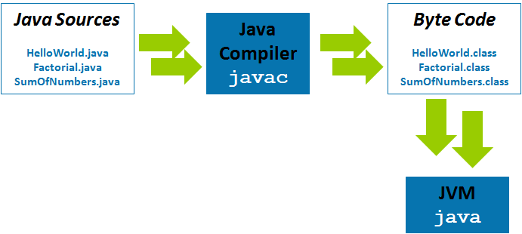
Figure 1: Java Program execution process

Java - Environment Setup

Local Environment Setup
If you are still willing to set up your environment for Java programming language, then this section guides you on how to download and set up Java on your machine. Please follow the following steps to set up the environment.
After downloading Java Development Kit freely available on Internet, the next step is install a .EXE setup and finally you set the environment variables in the following ways:

Setting up the path for windows:
Assuming you have installed Java in c:\Program Files\java\jdk directory:
- Right-click on 'My Computer' and select 'Properties'.
- Click on the 'Environment variables' button under the 'Advanced' tab.
- Now, alter the 'Path' variable so that it also contains the path to the Java executable. Example, if the path is currently set to 'C:\WINDOWS\SYSTEM32', then change your path to read 'C:\WINDOWS\SYSTEM32;c:\Program Files\java\jdk\bin'.

Setting up the path for Linux, UNIX, Solaris, FreeBSD:
Environment variable PATH should be set to point to where the Java binaries have been installed. Refer to your shell documentation if you have trouble doing this.
Example, if you use bash as your shell, then you would add the following line to the end of your '.bashrc: export PATH=/path/to/java:$PATH'

Popular Java Editors:
To write your Java programs, you will need a text editor. There are even more sophisticated IDEs available in the market. But for now, you can consider one of the following:
- Notepad: On Windows machine you can use any simple text editor like Notepad (JCreator is Recommended for this course), TextPad.
- Netbeans: is a Java IDE that is open-source and free which can be downloaded from http://www.netbeans.org/index.html (Also recommended for creating GUI interfaces)
- Eclipse: is also a Java IDE developed by the eclipse open-source community and can be downloaded from http://www.eclipse.org/

History of Java
Java history is interesting to know. The history of java starts from Green Team. Java team members (also known as Green Team), initiated a revolutionary task to develop a language for digital devices such as set-top boxes, televisions etc.
For the green team members, it was an advance concept at that time. But, it was suited for internet programming. Later, Java technology as incorporated by Netscape.
Currently, Java is used in internet programming, mobile devices, games, e-business solutions etc. There are given the major points that describes the history of java.
1) James Gosling, Mike Sheridan, and Patrick Naughton initiated the Java language project in June 1991. The small team of sun engineers called Green Team.
2) Originally designed for small, embedded systems in electronic appliances like set-top boxes.
3) Firstly, it was called "Greentalk" by James Gosling and file extension was .gt
4) After that, it was called Oak and was developed as a part of the Green project.
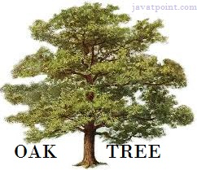
Figure: OAK Tree

Why Oak name for java language?

5) Why Oak? Oak is a symbol of strength and chosen as a national tree of many countries like U.S.A., France, Germany, Romania etc.
6) In 1995, Oak was renamed as "Java" because it was already a trademark by Oak Technologies.

Why Java name for java language?
7) Why did they choose java name for java language? The team gathered to choose a new name. The suggested words were "dynamic", "revolutionary", "Silk", "jolt", "DNA" etc. They wanted something that reflected the essence of the technology: revolutionary, dynamic, lively, cool, unique, and easy to spell and fun to say.
According to James Gosling "Java was one of the top choices along with Silk". Since java was so unique, most of the team members preferred java.
8) Java is an island of Indonesia where first coffee was produced (called java coffee).
9) Notice that Java is just a name not an acronym.
10) Originally developed by James Gosling at Sun Microsystems (which is now a subsidiary of Oracle Corporation) and released in 1995.
11) In 1995, Time magazine called Java one of the Ten Best Products of 1995.
12) JDK 1.0 released in(January 23, 1996).

Java Version History
There are many java versions that has been released. Current stable release of Java is Java SE 8.
- JDK Alpha and Beta (1995)
- JDK 1.0 (23rd Jan, 1996)
- JDK 1.1 (19th Feb, 1997)
- J2SE 1.2 (8th Dec, 1998)
- J2SE 1.3 (8th May, 2000)
- J2SE 1.4 (6th Feb, 2002)
- J2SE 5.0 (30th Sep, 2004)
- Java SE 6 (11th Dec, 2006)
- Java SE 7 (28th July, 2011)
- Java SE 8 (18th March, 2014)

Features of Java
There is given many features of java. They are also known as java buzzwords. The Java Features given below are simple and easy to understand.
- Simple
- Object-Oriented
- Platform independent
- Secured
- Robust
- Architecture neutral
- Portable
- Dynamic
- Interpreted
- High Performance
- Multithreaded
- Distributed

Simple
According to Sun, Java language is simple because:
syntax is based on C++ (so easier for programmers to learn it after C++).
removed many confusing and/or rarely-used features e.g., explicit pointers, operator overloading etc.
No need to remove unreferenced objects because there is Automatic Garbage Collection in java.

Object-oriented
Object-oriented means we organize our software as a combination of different types of objects that incorporates both data and behavior.
Object-oriented programming (OOPs) is a methodology that simplifies software development and maintenance by providing some rules.
Basic concepts of OOPs are:
- Object
- Class
- Inheritance
- Polymorphism
- Abstraction
- Encapsulation

Platform Independent
A platform is the hardware or software environment in which a program runs. There are two types of platforms software-based and hardware-based. Java provides software-based platform. The Java platform differs from most other platforms in the sense that it's a software-based platform that runs on top of other hardware-based platforms.It has two components:
- Runtime Environment
- API(Application Programming Interface)

Java code can be run on multiple platforms e.g. Windows, Linux, Sun Solaris, Mac/OS etc. Java code is compiled by the compiler and converted into bytecode. This bytecode is a platform independent code because it can be run on multiple platforms i.e. Write Once and Run Anywhere(WORA).

Secured
Java is secured because:
- No explicit pointer
- Programs run inside virtual machine sandbox.

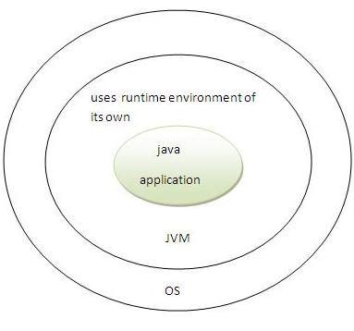

- Classloader- adds security by separating the package for the classes of the local file system from those that are imported from network sources.
- Bytecode Verifier- checks the code fragments for illegal code that can violate access right to objects.
- Security Manager- determines what resources a class can access such as reading and writing to the local disk.
These security are provided by java language. Some security can also be provided by application developer through SSL, JAAS, cryptography etc.

Robust
Robust simply means strong. Java uses strong memory management. There are lack of pointers that avoids security problem. There is automatic garbage collection in java. There is exception handling and type checking mechanism in java. All these points make java robust.

Architecture-neutral
There are no implementation dependent features e.g. size of primitive types is set.

Portable
We may carry the java bytecode to any platform.

High-performance
Java is faster than traditional interpretation since byte code is "close" to native code still somewhat slower than a compiled language (e.g., C++)

Distributed
We can create distributed applications in java. RMI and EJB are used for creating distributed applications. We may access files by calling the methods from any machine on the internet.

Multi-threaded
A thread is like a separate program, executing concurrently. We can write Java programs that deal with many tasks at once by defining multiple threads. The main advantage of multi-threading is that it shares the same memory. Threads are important for multi-media, Web applications etc.

Simple Program of Java
In this page, we will learn how to write the simple program of java. We can write a simple hello java program easily after installing the JDK.
To create a simple java program, you need to create a class that contains main method. Let's understand the requirement first.

Requirement for Hello Java Example
For executing any java program, you need to
- install the JDK if you don't have installed it.
- set path of the jdk/bin directory.
- compile and run the java program

Creating hello java example
Let's create the hello java program:
class Simple{
public static void main(String args[]){
System.out.println("Hello Java");
}
}
save this file as Simple.java
To compile: | javac Simple.java
To execute: | java Simple
Output:Hello Java

Understanding first java program
Let's see what is the meaning of class, public, static, void, main, String[], System.out.println().
- class keyword is used to declare a class in java.
- public keyword is an access modifier which represents visibility, it means it is visible to all.
- static is a keyword, if we declare any method as static, it is known as static method. The core advantage of static method is that there is no need to create object to invoke the static method. The main method is executed by the JVM, so it doesn't require to create object to invoke the main method. So it saves memory.
- void is the return type of the method, it means it doesn't return any value.
- main represents startup of the program.
- String[] args is used for command line argument. We will learn it later.
- System.out.println() is used print statement. We will learn about the internal working of System.out.println statement later.
To write the simple program, open notepad by start menu -> All Programs -> Accessories -> notepad and write simple program as displayed below:
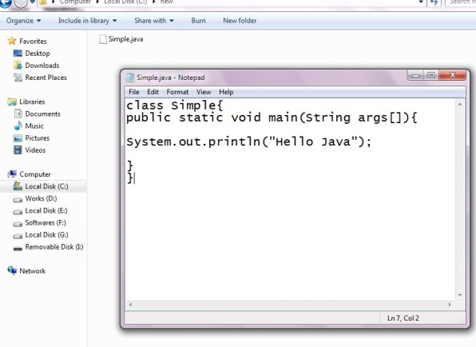
As displayed in the above diagram, write the simple program of java in notepad and saved it as Simple.java. To compile and run this program, you need to open command prompt by start menu -> All Programs -> Accessories -> command prompt.
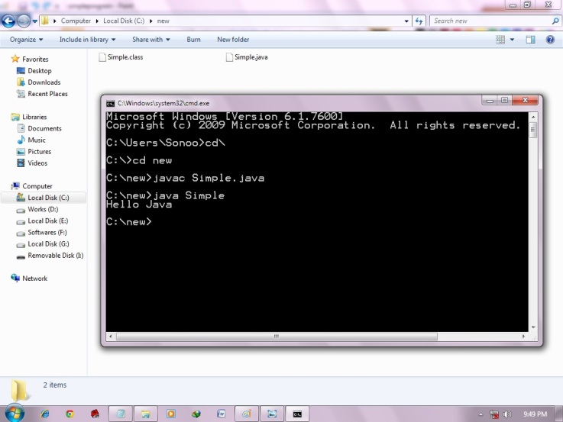
To compile and run the above program, go to your current directory first; my current directory is c:\new . Write here:

To compile: | javac Simple.java
To execute: | java Simple

How many ways can we write a java program
There are many ways to write a java program. The modifications that can be done in a java program are given below:
1) By changing sequence of the modifiers, method prototype is not changed.
Let's see the simple code of main method.
- static public void main(String args[])
2) subscript notation in java array can be used after type, before variable or after variable.
Let's see the different codes to write the main method.
- public static void main(String[] args)
- public static void main(String []args)
- public static void main(String args[])
3) You can provide var-args support to main method by passing 3 ellipses (dots)
Let's see the simple code of using var-args in main method. We will learn about var-args later in Java New Features chapter.
- public static void main(String... args)
4) Having semicolon at the end of class in java is optional.
Let's see the simple code.
- class A{
- static public void main(String... args){
- System.out.println("hello java programmers");
- }
- };

Valid java main method signature
- public static void main(String[] args)
- public static void main(String []args)
- public static void main(String args[])
- public static void main(String... args)
- static public void main(String[] args)
- public static final void main(String[] args)
- final public static void main(String[] args)
- final strictfp public static void main(String[] args)

Invalid java main method signature
- public void main(String[] args)
- static void main(String[] args)
- public void static main(String[] args)
- abstract public static void main(String[] args)

Resolving an error "javac is not recognized as an internal or external command" ?
If there occurs a problem like displayed in the below figure, you need to set path. Since DOS doesn't know javac or java, we need to set path. Path is not required in such a case if you save your program inside the jdk/bin folder. But its good approach to set path.

Internal Details of Hello Java Program
In the previous page, we have learned about the first program, how to compile and how to run the first java program. Here, we are going to learn, what happens while compiling and running the java program. Moreover, we will see some question based on the first program.

What happens at compile time?
At compile time, java file is compiled by Java Compiler (It does not interact with OS) and converts the java code into bytecode.
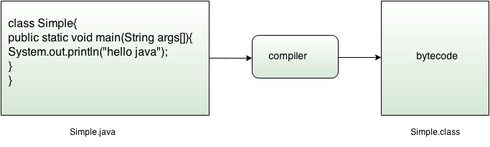

What happens at runtime?
At runtime, following steps are performed:
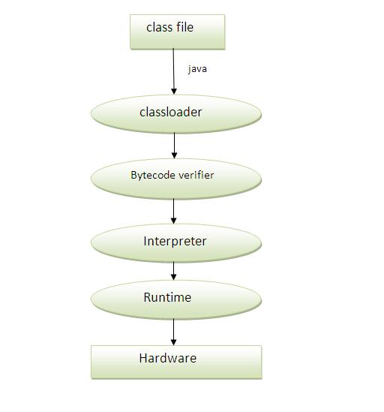

Classloader: is the subsystem of JVM that is used to load class files.
Bytecode Verifier: checks the code fragments for illegal code that can violate access right to objects.
Interpreter: read bytecode stream then execute the instructions.

Q)Can you save a java source file by other name than the class name?
Yes, if the class is not public. It is explained in the figure given below:
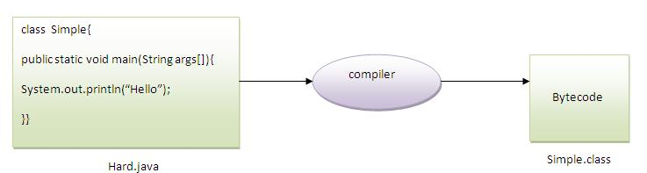

To compile: | javac Hard.java
To execute: | java Simple

Can you have multiple classes in a java source file?
Yes, like the figure given below illustrates:
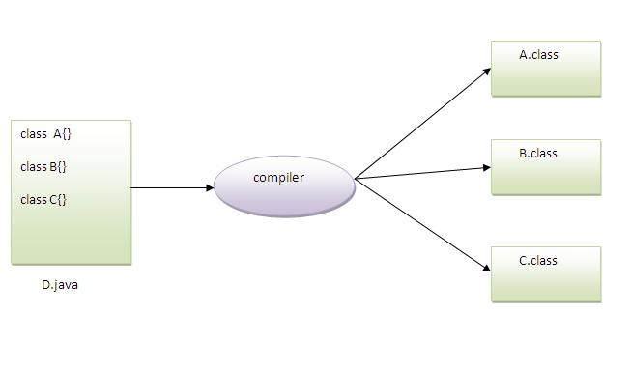

How to set path in Java
The path is required to be set for using tools such as javac, java etc.
If you are saving the java source file inside the jdk/bin directory, path is not required to be set because all the tools will be available in the current directory.
But If you are having your java file outside the jdk/bin folder, it is necessary to set path of JDK.
There are 2 ways to set java path:
- temporary
- permanent

1) How to set Temporary Path of JDK in Windows
To set the temporary path of JDK, you need to follow following steps:
- Open command prompt
- copy the path of jdk/bin directory
- write in command prompt: set path=copied_path

For Example:
set path=C:\Program Files\Java\jdk1.6.0_23\bin
Let's see it in the figure given below:
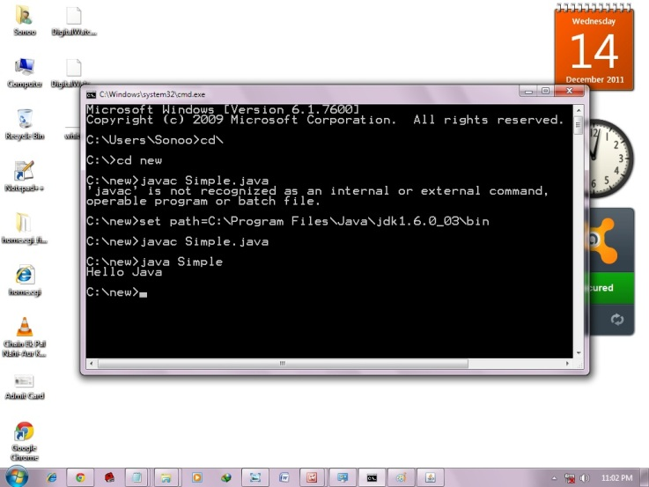

2) How to set Permanent Path of JDK in Windows
For setting the permanent path of JDK, you need to follow these steps:
- Go to MyComputer properties -> advanced tab -> environment variables -> new tab of user variable -> write path in variable name -> write path of bin folder in variable value -> ok -> ok -> ok

For Example:
1)Go to MyComputer properties
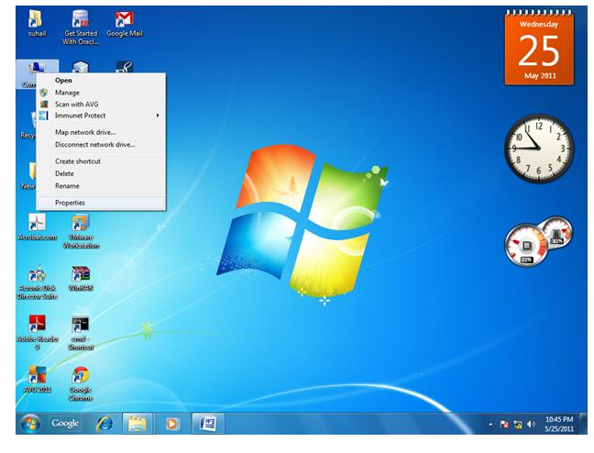
2)click on advanced tab
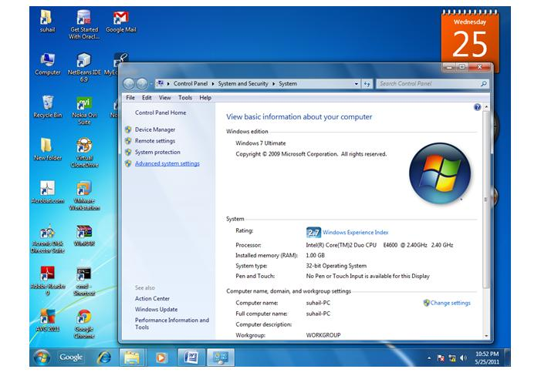
3)click on environment variables
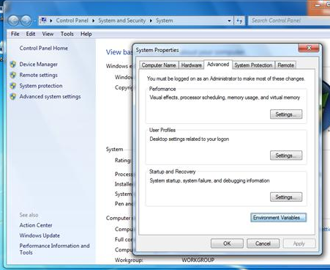
4)click on new tab of user variables
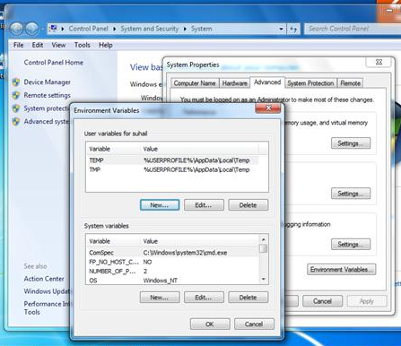
5)write path in variable name
6)Copy the path of bin folder
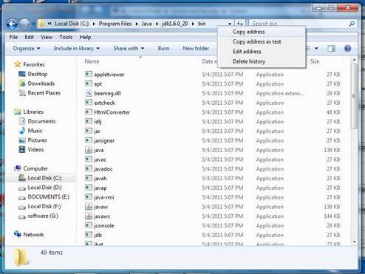
7)paste path of bin folder in variable value
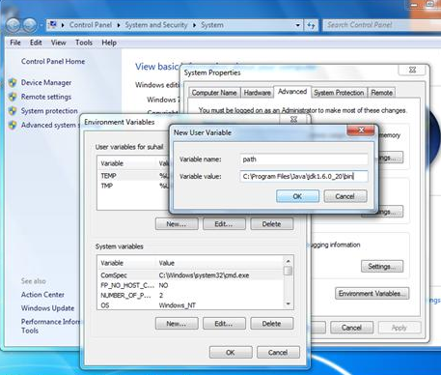
8)click on ok button
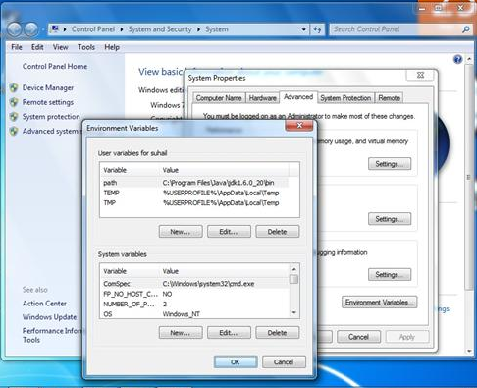
9)click on ok button
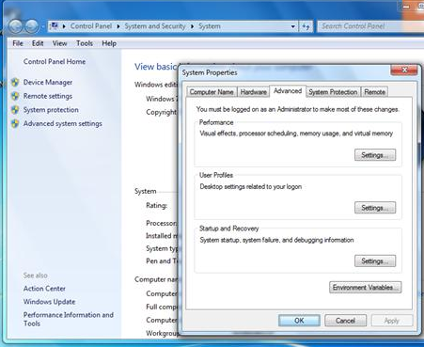
Now your permanent path is set.You can now execute any program of java from any drive.

Difference between JDK, JRE and JVM
Understanding the difference between JDK, JRE and JVM is important in Java. We are having brief overview of JVM here.
If you want to get the detailed knowledge of Java Virtural Machine, move to the next page. Firstly, let's see the basic differences between the JDK, JRE and JVM.

JVM
JVM (Java Virtual Machine) is an abstract machine. It is a specification that provides runtime environment in which java bytecode can be executed.
JVMs are available for many hardware and software platforms. JVM, JRE and JDK are platform dependent because configuration of each OS differs. But, Java is platform independent.
The JVM performs following main tasks:
- Loads code
- Verifies code
- Executes code
- Provides runtime environment

JRE
JRE is an acronym for Java Runtime Environment.It is used to provide runtime environment.It is the implementation of JVM.It physically exists.It contains set of libraries + other files that JVM uses at runtime.
Implementation of JVMs are also actively released by other companies besides Sun Micro Systems.
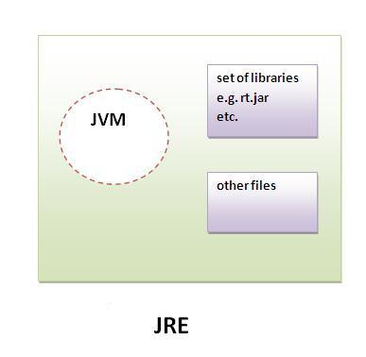

JDK
JDK is an acronym for Java Development Kit. It physically exists. It contains JRE + development tools.
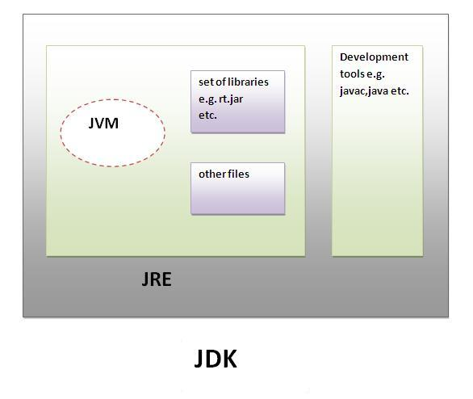

Internal Details of JVM (Java Virtual Machine)
JVM (Java Virtual Machine) is an abstract machine. It is a specification that provides runtime environment in which java bytecode can be executed.
JVMs are available for many hardware and software platforms (i.e.JVM is plateform dependent).

What is JVM?
It is:
- A specification where working of Java Virtual Machine is specified. But implementation provider is independent to choose the algorithm. Its implementation has been provided by Sun and other companies.
- An implementation Its implementation is known as JRE (Java Runtime Environment).
- Runtime Instance Whenever you write java command on the command prompt to run the java class, and instance of JVM is created.

What it does?
The JVM performs following operation:
- Loads code
- Verifies code
- Executes code
- Provides runtime environment
JVM provides definitions for the:
- Memory area
- Class file format
- Register set
- Garbage-collected heap
- Fatal error reporting etc.

Internal Architecture of JVM
Let's understand the internal architecture of JVM. It contains classloader, memory area, execution engine etc.
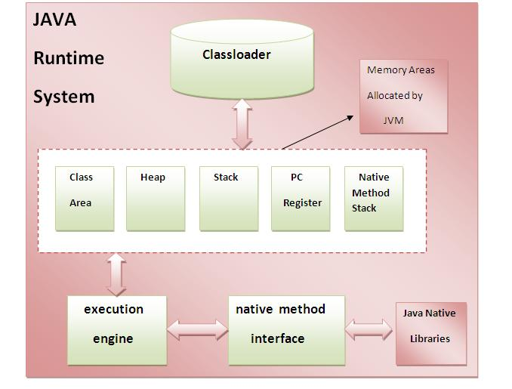

1) Classloader:
Classloader is a subsystem of JVM that is used to load class files.

2) Class(Method) Area:
Class(Method) Area stores per-class structures such as the runtime constant pool, field and method data, the code for methods.

3) Heap:
It is the runtime data area in which objects are allocated.

4) Stack:
Java Stack stores frames. It holds local variables and partial results, and plays a part in method invocation and return.
Each thread has a private JVM stack, created at the same time as thread.
A new frame is created each time a method is invoked. A frame is destroyed when its method invocation completes.

5) Program Counter Register:
PC (program counter) register. It contains the address of the Java virtual machine instruction currently being executed.

6) Native Method Stack:
It contains all the native methods used in the application.

7) Execution Engine:
It contains:
1) A virtual processor
2) Interpreter:Read bytecode stream then execute the instructions.
3) Just-In-Time(JIT) compiler:It is used to improve the performance.JIT compiles parts of the byte code that have similar functionality at the same time, and hence reduces the amount of time needed for compilation.Here the term ?compiler? refers to a translator from the instruction set of a Java virtual machine (JVM) to the instruction set of a specific CPU.

Variable and Datatype in Java
In this page, we will learn about the variable and java data types. Variable is a name of memory location. There are three types of variables: local, instance and static. There are two types of datatypes in java, primitive and non-primitive.

Variable
Variable is name of reserved area allocated in memory.
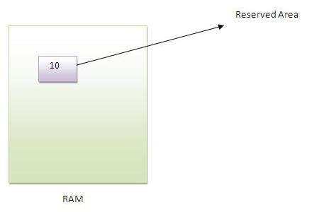
- int data=50;//Here data is variable

Types of Variable
There are three types of variables in java
- local variable
- instance variable
- static variable
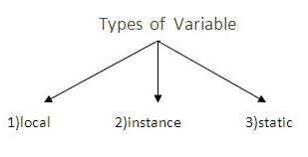

Local Variable
A variable that is declared inside the method is called local variable.

Instance Variable
A variable that is declared inside the class but outside the method is called instance variable . It is not declared as static.

Static variable
A variable that is declared as static is called static variable. It cannot be local.

We will have detailed learning of these variables in next chapters.

Example to understand the types of variables
- class A{
- int data=50;//instance variable
- static int m=100;//static variable
- void method(){
- int n=90;//local variable
- }
- }//end of class

Data Types in Java
In java, there are two types of data types
- primitive data types
- non-primitive data types
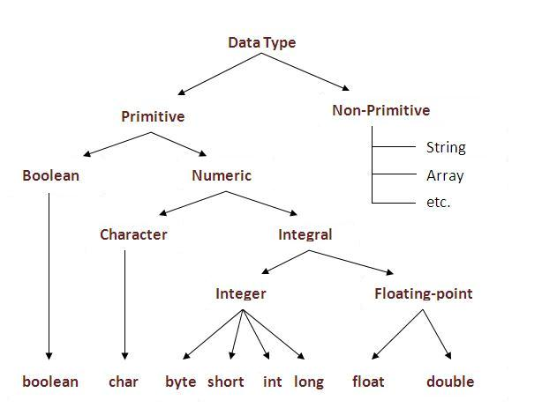

Data Type | Default Value | Default size
boolean | false | 1 bit
char | '\u0000' | 2 byte
byte | 0 | 1 byte
short | 0 | 2 byte
int | 0 | 4 byte
long | 0L | 8 byte
float | 0.0f | 4 byte
double | 0.0d | 8 byte

Operators in java
Operator in java is a symbol that is used to perform operations. There are many types of operators in java such as unary operator, arithmetic operator, relational operator, shift operator, bitwise operator, ternary operator and assignment operator.
Operators | Precedence
postfix | expr++ expr--
unary | ++expr --expr +expr -expr ~ !
multiplicative | * / %
additive | + -
shift | << >> >>>
relational | < > <= >= instanceof
equality | == !=
bitwise AND | &
bitwise exclusive OR | ^
bitwise inclusive OR | |
logical AND | &&
logical OR | ||
ternary | ? :
assignment | = += -= *= /= %= &= ^= |= <<= >>= >>>=
Java Programming Exercises

Java Programs
Java programs are frequently asked in the interview. These programs can be asked from control statements, array, string, oops etc. Let's see the list of java programs.

1) Fibonacci series
Write a java program to print fibonacci series without using recursion and using recursion.
Input: 10
Output: 0 1 1 2 3 5 8 13 21 34

2) Prime number
Write a java program to check prime number.
Input: 44
Output: not prime number
Input: 7
Output: prime number

3) Palindrome number
Write a java program to check palindrome number.
Input: 329
Output: not palindrome number
Input: 12321
Output: palindrome number

4) Factorial number
Write a java program to print factorial of a number.
Input: 5
Output: 120
Input: 6
Output: 720

5) Armstrong number
Write a java program to check Armstrong number.
Input: 153
Output: Armstrong number
Input: 22
Output: not Armstrong number

6) Bubble Sort
Write a java program to sort an array elements using bubble sort algorithm.
Input: 18 9 33 4 84 32
Output: 4 9 18 32 33 84

7) Selection Sort
Write a java program to sort an array elements using selection sort algorithm.
Input: 18 9 33 4 84 32
Output: 4 9 18 32 33 84

7) Insertion Sort
Write a java program to sort an array elements using insertion sort algorithm.
Input: 18 9 33 4 84 32
Output: 4 9 18 32 33 84
Chapter 2: Java Input, Control Statements and Java Methods

  - Using BufferedReader Class
  - Using DataInputStream Class
  - Using Scanner class
  - Using JOptionPane Class

- Using BufferedReader Class to get User Input

We are providing you a java application that will communicate with the user at the command line and returns the user input.
We have prompt the user to enter the name by using System.out.print() method to keep the cursor on the same line. Then we have used the System.in object, along with the InputstreamReader and BufferedReader classes in order to read the user input. The br.readline() method reads the name from the command line. After pressing the enter key, you will get the user input.
Here is the code of GetUserInput.java
import java.io.*;

public class GetUserInput {
public static void main (String[] args) {
System.out.print("Enter your name and press Enter: ");
BufferedReader br = new BufferedReader(new InputStreamReader(System.in));
String name = null;
try {
name = br.readLine();
} catch (IOException e) {
System.out.println("Error!");
System.exit(1);
}
System.out.println("Your name is " + name);
}
}
- Using DataInputStream Class to get input

Example on Keyboard Input DataInputStream
Following program uses readLine() method of DataInputStream to read data from the keyboard.
import java.io.*;
public class KeyboardReading1
{
public static void main(String args[]) throws IOException
{
DataInputStream dis = new DataInputStream(System.in);
System.out.println("Enter your name: ");
String str1 = dis.readLine();
System.out.println("I know your name is " + str1);

System.out.println("Enter a whole number: ");
String str2 = dis.readLine();
int x = Integer.parseInt(str2);

System.out.println("Enter a double value: ");
String str3 = dis.readLine();
double y = Double.parseDouble(str3);

if(x > y)
System.out.println("First number " +x + " is greater than second number " + y);
else
System.out.println("First number " +x + " is less than second number " + y);

dis.close();
}
}
The readLine() method of DataInputStream reads a line at a time and returns as a string, irrespective of what the line contains. Depending on the input value, the string is to be parsed into an int or double etc. This is extra work in the keyboard reading when compared to C/C++. In C/C++, parsing is done implicitly by %d and %f etc.
What is "System.in"?
" in" is an object of " InputStream" class defined in System class (like "out" is an object of PrintStream class defined in System class). It is declared as static and final object. The in object is connected implicitly to the " standard input stream" of the underlying OS.
DataInputStream dis = new DataInputStream(System.in);
System.in is a byte stream which is automatically connected to the keyboard reading mechanism of operating system. It is a low-level byte stream. The low-level byte stream is passed to high-level byte stream DataInputStream following the rules of chaining. It is chained to DataInputStream to facilitate the reading of user input with it 's readLine() method.
Like System.in is connected to the keyboard mechanism of OS, the System.out is connected to the standard output mechanism of OS.

- Using Scanner Class to get User Input
The Scanner class is placed in java.util package (not in java.io) to facilitate to take input for DS (Data structure) elements. The advantage of Scanner class is parsing is not required for keyboard input data which is required with DataInputStream (as in DataInpuStream Example) and BufferedReader (as in BufferedReader Example).
import java.util.Scanner;
public class KeyboardReading3
{
public static void main(String args[])
{
Scanner scan = new Scanner(System.in);
// reads a whole line
System.out.println("Enter your name:");
String s1 = scan.nextLine();
System.out.println("Your name is " + s1);
// reads only one word
System.out.println("City name:");
String s2 = scan.next();
System.out.println("City is " + s2);
// reading an integer
System.out.println("Enter whole number:");
int x = scan.nextInt();
// reading a double
System.out.println("Enter double value:");
double y = scan.nextDouble();

System.out.println("Number are " + x + " and " + y + " and their product is " + (x*y));
// all data entering at a time in a single line
System.out.println("Enter name, age, maraks, height (floating-point) and \npromoted or not (boolean) (giving whitespace):");
String name = scan.next();
byte age = scan.nextByte();
short marks = scan.nextShort();
float height = scan.nextFloat();
boolean promoted = scan.nextBoolean();
System.out.println("The values entered: " + name + ", " + age + ", " + marks + ", " + height + " and " + promoted);

scan.close();
}
}
This way of taking keyboard input is much easier as parsing is not required by the programmer. The Scanner class includes special methods like nextLine(), next(), nextByte(), nextShort(), nextFloat() and nextBoolean() etc. which parses to the appropriate data type implicitly. These methods are used in the above program.
The nextLine() method reads whole line that may contain whitespaces in the middle of the input. The next() method reads one word only delimited by whitespace. For example, if the user enters "Hello World", the next() method reads only "Hello" leaving "World".
- Using JOptionPane Class to get User Input

JOptionPane is a easy way to do dialog boxes, messages or inputs. You have to import it at the beginning of the program: import javax.swing.JOptionPane;

import javax.swing.JOptionPane; //import class JOptionPane
public class Addition {
public static void main ( String args[] )
{
String firstNumber, //first string entered by user
secondNumber; // second string entered by user
int number1, // first number to add
number2, //second number to add
sum; //sum of number1 and number2
//read in the first number from user as a string
firstNumber = JOptionPane.showInputDialog ( "Enter first integer" );
//read in the second number from user as a string
secondNumber = JOptionPane.showInputDialog ( "Enter second interger" );
//convert numbers from type String to type int
number1 = Integer.parseInt ( firstNumber);
number2 = Integer.parseInt ( secondNumber);
//add the numbers
sum = number1 + number2;
//display the results
JOptionPane.showMessageDialog ( null, "The sum is " + sum);
System. exit ( 0 ); //ends the program
}
}
NOTE:
JOptionPane can ONLY be used to input string, so if you want to use numbers, you have to create separate variables to change it into integers, or real numbers.
Control Statements in Java Programming
A program executes from top to bottom except when we use control statements, we can control the order of execution of the program, based on logic and values.
In Java, control statements can be divided into the following three categories:
- Selection Statements
- Iteration Statements
- Jump Statements
Selection Statements
Selection statements allow you to control the flow of program execution on the basis of the outcome of an expression or state of a variable known during runtime.
Selection statements can be divided into the following categories:
- The if and if-else statements
- The if-else statements
- The if-else-if statements
- The switch statements
The if statements
The first contained statement (that can be a block) of an if statement only executes when the specified condition is true. If the condition is false and there is not else keyword then the first contained statement will be skipped and execution continues with the rest of the program. The condition is an expression that returns a boolean value.
Example:
import java.util.Scanner;
public class IfDemo
{
public static void main(String[] args) {
int age;
Scanner inputDevice = new Scanner(System.in);
System.out.print("Please enter Age: ");
age = inputDevice.nextInt();
if(age > 18)
System.out.println("above 18 ");
}
}
The if-else statements
In if-else statements, if the specified condition in the if statement is false, then the statemet after the else keyword (that can be a block) will execute.
Example:
import java.util.Scanner;
public class IfElseDemo
{
public static void main( String[] args )
{
int age;
Scanner inputDevice = new Scanner( System.in );
System.out.print( "Please enter Age: " );
age = inputDevice.nextInt();
if ( age >= 18 )
System.out.println( "above 18 " );
else
System.out.println( "below 18" );
}
}
The if-else-if statements
This statement following the else keyword can be another if or if-else statement.
That would looks like this:
if(condition)
statements;
else if (condition)
statements;
else if(condition)
statement;
else
statements;
Whenever the condition is true, the associated statement will be executed and the remaining conditions will be bypassed. If none of the conditions are true then the else block will execute.
Example:
import java.util.Scanner;
public class IfElseIfDemo
{
public static void main( String[] args )
{
int age;
Scanner inputDevice = new Scanner( System.in );
System.out.print( "Please enter Age: " );
age = inputDevice.nextInt();
if ( age >= 18 && age <=35 )
System.out.println( "between 18-35 " );
else if(age >35 && age <=60)
System.out.println("between 36-60");
else
System.out.println( "not matched" );
}
}
The Switch Statements
The switch statement is a multi-way branch statement. The switch statement of Java is another selection statement that defines multiple paths of execution of a program. It provides a better alternative than a large series of if-else-if statements.
Example:
import java.util.Scanner;
public class SwitchDemo
{
public static void main( String[] args )
{
int age;
Scanner inputDevice = new Scanner( System.in );
System.out.print( "Please enter Age: " );
age = inputDevice.nextInt();
switch ( age )
{
case 18:
System.out.println( "age 18" );
break;
case 19:
System.out.println( "age 19" );
break;
default:
System.out.println( "not matched" );
break;
}
}
}
An expression must be of a type of byte, short, int or char. Each of the values specified in the case statement must be of a type compatible with the expression. Duplicate case values are not allowed. The break statement is used inside the switch to terminate a statement sequence. The break statement is optional in the switch statement.
Iteration Statements
Repeating the same code fragment several times until a specified condition is satisfied is called iteration. Iteration statements execute the same set of instructions until a termination condition is met.
Java provides the following loop for iteration statements:
- The while loop
- The for loop
- The do-while loop
- The for each loop
The while loop
It continually executes a statement (that is usually be a block) while a condition is true. The condition must return a boolean value.
Example:
public class WhileDemo {
public static void main( String[] args ) {
int i = 0;
while ( i < 5 )
{
System.out.println( "Value :: " + i );
i++;
}
}
}
The do-while loop
The only difference between a while and a do-while loop is that do-while evaluates its expression at the bottom of the loop instead of the top. The do-while loop executes at least one time then it will check the expression prior to the next iteration.
Example
public class DoWhileDemo {
public static void main( String[] args ) {
int i = 0;
do{
System.out.println( "value :: " + i );
i++;
}
while ( i < 5);
}
}
The for loop
A for loop executes a statement (that is usually a block) as long as the boolean condition evaluates to true. A for loop is a combination of the three elements initialization statement, boolean expression and increment or decrement statement.
Syntax:
for(<initialization>;<condition>;<increment or decrement statement>){
<block of code>
}
The initialization block executes first before the loop starts. It is used to initialize the loop variable.
The condition statement evaluates every time prior to when the statement (that is usually be a block) executes, if the condition is true then only the statement (that is usually a block) will execute.
The increment or decrement statement executes every time after the statement (that is usually a block).
Example:
public class DoWhileDemo {
public static void main( String[] args ){
int i;
for(i=0; i<5;i++){
System.out.println( "value :: " + i );
}
}
}
Jump Statements
Jump statements are used to unconditionally transfer the program control to another part of the program.
Java provides the following jump statements:
- break statement
- continue statement
- return statement
Break Statement
The break statement immediately quits the current iteration and goes to the first statement following the loop. Another form of break is used in the switch statement.
The break statement has the following two forms:
- Labeled Break Statement
- Unlabeled Break Statement
Unlabeled Break Statement: This is used to jump program control out of the specific loop on the specific condition.
Example:
public class UnLabeledBreakDemo{
public static void main( String[] args ) {
for ( int var = 0; var < 5; var++ ) {
System.out.println( "Var is : " + var );
if ( var == 3 )
break;
}
}
}
Labeled Break Statement: This is used for when we want to jump the program control out of nested loops or multiple loops.
Example:
public class LabeledBreakDemo{
public static void main( String[] args ) {
Outer: for ( int var1 = 0; var1 < 5; var1++ ) {
for ( int var2 = 1; var2 < 5; var2++ ) {
System.out.println( "var1:" + var1 + ", var2:" + var2 );
if ( var1 == 3 )
break Outer;
}
}
}
}
Continue Statement
The continue statement is used when you want to continue running the loop with the next iteration and want to skip the rest of the statements of the body for the current iteration. The continue statement has the following two forms:
- Labeled Continue Statement
- Unlabeled Continue Statement
Unlabeled Continue Statement: This statement skips the current iteration of the innermost for, while and do-while loop.
Example 1: Unlabeled Continue
public class UnlabeledContinueDemo{
public static void main( String[] args ) {
for ( int var1 = 0; var1 < 4; var1++ ) {
for ( int var2 = 0; var2 < 4; var2++ ) {
if ( var2 == 2 )
continue;
System.out.println( "var1:" + var1 + ", var2:" + var2 );
}
}
}
}
Example 2: Labeled Continue
public class LabeledContinueDemo {
public static void main( String[] args ) {
Outer: for ( int var1 = 0; var1 < 5; var1++ ) {
for ( int var2 = 0; var2 < 5; var2++ ) {
if ( var2 == 2 )
continue Outer;
System.out.println( "var1:" + var1 + ", var2:" + var2 );
}
}
}
}

Return Statement
The return statement is used to immediately quit the current method and return to the calling method. It is mandatory to use a return statement for non-void methods to return a value.
Example:
public class ReturnDemo {
public static void main( String[] args ) {
ReturnDemo returnDemo = new ReturnDemo();
System.out.println( "No : " + returnDemo.returnCall() );
}
int returnCall() {
return 5;
}
}

Java - Methods
Definition 1:
A Java method is a collection of statements that are grouped together to perform an operation.
Definition 2:
A method is a set of code which is referred to by name and can be called (invoked) at any point in a program simply by utilizing the method's name.
Defining Methods:
Method definition consists of a method header and a method body. The same is shown below:
modifier returnType nameOfMethod (Parameter List) {
// method body
}

Example:

public static int methodName(int a, int b) {
// body
}
Here,
- public static : modifier.
- int: return type
- methodName: name of the method
- a, b: formal parameters
- int a, int b: list of parameters

Example:
Here is the source code of the above defined method called max(). This method takes two parameters num1 and num2 and returns the maximum between the two:
public static int MaxFunction(int n1, int n2) {
int max;
if (n1 > n2)
max = n1;
else
max = n2;

return max;
}

Method Calling:
For using a method, it should be called. There are two ways in which a method is called i.e. method returns a value or returning nothing (no return value).
The process of method calling is simple. When a program invokes a method, the program control gets transferred to the called method. This called method then returns control to the caller in two conditions, when:
- return statement is executed.
- reaches the method ending closing brace.
Think of a method as a subprogram that acts on data and often returns a value.
When the method is finished, execution returns to the area of the program code from which it was called, and the program continues on to the next line of code. As the following figure shows, the methods are called in main method.
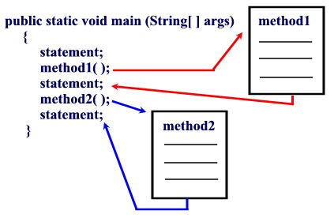
Figure: Method Calling
Types of Methods
There are two basic types of methods:
Built-in: Build-in methods are part of the compiler package, such as System.out.println( ) and System.exit(0).
User-defined: User-defined methods are created by you, the programmer. These methods take-on names that you assign to them and perform tasks that you create.
Working Exaple:
public class MyMethod{
public static int sum(){
int a,b,c;
a=5;
b=10;
c=a+b;
return c;
}
public static int square(int x){
int sq=x*x;
System.out.println(sq);
return 0;
}
public static void main(String args[]){
int d=sum();
System.out.println(d);
square(52);
}
}

Overloading Methods
The Java programming language supports overloading methods, and Java can distinguish between methods with different method signatures. This means that methods within a class can have the same name if they have different parameter lists.
Example:
public class DataArtist {
...
public void draw(String s) {
...
}
public void draw(int i) {
...
}
public void draw(double f) {
...
}
public void draw(int i, double f) {
...
}
}
Method Overloading is a feature that allows a class to have two or more methods having same name, if their argument lists are different.
Argument lists could differ in:
1. Number of parameters.
2. Data type of parameters.
3. Sequence of Data type of parameters.
Method overloading is also known as Static Polymorphism.
Working Example:
public class Calculation{
public static void sum(int a,int b){
System.out.println(a+b);
}
public static void sum(int a,int b,int c){
System.out.println(a+b+c);
}
public static void main(String args[]){
sum(10,10,10);
sum(20,20);
}
}
In this example, we have created two overloaded methods, first sum method performs addition of two numbers and second sum method performs addition of three numbers.
Working Example 2:
public class Calculation2{
public static void sum(int a,int b){
System.out.println(a+b);
}
public static void sum(double a,double b){
System.out.println(a+b);
}
public static void main(String args[]){
sum(10.5,10.5);
sum(20,20);
}
}
In this example, we have created two overloaded methods that differs in data type. The first sum method receives two integer arguments and second sum method receives two double arguments.

Chapter 3: Java OOPs Concepts
Object means a real word entity such as pen, chair, table etc. Object-Oriented Programming is a methodology or paradigm to design a program using classes and objects. It simplifies the software development and maintenance by providing some concepts:
- Object
- Class
- Inheritance
- Polymorphism
- Abstraction
- Encapsulation

Object
Any entity that has state and behavior is known as an object. For example: chair, pen, table, keyboard, bike etc. It can be physical and logical.
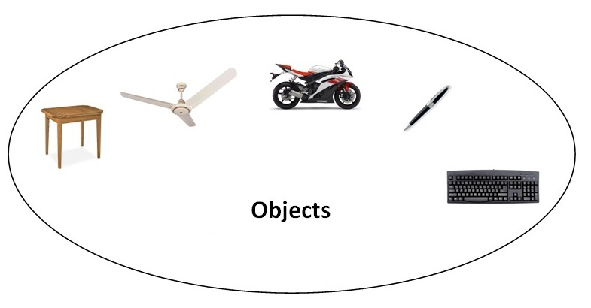

Class
Collection of objects is called class. It is a logical entity.

Inheritance
When one object acquires all the properties and behaviours of parent object i.e. known as inheritance. It provides code reusability. It is used to achieve runtime polymorphism.

Polymorphism
When one task is performed by different ways i.e. known as polymorphism. For example: to convense the customer differently, to draw something e.g. shape or rectangle etc. In java, we use method overloading and method overriding to achieve polymorphism. Another example can be to speak something e.g. cat speaks meaw, dog barks woof etc.

Abstraction
Hiding internal details and showing functionality is known as abstraction. For example: phone call, we don't know the internal processing. In java, we use abstract class and interface to achieve abstraction.

Encapsulation
Binding (or wrapping) code and data together into a single unit is known as encapsulation. For example: capsule, it is wrapped with different medicines. A java class is the example of encapsulation. Java bean is the fully encapsulated class because all the data members are private here.

Advantage of OOPs over Procedure-oriented programming language
1) OOP makes development and maintenance easier where as in Procedure-oriented programming language it is not easy to manage if code grows as project size grows.
2) OOP provides data hiding whereas in Procedure-oriented programming language a global data can be accessed from anywhere.
3) OOP provides ability to simulate real-world event much more effectively. We can provide the solution of real word problem if we are using the Object-Oriented Programming language.

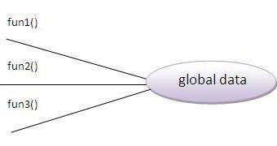 | 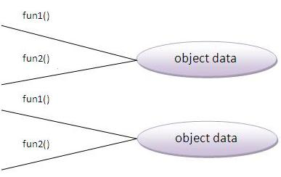

Object-oriented programming (OOP) languages are designed to overcome these problems.
- The basic unit of OOP is a class, which encapsulates both the static properties and dynamic operations within a "box", and specifies the public interface for using these boxes. Since classes are well-encapsulated, it is easier to reuse these classes. In other words, OOP combines the data structures and algorithms of a software entity inside the same box.
- OOP languages permit higher level of abstraction for solving real-life problems. The traditional procedural language (such as C and Pascal) forces you to think in terms of the structure of the computer (e.g. memory bits and bytes, array, decision, loop) rather than thinking in terms of the problem you are trying to solve. The OOP languages (such as Java, C++ and C#) let you think in the problem space, and use software objects to represent and abstract entities of the problem space to solve the problem.
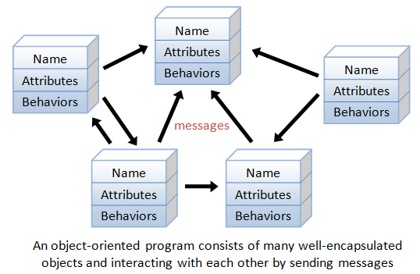
As an example, suppose you wish to write a computer soccer games (which I consider as a complex application). It is quite difficult to model the game in procedural-oriented languages. But using OOP languages, you can easily model the program accordingly to the "real things" appear in the soccer games.
- Player: attributes include name, number, location in the field, and etc; operations include run, jump, kick-the-ball, and etc.
- Ball:
- Reference:
- Field:
- Audience:
- Weather:
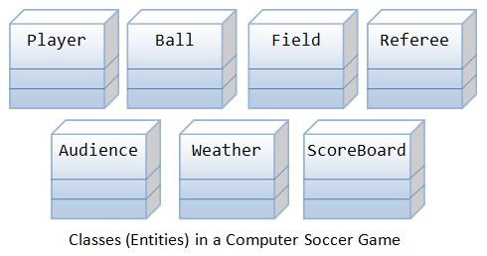
Most importantly, some of these classes (such as Ball and Audience) can be reused in another application, e.g., computer basketball game, with little or no modification

Benefits of OOP
The procedural-oriented languages focus on procedures, with function as the basic unit. You need to first figure out all the functions and then think about how to represent data.
The object-oriented languages focus on components that the user perceives, with objects as the basic unit. You figure out all the objects by putting all the data and operations that describe the user's interaction with the data.
Object-Oriented technology has many benefits:
- Ease in software design as you could think in the problem space rather than the machine's bits and bytes. You are dealing with high-level concepts and abstractions. Ease in design leads to more productive software development.
- Ease in software maintenance: object-oriented software are easier to understand, therefore easier to test, debug, and maintain.
- Reusable software: you don't need to keep re-inventing the wheels and re-write the same functions for different situations. The fastest and safest way of developing a new application is to reuse existing codes - fully tested and proven codes

Class & Instances
In Java, a class is a definition of objects of the same kind. In other words, a class is a blueprint, template, or prototype that defines and describes the static attributes and dynamic behaviors common to all objects of the same kind.
An instance is a realization of a particular item of a class. In other words, an instance is an instantiation of a class. All the instances of a class have similar properties, as described in the class definition. For example, you can define a class called "Student" and create three instances of the class "Student" for "Peter", "Paul" and "Pauline".
The term "object" usually refers to instance. But it is often used loosely, which may refer to a class or an instance.

A Class is a 3-Compartment Box encapsulating Data and Operations
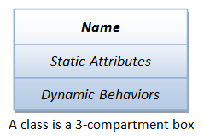
A class can be visualized as a three-compartment box, as illustrated:
- Name (or identity): identifies the class.
- Variables (or attribute, state, field): contains the static attributes of the class.
- Methods (or behaviors, function, operation): contains the dynamic behaviors of the class.
In other words, a class encapsulates the static attributes (data) and dynamic behaviors (operations that operate on the data) in a box.
The followings figure shows a few examples of classes:
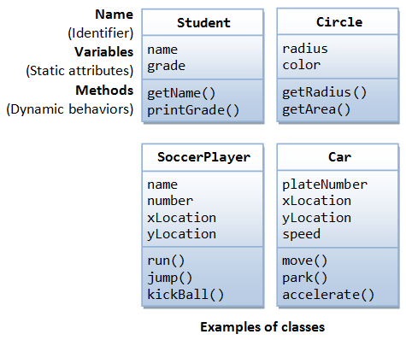
The following figure shows two instances of the class Student, identified as "paul" and "peter".
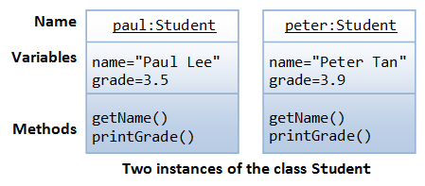
Working Example of Class and Object:
class MyObject // Start of Class Definition{
int a, b;
public void Addition(){
int c=a+b;
System.out.println("Sum="+c);
}
}//End of class Definition
class MainClass{
public static void main(String args[]){
MyObject mo=new MyObject();//Creation of Instance Variable mo or Object mo
mo.a=10;
mo.b=25;
mo.Addition();//Accessing Class Member Function using Object
}
}
Constructor in Java
Constructor in Java is block of code which is executed at the time of Object creation. But other than getting called, Constructor is entirely different than methods and has some specific properties like name of constructor must be same as name of Class. Constructor also can not have any return type, constructor’s are automatically chained by using this keyword and super. Since Constructor is used to create object, object initialization code is normally hosted in Constructor. Similar to method you can also overload constructor in Java.

Characteristics of Java Constructor
- First and most important rule of declaring constructor is that name of constructor in Java must be exactly same with the class on which you declare constructor.

- Another important rule of declaring constructor is that constructor in Java doesn't have return type.

- A Constructor is initialized up on the creation of object.

Example 1:
class ConstructorDemo{
public ConstructorDemo(){
System.out.println("No argument inside constructor");
}

public ConstructorDemo(String name){
System.out.println("One argument inside constructor in Java with name: " + name);
}

public static void main(String args[]){

ConstructorDemo d = new ConstructorDemo(); //calling no argument constructor in java
ConstructorDemo e = new ConstructorDemo("Testing"); //calling one argument constructor in java

}
}

Example 2:
class Example{
private int var;
public Example(){
//code for default one
var = 10;
String msg="Constructor";
System.out.println(msg);
}
public Example(int num) { //code for parameterized one
var = num;
}
public int getValue() {
return var;
}
public static void main(String args[]) {
Example ob = new Example();
int c=ob.getValue();
System.out.println("var is: "+c);
}
}

Inheritance

An important feature of object-oriented programs is inheritance—the ability to create classes that share the attributes and methods of existing classes, but with more specific features. Inheritance is mainly used for code reusability. So you are making use of already written class and further extending on that. That why we discussed about the code reusability the concept. In general one line definition we can tell that deriving a new class from existing class, it’s called as Inheritance. You can look into the following example for inheritance concept.
The class which inherits the properties of other is known as subclass (derived class, child class) and the class whose properties are inherited is known as superclass (base class, parent class).

extends Keyword
extends is the keyword used to inherit the properties of a class. Below given is the syntax of extends keyword.
Format:
class Super{
.....
.....
}

class Sub extends Super{
.....
.....

}

Example - 1
class Box {

double width;
double height;
double depth;
Box() {
}
Box(double w, double h, double d) {
width = w;
height = h;
depth = d;
}
void getVolume() {
System.out.println("Volume is : " + width * height * depth);
}
}
public class MatchBox extends Box {

double weight;
MatchBox() {
}
MatchBox(double w, double h, double d, double m) {
super(w, h, d);
weight = m;
}
public static void main(String args[]) {
MatchBox mb1 = new MatchBox(10, 10, 10, 10);
mb1.getVolume();
System.out.println("width of MatchBox 1 is " + mb1.width);
System.out.println("height of MatchBox 1 is " + mb1.height);
System.out.println("depth of MatchBox 1 is " + mb1.depth);
System.out.println("weight of MatchBox 1 is " + mb1.weight);
}
}

Example – 2
class Calculation{
int z;
public void addition(int x, int y){
z = x+y;
System.out.println("The sum of the given numbers:"+z);
}
public void Substraction(int x,int y){
z = x-y;
System.out.println("The difference between the given numbers:"+z);
}
}
public class My_Calculation extends Calculation{

public void multiplication(int x, int y){
z = x*y;
System.out.println("The product of the given numbers:"+z);
}
public static void main(String args[]){
int a = 20, b = 10;
My_Calculation demo = new My_Calculation();
demo.addition(a, b);
demo.Substraction(a, b);
demo.multiplication(a, b);
}

}

Polymorphism in Java
Polymorphism in java is a concept by which we can perform a single action by different ways. Polymorphism is derived from 2 greek words: poly and morphs. The word "poly" means many and "morphs" means forms. So polymorphism means many forms.
There are two types of polymorphism in java: compile time polymorphism and runtime polymorphism. We can perform polymorphism in java by method overloading and method overriding.
If you overload static method in java, it is the example of compile time polymorphism. Here, we will focus on runtime polymorphism in java.

Runtime Polymorphism in Java
Runtime polymorphism or Dynamic Method Dispatch is a process in which a call to an overridden method is resolved at runtime rather than compile-time.
In this process, an overridden method is called through the reference variable of a superclass. The determination of the method to be called is based on the object being referred to by the reference variable.
Let's first understand the upcasting before Runtime Polymorphism.

Upcasting
When reference variable of Parent class refers to the object of Child class, it is known as upcasting. For example:
class Bike{
void run(){System.out.println("running");}
}
class Splender extends Bike{
void run(){System.out.println("running safely with 60km");}
public static void main(String args[]){
Bike b = new Splender();//upcasting
b.run();
}
}
Example -2
class Bank{
int getRateOfInterest(){
return 0;
}
}
class BK extends Bank{
int getRateOfInterest(){
return 18;
}
}
class ECOBANK extends Bank{
int getRateOfInterest(){
return 17;
}
}
class BPR extends Bank{
int getRateOfInterest(){
return 19;
}
}
class Test3{
public static void main(String args[]){
Bank b1=new BK();
Bank b2=newECOBANK();
Bank b3=new BPR();
System.out.println("BK Rate of Interest: "+b1.getRateOfInterest());
System.out.println("EOBANK Rate of Interest: "+b2.getRateOfInterest());
System.out.println("BPR Rate of Interest: "+b3.getRateOfInterest());
}
}
Use of Keyword super in Java
In short we can say that, super is used to serve following two objectives:
1) Accessing super class members (Methods and Variables).
2) Calling super class Constructor.

1) Using 'super' to access superclass members

In Java 'super' keyword can be used to refer superclass instance in a subclass. In the code below we have a superclass 'Fruit' and a subclass 'Apple'. These two classes have member variable 'name' in them. And a method 'getClassName()' that is being overriden by 'Apple'. In normal condition if we call 'getClassName()' or try to access 'name' with apple instance, we will get members of 'Apple' called. To call superclass(Fruit) members within a subclass(Apple) 'super' keyword is used.
Example 1:
class Vehicle{
int speed=50;
}
class Bike4 extends Vehicle{
int speed=100;
void display(){
System.out.println(super.speed);//will print speed of Vehicle now
}
public static void main(String args[]){
Bike4 b=new Bike4();
b.display();
}
}
Super with parent’s constructor and method:

class Parentclass{
Parentclass(){
System.out.println("Constructor of Superclass");
}
void MethodHello(){
System.out.println(" Hello Super Class");
}
}
class Subclass extends Parentclass{
Subclass(){
super();
super.MethodHello();
System.out.println("Constructor of Subclass");
}
void display(){
System.out.println("Hello");
}
public static void main(String args[]){
Subclass obj= new Subclass();
obj.display();
}
}
Use of this Keyword in Java
this is a keyword in Java. Which can be used inside method or constructor of class. It(this) works as a reference to current object whose method
or constructor is being invoked. this keyword can be used to refer any member of current object from within an instance method or a constructor.
Example:

class ThisClass {
int variable = 5;
public static void main(String args[]) {
ThisClass obj = new ThisClass ();
obj.method(20);
obj.method();
}
void method(int variable) {
variable = 10;
System.out.println("Value of Instance variable :" + this.variable);
System.out.println("Value of Local variable :" + variable);
}
void method() {
int variable = 40;
System.out.println("Value of Instance variable :" + this.variable);
System.out.println("Value of Local variable :" + variable);
}
}

Abstract Class in Java

Abstract classes cannot be instantiated, but they can be subclassed. In other words, a class that is declared with abstract keyword, is known as abstract class in java. It can have abstract(method without body) and non-abstract methods (method with body).

Interface in Java
An interface in java is a blueprint of a class. It has static constants and abstract methods only.
The interface in java is a mechanism to achieve fully abstraction. There can be only abstract methods in the java interface not method body. It is used to achieve fully abstraction and multiple inheritance in Java.

Understanding relationship between classes and interfaces
As shown in the figure given below, a class extends another class, an interface extends another interface but a class implements an interface.
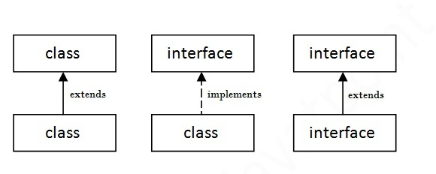

Simple example of Java interface
In this example, Printable interface have only one method, its implementation is provided in the A class.
interface printable{
void print();
}
class A6 implements printable{
public void print(){
System.out.println("Hello Interface Method");
}
public static void main(String args[]){
A6 obj = new A6();
obj.print();
}
}

Key Points about Interface in Java

1. Interface in java is declared using keyword interface and it represents a Type like any Class in Java. a reference variable of type interface can point to any implementation of that interface in Java. Its also a good Object oriented design principle to "program for interfaces than implementation" because when you use interface to declare reference variable, method return type or method argument you are flexible enough to accept any future implementation of that interface which could be much better and high performance alternative of current implementation. similarly calling any method on interface doesn't tie you with any particular implementation and you can leverage benefit of better or improved implementation over time.
2) All variables declared inside interface is implicitly public final variable or constants. which brings a useful case of using Interface for declaring Constants. We have used both Class and interface for storing application wide constants and advantage of using Interface was that you can implement interface and can directly access constants without referring them with class name which was the case earlier when Class is used for storing Constants.
3) All methods declared inside Java Interfaces are implicitly public and abstract, even if you don't use public or abstract keyword. you can not define any concrete method in interface. That's why interface is used to define contracts in terms of variables and methods and you can rely on its implementation for performing job.
4) In Java its legal for an interface to extend multiple interface.

Multiple inheritance in Java by interface

If a class implements multiple interfaces, or an interface extends multiple interfaces i.e. known as multiple inheritance.
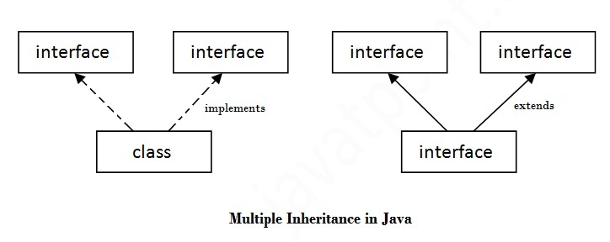
interface Printable{
void print();
}
interface Showable{
void show();
}
class A7 implements Printable,Showable{
public void print(){System.out.println("Hello");
}
public void show(){System.out.println("Welcome");
}
public static void main(String args[]){
A7 obj = new A7();
obj.print();
obj.show();
}
}

Abstract Classes
A class that is declared with abstract keyword, is known as abstract class in java. It can have abstract and non-abstract methods (method with body).
Before learning java abstract class, let's understand the abstraction in java first.

Abstraction in Java
Abstraction is a process of hiding the implementation details and showing only functionality to the user.
Another way, it shows only important things to the user and hides the internal details for example sending sms, you just type the text and send the message. You don't know the internal processing about the message delivery.
Abstraction lets you focus on what the object does instead of how it does it.

Ways to achieve Abstaction
There are two ways to achieve abstraction in java
- Abstract class (0 to 100%)
- Interface (100%)
- A class that is declared as abstract is known as abstract class. It needs to be extended and its method implemented. It cannot be instantiated.

Example abstract class:
abstract class A{}

Example of abstract class that has abstract method
In this example, Bike the abstract class that contains only one abstract method run. It implementation is provided by the Honda class.
abstract class Bike{
abstract void run();
}
class Honda4 extends Bike{
void run(){
System.out.println("running safely..");
}
public static void main(String args[]){
Bike obj = new Honda4();
obj.run();
}
}

Abstract class having constructor, data member, methods etc.
An abstract class can have data member, abstract method, method body, constructor and even main() method.
//example of abstract class that have method body
abstract class Bike{
Bike(){
System.out.println("bike is created");
}
abstract void run();
void changeGear(){
System.out.println("gear changed");
}
}
class Honda extends Bike{
void run(){
System.out.println("running safely..");
}
}
class TestAbstraction2{
public static void main(String args[]){
Bike obj = new Honda();
obj.run();
obj.changeGear();
}
}

Another real scenario of abstract class
The abstract class can also be used to provide some implementation of the interface. In such case, the end user may not be forced to override all the methods of the interface.
interface A{
void a();
void b();
void c();
void d();
}
abstract class B implements A{
public void c(){
System.out.println("I am C");}
}
class M extends B{
public void a(){System.out.println("I am a");}
public void b(){System.out.println("I am b");}
public void d(){System.out.println("I am d");}
}
class Test5{
public static void main(String args[]){
A a=new M();
a.a();
a.b();
a.c();
a.d();
}
}
Inner and Outer Classes
In object-oriented programming (OOP), an inner class or nested class is a class declared entirely within the body of another class or interface. It is distinguished from a subclass. An instance of a normal or top-level class can exist on its own. By contrast, an instance of an inner class cannot be instantiated without being bound to a top-level class.
Syntax:
class Outer{
//code
class Inner{
//code
}
}
Example:
class Outer{
private int size ;
private String OuterMsg = "My outer Message";
void MethodOuter(){
System.out.println(OuterMsg);
}
class Inner{
String InnerMsg = "My inner Message";
void doStuff(){
// inner object has its own "this"
System.out.println( InnerMsg );
// and it also has a kind of "outer this"
// even for private data of outer class
}
}
}
class TestMe{
public static void main( String args[] ) {
// instantiate me, the outer object
Outer o = new Outer();
// Inner i = new Inner();
// NO! Can't instantiate Inner by itself!
Outer.Inner i = o.new Inner();
// now I have my special inner object
i.doStuff();
o.MethodOuter();
// OK to call methods on Outerr object
}
}

Advantage of java inner classes
There are basically three advantages of inner classes in java. They are as follows:
1) Nested classes represent a special type of relationship that is it can access all the members (data members and methods) of outer class including private.
2) Nested classes are used to develop more readable and maintainable code because it logically group classes and interfaces in one place only.
3) Code Optimization: It requires less code to write.
Packages
Package are used in Java, in-order to avoid name conflicts and to control access of class, interface and enumeration etc. A package can be defined as a group of similar types of classes, interface, enumeration and sub-package. Using package it becomes easier to locate the related classes.

Package are categorized into two forms
- Built-in Package:-Existing Java package for example java.lang, java.util etc.
- User-defined-package:- Java package created by user to categorized classes and interface
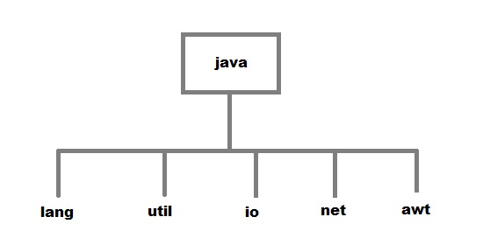

Creating a package
Creating a package in java is quite easy. Simply include a package command followed by name of the package as the first statement in java source file.
package mypack;
public class employee
{
...statement;
}

The above statement create a package called mypack.
Java uses file system directory to store package. For example the .class for any classes you define to be part of mypack package must be stored in a directory called mypack.

Purpose of Package in Java
The purpose of package concept is to provide common classes and interfaces for any program separately. In other words if we want to develop any class or interface which is common for most of the java programs than such common classes and interfaces must be place in a package.
Example:
package MyPack;
class A{
public void show(){
System.out.println("Hello Class A");
}
}
class B{
String msg;
public void SayHello(){
msg="Hello CS Students";
System.out.println(msg);
}
}
Save and compile this as: MyPackage.java
Accessing User Defined Package
We use the keyword import as in the following example:

package MyPack;
public class MyPackage_Import{
public static void main(String args[]){
A a=new A();
a.show();
B b=new B();
b.SayHello();
}
}
Accessing User Defined Package using import
We can import all classes in a package or we can specify a particular class to import. If we want to access a class in a package using import, that should be declared as public.
Example:
package MyPackage1;
public class MyClass1{
public void show(){
System.out.println("Hello CS Students");
}
}
Save this as Myclass1.java
import MyPackage1.*;//importing all classes of package
import MyPackage1.Myclass1;
class Hello {
public static void main(String arg[]){
Myclass1 a=new Myclass1();
a.show();
System.out.println("Accessing a Class in a Package");
}
}
Applet Programming
Applet is a predefined class in java.applet package used to design distributed application. It is a client side technology. Applets are run on web browser.

Advantage of Applet
- Applets are supported by most web browsers.
- Applets works at client side so less response time.
- Secured: No access to the local machine and can only access the server it came from.
- Easy to develop applet, just extends applet class.
- To run applets, it requires the Java plug-in at client side.
- Android, do not run Java applets.

Life cycle of applet
- init()
- start()
- stop
- destroy
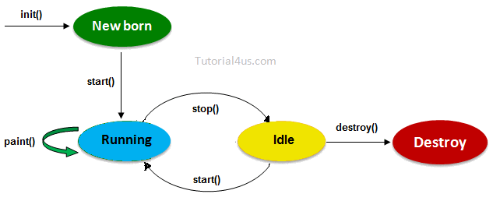
init(): Which will be executed whenever an applet program start loading, it contains the logic to initiate the applet properties.
start(): It will be executed whenever applet program starts running.
stop(): Which will be executed whenever applet window or browser is minimized.
destroy(): It will be executed whenever applet window or browser is going to be closed (at the time of destroying the applet program permanently).

Design applet program
We can design our own applet program by extending applet class in the user defined class.

Syntax:
class className extends Applet
{
......
// override lifecycle methods
......
}
Note: Whenever an applet program is running inti() and start() will be executed one after another but stop() and destroy() will be executed if the browser is minimized and closed by the end user respectively.
Note: Applet program may or may not contain life cycle methods.

Running of applet programs
Applet program can run in two ways.
- Using html (in the web browser)
- Using appletviewer tool (in applet window)

Running of applet using html
In general no java program can directly execute on the web browser except markup language like html, xml etc. Html support a predefined tag called <applet> to load the applet program on the browser window.

Syntax:
<applet code="udc.class">
height="100px"
width="100px"
</applet>

Example of applet program to run applet using html

Java code, JavaApp.java

import java.applet.*;
import java.awt.*;
public class JavaApp extends Applet
{
public void paint(Graphics g)
{
Font f=new Font("Arial",Font.BOLD,30);
g.setFont(f);
setForeground(Color.red);
setBackground(Color.white);
g.drawString("Student",200,200);
}
}

Html code, myapplet.html
<html>
<title> AppletEx</Title>
<body>
<applet code="JavaApp.class"
height="70%"
width="80%">
</applet>
</body>
</html>

Running of applet using appletviewer
Some browser does not support <applet> tag so that Sun MicroSystem was introduced a special tool called appletviewer to run the applet program.
In this Scenario java program should contains <applet> tag in the commented lines so that appletviewer tools can run the current applet program.

Example of Applet
import java.applet.*;
import java.awt.*;
/*<applet code="JavaLifeApp.class" height="500",width="800">
</applet>*/
public class JavaLifeApp extends Applet{
String s= " ";
public void init(){
s=s+ " int ";
}
public void start(){
s=s+ "start ";
}
public void stop(){
s=s+ "stop ";
}
public void destroy(){
s=s+ " destory ";
}
public void paint(Graphics g){
Font f=new Font("Arial",Font.BOLD,18);
setBackground(Color.red);
g.setFont(f);
g.drawString(s,200,250);
g.drawString("Welcome",100,250);
g.drawRect(100,60,200,160);
}
}
Save the above code as JavaLifeApp.java and compile it to create JavaLifeApp.class, then in command prompt go to location where JavaLifeApp.java is saved then after type appletviewer JavaLifeApp.java to run it.
In this course almost all examples will run using applet viewer as Applets are not supported by all browsers.

Displaying Graphics in Applet
java.awt.Graphics class provides many methods for graphics programming.

Commonly used methods of Graphics class:
- public abstract void drawString(String str, int x, int y): is used to draw the specified string.
- public void drawRect(int x, int y, int width, int height): draws a rectangle with the specified width and height.
- public abstract void fillRect(int x, int y, int width, int height): is used to fill rectangle with the default color and specified width and height.
- public abstract void drawOval(int x, int y, int width, int height): is used to draw oval with the specified width and height.
- public abstract void fillOval(int x, int y, int width, int height): is used to fill oval with the default color and specified width and height.
- public abstract void drawLine(int x1, int y1, int x2, int y2): is used to draw line between the points(x1, y1) and (x2, y2).
- public abstract boolean drawImage(Image img, int x, int y, ImageObserver observer): is used draw the specified image.
- public abstract void drawArc(int x, int y, int width, int height, int startAngle, int arcAngle): is used draw a circular or elliptical arc.
- public abstract void fillArc(int x, int y, int width, int height, int startAngle, int arcAngle): is used to fill a circular or elliptical arc.
- public abstract void setColor(Color c): is used to set the graphics current color to the specified color.
- public abstract void setFont(Font font): is used to set the graphics current font to the specified font.

Example of Graphics in applet:
import java.applet.Applet;
import java.awt.*;
/*<applet code="GraphicsDemo.class" height="500",width="800">
</applet>*/
public class GraphicsDemo extends Applet{
public void paint(Graphics g){
g.setColor(Color.red);
g.drawString("Welcome",50, 50);
g.setColor(Color.blue);
g.drawLine(20,30,20,300);
g.drawRect(70,100,30,30);
g.fillRect(170,100,30,30);
g.drawOval(70,200,30,30);
g.setColor(Color.pink);
g.fillOval(170,200,30,30);
g.drawArc(90,150,30,30,30,270);
g.setColor(Color.orange);
g.fillArc(270,150,30,30,0,180);
}
}

Displaying Image in Applet
Applet is mostly used in games and animation. For this purpose image is required to be displayed. The java.awt.Graphics class provide a method drawImage() to display the image.
Example:
import java.awt.*;
import java.applet.*;
/*<applet code="DisplayImage.class" height="500",width="800">
</applet>*/
public class DisplayImage extends Applet {
Image picture;
public void init() {
picture = getImage(getDocumentBase(),"Ryan.jpg");
}
public void paint(Graphics g) {
g.drawImage(picture, 30,30, this);
// you can resize the image easily
g.drawImage(my_gif,20,140,30,40,this);
} }

Required methods of Applet class to display image:
- public URL getDocumentBase(): is used to return the URL of the document in which applet is embedded.
- public URL getCodeBase(): is used to return the base URL.

Using Applet to design Graphical User Interface and Events Handling
With Java Applet, it is possible to create a Graphical User Interface window which can perform an action through the use of event listeners.
Example:
import java.awt.*;
import java.applet.*;
import java.awt.event.*; // Using AWT event classes and listener interfaces
public class MyGUI_Window extends Frame implements ActionListener {
private Label Count_Label; // Declare component Label
private TextField Count_Text; // Declare component TextField
private Button Count_Button; // Declare component Button
private int count = 0; // Counter's value, Constructor to setup GUI components and event handling */
public MyGUI_Window () {
setLayout(new FlowLayout());
Count_Label = new Label("Counter"); // construct Label
Count_Text = new TextField("0", 10); // construct TextField
Count_Button = new Button("Count"); // construct Button
add(Count_Label); // "super" Frame adds Label
add(Count_Text); // "super" Frame adds TextField
add(Count_Button); // "super" Frame adds Button
Count_Text.setEditable(false); // set to read-only
Count_Button.addActionListener(this); // Clicking Button fires ActionEvent to register this instance as ActionEvent listener
setTitle("Applet Window for Counting"); // "super" Frame sets title
setSize(250, 100); // "super" Frame sets initial window size
setVisible(true); // "super" Frame shows
}
public static void main(String[] args) { /** The entry main() method */
MyGUI_Window app = new MyGUI_Window (); // Invoke the constructor to setup the GUI, by allocating an instance
}
public void actionPerformed(ActionEvent evt) { //ActionEvent handler - Called back upon button-click.
++count; // increase the counter value, Display the counter value on the TextField
Count_Text.setText(count + ""); // convert integer to String
}
}
Note: GUI in Applets was not fully implemented because of Java Swing API which is designed only for developing Software Interfaces. Java Applets are still powerful in dealing with graphics.

Java Swing
Swing is the principal GUI toolkit for the Java programming language. It is a part of the JFC (Java Foundation Classes), which is an API for providing a graphical user interface for Java programs. It is completely written in Java. Swing API is set of extensible GUI Components to ease developer's life to create JAVA based Front End/ GUI Applications. It is build upon top of AWT API and acts as replacement of AWT API as it has almost every control corresponding to AWT controls.

Hierarchy of Java Swing classes
The hierarchy of java swing API is given below.

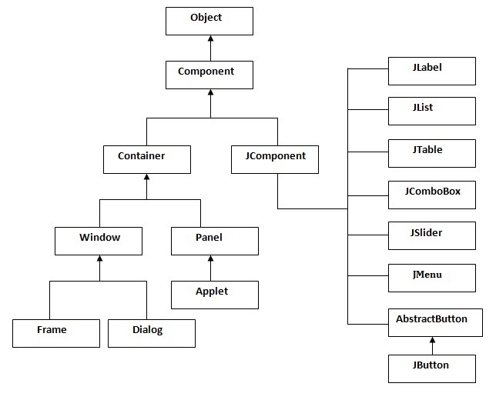

Commonly used Methods of Component class
The methods of Component class are widely used in java swing that are given below.
Method | Description
public void add(Component c) | add a component on another component.
public void setSize(int width,int height) | sets size of the component.
public void setLayout(LayoutManager m) | sets the layout manager for the component.
public void setVisible(boolean b) | sets the visibility of the component. It is by default false.

Java Swing Examples

Example 1:
import java.awt.*;
import java.awt.event.*;
import javax.swing.*;
public class Log extends JApplet{
public static void main(String[] args) {
JFrame f=new JFrame();//creating instance of JFrame
JLabel n=new JLabel("Username: ");
JLabel m=new JLabel("Password: ");
JTextField t=new JTextField(10);
JPasswordField p=new JPasswordField(10);
JButton b=new JButton("Login");//creating instance of JButton
JButton c=new JButton("Cancel");
f.setTitle("Login Interface");
b.setBounds(130,100,100, 40);//x axis, y axis, width, height
c.setBounds(130,100,100, 40);//x axis, y axis, width, height
f.add(n);
f.add(t);
f.add(m);
f.add(p);
f.add(b);//adding button in JFrame
f.add(c );
f.setLayout(new GridLayout(4,2));
f.setSize(250,150);//400 width and 500 height
f.setVisible(true);//making the frame visible
}
}
- JPanel is Swing’s version of the AWT class Panel and uses the same default layout, FlowLayout. JPanel is descended directly from JComponent.
- JFrame is Swing’s version of Frame and is descended directly from that class. The components added to the frame are referred to as its contents; these are managed by the contentPane. To add a component to a JFrame, we must use its contentPane instead.
- JInternalFrame is confined to a visible area of a container it is placed in. It can be iconified , maximized and layered.
- JWindow is Swing’s version of Window and is descended directly from that class. Like Window, it uses BorderLayout by default.
- JDialog is Swing’s version of Dialog and is descended directly from that class. Like Dialog, it uses BorderLayout by default. Like JFrame and JWindow,
- JDialog contains a rootPane hierarchy including a contentPane, and it allows layered and glass panes. All dialogs are modal, which means the current thread is blocked until user interaction with it has been completed.
JDialog class is intended as the basis for creating custom dialogs; however, some of the most common dialogs are provided through static methods in the class JOptionPane.
- JLabel, descended from JComponent, is used to create text labels. The abstract class AbstractButton extends class JComponent and provides a foundation for a family of button classes, includingJButton.
- JTextField allows editing of a single line of text. New features include the ability to justify the text left, right, or center, and to set the text’s font.
- JPasswordField (a direct subclass of JTextField) you can suppress the display of input. Each character entered can be replaced by an echo character. This allows confidential input for passwords, for example. By default, the echo character is the asterisk, *.
- JTextArea allows editing of multiple lines of text. JTextArea can be used in conjunction with class JScrollPane to achieve scrolling. The underlying JScrollPane can be forced to always or never have either the vertical or horizontal scrollbar;
- JButton is a component the user clicks to trigger a specific action.
- JRadioButton is similar to JCheckbox, except for the default icon for each class. A set of radio buttons can be associated as a group in which only one button at a time can be selected.
- JCheckBox is not a member of a checkbox group. A checkbox can be selected and deselected, and it also displays its current state.
- JComboBox is like a drop down box. You can click a drop-down arrow and select an option from a list. For example, when the component has focus, pressing a key that corresponds to the first character in some entry’s name selects that entry. A vertical scrollbar is used for longer lists.
- JList ;provides a scrollable set of items from which one or more may be selected. JList can be populated from an Array or Vector. JList does not support scrolling directly, instead, the list must be associated with a scrollpane. The view port used by the scroll pane can also have a user-defined border. JList actions are handled using ListSelectionListener.
- JTabbedPane contains a tab that can have a tool tip and a mnemonic, and it can display both text and an image.
- JToolbar contains a number of components whose type is usually some kind of button which can also include separators to group related components within the toolbar.
- FlowLayout when used arranges swing components from left to right until there’s no more space available. Then it begins a new row below it and moves from left to right again. Each component in a FlowLayout gets as much space as it needs and no more.
- BorderLayout places swing components in the North, South, East, West and center of a container. You can add horizontal and vertical gaps between the areas.
- GridLayout is a layout manager that lays out a container’s components in a rectangular grid. The container is divided into equal-sized rectangles, and one component is placed in each rectangle.
- GridBagLayout is a layout manager that lays out a container’s components in a grid of cells with each component occupying one or more cells, called its display area. The display area aligns components vertically and horizontally, without requiring that the components be of the same size.
- JMenubar can contain several JMenu’s. Each of the JMenu’s can contain a series of JMenuItem ‘s that you can select. Swing provides support for pull-down and popup menus.
- Scrollable JPopupMenu is a scrollable popup menu that can be used whenever we have so many items in a popup menu that exceeds the screen visible height.

Event and Listener (Java Event Handling)
Changing the state of an object is known as an event. For example, click on button, dragging mouse etc. The java.awt.event package provides many event classes and Listener interfaces for event handling.

Event classes and Listener interfaces:
Event Classes | Listener Interfaces
ActionEvent | ActionListener
MouseEvent | MouseListener and MouseMotionListener
MouseWheelEvent | MouseWheelListener
KeyEvent | KeyListener
ItemEvent | ItemListener
TextEvent | TextListener
AdjustmentEvent | AdjustmentListener
WindowEvent | WindowListener
ComponentEvent | ComponentListener
ContainerEvent | ContainerListener
FocusEvent | FocusListener

Steps to perform Event Handling
Following steps are required to perform event handling:
- Implement the Listener interface and overrides its methods
- Register the component with the Listener
For registering the component with the Listener, many classes provide the registration methods. For example:
- Button
  - public void addActionListener(ActionListener a){}
- MenuItem
  - public void addActionListener(ActionListener a){}
- TextField
  - public void addActionListener(ActionListener a){}
  - public void addTextListener(TextListener a){}
- TextArea
  - public void addTextListener(TextListener a){}
- Checkbox
  - public void addItemListener(ItemListener a){}
- Choice
  - public void addItemListener(ItemListener a){}
- List
  - public void addActionListener(ActionListener a){}
  - public void addItemListener(ItemListener a){}

EventHandling Codes:
We can put the event handling code into one of the following places:
- Same class
- Other class
- Annonymous class
Java Swing Event Listeners Example1
import javax.swing.*;
import java.awt.*;
import java.awt.event.*;
class MyEvent extends JApplet implements ActionListener{
JTextField tf;
MyEvent(){
JFrame f=new JFrame("Event Listtener");
tf=new JTextField(10);
tf.setBounds(60,50,170,20);
JButton b=new JButton("Clik me");
JButton k=new JButton("Reset");
b.setBounds(100,120,80,30);
b.addActionListener(this);
k.addActionListener(this);
f.add(b);f.add(tf);f.add(k);
f.setSize(300,300);
f.setLayout(new FlowLayout());
f.setVisible(true);
}
public void actionPerformed(ActionEvent e){
if(e.getActionCommand()=="Clik me") {
tf.setText("Welcome");
}
else if (e.getActionCommand()=="Reset") {
tf.setText("");
}
}
public static void main(String args[]){
MyEvent me=new MyEvent();
}
}
Example 2: Menu and MenuItems with Listeners
import java.awt.*;
import java.awt.event.*;
import javax.swing.*;
class MenuItemActionListenerTest extends JApplet implements ActionListener{
JFrame myFrame = null;
public static void main(String[] a) {
MenuItemActionListenerTest mat=new MenuItemActionListenerTest();
mat.test();
}
private void test() {
myFrame = new JFrame("Menu Listener Test");
myFrame.setDefaultCloseOperation(JFrame.EXIT_ON_CLOSE);
myFrame.setBounds(50,50,250,150);
myFrame.setContentPane(new JDesktopPane());
JMenuBar myMenuBar = new JMenuBar();
JMenu file = new JMenu("File");
JMenu color = new JMenu("Color");
JMenu option = new JMenu("Option");
JMenu help= new JMenu("Help");
JMenuItem fitem1=new JMenuItem("Open");
JMenuItem fitem2=new JMenuItem("Close");
JMenuItem fitem3=new JMenuItem("Exit");
fitem1.addActionListener(this);
fitem2.addActionListener(this);
fitem3.addActionListener(this);
file.add(fitem1);
file.add(fitem2);
file.add(fitem3);
myMenuBar.add(file);
JMenuItem citem1=new JMenuItem("Red");
JMenuItem citem2=new JMenuItem("Green");
JMenuItem citem3=new JMenuItem("Blue");
citem1.addActionListener(this);
citem2.addActionListener(this);
citem3.addActionListener(this);
color.add(citem1);
color.add(citem2);
color.add(citem3);
myMenuBar.add(color);
JMenuItem oitem1=new JMenuItem("Sound");
JMenuItem oitem2=new JMenuItem("Auto Save");
oitem1.addActionListener(this);
oitem2.addActionListener(this);
option.add(oitem1);
option.add(oitem2);
myMenuBar.add(option);
JMenuItem hitem=new JMenuItem("Help");
hitem.addActionListener(this);
help.add(hitem);
myMenuBar.add(help);
myFrame.setJMenuBar(myMenuBar);
myFrame.setVisible(true);
}
public void actionPerformed(ActionEvent e) {
System.out.println("Item clicked: "+e.getActionCommand());
}
}

Java Database Connectivity (JDBC)
JDBC API is a Java API that can access any kind of tabular data, especially data stored in a Relational Database. JDBC works with Java on a variety of platforms, such as Windows, Mac OS, and the various versions of UNIX. JDBC API uses jdbc drivers to connect with the database. 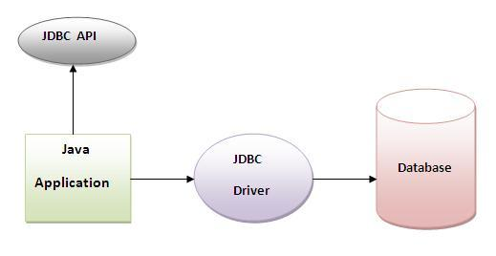
The JDBC library includes APIs for each of the tasks mentioned below that are commonly associated with database usage.
- Making a connection to a database.
- Creating SQL statements.
- Executing SQL queries in the database.
- Viewing & Modifying the resulting records.
Fundamentally, JDBC is a specification that provides a complete set of interfaces that allows for portable access to an underlying database. Java can be used to write different types of executables, such as −
- Java Applications
- Java Applets
- Java Servlets
- Java ServerPages (JSPs)
- Enterprise JavaBeans (EJBs).
All of these different executables are able to use a JDBC driver to access a database, and take advantage of the stored data.
JDBC provides the same capabilities as ODBC, allowing Java programs to contain database-independent code.

JDBC Architecture

Following is the architectural diagram, which shows the location of the driver manager with respect to the JDBC drivers and the Java application:

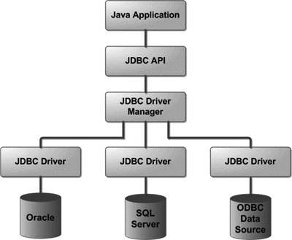

Common JDBC Components
The JDBC API provides the following interfaces and classes −
- DriverManager: This class manages a list of database drivers. Matches connection requests from the java application with the proper database driver using communication sub protocol. The first driver that recognizes a certain subprotocol under JDBC will be used to establish a database Connection.
- Driver: This interface handles the communications with the database server. You will interact directly with Driver objects very rarely. Instead, you use DriverManager objects, which manages objects of this type. It also abstracts the details associated with working with Driver objects.
- Connection: This interface with all methods for contacting a database. The connection object represents communication context, i.e., all communication with database is through connection object only.
- Statement: You use objects created from this interface to submit the SQL statements to the database. Some derived interfaces accept parameters in addition to executing stored procedures.
- ResultSet: These objects hold data retrieved from a database after you execute an SQL query using Statement objects. It acts as an iterator to allow you to move through its data.
- SQLException: This class handles any errors that occur in a database application.

5 Steps to connect to the database in java
There are 5 steps to connect any java application with the database in java using JDBC. They are as follows:
- Register the driver class
- Creating connection
- Creating statement
- Executing queries
- Closing connection

There are 5 steps to connect any java application with the database in java using JDBC. They are as follows:
- Register the driver class
- Creating connection
- Creating statement
- Executing queries
- Closing connection

Using Databases with Java
Java provides support for industry-standard databases that respond to SQL statements via JDBC (Java Database Connectivity).The JDBC-ODBC bridge allows Java to interface with any ODBC database. However, this connection is somewhat inefficient, since two drivers are required to process the database access. Many database suppliers such as Informix, Oracle and Sybase provide JDBC interfaces that communicate directly with the database server. However, these are not part of the Java language and must be obtained from the vendor.
From a programming point of view, all databases are treated alike. This course uses a connection to Microsoft Access to illustrate database concepts, but, other than the setting up of the URL which implements the database connection, all databases will behave in the same way.
To use Microsoft Access with Java, you will first have to set up an ODBC connection as below. Other databases may need similar steps to create the connection.
- From the control panel, system and security, administrative tools, select ODBC Data Sources
- From the User DSN tab, choose Add
- This will bring up the Create new Data Source window.
- Choose Microsoft Access and click Finish
- This will bring up the Microsoft Access setup window.
- Enter a data source name (DSN) and description. The name will be used to refer to the database when setting up an URL for the connection.
- In the Database panel, choose Select. This will bring up a file browser from which the database can be selected. Select the database and click OK
- From the Access setup screen, click OK
- From the Data Source Administrator screen, click OK
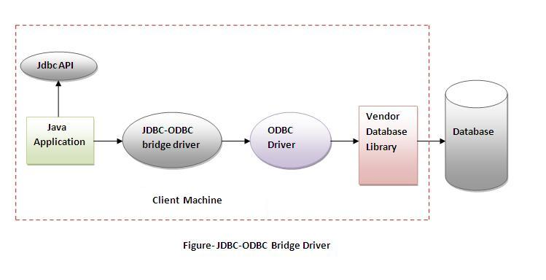
The following sample program retrieves the account number, surname and first names for all rows in a Customer table in a database pointed to by a DSN of JavaCourse
import java.sql.*; //Importing sql Package
public class MyJavaAccessDB {
public static void main(String[] args) throws SQLException {
String url = "jdbc:odbc:MyDSN";
try {
String query="insert into Customer (FirstName,LastName,Location,Telephone,Email)//SQL Insert Query
values('Silas','Majyambere','Kigali','0783437123','ms@gmail.com')";
String query1="insert into Customer (FirstName,LastName,Location,Telephone,Email)
values('Thadee','Gatera','Butare','0783437145','gt@gmail.com')";
String query2 = "select * from Customer";//SQL Select Query
Class.forName("sun.jdbc.odbc.JdbcOdbcDriver");//Loading Driver
Connection con =DriverManager.getConnection(url, "",""); //Opening a Connection
Statement stmt = con.createStatement();//creating a Statement
stmt.executeUpdate(query);//Executing Insert Query Statement
stmt.executeUpdate(query1);
ResultSet rs = stmt.executeQuery(query2);//Executing Select Query Statement
while (rs.next()) { //Checking the Number of Rows of Records
System.out.println(rs.getString("FirstName")+" "+rs.getString("LastName")+" "+ rs.getInt("Telephone")+" "+ rs.getString("Email"));//Displaying Records from Database
}
Con.close();//closing a connection
}
catch(Exception ex) { // try and catch exception handling must be used
ex.printStackTrace();//Method used to print error messages especially run-time errors.
}
}
}
Notes:
- Programs that use databases must import the java.sql package
- An url is needed to point to the DSN set up in the previous step. For this to work, we would need
to have set up a DSN called JavaCourse to point to the database containing the Customer table.
String url = "jdbc:odbc:JavaCourse";
- The statement below is used to find the correct class to deal with the connection. This statement
may be different when you are using JDBC connectivity supplied by a databadse vendor.
Class.forName("sun.jdbc.odbc.JdbcOdbcDriver");
- The following statement creates a connection to the database
Connection con =DriverManager.getConnection(url, "","");
- A Statement object is needed to enable your programs to run SQL statements.
Statement stmt = con.createStatement();
- A ResultSet object stores the result of running an SQL statement. It has a next method that allows
you to page through the results one row at a time. It also provides get methods to allow you to
access the actual data.
ResultSet rs = stmt.executeQuery(query);
- Any programs that deal with the java.sql classes must check for SQLExceptions and deal with them.
Connecting Java to Mysql Database
In order to connect java to Mysql Database you need to install Mysql-Connector/J which is free downloadable from Mysql website. After you download Mysql-Connector/J you unzip it and copy the file named mysql-connector-java-5.1.38-bin to the location C:\Program Files\Java\jdk1.7.0_02\jre\lib\ext. Sometimes Java is refusing to paste into this folder, for this you can change security permission on this folder to full access.

Java Mysql Example
import java.sql.*;
public class MyMysqlDB{
public static void main(String args[]) {
try {
String driver="com.mysql.jdbc.Driver"; //JDBC Driver for Mysql
String url="jdbc:mysql://localhost:3306/";//Path to Mysql Database running on Port 3306
String user="root";
String pass="";
String db="CS2";
Class.forName(driver).newInstance();//Loading JDBC Driver for Mysql into the memory
Connection con=DriverManager.getConnection(url+db,user,pass);//Creating a Connection Mysql Database
Statement st=con.createStatement();//Creating Statement for SQL Queries
String q="insert into Student (Fname,LName,Class,Tel,Email)values
('Charles','Mugabo','CS3',0786765566,'cm@gmail.com')";
String query="select * from Student";
st.executeUpdate(q);
ResultSet rs=st.executeQuery(query);
while(rs.next()) {
System.out.println(rs.getInt("StId")+"\t"+rs.getString("FName")+"\t"+rs.getString("LName"));
}
}
catch(Exception e) {
e.printStackTrace();
}
}
}

Java Networking and Socket Programming
The term network programming refers to writing programs that execute across multiple devices (computers), in which the devices are all connected to each other using a network.
The java.net package of the J2SE APIs contains a collection of classes and interfaces that provide the low-level communication details, allowing you to write programs that focus on solving the problem at hand.
The java.net package provides support for the two common network protocols:
- TCP: TCP stands for Transmission Control Protocol, which allows for reliable communication between two applications. TCP is typically used over the Internet Protocol, which is referred to as TCP/IP.
- UDP: UDP stands for User Datagram Protocol, a connection-less protocol that allows for packets of data to be transmitted between applications.
The widely used java networking terminologies are given below:
- IP Address
- Protocol
- Port Number
- MAC Address
- Connection-oriented and connection-less protocol
- Socket

1) IP Address
IP address is a unique number assigned to a node of a network e.g. 192.168.0.1 . It is composed of octets that range from 0 to 255.
It is a logical address that can be changed.

2) Protocol
A protocol is a set of rules basically that is followed for communication. For example:
- TCP
- FTP
- Telnet
- SMTP
- POP etc.

3) Port Number
The port number is used to uniquely identify different applications. It acts as a communication endpoint between applications.
The port number is associated with the IP address for communication between two applications.

4) MAC Address
MAC (Media Access Control) Address is a unique identifier of NIC (Network Interface Controller). A network node can have multiple NIC but each with unique MAC.

5) Connection-oriented and connection-less protocol
In connection-oriented protocol, acknowledgement is sent by the receiver. So it is reliable but slow. The example of connection-oriented protocol is TCP. But, in connection-less protocol, acknowledgement is not sent by the receiver. So it is not reliable but fast. The example of connection-less protocol is UDP.

6) Socket
A socket is an endpoint between two way communications.
The java.net Package
The java.net package contains the classes and interfaces required for networking. Some important classes are MulticastSocket, ContentHandler, URLServerSocket, Socket, InetAddress, URLConnection, DatagramSocket, and DatagramPacket.

InetAddress
This class encapsulates the numerical IP address and the domain name for the address. Factory methods of a class allow you to call the method without referencing the object. The factory methods of this class are:
- getLocalHost() method: Returns the name of the local computer
- getByName() method: Returns the address by the Domain name
- getAllByName() method: Returns all the addresses by their domain name
The instance methods of a class are methods that can be called from an object only. The instance methods for the class are:
- getAddress() method: Returns a four-element byte array that represents the object’s IP address in network byte order
- getHostAddress() method: Returns the host address
- getHostName() method: Returns the hostname that is associated with the host address.

Java Network Example: Displaying Host IP Address and Host Name
import java.net.*;
public class JavaNet1 {
public static void main(String[] args) throws Exception {
InetAddress addr = InetAddress.getLocalHost();
System.out.println("Local HostAddress: "+addr.getHostAddress());
String hostname = addr.getHostName();
System.out.println("Local host name: "+hostname);
}
}

URL Class and its Methods
The java.net.URL class represents a URL and has complete set of methods to manipulate URL in Java.
The URL class contains many methods for accessing the various parts of the URL being represented. Some of the methods in the URL class include the following:
SN | Methods with Description
1 | public String getPath()  Returns the path of the URL.
2 | public String getQuery()  Returns the query part of the URL.
3 | public String getAuthority()  Returns the authority of the URL.
4 | public int getPort()  Returns the port of the URL.
5 | public int getDefaultPort()  Returns the default port for the protocol of the URL.
6 | public String getProtocol()  Returns the protocol of the URL.
7 | public String getHost()  Returns the host of the URL.
8 | public String getHost()  Returns the host of the URL.
9 | public String getFile()  Returns the filename of the URL.
10 | public String getRef()  Returns the reference part of the URL.

URL Class Example
import java.net.*;
import java.io.*;
public class JavaNet2 {
public static void main(String [] args) {
try {
URL url = new URL("http://cst.ur.ac.rw/timetable/t_table/full/");
System.out.println("URL is " + url.toString());
System.out.println("protocol is " + url.getProtocol());
System.out.println("authority is " + url.getAuthority());
System.out.println("file name is " + url.getFile());
System.out.println("host is " + url.getHost());
System.out.println("path is " + url.getPath());
System.out.println("default port is " + url.getDefaultPort());
}
catch(IOException e) {
e.printStackTrace();
}
}
}

Socket Programming:
Sockets provide the communication mechanism between two computers using TCP. A client program creates a socket on its end of the communication and attempts to connect that socket to a server.
When the connection is made, the server creates a socket object on its end of the communication. The client and server can now communicate by writing to and reading from the socket.
The java.net.Socket class represents a socket, and the java.net.ServerSocket class provides a mechanism for the server program to listen for clients and establish connections with them.
The following steps occur when establishing a TCP connection between two computers using sockets:
- The server instantiates a ServerSocket object, denoting which port number communication is to occur on.
- The server invokes the accept() method of the ServerSocket class. This method waits until a client connects to the server on the given port.
- After the server is waiting, a client instantiates a Socket object, specifying the server name and port number to connect to.
- The constructor of the Socket class attempts to connect the client to the specified server and port number. If communication is established, the client now has a Socket object capable of communicating with the server.
- On the server side, the accept() method returns a reference to a new socket on the server that is connected to the client's socket.
After the connections are established, communication can occur using I/O streams. Each socket has both an OutputStream and an InputStream. The client's OutputStream is connected to the server's InputStream, and the client's InputStream is connected to the server's OutputStream.
TCP is a twoway communication protocol, so data can be sent across both streams at the same time. There are following usefull classes providing complete set of methods to implement sockets.
Socket Programming Example:
Let us starting by writing Socket Server Code. Save this as MySocketServer.java
import java.io.*;
import java.net.*;
public class MySocketServer{
public static void main(String args[]) throws IOException {
ServerSocket server=new ServerSocket(1235);
System.out.println("waiting for request from client");
Socket client=server.accept();
System.out.println("request accepted");
BufferedReader br=new BufferedReader(new InputStreamReader(client.getInputStream()));
while(true){
String st=br.readLine();
if(st.equals("exit")==true){
System.out.println("connection with client is lost....");
System.exit(1);
}
PrintStream ps=new PrintStream(client.getOutputStream());
ps.println(st);
}
}
}
For the client Socket Program, you open a new JCreator because both Server and Client Programs cannot run in the same JCreator. Save Client Socket Program as MySocketClient.java
import java.net.*;
import java.io.*;
public class MySocketClient {
public static void main(String args[]) throws IOException
{
System.out.println("sending request to server....");
Socket client=new Socket("127.0.0.1",1235);
System.out.println("successfully conneted");
BufferedReader br1=new BufferedReader(new InputStreamReader(System.in));
PrintStream ps=new PrintStream(client.getOutputStream());
BufferedReader br=new BufferedReader(new InputStreamReader(client.getInputStream()));
while(true){
System.out.println("Write Data to Send to Socket Server: ");
String s=br1.readLine();
ps.println(s);
if(s.equals("exit"))
{
System.exit(1);
}
String st=br.readLine();
System.out.println("data returned by the server: ");
System.out.println(st);
}
}
}
Note that Socket Server and Socket Client must run on the same port in order to communicate.
Java Servlet
Java Servlet is the one of the most important Java technologies. It is the simplest model to build a complete Java J2EE Web Application. Furthermore, even for complex J2EE Web Application that uses Struts, Spring, EJB and etc, they are still using Servlet for certain purposes such as Servlet Filter, Listener and etc. Thus, it is just a good idea for you to have well-built understanding of Java Servlet. At the completion of this part, you are expected to comprehend the concept of the Java Servlet, be familiar with the ways to create Java Servlet using NetBeans 7.0, differences between POST and GET and should be ready to go to the next level.

Creating First Servlet Application using Netbeans IDE
In the last lesson we created our first Servlet Application but without using any IDE. An IDE is Integrated Development Environment, and it makes creating applications a lot easier. We will learn how to create Servlet applications on NetBeans IDE

Steps to Create Servlet Application in Netbeans IDE
To create a servlet application in Netbeans IDE, you will need to follow the following (simple) steps :
- Open Netbeans IDE, Select File -> New Project
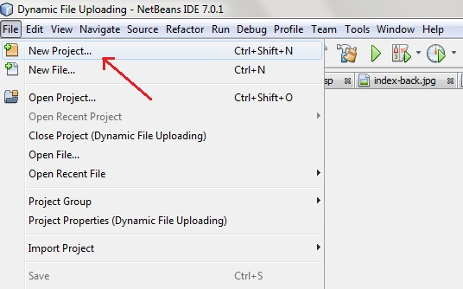
- Select Java Web -> Web Application, then click on Next,
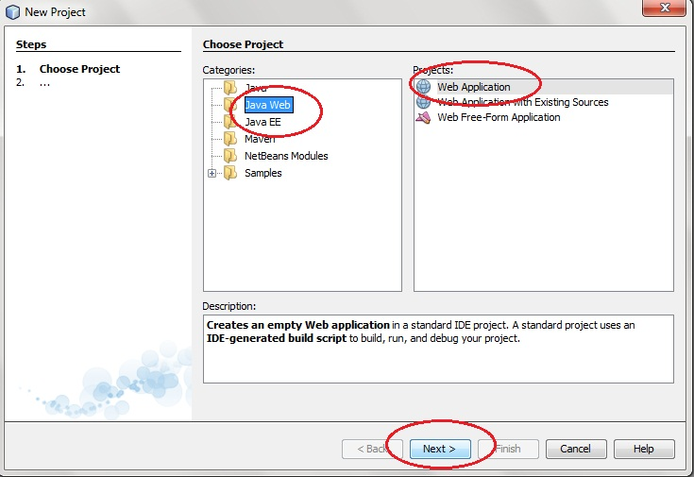
- Give a name to your project and click on Next,
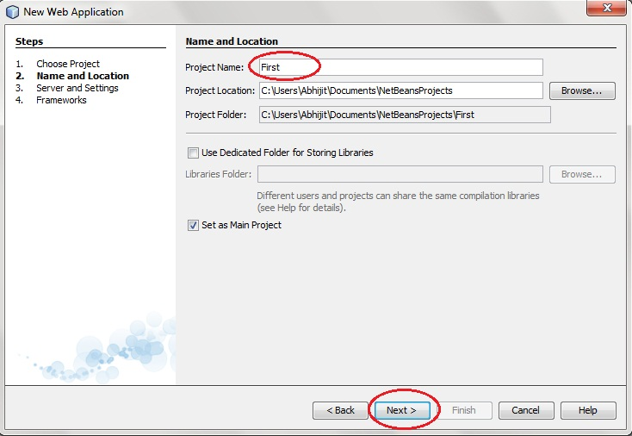
- and then, Click Finish
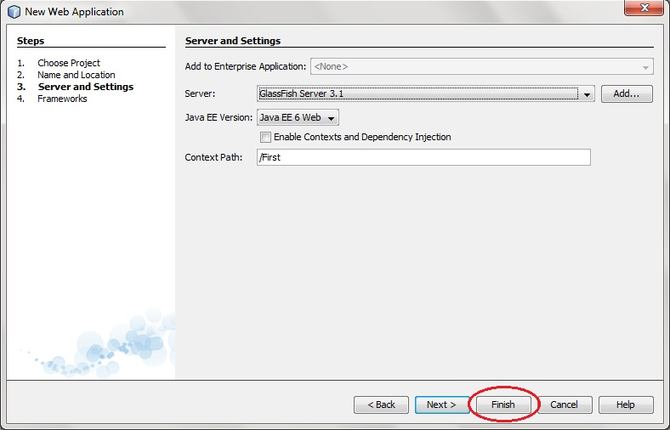

- The complete directory structure required for the Servlet Application will be created automatically by the IDE.
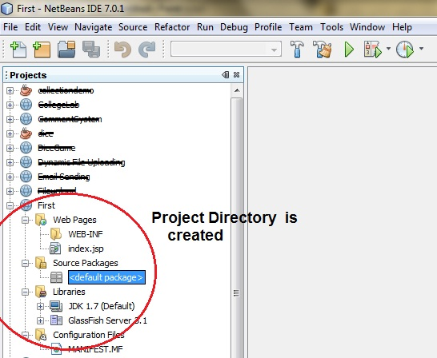
- To create a Servlet, open Source Package, right click on default packages -> New -> Servlet.
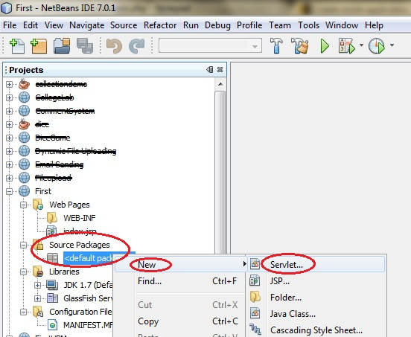
- Give a Name to your Servlet class file,
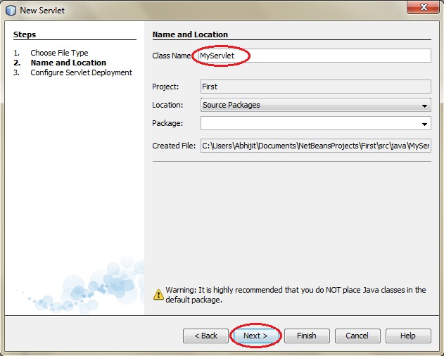
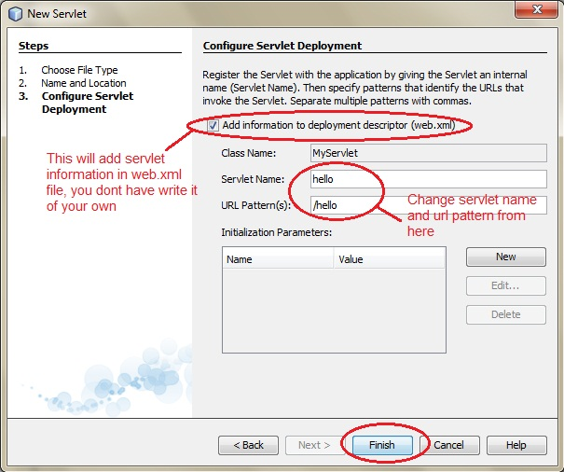
- Now, your Servlet class is ready, and you just need to change the method definitions and you will good to go.
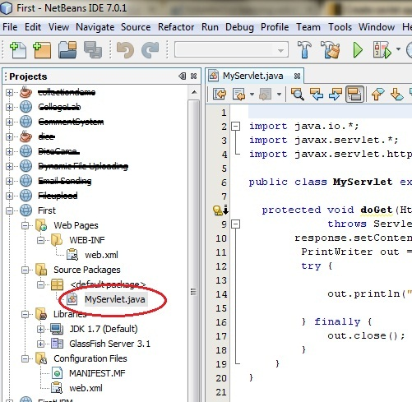
- Write some code inside your Servlet class.
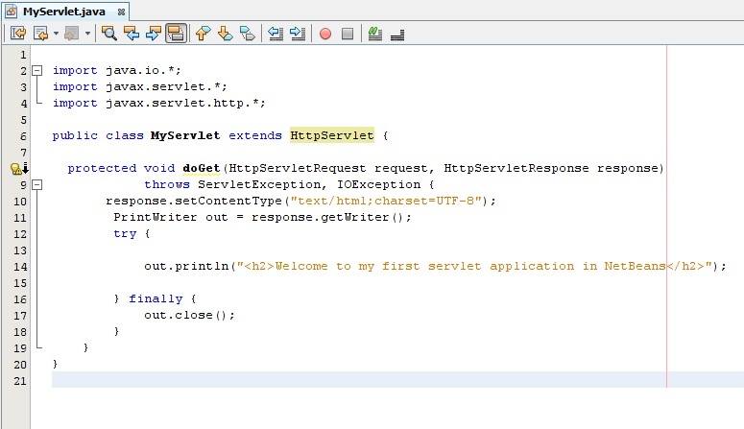
- Create an HTML file, right click on Web Pages -> New -> HTML
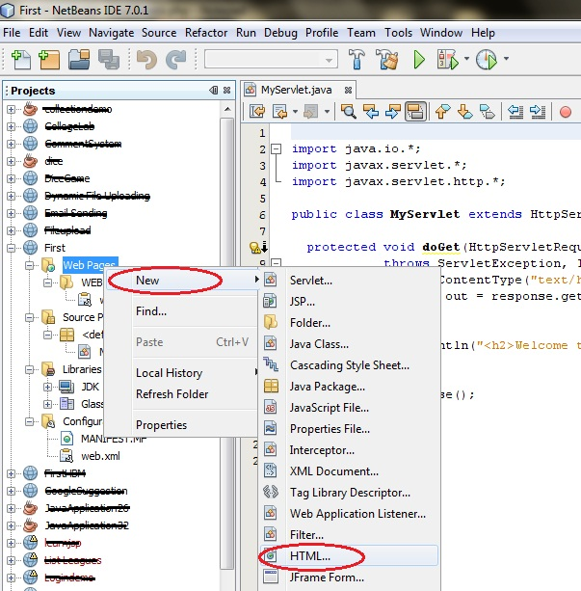
- Give it a name. We recommend you to name it index, because browser will always pick up theindex.html file automatically from a directory. Index file is read as the first page of the web application.
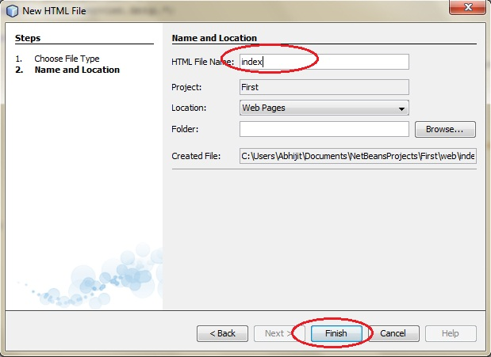
- Write some code inside your HTML file. We have created a hyperlink to our Servlet in our HTML file.
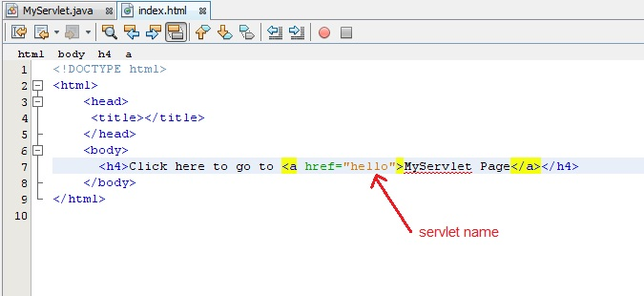
- Edit web.xml file. In the web.xml file you can see, we have specified the url-pattern and the servlet-name, this means when hello url is accessed our Servlet file will be executed.
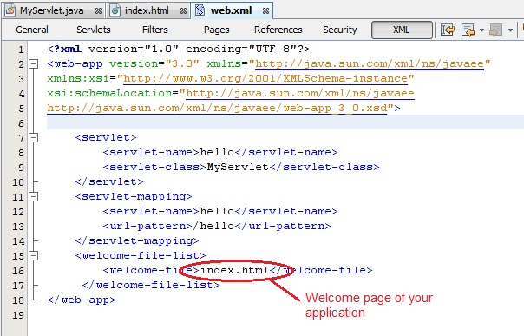
- Run your application, right click on your Project and select Run
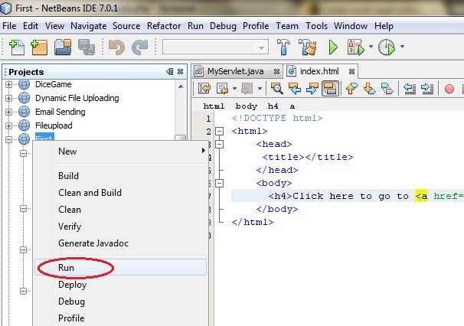
- Click on the link created, to open your Servlet.
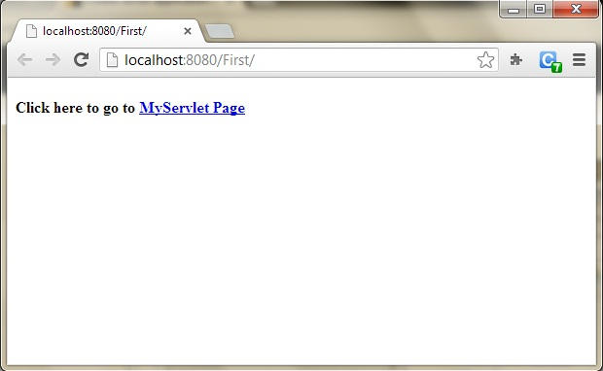
- Hurray! Our First Servlet class is running.
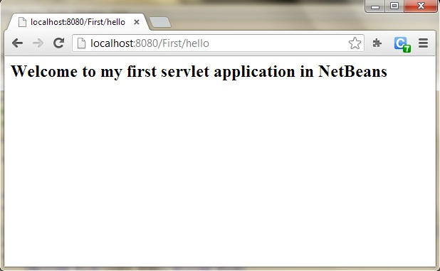

Servlet Mysql Example:

First you create a Servlet File in your Servlet Netbeans Project and name it MysqlConnect.java then you edit this Sevlet Code to the following:
//MySQLConnect.java
import java.io.*;
import javax.servlet.http.*;
import javax.servlet.*;
import java.sql.*;

/**
* Servlet implementation class MySQLConnect
*/

public class MySQLConnect extends HttpServlet {

//private static final long serialVersionUID = 1L;

@Override
protected void doPost(HttpServletRequest request, HttpServletResponse response) throws ServletException, IOException {
response.setContentType("text/html");
PrintWriter out = response.getWriter();
String user = request.getParameter("user");
String pass = request.getParameter("pass");
try {
Class.forName("com.mysql.jdbc.Driver");
Connection conn = DriverManager.getConnection("jdbc:mysql://localhost:3306/javademo", "root", "");
PreparedStatement pst = conn.prepareStatement("Select user,pass from login where user=? And pass=?");
pst.setString(1, user);
pst.setString(2, pass);
ResultSet rs = pst.executeQuery();
if (rs.next()) {
out.println("Correct login credentials");
}
else {
out.println("Incorrect login credentials");
}
}
catch (ClassNotFoundException | SQLException e) {
e.printStackTrace();
}
}
}
NB: Make sure Mysql Connector/J is configured and Glassfish Server is running.
The next step is create your HTML File and call it index.html, you create it in your web pages and edit it as follows:

<!DOCTYPE html>
<html>
<head>
<title>Login form</title>
</head>
<body>
<form method="post" action="MySQLConnect">
Username :<input type="text" name="user" /><br/><br/>
Password :<input type="password" name="pass" /><br/><br/>
<input type="submit" value="Login" />
</form>
</body>
</html>

The final step is to create your XML File and name it web.xml and edit it as follows:
<?xml version="1.0" encoding="UTF-8"?>
<web-app version="3.1" xmlns="http://xmlns.jcp.org/xml/ns/javaee" xmlns:xsi="http://www.w3.org/2001/XMLSchema-instance" xsi:schemaLocation="http://xmlns.jcp.org/xml/ns/javaee http://xmlns.jcp.org/xml/ns/javaee/web-app_3_1.xsd">
<servlet>
<servlet-name>MySQLConnect</servlet-name>
<servlet-class>MySQLConnect</servlet-class>
</servlet>
<servlet-mapping>
<servlet-name>MySQLConnect</servlet-name>
<url-pattern>/MySQLConnect</url-pattern>
</servlet-mapping>
<session-config>
<session-timeout>30</session-timeout>
</session-config>
</web-app>

Java Server Pages
Java Server Pages (JSP) is a technology that helps software developers create dynamically generated web pages based on HTML, XML, or other document types. Released in 1999 by Sun Microsystems, JSP is similar to PHP and ASP, but it uses the Java programming language.
JavaServer Pages (JSP) is a server-side programming technology that enables the creation of dynamic, platform-independent method for building Web-based applications. JSP have access to the entire family of Java APIs, including the JDBC API to access enterprise databases. This tutorial will teach you how to use Java Server Pages to develop your web applications in simple and easy steps.
JavaServer Pages (JSP) is a technology for developing web pages that support dynamic content which helps developers insert java code in HTML pages by making use of special JSP tags, most of which start with <% and end with %>.
A JavaServer Pages component is a type of Java servlet that is designed to fulfill the role of a user interface for a Java web application. Web developers write JSPs as text files that combine HTML or XHTML code, XML elements, and embedded JSP actions and commands.
Using JSP, you can collect input from users through web page forms, present records from a database or another source, and create web pages dynamically.
JSP tags can be used for a variety of purposes, such as retrieving information from a database or registering user preferences, accessing JavaBeans components, passing control between pages and sharing information between requests, pages etc.
JSP Example1:
<%-- JSP comment --%>
<HTML>
<HEAD>
<TITLE>MESSAGE</TITLE>
</HEAD>
<BODY>
<%out.print("Hello, Sample JSP code");%>
</BODY>
</HTML>

JSP Example 2:
Your HTML Code
<%--
Document : validate
Created on : 21 April, 2016, 7:50:26 AM
Author : Silas
--%>
<%@page contentType="text/html" pageEncoding="UTF-8"%>
<!DOCTYPE html>
<html>
<head>
<meta http-equiv="Content-Type" content="text/html; charset=UTF-8">
<title>Login Demo with JSP</title>
</head>
<body>
<form method="post" action="validate.jsp">
<center>
<table border="1" cellpadding="5" cellspacing="2">
<thead>
<tr>
<th colspan="2">Login Here</th>
</tr>
</thead>
<tbody>
<tr>
<td>Username</td>
<td><input type="text" name="username" required/></td>
</tr>
<tr>
<td>Password</td>
<td><input type="password" name="password" required/></td>
</tr>
<tr>
<td colspan="2" align="center"><input type="submit" value="Login" />
&nbsp;&nbsp;
<input type="reset" value="Reset" />
</td>
</tr>
</tbody>
</table>
</center>
</form>
</body>
</html>

Your JSP Code:
<%--
Document : validate
Created on : 21 April, 2016, 7:50:26 AM
Author : Silas
--%>

<%@ page import ="java.sql.*" %>
<%
try{
String username = request.getParameter("username");
String password = request.getParameter("password");
Class.forName("com.mysql.jdbc.Driver"); // MySQL database connection
Connection conn = DriverManager.getConnection("jdbc:mysql://localhost:3306/javademo?" + "user=root&password=");
PreparedStatement pst = conn.prepareStatement("Select user,pass from login where user=? and pass=?");
pst.setString(1, username);
pst.setString(2, password);
ResultSet rs = pst.executeQuery();
if(rs.next())
out.println("Valid login credentials");
else
out.println("Invalid login credentials");
}
catch(Exception e){
out.println("Something went wrong !! Please try again");
}
%>

