Mean for Cases And Deaths :

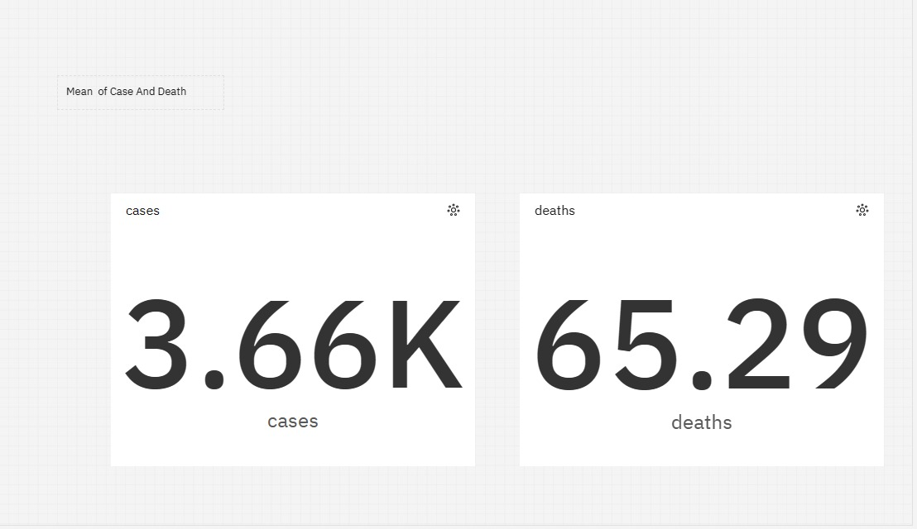

Standard Deviation For Cases And Deaths:

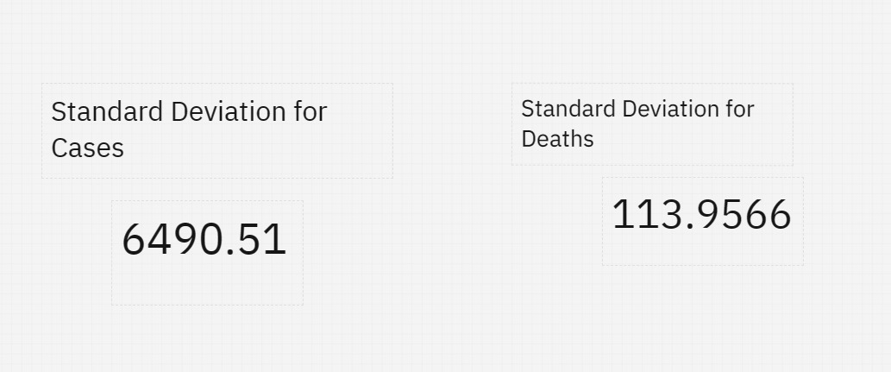

Relationship Between Deaths And Cases:

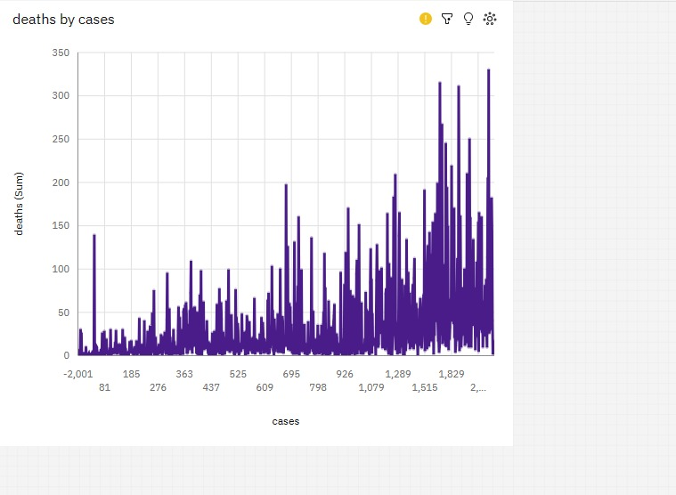

Relationship Between Days And Cases:

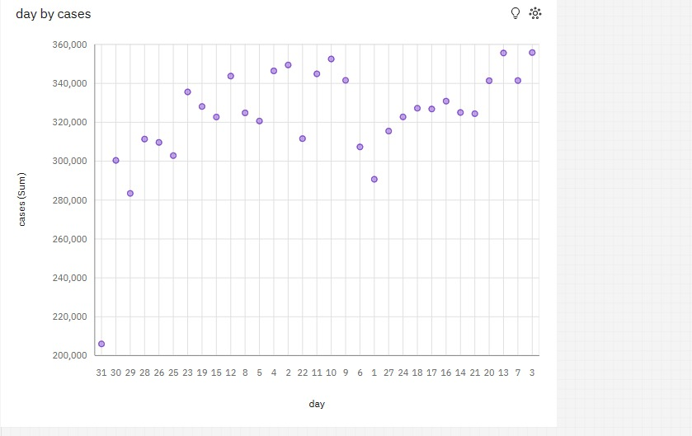

Relationship Between Cases And Months:

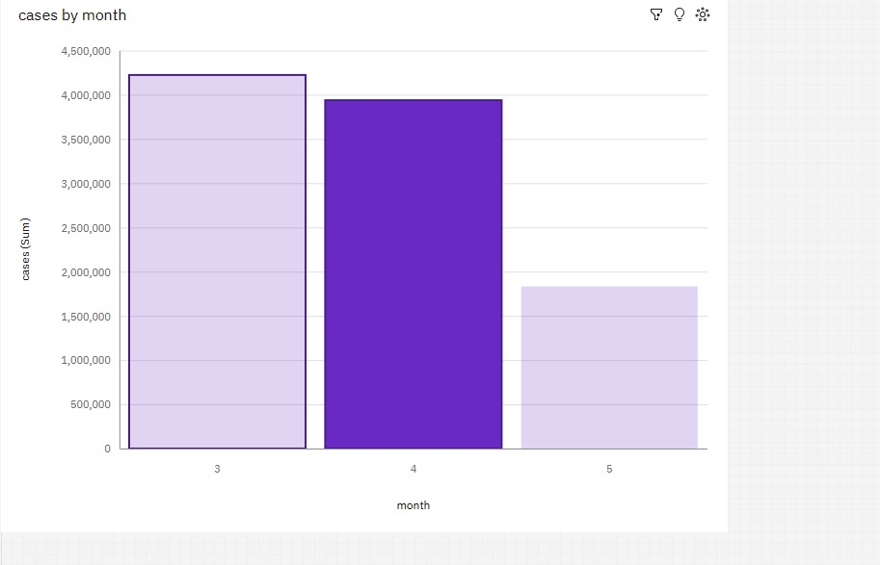

Relationship Between Cases And Year:

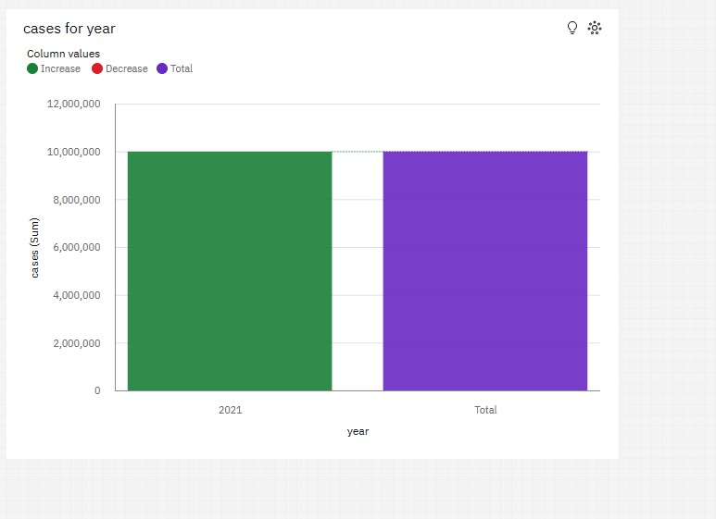

Relationship Between Days And Deaths:

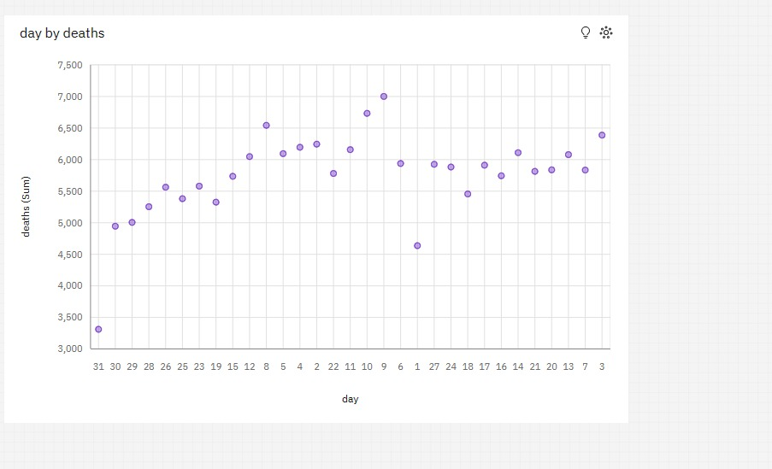

Relationship Between Months And Deaths:

