**Covid - 19 Cases Analysis**

Analyzing COVID-19 cases in a data analytics project is a valuable endeavor that can provide insights into the spread and impact of the virus. Here's a step-by-step guide on how to approach such a project:

**Project Objectives:**

1. **Data Collection:**

Gather data from reliable sources, such as government health departments, the World Health Organization (WHO), or reputable research institutions.

Data sources should include information on the number of cases, deaths, recoveries, testing, vaccination rates, and other relevant variables.

Ensure the data is updated regularly to reflect the current situation.

1. **Data Preprocessing:**

Clean and preprocess the data to handle missing values, duplicates, and inconsistencies.

Convert data types as needed and handle outliers.

Normalize or scale variables if necessary.

1. **Exploratory Data Analysis (EDA):**

Conduct preliminary data analysis to gain insights into the data.

Create visualizations like line charts, bar graphs, and heatmaps to visualize trends, regional variations, and correlations between variables.

Calculate summary statistics to understand the central tendencies and distributions.

1. **Time Series Analysis:**

If dealing with time-series data, perform time series analysis to identify patterns, seasonality, and trends in COVID-19 cases over time.

Use techniques like moving averages, decomposition, and autoregressive integrated moving average (ARIMA) modeling.

1. **Geospatial Analysis:**

If your data includes location information, create maps to visualize the geographical spread of the virus.

Use GIS (Geographic Information Systems) tools to analyze spatial patterns and hotspots.

1. **Statistical Analysis:**

Perform statistical tests to analyze the impact of various factors on COVID-19 cases. For example, you can analyze the effect of lockdown measures, mask mandates, or vaccination rates on case numbers.

1. **Predictive Modeling:**

Build predictive models to forecast future COVID-19 cases, hospitalizations, or deaths. Time series forecasting techniques like ARIMA or machine learning algorithms like XGBoost can be useful.

Evaluate model performance using metrics like Mean Absolute Error (MAE) or Root Mean Squared Error (RMSE).

1. **Data Visualization:**

Create interactive dashboards or reports using tools like Tableau, Power BI, or Python libraries like Matplotlib and Plotly.

Present your findings visually to make it easier for stakeholders to understand the data.

1. **Interpretation and Insights:**

Interpret your analysis results and provide actionable insights.

Highlight key trends, risk factors, and recommendations for public health or policy measures.

1. **Documentation and Communication:**

* Document your analysis process, including data sources, methods, and code.
* Communicate your findings to a broader audience, which could include public health officials, policymakers, or the general public.

**11. Regular Updates:**

- Keep your analysis up-to-date as new data becomes available to provide ongoing insights into the COVID-19 situation.

**12. Ethical Considerations:**

- Ensure that you handle COVID-19 data responsibly, considering privacy and ethical guidelines.

**components for Covid -19 cases analysis :**

Analyzing COVID-19 cases involves examining various components and aspects of the pandemic. Here are the key components to consider when conducting a comprehensive COVID-19 cases analysis:

1.Epidemiological Data:

Confirmed Cases: The number of individuals who have tested positive for COVID-19.

Deaths: The number of individuals who have died due to COVID-19.

Recoveries: The number of individuals who have recovered from COVID-19.

Active Cases: The number of currently infected individuals (confirmed cases - deaths - recoveries).

Incidence Rate: The rate of new cases reported over a specific time period.

Case Fatality Rate (CFR): The percentage of confirmed cases that result in death (deaths / confirmed cases).

Recovery Rate: The percentage of confirmed cases that have recovered (recoveries / confirmed cases).

2.Demographic Data:

Analyze COVID-19 data by demographic variables such as age, gender, ethnicity, and comorbidities to identify high-risk groups.

3.Geographical Analysis:

Examine the geographical distribution of COVID-19 cases by region, city, or country.

Identify hotspots and areas with high transmission rates.

Use geospatial analysis to visualize the spread of the virus.

4.Time Series Analysis:

Analyze data over time to identify trends, seasonality, and changes in the rate of infection.

Use time series forecasting to make predictions about future cases.

5.Testing and Diagnosis:

Analyze testing data, including the number of tests conducted, test positivity rates, and types of tests used (e.g., PCR, antigen).

Assess the availability and accessibility of testing facilities.

6.Public Health Measures:

Evaluate the impact of public health interventions such as lockdowns, mask mandates, social distancing, and vaccination campaigns on COVID-19 transmission.

7.Vaccination Data:

Monitor vaccination rates, coverage, and the effectiveness of vaccines in reducing cases, hospitalizations, and deaths.

8.Hospitalization Data:

Analyze hospitalization rates, ICU admissions, and the strain on healthcare systems.

Assess the availability of hospital beds, ventilators, and other medical resources.

9.Genomic Sequencing:

Examine genomic data to track the emergence of new variants of the virus and their potential impact on transmission and severity.

10.Behavioral Factors:

Study human behavior and compliance with public health guidelines to understand the role of social interactions in virus transmission.

11.Economic and Social Impact:

Assess the economic consequences of the pandemic, including unemployment rates, business closures, and government relief measures.

12.Risk Factors and Comorbidities:

Investigate underlying health conditions and other risk factors associated with severe COVID-19 outcomes.

13.Ethical and Privacy Considerations:

Ensure that data collection and analysis adhere to ethical guidelines and respect individuals' privacy.

14.Communication and Visualization:

Develop clear and informative visualizations, dashboards, and reports to communicate findings to various stakeholders, including the general public, policymakers, and healthcare professionals.

15.Machine Learning and Predictive Models:

Utilize machine learning models to predict future COVID-19 trends, identify at-risk populations, and optimize resource allocation.

16.International Comparisons:

Compare COVID-19 data across different countries to understand variations in response strategies and outcomes.

17.Long-Term Effects:

Investigate the potential long-term health effects of COVID-19, often referred to as "Long COVID."

COVID-19 analysis is a multidisciplinary effort that involves epidemiologists, data scientists, public health experts, and policymakers. The combination of these components provides a comprehensive understanding of the pandemic's impact and informs strategies for mitigation and response.

**COVID – 19 CASE ANALYSIS**

GOALS :

The Goal of the project is to analysis the total analysis of this huge impact of the covid -19. Our moto is to create the awareness in the people mind. Provide vaccination facility across all places. The covid 19 is a spreadable disease so everyone should maintain privacy and should follow some strategies.

STEPS :

1. *Vaccination Campaigns:* Implement widespread vaccination programs to achieve herd immunity and reduce the severity of COVID-19 cases.

2. *Public Health Measures:* Promote and enforce basic preventive measures such as wearing masks, practicing good hand hygiene, and maintaining physical distancing.

3. *Testing and Contact Tracing:* Enhance testing infrastructure and contact tracing capabilities to quickly identify and isolate infected individuals.

4. *Public Awareness and Education:* Conduct extensive public awareness campaigns to educate the population about COVID-19, its transmission, and the importance of vaccination and preventive measures.

5. *International Collaboration:* Foster global cooperation for sharing information, resources, and vaccines to ensure a coordinated and effective response to the pandemic.

6. *Healthcare Capacity:* Strengthen healthcare infrastructure, ensuring that hospitals have sufficient resources, beds, and medical staff to handle COVID-19 cases.

7. *Research and Development:* Support ongoing research for better treatments, therapeutics, and new technologies to combat the virus.

8. *Flexible Work Arrangements:* Encourage and facilitate remote work options where possible to reduce the spread of the virus in workplaces.

9. *Travel Restrictions:* Implement and adjust travel restrictions based on the evolving situation to prevent the spread of the virus across regions.

10. *Mental Health Support:* Provide mental health resources and support to individuals affected by the pandemic, addressing the psychological impact of isolation and uncertainty.

Remember, the effectiveness of these steps may vary based on the specific context and the stage of the pandemic in a given region.

**Data Preprocessing:**

* Data preprocessing is a crucial step within the statistics analysis and gadget gaining knowledge of pipeline.
* It includes a sequence of strategies and operations finished on uncooked statistics to clean, organize, and transform it right into a layout that is suitable for analysis or device mastering version schooling.
* Data preprocessing goals to enhance the first-class of the records, making it greater reliable and conducive to generating accurate consequences.

Here are some common tasks and techniques involved in data preprocessing:

**Data Cleaning:**

* Handling missing values: Deciding how to deal with missing data, whether by imputing values or removing incomplete records.
* Outlier detection and treatment: Identifying and handling data points that significantly deviate from the norm.

**Noise reduction:**

* Smoothing noisy data through techniques like filtering.

**Data Transformation:**

* **Data normalization:** Scaling numerical features to a standard range (e.g., between 0 and 1) to ensure that they have similar influence in the analysis.
* **Encoding categorical variables:** Converting categorical data into numerical format, such as one-hot encoding or label encoding.
* **Feature engineering:** Creating new features or modifying existing ones to capture more meaningful information from the data.
* **Dimensionality reduction:** Reducing the number of features while retaining essential information, using methods like Principal Component Analysis (PCA).

**Data Integration:**

* **Merging or joining datasets:** Combining data from multiple sources into a single dataset for analysis.

**Aggregation:** Summarizing data at a higher level of granularity, such as aggregating daily sales into monthly totals.

**Data Reduction:**

* **Sampling:** Reducing the size of a large dataset by randomly selecting a representative subset.
* **Binning:** Grouping continuous data into discrete bins to simplify analysis.
* **Filtering:** Selecting a subset of data based on specific criteria.

**Data Standardization:**

* Ensuring that data follows a consistent format and structure.
* Date and time format conversion: Converting date and time data into a uniform format.
* Currency conversion: Converting monetary values into a common currency.

**Data Scaling:**

* Scaling numerical data to a common range to prevent some features from dominating the analysis.

Data preprocessing is an iterative process that may involve several of these steps in various orders, depending on the specific dataset and the analysis goals. Proper data preprocessing is essential for improving the accuracy and effectiveness of machine learning models, as well as for making data more accessible for traditional statistical analysis.

Here is the data preprocessing codes along with the output of the given dataset:

**Importing the libraries:**

Import three basic libraries which are very common in machine learning and will be used every time you train a model

* **NumPy:** it is a library that allows us to work with arrays and as most machine learning models work on arrays NumPy makes it easier
* **matplotlib:** this library helps in plotting graphs and charts, which are very useful while showing the result of your model
* **Pandas:** pandas allows us to import our dataset and also creates a matrix of features containing the dependent and independent variable.

**Code:**

import numpy as np

import pandas as pd

import matplotlib.pyplot as plt

import seaborn as sns

**Output:**

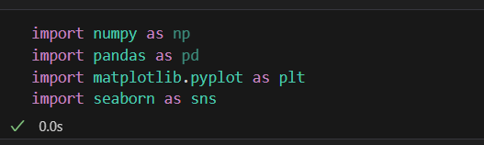

**Load the dataset: (DATASET 1)**

* Data sets are available in .csv format. A CSV file stores tabular data in plain text.
* Each line of the file is a data record. We use the read_csv method of the pandas library to read a local CSV file as a dataframe.
* Load our customer data from the CSV file

**Code:**

**import pandas as pd**

**# Try reading the file with different encodings**

**encodings = ['utf-8', 'latin1', 'ISO-8859-1']**

**for encoding in encodings:**

**try:**

**dataset = pd.read_csv(r'/content/Covid_19_cases4.csv', encoding=encoding)**

**print(f"Successfully read with encoding: {encoding}")**

**break**

**except UnicodeDecodeError:**

**print(f"Failed to read with encoding: {encoding}")**

**# Now 'dataset' should contain your data**

**Output:**

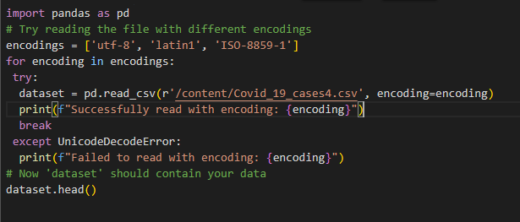

**Head() Function:**

* The head() function is used to get the first n rows.
* This function returns the first n rows for the object based on position.
* It is useful for quickly testing if your object has the right type of data in it.
* If the value of the n is not assigned it returns a default value of first 5 rows

**Code:**

dataset.head()

**Output:**

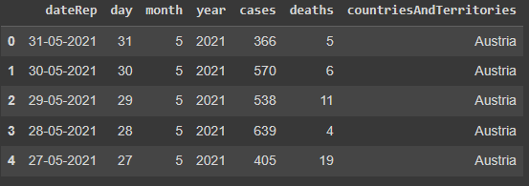

**Info() Function:**

* The info() method prints information about the DataFrame.
* The information contains the number of columns, column labels, column data types, memory usage, range index, and the number of cells in each column (non-nullvalues).

**Code:**

dataset.info()

**Output:**

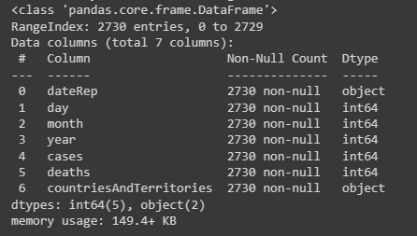

**Df.isnull().sum() Function:**

* This code is used to count the number of missing (null) values in each column of a DataFrame, denoted as df.
* It returns a summary of the missing data for each column, showing how many missing values are there in each column.
* This information is essential in data preprocessing and analysis to identify and handle missing data appropriately.Top of Form

**Code:**

dataset.isnull().sum()

**Output:**

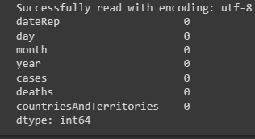

**Describe Function:**

* The describe() function in pandas, a popular Python data analysis library, is used to generate summary statistics of a DataFrame or Series.

It provides a quick overview of the key statistics for numerical data in the dataset, including:

* **Count:** The number of non-null values.
* **Mean:** The average of the values.
* **Standard Deviation (std):** A measure of the spread or dispersion of the data.
* **Minimum:** The minimum value in the dataset.
* **25th Percentile (25%):** The value below which 25% of the data falls (the first quartile).
* **Median (50% or the 2nd quartile):** The middle value when the data is sorted.
* **75th Percentile (75%):** The value below which 75% of the data falls (the third quartile).
* **Maximum:** The maximum value in the dataset.

**Code:**

dataset.describe()

**Output:**

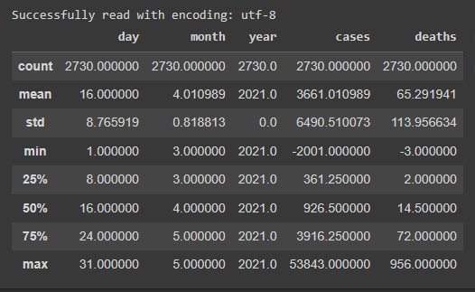

**Outliers:**

* Outliers are data points that significantly deviate from the rest of the data in a dataset.
* They can be exceptionally high or low values compared to the majority of the data.

**Code:**

**import matplotlib.pyplot as plt**

**# Ensure your dataset contains only numerical data for box plotting**

**dataset = pd.read_csv(r'/content/Covid_19_cases4.csv', encoding=encoding)**

**numerical_data = dataset.select_dtypes(include='number')**

**# Transpose the data to prepare for box plotting**

**data_to_plot = numerical_data.values.T**

**# Create subplots**

**fig, axs = plt.subplots(9, 1, dpi=95, figsize=(7, 17))**

**# Iterate through columns and create boxplots**

**for i, col in enumerate(numerical_data.columns):**

**axs[i].boxplot(data_to_plot[i], vert=False)**

**axs[i].set_ylabel(col)**

**plt.show()**

**Output:**

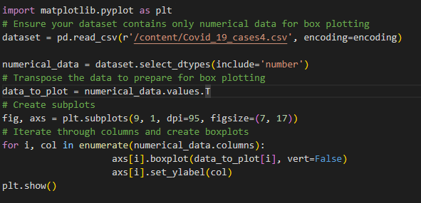

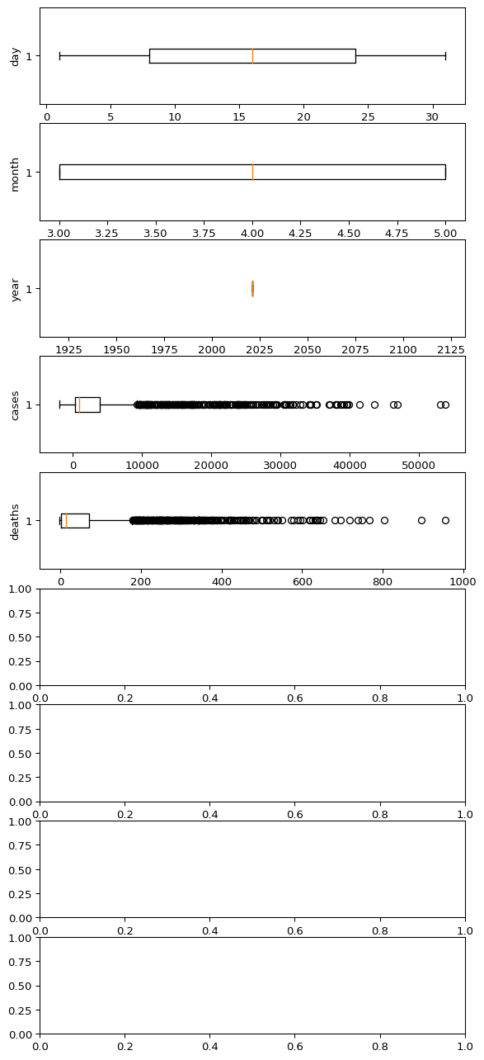

**Corelation:**

* Correlation is a statistical measure that indicates the extent to which two or more variables fluctuate in relation to each other.
* Correlation describes the relationship between variables. It can be described as either strong or weak, and as either positive or negative.

**Code:**

dataset = pd.read_csv(r'/content/Covid_19_cases4.csv', encoding=encoding)

numeric_dataset = dataset.select_dtypes(include=['number'])

corr = numeric_dataset.corr()

import matplotlib.pyplot as plt

import seaborn as sns

plt.figure(dpi=130)

sns.heatmap(corr, annot=True, fmt='.2f')

plt.show()

**Output:**

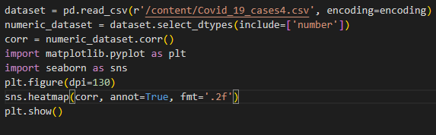

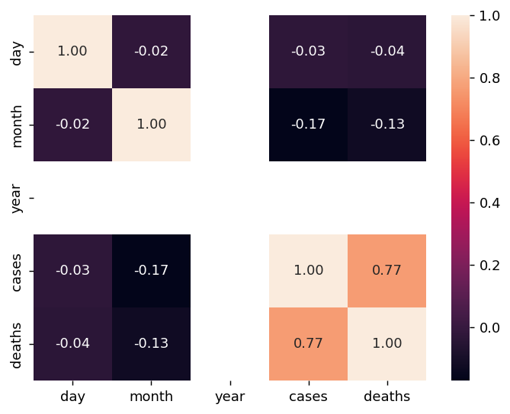

**Normalization**

* MinMaxScaler scales the data so that each feature is in the range [0, 1].
* It works well when the features have different scales and the algorithm being used is sensitive to the scale of the features, such as k-nearest neighbors or neural networks.
* Rescale your data using scikit-learn using the MinMaxScalar.

Mean for Cases And Deaths :

Standard Deviation For Cases And Deaths:

Relationship Between Deaths And Cases:

Relationship Between Days And Cases:

Relationship Between Cases And Months:

Relationship Between Cases And Year:

Relationship Between Days And Deaths:

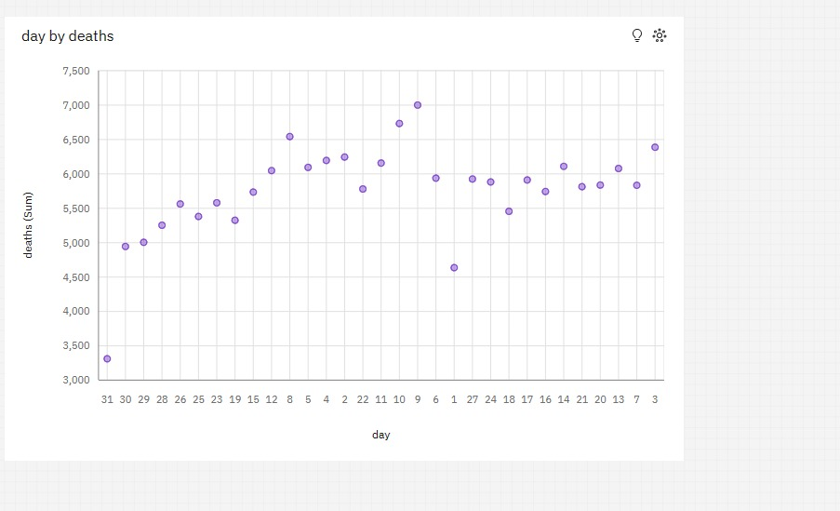

Relationship Between Months And Deaths:

