INTRODUCTION

Any physical activity in this world, whether carried out by human beings or by nature, is cause due to flow of energy in one form or the other. The word ‘energy’ itself is derived from the Greek word ‘en-ergon’, which means ‘in-work’ or ‘work content’. The work output depends on the energy input. Thus in all industrial operation, the input of energy is must to obtained the output from in the form of work. Over the years due to rapid industrialization and population growth the requirements of energy has increased manifolds. It is also known that usage of Fossils fuels as compared to other energy sources is maximum, which is unsustainable. Moreover, during their uses the environmental issues have also been encountered. Overall view of this situation has made man to look for other sustainable sources of energy like green fuels, solar energy and battery technology.

Classification

Energy sources are classified into following two category

1. **Conventional or Non-Renewable Sources**

Conventional energy resources which are being traditionally used for many decades and were in common use around oil crisis of 1973 are called conventional energy resources, e.g., fossil fuel, Coal

2. Non-Conventional or Renewable Sources

Non-conventional energy resources which are considered for large scale use after oil crisis of 1973, are called non-conventional energy sources, e.g., solar, wind, Hydro, Tidal

**Solar Energy:**

The electromagnetic radiation from sun is commonly known as solar energy. These radiations are resulted from thermo nuclear fusion reaction on the surface of sun. All the radiation from the sun is not in the same wavelength range. Almost 92% lie in the range of 315 nm to 1400nm. The estimated amount of solar flux reaching the atmosphere of earth is approximately 1400W/m2min.and that of heat equivalent is 2.68 X 1024 J/Year. The eco system of earth utilizes about 0.2-0.5 % of total amount of solar energy received. It indicates clearly that large amount solar energy get wasted, which otherwise can be immense use for satisfying needs of humans.

Advantage of solar energy:

1. It is non-polluting and non-depleting source of energy.
2. It is renewable source of energy.
3. It is available abundantly.

In spite of these advantage, the use of solar energy in large scale is still not in practice, due to following reasons,

1. Non availability of intense light in all areas throughout year
2. Difficulties faced in economic collection and conversion of solar energy into other forms of energy such as electricity.

The solar energy has been successfully used in following purpose

1. Heating: Used for water and space heating in colder countries.
2. Electricity: Using solar energy electric energy can be generated.

**Flat Plate Collector:**

The device works on the principle of black body in which heat absorbing capacity and tendency of a black surface is utilized to achieve benefits for human.

Diagram:

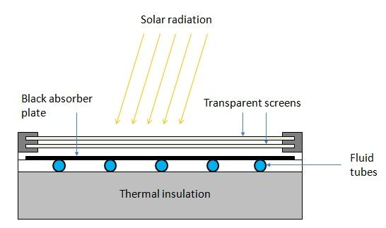

Construction:

These are the main components of a typical flat-plate solar collector:

* Black surface  - absorbent of the incident solar energy
* Glazing cover - a transparent layer that transmits radiation to the absorber, but prevents radiative and convective heat loss from the surface
* Tubes containing heating fluid to transfer the heat from the collector
* Support structure to protect the components and hold them in place
* Insulation covering sides and bottom of the collector to reduce heat losses

Application

Some advantages of the flat-plate collectors are that they are:Easy to manufacture

* Low cost, Collect both beam and diffuse radiation
* Permanently fixed (no sophisticated positioning or tracking equipment is required)
* Little maintenance

**PHOTO VOTAIC CELL (SOLAR CELL)**

A conventional solar cell structure is shown in figure:

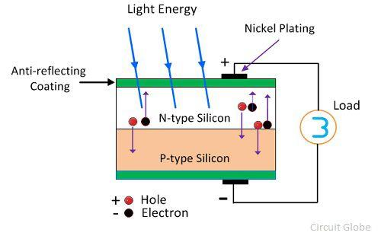

Semiconductors like silicon has the capacity to absorb light and deliver a portion of the energy of the absorbed photons to carry charge carriers (electrons and hole).Thus solar cell is a semiconductor diode that has been designed carefully so that it can absorb the light energy efficiently and convert light energy from the sun into electrical energy.

**Construction:** A typical silicon photo voltaic cell composed of thin layer of phosphorus doped silicon (n-type) on top of boron doped (p-type) silicon. Hence these two layers form p-n junction. A metallic grid is the electrical contact of the diode and allows light to fall on the semiconductor between the grid lines. An anti-reflective layer between the grid lines increases the amount of light transmitted to semiconductor.

**Working:**  of tiny energy packets called photon.When light radiation falls on the p-n junction diode, photon are absorbed and electron-hole pairs are generated. The electrons are diffused and collected at the n-type end and holes are diffused and collected at the p-type end. When these two ends are electrically connected through a conductor, there is a flow of current between the two ends through the external circuit. Thus photoelectric current is produced and available for use. The current output of a cell depends on its efficiency and size and is proportional to the intensity of sun light striking the surface of the cell. Therefore, hotovoltaic cells are connected electrically in series or parallel circuits to produce higher voltages, currents and power levels. A number of solar cells electrically connected to each other and mounted in a support structure or frame is called a photovoltaic module. A photovoltaic array is the complete power generating unit, consisting of any number of photovoltaic modules and panels.

|  |  |
| --- | --- |
| Advantage | Disadvantage |
| 1. Fuel source is vast and essentially infinite. | Sun light is a diffuse or relatively low density energy. |
| 1. Does not contribute to global change or pollution. | 1. Poor reliability of auxiliary elements including storage. |
| 1. No moving parts and so no wear and tear and low operating cost | 3. Sun light is a diffuse, i.c., it is relatively low density energy. |
| High reliability in modules. | Energy can be produced only during the day time. |

**Fuels**

A fuel is a combustible substance containing carbon as the main constituent which on combustion or proper burning gives large amount of heat that can be used economically for domestic and industrial purposes. During the process of combustion of a fuel, the atoms of carbon, hydrogen, etc combine with oxygen with simultaneous liberation of heat. The calorific value of a fuel depends mainly on the two elements.

C + O2 ----->CO2 + 94 kcals.

2H2 + O2 -----> 2H2 O + 68.5 kcals.

So, carbon compounds have been used for many centuries as the source of heat and energy. The main source of fuel is coal and petroleum. These are stored fuels available in earth's crust and are generally called fossil fuels because they were formed from the fossilised remains of plants and animals.

Characteristics of Good Fuels:

The good fuel should have following characteristics

1. High calorific value
2. Moderate ignition temperature
3. Easily available and cost efficient
4. Easy to transport
5. Low or no harmful by-product of combustion
6. Low moisture content
7. Moderate rate of combustion
8. Low or no ash
9. Cost Effecient

**Classification of fuels:** On the basis of origin, fuels are classified as primary and secondary fuels.

|  |  |  |
| --- | --- | --- |
| Physical state | Primary fuels | Secondary fuels |
| Solid | Wood,Coal | Charcoal,coke |
| Liquid | Petroleum | Petrol,diesel |
| Gas | Natural gas | LPG |

**Primary fuels:** It is the one which is natural and doesn’t require any chemical processing before utilization.

**Ex:** wood, coal, crude petroleum and natural gas.

**Secondary fuels:** They are produced from naturally occurring substances by subjecting to treatments, which alter their chemical composition and improve their calorific value.

**Ex:** Coke, gas-LPG, Diesel, Petrol, Kerosene

**Hydrocarbon fuels:** Fuels which contain hydrogen and carbon are called hydrocarbon fuels. Ex: Petrol, diesel, kerosene.

Calorific value: Calorific value of a fuel is "the total quantity of heat liberated, when a unit mass (or volume) of the fuel is burnt completely."

**Units of heat :**

(1) 'Calorie' is the amount of heat required to raise the temperature of one gram of water through one degree Centigrade (15-16°C).

(2) "Kilocalorie" is equal to 1,000 calories. It may be defined as 'the quantity of heat required to raise the temperature of one kilogram of water through one degree Centigrade. Thus: 1 kcal = 1,000 cal

(3) "British Thermal unit" (B.T.U.) is defined as "the quantity of heat required to raise the temperature of one pound of water through one degree Fahrenheit (60-61°F).

This is the English system unit.

(4) Centigrade Heat Unit (C.H.U): It is the quantity of heat required to raise the temperature of 1 pound of water through 1 degree centigrade.

1 B.T.U. = 252 cal = 0.252 kcal 1 kcal = 3.968 B.T.U.

1 Kcal = 3.968 B.Th.U = 2.2 C.H.U

Determination of calorific value:

Higher or gross calorific value (HCV) Higher or gross calorific value: Usually, all fuels contain some hydrogen and when the calorific value of hydrogen-containing fuel is determined experimentally, the hydrogen is converted into steam. If the products of combustion are condensed to the room temperature (15°C or 60°F), the latent heat of condensation of steam also gets included in the measured heat, which is then called "higher or gross calorific value".

Gross or higher calorific value (HCV) is "the total amount of heat produced, when unit mass/volume of the fuel has been burnt completely and the products of combustion have been cooled to room temperature"(i.e., 15°C or 60°F ).

Lower or net calorific value (LCV) Lower or net calorific value: In actual use of any fuel, the water vapour and moisture, etc., are not condensed and escape as such along-with hot combustion gases. Hence, a lesser amount of heat is available.

Net or Lower calorific value (LCV) is "the net heat produced, when unit mass /volume of the fuel is burnt completely and the products are permitted to escape".

Net calorific value = Gross calorific value - Latent heat of condensation of water vapour

= GCV - Mass of hydrogen x 9 x Latent heat of condensation of water

Dulong's formula for calorific value from the chemical composition of fuel is :

HCV = 1/100 [8,080 C + 34,500 (H – O/8)+ 2,240 S] kcal/kg

where C, H, 0, and S are the percentages of carbon, hydrogen, oxygen and sulphur in the fuel respectively. In this formula, oxygen is assumed to be present in combination with hydrogen as water,

and LCV = [ HCV - 9H/100 x 587] kcal/kg

= [HCV - 0.09 H x 587] kcal/kg

This is based on the fact that 1 part of H by mass gives 9 parts of H2O, and latent heat of steam is 587

Solid Fuels COAL

Coal is a highly carbonaceous matter that has been formed as a result of alteration of vegetable matter (e.g., plants) under certain favourable conditions by the action of heat and pressure over millions of years.

It is chiefly composed of C, H, N, and 0, besides non-combustible inorganic matter.

Analysis of Coal

In order to assess the quality of coal the following two types of analysis are made.

1. Proximate Analysis It includes the determination of moisture, volatile matter, ash and fixed carbon. This gives quick and valuable information regarding commercial classification and determination of suitability for a particular industrial use.

2. Ultimate Analysis It includes the determination of carbon, hydrogen, nitrogen, sulphur and oxygen in coal. Since it is used for the determination of elements present in the coal, it is also called elemental analysis. This analysis gives exact results and are useful in calculating the calorific value of coal using Dulong's formula.

Proximate analysis

1. Moisture: About 1 g of finely powered air-dried coal sample is weighed in a crucible. The crucible is placed inside an electric hot air-oven, maintained at 105° - 110°C. The crucible is allowed to remain in oven for 1 hour and then taken out, cooled in a desiccator and weighed. Loss in weight is reported as moisture (on percentage-basis).

Percentage of moisture = Loss in weight x 100

Wt. of coal taken

1. Volatile matter: The dried sample of coal left in the crucible in (1) is then covered with a lid and placed in an electric furnace (muffle furnace), maintained at 925°± 20°C. The crucible is taken out of the oven after 7 minutes of heating. The crucible is cooled first in air, then inside a desiccator and weighed again. Loss in weight is reported as volatile matter on percentage-basis.

Percentage of volatile matter = Loss in weight due to removal of volatile matter x 100

Wt. of coal sample taken

1. Ash: The residual coal in the crucible in (2) is then heated without lid in a muffle furnace at 700 ± 50° C for 1/2 hour. The crucible is then taken out, cooled first in air, then in desiccator and weighed. Heating, cooling and weighing is repeated, till a constant weight is obtained. The residue is reported as ash on percentage-basis.

Percentage of ash = Weight. of ash left x 100

Wt. of coal taken

1. Fixed carbon: Percentage of fixed carbon = 100 - % of (moisture + volatile matter+Ash)

**Importance or significance of proximate analysis:**

Proximate analysis provides following valuable informations in assessing the quality of coal:

1. Moisture: Moisture lowers the effective calorific value of coal. Moreover, it quenches the fire in the furnace. Hence, lesser the moisture content, better the quality of coal as a fuel. However, presence of moisture, up to 10%, produces a more uniform fuel-bed and less of "fly-ash".

1. Volatile matter: A high volatile matter containing coal burns with a long flame, high smoke and has low calorific value. Hence, lesser the volatile matter, better the rank of the coal. Higher volatile content in coal is undesirable. A high volatile matter content means that high-proportion of fuel will be distilled and burned as a gas or vapour. The volatile matter present in the coal may be combustible gases (such as methane, hydrogen, carbon monoxide and other hydrocarbons) or non-combustible gases (like CO2 and N2). Volatile matter content is of special significance in coal gas manufacture and in carbonization plants, particularly when by-product recovery is the main object. Thus, high-volatile matter containing coals do not cake well; whereas medium-volatile matter content coals are capable of yielding hard and strong coke on carbonization.
2. Ash is a useless, non-combustible matter, which reduces the calorific value of coal. Moreover, ash causes the hindrance to the flow of air and heat, thereby lowering the temperature. Also, it often causes. trouble during firing by forming clinker), which block the inters paces of the grate. This in-turn causes obstruction to air supply; thereby the burning of coal becomes irregular. Hence, lower the ash content, better the quality of coal. The presence of ash also increases transporting, handling and storage costs. The presence of ash also causes early wear of furnace walls, burning of apparatus and feeding mechanism.
3. Fixed carbon: Higher the percentage of fixed carbon, greater is its calorific and better the quality coal. Greater the percentage of fixed carbon, smaller is the percentage of volatile matter. This also represents the quantity of carbon (in coal) that can be burnt by a primary current of air drawn through the hot bed of a fuel. Hence, high percentage of rued carbon is desirable.

**Ultimate analysis** involves in the following determinations:

**Carbon and hydrogen**:

About 1-2 g of accurately weighed coal sample is burnt in a current of oxygen in a combustion apparatus. C and H of the coal are converted into CO2 and H2O respectively. The gaseous products of combustion are absorbed respectively in KOH and CaCl2 tubes of known weights.

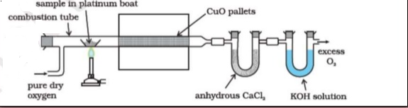

The increase in weights of these are then determined.

C + O2 ----->CO2:

2H2 + O2-----> 2H2O

KOH + CO2-----> K2CO3 + H2O

CaCl2 + 7 H2O-----> CaC12.7 H2O

C = Increase in mass of KOH x 12 x 100

Weight of coal sample taken x 44

H = Increase in weight of CaCl2 tube x 2 x 100

Weight of coal sample taken x 18

**Nitrogen by Kjeldahl’s Method:** About 1 g of accurately weighed powdered 'coal is heated with concentrated H2SO4 along-with K2S04(catalyst) in a long-necked flask(called Kjeldahl's flask). After the solution becomes clear, it is treated with excess of KOH and the liberated ammonia is distilled over and absorbed in a known volume of standard acid solution. The unused acid is then determined by back titration with standard KOH solution. From the volume of acid used by ammonia liberated, the percentage of N in coal is calculated as: 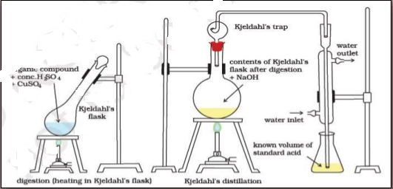

Percentage of N = Volume of acid used x Normality x 1.4

Weight of coal taken

**Sulphur** is determined from the washings obtained from the known mass of coal, used in a bomb calorimeter for determination of a calorific value. During this determination, S is converted into sulphate. The washings are treated with barium chloride solution, when barium sulphatThe washings are treated with barium chloride solution, when barium sulphate is precipitated. This precipitate is filtered, washed and heated to constant weight.

Percentage of S = Weight of BaS04 residue obtained x 32 x 100

Weight of coal sample taken in bomb x 233

Ash determination is carried out as in proximate analysis.

1. Oxygen: It is obtained by difference. Percentage of O = 100 - Percentage of (C + H + S + N + ash)

Significance of ultimate analysis:

(1) Carbon and hydrogen: Greater the percentage of carbon and hydrogen better is the coal in quality and calorific value. However, hydrogen is mostly associated with the volatile matter and hence, it affects the use to which the coal is put. Also higher percentage of carbon in coal reduces the size of combustion chamber required. The amount of carbon, the major combustible consti1fent of coal, depends on the type of coal and its percentage increases with rank from lignite to anthracite. Thus, percentage of carbon forms the basis of classification of coal

(2) Nitrogen has no calorific value and hence, its presence in coal is undesirable; thus, a good quality coal should have very little nitrogen content.

(3) Sulphur, although contributes to the heating value of coal, yet on combustion produces acids (S02 and S03), which have harmful effects of corroding the equipments and also cause atmospheric pollution. Sulphur is, usually, present to the extent of 0.5 to 3.0% and derived from ores like iron pyrites, gypsum, etc., mines along-with the coal. Presence of sulphur is highly undesirable in coal to be, used for making coke for iron industry, since it is transferred to the iron metal and badly affects the quality and properties of steel. Moreover, oxides of sulphur (formed as combustion products) pollute the atmosphere and leads to corrosion.

(4) Oxygen content decreases the calorific value of coal. High oxygen-content coals are characterized by high inherent moisture, low calorific value, and low coking power. Moreover, oxygen is in combined form with hydrogen in coal and thus, hydrogen available for combustion is lesser than actual one. An increase in 1% oxygen content decreases the calorific value by about 1. 7% and hence, oxygen is undesirable. Thus, a good quality coal should have low percentage of oxygen.

**Liquid Fuels** These are naturally found under the sea surface.. Liquid fuels find extensive use in domestic and industrial fields. Petroleum or crude oil is a dark greenish brown or black coloured viscous oil found deep in earth's crust. The oil is usually floating over a brine solution and above the oil, natural gas is present. Crude oil containing mixture of paraffinic, olefinic and aromatic hydrocarbons with minor amounts of organic compounds like N, 0 and S. The average composition of crude oil is C =80 - 87 %, H =11-15%, S = 0.1 -3.5%, (N +O) =0.1- 2.5%. a)

Classification of petroleum Petroleum is classified into three types based on variation of chemical nature of crude oil found in the earth.

1. Paraffinic-base type crude oil: It contains saturated hydrocarbons from CH4 to C35H72 and little amount of naphthalenes and aromatics.
2. Asphaltic-base type crude oil: It contains mainly cycloparaffins or naphthalenes with smaller amount of paraffins and aromatic hydrocarbons.
3. Mixed-base type crude oil : It contains both paraffinic and asphaltic hydrocarbons and are generally in the form of semi-solid waxes.

**Refining of Petroleum**

The crude oil obtained from the earth crust contains water, sulphur and some unwanted impurities. After removal of water, sulphur and these impurities, the crude oil is separated into various useful fractions by fractional distillation and finally conveI1ed into desired specific products having different boiling points. The process is called "Refining of Petroleum" and the refining plants are called "Oil refineries".

The process of refining involves the following steps.

Step -I: Separation of water (Cottrell's process) The crude oil from the oil well is an extremely stable emulsion 0 f oil and salt water. The crude oil is allowed to flow between two highly charged electrodes, where colloidal water droplets coalesce to form large drops, which is then separated out from the oil.

Step - II: Removal of harmful impurities

The sulphur compounds present in the crude oil is removed by treating oil with copper oxide

Step - III: Fractional distillation The crude oil is then heated to about 400°C in an iron retort, whereby all volatile substances (except asphalt or coke) are evaporated. The hot vapors are then passed up a fractionating column, which is a tall cylindrical tower containing a number of horizontal stainless steel trays at short distances. Each tray is provided with small chimney covered with a loose cap. (Figure 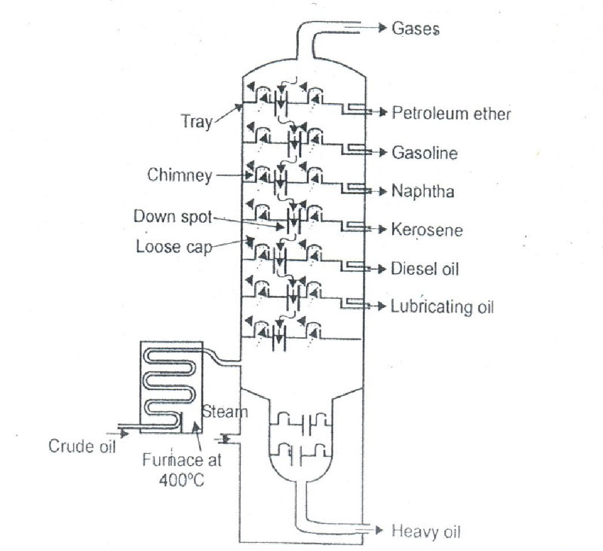

When the vapours of the oil go up in the fractionating column, they become gradually cooler and get condensed at different heights of column. The fractions having higher boiling points condense at lower trays whereas the fractions having lower boiling points condense at higher trays. The gasoline obtained by the fractional distillation is called straight --run gasoline. Various fractions obtained at different trays are given in table.

|  |  |  |  |  |
| --- | --- | --- | --- | --- |
| **Sr. No.** | **Fraction Name** | **Carbon Content** | **Boiling Range** | **Application** |
|  |  |  |  |  |
| 1 | Uncondensed Natual Gas | C1-C4 | < 30 0 | Used as domestic fuel, IC engine |
| 2 | Petroleum Ether | C3-C7 | 30-70 0 | Aviation Fuel and solvents |
| 3 | Gasoline or Petrol | C5-C8 | 40-120 0 | Fuel in IC engine |
| 4 | Naphtha or Solvent Spirit | C9-C10 | 120-180 0 | Solvent, dry cleaning |
| 5 | Kerosene | C10-C16 | 180-250 0 | Illuminant, jet engine |
| 6 | Diesel | C12-C18 | 250-320 0 | Fuel in Ic engine |
| 7 | Heavy Oil   1. Lubricating oil 2. Petroleum gelly 3. Grease 4. Wax | C17-C30 | 300-400 | Cracking   1. Lubricant 2. Shoe polish, candle, 3. Lubricant 4. Candle, water proofing |
| 8 | Residue   1. Asphalt 2. Coke | C30 and above | > 4000 | 1. Road making 2. Fuel in molding arc light rods |

(DELETED Not included in Portion)

**Cracking**

The decomposition of bigger hydrocarbon molecules into simpler, low boiling hydrocarbons of lower molecular weight is called cracking. The gasoline obtained from the fractional distillation of petroleum, has the highest demand as a motor fuel, but the yield of this fractions is only 20-30% (Crude oil) and also quality as straight-run gasoline which is not good an_ hence is used only after proper blending. To overcome these difficulties, the higher boiling fractions (e.g. fuel oil and gas oil) are converted into lower boiling fractions gasoline (petrol) by cracking process. The cracked gasoline gives better engine performance i.e., they are suitable for spark –ignition engines of automobiles. In cracking process, higher saturated hydrocarbon molecules are converted into simpler molecules such as paraffinic and olefinic hydrocarbons,

There are two methods of cracking in use

1. Thermal cracking 2. Catalytic cracking

**Thermal cracking**.

In this process, the heavy oil is subjected to high temperature and pressure, when the bigger

hydrocarbon molecules break down to give smaller molecules of the paraffins, olefins and hydrogen. The cracked products are then separated by fractional distillation. This process is carried out in liquid phase at a temperature of 4 75 - 530° C and under pressure of 100 kg/cm2 is called Liquid-phase thermal cracking or at a temperature of 600-650°C (heavy oil is vapourised) and under a low pressure of 10-20 kg/cm2, such process is called Vapour-phase thermal cracking.

**Catalytic cracking**

In this process, cracking is carried out in presence of a catalyst at lower temperature (400° C to 500° C) and pressures (l to 5 kg/cm2). The catalyst like aluminium silicate or alumina [A12O3] used in cracking gives higher yield and better quality of gasoline. There are two types of catalytic cracking in use

**i) Fixed-bed catalytic cracking**

The heavy oil is passed through the heater, where the oil is vapourised and heated to 400 to 500°C and then forced through a catalytic champers containing the catalyst of silica alumina gel (SiO2, Al2O3) or bauxite, is mixed with clay and zirconium oxide maintained at 400 to 500°C and 1.5 kg/cm2 pressure. During their passage through the tower, cracking takes place about 30-40% of the charge is converted into gasoline and about 2- 4% carbon is formed which gets deposited on the catalytic bed. (Figure )

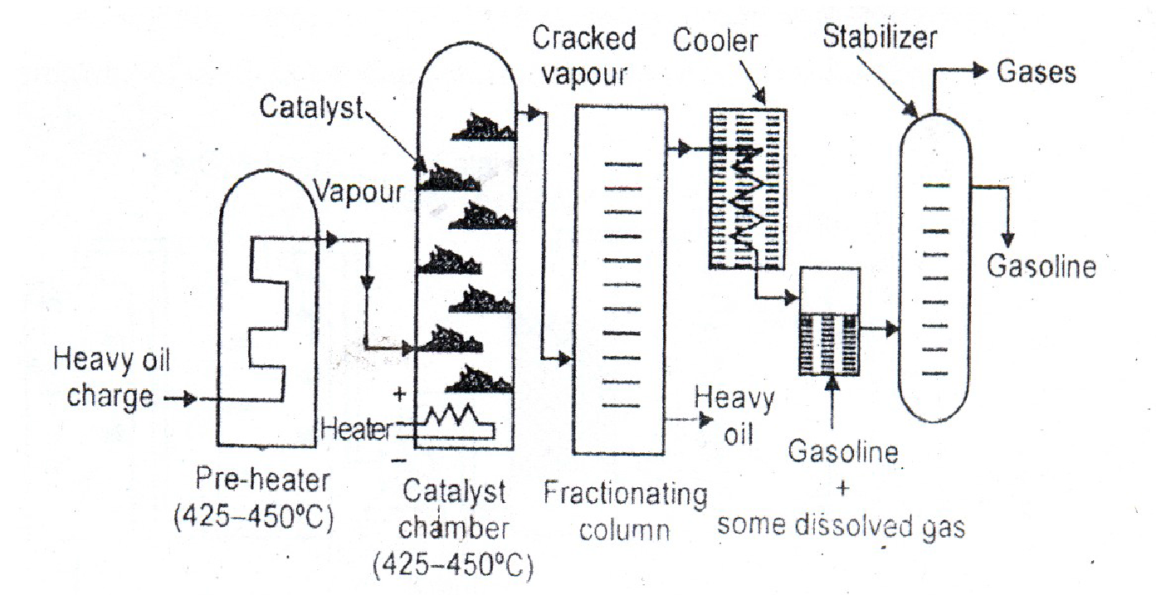

The vapours produced are then passed through a fractionating column, where heavy oil fractions

condensed. The vapours are then admitted into a cooler, where some of the gaseous products are

condensed along with gasoline and uncondensed gases move on. The gasoline containing some dissolved gases is then sent to a stabilizer, where the dissolved gases are removed and pure gasoline is obtainedWhen substantial amount of carbon is deposited on the catalyst bed, during cracking, the catalyst stops functioning. It is reactivated by burning off the deposited carbon in a stream of hot air. During the reactivation of catalyst, the vapours are diverted through another catalyst chamber.

**ii) Fluid (Moving)-bed catalytic cracking**

In this process, solid catalyst is finely powdered, so that it behaves almost as a fluid, which can be circulated in gas stream. The vapours of cracking stock (gas oil, heavy oil, etc.,) mixed with fluidized catalyst is forced up into a large reactor bed in which cracking of the heavier molecules into lighter molecules occurs at a temperature of 530°C and pressure of about 3' to 5 kg/cm2. The top of the reactor, there is a centrifugal separator, which, allows the low boiling lighter molecules move up to the top of the reactor and enter into the fractionating column but retains all the catalyst powder in the reactor itself. The carbon deposited on the catalyst powder are burnt off in the regenerator and the temperature rises to about 590°C or more. The cracked gases and gasoline are removed from the top of the fractionating column and sent to a cooler, where gasoline is condensed. It is then sent to a stabilizer to recover pure gasoline. The

product contains a higher proportion of aromatics and iso-paraffins.

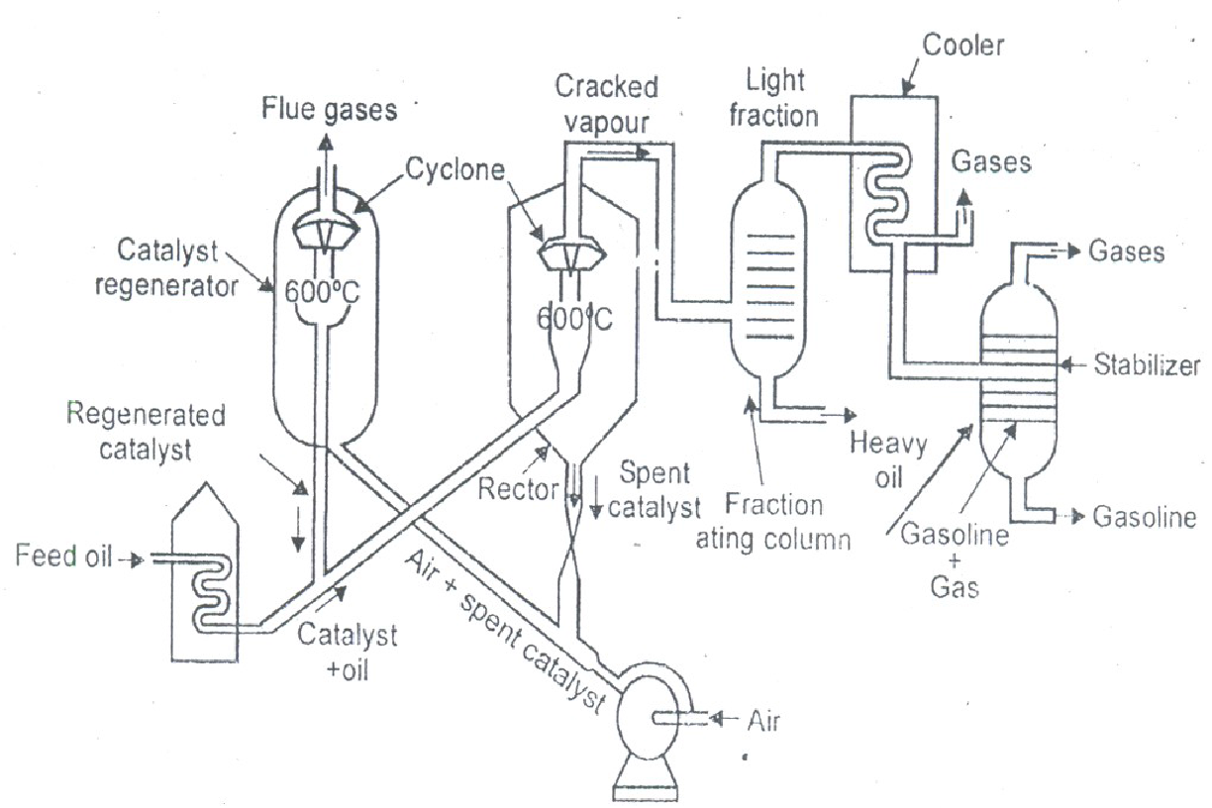

**Advantages of catalytic Cracking:**

1. The yield of petrol is higher
2. The quality of petrol i.e. octane number is higher
3. No external fuel is necessary for cracking the heat required for cracking is is derived from regeneration of catalyst.
4. Lower pressure is needed for catalytic cracking
5. The product of cracking can be easily controlled hence better knocking characteristic
6. Isomerization of branched chain product occurs hence improving the quality of fuel.
7. Catalyst is selective in cracking and therefore they permit cracking of only high boiling hydrocarbon.
8. Decomposition of aromatics removes only side chains but no ring is broken hence improving octane number.

**KNOCKING in petrol Engine:** Knocking is defined as sharp metallic noise produced in internal combustion engine due to premature ignition of fuel; and result in loss of energy and wear and tear of engine.

The fuel air mixture is heated to temperature equal to ignition temperature as a result of compression. The spark plug than ignite the mixture and combustion takes place uniformly.

It is possible that portion of air mixture undergoes self-ignition due to overheating of air fuel mixture. The resulting shock wave dissipates its energy by throwing the piston which in turn hit the cylinder walls. This result in sharp noise similar to rattling of hammer is called Knocking.

Factors on which knocking depends:

1. Engine Design
2. Chemical composition of fuel
3. Running Condition

Since knocking in petrol engine is due to premature ignition of fuel mixture, it can be controlled by modifying the composition of fuel composition.

n-alkanes> mono substituted alkanes>cyclo alkanes> alkenes>polysubsituted alkenes> aromatics

**LEADED PETROL (ANTI-KNOCK AGENT)**

The knocking of petrol can be reduced by the addition of suitable additives like tetraethyl lead (TEL) or (C2H5)4 Pb is an important additive added to petrol. Thus the petrol containing tetra ethyl lead is called leaded petrol.TEL reduces the knocking tendency of hydrocarbon. Knocking follows a free radical mechanism, leading to a chain growth which results in an explosion. If the chains are terminated before their growth, knocking will cease. TEL decomposes thermally to form ethyl free radicals which combine with the growing free radicals of knocking process and thus the chain growth is stopped.

**Disadvantages of using TEL**

When the leaded petrol is used as a fuel, the TEL is converted to lead oxide and metallic lead. This lead deposits on the spark plug and on cylinder walls which is harmful to engine life. To avoid this, small amount of ethylene dibromide is added along with TEL. This ethylene dibromide reacts with Pb and PbO to give volatile lead bromide, which goes out along with exhaust gases. But this creates atmospheric pollution. So nowadays aromatic phosphates are used instead of TEL

(iii) Nowadays aromatic phosphates are used as antiknock agent because it avoids lead pollution.

**Unleaded Petrol:**

The petrol whose knocking property is reduced without addition of TEL is called unleaded petrol. The anti-knocking properties of petrol can be improved by adding MTBE (methyl tertiary butyl ether). MTBE has oxygen atom in the form of ether and supplies oxygen for the combustion and thus reducing the formation peroxy free radicals.

**OCTANE NUMBER (or) OCTANE RATING**

Octane number is introduced to express the knocking characteristics of petrol. It has been found

that n-heptane knocks very badly and hence, its anti-knock value has been given zero. On the other hand, iso-octane gives very little knocking and so, its anti-knock value has been given 100.Thus octane number is defined as 'the percentage of iso-octane present in a mixture of iso-octane and n-heptane.'

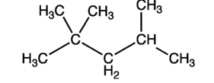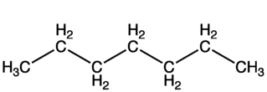

**2,2,4-trimethyl Pentane (Iso Octane) n- Heptane**

**Octane Rating = 100 Octane Rating = 0**

**Diesel Engine and Cetane Number**

In the diesel engine, air is first drawn into cylinder and compressed to a pressure of about 500 Psi. This compression is accompanied by rise in temperature to about 500 degree. Towards the end of compression stroke, diesel is injected in the form of finely divided spray in to hot air. The fuel droplet absorb heat from air and it iis ignited by spark plug and then it combust uniformly. The combustion of fuel in diesel engine is not instantaneous; the interval between the start of fuel injection and ignition is called ignition delay. It depends on the a) Engine Design b) injector design c) chemical composition of fuel

If ignition delay is long, it will lead to fuel it will lead to fuel accumulation in engiune even before ignition. When ignited an explosion result as combined effect of temperature and pressure. This is responsible for knocking in diesel engine.

n-alkanes > Cycloalkanes > alkenes >branched alkanes >aromatics

Thus the cetane number is defined as "the percentage of hexa decane present in a mixture of hexa decane

and 2-methyl napthalene, which has the same ignition lag as the fuel under test".

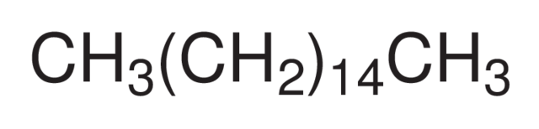 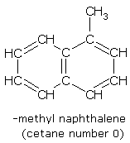

Cetane

Cetane Rating = 100

.

**BIODIESEL :**

Biodiesel is a renewable, biodegradable fuel made from natural oils or fats. It is an eco-friendly alternative to conventional diesel and can be used in diesel engines with minimal modifications.

The primary process for biodiesel production is **transesterification**, where triglycerides in oils or fats react with alcohol (usually methanol or ethanol) in the presence of a catalyst.

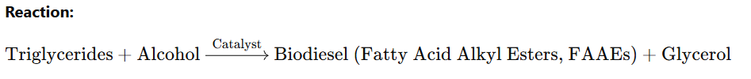

**Triglycerides:** Found in natural oils and fats.

**Alcohol:** Methanol or ethanol (methanol is most commonly used due to cost and availability).

**Catalysts:** Alkali (e.g., sodium hydroxide or potassium hydroxide) or acid catalysts.

**Transesterification:**

Mixing the feedstock oil with alcohol and a catalyst

Heating the mixture (50-60°C for methanol)

Allowing the reaction to proceed for 1-2 hours

**Separation:**

Biodiesel is separated from the by-product glycerol based on density differences.

Glycerol settles at the bottom, while biodiesel floats on top.

**Advantages of Biodiesel**

1. **Environmental Benefits:**

Reduces greenhouse gas emissions and air pollutants.

Biodegradable and non-toxic.

1. **Renewable:**

Derived from plant or animal sources.

1. **Engine Performance:**

Provides better lubrication compared to fossil diesel.

1. **Blending:**

Can be blended with petroleum diesel (e.g., B20: 20% biodiesel, 80% diesel).

**7. Challenges in Biodiesel Production**

1. **Feedstock Cost:** High costs of edible oils.
2. **Competition with Food Supply:** Edible oils may lead to food vs. fuel conflicts.
3. **Cold Flow Properties:** Poor performance in cold climates.
4. **By-Product Management:** Disposal or use of glycerol.

POWER ALCOHOL:

Power alcohol is a **blend of ethanol (ethyl alcohol)** and petrol, typically consisting of 5–25% ethanol mixed with gasoline. Common blends include:

**E10:** 10% ethanol and 90% gasoline.

**E20:** 20% ethanol and 80% gasoline.

**Production of Ethanol**

Ethanol, the main component of power alcohol, is produced through:

**Fermentation Process:**

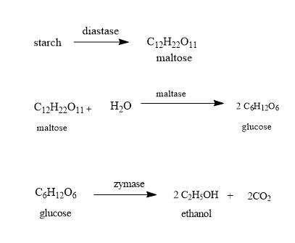

**Distillation:**

Ethanol is purified to remove water and impurities.

**Dehydration:**

Water-free (anhydrous) ethanol is obtained by azeotropic distillation or molecular sieves, making it suitable for blending with petrol.

**Properties of Power Alcohol**

1. **Octane Number:**

Higher than pure petrol, leading to better engine performance

1. **Burning Characteristics:**

Burns cleaner with fewer emissions (reduced CO and unburnt hydrocarbons)

1. **Energy Content:**

Slightly lower energy density compared to petrol, leading to a minor reduction in mileage.

1. **Renewable:**

Produced from biomass, making it a sustainable option

**Advantages of Power Alcohol**

1. **Environmental Benefits:**

Reduces greenhouse gas emissions

Produces fewer toxic pollutants, such as carbon monoxide

1. **Renewable Resource:**

Made from agricultural products, supporting circular economies

1. **Improves Engine Performance:**

Higher octane rating 92 % reduces engine knocking.

1. **Economic Benefits:**

Reduces dependence on imported petroleum

**Disadvantages of Power Alcohol**

1. **Lower Energy Output:**

Ethanol contains about **33% less energy** per unit volume compared to petrol.

1. **Corrosion Risk:**

Ethanol absorbs water and can cause engine corrosion over time.

1. **Compatibility Issues:**

Requires modifications in older engines to handle ethanol blends

1. **Food vs. Fuel Debate:**

Production from food crops like corn may lead to higher food prices and shortages.

**BATTERY TECHNOLOGY:**

Battery is a combination of two or more electrochemical cells. These electrochemical cells store energy in the form of chemical energy, and this is converted into electrical energy when connected to an electrical circuit in which an electrical current can flow. A cell consists of two electrodes with an electrolyte placed between them. The negative electrode is known as the cathode, while the positive electrode is known as the anode. The electrolyte between them can either be a liquid or a solid. Today many cells are enclosed in a special container, and there is an element known as a separator placed between the anode and cathode. This is porous to the electrolyte and prevents the tow electrodes from coming into contact with each other.

Batteries are becoming more widely used. As the use of portable and mobile equipment increases, so does the use of battery technology. The increasing demands being placed on batteries has meant that the technology has developed considerably in the past few years, and more development can be expected in the future. With the huge demand for batteries, there is a wide variety of different battery and cell technologies available. These range from the established non-rechargeable technologies such as zinc-carbon and alkaline batteries to rechargeable batteries that have moved from NiCd through NiMH cells to the newer lithium ion rechargeable batteries. Another area of battery technology that is becoming more important is the green or environmental aspects.

## Primary and secondary cells

Although there are many different types of battery, there are two main categories of cell or battery that can be used to provide electrical power. Each type has its own advantages and disadvantages and therefore each type of battery is used in different applications, although they can often be interchanged:

* **Primary batteries:**   Primary batteries are essentially batteries that cannot be recharged. They irreversibly transform chemical energy to electrical energy. When the chemicals within the battery have all reacted to produce electrical energy and they are exhausted, the battery or cell cannot be readily restored by electrical means.
* **Secondary batteries:**   Secondary batteries or secondary cells are different to primary ones in that they can be recharged. The chemical reactions within the cell or battery can be reversed by supplying electrical energy to the cell, restoring their original composition.

**Lead Acid Battery:**

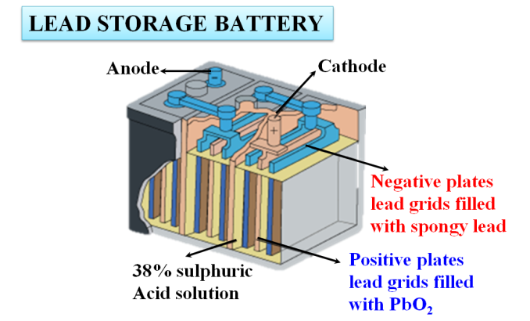**CATHODE:** Spongy lead coated with PbO2

**ANODE:** Spongy lead Plates

**Electrolyte:** Conc. H2SO4(38%)

A lead-acid battery is a rechargeable electrochemical energy storage device.

It is one of the oldest battery types, invented in 1859 by Gaston Planté.

Commonly used in vehicles, UPS systems, and solar power systems due to its reliability and cost-effectiveness.

During discharge, chemical energy is converted into electrical energy through redox reactions.

During charging, electrical energy is supplied to reverse the chemical reactions.

* **Advantages:**

Cost-effective

High surge current capability

Simple manufacturing process

* **Limitations:**

Heavy and bulky

Limited cycle life compared to newer battery technologies.

Potential for sulfuric acid leakage and environmental concerns

**Nickel Cadmium Battery**

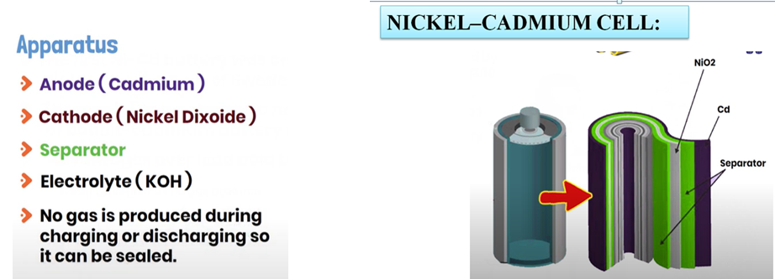

Nickel-Cadmium (Ni-Cd) batteries are rechargeable electrochemical storage devices that use nickel oxide hydroxide (NiO (OH) as the positive electrode and cadmium (Cd) as the negative electrode. These batteries are known for their durability, high discharge rates, and resistance to extreme temperatures.

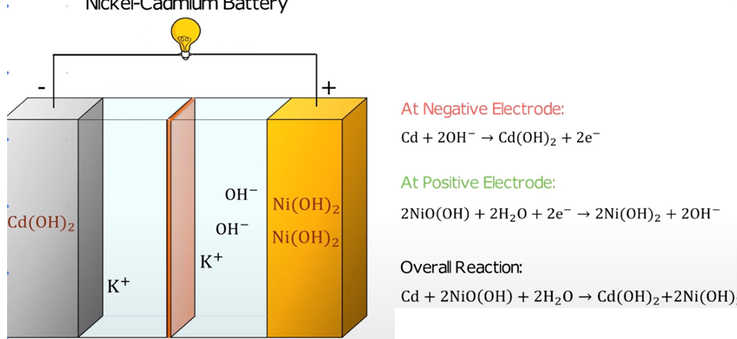

# Advantages:

# Durability:

# Long cycle life (500–1000 cycles)

# Performance:

# High discharge rates and steady voltage output

# Performs well in extreme temperatures (-40°C to 60°C).

# Maintenance:

# Can be stored in a discharged state without damage

# Limitations:

# Memory Effect:

# Partial discharges followed by recharging can reduce battery capacity if not fully discharged occasionally.

# Toxicity:

# Cadmium is highly toxic and environmentally hazardous.

# Cost:

# Higher initial cost compared to some other rechargeable batteries.

# Lithium Ion Battery

Since the late 1980s rechargeable lithium cells have come onto the market. They offer greatly increased energy density in comparison with other rechargeable batteries, though at greatly increased cost. It is a well-established feature of the most expensive laptop computers and mobile phones that lithium rechargeable batteries are specified, rather than the lower cost NiCad or NiHM cells that we have been considering earlier. The battery consists of a anode of Lithium, dissolved as ions, into a carbon. The cathode material is made up from Lithium liberating compounds, typically the three electro-active oxide materials,

## Construction:

## CATHODE: LiMO2

## ANODE: Graphite

## SEPERATOR: polymer film(PE/PP)

## ELECTROLYTE: Lithium ion solution

A positive electrode made with Lithium metal Oxide has a current collector made of thin aluminum foil – cathode.

1. A negative electrode made with specialty carbon has a current collector of thin copper foil – anode.
2. A separator is a fine porous polymer film.
3. An electrolyte made with lithium salt in an organic solvent.
4. The electrolytes are selected in such a way that there should be an effective transport of Li-ion to the cathode during discharge.
5. The type of conductivity of electrolyte is ionic in nature rather than electronic

## Working:

1. The traditional batteries are based on galvanic action but Lithium ion secondary battery depends on an "intercalation" mechanism.

**Intercalation :**   The process where the lithium ions in the lithium ion battery are inserted into the electrode is called intercalation.

1. The chemical reaction that takes place inside the battery is as follows, during charge and discharge operation:
2. The lithium ion is inserted and exerted into the lattice structure of anode and cathode during charging and discharging

During discharge Li ions are dissociated from the anode and migrate across the electrolyte and are inserted into the crystal structure of the host compound of cathode

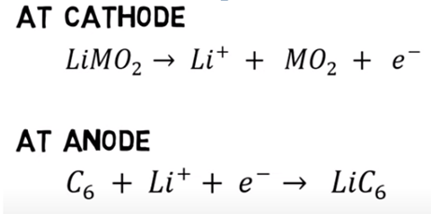

Advantages

1. They have high energy density than other rechargeable batteries
2. They are less weight
3. They produce high voltage out about 4 V as compared with other batteries.
4. No liquid electrolyte means they are immune from leaking.
5. Fast charge and discharge rate
6. Long cycle life, tolerate microcycles.
7. Very low sellf discharge rate

## Disadvantage:

1. They are expensive.
2. Internal impedance is higher than equivalent
3. Degrades at higher temperature
4. It does sustain overcharging
5. Long term implication is not yet clear
6. They are not available in standard cell types.
7. It requires to charge regularly

## Applications

1. The Li-ion batteries are used in cameras, calculators.
2. They are used in cardiac pacemakers and other implantable device.
3. They are used in telecommunication equipment, instruments, portable radios and TVs, pagers.
4. They are used to operate laptop computers and mobile phones and aerospace application.
5. Lithium ion rechargeable battery used as main power supply for mobile phone , PCs, digital camera replacing Nickel metal hydride cell
6. Upto 1000MAh capacity and more available for use in traction application as well as stand by power.

**Nickel-Cadmium Rechargeable Cell:**

Thsis is secondary storage rechargeable battery. This cell can be represented as:

Cd| CdO| KOH (6 M) || NIOOH.Ni (OH)2 |Ni

Anode: Spongy Cd|CdO

Cathode: Nickel Oxide hydroxide|Ni

Electrolyte: KOH (6M)

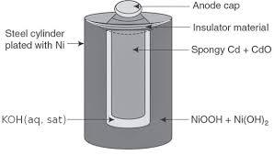

Rechargeable Ni-Cd batteries composed of positive electrode plate which uses nickel oxy hydroxide as an active material and negative plate which uses cadmium as active materials, a separator consist of thin non-woven fabric. In Ni-Cd cells shown a cell cup made up of steel coated with nickel acts as cathode and cell cap in contact with anode of the cell is in the center.

At Anode: When cell is supplying to an external circuit electron flow from this electrode.

Cd(s) + 2 OH- -----🡪 Cd (OH)2 + 2 e-

At cathode: The positive electrode is hydrated oxide of nickel.

2 NIO(OH) + 2 H2O + 2 e-  ---🡪 2 NI(OH)2  + 2 OH-

When the cell is supplying current to an external circuit, electron flow into the cathode from the external circuit and reaction proceed to form nickel hydroxide.

Advantage:

1 . It is very reliable sturdy and long-life battery

1. It can be stored for long period in any condition without deterioration.

**DELETED PART**

| **BATTERY TYPES & THEIR PROEPRTIES** | | | |
| --- | --- | --- | --- |
| **CELL TYPE** | **NOMINAL VOLTAGE V** | **CHARACTERISTICS** |  |
| **Primary cells and batteries** |  |  |  |
| Alkaline manganese dioxide | 1.5 | Widely available, providing high capacity. Shelf life normally up to about five years. Capable of providing moderate current. |  |
| Lithium thionyl chloride | 3.6 | Good for low to medium currents. High energy density and long shelf life. |  |
| Lithium manganese dioxide | 3.0 | Long shelf life combined with high energy density and moderate current capability. |  |
| Mercury oxide | 1.35 | Used for button cells but are virtually phased out now because of the mercury they contain. |  |
| Silve oxide | 1.5 | Good energy density. Mainly used for button cells. |  |
| Zinc carbon | 1.5 | Widely used for consumer applications. Low cost, moderate capacity. Operate best under intermittent use conditions. |  |
| Zinc air | 1.4 | Mostly used for button cells. Have a limited life once opened and low current capability but a high energy density. |  |
| **Secondary cells and batteries** |  |  |  |
| Nickel cadmium NiCd | 1.2 | Were in very common use, but now giving way to NiMH cells and batteries in view of environmental impacts. Low internal resistance and can supply large currents. Long life if used with care. |  |
| Nickel metal hydride NiMH | 1.2 | Higher capacity but more expensive than NiCads. Charging must be carefully controlled. Being used in many applications where NiCads were previously used. |  |
| Lithium ion Lion |  | Highest capacity and they are now widely used in many laptops, mobile phones, cameras . . etc. Charging must be carefully controlled and often have a limited life ~ typically 300 charge discharge cycles. |  |
| Lead acid | 2.0 | Widely used for automotive applications. Relatively cheap, but life expectancy often short. |  |

## Battery definitions, terms, & terminology

* **Anode:**   The definition for the anode is the electrode at which an oxidation reaction occurs. This means that the anode electrode is a supplier of electrons. However the electron flow reverses between charge and discharge activities. As a result, the positive electrode is the anode during charging and the negative electrode is the anode during discharging.   
    
  In order to prevent confusion, the anode is normally defined for its activity during the discharge cycle. In this way the term anode is used for the negative electrode in a cell or battery.
* **Battery:**   A battery is the generic name for a unit that creates electrical energy from stored chemical energy. Strictly it consists of two or more cells connected in an appropriate series / parallel arrangement to provide the required operating voltage and capacity to meet its operating requirements. The term battery is also frequently used to refer to a unit consisting of a single cell, especially when it contains battery management circuitry.
* **Cathode:**   The definition of a cathode is the electrode in a battery or other system at which a reduction reaction occurs. The electrode takes up electrons from an external circuit. Accordingly, the, the negative electrode of the battery or cell is the cathode during charging and the positive electrode is the cathode during discharging.  
    
  To prevent confusion the cathode is normally specified for the discharge cycle. As a result, the name cathode is commonly used for the positive electrode of the cell or battery.
* **Capacity:**   The capacity of a battery or cell is defined as the amount of energy that it can deliver in a single discharge. Battery capacity is normally specified in amp-hours (or milli-amp-hours) or as watt-hours.
* **Charge rate or C-rate :**   The definition of the charge rate or C-rate of a battery or cell is the charge or discharge current in Amperes as a proportion of the rated capacity in Ah. For example, in the case of a 500 mAh battery, a C/2 rate is 250 mA and a 2C rate would be1 A.
* **Constant-Current Charge:**   This refers to a charging process where the level of current is maintained at a constant level regardless of the voltage of the battery or cell.
* **Constant-Voltage Charge:**   - This definition refers to a charging process in which the voltage applied to a battery is held at a constant value over the charge cycle regardless of the current drawn.
* **Cycle Life:**   The capacity of a rechargeable cell or battery changes over its life. The definition of the battery life or cycle life of a battery is number of cycles that a cell or battery can be charged and discharged under specific conditions, before the available capacity falls to a specific performance criteria - normally 80% of the rated capacity.
* **Cut-off voltage:**   As a battery or cell is discharged it has a voltage curve that it follows - the voltage generally falling over the discharge cycle. The definition for a cell or battery of the cut-off voltage cell or battery is the voltage at which the discharge is terminated by any battery management system. This point may also be referred to as the End-of-Discharge voltage.
* **Deep Cycle:**   A charge discharge cycle in which the discharge is continued until the battery is fully discharged. This is normally take to be the point at which it reaches its cut-off voltage, typically 80% of discharge.
* **Energy Density:**   The volumetric energy storage density of a battery, expressed in Watt-hours per litre (Wh/l).
* **Power Density:**   The volumetric power density of a battery, expressed in Watts per litre (W/l).
* **Rated Capacity:**   The capacity of a battery is expressed in Ampere-hours, Ah and it is the total charge that can be obtained from a fully charged battery under specified discharge conditions
* **Self-Discharge:**   It is found that batteries and cells will lose their charge over a period of time, and need re-charging. This self-discharge is normal, but various according to a number of variables including the technology used and the conditions. Self-discharge is defined as the recoverable loss of capacity of a cell or battery. The figure is normally expressed in a percentage of the rated capacity lost per month and at a given temperature. The self-discharge rate of a battery or cell is very dependent upon the temperature.
* **Separator:**   This battery terminology is used to define the membrane that is required within a cell to prevent the anode and cathode shorting together. With cells being made more compact, the space between the anode and cathode becomes much smaller and as a result the two electrodes could short together causing a catastrophic and possibly explosive reaction. The separator is an ion-permeable, electronically non-conductive material or spacer that is placed between the anode and cathode.

## Lead acid battery

* **Positive plate:**   This is covered with a paste of lead dioxide.
* **Negative plate:**   This is made of sponge lead.
* **Separator:**   This is an insulating material between the two plates, but it allows the electrolyte and the ions into it to enable conduction without the two plates touching.
* **Electrolyte:**   This consists of water and sulphuric acid

These constituents are all contained within a plastic container which acts to keep the electrolyte in and the battery together.

The overall battery will normally consist of several cells placed in series to give the required voltage as each cell is capable of providing an EMF of 2.1 volts.

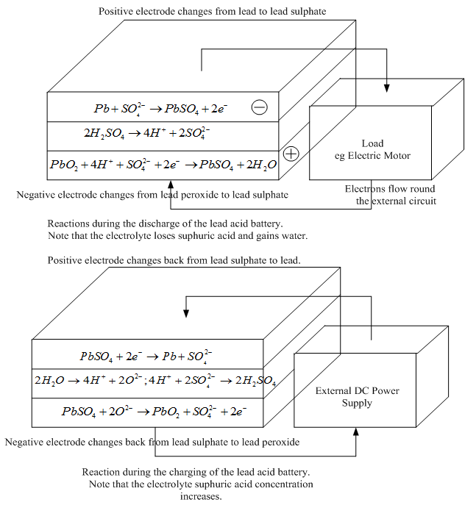

In order to enable the basic lead acid cell to produce a voltage, it must first receive charge. The voltage applied to provide this must be greater than the 2.1 volts to enable current to flow into the cell. If it were less than this, charge would actually flow out of it.

Once charged, the cell or battery will be able to provide charge to external circuits, often operating over several hours dependent upon the drain on the cell or battery.

**Lead Acid Battery Advantages**

* Mature technology
* Relatively cheap to manufacture and buy (they provide the lowest cost per unit capacity for rechargeable cells)
* Large current capability
* Can be made for a variety of applications
* Tolerant to abuse
* Tolerant of overcharging
* Wide range of sizes and specifications available
* Many producers worldwide

**Lead Acid Battery Disadvantages**

* Fails after a few years use lifespan typically 300 - 500 cycles
* Cannot always be used in a variety of orientations
* Corrosive electrolyte (can cause burns to people and corrosion on metalwork)
* Lead is not environmentally friendly
* Acid needs disposing of with care
* Not suitable for fast charging
* Must be stored in charged state once electrolyte introduced
* Typical charging efficiency only around 70%

**Fuel Cell (Deleted)**

Fuel cells were invented in about 1840, but they are yet to really make their mark as a power source for electric vehicles. However, this might be set to change over the next 20 or 30 years. Certainly most of the major motor companies are spending very large sums of money developing fuel cell powered vehicles. The basic principle of the fuel cell is that it uses hydrogen fuel to produce electricity in a battery-like device to be explained in the next section. The basic chemical reaction is:

The main components of fuel cell are

Anode comprising of fuel

An electrolyte (solution of H2SO4 and KOH)

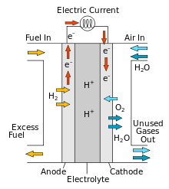 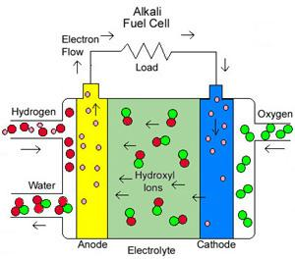

To understand this we need to consider the separate reactions taking place at each electrode. These important details vary for different types of fuel cell, but if we start with a cell based on an acid electrolyte, we shall consider the simplest and the most common type.

At the anode of an acid electrolyte fuel cell the hydrogen gas ionizes, releasing electrons and creating H+ ions (or protons).

|  |  |
| --- | --- |
|  | (2 |

This reaction releases energy. At the cathode, oxygen reacts with electrons taken from the electrode, and H+ ions from the electrolyte, to form water.

|  |  |
| --- | --- |
|  | (3) |

Different electrolytes

The reactions given above may seem simple enough, but they do not proceed rapidly in normal circumstances. Also, the fact that hydrogen has to be used as a fuel is a disadvantage. To solve these and other problems many different fuel cell types have been tried. The different types are usually distinguished by the electrolyte that is used, though there are always other important differences as well.

**LIMITATIONS:**

* 1. Stroage of fuel and oxidant.
  2. Electrolytes and electrodes are costly

3. Gives DC output and should be converted into AC.

## ADVANTAGES:

1. High power efficacy around 75%
2. Eco-friendly
3. Space required for fuel cell is less.
4. 4.Produce DC for a long time.